Resonance
L4 –Electrical and Electronic Principles– ACDA4021
Electrical & Electronic Engineering Degree Apprenticeship
Joshua H – Student Number: 2420839

Abstract
This report explores how parallel RCL circuit’s function and possible problems with using simulation software to model them. Parallel RLC circuits are made of a resistor in series, with an inductor and a capacitor which are then connected in parallel. The report will show the key differences between the outputs of a real-world RLC circuit and a simulated circuit. Namely being the large disparity in quality-factor value , in this case, it denotes the selectiveness of a frequency response, as well as, the difference in attenuation for both. A key part of RCL circuitry is the phenomenon known as resonance which is due to the interactions between the reactances of both inductor and capacitor resulting in a purely resistive circuit. The analysis is based on simulations in Proteus 8 and a breadboard circuit set up to be able to observe the phenomenon, including the effects of parasitic elements and component tolerances. Results from these experiments show an attenuation of -18.9 dB for the breadboard circuit and an attenuation approaching 0 for the simulated. This report shows clearly that whilst simulations are a valuable tool for circuit design, they lack the real-world conditions needed for accurate predictions and performance.
Introduction
Parallel RLC circuits consist of three main elements, a resistor, an inductor, and a capacitor. A key feature of this circuit is that when driven at a specific frequency to the components the reactive properties of the inductor and capacitor will cancel each other out because their currents are 180 degrees out of phase resulting in a purely resistive circuit. When connected to a voltage source the RLC circuit will store energy within the magnetic field of the inductor and the electric field of the capacitor. The energy In this system will be transferred back and forth between the two stores resulting in an oscillatory response, and the cancellation of currents as the capacitor lags 90 degrees behind and the inductor 90 degrees ahead of supply. Parasitics such as the winding in the inductors coil and wires used in the circuit will have their resistance which will affect the efficiency of the system. [1,2,8]
These circuits are used in many electronic devices, in band-pass filters found in radios allow specific frequencies through whilst preventing others, as oscillators where their passing of charge between the inductor and capacitor can be utilised. [3,4]
The scope of this report is to explain this phenomenon and show how the theory works in practice, this will be achieved using the simulation software Proteus 8 and by using components to show any differences between a perfect system and a real-world system. By knowing the properties of the components, the behavior of an RLC circuit can be estimated.
Reactance is a component's opposition to the change in direction of current, it is specific to AC circuitry and is a key parameter in the impedance function. Impedance in the case of the RLC circuit describes the circuit's total resistance, this value with affect the total useful bandwidth when attenuation is at -3dB. Reactance is a components opposition to the change in direction of current, it is specific to AC circuitry and is a key parameter in the impedance function. Impedance in the case of the RLC circuit describes the circuits total resistance, this value with effect the total useful bandwidth when attenuation is at -3dB.
$$X_{c}=\frac{1}{2πfC} X_{l}=2πfL$$
- $X_{c}$ being the capacitive reactance, $X_{l}$ being the inductive reactance
- $f$ being the frequency
- $C$ being the capacitance of the capacitor
- $L$being the inductance of the coil
As shown by the formula, the reactance of a capacitor is inversely proportional to its capacitance and to the frequency of current applied to it. In a purely capacitive circuit, the capacitive reactance leads supply by 90 degrees of phase. The inductor is the opposite; it is directly proportional to its inductance and to the frequency of current applied to it. In a purely inductive circuit, the inductive reactance lags supply by 90 degrees. It’s due to these properties that we observe the main feature of an RLC circuit, resonance. [6,7]
$${ X}_{l}=X_{c}$$
Resonance is the state in which the reactance of both the inductor and capacitor are equal. The resonant frequency is the frequency in which the circuit is resonant. At resonance in an RLC circuit the reactance, being 180 degrees apart in phase, cancels each other out leading to the resistor being the only component to have an effect on the circuit impedance. [6,7]
$$Z=R+jX$$
Impedance is the combined opposition of the change in alternating current, it takes resistance and reactance as an imaginary number. Reactance can be seen as imaginary as both reactance equations can be substituted into equations using imaginary numbers. As j being the √(-1) ω being the frequency in radians ( 2πf)
$$X_{c}=\frac{1}{jωC} and X_{l}=jωL$$

Q factor or quality factor is the ratio of a resonator’s frequency to its bandwidth, it is a useful measure in determining how selective a circuit is at specific frequencies. [5]
$Q=\frac{f_{c}}{B_{w}}$
$$where B_{w}=f_{h}-f_{l} and f_{c}=f_{l}+ \frac{B_{w}}{2}$$
- $f_{c}$ being the midpoint frequency, $f_{l}$ being the lowest frequency and $f_{h}$ being the highest frequency at -3dB
- $B_{w}$ being the bandwidth

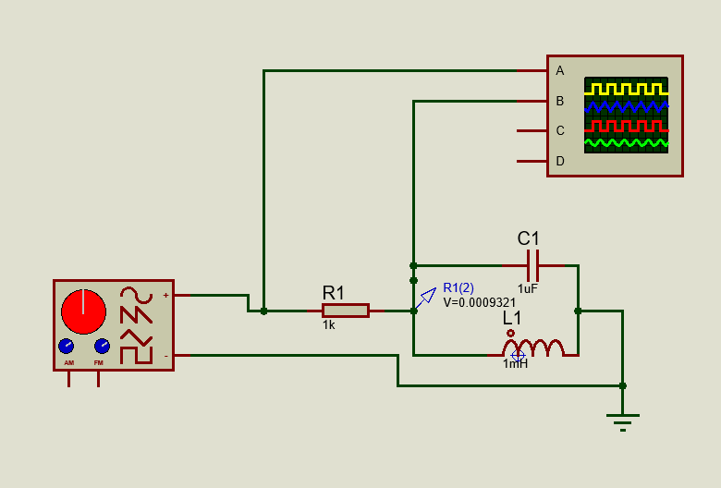
Simulation Setups

The simulation was created in proteus mirroring the specification, the wave generator was set at two volts, peak to peak, and a voltage probe (R1(2)) was placed in between the resistor, inductor, and capacitor. The oscilloscope recorded the wave at the source and then after the resistor in between the inductor and capacitor. Then using a tool within proteus a frequency response curve was able to be generated using the voltage measured in R1(2). Data from this graph was then used in Microsoft Excel so that it could be manipulated further.
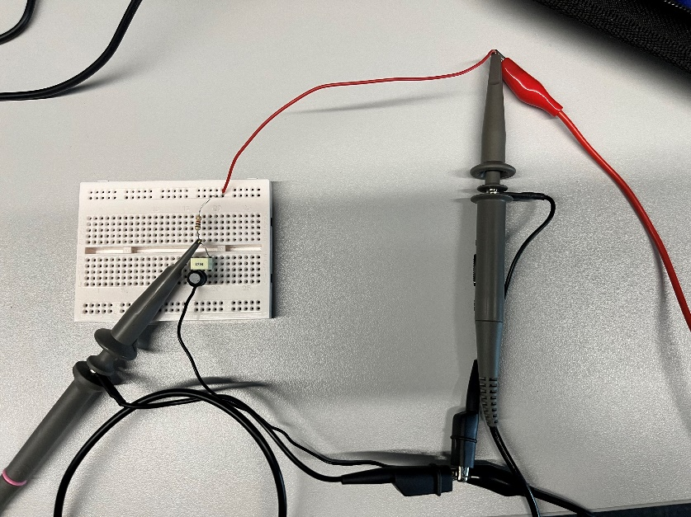

For the breadboard set-up a 1000 ohm resistor was connected in series with a 1 mH inductor and a 1 µF capacitor, these components were connected in parallel as following the circuit diagram above. These components were checked using an LCR meter, as shown in Figure 3 below, this showed that whilst the components were not exact, they were within good enough tolerance for use in the circuit. An oscilloscope probe was placed in between the resistor and the two other components to measure the change in voltage across the circuit. Another probe was placed on the input signal to allow for attenuation calculations to be made using the equation below as well as insuring that the inputted signal was accurate.
$$A=20×\log_{10}{\frac{V_{Out}}{V_{In}}}$$

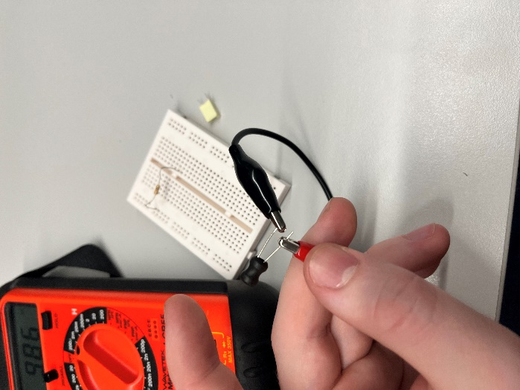

Figure 3: The inductor under test to find the components values
Results
Graph 1:

Graph 1 shows the initial readings taken in proteus to find the point of resonance. This graph shows the peak in the region of 4000 to 6000 Hertz, peaking at a maximum amplitude of 2 volts peak to peak.
Graph 2:

Graph 2 shows the second set of readings taken at a higher resolution. Readings were taken from 4000Hz to 6000Hz at 100Hz intervals. Findings show a peak at 5000Hz with a maximum amplitude of 2 volts.
Graph 3:

Graph 3 shows the set of readings taken n a breadboard. Readings were taken from 100Hz to 20,000Hz at 200Hz intervals. Findings show a peak at 5200Hz with an amplitude of 2.26 volts.
Graph 4:

Graph 4 shows the comparison of simulated and breadboarded results. The blue series represents simulated results and the orange breadboarded results. These results are in dB’s shows and whilst the breadboard’s maximum attenuation is -18.938 the simulated is -0.298. Further, the minimum attenuation in the simulated circuit is -64.033 dB and the breadboard minimum is -41.31 dB
Graph 5:
Graph 5 shows the bandwidth the simulated circuit would have at -3dB. Starting at 4954Hz and ending at 5113Hz. With a midpoint of 5035Hz1 and a total bandwidth of m 159Hz. When calculated with the formula shown in the introduction the resulting Q factor would be 31.6667
Graph 6:
Graph 6 shows the bandwidth the breadboarded circuit would have at -3dB. Starting at 4438Hz and ending at 5852Hz. With a midpoint of 5200Hz1 and a total bandwidth of 1414Hz. When calculated with the formula shown in the introduction the resulting Q factor would be 3.6755

Discussion
Graph 1 shows the initial readings taken; this was done to find the general frequency the circuit resonated at. Once this frequency range was determined a more focused scan of frequencies could be done to determine at which exact frequency the circuit began resonating. This was done by taking a 100 Hz interval from 4000 Hz to 6000 Hz, as shown in Graph 2. The same process was applied to the breadboard circuit using the range found within the initial readings. Graph 3 shows a slight difference between Graphs 1 and 2 in the resonant frequency as well as a smaller Q characterized by a shallower peak. Further readings of both breadboard and simulated circuits were taken to provide a greater resolution thus allowing for a more accurate response curve and Q factor which would then help determine possible reasons as to why there was a difference.
From Graph 4 onwards data converted from voltage to attenuation. Attenuation is the loss of aspects within an input signal generally characterised as a loss of strength. Frequency Response curves that use attenuation allow viewers to better understand where a signal's strength is best. [9]
Graph 4 shows the large variation between simulation and real-world components. Both start to peak at around the 4800 Hz and fall at 7000 Hz with the simulated peaking at 5035 Hz and the breadboard peaking at 5200. However, the Q factor of the simulated circuit was ten times that of the breadboard. This could be possible due to the differences in component values. Rearranging the equations set out in the introduction and using the values recorded by the LCR we can calculate what the frequency and Q factor should be given the different values.
$$f=\frac{1}{2π\sqrt{LC}}=\frac{1}{2π\sqrt{(1.008∙{10}^{-6})∙(0.986∙{10}^{-3})}}$$
$$∴f=5048$$
$$Q = \frac{1}{0.986} ∙ \sqrt{\frac{(0.986∙{10}^{-3})}{1.008∙{10}^{-6})}}$$
$∴Q=31.72$
These results obviously don’t match the breadboarded results and more closely mirror the simulation, this could be due to a multitude of reasons however it is most likely parasitics. Parasitics are unintended aspects of all electronics, wires connecting components inherently have resistance, as well as coils in inductors. Fields can be generated unintentionally and whilst small will have an effect on the current inside a circuit. Furthermore, components too close together may inadvertently create a small capacitive charge across each other. Breadboards are also notoriously poor for sensitive circuits due to their composition. Finally, when temperature increases, so does the resistance of components this then by Ohm’s law affects voltage and current. These factors all affect how a circuit in the real world functions. When compared to a simulated circuit where all the components are treated as being perfect differences are bound to be observed.

Conclusion
In conclusion, the differences between a simulated circuit and a real-world circuit are clear, with the simulated circuit attenuation approaching to near 0 and the real-world circuit only reaching -18.9 as well as the Q-factor being ten times that of the real in the simulated, this is most probably due to the effects of parasitics as well as differing component values. However, this does show that simulations are still valid to use as a tool to create RLC circuitry, as long as the user understands that the output of the simulations is most likely impossible in a real-world scenario.

References
[1]
M. Mulko, “Parallel RLC Circuits: What Are They and How Do They Work?,” interestingengineering.com, Sep. 24, 2021. https://interestingengineering.com/science/parallel-rlc-circuits-what-are-they-and-how-do-they-work
[2]
Wikipedia Contributors, “LC circuit,” Wikipedia, Mar. 08, 2025. https://en.wikipedia.org/wiki/LC_circuit#Operation
[3]
Wikipedia Contributors, “Band-pass filter,” Wikipedia, Apr. 18, 2019. https://en.wikipedia.org/wiki/Band-pass_filter
[4]
“Electronic filter,” Wikipedia, Apr. 07, 2020. https://en.wikipedia.org/wiki/Electronic_filter
[5]
Wikipedia Contributors, “Q factor,” Wikipedia, Apr. 21, 2019. https://en.wikipedia.org/wiki/Q_factor
[6]
electronics tutorials, “Parallel RLC Circuit and RLC Parallel Circuit Analysis,” Basic Electronics Tutorials, Jun. 25, 2013. https://www.electronics-tutorials.ws/accircuits/parallel-circuit.html
[7]
Electronics Tutorials, “Parallel Resonance and Parallel RLC Resonant Circuit,” Basic Electronics Tutorials, Oct. 15, 2018. https://www.electronics-tutorials.ws/accircuits/parallel-resonance.html
[8]
Electronics tutorials, “Series Resonance in a Series RLC Resonant Circuit,” Basic Electronics Tutorials, Jun. 04, 2018. https://www.electronics-tutorials.ws/accircuits/series-resonance.html

[9]
S. Mugo, “Understanding Attenuation in Signal Transmission,” Eepower.com, Oct. 26, 2022. https://eepower.com/technical-articles/understanding-attenuation-in-signal-transmission/#

