
Project Proposal
Name: Iolo Williams
Student No: 2508067

L5-Engineering and project management
ACDA5025A
Electrical and Electronic Degree Apprenticeship

Table of Contents
Table of Figures 4
List of Tables 5
List of abbreviations 6
1. Project Description 7
2 Aims & Objectives 7
3 Background 7
4 Project Design 8
4.1 Luminaire Bulkheads 8
4.1.1 Luminaire Specification 8
4.1.2 Luminaire Bulkhead Including CCTV 8
4.2 Cables 9
4.2.1 Power Supply Cables 9
4.2.2 CCTV Cabling 9
5. Resources 10
6 Project Plan 12
6.1 Initiation 12
6.2 Engineering Design 12
6.2.1 Site Visit 12
6.2.2 Selection of Luminaires 13
6.2.3 Creation of Deliverables 13
6.2.4 Checking & Approval 13
6.3 Construction Phase 13
6.3.1 Cable Containment 13
6.3.2 Foundation Works 13
6.3.3 Lamppost Installation 14
6.3.4 Cable Installation 14
6.3.5 Backfilling Cable Trenches 14
6.3.4 Finalising Construction Phase 14
6.4 Critical Path Analysis 15
7 Project Outcomes 17
7.1 Project Result 17
7.2 Deliverables 17
7.3 Project Landmarks 18
8 Risks and Mitigation Strategies 19
8.1 Risks 19
8.2 QA/QC Documentation 19
8.3 Testing and Commissioning 19
8.4 Scheduling 20
8.5 Using Contractors 20
8.6 Compliance with Standards 20
9 Legal, Ethical, and Societal Considerations 21
9.1 Legal Considerations 21
9.2 Ethical Considerations 21
9.3 Social Considerations 21
10. Conclusion 22
References 23
APPENDIX A- PREVENT CERTIFICATE 25
APPENDIX B- EQUALITY AND DIVERSITY TRAINING 26

Table of Figures
Figure 1: Selected luminaire Data sheet 8
Figure 2: Selected ASD luminaire bulkhead with CCTV system[3] 9
Figure 3: Initiation Phase of project timeline 12
Figure 4: Engineering design phase of project timeline 12
Figure 5: Construction phase of project timeline 13
Figure 6: End of construction phase timeline 14
Figure 7: Engineering design phase critical path analysis 15
Figure 8: Critical path analysis for construction phase 15
Figure 9: Critical path analysis for project support 16
Figure 10: Routings and Layouts drawing 18

List of Tables
Table 1: Man-Hour Estimation 10
Table 2: Bill of materials 11
Table 3: Deliverable document numbers 17
Table 4: Project risk matrix 19

List of abbreviations
Abbreviation | Meaning
BOM | Bill of Materials
BS | British Standard
CCTV | Closed-Circuit Television
CAT 6 | Category 6 Data Cable
CPC | Circuit Protective Conductor
EMI | Electromagnetic Interference
IP | Ingress Protection
LED | Light Emitting Diode
Lux (lx) | Unit of Illuminance
L/N | Live and Neutral Conductors
M/Cu | Multi-Core Copper
PM | Project Manager
PVC | Polyvinyl Chloride
QA | Quality Assurance
QC | Quality Control
RG59 | Radio Guide 59 Coaxial Cable
W | Watt
mm/sq | Millimetres Squared

1. Project Description
This proposal aims to design and install a brand-new lighting arrangement in an existing large public shopping centre car park. The designers and engineers will use calculation and design software for this project, such as Electrical OM, AutoCAD 2026 and Relux, to ensure compliance with British standards such as BS 12464-2 [1]. The specialist luminaire bulkheads will also contain security cameras with the benefits discussed in this proposal.

2 Aims & Objectives
- Firstly, the engineer will aim to have the project constructed within 9 weeks of the project start date ± 10%.
- Where convenient, re-purpose existing electrical components to reduce cost and wasted material.
- Produce drawing deliverables, materials list, and man-hour estimates for installation purposes within 5 weeks of the project kickoff meeting, ready for construction to commence.
- The finished car park is to have a minimum luminance of 10 Lux and a uniformity of 0.25 to comply with BS 12464-2, and a substantial portion of the area covered with CCTV.
- Consider every potential societal, environmental, and ethical impact, mitigating them when financially possible.

3 Background
As this car park is going to see constant use throughout all hours of the day by pedestrians and vehicles, ensuring this car park is well lit to follow the British standard contains multiple benefits. With the ability to use specific luminaire bulkheads that also contain CCTV cameras, the combination of these will enhance safety by improving visibility for cars and pedestrians. With a car park illuminated to follow the British standard, this will reduce any chance of a legal claim. Moreover, many modern fixtures have very low upkeep costs, and the CCTV could be used to enforce parking charges, allowing the site to profit from the installation.

4 Project Design

4.1 Luminaire Bulkheads
For this project, LED luminaires will be used due to their more efficient nature, keeping running costs down and allowing for a less cluttered car park as a result of the lower number of lighting posts required
The company used to supply the CCTV incorporated and ordinary luminaire bulkheads, which will be ASD lighting. This is due to their offering of “remanufacturing” [2], reducing environmental impact, IP 66 rating, and a fast delivery time compared to many competitors.

4.1.1 Luminaire Specification
The new luminaires will require a 60-Watt supply for a single luminaire with a built-in CCTV fixture, and for the basic luminaire without CCTV, a 47-Watt supply will be required.
For the engineer working on the project to make the necessary calculations, the Data sheet is shown below in Figure 1.
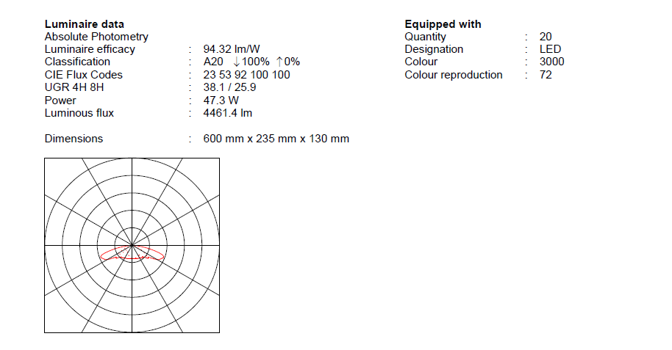
Figure 1: Selected luminaire Data sheet
Shown in Figure 1 above is the data sheet used by the engineer to produce the Relux calculation document shown further on, labelled in Table 2.

4.1.2 Luminaire Bulkhead Including CCTV
While the LED layout will be identical to the luminaire without CCTV, the power requirement will be slightly greater at 60 Watts. The bulkhead will also be larger due to the built-in CCTV system. With each bulkhead having a total Horizontal field of view of 339 degrees, this ensures the car park is not only well lit, but all areas are visible.
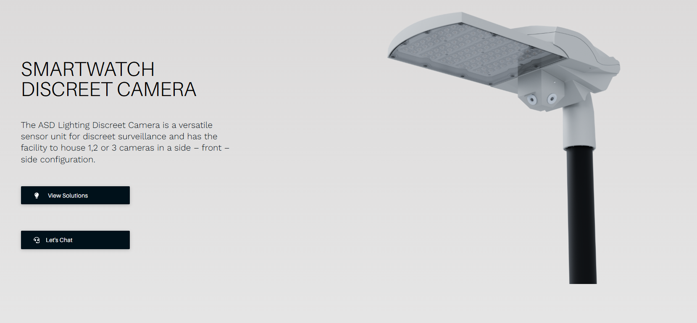
Figure 2: Selected ASD luminaire bulkhead with CCTV system[3]

4.2 Cables

4.2.1 Power Supply Cables
To supply the luminaires with their power, an L/N 3Cx2.5mm² (E Cable Core) PVC70/M/Cu. This cable was selected due to its cost-effectiveness, lightweight nature, and being the smallest cable compliant with BS 7671 wiring regulations, minimising material waste.

4.2.2 CCTV Cabling
While there are multiple different types of CCTV cables, such as coaxial, Cat 6 Data or Fibre optic. Due to the large distance this cable would cover, coaxial cables like the RG59 cable would not be acceptable due to the maximum run distance of 300 meters [4]. With fibre optic cables coming with many benefits like being immune to electromagnetic interference (EMI), but unfortunately wouldn’t fit within the budget [4]. Making the CAT 6 Data cable the preferred choice due to its high quality and low price point [5].

5. Resources
It is estimated that completing the required work for this project will require a budget of £75,368 $±$5%. This total cost is broken down in the man-hour estimation Table 1 below and in Table 2, detailing the bill of materials.
Table 1: Man-Hour Estimation
Activities | Discipline | Position | Hours | Rate (£)
Engineering | Electrical | Designer | 52 | 45
Engineering | Electrical | Engineer | 60 | 80
Engineering | Electrical | Principal Engineer | 16 | 110
Cable containment | Electrical | Electrical Technician | 48 | 65
Cable containment | Electrical | Electrical Technician | 48 | 65
Lamppost Install | Electrical | Electrical Technician | 40 | 65
Lamppost Install | Electrical | Electrical Technician | 40 | 65
Cable installation & cable termination | Electrical | Electrical Technician | 40 | 65
Cable installation & cable termination | Electrical | Electrical Technician | 40 | 65
Electrical Testing and Commissioning with certification | Electrical | Electrical Technician | 16 | 65
Electrical Testing and Commissioning with certification | Electrical | Electrical Technician | 16 | 65
Backfilling cable trenches | Electrical | Electrical Technician | 8 | 65
Backfilling cable trenches | Construction | Construction Worker | 20 | 30
Backfilling cable trenches | Construction | Construction Worker | 20 | 30
Foundation works for lampposts | Construction | Construction Worker | 40 | 30
Foundation works for lampposts | Construction | Construction Worker | 40 | 30
Support | Management | Project Manager | 40 | 105
Support | Management | Construction Manager | 12 | 125
Support | Management | Engineering Manager | 8 | 127
As shown in Table 1, the total expected hours will be 604 $±$10 %.
Table 2: Bill of materials
Bill of Materials – UWTSD-E-BOM-1000
Description | Quantity of each component | Total Cost (£)
ASD Luminaire with CCTV camera integrated | 11 | £4950
ASD Luminaire with no CCTV capabilities | 20 | £6000
8-meter-high lighting post with flange plate | 16 | £8992
Lighting post foundation block | 16 | £12720
Electrical power cables L/N 3Cx2.5 mm PVC 70/M/CU CPC cable core | 426 Meters | £2000
CAT 6 CCTV Data cables | 380 Meters | £1000
Plastic Cable ducting 20mm/sq | 426 Meters | £1250

6 Project Plan

6.1 Initiation
Shown below in Figure 3, this phase of the project will only last three days; however, it will be vital to the success of the project.
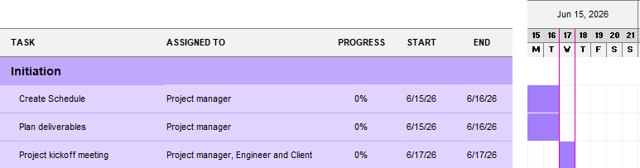
Figure 3: Initiation Phase of project timeline
As shown in Figure 3 above, the project begins with the PM creating a schedule, then planning the deliverables to be produced. Once this is completed, the Project manager will arrange a meeting with the required attendees to discuss required tasks and ensure the budget is kept to, then the project will begin. While this is the shortest phase of any project, it is incredibly important that it's completed with incredible precision, as if even one point is missed, it could leave the project in despair.

6.2 Engineering Design
This phase spans 4 weeks of the project and involves designing and producing deliverables.
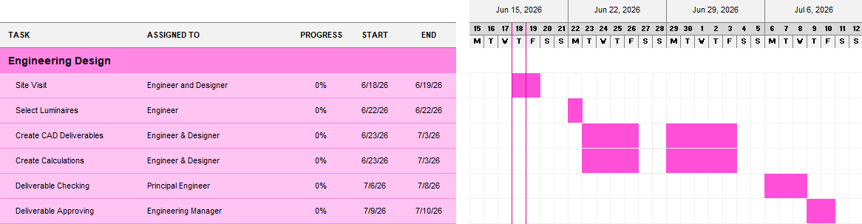
Figure 4: Engineering design phase of the project timeline

6.2.1 Site Visit
A site visit allows the team to identify potential problems with the site that may affect the work, help the project team gain a better understanding of the project, while also building a strong bond with the client [6].

6.2.2 Selection of Luminaires
With a wide variety of luminaires available, the engineer will need to find suitable IP-rated luminaires that also have an option for CCTV integration. The luminaire selected will need to be energy-efficient and cost-effective while having a sleek design.

6.2.3 Creation of Deliverables
The electrical engineer and designer will work as a team to create the deliverables required. Using the two together will ensure strong communication and reduce the amount of time the work continues for, compared to just an engineer. This will take two weeks for the team to complete the required documents that can be found in Table 2.

6.2.4 Checking & Approval
To ensure quality in the deliverables produced, the documents will be checked, ensuring correct information, spelling, grammar, and overall visual appeal. Then the engineering manager will give the documentation the final seal of approval, ready to be sent to the construction team on site.

6.3 Construction Phase
Figure 5 details the Gantt chart for the construction phase of the project. This phase is dependent on the Engineering phase, so delays are possible. This will take a team of four technicians, taking 4 weeks to complete construction.
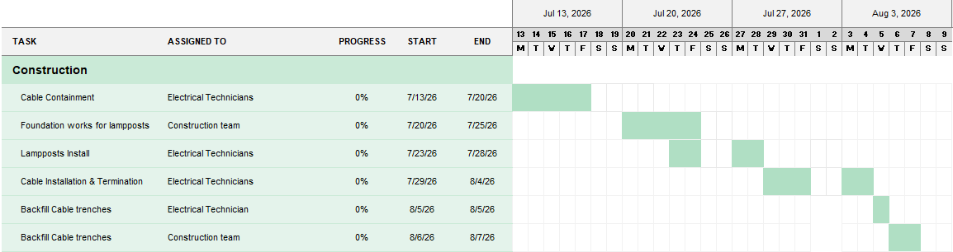
Figure 5: Construction phase of the project timeline

6.3.1 Cable Containment
The first step in construction will be to dig the cable trenches and lay the 20 mm² plastic ducting for the cable to be pulled through. This will decrease the risk of electrical shocks, fires and potential damage to cables [7]. Using the electrical technicians, this will take 5 full days of work to complete.

6.3.2 Foundation Works
Secondly, a team of two construction workers will install the Titan Base ducted foundation block [8] to allow for efficient mounting of the lighting columns. Using the precast block will prevent the disruption from weather and reduce the cost compared to pouring concrete foundations on site [8]. Due to the weight of each block and the precision needed to install these foundations, this is expected to take five full days of work to ensure a high-quality installation.

6.3.3 Lamppost Installation
To improve efficiency, the electrical technicians can begin installing the Luminaire bulkheads and CCTV systems simultaneously with the foundation blocks. Throughout this task, the technicians will connect the Bulkheads to the Lamppost and place them on the concrete foundation blocks, ready to have the supply cables and, when necessary, CCTV Cat6 data cables connected as well [9].

6.3.4 Cable Installation
To allow the luminaire and CCTV system to run effectively, they must receive an adequate power supply without breaking regulations like BS 7671. This phase of the project will take 5 full working days to complete. This long-time frame is due to the large number of connections that are to be made and the length of cables to be terminated.

6.3.5 Backfilling Cable Trenches
Firstly, the electrical technician will lay cable marking tape, which will take one day to complete the whole cable trench. This will be done as a protective measure to warn any future diggings that cables are run below. Then two members of the construction team will refill the trenches and cover them with tarmac to match the rest of the car park, taking three days.

6.3.4 Finalising Construction Phase
Detailed below in Figure 6, to ensure the safety and ensure there are no fundamental issues that may cause shocks, fires or damage to the installed equipment [7]. To combat these risks, there will be testing scheduled that will last for two days. The testing is not expected to last the full two days; however, there is a likelihood that some minor errors will be discovered, hence the extra time allocated. And finally, for any future work that may be carried out on the site, the designer will create As-Built drawings, which require little time and offer many benefits in the future [10].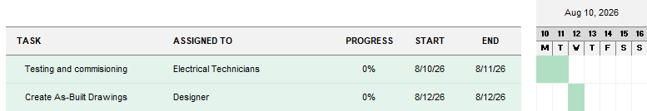
Figure 6: End of construction phase timeline

6.4 Critical Path Analysis
Figures 7, 8 and 9 below detail the critical path analysis for each different phase of the project.
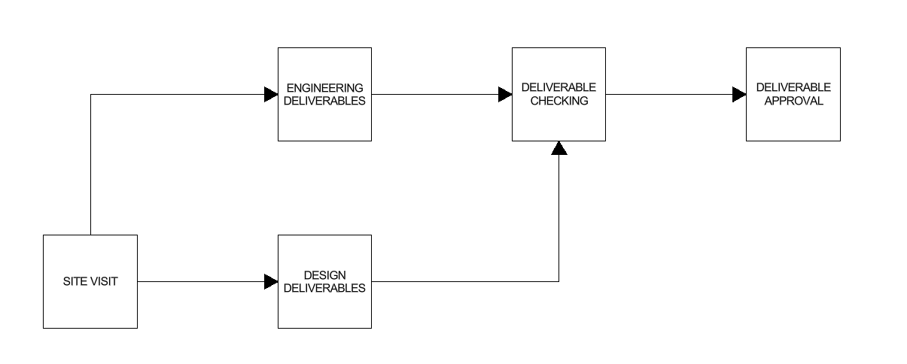
Figure 7: Engineering design phase critical path analysis

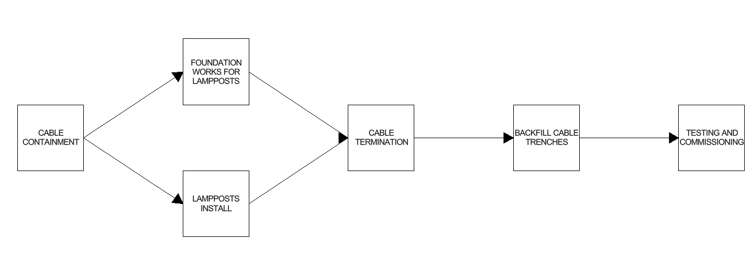
Figure 8: Critical path analysis for the construction phase
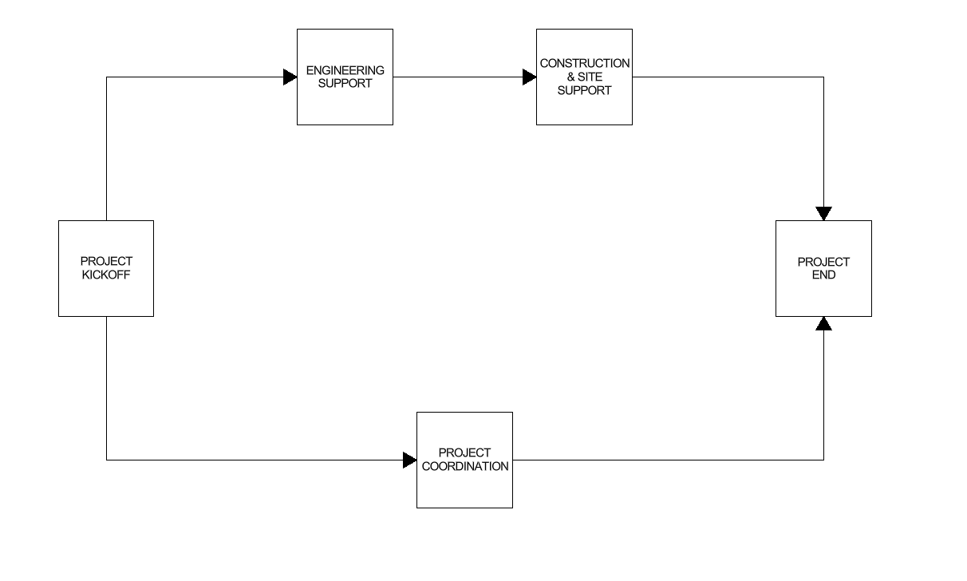
Figure 9: Critical path analysis for project support

7 Project Outcomes

7.1 Project Result
Upon completion of this project, a fully functional car park lighting and CCTV system will be designed and installed, adhering to the regulation BS 12464-2 [1].

7.2 Deliverables
As shown in Table 3 below, a list of document numbers and their respective titles has been included.
Table 3: Deliverable document numbers
Ref. | Document number | Title
1 | UWTSD-E-BOM-1000 | Bill of materials
2 | UWTSD-E-LAY-1000 | Cable Routings and layouts
3 | UWTSD-E-BLD-1000 | Cable block diagram
4 | UWTSD-E-CAL-1000 | Cable calculation
5 | UWTSD-E-CAL-1001 | Lighting calculation
6 | UWTSD-E-SLD-1000 | Cable single-line diagram
7 | UWTSD-E-SOW-1000 | Electrical scope of work
8 | UWTSD-E-CSC-1000 | Electrical cable schedule

Each deliverable will ensure regulatory compliance and be used to support the installation of each component needed. Moreover, they define specific details like the chosen equipment, minimising possible errors on site due to the accuracy of each document, reducing construction time and cost.
Figure 8 shows the cable routing and layout drawing, UWTSD-E-LAY-1000, for the installation of new luminaires and a CCTV system.
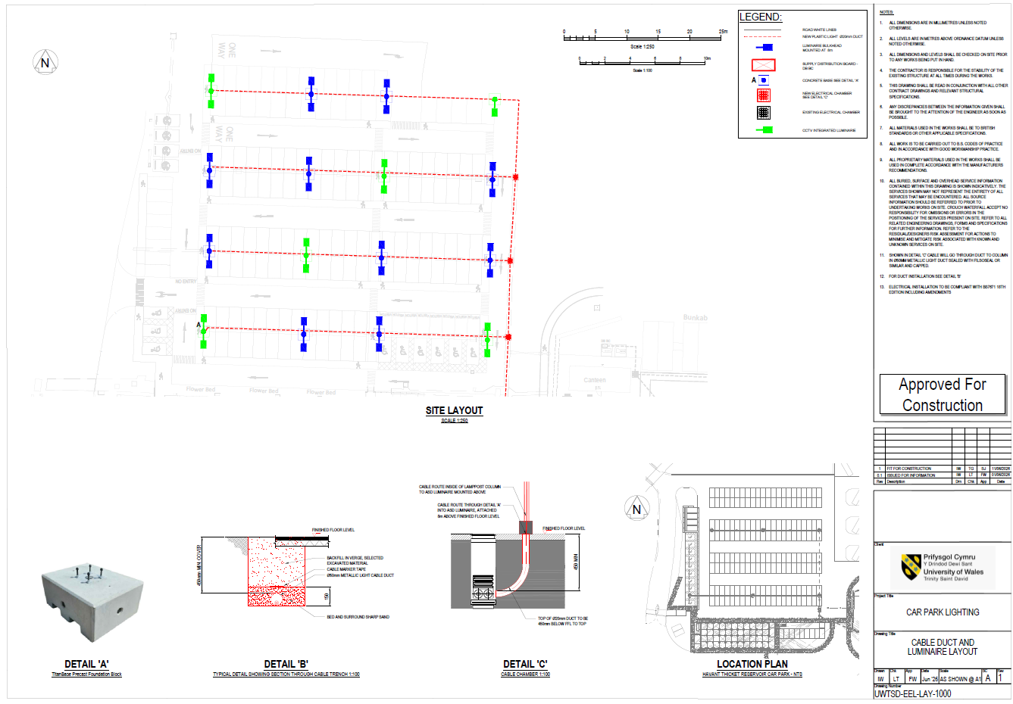
Figure 10: Routings and Layouts drawing

7.3 Project Landmarks
The first and most important landmark for this project will be the completion of the Lighting and Cable calculations. These documents will be the backbone of the project, as they determine many important details, such as luminaire placement, cable type, and installation method.
Secondly, after the completion of the two calculations, they can be used to produce the other engineering deliverables like the Cable schedule, scope of work and bill of materials.
Next, the design deliverables will be created, ready to be used to aid installation on site, streamlining the process.
Once the project deliverables are produced, the work can begin on site. This next stage will involve the digging of trenches, installation of cables, luminaire and refilling of trenches.
Lastly, the project will be completed when the functionality and compliance tests have been completed, enabling the operation of the car park.

8 Risks and Mitigation Strategies

8.1 Risks
Delays are likely to occur in this project, which is due to the majority of work involved in this project requiring completion one after another. As this work cannot take place in parallel, minor delays will accumulate and have a knock-on effect on the overall project timeline.
After installation of all necessary components during testing, some errors may be discovered that will need to be corrected.
Staff injury or sickness during design and construction could delay the project lifecycle.
As humans are susceptible to making mistakes its possible this may lead to damaged equipment, incorrect install or non-compliance.
Table 4: Project risk matrix
 | Negligible | Marginal | Critical | Catastrophic
Certain
Likely
Possible |  | Material Shortage | Missing Deadline
Unlikely |  | Employee Sickness
Rare | Printing error in design phase |  |  | Worker Injury

8.2 QA/QC Documentation
To confirm all documents produced are to a high standard, a detailed checking and approval standard will be adhered to. This involves dedicated checklists with specific checking points like spelling and grammar, correct notes, and drawing information, ensuring the highest quality document is produced. This will then be sent to the principal engineer for more checking and approval by the engineering manager.

8.3 Testing and Commissioning
To guarantee the expected quality is reached once the project has been completed, mandatory tests will be performed on each piece of equipment. These tests will search for damaged devices, competent cable connections, CCTV coverage and much more. Any faults found will be reported to the relevant personnel, and a solution will be ready as soon as possible. Once all equipment is confirmed for its operational and safety functionality, the car park will be monitored over the course of a month to confirm its performance. Any ongoing maintenance required will be completed.

8.4 Scheduling
As delays in projects can occur, some slack has been included in the overall project schedule. This offers a safety net in the event of any minor delays, such as accidents, sickness, or equipment damage occur over the course of the project.

8.5 Using Contractors
Contracts are permitted to be used for work on the project to assist in keeping the project on schedule. However, their use will impact the project cost, so they should be avoided unless vital to project completion.

8.6 Compliance with Standards
All work completed through this project shall comply with the standards to ensure the installation of a safe and secure system. These standards are listed below.
- BS 7671 [12]
- BS 12464-2 [1]
- BS EN 50132[1]

9 Legal, Ethical, and Societal Considerations

9.1 Legal Considerations
As previously mentioned in section 8.6, the installed system will comply with the standards required. Following these regulations and keeping accurate records by using As-Built drawings will ensure that, in the event of any future accidents, there is protection against any legal troubles. Secondly, health and safety regulations should also be followed by carrying out health and safety assessments and following the Health and Safety at Work Act to ensure worker safety [13]. Regarding the inclusion of CCTV installation in the project, it is important that any data protection laws are followed [14]. Failure to comply with any of these could result in financial loss, reputational damage or even legal liability.

9.2 Ethical Considerations
All decisions in this project should take the evidence of any testing completed and all calculations into consideration when installing this car park. Before this project is completed, it’s important to consider long-term impacts on local people and the environment. This will be done by using the most sustainable materials to minimise environmental damage to the area when possible, as well as ensuring any work is structurally safe and tested to protect life. All employees must feel confident to whistleblow, raising concerns about any unsafe work, illegal activities or unethical practices inside the project.

9.3 Social Considerations
Overall, this project will be beneficial to the local community. Firstly, the addition of the car park creates space for more visitors to come to the local area, increasing the area's revenue, improving local infrastructure and supporting local businesses. The installation of luminaires will contribute to local safety, as research suggests the addition can reduce crime by 21% [15]. Moreover, with CCTV also being installed, any accidents or crimes taking place will be recorded by the car park owner, aiding law enforcement if needed. On the other hand, while construction is taking place, the surrounding area may experience increased traffic during construction and greater noise during normal working hours.

10. Conclusion
To conclude, upon completion of the project, the aims to be achieved will be to have a positive environmental impact with the selection of materials and installation methods. To ensure the work involved in this project is completed to the best possible standard, there will be a dedicated focus on safety, quality of work and a strong emphasis on communication, ensuring the best chance of success.

References
[1] | user6410c3cb72dd8, “Car Park Lighting Standards Explained: Compliance, Safety and Smart Controls,” Trojan Intelligent Lighting Solutions, June 30, 2026. https://trojan-lighting.co.uk/car-park-lighting-standards-explained-compliance-safety-and-smart-controls/ (accessed July 10, 2026).
[2] | “Guide to Remanufacturing – ASD Lighting PLC,” ASD Lighting PLC, 2023. https://asdlighting.com/guide-to-remanufacturing/ (accessed June 30, 2026).
[3] | A. L. PLC, “SmartWatch Discreet Camera – ASD Lighting PLC,” ASD Lighting PLC, Oct. 05, 2021. https://asdlighting.com/products/smartwatch-discreet-camera/ (accessed July 10, 2026).
[4] | PSS Installations, “Understanding CCTV Cabling: A Guide to Fibre, Copper and Coax Cables,” PSS Installations, Aug. 11, 2023. https://pssinstallations.co.uk/understanding-cctv-cabling-a-guide-to-fibre-copper-and-coax-cables/ (accessed June 30, 2026).
[5] | ETK Kablo, “What Is a CCTV Cable? | Types, Specs & Best Practices,” ETK Kablo English, Oct. 07, 2025. https://www.etkkablo.com/en/blog/what-is-a-cctv-cable/
[6] | B. Rae, “What is a Site Visit?,” doodle.com, Aug. 29, 2023. https://doodle.com/en/site-visit/
[7] | M. Skredele, “Essential guide to underground cable ducting | Pipelife,” WPS-International, July 08, 2025. https://www.pipelife.com/service/news-and-projects/2025/guide-to-underground-cable-ducting.html
[8] | “TitanBaseTM Ducted Precast Foundation Block for Lighting Columns,” Wydels Electrical Wholesalers, 2026. https://wydels.co.uk/products/titanbase-ducted-precast-foundation-block-lighting-columns (accessed July 01, 2026).
[9] | “8 Metre Galvanized Lighting Column Lamp Post,” Wydels Electrical Wholesalers, 2026. https://wydels.co.uk/products/8-metre-galvanized-lighting-column-lamp-post?variant=21285224677435 (accessed July 10, 2026).
[10] | P. B. Service, “What is electrical testing?,” Peninsula Group, Jan. 22, 2026. https://www.peninsulagrouplimited.com/guide/what-is-electrical-testing/ (accessed July 07, 2026).
[11] | “Why As-Built Drawings Matter in Construction | Procore UK,” Procore UK, Aug. 28, 2025. https://www.procore.com/en-gb/library/as-built-drawings (accessed July 10, 2026).
[12] | “BS 7671 - 18th Edition,” Theiet.org, 2018. https://electrical.theiet.org/bs-7671-18th-edition-wiring-regulations/ (accessed July 10, 2026).
[13] | GOV.UK, “Health and Safety at Work etc. Act 1974,” legislation.gov.uk, 1974. https://www.legislation.gov.uk/ukpga/1974/37/contents (accessed July 13, 2026).
[14] | K. Williams, “CCTV in car parks,” Longmores Solicitors, Mar. 11, 2025. https://www.longmores.law/articles/cctv-in-car-parks/ (accessed July 13, 2026).
[15] | College of Policing, “Street lighting,” College of Policing, Feb. 19, 2015. https://www.college.police.uk/research/crime-reduction-toolkit/street-lighting (accessed July 13, 2026).

APPENDIX A- PREVENT CERTIFICATE


APPENDIX B- EQUALITY AND DIVERSITY TRAINING


