OOP and Advanced Software Development (Algorithms)

Algorithms and Data Structures

Author: Kallum Gordon
Prepared for: Mike Dacey

28th April 2021

Table of Contents
OOP and Advanced Software Development (Algorithms) 1
1.0 Part A: 3
2.0 Part B: 5
3.0 Part C: 6
References 7

1.0 Part A:
- Arrays are essentially a simplified and optimised variable. Variables store a value in the memory and the value can change or vary. Each variable can only hold one item of data whereas an array is a series of memory locations which each hold an item of data. So rather than having, for example, ten variables holding similar data like a score, you could hold all ten items under one array and have each individual bit of data pulled when necessary. [1] When creating an array you may not know exactly how much memory to allocate, which could lead to wasted memory and time. You also may not be sure how high any given user would ever score in a game, so you have to account for that possibility.

A linked list is a dynamic data structure meaning it can allocate and deallocate memory while the program is running so it’s not necessary to give the initial size of the list. This means that no memory is wasted and reduces human error. However, more memory is required to store elements in a linked list than in an array as each node contains a pointer which requires additional memory which could lead to slower search times. [2]

- If thousands of records are being inserted every day, it would be preferable to use a linked list as they have a faster insertion time due to the fact that memory can be dynamically created in the middle of the list rather than an array having to shift existing elements to create room. Additionally, while a linked list may use more memory per element due to the pointer, it may end up saving memory in the long run compared to an array as an array requires the user themselves to manually allocate memory in advance, and the amount of memory required can’t always be accurately predicted.
The figure seems to be presenting a linked list array hybrid. It stores a person’s name and has an array for every letter in ascending order of the number of letters a name uses. This can dramatically increase cache performance while decreasing memory overhead.
The problems that may be faced using this method include many drawbacks of arrays. It will be difficult to predict just how many names will be entered into the system, how many names of a specific letter, and how large a name is. This may lead to overestimating or underestimating the memory allocation requirements and could cause the program to stop working if the issue isn’t patched.

- A binary tree is a tree data structure where each node has at most two children. As this is a regular binary search tree it will not be automatically sorted. The root value of this tree will be 34, this will be at the top of the tree and every value will descend from it. The next value is 6, and is less than 34 so will go on the left. The value after that is 7, and so it will go to the right of 34 etc.

If a node was the same value as the root node, or any value after the root node, it would still go after the same value in the tree.

It is critical to balance a binary search tree because this sorts the tree and makes it easier to find values by following the set pattern. For example, looking for the value 45 in an unbalanced search tree would take 8 hops to find. Whereas searching for 45 in a balanced binary search tree would take 4 hops. This theoretically halves the search time.

Here is the completed binary search tree:

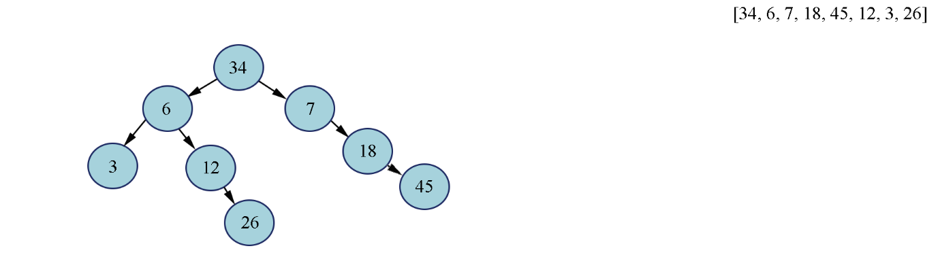

2.0 Part B:
- Dijkstra’s algorithm is an algorithm for finding the shortest path from a starting node to the target node. The algorithm creates a tree of paths throughout a graph with the inputted values. Our objective is the find the most cost effective path (essentially the shortest path) to trade stamps for a camera. This won’t be as simple as finding the shortest path from one place to another as there are additional layers to calculate such as acceptable trades, costs, and items.
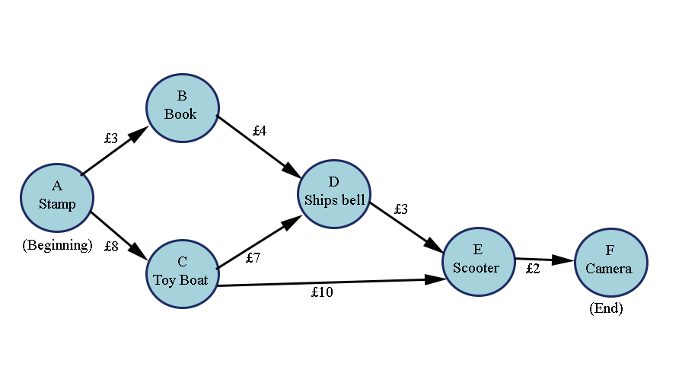

As demonstrated in the diagram above, the most cost-effective path to the camera from the stamp would be A-B-D-E-F which in total would cost £12.
Other possible more expensive paths would be A-C-E-F which would cost £20, or A-C-D-E-F which would also cost £20.

- Big O aids with algorithmic efficiency and determines the definitive best implementation of the same function. It describes how the runtime scales in respect to the variables. To use an example, say a person wanted to use a combination of three values (a, b, c) to find every combination of numbers possible to find the value of f. f = 3. Code could be written to try every single combination of a, b, and c that produces the value of f (eg: 2, 1, 0 = 3) but this is very inefficient and takes a lot of time. This can be streamlined by instead of trying every combination, write ‘smarter’ code. Since f is a specific value that’s given, every combination of a, and b could be used up to f, then for each combination set c to be equal to n minus a + b. If c > 0 then a valid combination has been found. This solution eliminates the need to add up more than two values, hence making it a more efficient solution. You can put both solutions on a graph, and scale time by input (n)x(s) to chart efficiency.

O(EV²) means O edges vertices squared. It’s not the worst algorithm as it’s polynomal but is improved by using O(E log V) because it is linearithmic.

3.0 Part C:
- The minimax algorithm is an artificial intelligence algorithm which is best described as a ‘backtracking algorithm’. It’s used in decision making in a game to find the optimal move for a player assuming the opponent also plays optimally. You often find this in online chess games. The two players are called minimizer and maximiser. The minimizer tries to get the lowest possible score while the maximiser does the opposite. This is done by assigning a value to each board state and if the maximiser has the upper hand the board will tend to be a positive value and vice versa. Backtracking is also used by the algorithm and after trying all possible moves it backtracks to make a decision. [3]

References

[1] | BBC, “Arrays and lists,” BBC, [Online]. Available: https://www.bbc.co.uk/bitesize/guides/zy9thyc/revision/1. [Accessed 28th April 2021].
[2] | H. Krohn, “Linked Lists vs. Arrays,” towards data science, 2nd July 2019. [Online]. Available: https://towardsdatascience.com/linked-lists-vs-arrays-78746f983267. [Accessed 28th April 2021].
[3] | GeeksforGeeks, “Minimax Algorithm in Game Theory | Set 1 (Introduction),” GeeksforGeeks, 31st March 2021. [Online]. Available: https://www.geeksforgeeks.org/minimax-algorithm-in-game-theory-set-1-introduction/. [Accessed 29th April 2021].

