Staff Burnout in the UK Health and Social Care Sector
Component 2 – Research Report

Name: Hamna Nasir
Student ID: 2523960
Lecturer: Sam Parker
Submitted on: 17.04.2026
Programme: Certificate of Higher Education Skills for the Workplace (Health & Social Care) Module: Digital Skills and Research Methods

Module code: LCHS4007

Word Count: 1500 (Excluding Table of Contents, In-Text Citations and References)
Table of Contents
1. Introduction 2
Task 1: Selection of a Research Topic 2
2.1 Identification of the Issue 2
2.2 Who is Affected and Why It Matters 2
2.3 Personal Reflection and Rationale 2
Task 2: Evaluating Information Sources 3
3.1 Source 1: NHS Staff Survey (2023) 3
3.2 Source 2: West et al. (2022) – Workforce Burnout in Healthcare 4
3.3 Source 3: Health Foundation Report (2023) 4
Task 3: Research Methodologies 4
4.1 Definition of Research Methodologies 4
4.2 Chosen Methodology and Justification 5
Task 4: Data Collection 6
5.1 Primary vs Secondary Data Collection 6
5.2 Chosen Data Type and Justification 6
5.3 Advantages and Challenges of Primary Data 6
6. Conclusion 6
References 9

1. Introduction
Staff burnout has been a pressing problem within the UK health and social care sector especially due to the demanded increase in service following the workforce shortages and the pressures after the pandemic. Burnout is not only a state that impacts the wellbeing of medical workers, but also the quality and safety of patient healthcare. This report discusses the concept of staff burnout as an important phenomenon of the modern era, its origins, effects. It assesses the related scholarly resources and explains proper approaches to research, as well as describes a suggested plan of a data collection (Saloniki et al., 2022).

Task 1: Selection of a Research Topic

2.1 Identification of the Issue
Staff burnout is an important and expanding issue in the health and social care industry in the UK, which is marked by emotional exhaustion, physical weariness, and lack of professional efficiency. It is normally a result of long working time with high pressure working conditions such as overworking, lack of staff and authoritative support by the organisation. Burnout has been more common among the NHS employees in the UK, especially after the increased service demand and the lack of resources following high demand (Bertomeu et al., 2024). This is not only an individual wellbeing problem but a problem that had a negative impact on the sustainability of the workforce and the performance of organisations.

2.2 Who is Affected and Why It Matters
Nurses, doctors, social care workers, and other support personnel in hospitals and communities are among the broad group of professionals that experience burnout. These practitioners play a leading role in providing quality and safe care and their wellbeing personally determines patient outcomes. The burnout effects are massive, such as declining quality of care, high chances of medical errors, increasing level of absenteeism, and staff turnover. In the case of organisations, it leads to financial inefficiencies in the operation and higher costs of recruitment and training (Mojtahedi et al., 2025).

2.3 Personal Reflection and Rationale
This topic is chosen because it is relevant to the modern healthcare issues and will be relevant to the future professional objectives. As an individual who plans to operate in health and social care sector, the concept of workforce wellbeing is critical in the event of effective service provision. It is also an academically and professionally relevant topic as it mirrors existing policy priorities and the current debate regarding the sustainability of NHS workforce (Neill et al., 2022).
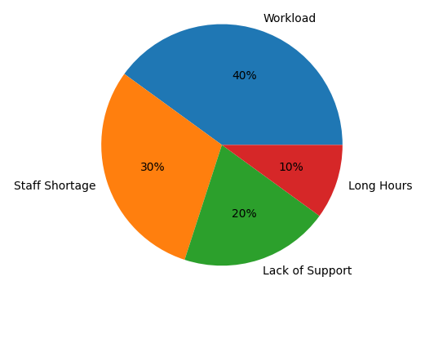
Figure 1 Key Causes of Staff Burnout (Owens et al., 2024)

Task 2: Evaluating Information Sources

3.1 Source 1: NHS Staff Survey (2023)
The NHS Staff Survey (2023) is one of the most important national data that can include the experience of medical employees in England, concentrating on workload, job satisfaction, wellbeing, and pressures in the workplace (Mallorie, 2024). The results reveal that an impressive percentage of employees were experiencing burnout-related symptoms that were mostly caused by a high workload, a lengthy working schedule, and a chronic shortage of staff. Such situations have increased the stress of medical practitioners, especially in clinical settings with high demand. This source is very credible in regards to its usefulness because it has a large sample size, and the data have been systematically collected. It provides a solid quantitative data, which makes researchers see the trends and patterns of the staff wellbeing over the period (Gillen, Neill, et al., 2022). The nature of the survey was also statistical, which is why it could be especially effective in gauging the prevalence and magnitude of burnout in the NHS.

3.2 Source 2: West et al. (2022) – Workforce Burnout in Healthcare
West et al. (2022) give a profound scholarly discussion on burnout in the life of the healthcare environment by addressing its causal factors and effects. Some of the organisational variables highlighted in the study as key contributors to burnout among health care professionals include leadership quality, workplace culture, staffing levels and workload distribution (West, 2022). The source is especially practical because it does not concern itself with descriptive statistics but rather characteristics explaining burnout theoretically and empirically. It is useful to conceptualise burnout as an organisational problem, but not just an individual one. The research includes defining the main drivers, which enables it to offer a framework in discerning the role of workplace conditions in staff wellbeing. The study promotes the subject by emphasising the relevance of systemic interventions, which include bettering leadership behaviours and organisational assistance and attractions to mitigate burnout and its weakness lies in expanded scope. The research analyses the healthcare systems in general, and might not be fully representative of the challenges, especially the post-pandemic workplace, of the UK workforce (Hussein, 2022).

3.3 Source 3: Health Foundation Report (2023)
A policy-focused insight into the workforce problem in the UK health and social care industry is provided in the Health Foundation Report (2023). It covers such topics as staffing, retention challenges, and rising mental health concerns among healthcare professionals, which are highly interconnected with burnout. This source proves most instrumental because the Health Foundation is a respected independent health policy organisation (Organization, 2023). It offers strategic knowledge on workforce sustainability and the larger structural issue of workforce that affect burnout such as funding shortages and workforce planning deficits. The report also works in favour of the research topic, relating burnout to the broader issues within the system and providing a thorough insight into the underlying causes of burnout. Nevertheless, its policy-oriented design implies that it does not have the individual level that is as detailed and does not address fully the experience of frontline staff that would give a better idea of burnout (Cogan et al., 2022).

Task 3: Research Methodologies

4.1 Definition of Research Methodologies
Research methodologies are defined as the systematic methods of gathering, analysing and interpreting data in a bid to obtain research answers. There are three major methodologies that are generally used in health and social care research. Quantitative research is one that involves collection of numerical data and which are subject to statistical analysis. Pattern, relation and trend are examples where this method can be applied (Boamah et al., 2023). As an example, the level of stress, the degree of workload, and the prevalence of burnout among the healthcare employees can be assessed with the help of structured surveys. Qualitative research on the other hand concerns non-numerical information to explore the experiences, perception, and meanings of the people (Giebel et al., 2022). Such methods as interviews and focus groups enable a researcher to understand the reasons and the ways in which burnout impacts healthcare professionals. Mixed-method research involves the quantitative and the qualitative research approaches, allowing the researcher to get a more detailed investigation of a research problem.

4.2 Chosen Methodology and Justification
In this case, a mixed-methods method is best suited. Burnout levels and patterns could be measurable and patterns observed in a larger population using quantitative methods such as surveys. Simultaneously, qualitative approaches, including semi-structured interviews, would offer specific information on the personal experience, affective experiences, and managing strategies. This mixture makes breadth and depth of analysis certain. Because burnout is a quantifiable phenomenon and a subjective phenomenon, mixed methods provide a more comprehensive perspective (Gillen, McFadden, et al., 2022).
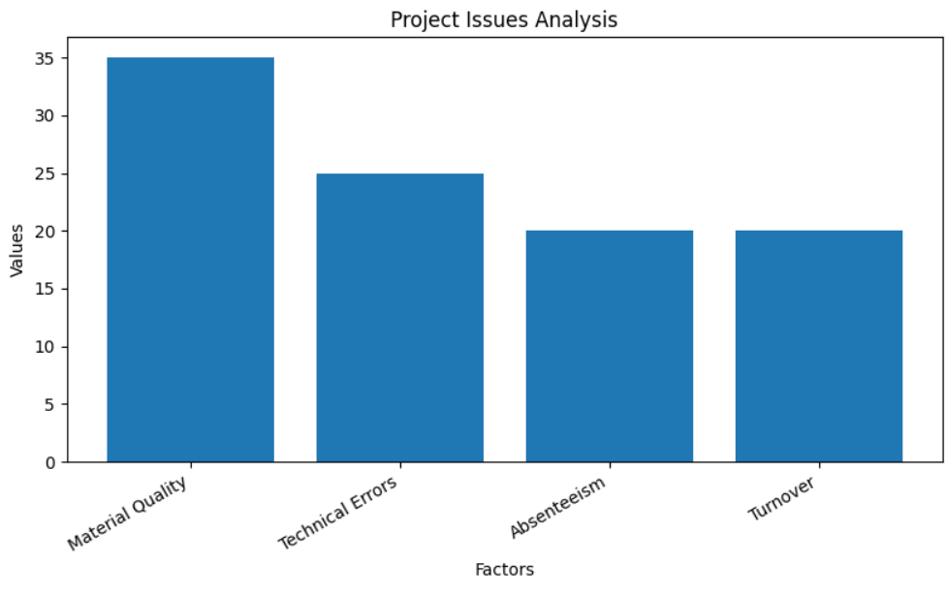
Figure 2 Impact of Burnout on Healthcare System (Wolfe, 2025)

Task 4: Data Collection

5.1 Primary vs Secondary Data Collection
Research involves data collection which is a crucial and determining aspect of research in terms of the quality and relevance of the findings. Primary data is data that has been gathered by a researcher following a given research agenda. Such common approaches are surveys and observations, which enable the researcher to acquire focused information. Secondary data on the other hand is existing information that has been compiled by other researchers or other organisations such as academic journal articles, government reports, and official statistics (Allsopp et al., 2023).

5.2 Chosen Data Type and Justification
Primary data collection with the assistance of pertinent secondary sources would be the main source in conducted study. The major approaches would be online surveys that will be administered to health care workers. Surveys would make it possible to gather quantitative data on the burnout rates.

5.3 Advantages and Challenges of Primary Data
The main benefits of primary data are the opportunity to receive up-to-date information, preserve control over research form, and gain detailed and first-hand information. Nonetheless, it is also associated with such disadvantages as time-consuming, resource-intensive, and possibly problematic in regard to the accessibility of the participants (Liu et al., 2023). There are also ethical aspects such as informed consent and confidentiality to consider. Primary results would be augmented with secondary data that would offer situational insight and allow comparison to previous research. The reliability and credibility of the research would be reinforced with the help of sources like NHS reports and scholarly literature (Mercer et al., 2023).

6. Conclusion
This report has discussed staff burnout as a relevant issue in the health and social care of the UK. It has emphasized its role in influencing healthcare professionals, organisations, and the outcomes of patients. The report then indicated gaps in available studies especially gaps in qualitative researches through assessment of legitimate sources. These gaps were suggested to be addressed with the help of a mixed-methods research methodology and a primary data collection. To promote the wellbeing of workforce and guarantee high-quality care, it is crucial to understand and address burnout. The subject is still very topical in terms of further research (Ocean and Meyer, 2023).
Section | Your Response (Use your own words!)
1. Research | In completing this task, I developed a clearer understanding of how to identify and analyse a relevant issue within the UK health and social care sector. I focused on staff burnout, examining its causes, impacts, and significance using credible academic and policy sources. This process improved my ability to critically evaluate information by comparing different types of evidence and identifying research gaps, particularly the lack of qualitative insights into staff experiences. Overall, it enhanced my critical thinking and ability to connect theory with real-world issues.
2. Presenting | While presenting the report, I ensured a clear academic structure with appropriate headings and logical flow. I maintained formal language and clarity throughout, ensuring each section met the assignment requirements. I improved my ability to explain complex concepts such as research methodologies and data collection in a simple and understandable way. This task strengthened my academic writing skills, especially in organising ideas and presenting arguments coherently.
3. Challenges you faced | One of the main challenges was selecting the most relevant and credible sources from a large amount of available information. It was also difficult to balance description with critical evaluation, particularly when identifying gaps in research. Managing the word limit while maintaining depth in each section was another challenge. Additionally, clearly explaining research methodologies in a concise manner required careful understanding and application.
4. Actions to improve | To address these challenges, I focused on using reliable sources such as academic journals and official reports. I improved my critical evaluation by comparing sources instead of only describing them. I used time management strategies, including drafting and revising sections separately, to stay within word limits. I also referred to academic guidelines to improve the clarity and structure of my explanations.
5. Further steps needed to Prepare for Task 3 | To prepare for the next task, I need to strengthen my understanding of research design and data analysis techniques. This includes learning how to develop research questions, design surveys or interview guides, and consider ethical issues. I also need to improve my referencing skills and practice interpreting data. Gaining familiarity with basic research tools and methods will help me perform more effectively in Task 3.

References
Allsopp, K. et al. (2023) ‘Implementing psychological support for health and social care staff affected by the COVID-19 pandemic: a qualitative exploration of staff well-being hubs (“Resilience Hubs”) using normalisation process theory’, BMJ open, 13(8), p. e071826.
Bertomeu, V.M.G.- et al. (2024) ‘Burnout Among Social Workers in Social Services: A Systematic Review and Meta-Analysis of Prevalence’, Journal of Social Service Research, 50(4), pp. 664–683. Available at: https://doi.org/10.1080/01488376.2024.2371847.
Boamah, S.A. et al. (2023) ‘Experiences of Healthcare Workers in Long-Term Care during COVID-19: A Scoping Review’, Journal of Applied Gerontology, 42(5), pp. 1118–1136. Available at: https://doi.org/10.1177/07334648221146252.
Cogan, N. et al. (2022) ‘ENACT study: What has helped health and social care workers maintain their mental well‐being during the COVID ‐19 pandemic?’, Health & Social Care in the Community, 30(6). Available at: https://doi.org/10.1111/hsc.13992.
Giebel, C. et al. (2022) ‘Guilt, tears and burnout—Impact of UK care home restrictions on the mental well‐being of staff, families and residents’, Journal of Advanced Nursing, 78(7), pp. 2191–2202. Available at: https://doi.org/10.1111/jan.15181.
Gillen, P., Neill, R.D., et al. (2022) ‘Decreasing wellbeing and increasing use of negative coping strategies: the effect of the COVID-19 pandemic on the UK health and social care workforce’, Epidemiologia, 3(1), pp. 26–39.
Gillen, P., McFadden, P., et al. (2022) ‘Health and social care workers’ quality of working life and coping while working during the COVID-19 pandemic: Findings from a UK Survey and Focus Groups’. Available at: https://research.hscni.net/sites/default/files/Report%205%20-%20Executive%20summary.pdf (Accessed: 24 March 2026).
Hussein, S. (2022) ‘Employment inequalities among British minority ethnic workers in health and social care at the time of COVID-19: A rapid review of the literature’, Social Policy and Society, 21(2), pp. 316–330.
Liu, Y. et al. (2023) ‘Internal Corporate Social Responsibility and Employee Burnout: An Employee Management Perspective from the Healthcare Sector’, Psychology Research and Behavior Management, Volume 16, pp. 283–302. Available at: https://doi.org/10.2147/PRBM.S388207.
Mallorie, S. (2024) What Does The 2023 NHS Staff Survey Really Tell Us?, The King’s Fund. Available at: https://www.kingsfund.org.uk/insight-and-analysis/blogs/2023-nhs-staff-survey (Accessed: 24 March 2026).
Mercer, L. et al. (2023) Prevalence of adverse childhood experiences and associations with personal and professional factors in health and social care workers: A systematic review. Educational Publishing Foundation (S2). Available at: https://psycnet.apa.org/record/2023-68180-001 (Accessed: 24 March 2026).
Mojtahedi, D. et al. (2025) ‘Burnout interventions for UK healthcare workers: a systematic literature review’, Mental Health and Social Inclusion [Preprint]. Available at: https://www.emerald.com/mhsi/article/doi/10.1108/MHSI-05-2025-0136/1299670 (Accessed: 24 March 2026).
Neill, R.D. et al. (2022) ‘Comparing the mental wellbeing and quality of working life among nurses and social care workers in the UK and Japan in older adults’ care services during the COVID-19 pandemic’, Psych, 4(4), pp. 843–855.
Ocean, N. and Meyer, C. (2023) ‘Satisfaction and attrition in the UK healthcare sector over the past decade’, PLoS One, 18(4), p. e0284516.
Organization, W.H. (2023) Progress report on the United Nations Decade of Healthy Ageing, 2021-2023. World Health Organization.
Owens, J. et al. (2024) ‘The impact of COVID-19 on social care and social work in the UK: A scoping review’, The British Journal of Social Work, 54(3), pp. 885–904.
Saloniki, E.-C. et al. (2022) ‘Abuse and wellbeing of long-term care workers in the COVID-19 era: Evidence from the UK’, Sustainability, 14(15), p. 9620.
West, C.P. (2022) ‘COVID-19 impact on health care worker burnout: Insights from the areas of worklife model for job burnout’, Burnout While Working. Routledge.
Wolfe, K. (2025) ‘The impact of high-performance work practices on employee burnout experience in UK higher education: a professional services perspective’, Perspectives: Policy and Practice in Higher Education, 29(1), pp. 3–13. Available at: https://doi.org/10.1080/13603108.2024.2392165.

