Assignment 1: E-Portfolio
Nicholas Gelstharp (2211042)
Changemakers: Creativity and Value Creation
6/13/23

Contents

Task 1: 2
Task 2: 3
Task 3 8
Activity Completion: 9
References 23
References used in Mindmap 23

Link to e-portfolio: https://sites.google.com/view/changemakerscreativityandvalue/home

Task 1:

Link to Mind Map: https://mm.tt/map/2788587704?t=KLwZTeLWbX

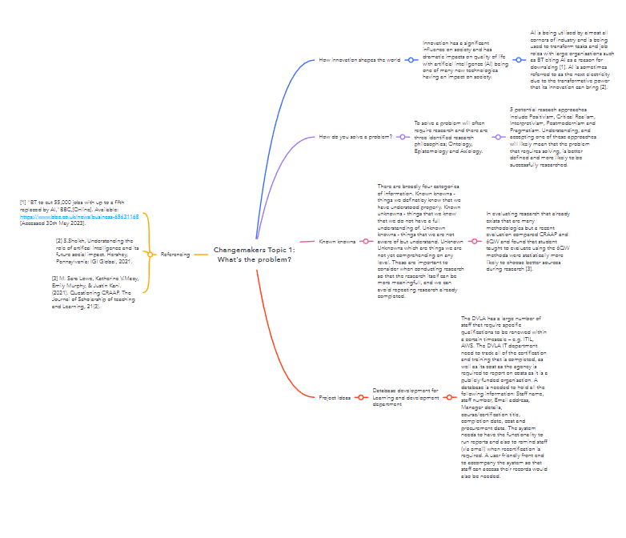

Task 2:

The project chosen is “The DVLA has a large number of staff that require specific qualifications to be renewed within a certain timescale – e.g. ITIL, AWS. The DVLA IT department need to track all of the certification and training that is completed, as well as its cost as the agency is required to report on costs as it is a publicly funded organisation. A database is needed to hold all the following information: Staff name, staff number, Email address, Manager details, course/certification title, completion date, cost and procurement data. The system needs to have the functionality to run reports and also to remind staff (via email) when recertification is required. A user friendly front end to accompany the system so that staff can access their records would also be needed.”
Pragmatism is the most appropriate fit for this research project as there is one service that all individuals will access in a similar fashion., i.e. access to training. However, the value of the training and service received will depend on the perception of the individual. For example some individuals with a kinaesthetic learning preference would prefer face to face learning opportunities, however in the post covid world the majority of training has now transitioned to a digital delivery model that allows most people to fit in their learning around their lives and also it has a significant cost saving impact on travel and hotels for the business. The systems that the training team use are dynamic and evolve around the changes in individuals needs, which are also dynamic and evolving and the success of the practical application of the result of the project in the from the perspectives of its consumers and the business, however as research in this area will likely involve elements of survey and observation being aware of potential reactivity of participant as well as thing like the Hawthorne effect (changed behaviours as a result of knowing observation is underway), the John Henry effect (altering performance from knowing they are in a control group) and the experimenter effect (where the expectations are implied) and the impacts this could have on any data collected on performance [1].
The databases that will be needed to ensure that the project are completed include the DVLA ITS database of all historical learning information which is referred to as The Master Dataset. This contains all of the information from 2017 to March 31st, 2022, from which the system can be built. Further to this access to Dataset 2023-2024 will also be required as this contains the currently active data for all learning interventions that are being undertaken in the current financial year.
The research that will need to be completed will be centred around what database systems can be used to house this information that will be able to produce reports, send staff reminders, prompt for recertification and can be utilised with a front-end system. Any databases or systems that are identified must also conform with DVLA security requirements. Two potential sources of research are going to be the Cyber Security department within the organisation including the accompanying database which details the minimum cyber security standard (use of Boolean search shown below) [2] 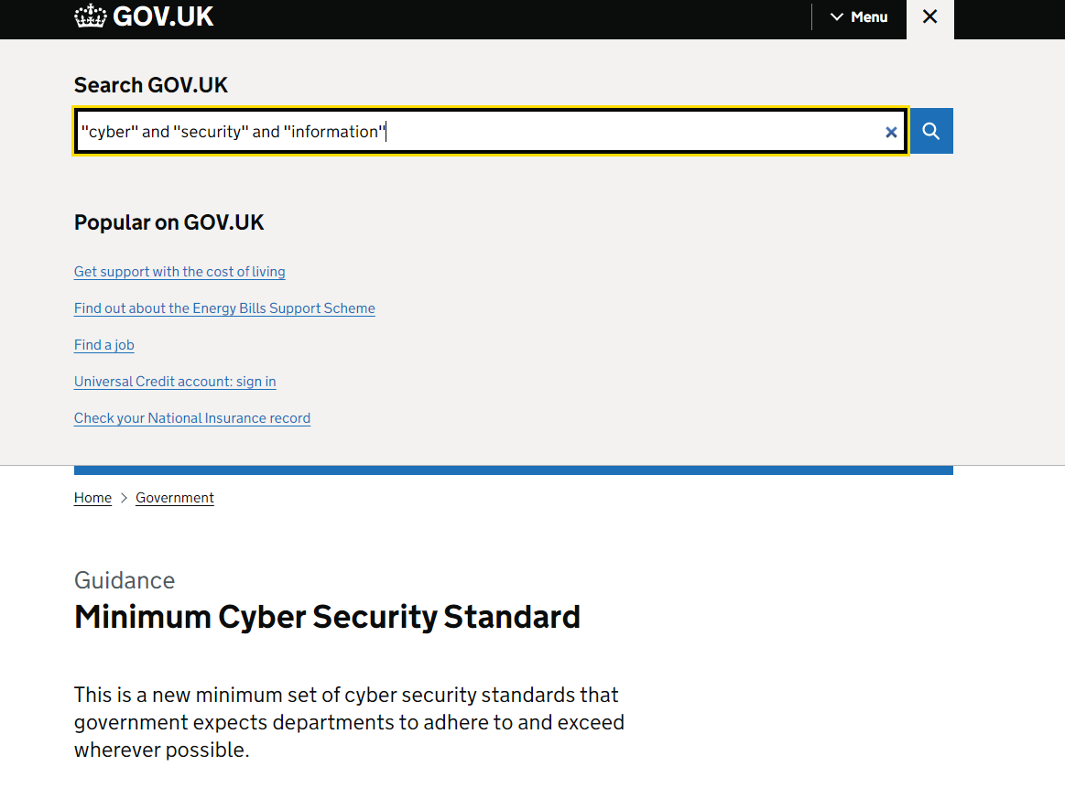
. Due to the nature of the information the GDPR regulations will also be relevant and can be found using the ICO database (use of Boolean search shown below) [3]
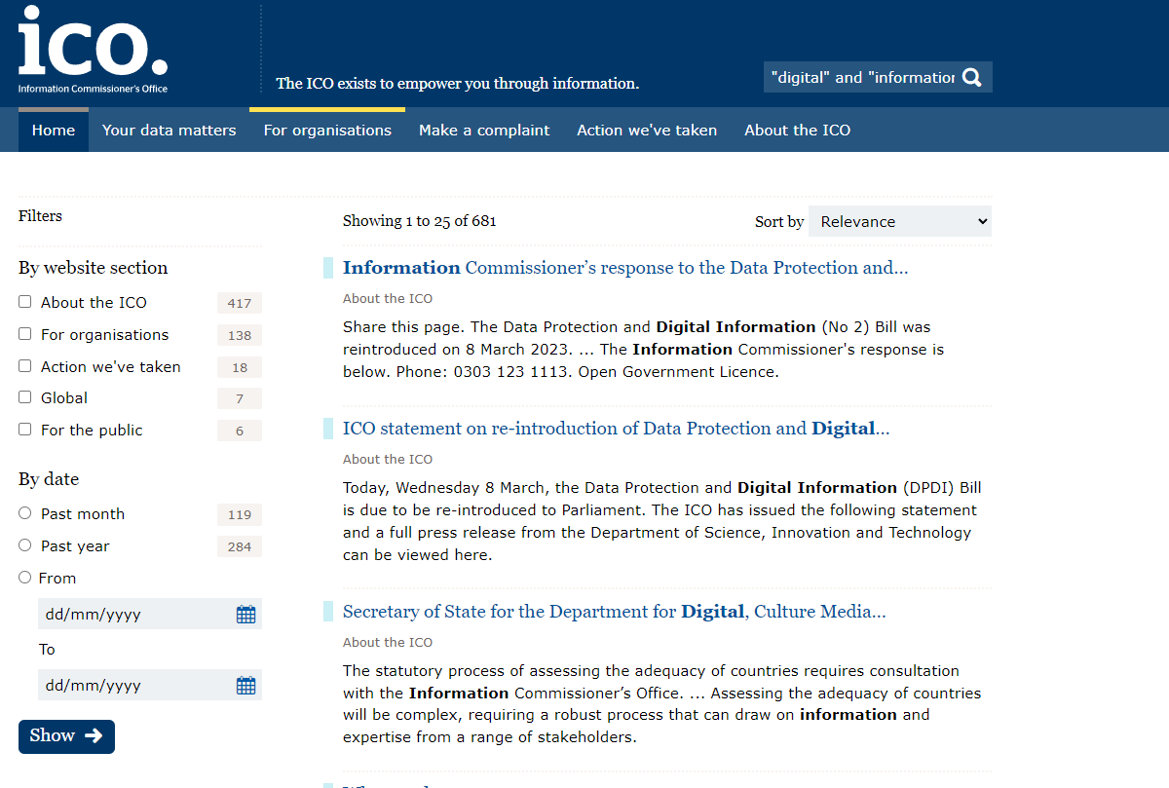and the course tutors that have a broad understanding of what solutions may be a good fit, as well as potentially the Architecture department within the business that may be able to advise on what is and is not available and appropriate. Research will need to be conducted with the end user to determine in a pragmatic fashion, whether or not the solution developed is appropriate.
Feedback has been sought from Craig James, a senior manager based at the DVLA. Craig was chosen due to his expertise from a business perspective as he is the service owner of this product. This email exchange has been captured in the space below

From: Nicholas Gelstharp (2211042) <2211042@student.uwtsd.ac.uk>
Sent: 13 June 2023 09:10
To: Craig James <Craig.James@dvla.gov.uk>
Subject: Project

Hi Craig,

Thank you for this feedback, I will include the below to increase the focus and dedicate some research to this area

Thanks,
Nick

From: Craig James <Craig.James@dvla.gov.uk>
Sent: 07 June 2023 08:25
To: Nicholas Gelstharp (2211042) <2211042@student.uwtsd.ac.uk>
Subject: RE: Project

RHYBUDD: Deilliodd yr e-bost hwn o du allan i system E-bost Prifysgol Cymru Y Drindod Dewi Sant. Peidiwch ag ateb, na chlicio ar ddolenni nac agor atodiadau oni bai eich bod yn adnabod cyfeiriad e-bost yr anfonwr ac yn gwybod bod y cynnwys yn ddiogel.
WARNING: This email originated from outside University of Wales Trinity Saint David’s Email System. Do not reply, click links or open attachments unless you recognise the sender's email address and know the content is safe.

Morning

How does a major project compare to a dissertation? Are they the same thing? I’m only asking as, a dissertation would need a literature review for example, so would you need to include something in your brief that would allow you to research different deployments and test something?

For instance analyse the differences between the use of a relational and non-relational database to….

Thanks

Craig

Craig James
Information Technology Services
DVLA
Ext. 88929
(01792) 788929
Currently Working From Home - 07967600902

We can always spot an untaxed car. Tax it or lose it.
Go to www.gov.uk/vehicletax

Twitter: @dvlagovuk | Facebook: dvlagovuk | YouTube: dvlagov

From: Nicholas Gelstharp (2211042) <2211042@student.uwtsd.ac.uk>
Sent: 06 June 2023 11:32
To: Craig James <Craig.James@dvla.gov.uk>
Subject: Project

Hi Craig,

I have drafted the following as a brief for my major project as part of my university studies. Please could you read the below and provide feedback. I am specifically looking for anything that will help me be more focused in my brief

Thanks,
Nick

Project title
Data Management
Project type
(Delete as appropriate)
Development/Experiment/Review:
Description:
The DVLA has a large number of staff that require specific qualifications to be renewed within a certain timescale – e.g. ITIL, AWS. The DVLA IT department need to track all of the certification and training that is completed, as well as its cost as the agency is required to report on costs as it is a publicly funded organisation. A database is needed to hold all the following information: Staff name, staff number, Email address, Manager details, course/certification title, completion date, cost and procurement data. The system needs to have the functionality to run reports and also to remind staff (via email) when recertification is required. A user friendly front end to accompany the system so that staff can access their records would also be needed.

************************************************************************************
Correspondents should note that all communications to DVLA may be automatically logged, monitored and/or recorded for lawful purposes.
Please visit www.gov.uk/browse/driving for government information on all aspects of motoring, ranging from log books and driving licences to driving tests and vehicle tax.
************************************************************************************

The project idea has now evolved to take this feedback into consideration and has changed from the initial iteration to the below

"The DVLA has a large number of staff that require specific qualifications to be renewed within a certain timescale – e.g. ITIL, AWS. The DVLA IT department need to track all of the certification and training that is completed, as well as its cost as the agency is required to report on costs as it is a publicly funded organisation. A database is needed to hold all the following information: Staff name, staff number, Email address, Manager details, course/certification title, completion date, cost and procurement data. The system needs to have the functionality to run reports and also to remind staff (via email) when recertification is required. A user friendly front end to accompany the system so that staff can access their records would also be needed. Research will be conducted on the most appropriate database to serve this function including analysing the differences between relational and non-relational databases as well as their ability to serve up the functionality required."

Task 3

Quantitative research strategies are commonly associated with the understanding of cause and meaning. Whereas qualitative research strategies can be attributed to the understanding or elaboration of meaning [4]. For the project a combination is likely to be required as there will also be at least two distinct aspects where research will be required. The first is the pre-work research which will look to establish from the staff body their current levels of understanding of availability and service levels, as well as measuring their general happiness with the services received. The appropriate research strategy here will be quantitative as trends are sought so that efforts can be placed where needed. Qualitative research will then likely follow this, with trying to use the trends identified and to dig deeper as to why those trends exist. For example if people are not aware of the service is will be looking at why, was there an induction? What should have happened and what did? Then once a solution has been developed more user research will be required to establish if the solution now meets the needs of the user base and to measure to see if there has been an improvement in the perception of quality from when the first tranche of research was completed.
In order to enhance the validity of the data research will only be conducted using either recognised bodies (e.g. gov.uk website, ICO and for user research only email addresses ending in .gov.uk) as this will ensure that the users and databases are valid to my purpose and are legally required to be up to date and can therefore be considered as the most reliable sources available on the topics chosen. The use of only gov.uk email addresses means that users must be working for a government agency and are required to login to a secure domain which will be able to access the services that the project is concerned with. This means the research gathered will be valuable and again reliable as it targets the direct users of the service.
To enhance generalisability, research could be performed on non-governmental environments that would allow insight from the general public into expectations and this could provide a more diverse set of data that may result in an enhanced end product. This will also include research into relational and non-relational databases, and the functionality associated with them to ensure that the functionality required can be achieved,.
In order to gather quantitative data, the following Microsoft forms page has been created that can be used to easily gather a significant amount of data. The link to this form can be accessed here.
https://forms.office.com/Pages/ResponsePage.aspx?id=-REPTm4EBUWcuNshUjEeIcDxKkol9GJCjIs0wmEl4DlUMFlCTEgyS0k1WFNOUlU4QkJHMjFRSU44OS4u

Activity Completion:

Reflect:
I feel that all of these have made my life better as they are efficient and they mean that I am able to live a life of comfort and convenience.
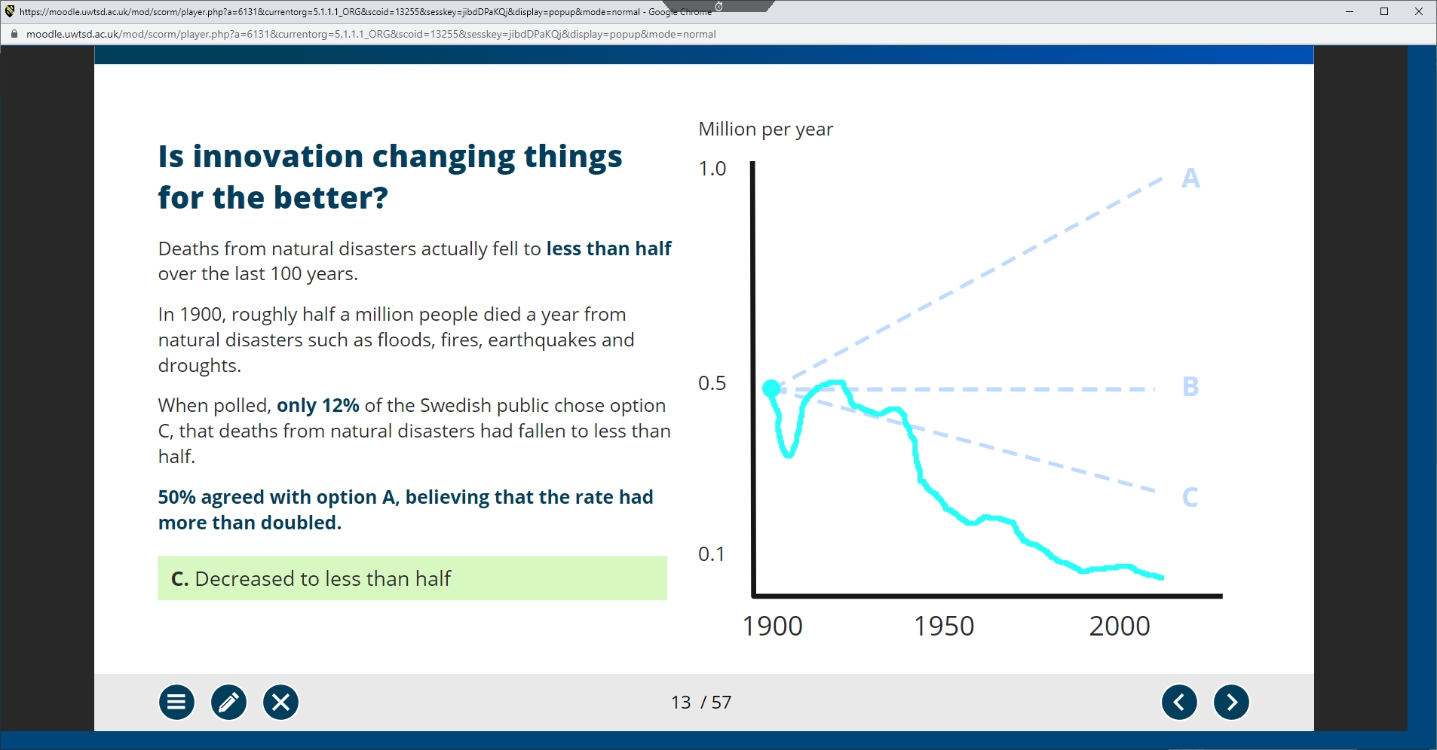
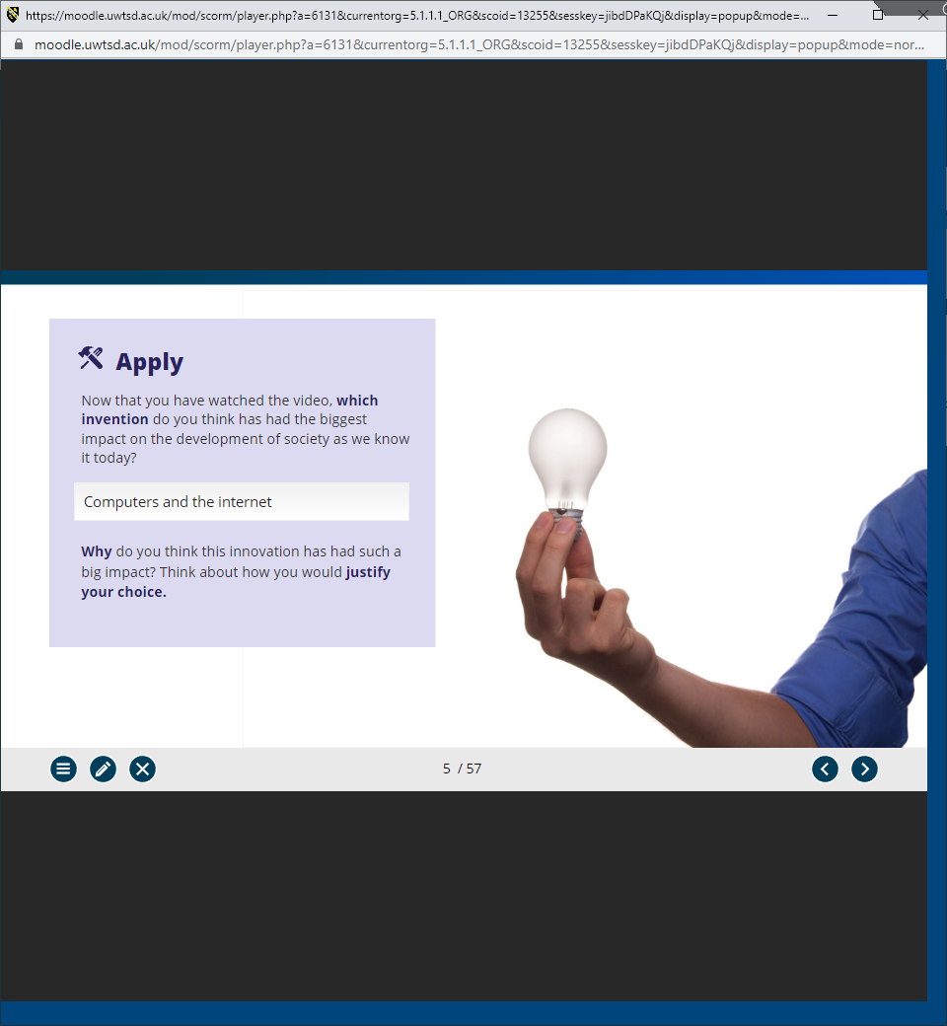
Computerisation means that we are able to find patterns in extraordinary amounts of data and communicate and collaborate on a worldwide scale. This means we are able to research and develop solutions for emerging issues like COVID as well as establish the effects of potential medications on the body. Worldwide communication has transformed all aspects of live and society and I cannot think of anything that has had, and continues to have such a significant impact.
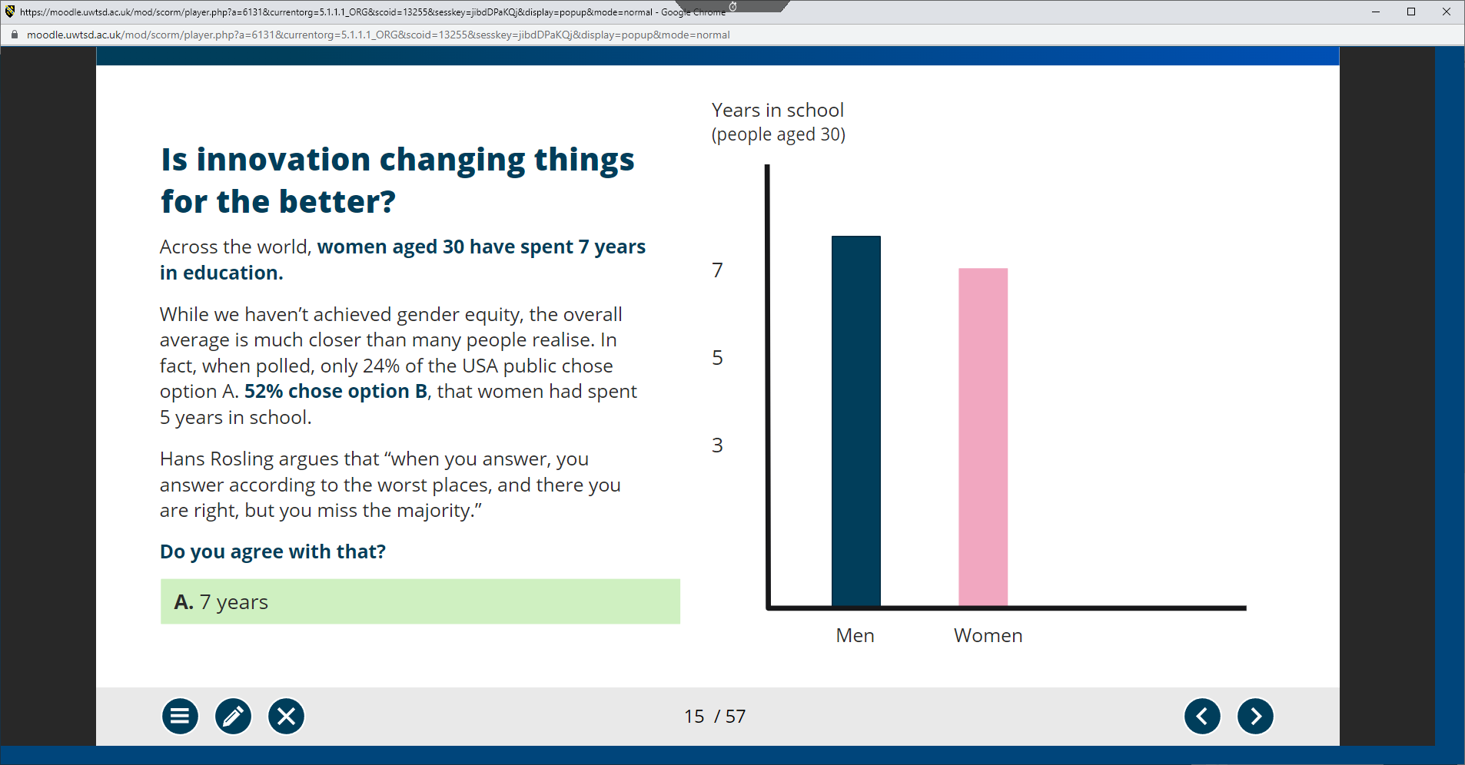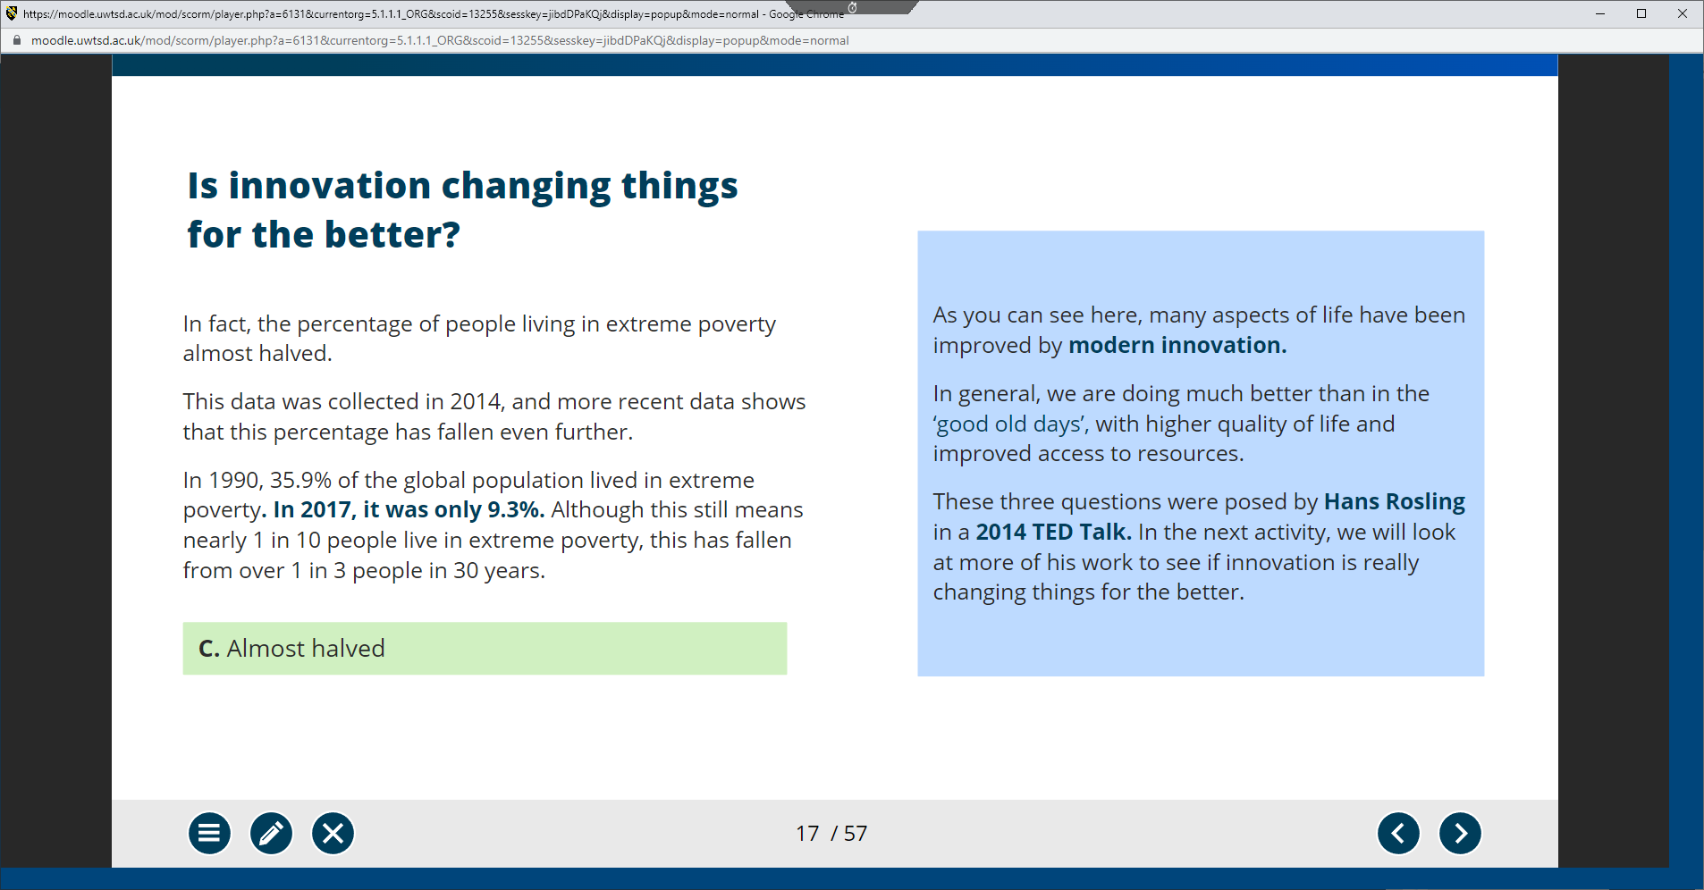
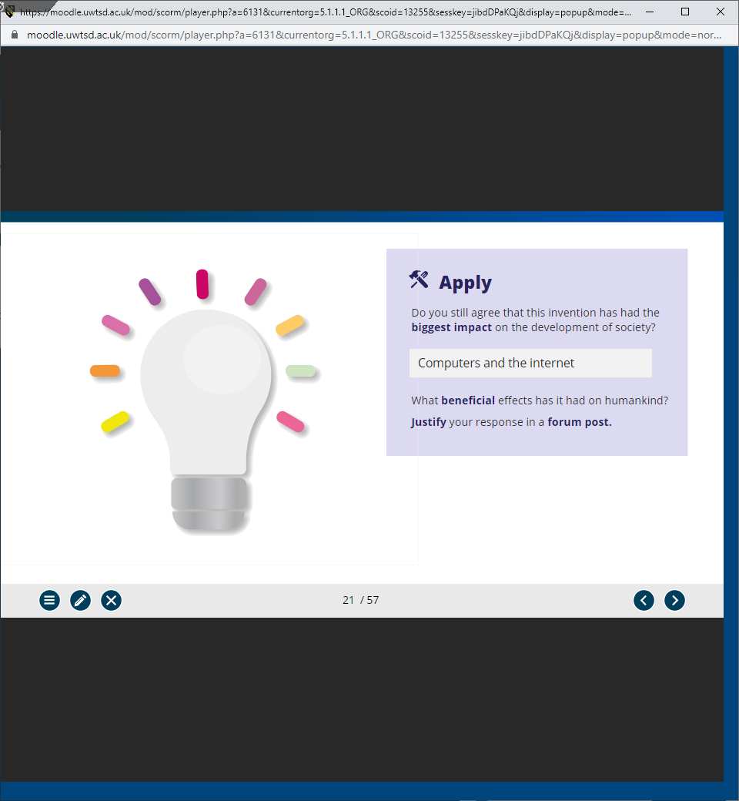
Forum Post: I believe that Computers and the internet have transformed our ability to collaborate and accelerated our learning in a way that has never before been seen. This means benefits to all aspects of society are now being reaped and I cannot think of another more significant development in the modern age.
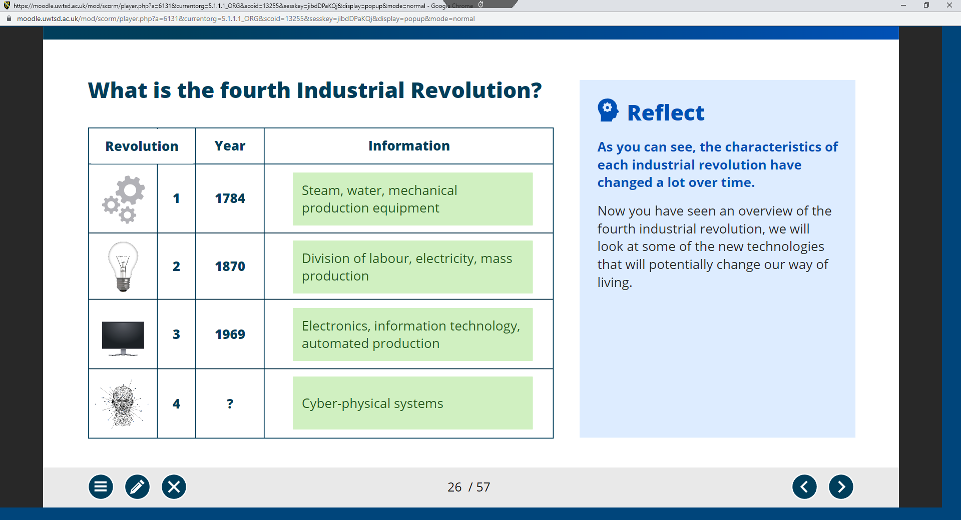
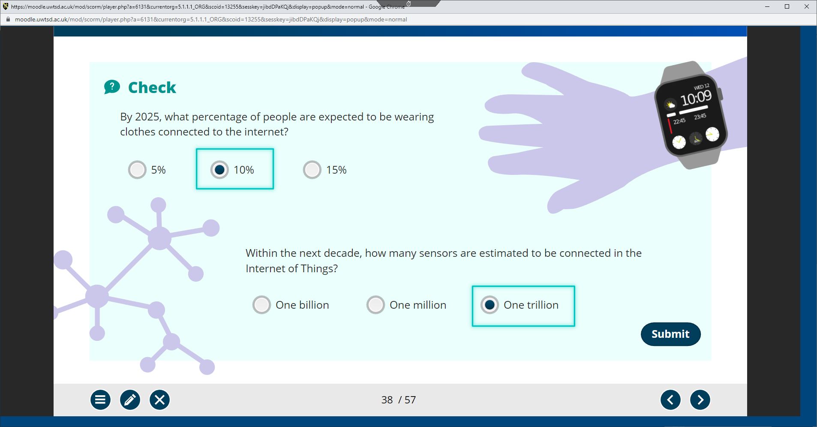

The internet of things has the potential to see significant developments as more technologies become embedded within life it has the potential to catch health issues such as heart attacks can be caught and potentially be life saving.
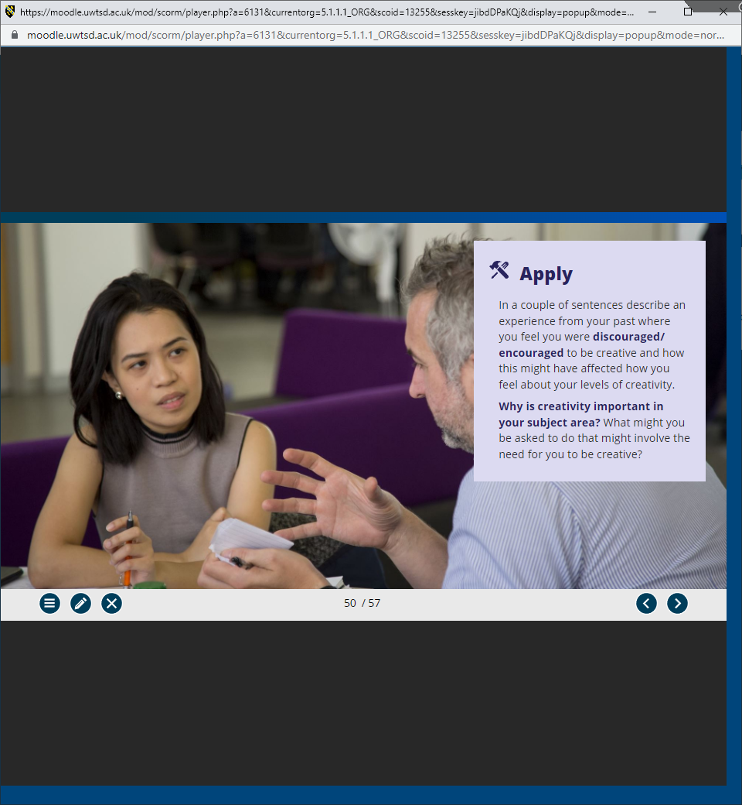

I felt encouraged in my role where I have been able to apply automation to my teams work and this has meant that I can be creative in the solutions that I have been able to apply. I feel that I am known for applying creative solutions to digital problems within the workplace.
Unit 1: Part 2:
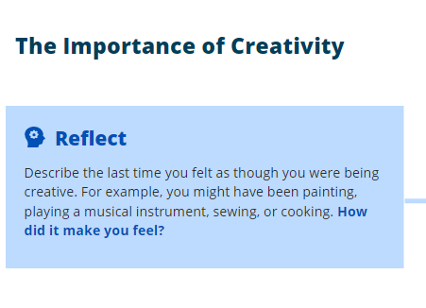
I recently had to change a process in work which affected peoples salaries. The old process was very complex and also very slow and inefficient. I managed to create a new automated process that has had universal approval. This made me feel great
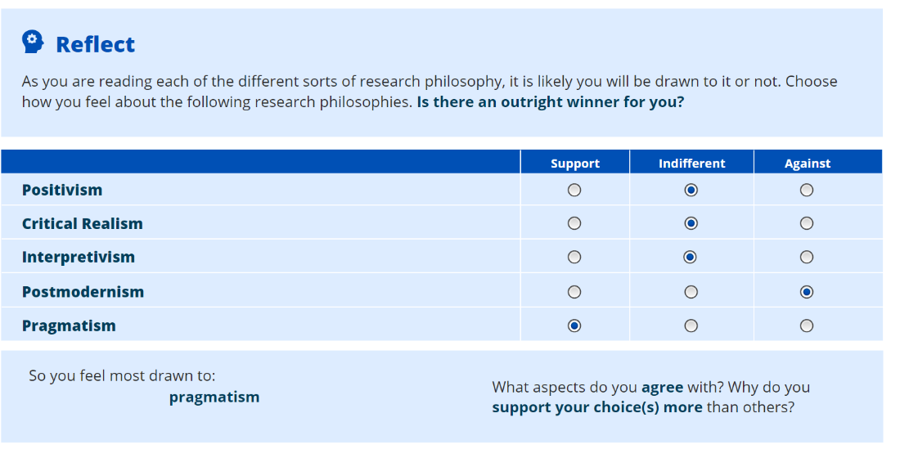
I agree that there are multiple different perspectives that must be considered, and that there can be two different versions of correct depending on perspective. I am indifferent to the other choices because of their lack of allowing multiple perspectives and my own desire to stay away from a “one truth” type of solution, as in my experience being rigid in opinion can be quite negative.
Unit 1: Topic 3
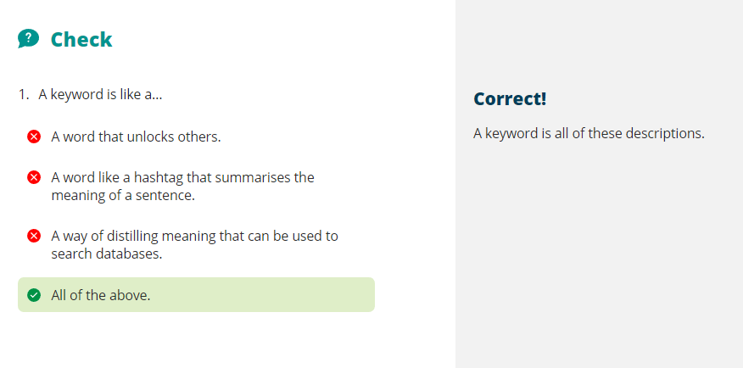
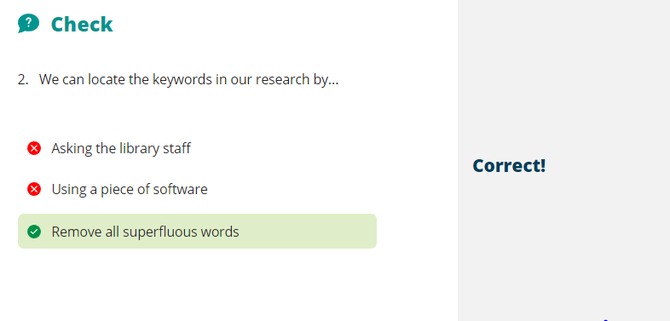
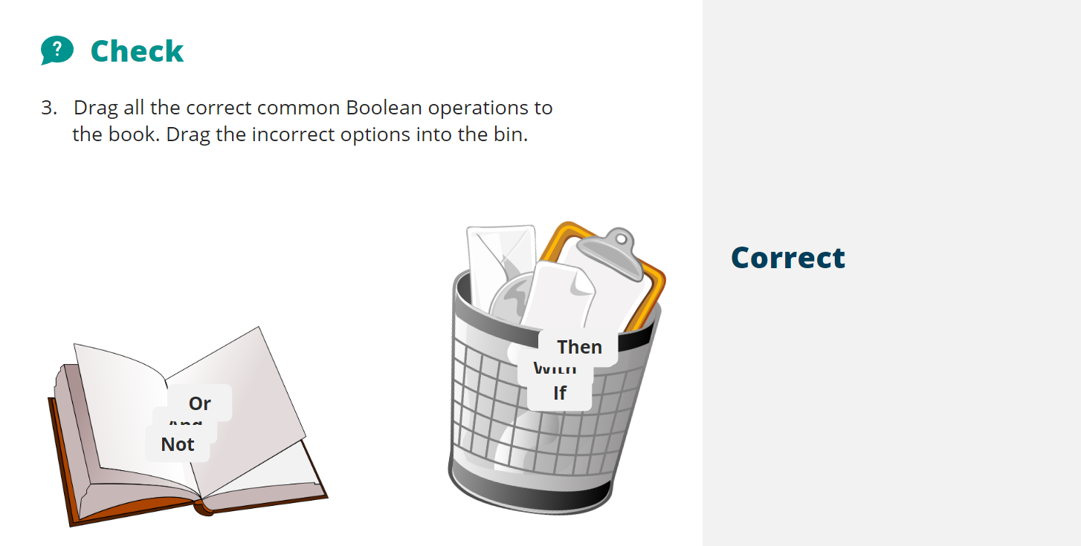
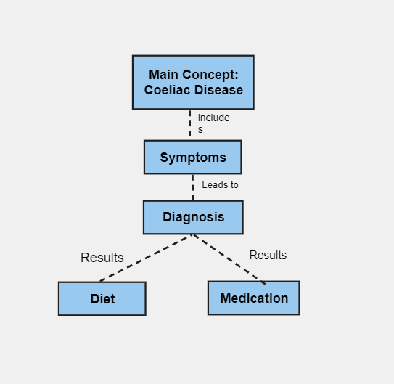
Unit 1: Topic 4
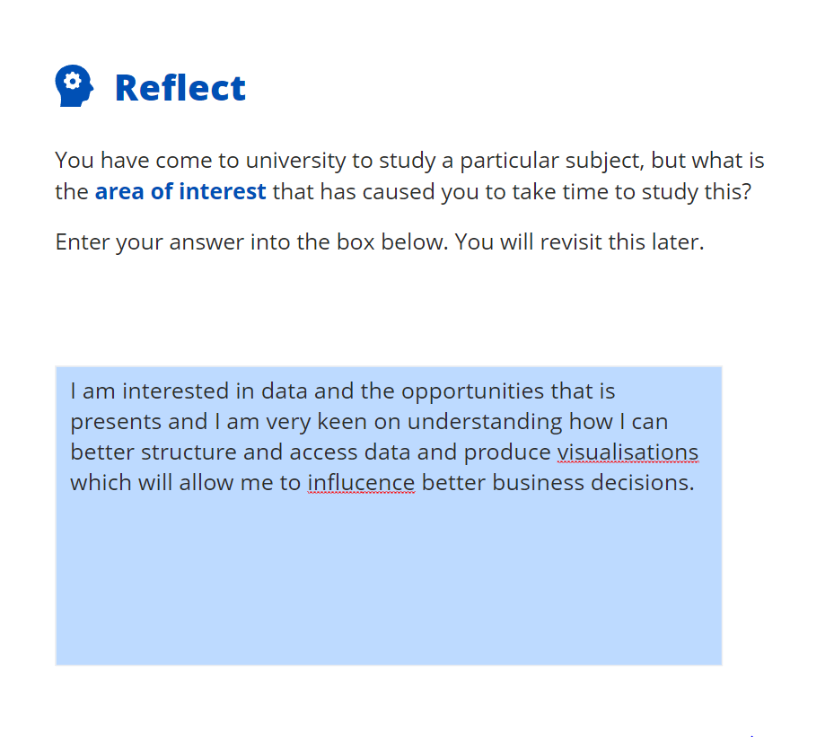
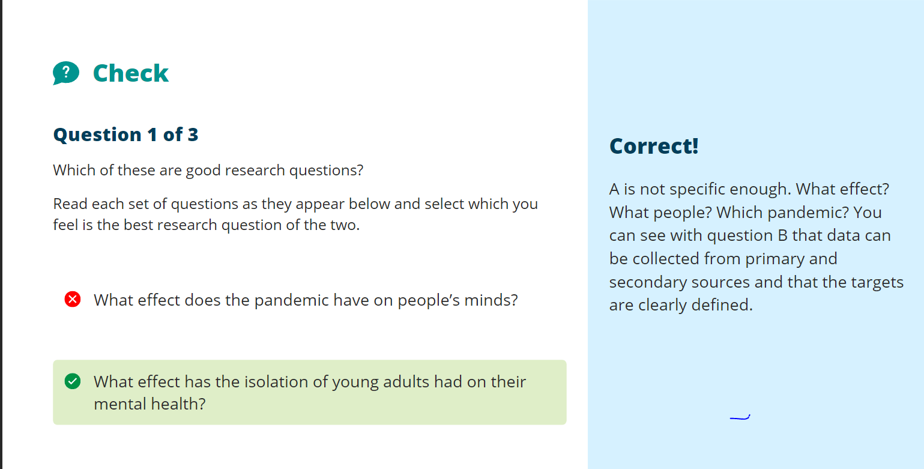
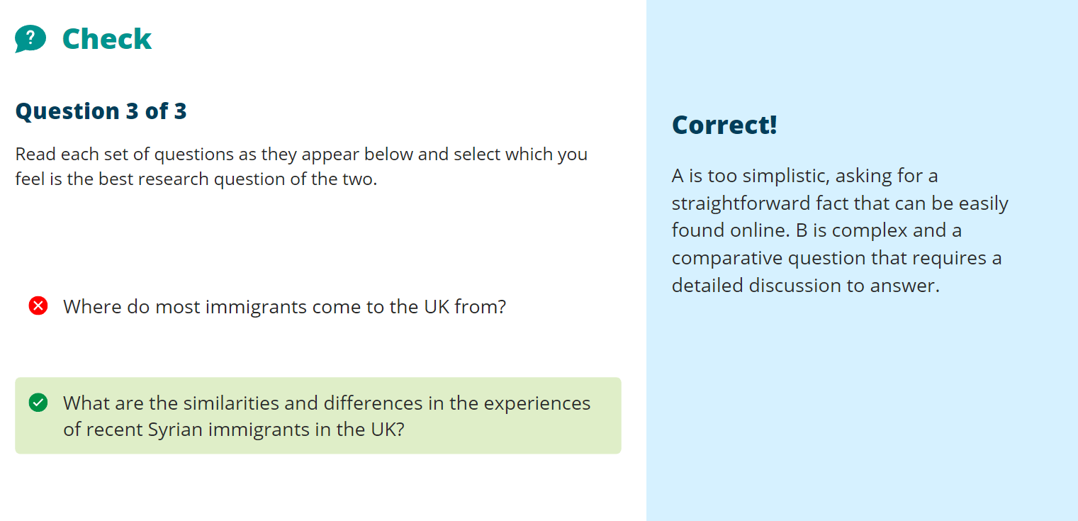
Reflect:
I believe that what will make my research in the university meaningful is going to be identifying a research opportunity that will allow me to make use of the data analytics and visualisation techniques that I will be taught as part of the course that I am participating on.
Reflect:
What did you do before parting with your money? Research and checked for compatibility (Submitted to word cloud as confirmed below)


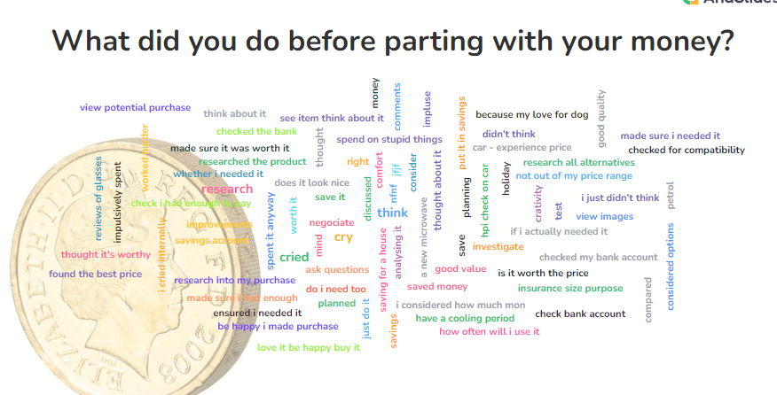
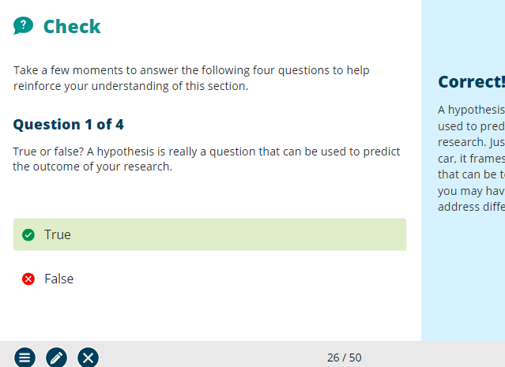
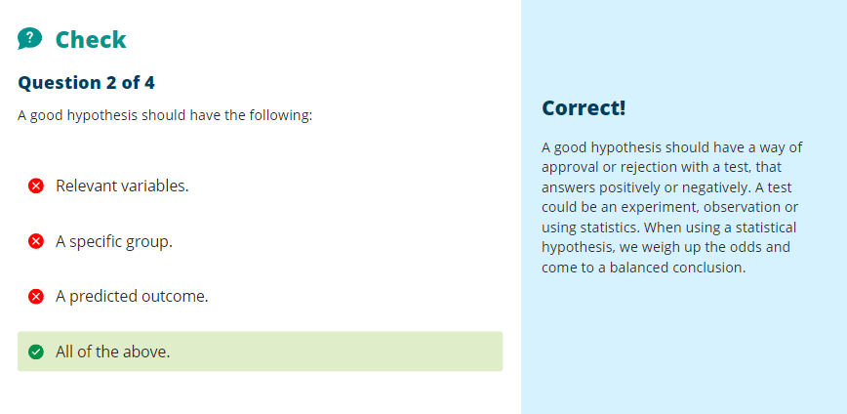
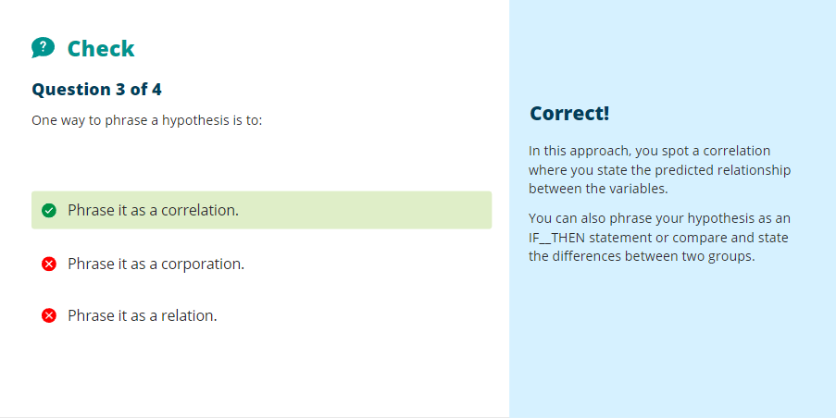

References

[1] | F. T. Burke, What pragmatism was, Bloomington: Indiana University Press, 2013, p. 77.
[2] | Cabinet Office, “Minimum Cyber Security Standard,” Gov.uk, 25 June 2018. [Online]. Available: https://www.gov.uk/government/publications/the-minimum-cyber-security-standard. [Accessed 6 June 2023].
[3] | ICO, “UK GDPR guidance and resources,” ICO, [Online]. Available: https://ico.org.uk/for-organisations/uk-gdpr-guidance-and-resources/. [Accessed 6 June 2023].
[4] | D. S. Byrne, in Interpreting quantitative data, London, SAGE, 2002, p. 144.

References used in Mindmap

[1] “BT to cut 55,000 jobs with up to a fifth replaced by AI,”BBC,[online]. Available: https://www.bbc.co.uk/news/business-65631168 [Accessed 30th May 2023].
[2] S. Sheikh, Understanding the role of artificial intelligence and its future social impact. Hershey, Pennsylvania: IGI Global , 2021.
[3] M. Sara Lowe, Katherine V. Macy, Emily Murphy, & Justin Kani. (2021). Questioning CRAAP. The Journal of Scholarship of teaching and Learning, 21(3).

