Dylan BSc Software Engineering
1701153@student.uwtsd.ac.uk
AdvanceD Web Development
Assignment 2

Table of Contents
Introduction 2
1.0 Angular 2
1.1 What is Angular? 2
1.1.1 A brief history of angular 2
1.2 Angular Functions Used in Application 2
1.3 File structure explained 3
1.4 Basic Description of Each Page/Service Within App Folder 3
2.0 What is Docker? 4
3.0 How to Launch Angular Application 5
3.1 Common errors while running the docker container 6
4.0 Black and White Box Testing 7
4.1 Black Box Testing 7
4.2 White Box Testing 7
5.0 Behavioural Driven Development (BDD) 7
5.1 What is Behavioural Driven Development (BDD) 7
5.2 Benefits and Disadvantages of Behavioural Driven Development (BDD) 8
6.0 Testing 8
6.1 Characteristics of a test framework 8
6.2 Benefits and Disadvantages to Using a Test Framework 8
6.3 Test Examples 9
8.0 References 10

Introduction
This report will cover the authors findings on web development principles, syntax, concepts and semantics. The authors implementation of an angular web application will also be included. The report will then go onto cover the principles of black and white box testing, Behavioural Driven Development and automated testing.

Angular

What is Angular?
Angular is a framework used to create elaborate single paged web applications. Angular uses HTML, CSS and JavaScript to create these applications. Angular is best used with typescript which is an extension of the language JavaScript.
Angular was developed by Google specifically with the MVC (Model View Controller) model in mind. The version of angular used by the author is version 9. [1]

A brief history of angular
Angular started out with version 1 where it was known as AngularJS. Angular 2 was then created and renamed to Angular instead of AngularJS and rewritten in typescript. Angular 2 introduced mobile support a feature which AngularJS lacked. Version 3 was skipped and then the major releases 3,4,5,6,7,8 and the latest version 9 followed.

Angular Functions Used in Application
Pipes: Angular pipes are used to format user input and sanitise it for example the uppercase pipe can be used to make string all uppercase.
ngOnInit: this function can be used in classes and it is called when a class is created and will run any code in this function before anything else, very similar to a constructor except the constructors in angular can cause problems when performing async operations and can execute other code before the operations complete this causes problems with http requests.
.subscribe: in order to make http requests observables need to be created and for angular to be able use these observable objects the .subscribe method must be used. The .subscribe method will run in asynchronous, by default observables are synchronous and the .subscribe method is used to make this async. But angular cannot interface with observable objects without first subscribing to them. When a synchronous request needs to be made a promise of a subscribe method (observable) can be created.
*ngFor: this is a for each loop.
{{var name here}}: when this code syntax is seen within html in angular this is known as Interpolation. The variable will be called from the typescript class and displayed in plain text within html.
Mat: this is the material library within angular very similar to the bootstrap library.
[ngModel]: this is used to set values within forms and helps with form control.

File structure explained
This is the file structure of the authors angular app.
The dist folder contains all the built code including typescript to JavaScript.
E2E folder contains end to end tests if using the angular test framework.
Src is the main folder for the application
App is the folder which contains all the main code for the application including HTML, CSS and TypeScript. Within this folder the app.component.html is the main page containing links to each part of the application using <> selectors. The app.module.ts is the file containing all of the main import statements along with the routing of the application
Each folder within the app folder contains a HTML, CSS, TS, and spec.ts for pages/services. The spec.ts is used if using automated testing.

The assets folder contains any images used within the angular app. The folder also contains a DB folder which contains a json file for data storage.

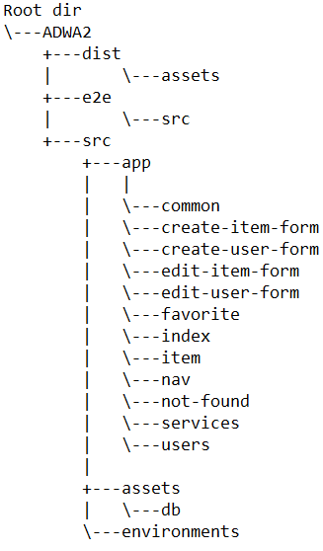

Basic Description of Each Page/Service Within App Folder
  - Common
The common folder contains two files; app-error-handler.ts and custom-validators.ts. These files are used in more than one place therefore they are in a common folder. These files are not pages but functions used throughout the application.
  - Create-item-form & edit-item-form & create-user-form & edit-user-form
This folder contains the TypeScript, HTML and CSS for the create item and edit forms for items and users which are used on the items and user’s pages.
  - Index & item & users
These are the main pages of the application and the folders contain the TypeScript, HTML and CSS for the pages.

  - Favourite
This folder contains the TypeScript, HTML and CSS for the favourite function which is used on the items page.
  - not-found
This folder contains the TypeScript, HTML and CSS for the not found page which is displayed when a 404 error occurs.
  - Nav
This folder contains the TypeScript, HTML and CSS for the navigation bar which is displayed on top of each page.
  - Services
This folder contains three TypeScript files one class called data and then two classes user and items which extend the data class.

What is Docker?
Docker is used to easily deploy applications. Docker also makes bundling multiple applications together as one which has been utilised in the authors case with angular and a json server.

How to Launch Angular Application
Step 1 open a cmd and run npm install in the ADWA2 folder and not AngularApp
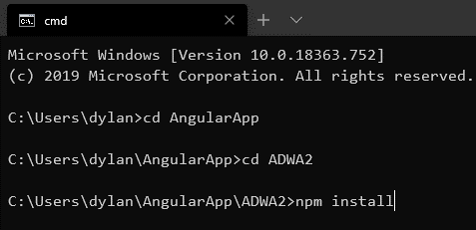
Step 2 Enable drive sharing of the drive containing the application in the docker settings then apply and restart.
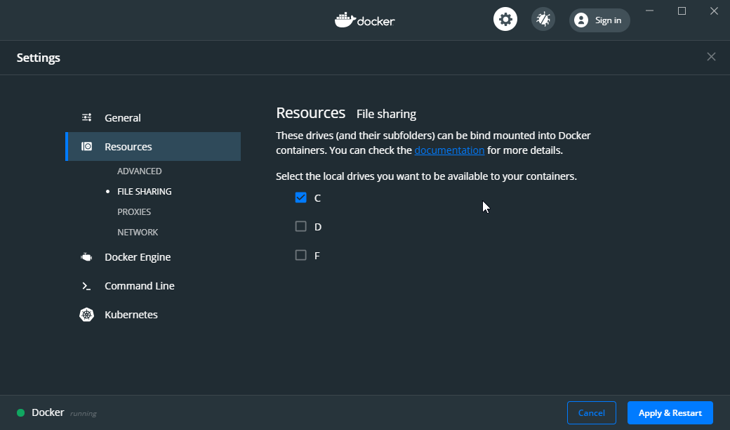

Step 3 Open a command prompt then change directory into the top-most directory of the application. This application will contain the docker-compose.yml file. Then run docker-compose up.
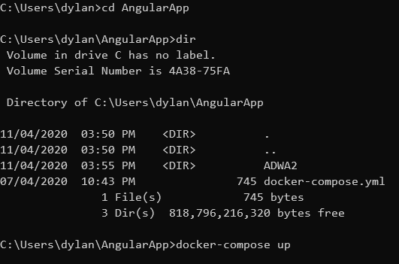

Step 4 wait for the application to launch this is what will be shown in the build process. The first build can take up to 15 minutes and will appear to hang at some points during build this is normal.
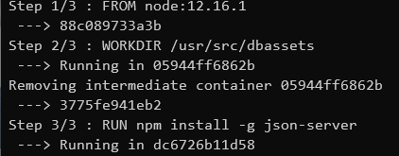
Once the application is ready this message will appear seen on the bottom compiled successfully:
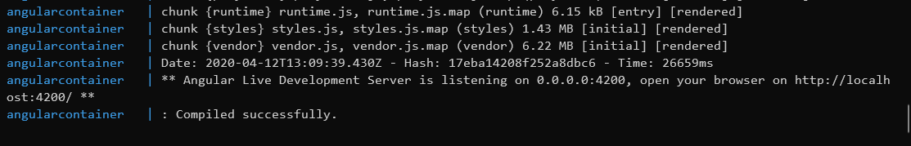

Step 5 the application can now be accessed at localhost:4200 and the json server can be accessed at localhost:3000
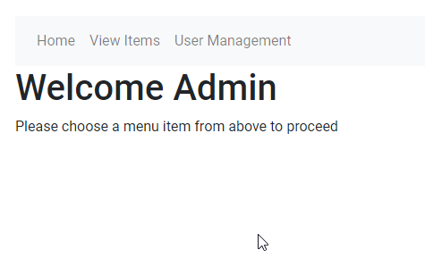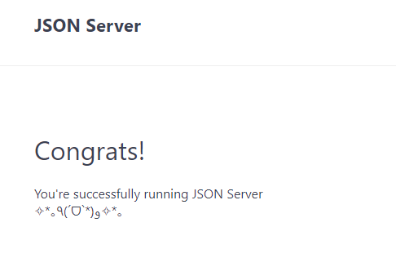

3.1 Common errors while running the docker container
This error is displayed when the drive is not shared go back to step 2 of the launch guide in order to fix this error. The drive sharing is required in order to access the .json file.
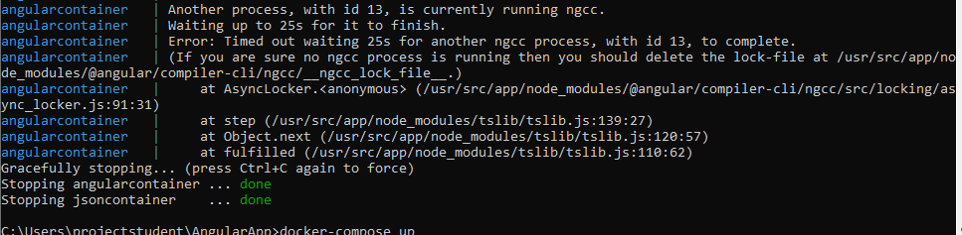
This above error is rare and should not occur if it does go into the node_modules/@angular/compiler-cli and delete the lock file.
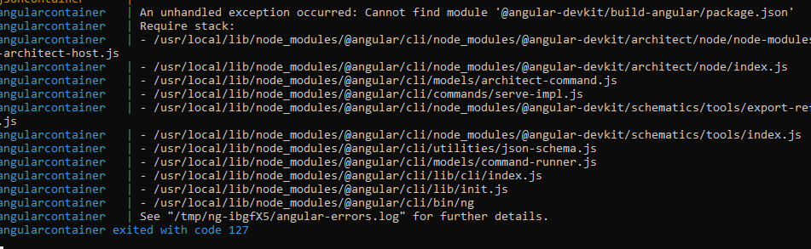
This error occurs if the node modules are not present on the local machine return to step 1 of how to run to install node modules.

Black and White Box Testing

4.1 Black Box Testing
Black box testing is a form of testing where the application contents or structure is not known to the tester. With this method of testing knowledge of software development isn’t required as the tester would just be testing the functionality and behaviour of the software. Black box testing quicker than white box testing as it’s not as in depth. The software tester does not need to know how to use the software as it can be tested via trial and error. The only requirements for black box testing are knowledge of the requirement specifications the tester does not need to know how this has been implemented. Black box testers are looking for errors such as missing functionalities of the application and performance issues. An example of black box testing is a user is given a website without the knowledge of the internal structure which they will then take test all inputs and navigation to make sure that the website has no errors and is useable and verifies the website against the requirement specification. The main advantage to black box testing is that the testing can be done by an independent body so that the feedback is not biased, whereas if the developers tested it, they may not point out areas which could be improved within their own work. The biggest disadvantage to black box testing is that not all paths within the application would be tested, the tester does not know the implementation so may miss things. Black box testing applies to: System Testing, Integration Testing and Acceptance Testing.

4.2 White Box Testing
White box testing is the opposite of black box testing the internal design and structure is known to the tester and this testing is normally carried out by the software development team behind the application. White box testing can be very time consuming. White box testing is also known as code-based testing. The tester can test the program from a code point of view, a GUI isn’t required as the tester can provide test inputs via methods such as unit tests. The tester knows exactly how the program works so when errors occur, they will have knowledge of why the errors have occurred compared to black box testing where the steps to reproduce the error provided by the black box tester may not always work. White box can be more thorough than black box testing because, the tester knows everything about the application and can test all possible areas whereas a black box tester may miss areas. A disadvantage of white box testing can occur when implementations change regularly this would make things more difficult to write automated tests as they would need to be in line with the implementation. An example of black box testing could a developer taking a piece of code and running that with different variables seeing if the output is as expected, for example if a program took two numbers and added them together the tester could provide two numbers to see if they were being added correctly. Types of white box testing include unit testing, memory leak testing and penetration testing.

5.0 Behavioural Driven Development (BDD)

5.1 What is Behavioural Driven Development (BDD)
Behavioural Driven Development (BDD) is when business teams and development teams come together to create software which is more useful to business. The teams collaborate in order to write software to satisfy the business needs to a high standard [2]. For BDD to work requirements can be in the form of user stories from the business team. Each user story would include a valid scenario. A good template used for user stories within BDD is the role-feature-reason matrix. This template works as followed:

As a <role>
I want <feature>
So that <reason>
Example: as a customer I want to be able to check stock of an item so that I can purchase this item when its stocked.
Tools can also be utilized within BDD to help development, one of these tools which supports BDD is known as Cucumber which is a test framework. This framework can be used to write specifications in plain English which cucumber calls Gherkin language. Cucumber is developed by ruby but can work across different languages.

5.2 Benefits and Disadvantages of Behavioural Driven Development (BDD)
There are many benefits of using BDD the main advantage being that the team are not defining ‘test’ cases but instead are implementing behavioural tests. Because of the way BDD works it also enhances the communication between the developers and business team which can vastly improve the end quality of an application as the users of the application are involved within the design, implementation and testing stages of the application. With the concept of BDD an acceptable benchmark of an application can be defined before development.
On the other hand, BDD also has its disadvantages. One disadvantage is that testers will need to be technical minded in order to efficiently test the programs. If developers are using the waterfall approach, then BDD cannot be used. One final disadvantage is that when the requirements are not specified to the highest standard BDD will become ineffective.

6.0 Testing

6.1 Characteristics of a test framework
The main characteristics of a test framework are as follows:
Reusable: Code written to test applications should be easily duplicated and refactored for other applications.
Repeatable: the test framework should have the ability to run test code recursively without input required from the tester.
Extendable: the test code must be easily added to if further tests are required the ability to easily implement further tests without modifying structure is essential.
Compatibility: compatibility is a necessity when using a test framework, the code needs to be compatible with multiple browsers and not just one as clients will not all be using the same browser.

6.2 Benefits and Disadvantages to Using a Test Framework
There are many benefits to using test frameworks when writing applications, the main advantage to using them is for efficiency, these frameworks are very effective at testing applications as the tests are easily extendable and repeatable. Another big advantage is the automation aspect of the testing once the tests have been written they can be run and left to their own devices reducing employment costs compared to manual testing. Test frameworks give developers low cost maintenance easy reporting and very little manual intervention is required therefore test frameworks are very useful.

6.3 Test Examples
Test Number | Test Description | Expected Outcome | Actual Outcome | Pass/Fail
1 | Http request for each page(route) | Items will load at /items; users will load at /users | As expected | pass
2 | Navigation links link to routes | Items page will load on click; users page will load on click | As expected | pass
3 | Click add user button | Add user form will load | As expected | pass
4 | Click add item button | Add item button will load | As expected | pass
5 | Submit add item form with no data | Submit button should be disabled and disallow adding blank item and errors will be displayed | As expected | pass
6 | Populate add item form with valid data and submit | Item will be added to json server and displayed on screen | As expected | Pass
7 | Click remove item button | Item will be removed from screen and json server | As expected | Pass
8 | Click edit item button and change some data on form and submit | Edit item form will appear with the information of item of which edit was clicked. Once changed and submitted this will be reflected on screen and in json server | As expected | Pass
9 | Click favourite button when no favourites are chosen | Star icon should change to black and Boolean updated in json server | As expected | Pass
10 | Change favourite item by clicking star on different item | New favourite will be highlighted and the other star of previous favourite unhighlighted. | If the user clicks on a different star before initial request completes then there will be no favourite highlighted. | Partial Fail – This is a limitation of the JSON server once the application is in production and an SQL database is implemented the requests will be quicker and the chances of this error occurring minimalised.

8.0 References
[1] “Angular.” https://angular.io/ (accessed Apr. 13, 2020).
[2] A. Sheshasaayee and P. Banumathi, “Impacts of behavioral driven development in the improvement of quality software deliverables,” Mar. 2020, pp. 228–230, doi: 10.1109/icict43934.2018.9034287.

