Coaching and Mentoring Skills for the Workplace
Code: BMSW6105_London
Student Name: Georgiana-Ioana Chirita
Student ID: 2120500
Teacher name: Nishi Ramsurrun

Table of Contents:

- Introduction………………………………………………….3
- Advantages of Coaching and Mentoring…………. 3-5
- GROW Model………………………………………………5-6
- Reflection using Gibbs Reflective Cycle (coaching/mentoring) …………………………………. 6-8
- Conclusion……………………………………………………8
- Feedback……………………………………………………9-10
- References……………………………………………………11

This reflective report explores my coaching and mentoring experience with a colleague who is a single mother to a 3-year-old child. She is overwhelmed by the challenge of balancing her responsibilities- raising her son alone, working to meet financial needs, and aspiring to grow to her career. Our sessions aimed to identify practical strategies to help her manage her time, prioritize self-care and explore opportunities for career development without compromising her parental duties.
To guide this reflection, I will use the GIBB’S REFLECTIVE CYCLE, as it allows a structured approach to reviewing experiences by focusing on description, feelings, evaluation, analysis, conclusion, and an action plan. This model encourages critical thinking and supports continuous learning.
During our interaction, I took on a supportive, non-judgmental role, listening actively and offering guidance tailored to her unique situation. We discuss tools for the time management, sought flexible work arrangements, and explored realistic short-term career goals. I also emphasized the importance of seeking social support and using local resources for childcare.
This experience was not only meaningful for her growth but also deepened my understanding of empathy, active listening, and the importance of adapting coaching styles to meet individual needs. Reflecting on this process helps me grow as a mentor and highlights the human aspects behind professional development challenges.
Coaching is a structured, goal-oriented process aimed at enhancing an individual’s performance, typically in a professional context (Whitmore,2009). Mentoring, on the other hand, is a longer-term developmental relationship where a more experienced individual supports the personal and career growth of a less experienced colleague (Clutterbuck, 2004). While coaching focuses on specific outcomes and is often non-directive, mentoring is broader and can be more directive, involving advice and knowledge sharing.
Key attributes of an effective coach include active listening, empathy, the ability to ask powerful questions, and fostering self-awareness (Rogers,2012). Models such as GROW (Whitmore, 2009) and Gibbs’ Reflective Cycle (1988) support reflective and developmental practice. Mentors may additionally demonstrate patience, experience-based guidance, and emotional support. Both roles require trust confidentiality, and mutual respect, but differ in purpose, structure, and duration. These distinctions shape how support is provided and the outcomes achieved.
Coaching and mentoring are increasingly recognized as vital tools for enhancing individual and organizational performance in the workplace. Though they often overlap in their goals of development and support, they differ in execution, scope, and the nature of relationships involved. A critical evaluation of their purpose’s highlights both their unique benefits and complementary roles.
The primary purpose of coaching in the workplace is to improve performance, develop specific skills, and facilitate goal attainment (Whitmore, 2009). Coaching is typically short-term, structured, and focused on measurable outcomes, such as enhancing leadership, communication, or problem-solving abilities (Passmore, 2010). It empowers employees to find their own solutions through guided reflection and questioning, encouraging autonomy and responsibility.
In contrast, mentoring aims at broader personal and professional development, often including psychosocial support, career guidance, and role modelling (Clutterbuck, 2004). It is usually a longer-term, relationship-based process where a senior or more experienced individual shares knowledge, offers advice, and supports the mentee’s career path. Mentoring provides a safe space for exploring aspirations, identify, and work-life integration, particularly valuable for individuals navigating complex challenges or transitions (Kram, 1985).
From an organizational perspective, both coaching and mentoring serve key strategic purposes. Coaching helps build a high-performance culture by focusing on competencies and individual accountability (Grant, 2017). It also supports change management, employee engagement and succession planning. Mentoring contributes to knowledge transfer, talent retention, and diversity and inclusion by supporting underrepresented groups (Allen et al, 2004). For instance, single parents or junior employees from marginalized backgrounds can benefit greatly from mentoring relationships that offer both guidance and empathy.
Despite their shared developmental focus, key distinctions remain. Coaching tends to be non-directive, encouraging self-discovery through questioning (Rogers, 2012), while mentoring often involves directive input and sharing of personal experiences. Coaches may or may not have subject matter expertise, while mentors usually draw from their own professional backgrounds to guide others. Additionally, coaching relationship are often formalized with set goals and timelines, whereas mentoring may evolve informally and be more relational.
Critics argue that the boundaries between coaching and mentoring are increasingly blurred, especially with the rise of internal coaching and hybrid roles (Garvey et al, 2018). Some suggest that coaching is more aligned with organizational objectives, while mentoring is more personal and developmental. However, both can be integrated strategically to support employee growth at different career stages.
Effective implementation of coaching and mentoring relies on trained practitioners, organizational support, and a culture that values learning and development. The GROW model (Whitmore, 2009) and Gibb’s Reflective Cycle (1988) provide frameworks to guide structured conversations and reflection. Ultimately, when used appropriately, coaching and mentoring can foster resilience, confidence, and capability- benefiting not only individuals but also the wider organization.
One of the most widely used coaching models in both corporate and developmental settings is the GROW model, developed by Sir John Whitmore (2009). GROW stands for Goal, Reality, Options and Will- a simple yet powerful framework that structures coaching conversations to promote clarity, action, and personal responsibility.
The first stage, Goal, helps the coaches define what they want to achieve. This could be a long-term aspiration on a short-term objective. The second stage, Reality, encourages honest self-assessment by exploring the current situation, barriers, and context. Options involve brainstorming potential solutions or strategies, while the final stage, Will, focused on commitment, accountability, and setting actions with timelines.
The GROW model’s greatest strength lies in its simplicity and structure, which makes it accessible for both professional coaches and managers with limited training (Passmore, 2010). It encourages a non-directive, coaches-centered approach, enabling individuals to take ownership of their development. By using open-ended questions-such as” What do you want to achieve?” or “What’s stopping you?”- coaches facilitate self-discovery, which research has shown to increase motivation and performance (Grant, 2017).
Another advantage is its flexibility. GROW can be applied in various settings, from performance management and career development to problem-solving and team coaching. For example, it can be highly effective when supporting an employee returning from maternity leave, helping them rebuild confidence and establish work-life boundaries. It is also suitable for goal-driven contexts like sales or leadership development, where performance outcomes are clearly defined.
However, the GROW model is not without limitations. Its linear structure may oversimplify the complex and emotional nature of real-life challenges. Individuals facing emotional distress, identity crises, or significant life changes- such as a single mother struggling with work-life balance- might require more holistic or therapeutic support that GROW offers. In such cases, models like Clear (Revan’s, 1983) or Co-Active Coaching (Whitworth et al., 2007) which emphasize emotional intelligence and relational depth, might be more appropriate.
Furthermore, the model assumes that individuals can articulate goals clearly at the outset, which may not always be the case. Some clients may need help exploring their values or beliefs before setting meaningful goals. Critics argue that an over-reliance on outcomes can lead to a tick-box approach, neglecting deeper personal growth (Bach Kirova, 2011).
Despite these criticisms, GROW remains a foundational tool in coaching practice. It is particularly useful in time-constrained environments where a structured, action-oriented approach is needed. When combined with skilled questioning and emotional awareness, the GROW model can be adapted to suit a range of needs and contexts.
My coacher was a colleague overwhelmed by the demands of raising her 3-year-old child alone while trying to improve her career prospects. During our sessions, I applied the GROW model to guide the conversation, beginning by helping her identify a clear, achievable goal: to create a realistic weekly routine that allowed time for work, parenting, and self-development. We then explored her current reality, brainstorming options for improving time management, and finally established a specific action plan with short-term steps.
Initially, I felt nervous about facilitating the session, fearing I might be too directive or miss emotional cues. However, as the session progressed, I become more confident, especially when I saw that my coacher felt comfortable sharing her struggles. I also felt inspired by her determination and began to appreciate the real-world impact of coaching beyond theory.
The session had several strengths. I was able to build rapport and maintain a non-judgmental space, which encouraged openness. Using the GROW model gave the conversation structure, and the coacher left with clear, actionable steps. However, one limitation was my tendency to jump to the options stage too quickly, potentially overlooking deeper emotional or contextual factors that influenced her situation. I also noticed moments where I struggled to balance active listening with the urge to fix the problem.
The structured nature of the GROW model helped maintain focus and move towards action, which was particularly useful for someone seeking clarity and control amid chaos. However, Gibb’s reflective cycle helped me see that coaching is not just about goal setting but about understanding the person holistically. In this case, the coach’s emotional exhaustion required more space for empathy and exploration.
This experience taught me that structure is essential, flexibility is equally important. Coaching is a dynamic process that must respond to the client’s emotional and practical needs. I learned the value of value of silence, deep listening, and resisting the urge to solve problems on behalf of the coaches. The session also affirmed the importance of reflective practice for my own growth.
To improve, I will deepen my listening skills and study more emotionally responsive coaching models. I plan to observe experienced coaches and seek feedback on my technique. Additionally, I will continue using Gibbs ‘model after each session to evaluate both the coacher’s progress and my development as a practitioner. Building confidence in holding space for complex emotions will be a key focus in future sessions.
Using Gibb’s Reflective Cycle (1988), I reflect on my first assessed mentoring session, where I supported a colleague- a single mother balancing full-time work, parenting, and career aspirations. The session involved mentoring her on time management strategies and offering constructive feedback to help her identify personal strengths and areas for development.
During the session, I took on the role of a mentor to help my colleague manage her daily responsibilities and make space for career growth. She expressed feelings of burnout and guilt, feeling torn between being a good mother and progressing professionally. My role was to listen, empathize, and guide her in creating a sustainable plan. I offered feedback on her strengths- resilience, discipline, and commitment- and highlighted how these qualities could be transferred into her professional development.
Initially, I felt unsure about striking the right balance between being supportive and providing honest feedback. I didn’t want to add to her stress. However, I also felt motivated by the opportunity to make a real difference in someone’s life. As the conversation progressed, I began to feel more comfortable and connected, especially when she responded positively to my feedback and reflected on her own accomplishments with pride.
The session went well in several areas. I was able to build trust quickly, which helped create an open and honest dialogue. Providing feedback in a strength-based way helped boost her confidence and made her more receptive to discussing areas for improvement. However, I recognized I could have done better in asking more reflective questions to help her explore solutions on her own. At times, I slipped into a problem-solving mindset rather than encouraging her to think through options.
This experience highlighted key differences between mentoring and coaching. Unlike coaching, mentoring allowed for sharing personal insights and experiences, which my colleague found comforting and relatable. According to Clutterbuck (2004), effective mentoring includes both career guidance and emotional support-both of which were needed in this session. The feedback I provided was guided by the principles of constructive communication-focusing on behaviors, not personality, and balancing praise with areas to grow (Rogers, 2012). However, I could have applied a more structured feedback model like BOOST (Balanced, Observed, Objective, Specific, Timely) to ensure clarity and follow-up actions.
I learned that mentoring requires empathy, patience, and the ability to communicate feedback in a way that motivates, not discourages, it also taught me to be mindful or not overshadowing the mentee’s voice with advice. My role was not to provide all the answers but to empower her to discover them. This shift in mindset is crucial for effective mentoring.
In future sessions, I will use more reflective questioning techniques and adopt structured feedback models to guide my approach. I also plan to enhance my active listening skills to better support emotional needs and reinforce confidence. Regular reflection using Gibbs’ cycle will help me continuously improve and become a more effective, empathetic mentor.
This report has explored my coaching and mentoring experiences using key models and theories to guide reflection and practice. Coaching was defined as a structured, performance-focused approach that empowers individuals to find solutions and achieve specific goals (Whitmore, 2009), while mentoring was described as a longer-term, relationship-based process offering guidance, knowledge sharing, and emotional support (Clutterbuck, 2004).
The GROW Model (Whitmore, 2009) was applied during my coaching session to help structure the conversation, enabling my colleague to set realistic goals and create an actionable plan. While effective for short-term, outcome-driven contexts, its linear nature showed limitations in addressing deeper emotional concerns, highlighting the need for greater flexibility. In mentoring, I focused on providing supportive feedback and career guidance, using a strength-based approach in line with Clutterbuck (2004) and Rogers (2012). I also used Gibbs’ Reflective Cycle (1988) to reflect critically on both experiences, which revealed the importance of emotional intelligence, empathy, and active listening.
In conclusion, these experiences have reinforced the value of adaptable, person-centered support in the workplace. Going forward, I will apply a more reflective, emotionally responsive approach to coaching and mentoring, using models like GROW alongside feedback frameworks such as BOOST. I aim to further develop my questioning and listening skills, ensuring I create space for self-discovery while still offering practical support. Continuous reflection, guided by Gibbs’s model, will play a crucial role in enhancing my future practice and ensuring meaningful, supportive relationships in my professional environment.

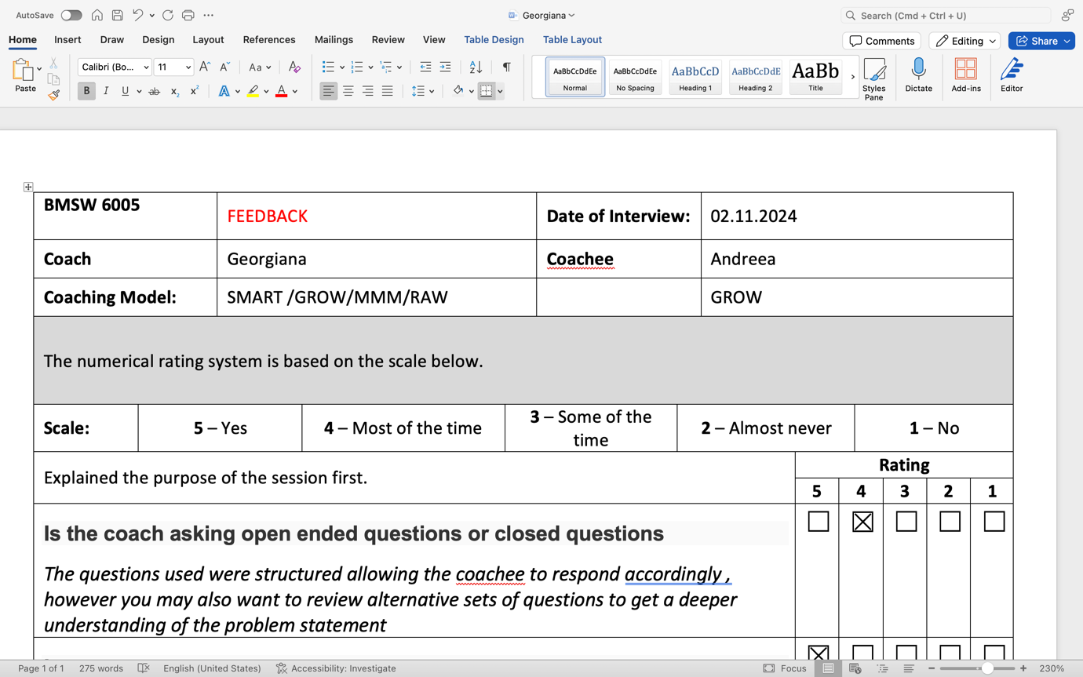

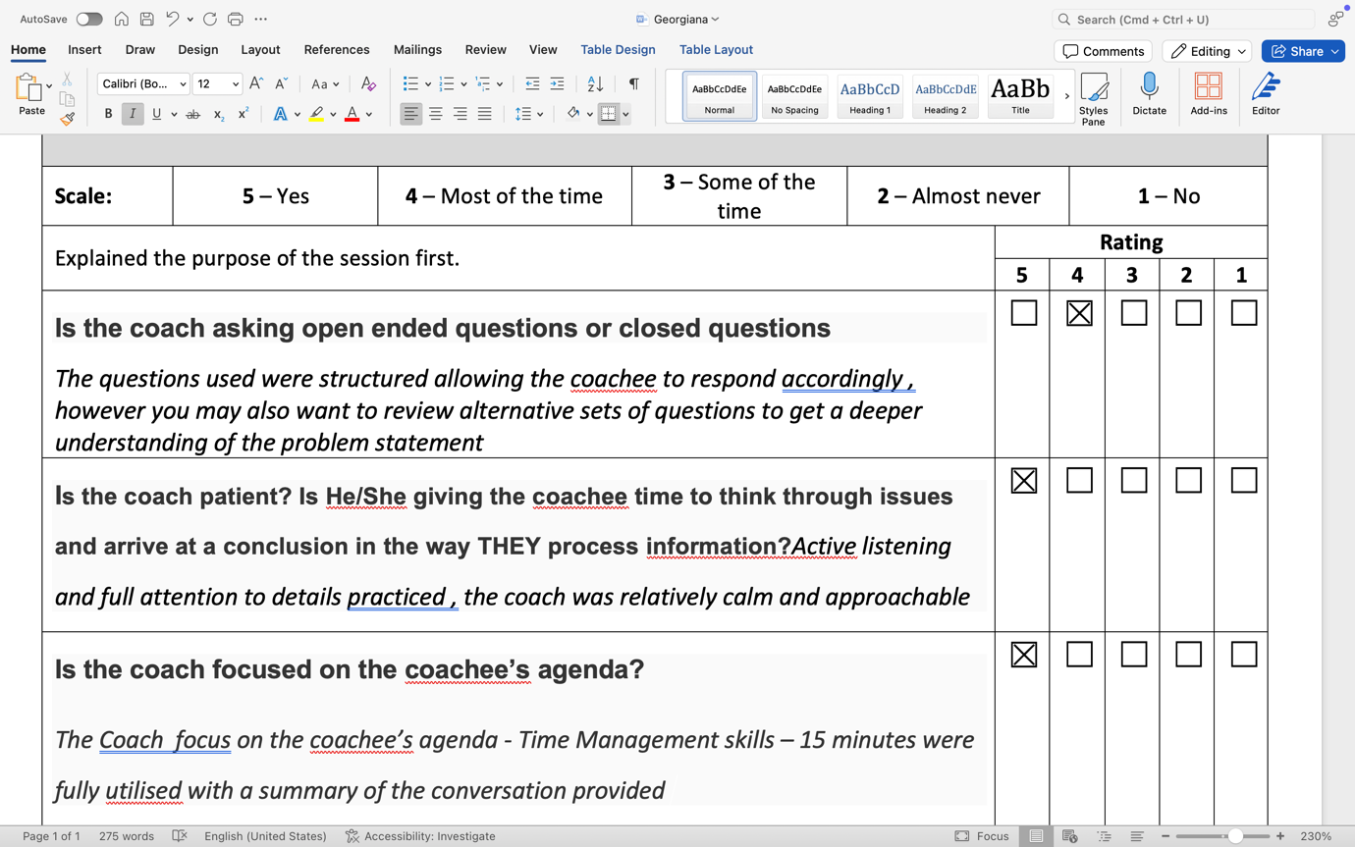

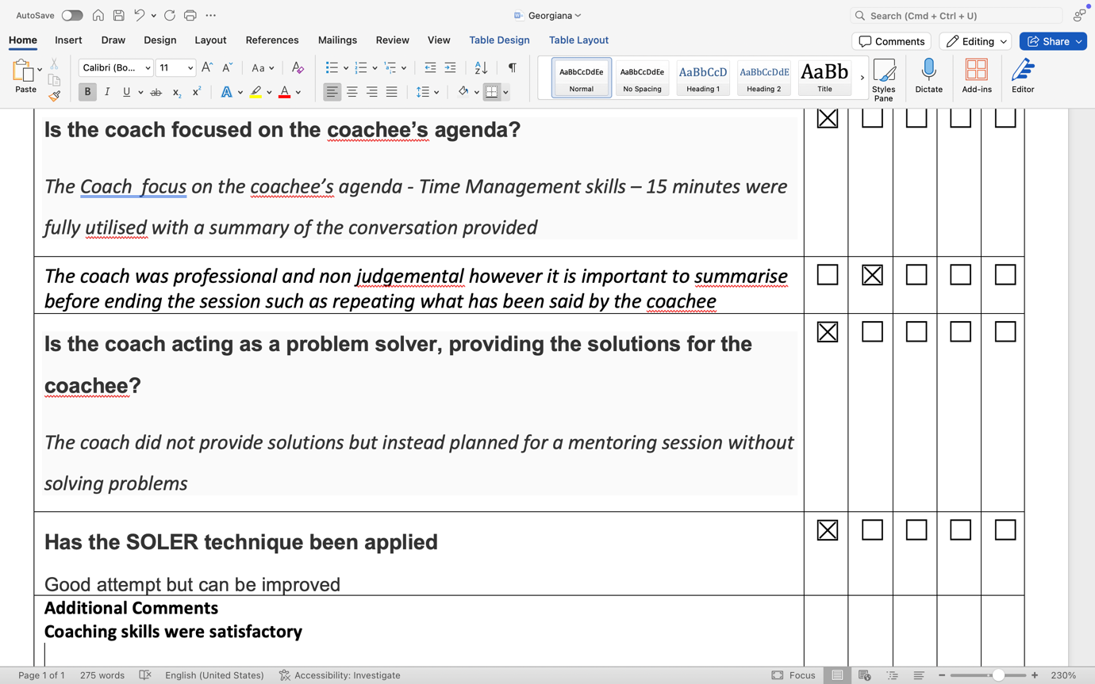

References:

Whitmore, J.(2009). Coaching for performance, London: Nicholas Brealey Publishing.

Clutterbuck, D.(2004). Everyone Needs a Mentor. CIPD
Kram, K.E.(1985). Mentoring at Work: Developmental Relationships in Organizational life. Scott Foresman
Grant, A.M. (2017). The Third “Generation” of Workplace Coaching. Coaching :An International Journal of Theory, Research and Practice.
Passmore, J. (2010). Excellence in Coaching. Kogan Page.
Rogers, J.(2012). Coaching Skills: A Handbook. McGraw-Hill Education.
Garvey, B., Stokes, P.,Megginson, D(2018). Coaching and Mentoring: Theory and Practice. Sage.
Backkirova, T.(2011). Developmental Coaching: Working with the Self.McGraw-Hill Education.

