Understanding and Engaging in the Customer Experience
Module Code: BMSK5003
Submitted By - Sufian Thareque Immon
Student Number: 1706493


Table of Contents
Introduction 3
Task 1 Analysing the factors that affect Under Armour’s ability to maximise customer value. 4
STP Analysis 4
Marketing Mix 4
How value is Created 5
External factors that affect Under Armour’s ability to maximize customers’ value 6
Internal factors that affect Under Armour’s ability to maximize customer’s value 8
IDIC Model 9
Task 2: A critical understanding of Under Armour’s quality processes and its effectiveness in meeting customer requirements 12
Quality Planning 12
Quality Monitoring and Assurance 13
Quality Controlling 13
Six Sigma Technique 13
Supply Chain Management 14
Quality Improvement 14
Kaizen Approach 14
Total Quality Management 14
The effectiveness of the Quality Process in Under Armour 15
Porter’s Value Chain Model 15
Conclusion and Recommendations 18
References 19

Figure 1: Value Creation per Unit (Source: bambooinnovator.com) 6
Figure 2: Value Creation Frontier (Source: Cram.com) 8
Figure 3: IDIC Model(Source: ninjaoutreach.com) 10
Figure 4: Quality Process in Under Armour (Source: author) 12
Figure 5: Porter’s Value Chain Model (Source: mindtools.com) 16

Introduction
A firm should have a competitive advantage over the other firms of its industry to be successful in its business. Competitive advantage means having some distinctive competencies to attract potential customers. Customers are the core concern of a profit-making organization. A firm can maximize its value by creating value for the customers. For this reason, business firms need to understand and know the needs and preferences of the customers. They should also know which factors are affecting the buying behaviour of the customers. Then they design products and services to attract the customers. Under Armour, Inc. is a transnational clothing, footwear and sporting equipment manufacturing company which was founded by Kevin Plank back in 1996. It doesn’t recognize any home country for the business purpose as it has international headquarter in Panama City, Global headquarter in Maryland and European headquarter in Amsterdam (Underarmour.com, 2018). The report will analyse the value creation process of Under Armour and the effect of different factors on the organization in maximizing the customers’ value along with the quality process.

Task 1 Analysing the factors that affect Under Armour’s ability to maximise customer value.
Before creating value for the customers, Under Armour needs to know about the customers’ needs and preferences. Then they will have to target the potential customers for the clothing, footwear and sporting equipment. For this reason, the company has done STP analysis.

STP Analysis
Segmenting: Firstly, Under Armour has to divide customers into different groups or segments based on their needs, characteristics and preferences. The company has divided the customers based on their age, income, gender, qualification, lifestyle etc. For example, the name of the groups is male and female, graduate from college, Undergraduate, Post Graduate, attended school, household income with $50,000-$59,999, $60,000-$74,999, $75,000-$149,999, $150,000+, adults with age 18-34, 35-49, 50+ and children etc.
Targeting: Under Armour has analysed different segments or groups of customers and then they have made their choice to target potential customers. Their main customers are educated adult aged from 18-49 years with household income level $60,000-$149,999. Approximately, 53% of the customers are male and 50% of the customers have income level $75,000-$149,999 and 36% of all customers are college graduate (Gfk Mediamark Research & Intelligence, 2015).
Positioning: Under Armour has position itself as an innovative company which uses technology and chemical material with the natural material to produce high value-added products. The company differentiated the products from other company by introducing products that can save people from the negative effect of the weather like excessive cold and hot. These products will give comports to the athletes and increase their efficiency.

Marketing Mix
For removing the knowledge barrier of the customers, the company has to design its marketing strategy. Marketing strategy also helps to increase the value of the products to the customers. The customers can know about the benefits of the products from the marketing and advertising campaign. A marketing mix which is the combination of product, pricing, distribution and promotional strategy, will provide an idea about the marketing strategy of the company (Gummesson, 2002).
Products: Under Armour produces and sells clothing, footwear, sporting equipment and accessories including T-shirts, Jackets, Hoodies, athletic shoes, pants, trousers, shorts, leggings, bag, cap, protective gear, gloves, football, baseball, jersey etc. The company introduces many innovative T-shirt, hoodies, jackets and shoes like sweat control, scent control, ColdGear, Coldblack, connected running shoes, speed form shoe etc. (Underarmour.com, 2018)
Pricing: Under Armour follows the value-added pricing strategy as the products are different from the competitors’ products to some extent and they provide some extra value to the customers. The customers can get more by paying more. As the company targets the middle and upper-middle income segment of customers, their pricing strategy suits the needs and buying the power of the customers.
Place (Distribution): Under Armour distributes its products through their recognized distributors. The company also has online sells centres where customers can place orders directly. In many countries, the products are shifted to the distributors and they shift them to the retailers in a shopping mall, super shop and other big retailers. The company has a weak distribution channel in many countries as it is a growing company and competing against Adidas, Nike, Puma etc.
Promotional Strategy: Under Armour has many sponsorship agreements with celebrity athletes, professional teams etc. The company also has sponsorship right in many famous sports and non-sports events. The company follows both offline and online advertising strategy. It has a YouTube Channel, Facebook page and Twitter to promote their products and they collect feedback from the social media. The company’s products also featured in many popular TV series and Movie Series. It has gift card, discount provision, any given Sunday etc. promotional strategy.

How value is Created
The ultimate goal of an organization is to increase the value of the firm. Under Armour also has the same goal to increase the value of the company. The value of the company can be increased by only increasing the value offered to the customers. A figure will help to understand how value is created.
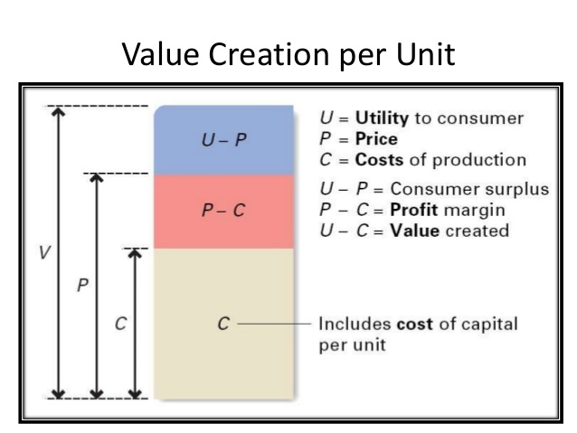
Figure 1: Value Creation per Unit in Under Armour (Source: bambooinnovator.com)
U represents the utility to the customers for the products of under armour. P represents the price the company offer to the customers. C represents the cost of the company to produce and sell a product including the cost of capital. Here, U–P means value created for the customers and P-C means the value created for the company. The company can gain more value by increasing the price if it can increase the value or utility to the customers.

External factors that affect Under Armour’s ability to maximize customers’ value
Economic Factors: The economic factors are affecting the ability to maximize customers’ value as the economic condition is changing. The personal spending and disposable income of people in European and North American countries are increasing. Their buying behaviour is also changing as they are more concern with the quality rather than price. The economic condition in South and South East Asia is improving as the GDP and Disposable income of people are rising at a very high rate. These are affecting the company to create more value for them. In return, they can earn more profit from them. The economic condition in Latin America and the Middle East is not improving much. The company has already cut their supply of products in some of those countries. It is hampering the value-creating a process of the company.
Changing Demographic and Social Factors: With the passage of time, the demographics are changing in the customer groups. The lifestyle is changing. People are now becoming more health conscious and they are now more involved in choosing brands. The customers want good quality products with great comfort and style from the company. The number of millennial is increasing and the old generation is decreasing. The culture shapes the buying behaviour of the customer (Mooij, 2004). The communities are becoming more diversified and the ethnic cultures are weakening. People are now becoming more technologically dependent. The beliefs of people on the products of under armour are building as the products are satisfying their needs properly. The customers have a positive attitude towards the products of the company which are different from other brands and they are getting more from the products. These beliefs and attitudes should be improved by the company to get a competitive advantage. The company can utilise the social networks of potential customers to reach more potential customers.

Internal factors that affect Under Armour’s ability to maximize customer’s value
Besides external factors, there are some internal factors that affect the maximum value creation of Under Armour. There are 4 building blocks for competitive advantage and value creation in an organization. The 4 building blocks are efficiency, quality, customer responsiveness and innovation (Goodman, 2009). The company follows a differentiation strategy and for that reason, it focuses more on the innovation, quality as excellence and customer responsiveness. A value creation frontier will help to understand the position of the company.

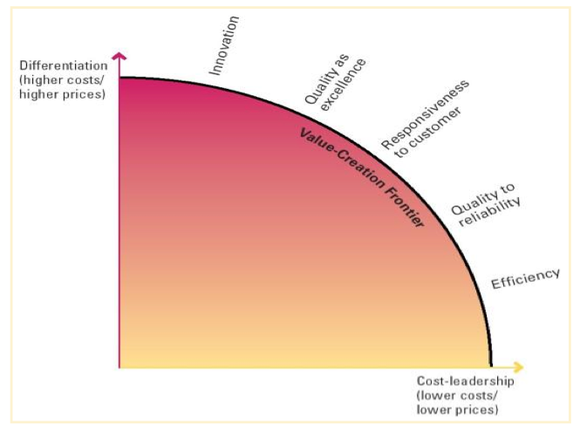
Figure 2: Value Creation Frontier in Under Armour (Source: Cram.com)

1. Efficiency: Efficiency is the first pillar of competitive advantage. Efficiency can be gained from economies of scale. The company can economies of scale when it produces a huge quantity of products. The fixed cost is distributed among the large quantity and the cost become lower. With the passage of time and learning effect, the employees become more efficient and they also save cost for the company. All the department in the organization works together by providing information to each other. The company can reduce the cost of goods sold and general and administrative cost by gaining efficiency. So they can offer less price for the product and when the price is slightly low, the customers will get more value than before.
2. Quality: Nowadays customers are more concern about the quality of the products. They seek both excellence and reliability in the product. As the company follows a differentiation strategy, the company focuses more on the excellence of the products. The products of the company are also reliable. The products are designed for providing maximum comfort to the customers. The products make the customer feel good. They serve their main purpose along with some augment services to the customers. The company doesn’t compromise with the quality and provide the best quality products to the customers.
3. Customer Responsiveness: Customer responsiveness means creating a positive image of the products in the mind of potential customers (Buttle, 2009). The company can gain its organizational goal by building a long-term profitable relationship with the customers. So the company has to manage a good customer relationship. The customer relationship management or CRM is now one of the best technique to turn potential customers into profitable loyal customers by managing interactions with them (Assael, 1995). IDIC model, a popular model of CRM will help to understand how CRM can influence the value created by the company.

IDIC Model
Under Armour can take 4 steps to build and maintain a profitable long-term customer relationship. The 4 steps are identifying, differentiating, interacting and customizing.
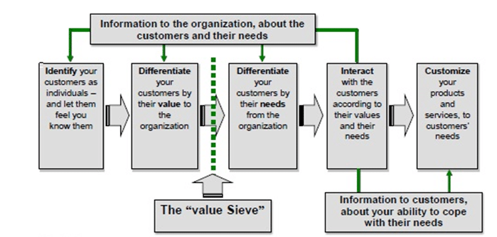
Figure 3: IDIC Model of CRM in Under Armour (Source: ninjaoutreach.com)

Identifying
First, Under Armour will have to identify the potential present and future customers of the company. The company will have to understand the customers’ behaviour and characteristics. Then it will have to recognize the customers in a way that the customers feel that the employees of the company know them very well and treat them in a way that they feel they are very important to the company (Schneider, 2016). The company can create more value for them if they know more about them. So to create more value for the customers and remain profitable, the company should know more about the customers’ needs and preferences.
Differentiation
Under Armour can differentiate the customers based on the value and needs. First, the company will have to know which customers are valuable and which customers are not. They will also have to differentiate the future valuable customers. Then they should treat the valuable customers differently from others which means creating more value for valuable customers (Wellington, 2010). The company can use BCG or Boston Matrix to differentiate the valuable customers based on the relative market share and market growth rate. There are 4 types of customers according to the BCG matrix namely star, cash cow, dog and question mark. The stars are the most valuable customers and cash cows are the loyal customers.
The company can also differentiate customers based on their needs. The company should know about the specific needs of different customers. Serving the customers based on their needs will help the company to create more value for the company.
Interaction
Under Armour should interact with the potential customers directly. They can track the potential customers and communicate with them to make them feel important for the company (Lewis and Varey, 2012). The company can go to different university or college campuses to interact with the customers directly. They can also go to a different sporting club, athletic team playground, different crowded playground etc. They can arrange different events and competition to grab the attention of the customers. This direct interaction with the customer builds trust and loyalty among them and they become profitable long-term customers for the company.
Customization
After the differentiation and interaction stage, the company has already known about the needs and values of the customers. In this stage, the company should customize the products according to the needs and values of the customers (Schneider, 2016). They take feedback from the customers in the interactions stage and use these feedbacks to design or redesign the products. Customization of the products according to the needs and values of the customers create more value for them. For example, the Scent Control and Cold Black jersey, t-shirts, shorts, leggings etc. are customized products for the comfort of athletes and young people who work or play in the hot weather.

4. Innovation: The 4th pillar of value creation is the innovation. The company is very innovative. It has mixed up technology, chemical materials with natural material for designing more value-added products for the customers. The microfibers, one kind of synthetic fabric first introduced by the company which designs t-shirts that can keep the wearer dry, clean and cool even in the hot summer. It has design ColdGear products are for controlling heat control and heat absorption. The Scent Control products are designed to control the scent and body odour of the wearer. The Cold Black t-shirts and shirts are designed to reflect heat which helps the wearer to remain cool in the sun. The company also has weather protection collection of hoodies, jackets and T-shirts which can protect the wearer from the excessive cold. Some jackets and hoodies are designed to heat the body in the cold by adding technology externally. The company also invented a connected pair of shoes with Bluetooth module, accelerator and gyroscope technology. The R&D of the company of the is very innovative and the company is investing huge money to introduce new products with new features.

Task 2: A critical understanding of Under Armour’s quality processes and its effectiveness in meeting customer requirements
Under Armour focuses more on the quality of the products along with the innovation. It follows the differentiation strategy to get a competitive advantage. The company’s major competitors are Adidas, Nike, Puma etc. giant global company. So the quality is a big issue for the company to survive and grow in the industry. The quality processes of Under Armour are analysed below:

Figure 4: Quality Process in Under Armour (Source: author)
Quality Planning
First, the company has to make a plan for quality standards and quality improvement. Here the company decides how much the company will focus on the quality of specific products. Then it sets standards for the products and also sets the acceptable range of quality. The company follows the ISO standards in setting quality standards for the product. The company knows that any problem in setting standards will lead to producing defected products. For example, if the t-shirts don’t meet the standard, then the customers will not buy this anymore. As the customers directly use the products in their body, the company focuses on the quality with utmost care. The company makes a plan about the quality according to the differentiation strategy it follows and will try to offer products with committed quality.
Quality Monitoring and Assurance
The quality monitoring and assurance is a defect prevention process which the company runs continuously (Sharma and Gadenne, 2011). For example, the supervisors continuously monitor the raw materials, process, people and other resources so that they can prevent defects from occurring. It is different from defects detection. The company takes precautionary measures before the defects occur. It is the best approach to the company in managing the quality of the products. They know that if they can reduce the defects, they will create more value for the customers and they will have fewer complaints about the products. This stage also reduces the pressure over the quality controlling division. The company uses much statistical software to monitor the quality of the product and process. The supervisors continuously report the operation managers about the quality process and suggest improvement in the process.
Quality Controlling
Quality controlling involves detecting the defects and take remedial actions to reduce the defects. In the company, the quality controlling involves three steps namely comparing the quality with standard, detecting defects and searching for the reasons, and taking remedial actions to reduce the defects (Sharma and Gadenne, 2011). Quality controlling involves different statistical technique and software. For example, under armour uses software like QMA, SQA, Audit.is etc. to control the defects rate in the production system. This is the major function in the quality process of the company. The company uses two approaches to control the quality of the products.

Six Sigma Technique
Six Sigma is a statistical technique to reduce the defects and variability in the production system. The main principle of Six Sigma is to keep defects rate only 3.4 in a million of the unit (Schonberger, 2008). Realistically, it is impossible but the company tries to keep it as low as possible. The managers remove all the possibility and problems that can create defects in the production process. So basically it is a production process improvement technique. The six sigma or 6s of the technique are sort, stabilize, standardize, shine, sustain and safety (Schonberger, 2008). The company uses the technique to identify defects, control defects and improve the process. With the help of statistical measure, the company uses the approach practically to set the acceptable level of defects. Then it compares the actual defects with the acceptable range. If there is any deviation from the acceptable level of quality, the managers find out the reasons and take actions to remove them. This approach is very effective for the company as the company ensures the best quality products with lowest defect rates.

Supply Chain Management
In the supply chain management approach, the company creates a network with the suppliers by making partnership or commitment. Good quality products are possible when the quality of raw materials is good. The company has many suppliers and they have an impact on the quality of the products. So the company create a network with them and give them access in the extranet. The shared similar strategic goals and committed to each other for better performance. The suppliers provide the best quality raw material for protecting their own interest and the company gets the best quality materials to produce and offer the best quality products to the customers. It helps to control the quality of the products in the company. This approach is also effective as it helps to improve the quality of the products directly.
Quality Improvement
The last step of the quality process of the company is the quality improvement process. The quality improvement is a never-ending process and is most important in quality management. The organization follows the Japanese Kaizen approach and Total Quality Management in improving the quality of the products.

Kaizen Approach
Kaizen is a Japanese term introduced by Toyota Company which means continuous improvement (Goetsch and Davis, 2014). The company follows the approach of continuous improvement of the quality. The R&D department of the company is always trying to add additional features to the products and improve the quality of existing products. The company believes that the best quality products will not remain best for a long time and for getting a competitive advantage, the company should have to improve the quality continuously. This approach helps to use the resources efficiently to improve the quality of the products.

Total Quality Management
Total quality management is a quality improvement approach which focuses on the improvement of the quality of all the resources of the firm involved in the operations. This means the approach focuses on the products, services, people, process and equipment etc. to improve their quality (Goetsch and Davis, 2014). It recognises the organization as a system and operation is a part of the system. So if a company wants to improve the quality of the products, it will have to improve the whole system like human resource management, marketing, sales, production, logistics management etc. It mainly focuses on operation management but focuses on the improvement of all functions. This approach also tells the company to improve quality continuously. The managers take 360-degree feedbacks about the quality of the products and services. Then they improve the people, process and products to create more value for the customers.

The effectiveness of the Quality Process in Under Armour
To understand the effectiveness of the quality process, it is necessary to analyse the value-creating functions of the organization which are related to the management of the quality. The value-creating functions can be known from the value chain of the organization. Porter has developed the value chain model, which the company also uses in creating value for the company.

Porter’s Value Chain Model
Porter introduced two types of activities related to value creation for the customers namely the primary activities and supporting activities. The primary activities include logistics management, operations, outbound logistics, marketing and sales and customer services. The supporting activities include the firm’s infrastructure, technology development, human resource management and procurement.

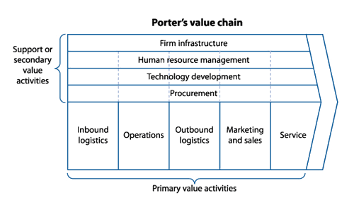
Figure 5: Porter’s Value Chain Model (Source: mindtools.com)
These activities will help to analyse the effectiveness of the quality process in the company.
Inbound Logistics: Under Armour is managing the logistics or inventory properly. It monitors the quality of the raw materials like fabrics, plastics etc. and checks their compatibility. The company also maintain the supply schedule to get the products timely. The supply chain network of the company helps to get the good quality raw materials timely by giving suppliers access to the extranet.
Operations: Under Armour is producing shoes, jackets, hoodies, T-shirts, bags, laggings, shorts, and other sporting accessories with utmost care. The operation includes quality monitoring and maintenance, quality control, production, packaging etc. The company has advanced technology and highly advanced machines and equipment to ensure the good quality of the products. The defects prevention and detection approach help the company to provide good quality products to the customers.
Outbound Logistics: Under Armour also handles the distribution channel and outlets directly and shift goods with their own vehicle. The company also fulfil the orders timely. The packaging is done with utmost care and with good quality packaging systems.
Infrastructure or Leadership: The organization encourages cooperation among the functions to be more effective. It gives a commitment to quality to the customers. The company has found ways to measure and control quality in a quantitative way. It also provides incentive and directs the employees to ensure better quality.
Marketing: The company focuses on the customers’ needs and value and interact directly with customers for feedback. The company runs market research periodically for knowing how they are doing. Under Armour has many sponsorship agreements with celebrity athletes, professional teams etc. The company also has sponsorship right in many famous sports and non-sports events. The company follows both offline and online advertising strategy. It has a YouTube Channel, Facebook page and Twitter to promote their products and they collect feedback from the social media. The company’s products also featured in many popular TV series and Movie Series. It has gift card, discount provision, any given Sunday etc. promotional strategy
Technological Development: The R&D in the company is very innovative and produces very innovative products line like the ColdGear, connected pair of shoes, Cool Black, Microfiber product line. It also emphasizes on the quality improvement. It uses software and information system like web based information system to detect defects rate and to manage inventory.
Human Resource Management: The company arranges training program for all employees for quality improvement. It also follows the quality team-building approach for better performance. The company make the employees believe that the company doesn’t compromise with the quality and they should create value for the company by providing good quality services to the organization.
Customer Services: In the outlets, the employees handle the customers with utmost care. They solve the problems of the customers by providing the right products to them. They also handle the complaints, warranties, quarries etc.
Procurement: The company procures advanced technology like artificial intelligence, robotics etc. It also procures software like ERP system, cloud based software etc. and machines to produce innovative and good quality products.
So the quality process of the company is effective but there is still some place to improve for the company.

Conclusion and Recommendations
The company can improve the value creation ability by focusing more on the human resource management. It should provide continuous training facilities along with proper incentives to the customers. The company should be more active in social media marketing. The company should also focus on the quality as reliability along with excellence. The company can follow the broad differentiation strategy to make more value for more customers. The quality management of the company is effective and the products are of good quality. The company should focus more on the team performance rather than individual performance. In a business world with aggressive competition, only quality and innovation can’t make a firm successful. The company should focus more on customer responsiveness and efficiency.

References
Assael, H. (1995). Consumer Behavior and Marketing Action. 5th ed. Cincinnati, Ohio: South-Western College Pub.
Buttle, F. (2009). Customer Relationship Management: Concepts and Technologies. 2nd ed. Amsterdam: Butterworth-Heinemann
Cram.com (2018). Strategic Management EXAM Flashcards - Cram.com. [online] Cram.com. Available at: https://www.cram.com/flashcards/strategic-management-exam-2455190 [Accessed 10 Dec. 2018].
Gfk Mediamark Research & Intelligence, E. (2015). Examining the strategic and entrepreneurial brand vision of Under Armour. International Journal of Entrepreneurial Venturing, 4(1), pp.42-57.
Goetsch, D.L. and Davis, S.B. (2014). Quality management for organizational excellence. Upper Saddle River, NJ: Pearson.
Goodman, J. A. (2009). Strategic customer service : managing the customer experience to increase positive word of mouth, build loyalty and maximize profits. (Online) New York: AMACOM. http://www.tsd.ac.uk/en/lrc/onlineresources/e-books/ (Accessed 9 Dec. 2018)
Gummesson, E. (2002). Total Relationship Marketing: Marketing Strategy Moving from the 4Ps product, Price, Promotion, Place of Traditional Marketing Management to the 30Rs the Thirty Relationships of a New Marketing Paradigm. 2nd ed. Oxford: Butterworth-Heinemann.
Hansell, G. (2013). How Value Patterns Shape Priorities for Value Creation. [online] Bamboo Innovator. Available at: https://bambooinnovator.com/2013/09/29/how-value-patterns-shape-priorities-for-value-creation/ [Accessed 10 Dec. 2018].
Lewis, B. and Varey, R. (2012). Internal Marketing. Hoboken: Taylor and Francis.
Mindtools.com. (2018). Porter's Value Chain Understanding How Value is Created Within Organizations. [online] Available at: https://www.mindtools.com/pages/article/newSTR_66.htm [Accessed 10 Dec. 2018].
Mooij, M. d. (2004). Consumer Behaviour and Culture: Consequences for Global Marketing and Advertising. Thousand Oaks, Calif: Sage Publications.
Schneider, D. (2016). CRM Models (Customer Relationship Management Model) - NinjaOutreach. [online] Ninjaoutreach.com. Available at: https://ninjaoutreach.com/crm-models/ [Accessed 10 Dec. 2018].
Schonberger, R.J. (2008). Best practices in lean six sigma process improvement: A deeper look. John Wiley & Sons.
Sharma, B. and Gadenne, D. (2011). An investigation of the perceived importance and effectiveness of quality management approaches. The TQM Magazine, 13(6), pp.433-445.
Underarmour.com. (2018). [online] Available at: https://www.underarmour.com/en-bd [Accessed 10 Dec. 2018].
Wellington, P. (2010). Effective customer care (Creating success). London: Kogan Page.

