kersha may davies

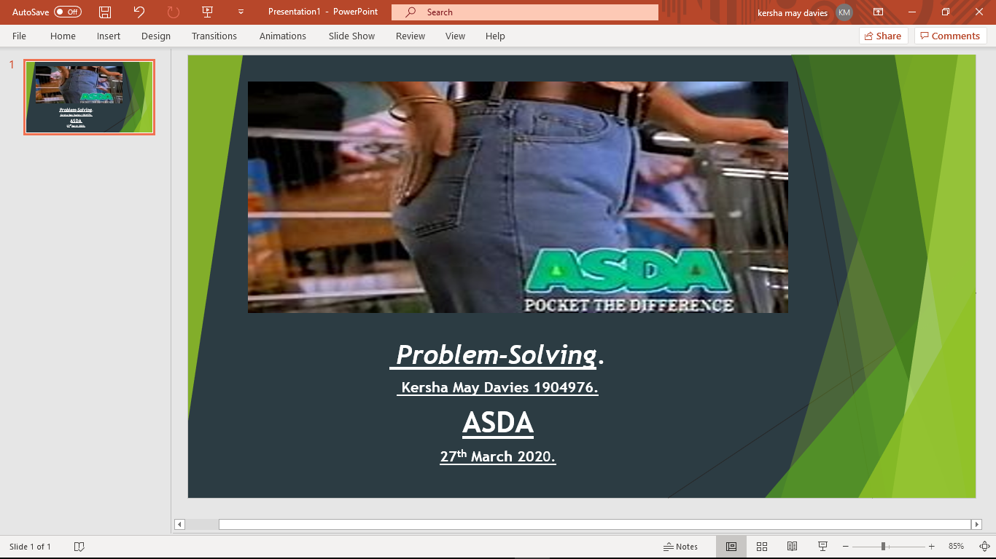
Problem-Solving.
Kersha May Davies. 1904976
Asda Problem-Solving.
27th March 2020.

Executive summary.

Asda’s main problem is its financial crisis. Being unable to merge with Sainsburys due to regulators barring the idea. Asda now wants to sell their store. Asda believed by merging their stores they would make a lucrative income. Seeing sales up to £51bn a year creating their businesses more profitable than its competitors such as Tesco, Aldi, Lidl, and Morrison’s.
Asda has had numerous political interests. Asda triumphed the victory of several court lawsuits. They broke the law on proposing Petrol, medicine, books, and cloths to sell in its store’s. this made the government pharmacies and authors threatened. Asda changed the Economical way of living. Asda changed history. Asda Drove the UK in to the 20th century.
Asda can change their financial problem by using a new business strategy called the seven P (7-P). This can help Asda communicate, Monitor and Review their company. The 6th and 7th P can help by showing Asda by employing the right people for the right job role can have a general impact on their customers. They can monitor their problem by using the 2nd P, examine and re-examine their strategy constantly. By constantly reviewing their company this will give them a better understanding of the market.

Contents page.
Contents
Executive summary. 1
Contents page. 2
1.0 Introduction. 3
2.0 Findings. 3
2.1 overview of the organisation. 3
2.1.1 the History of Asda. 4
2.1.2Products and services. 4
2.2 investigating Asda. 5
Asda’s problem 3.2. 6
2.3 SWOT Analysis. 7
2.4 PESTLE Analysis. 8
3.0 conclusion. 8
3.1 Based on analyses. 8
4.0 Options. 9
4.1 sales strategy. 9
4.1 The Seven P marketing approach. 10
5.0 Action Plan. 11
5.1 communicated. 11
5.2 Monitored. 11
Appendices. 12
Appendices 6.1 (timeframe) 12
6.2 SWOT Analysis. 12
6.3 PESTLE Analysis. 13
6.4 The seven P Model. 13
Reference list. 14

Introduction.

This report was requested by the chief executive officer. This report was requested on the 24th of February 2020 and the submission date will be on the 20th March 2020. This report is written by Kersha May Davies the Marketing Director. The purpose of this report is to analyse the problems of Asda. This report was requested due to the following problems: Asda’s pursuing case to sell their Business, upstanding their business measures, maintaining their prices low, being unable to compete with their rivals and keeping up with new technology. Their prices have risen on food, cloths, drugs and petrol.
This report will be demonstrating the malfunctions of Asda and how they went to war with their rivals and the government. By Using problem solving strategies and collecting specific data. This report will demonstrate the nature scope and impact of Asda’s main problem and how some other problems over the years lead up to this problem. It will involve a SWOT and PESTEL analysis.
The report will be discussing how Asda became successful in 1966 and in today’s century of 2020. It will reveal how their problem’s elevated. It will reveal how aware Asda is with their adversity's and how their behavioural actions towards their problem may have affected their business. In this report it will include their challenges using knowledge and data and what their implications are. It will include a conclusion.

2.0 Findings.

2.1 overview of the organisation.

Asda is a well-known superstore, it’s known for its inexpensive groceries, products, cloths and medicines. It sells everything from milk and bread to petrol. It is said that Asda is one of the UK’s cheapest provider of groceries and products.
Today in 2020 Asda foresees various changes. Asda has many new rivals such as Aldi, Lidl, Tesco, morrisons and high-tech companies such as Amazon. In today’s age using new up to date technology can let customers have more leeway in how they purchase their goods.
Asda has met their customers’ needs by establishing grocery online shopping. Extending their financial services and launching private brands. Netto stores and the successive conversion program viewed Asda’s supermarket format which grew to 180 stores in 2011. Keeping the same low prices in their smaller store’s as they did to their superstores (My5.tv, 2020).

2.1.1 the History of Asda.

The Asquith family and Stockdale family teamed together in 1949. The Asquith family were a family of butchers. whereas the Stockdale family ran a chain of dairies. After teaming up with the Asquith family in 1949. The families merged creating the name Asda specifically stating the two family’s names AS for Asquith and DA for dairy. This Made Asda a renowned business name. These families had ambition for growth and changes in the way business was traded.
They strongly believed that the key to success is lowering prices and make their customers satisfied and keep them arriving back. Asda made its first opening in the UK as its first ever superstore in 1996. They bought their products in bulk buy and drastically lowered their prices. By doing this they increased profits and dropped margins. Using the UK’s first ever fridges and freezers in the UKs super store market, letting produce last longer.
They wanted to make a statement and a rememberable slogan rather than using words they wanted to show physical action. This is when the “pocket tap” was created. It was created by two executive briefs Michal Barrington and Steve Johnston. This action is now used in British sign langue to understand their store “Asda”.
Asda has fought many disputes in the superstore industry such as, selling petrol at their petrol pumps, selling pharmaceutical drugs, selling books and selling cloth’s. They won all these encounters in court to sell these products at their store, All for discounted prices (Statista, 2020).

2.1.2Products and services.

Asda has many goods and amenities to offer, from your daily groceries to high quality cloths. Known as George.
Asda has an online website (https://storelocator.asda.com/directory) this website shows a number of Technical choice’s Asda has to offer. These range from: opticians, “money, such as insurance’s for motor vehicles, pet’s, home insurance, travel insurance, and breakdown cover”. Asda even prints customers photos on canvas, mugs, personalised gifts and passport photos. In some stores in the UK Asda has introduced the “scan and go” technical assistance, this helps customers save time while they shop, unfortunately Asda hasn’t yet introduced it to every store as of yet, but is still challenging itself to do so (Asda Money, 2020).
Asda has many retailers over the UK called Asda Living. Asda living stores sell manufactured goods from the George cloths range, offering a variety of George Home and an extensive marketing to their customers these stores are non-food stores.
Asda also possesses three Supercentres. Their largest super centre is in Milton Keynes quantifying more than 100,000 Square ft, these are endorsed by organizations such as: cuisine assistance proposals, banks, hairdressers and dry cleaners. Asda offers petrol pump’s with pay-at-the pump or pay-at-kiosk system, they also offer a home delivery or a click and collect service (Maxxi Atacado (Sonae) et al., 2020).

2.2 investigating Asda.

Asda explains that due to Tax increases and reductions in the government’s expenditure, it could be challenging for the company and its customers. Asda implied that through this period the UK’s family’s may have had a shortage of income therefore they may see a decrease in their profits. This affected the UK’s social environment. Tesco’s saw changes from 30.8%, Sainsburys stayed the same at 16.1% and Morrisons elevated up by 11.6%. according to Kantar World Panel in the year 2018 Asda has many strengths; it’s always had the reputation for low cost prices (UKEssays.com, 2020).
A MP called Siobhain McDonagh, the MP of Mitcham and Morden, claims that Asda is preparing to cut the wages for 3,000 employees. He wrote a letter to the Chief-Executive, Roger Burnley, declaring that the employees working for Asda maybe affected by a bereavement of £500 a year. There may be a loss of paid breaks, an end to premium pay and reducing night shifts. This can affect the employees’ wages considerably.
Asda has confirmed that discussions are taking place. This is to simplify the terms for hourly paid workers and increase the basic hourly rate to £9 per hour. McDonagh with a number of constituents working for Asda wrote “For the employees of Asda £500 is an enormous sum of money and would have a significant impact on their livelihoods. He welcomes the increase of the hourly rate, but this shouldn’t be used to disguise the pay cut for the 3,000 employees that work for Asda”.
The changes would include a reduce of night shifts, to approximately five hours. Responding to the letter, Burnley stated that they need keep up with the flexibility of the way their customers shop, they need to adjust with them in order to remain competitive. 50,000 employees are already in the field of the contract. It’s Asda’s best interest to keep equality and keep their flexibility underway.
They aim to increase take-home pay for over 100,000 colleagues. This investment can cost at least £80m. The customers continue to change the way they shop with Asda, they have made the change to meet their customer’s needs. The vital part of providing fantastic service is employing the right staff for the right place at the right time, which is what this agreement intends to accomplish. This contract may possibly take force towards the end of 2019. (Asda staff could end up £500 worse off under wage changes, says MP, 2020).
Asda’s biggest weakness is, after seeing an increase of customers of 30% Asda became a victim of its own success. By making their business a one stop shop, they started to increase their prices this is what drove customers away. As it grew it lost income by pushing prices up by doing so, they advocated from their message, they had first built their success off. Hence the pocket tap. 1000 million customers where retrieving (Statista, 2020).
Asda states that their goal is to be the most reliable retailer. They are committed to reducing the environmental impact of their operations and from the products that they sell. And from the suppliers who make their products. They are reducing their impact on the environment, and helping their customers do the same.
They stock sustainable goods at an inexpensive price to make being GREEN an achievable goal. Their focus is on eliminating excessive plastic. Packaging is helpful to the life of a product. They sample solutions that include many recycled products and then reprocess them as much as possible (Asda.com - Online Food Shopping, George, & more, 2020).

Asda’s problem 3.2.

2.2.1 Description of the Nature Scope and impact of Asda.

Nature.
Walmart bought Asda in 1999. The Nature of Asda’s problem is that Walmart has tried to sell Asda for two years. Asda is struggling financially. Until recently Asda wanted to merge their business with Sainsbury’s last April. UK regulators barred Asda’s proposal to merge with Sainsbury’s as they were threatened that the two stores would raise their expenses and reduce the quality of their products leading to having lesser choice for their customers.
An interview with CEO Mike Coupe was caught singing “we are in the money” before an interview streamed on live TV. “Showing off”. This was another reason why UK regulators fought against the two companies merging. Asda presumed by merging their stores together they would make a profitable income of sales up to £51bn a year making their business and Sainsburys business more successful than its rivals such as Tesco, Aldi, Lidl, and Morrison’s (Kollewe, 2020).
According to Chief-Executive of Sainsbury’s Mike Coup, He feels that merging the two stores will keep up with customer rates in addition to be more beneficial to their company and by merging with Asda will considerably benefit both the companies (Sainsbury's profits have slumped 29%, 2020).
Both companies said if the plan had gone forward this would have led them to cut their costs and allowed them to lower prices for the customers across the UK.
Political analysists alleged that it may help the supermarkets stall the growth of Aldi and Lidl in today’s competitive market.
Earlier in the year, Asda and Sainsbury’s which is owned by the US retailer Walmart, vowed to sell at least 125 and 150 of their stores to permit the merger to continue as well as their petrol stations and convenience stores. They promised to bring £1bn price cuts for their consumers if the deal went ahead (Sky News, 2020).

Scope.
The scope of Asda’s financial problem reaches many other drawback's, some research articles disclose, the reason for this is because: its trading profits in May 1999, were £436m and now it turns over £720m. These statistics show that Asda hasn’t made much of a profit increase since the year of 1999 this is one of the main threats for Asda.
Asda’s Estate has more than doubled since then, and its employment. The figures reveal the obstinate reality for what was once known as the world’s best grocery store. Therefore, Walmart has sought to distribute Asda and Sainsbury’s not just to benefit both business but to consider the Economic nation of the UK. (Sky News, 2020).
Asda soon returns to its progress after price cuts and general price level rises. “inflation”. A rise in sales has risen in the last three years, as customers where responding to price cuts and the improvement of its stores. At the end of June thanks to Easter trading, sales increased to 1.8%. This isn’t including petrol. Asda’s biggest weakness was being unable to keep up with its low price’s and cutbacks. Asda remained unable to keep up with its rivals Lidl and Aldi, this led them to a loss of profits.
Asda has had many political concerns over the years. Asda won the victory of many court lawsuits. It broke the law on offering Petrol, medicine, books, and selling cloths in its store’s. However, they were a threat to the government, the pharmaceutical stores and the Authors. But putting that aside Asda changed the Economical way of living. Asda changed history. Asda Drove the UK in to the 20th century.
This is one of Asda’s strengths. Asda never gave up when it came to be accomplishing their battles, they fought for their company and the UK citizens to have low-cost good’s and products. They relocated back to their roots by wanting to give the economy an easier way of life and selling quality produce and products for a reasonable price (Sky News, 2020).
Impact.
Although this may have had a great Impact on Asda’s success today. By always being recognised as the lowest priced superstore and keeping their prices down, this give them a rod for their own backs, after revamping their stores and spending most of their profits on their business, they needed to increase their prices, this had a massive impact on their customer’s and left customers looking for a cheaper store with just as good quality of produce.
According to Nils-Gerrit Wunsch, his statistic chart shows that Asda’s sales decreased significantly in the few weeks leading up to the 11th of August 2019 in this time frame sales decreased by 1.5 percent. This was noticeably different from the year before.
Statistics show from the 9th of November 2014 to the 26th of March, Asda’s sales dropped. After this date sales started to develop to an exceeding rate of 2.5 percent until March 2019.
This is because Asda lessened their prices and maintained them at this rate. This should be Asda’s main priority and maybe it’s only to stay as a successful superstore. The German discounters Aldi and Lidl had high sales statistics within this period, but other companies such as Tesco, Morrison, and Sainsbury’s wrestled with their sales further than Asda did (Statista, 2020).

2.3 SWOT Analysis.
S- Asda changed the Economical way of living. Asda changed history. Asda Drove the UK in to the 20th century by Winning victory in court. They broke the law on offering petrol, medicine, cloths and books in their retailers.
W- Asda saw 30% rise in profits leading them to increase their sales.
O- their opportunities will be brining scan as you go to all their stores and keep their sales down.
T- trading profits in May 1999, were £436m and now it turns over £720m. These statistics show that Asda hasn’t made much of a profit increase.
By following Asda’s strength and recognising their success in the year 1999, Asda can overcome the problem of wanting to merge or sell off their company, Asda should stick to their roots to overcome this problem. By enforcing update tech this may be attractive to the younger generation. By avoiding their weakness and threat they may see Increasing sales and profits rise again (Statista, 2020).

2.4 PESTLE Analysis.
P- Regulators fought against Asda and Sainsbury’s merging.
E- Increasing employees’ wages, cutting back on night shift work to, affecting the employability rate. employing the right staff at the right place and time to meet their customers need.
S- Tax reductions effected society this effected the social environment.
T- Provides up to date Tech but needs to improve in its areas of the Scan and Shop.
E- Committed to reducing the environmental impact of their operations and from the products that they sell. eliminating excessive plastic. Sample solutions that include many recycled products and then reprocess them.
L- Broke the law for selling Medicine, Books, Cloths and Petrol in its store.
Regulators fought against Asda and Sainsbury’s merging. This led Asda to want to sell their business. Tax reductions and decreased profits where one of the problems that lead Asda to intend on merging with Sainsbury’s. By Asda focusing on their customers needs without having to cut the employment but by raising their employees pay is a positive step to Asda’s future.

conclusion.

3.1 Based on analyses.

The main problem was wanting to sell its store. This is because Asda is having financial problems. Asda planned to merge its store with Sainsburys but was barred by watchdog. Regulators where worried that with these stores merging, they could increase their profits and felt threatened that they would lessen the quality of their products bringing little choice for their customers.

But I don’t agree that this is true.
I believe for Asda to solve this problem; they will need to battle against these company’s lowering their prices or using the BOGOFF sales to bring customers flocking. Also, by updating their company policies, such as introducing new update tech in their stores.
As amazon has introduced to their system and like Tesco by using the Club card points, and the scan while customers shop. Saving time for the customers, this brought new customers and made it more attractive to the younger generation.

If Asda focuses on turning back to its roots of selling produce at rock bottom prices promising to save the customers money, then this could bring Asda’s profits rising. Asda changed the way the UK’s economy is controlled. It also changed the way of life for the social environment by winning battles in court for the UK citizens. Asda needs to remember who they are and what they are about.

By brining employee motivation into their company may increase sales, by having a good relationship with their employees. Bringing job security to the employees will also give them motivation to work harder by knowing that their job is safe and secure. But Asda is cutting night shifts and working hours for its employees. Cutting employees wages from £500 a year but also increasing hourly rates to £9 an hour. Burnley does welcome this increased rate but suspects its used as a disguise to pay cut the 3,000 employees that work for Asda. Asda say’s this is vital for their customers. Because their customers have changed the way they shop, and they made this change to meet with their customers needs. In a sense I agree they need to expand their resources to meet their customers needs, but they should still give hours to their current employees.
By giving their employees the understanding that they’re not going to lose their jobs. Can make the employees feel secure in their job. If they enjoy their job position and understand it then they will bring a better influence on Asda’s company.
Also brining in a Status. If they provide an employee with a status the employee will be motivated to get a higher a status and feel rewarded for their labour.

So, I believe if Asda wants to sell their store, they should considerably rethink it. If they keep their prices low and at a flat rate, look after their employees and work hard to keep their customers sense of loyalty they might just see their profits rise. Asda should stick to its roots of being the best quality for a cheap price.

4.0 Options.

Regulates where intimidated of Asda and Sainsburys merging because they may have increased sale’s and had little choice for their customers. This made Asda want to sell their company. An example would be CEO mike coup was seen singing “we are in the money” this led regulators to believe the companies were merging just to maximise their profits and this resulted in the lesser thought for their customers. I believe that Asda should rethink their idea of selling as there are many ways to increase their profits such as keeping their prices on their produce and products down.

4.1 sales strategy.
A new sales strategy for Asda will include the 7-p model, this will help Asda be Distinct this may help them be perceived as different to their competitors. This may help them to be systematic, to keep having the same repeatable approach.
They will by need to be the complete opposite to their competitors. They should break the pattern off doing the same thing each time by creating the same approach to their customers can result in the customers getting fed-up of the same things. If Asda sustains their prices at a flat rate and prevent putting their sales up, the customers will want to purchase their products as they know how much their spending (Vliet, 2020).

4.1 The Seven P marketing approach.
The seven P marketing strategy model was first established by E. Jerome McCarthy he published his book of Basic Marketing in 1960. It has now been recreated by Brian Tracy.
The seven-p model helps with the brand development of a company. It helps companies evaluate and classify key concerns that influence the marketing of their product’s (How to use the 7Ps Marketing Mix? - Smart Insights, 2020).
Products- by making the products more attractive the customers may want to buy them also by making their services more appealing to the customers. By brining in a new marketing consultant can help them see if their products are selling at the right place at the right time.
Price- by examining and re-examining the prices they charge for their products. Making sure their prices are still approachable to the current market.
Promotion- Communicate with their customers about their products. Small changes in the way they promote their products by rewriting the description of their product. Or change the offer in the advertisement.
Place- If Asda review and reflect on their current locations in the UK and change location to somewhere they haven’t built an Asda store. This could help them increase their profits. By looking at other companies’ statistics to find out whether their store will be suitable in that area.
Packaging- By visualising their packaging of their products, can help them take their customer’s eye. Small improvements in packaging such as colour may get the customers to buy.
Positioning- By Influencing the way people view their business and getting to know what their consumer say’s about their products. understanding how their customers view their company and their products.
People- Asda can develop the habit of understanding their customers. It’s in their ability to recruit the right people for their store, by selecting and hiring the proper people with the right skills and personalities people must have improve their store (YouTube2020).
this includes all types of people involved with the trade. It’s mostly aimed at employees who have visual contact with the customer’s, these people are the face of the company.
Companies like Asda are aware that they need to manage customer contact employees, this helps them monitor their service on attitudes and behaviours. If these aren’t monitored it can impact customer satisfaction (Vliet, 2020).

Action Plan.

5.1 communicated.

5.2 Monitored.

5.3 Reviewed.

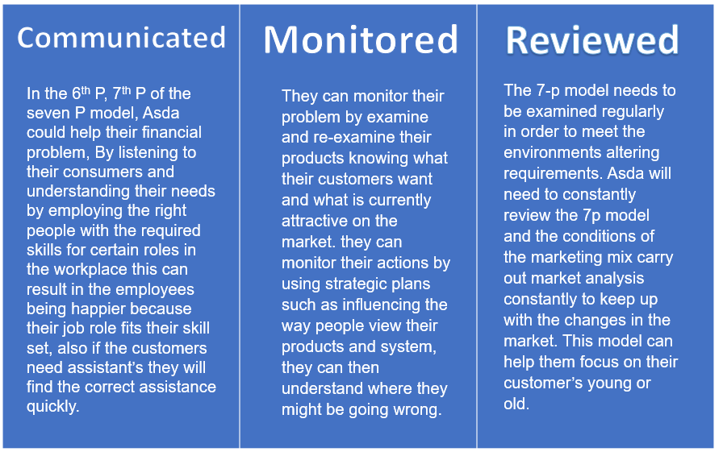(Vliet, 2020).

Appendices.

Appendices 6.1 (timeframe)
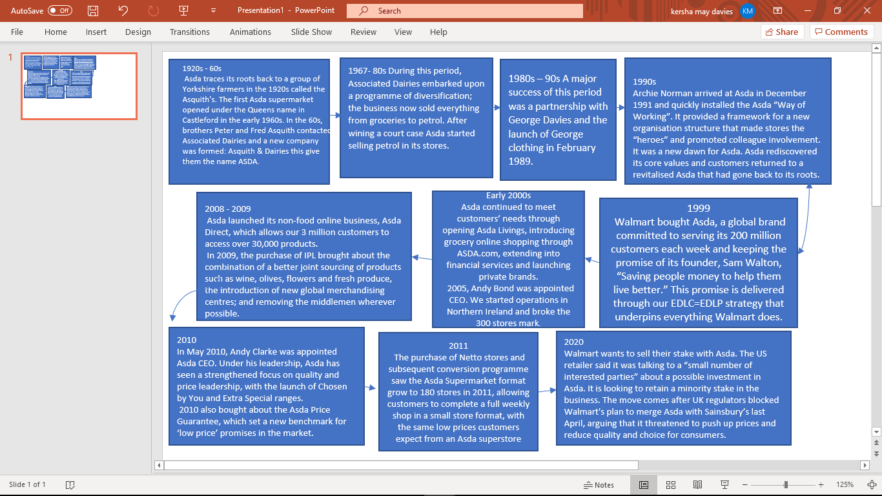(S2.q4cdn.com, 2020)

6.2 SWOT Analysis.
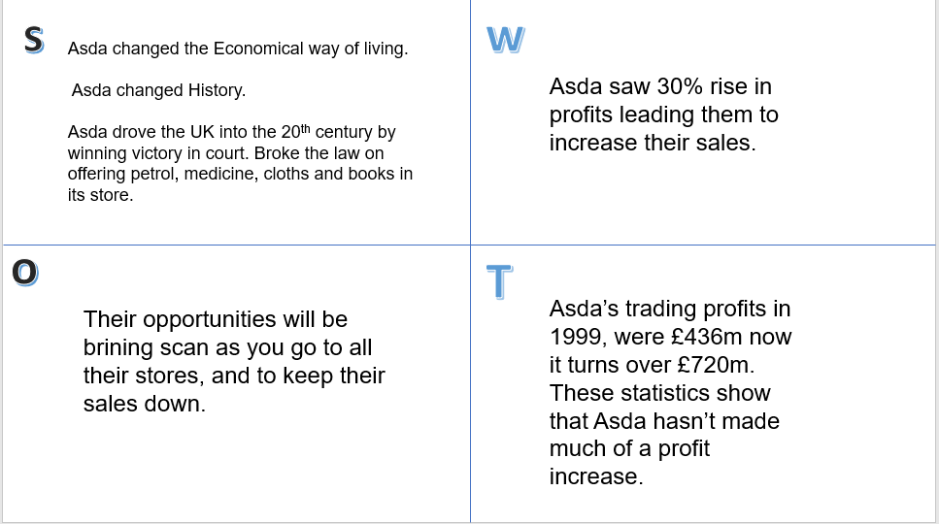

6.3 PESTLE Analysis.
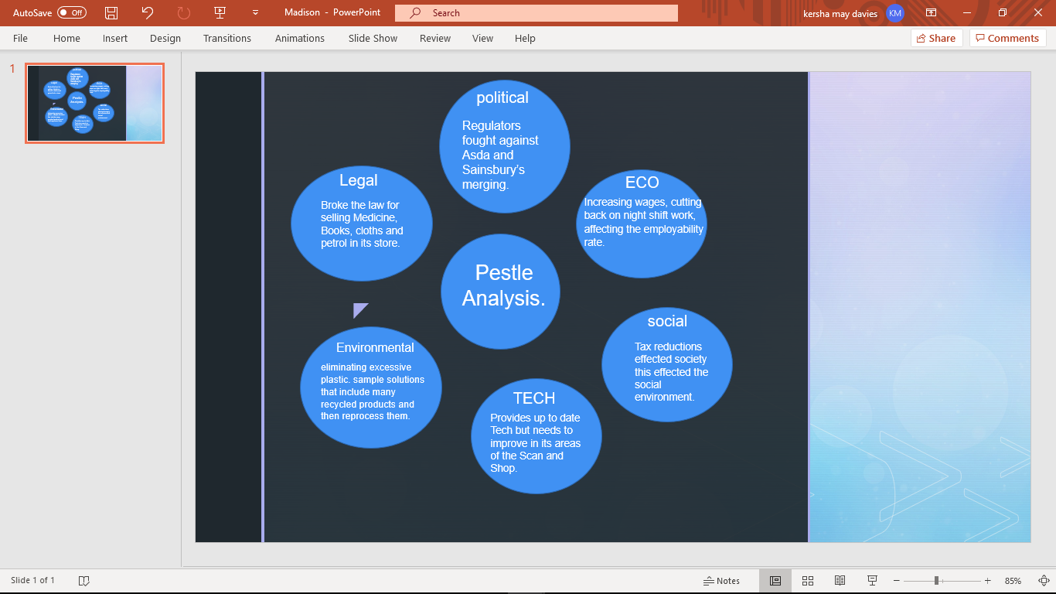

6.4 The seven P Model.
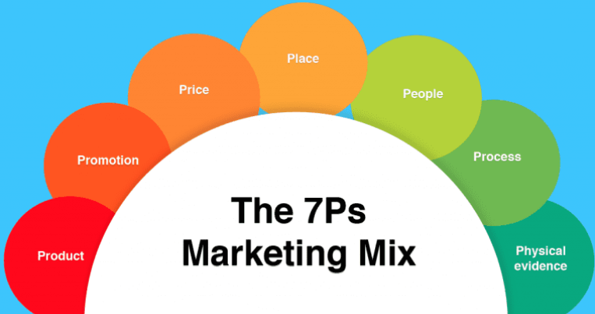
(How to use the 7Ps Marketing Mix? - Smart Insights, 2020).

Reference list.

2020. [online] Available at: <https://www.youtube.com/watch?v=BHWjw_6k47> [Accessed 11 March 2020].

ASDA Money. 2020. Buy Travel Money - Buy Foreign Currency 0% Commission | Asda Money. [online] Available at: <https://money.asda.com/travel-money/> [Accessed 9 March 2020].

Asda.com. 2020. Asda.Com - Online Food Shopping, George, & More. [online] Available at: <https://www.asda.com/creating-change-for-better/better-planet?cmpid=dmc-_-ahc-_-vanityurl-_-generic-_-environment&utm_source=vanityurl&utm_medium=dmc&utm_term=environment&utm_content=generic&utm_campaign=ahc> [Accessed 11 March 2020].

Kollewe, J. (2020). Walmart in talks to sell majority stake in Asda. [online] the Guardian. Available at: https://www.theguardian.com/business/2020/feb/26/walmart-in-talks-to-sell-majority-stake-in-asda [Accessed 4 Mar. 2020].

Maxxi Atacado (Sonae), B., Bodega Aurrera, M., China, W., Game, S., Super Jumbo Cash and Carry, S., Seiyu, J., Hiper (Bompreço), B., Best Price, I., Walmart Supercenter, U., Neighborhood Market, U., Sam&#x27;s Club, U. and Walmart Supercenter, C., 2020. Company Facts. [online] Corporate - ASDA. Available at: <https://corporate.asda.com/our-story/company-facts> [Accessed 9 March 2020].

Reference. My5.tv. (2020). My5. [online] Available at: https://www.my5.tv/inside-asda-bigger-better-cheaper/season-1/inside-asda-bigger-better-cheaper [Accessed 1 Mar. 2020].

S2.q4cdn.com. (2020). [online] Available at: https://s2.q4cdn.com/056532643/files/doc_downloads/Our%20Business/our-business-asda.pdf [Accessed 4 Mar. 2020].

Sky News. (2020). Why Walmart is willing to check out of Asda in £13bn Sainsbury's merger. [online] Available at: https://news.sky.com/story/why-walmarts-willing-to-check-out-of-asda-11353638 [Accessed 4 Mar. 2020].

Smart Insights. 2020. How To Use The 7Ps Marketing Mix? - Smart Insights. [online] Available at: <https://www.smartinsights.com/marketing-planning/marketing-models/how-to-use-the-7ps-marketing-mix/> [Accessed 11 March 2020].

Statista. 2020. Asda Sales Growth In Great Britain 2014-2019 | Statista. [online] Available at: <https://www.statista.com/statistics/386700/asda-sales-percentage-change-great-britain-uk/> [Accessed 9 March 2020].
the Guardian. 2020. Asda Staff Could End Up £500 Worse Off Under Wage Changes, Says MP. [online] Available at: <https://www.theguardian.com/business/2019/apr/16/asda-staff-could-end-up-500-worse-off-under-wage-changes-says-mp> [Accessed 9 March 2020].

The Independent. 2020. Sainsbury's Profits Have Slumped 29%. [online] Available at: <https://www.independent.co.uk/news/business/news/sainsburys-profits-fall-failed-asda-merger-attempt-annual-results-a8894556.html> [Accessed 9 March 2020].

UKEssays.com. (2020). ASDA Company Analysis. [online] Available at: https://www.ukessays.com/essays/marketing/history-and-company-profile-of-retailer-asda-marketing-essay.php [Accessed 4 Mar. 2020].

Vliet, V., 2020. Service Marketing Mix, The 7 P's By Booms And Bitner | Toolshero. [online] toolshero. Available at: <https://www.toolshero.com/marketing/service-marketing-mix-7ps/> [Accessed 12 March 2020].

