PGCE/ProfGCE/PCE (PCET)

Teaching Observation Record

Guidance on the use of form
This form is intended to be used to record feedback from formally observed teaching sessions including micro-teaching. The trainee teacher should complete Section 1 in advance of the teaching session and forward the completed form to the scheduled observer. They will then provide feedback to the trainee based on the headings indicated in Section 2 and suggested areas for feedback. However, this is not intended to be prescriptive in nature, but rather to promote dialogue on the quality of the teaching that has been observed in order to provide guidance and to inform targets for future professional development for the trainee teacher. Section 3 should be completed by students following receipt of the observation feedback as a reflection on the feedback obtained and the suggested points for development.

Section 1
Trainee teacher: Joanna Reed | Observer: Katie Gardner
Date: 25 November 2024 | Time: 30 minutes
Topic: Masculinity (Reeser,2020 and Deslandes 2021) & Myth (Barthes,1957 and Haute Couture and Haute Culture Bourdieu, 2020) | Group:  Paula Rees-Rehwald  Aimee Leigh Jenkins  Elsayed Elhoshi  Tracy Linsey
Setting (classroom, workshop etc): Small lecture room (microteach) | Number of learners: 4

Trainee Teacher notes
Please note here any information you feel would be beneficial for your observer to be aware of prior to the start of the lesson, such as your rationale for a particular teaching approach, how this lesson fits into the wider curriculum for the learners etc.
This content should be within your lesson plan (and it is) you do not need to provide so much information here too.

Rationale
built my lecture following the format of my master’s lecturer. His approach follows a method of presenting the breadth of a subject and then showing specific examples. I wanted my microteach to be simultaneously cognitive (lecture) psychomotor (object handling) and affective through (reflective or self-exploratory practice). To promote a variety of learning styles. I considered conventions in art lectures and curriculums in (Freedman,2024).

Learning Objectives
1 EXPLORE the key theme of the lecture: Masculinity (Reeser,2023 and Deslandes,2021) and Myth (Barthes,1957) Haute Couture and Haute Culture (Bourdieu,2020) ​
This lecture will cover Judith Butler’s Gender as a Performance (Smith-Laing, 2017) Dressed Embodiment (Hesselbein, 2021) and Archetypes (Braam & Dhoest,2022) (Barry et al, 2020) in relation to ideas surrounding [Fashion] photography and male models of the 1950s (Deslandes 2021) linking these to wider sociopolitical events in Britain during the 1950s and 1960s building on (Barthes, 1957), (Fuhg, 2020) and Bourdieu (2020). ​
2 INTERPRET this in the context of the 1950s in images of Robin Tattersall through the aforementioned lenses through visual analysis of a selection of period advertisements.​
3 CREATE a short reflective document of your ideas surrounding masculinity in the 1950s and be able to Define ideas surrounding Masculinity studies in relation to the aforementioned.

Teaching strategies and Taxonomies

I have set 3 tasks in developing taxonomies: 1 Exploring a handful of philosophical and sociopolitical theories as related to 1950s masculinity through a 15-minute lecture, 2 10 minute Interpretation of first-hand material (a case study of one male model Robin Tattersall and the photographer Norman Parkinson) in the form of a collaborative group seminar and then finally 3 a 5 minute Creation of a self-reflective or self-exploratory document looking at a personal encounter with a 1950s male either in personal life or visual media. Following the idea that “Research shows that students who participate in “self-exploratory activities develop stronger creative abilities” (Heckel, 2024, p.39). By presenting a large range of material through an overview format, the student is encouraged to continue a supported journey of self-exploration into the subject of masculinity.

The teaching strategies I have used include lecture (independent), seminar (collaborative) and self-exploratory or self-reflective learning (independent). Loughlin and Sand (2023) conclude that the ‘informal networks or Peer support offered during lectures enhanced their learning significantly which is why I have included a safe learning environment of a seminar/ object handling session which encourages peer supported learning instead of just an lecture alone, “emphasizing academic skill development” (Keup et al, 2023,p.5) I wanted to present the student with a range of skills including some around museology and touch (Chatterjee,2020) to emphasize the importance of touch as an educational practice as well as emphasize the importance of object handling/curation as well as collections in Wales (this is further detailed in my lesson plan) and will be further detailed in my own reflective practice.

Professional development & Wider Curriculum

The lecture in this way promotes the learner’s professional development through the future ability to write creative essays around a variety of subjects within photographic practice, gender being a key one of them. The lectures in this wider curriculum would be designed to show an overview of photographic development within the twentieth century. This lecture will follow a lecture about the depiction of femininity in fashion imagery during the 1950s.

Assessment strategies
The assessment strategy I am using is surrounding the idea of Authentic assessment (Ajjawi,2024). This includes ideas around ontological fidelity (Ajjawi,2024): which explores the lived experience of students and linking this to the concept of interpretative phenomenology (Stollz,2023) which is used by researchers to look at someone else’s lived experience in depth. By presenting the reasons behind the photographer’s choices including those made by the systems within they work as well as the biases which they may hold I aim to make the ideas as well as the individuals depicted in the photographs more tangible to my students. This is strengthened using a clear case study in the seminar using just 1 photographer and 1 male model to deconstruct the material in a way that is clear for the student. I have done this following the idea that “When tasks are overly abstracted from their contexts, complexities and narratives, and characters and events are seen as merely placeholders for a technical problem, ontological fidelity is lost.” (Ajjawi et al,2024).

Reece and Walker (Reece and Walker,2007, pp.123-124) explore seminar strategies. Yet according to Reece and Walker students in seminar often don’t have the information available to them. However, I have intentionally chosen to put the seminar after the lecture to reinforce the ideas presented in the lecture and to present them in a more manageable format of a case study and function almost as an assessment of whether the students can identify the ideas discussed in the lecture.

By presenting the ideas firstly as theoretical and secondly in practice by having the student look at the objects firsthand in a clear case study. I aim to accurately assess their understanding by asking the student first to think about (in the lecture) an encounter the student has already subconsciously with the material in their previous lived experience. Through the question what does a 1950s man look like? These ideas are then further discussed in the seminar increasing students’ confidence. This 'previous experience' is then combined with the student’s newfound knowledge into masculinity, through a self-reflective and self-exploratory document which asks the students to look at Two aspects of masculinity in the 1950s and provides a gentle first encounter through independent working into the ideas around what kind of men are not included.

This is also to include ideas around supporting student learning through conscious competence. “The more we can help students to be aware of their competences, the better their motivation. In other words, conscious competence links to the wanting-to-learn factor. It breeds confidence.” (Race, 2019, p.24) By making students aware of the fact that they likely already have ideas about 1950s men and strengthening this through both my lecture (independent learning) and seminar (collaborative learning) I aim to increase students’ confidence around this highly complex material at level 6/7.

References:

Ajjawi, R., Tai, J., Huu Nghia, T.L., Boud, D., Johnson, L. and Patrick, C.J., 2020. Aligning assessment with the needs of work-integrated learning: The challenges of authentic assessment in a complex context. Assessment & Evaluation in Higher Education, 45(2), pp.304-316.

Chatterjee, H. ed., 2020. Touch in museums: Policy and practice in object handling. Routledge.

Freedman, K. and Hernández-Hernández, F. eds., 2024. Curriculum, culture, and art education: Comparative perspectives. Suny Press.

Heckel, H., 2024. Leadership Skills and Teaching Creativity Through Art Education. Art Education, 77(1), pp.39-44.

Keup, J.R., Petschauer, J.W., Groccia, J.E., Hunter, M.S., Garner, B., Latino, J.A., Ashcraft, M.L. and Friedman, D.B. eds., 2023. The first-year seminar: Designing, implementing, and assessing courses to support student learning and success. The National Resource Center for The First-Year Experience.

Loughlin, C. and Lindberg-Sand, Å., 2023. The use of lectures: effective pedagogy or seeds scattered on the wind?. Higher Education, 85(2), pp.283-299.

Stolz, S.A., 2023. The practice of phenomenology in educational research. Educational Philosophy and Theory, 55(7), pp.822-834.

Race, P. (2019) The Lecturer’s Toolkit. 5th edn. Routledge. Available at: https://www.perlego.com/book/1603214 (Accessed: 1 November 2024).

Reece, I., Walker, S., Clues, D. and Charlton, M., 2007. Teaching, training and learning: A practical guide.

Resources used in lecture:
Bourdieu, P., 2020. Haute Couture and Haute Culture. In Fashion Theory (pp. 46-52). Routledge.

Fuhg, F., 2021. Did Britain rule the world again? The international fashion market and the continental look in 1960s London. Contemporary British History, 35(3), pp.365-391.

Deslandes, P.R., 2021. The Culture of Male Beauty in Britain: From the First Photographs to David Beckham. University of Chicago Press.
Hesselbein, C., 2021. Walking the catwalk: From Dressed Body to Dressed Embodiment. Fashion Theory, 25(3), pp.367-393.

Huppatz, D.J., 2011. Roland Barthes, Mythologies. Design and Culture, 3(1), pp.85-100.

Smith-Laing, T., 2017. An Analysis of Judith Butler's Gender Trouble. Macat Library.

Please note here any specific areas that you would like to request feedback on from your observer, for example delivery style, planning and preparation, teaching strategy used.
- Slide design and slide standards are an area for further exploration
- Structure
- Effectiveness of Assessment strategies
- Effectiveness of Teaching strategies used
- Lecture conclusion

Section 2

Observer Feedback:
- Lesson planning and preparation:
For example (but not limited to)
- Lesson plan (structure, detail provided, variety of activities, appropriateness)
- Resources prepared (clarity of any slides used, handouts provided, are resources accessible)
- Learning outcomes (suitability of outcomes for learning group and subject)
Within the resources of your lesson plan you do not need to outline the key readings – these would be better placed on your ppts for students to access.
Try not to use understand in your lesson aim as understand is not measurable, consider Blooms Taxonomy for appropriate verbs to use here. Your lesson aim is suitable for the context of what you planned.
Your lesson outcome should be short sentences that start with ‘At the end of my lecture students should be able to…’
These lesson outcomes do link with the lesson aim.
You have identified the previous required knowledge well.
You have identified the anticipated difficulties, and they are appropriate and correct for your microteach, it would have been good to reduce the volume of material, perhaps considering one aspect of the subject rather than it in its entirety for 30 minutes.
Your lesson detail section is very detailed which is very good, it might help to add slide numbers alongside each section so you know where you should be at any given time within your lesson. There is a lot of content, both on your plan, and within your ppt for 30 minutes.
Your PowerPoint has a lot of information within it, consider reducing the number of points on each slide and separating them onto more, and try to make sure the font, colour and layout is the same in each slide, especially for those with ALN. The pictures you used within your ppt were good and appropriate and added to your teaching in class.
Your Leaning objectives within the lesson plan did not need the references as it made it difficult to see what they were.

- Teaching and delivery:
For example (but not limited to)
- Lesson start/conclusion (timing, sharing and reflecting on outcomes, were outcomes met?)
- Classroom presence and presentation skills (appropriateness of teaching strategies used)
- Pace of lesson and use of time (inclusiveness of lesson for all students, overall workload expectation on students and impact on well-being)
It is good that you went through your learning outcomes. It set students up for what to expect.
It world have been good to introduce yourself to the group at the start and briefly outline what you were going to teach.
You started by stating your own stand point in relation to what you are teaching, it would have been good to not discuss in terms of what you sign up to but instead what theorists say – or at least give your view at the end so that students can come to their own conclusions – sometimes students agree with lecturers due to lack of confidence.
It would have been good to engage in entry level behaviour so that you knew what students already know.
You spoke quickly throughout the lesson, possibly so that you could get through everything you wanted to, this meant that there were times you would touch on a topic or slide, but not explore it completely, you also skipped through a lot of the images and slides which would have supported what you were saying.
You asked students to think about what a 1950s man looked like and then skipped this slide very quickly – it was good you started to engage with students, but it was a bit of a missed opportunity to engage fully with students within your lecture and to ensure students knew what a 1950s man would dress as, as it was the basis for your microteach.
It would have been good to define masculinity for the purposes of this microteach, and specifically what it meant in context of your microteach.
You clearly have exceptional knowledge in this field.
It would have been good to define some of the terms you used – eg dandy, hunter as some students were googling what words meant- checking in with students would have supported them in this.
There were times you skipped through a number of slides at once, this was confusing to follow for students at times, this meant that there were missed opportunities to check students understanding and ask questions
As an introduction it would have been good to chose a small amount of what you wanted to cover before the seminar section rather than giving so much information – this lesson would have been paced well for a 3 hour or more lecture, not 30 minutes.
It wasn’t clear what you wanted students to do within the seminar when looking at the magazines, but students took part in the activity and were willing to try. This shows you had the respect of all the students.
You came across as confident throughout your microteach.
You discussed haute couture and haute culture – it would have been good to define the difference for students here.
Reflection work, it would have been good to go through your acronym with more explanation as to what you meant as it would have supported students to be successful in the activity.
You ask if what you have said makes sense but do not wait for an answer because you did not have the time for it.

Thank you Jo for your session, it was very interesting, I feel there was too much information produced for a 30 minute microteach, however, over a few hours I can see how it would be very successful.

- Professional knowledge and skills
For example (but not limited to)
- Subject or vocational knowledge (familiarity with the subject being taught, responding to questions)
- Clear expectations for learning and behaviour (formative and summative assessment, checking on student knowledge)
- Identification of and engagement with professional standards (which standards are evidenced and where)
You have identified and met the professional standards well within your microteach – it is clear you have been able to apply this to your plan, and you demonstrated this within your lesson too. Well done.
You showed very good knowledge in your topic by explaining around your slides rather than reading from your slides – you were able to skip from one topic to another fluently and quickly.
You were able to answer questions asked well.
Your assessment strategies within your lesson plan is not overly clear. It would have been good to state what assessment strategy you were using to assess the students learning during the 30 minutes – how would you know that students have learnt? What entry level behaviour assessment would you use?

- Points for future development (no more than 3 or 4). Where possible these should be identified in negotiation with the trainee teacher.

Consider checking understanding throughout your teaching

Consider the format of your PowerPoint

Continue to use your excellent knowledge and enthusiasm in your teaching.

Consider the amount you want to teach in a 30-minute session.

Section 3

Student teacher reflections:
Note here your reflections on the lesson itself, the feedback obtained and any plans you have to address the development points notes.
PRACTICAL TEACHING REFLECTION

Close to Practice Research (Zwozdiak-Myers,2023,p.50) “Focusses on issues defined by practitioners as relevant to their own practice and involves collaboration between people whose main expertise is research, practice, or both”. (Zwozdiak-Myers,2023, p.50) Upon reflection of my microteach, I strongly benefited from feedback from those who had expertise in the area of teaching practice and aim to form stronger collaborative relationships with my more practice based peers to strengthen my own practical teaching skills. This includes closely utilising the close-to-practice research framework as outlined below. This dialogical process is also mirrored in Art & Design Pedagogy “Exchanges may take place amongst peers or students at different levels of experience as well as with tutors.” (Orr and Shreeve, 2017, p. 94)

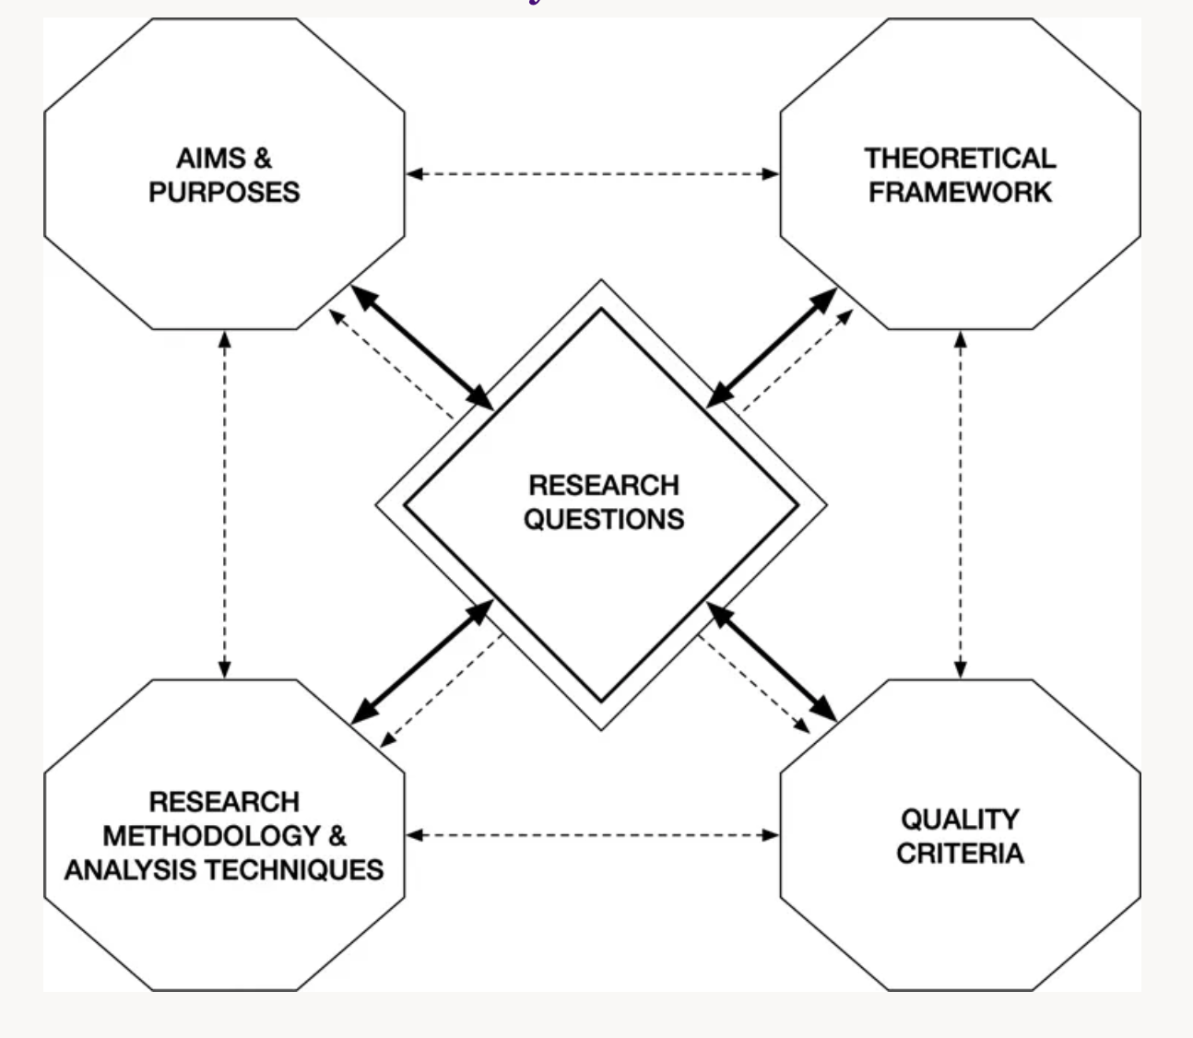
Taken from (Zwozdiak-Myers,2023, p.50)

My first assessment strategy- to ask the student what they would imagine by a 1950s man did not allow enough time for them to think or respond to these questions or collaborate. Nor did I as the teaching student provide clear answers to the questions. My second assessment opportunity was an object handling session. For the first part I got students to examine a 1950s magazine, although I could have provided clearer instructions. The second part involved students examining firsthand printed examples of work by Norman Parkinson of male model Robin Tattersall. I then asked each student to identify old and new versions of masculinity in each of the images. The students appeared unconfident, so I tried to reshow the slides as a reminder. Next time, I would make specific guidance slides to support students examining material. My third assessment strategy focused on self-exploration and answering a question with a model answer following examples from () I did not allow enough time for this activity and students felt too unconfident with the material to answer the question. I also did not include a summative slide.

Orr and Shreeve consider that in Art& Design Pedagogy “students must learn to manage and work through ambiguity to succeed in creative practice.” (Orr and Shreeve, 2017, p.92) however by implementing a clearly guided inquiry structure, it can improve student confidence with the material provided. Gregson and Duncan (2020) consider a managed enquiry strategy (Gregson and Duncan, 2020, p.280) Which is structured through preliminaries, stimulus, thinking time, question comparison, initial inquiry, development/review and summary.

In a future microteach I would aim to utilise this clear structure in my lesson plan

