M6X01439
A Professional Learning Journey
Anita Robinson
April 2018

How can we improve the quality of marking to ensure that it is meaningful and consistent in improving children’s learning?

The purpose of this report is to look at current research on marking and feedback in order to improve the quality of marking and feedback across a large Welsh primary school. The report focuses on current research on feedback and assessment for learning and includes a small scale action research project. This project involved interviewing staff and pupils about the feedback that was taking place and how effective they considered it to be. It also focusses on staff training on marking and feedback and how teaching staff began to introduce changes and improvements to marking in two classes before rewriting the whole school marking policy and developing more effective methods of marking and feedback across the school.

Introduction
The importance and impact of marking and feedback is not a new idea. There is a significant amount of research showing how effective the dialogue between the teacher and pupil can be in promoting understanding and the development of skills. Key research by a number of highly respected educationalists and researchers such as Hattie, Clarke, Black and Wiliam has developed our understanding of assessment and feedback and the effect this can have on both children’s learning and classroom practice. However it is important to consider that it is the type and quality of marking and feedback that supports the progression of skills and moves learning forwards.
Teacher workload is an ever present concern with many teachers reporting that marking is an onerous task with very little reward. Staff in this study felt that they could spend up to three hours every evening marking and that even with the initial changes made to the school’s marking and feedback policy that they still spent thirty to sixty minutes marking for each subject taught. This written marking took place after school or at home in the evenings or weekends and was not during the lessons, pupil led marking or verbal feedback.
In addition to this there were a number of other factors that led us to look at the current research and evaluate the way the teachers at the school marked and gave feedback. The end of phase results at Year Two and Six did not match the target setting and predicted levels of achievement. These two important assessment years had also dropped into the third and fourth quartiles in the Family of Schools Data (2016/2017). The More Able and Talented children were not achieving what was predicted for them and the school had been moved from a green school to amber in the ERW categorisations. Another concern was the fact that there was little consistency to the marking across the school; everyone had their own ways of marking which led to confusion for the children and a lack of understanding of what was expected.
The action research project was carried out in the Year Two classes to establish the impact of changing the current way of marking and feedback. It involved collecting a range of data including questionnaires, interviews and samples of work. An important part of the project was evaluating the current practice, trialing changes with the pupils and then looking at the impact again. It is expected that the final steps of this current cycle of improvement will be to model this practice across the school, then to rewrite the school marking and feedback policy with all teaching staff before implementing the new practice. This practice will then be part of a new cycle of evaluating practice, ensuring consistency, modifying and improving.
As with all educational research the guidelines from BERA the British Educational Research Association were followed.

Context
The school in this report is a large community primary school in Pembrokeshire, Wales. There are 420 pupils on role with two Learning Resource Centres, two nurture settings and Flying Start provision attached to the school. The school catchment area includes an area which is in the top 10% of the most deprived areas in Wales (Welsh Index of Multiple Deprivation 2014).
The school has a high number of Free School Meal pupils; this is currently 35%. This figure has dropped significantly over the past 12 months from 46%. This change in FSM has serious implications for not only the core data and family of schools comparison but also the amount of Pupil Deprivation Grant that the school receives to support children eligible for free school meals and looked after children.
The school currently has 8% of pupils registered as EAL. In addition to this the ALN register is 29% of the total number of pupils. This includes the children in the two Learning Resource Centres.
The schools attendance figure is currently 93%. This is slightly lower than the Local Authority and all Wales figures of 94%
Significantly following changes to the leadership of the school and governing body, the school was re-categorised in November 2017 from a category green school with an improvement rating of A to category amber school with an improvement rating of C.
The Family of Schools data from last year showed the school to be in the lower 50% quartiles for the Foundation Phase and Key Stage 2.

Summary of position in FSM benchmark group
Title | 10/11 | 11/12 | 12/13 | 13/14 | 14/15 | 15/16 | 16/17
FPI |  | 1 | 2 | 2 | 1 | 1 | 3
LLC |  | 1 | 3 | 2 | 1 | 1 | 3
MD |  | 1 | 3 | 2 | 1 | 2 | 3
PSDWCD |  | 3 | 4 | 3 | 2 | 3 | 3
Foundation Phase

Title​ | 10/11​ | 11/12​ | 12/13​ | 13/14​ | 14/15​ | 15/16​ | 16/17​
CSI | 2 | 2 | 4 | 3​ | 2​ | 3​ | 4​
LLC​ | 2 | 3​ | 4​ | 3​ | 2​ | 3​ | 4​
MD​ | 2 | 2​ | 3​ | 2​ | 1​ | 3​ | 4​
SCIENCE | 2 | 3​ | 4​ | 2​ | 1 | 2​ | 4​

Key Stage 2

Literature Review
Marking and Feedback is an important topic in education. The work of Hattie (2009, 2011, 2015, 2017) places feedback in the top 10 influences on achievement. The importance of effective marking and feedback cannot be under estimated while at the same time teaching staff report that marking adds hugely to their workload. The school recognised the need to develop an effective whole school marking strategy which improves attainment, understanding and challenge for pupils while not increasing the pressure on teaching staff. In particular the research behind learning outcomes, success criteria, time to act on feedback, self and peer assessment and verbal feedback considered.
Clarke (2003) focuses on learning outcomes and success criteria in detail and states that any feedback must be developed from the understanding of the learning outcome and specific success criteria. Hattie (2012) also discusses the importance of making learning intentions and success criteria clear to pupils in order for children to fully understand the task and how they are going to achieve it. In addition to this Welsh Assembly guidance on developing assessment for learning also refers to the importance of pupils internalising and understanding the success criteria which again supports the work of Clarke (2001 cited in Coombes 2017).
Success criteria are internalised and used by pupils when they have had a stake in their generation’
The aspect of time for feedback was a finding that arose from talking to learners. Very few children felt that they have time to improve their work. This idea supports the work of Clarke (2003).
Children are rarely given time to make any improvements on their work because of the teachers feeling of pressure.
Interestingly Clarke also found children often couldn’t read the teachers comments and were rarely given time to do so.
The importance of self and peer assessment is also recognised in the Successful Futures Report which recommends that:
Both self-assessment and peer-assessment should be developed as ways of encouraging children and young people to take greater responsibility for their own learning.
Black 2004 considers self-assessment to be far more essential to learning as pupils need to understand how to assess for themselves what they need to do to achieve their learning outcomes. Interestingly Nuthal (2007 cited in Feedback: The Communication of Praise, Criticism and Advice, 2011) notes that 80% of verbal feedback comes from peers and more of this information is incorrect!
A significant part in the development of marking and feedback is that of verbal feedback. Both staff and children agreed that verbal feedback was the most effective feedback. This idea is shown in the work of Clarke (2003). In addition to this it is important to consider the impact of immediate and continuous feedback throughout a lesson rather than it being ‘end loaded’ Wiliam (cited in the Welsh Assembly guidance on Developing Thinking and Assessment for Learning in the Classroom 2010) suggests that providing feedback should be a minute to minute process.

Research
An action plan was agreed with the Senior Management Team before beginning to implement any further changes in the marking and feedback in the school.

Two of the five targets in the School Development Plan were to implement change in outcomes and standards:
By the end of July 2018, we aim to:
1.Assessment  (Teaching) | Strengthen consistency between formative and summative assessment
2. Wellbeing | Improve attendance KPI
3. Standards | 1. Improve standards in English and Mathematics of more able pupils, and those capable of achieving the expected level in Key Stage 2 (Year 6 initially)  2. Improve standards in Language, literacy and communication and Mathematical Development of more able pupils, and those pupils capable of achieving the expected outcomes in Foundation Phase (Year 2 initially)
4. Foundation Phase | Improve the quality of provision in the Foundation Phase to enhance PSDWCD
5.Standards (Leadership) | Develop middle and senior management capacity

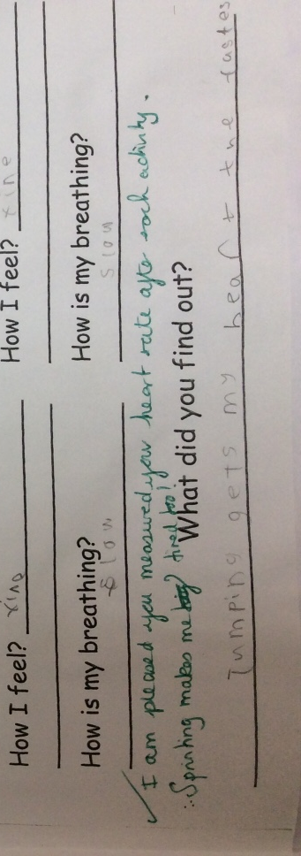
One of the first steps was to understand where we were as a school at the start. It was important to look at the marking and feedback that happens right across the school and understand what was taking place. It was important to look at what feedback was taking place, the effectiveness of this marking and how it was moving the children forward in their learning. A sample of marking was collected.


"Great work and fantastic spelling. Remember to use capital letters to start all sentences. I really enjoyed reading your work."


"What a super fact sheet! I love your drawings, great work”
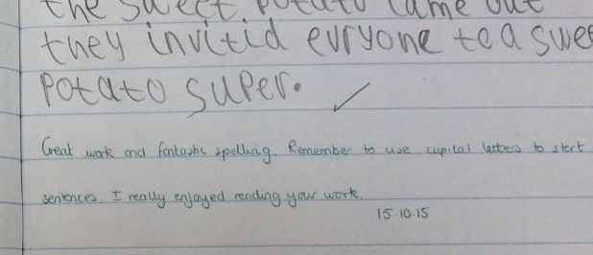

"I am pleased you measured your heart rate after each activity. Sprinting makes me tired too!"
"A lovely picture and a plan for your pizza"

It was clear from the initial evaluation of marking that the very little of the current feedback was constructive or moving learning on in any way for a number of reasons; the comments were what Coombes (2017) calls social marking. Clarke (2003) also discusses the issue of praise with a warning to use it sparingly to avoid ‘praise junkies’. Although there was evidence of the teacher suggesting a way to improve it wasn’t consistent, the majority of comments were praise but it was not specific what the teacher was actually praising and the feedback was linked to the task rather than the strategies or ideas that were being taught. Coombes (2017). There were no links to the learning outcomes or success criteria. There was also no evidence to show that the children had read the teachers comments or acted upon them. There was no evidence of challenge or developing prior learning. It was noted however that all staff were conscientious about marking and making sure that marking was on all pieces of work. Staff followed the handwriting policy of the school and presentation was important. It was clear that the importance of effective marking and feedback had not been recognised and understood.
Marking is usually conscientious but often fails to offer guidance on how work can be improved. In a significant minority of cases, marking reinforces underachievement and under expectation by being too generous or unfocused. (Black and Wiliam 1998).

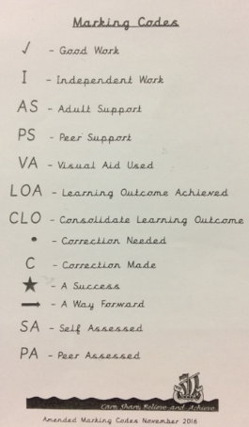
The next action was to begin to develop effective consistent strategies that would begin to improve the quality of marking across the school but also improve standards of learning. Any changes made must also recognise the workload and impact on teachers. Therefore a code system for marking was introduced. These were also displayed in classrooms and children knew what the different codes meant. The code VF was also added to encourage teaching staff to use verbal feedback when supporting children. Rather than lengthy dialogues and general comments it was decided with the staff that they began to use a star before writing what was done well and an arrow next to what needed to be improved on. In addition to this templates were developed to ensure that other important types of feedback were used including self and peer assessment.
As the research continued into marking and feedback it became clear that the schools marking was still not effective. Although it was evident that assessment for learning strategies were being used with children attempting to assess their own and their peers work, children were not reading the comments written or acting on the way forward. (Grigg 2010) refers to assessment for learning as being ongoing, short term and pupil led assessment linked to how well pupils have progressed against the learning objectives ‘learning valued for itself’.
Staff were still spending time marking after lessons and the comments although brief were not diagnostic.
It was felt that the next step was to find out more about the staff understanding of marking and feedback. Staff were invited to complete an anonymous questionnaire which provided a useful range of both quantitative and qualitative data. This information showed us that the several members of staff had particularly negative views on the marking process and also didn’t recognise the impact it can have on learning. Teachers still felt marking took up too much of their time and that it was not of any benefit. 54% of the staff who participated in the questionnaire felt that marking in books was for Estyn and senior managers and less than half of the teachers felt that their marking was for the children.
Teachers feel that they should be marking children’s work as a measure of their worth: for accountability purposes rather than to give feedback to the child. (Clarke, 2003)
An interesting point to note is that all of the teaching staff said that marking is to give praise and identify the next steps for the children. It could be argued that this key phrase is advice that teachers have been given previously. It would be interesting to find out more about staff understanding on marking and feedback. Research and information shows that marking and feedback however is far more praise and identifying next steps and it is so important to develop the staffs understanding of this.
The most significant finding from this data was that all the staff felt verbal feedback was by far the most beneficial type of feedback. This was really positive and at the same time frustrating. If staff understand the impact of verbal feedback in moving pupils learning forward and supporting children then why is marking after lessons still the main feedback that pupils were being given?
The next action was to gain the views of the pupils themselves. Pupils must become more engaged with learning. This involves recognising and setting their own targets, understanding what they need to do to improve and assessing their own progress as well as that of their peers. Again we used an online questionnaire to gain an insight into the views of the children. The results were interesting; children liked to see ticks and stars in their books to show the things they are doing well. Children felt that they were not given time to improve their work or act on the feedback. 50 percent of the children interviewed felt that marking was important however only 25% of the children thought written feedback was useful compared to 52% of children who preferred verbal feedback. None of the children could recall a written comment that helped them in their books but several children said that things like ‘Good Work!’ and ‘Well Done’ are often written.
If the teachers tell me what I need to do next I understand them and they can show me. I can't always read it or know what they mean when they write it down.
Our next step was training. In addition to the Aspiring New and Middle Leaders course that the members of the Senior Management Team were undertaking, teaching staff in Year 2 looked at the work of Coombes and in particular a course ‘High Quality Assessment for Learning; Working Harder Not Smarter (2017) as well as receiving mentoring and support from a highly successful school in Swansea.
As a result of the training, mentoring and research that had been undertaken initial changes were made to practice in both Year Two classes. One of the first things was to change our weekly timetable. This enabled us to have a longer quality session where the children in focus groups had direct teaching, independent work, feedback and importantly time to work on the feedback given. We then introduced a ‘polishing’ pen to the children. The children quickly understood that they needed to use this to act on feedback given and it was clear to see the improvements made. Success Criteria were established at the beginning of each lesson with the children rather than teachers telling the children what these were. In addition to ensuring that success criteria was linked to the learning outcomes, children also had ‘non negotiables’; these were the things that were in every recording session and included handwriting, spelling of regular words, basic punctuation etc. We called these ‘stickies’ to differentiate between the two different types of success criteria. (Clarke, 2003) discusses how this type of marking can give the children too many criteria to think about and the importance of keeping the focus on the skills begin taught. All activities have a learning outcomes attached to make the skill being taught explicit. (Clarke, 2003) suggests that the ‘learning objective needs to be separated from the learning context’ to ensure the focus is on the skills being taught. The learning outcomes all had an AfL traffic light printed on them and children used this to show their understanding. (Black, 2004) refers to the traffic light system of assessment as ‘a simple and effective idea’
These changes had some impact. Children had an involvement in deciding on the success criteria and also they had the time to discuss their work and make improvements. This also had a positive effect on their work as they were able to use what they had practiced in their next piece of work. However when looking at the research linked to this topic staff felt that effective marking and feedback is much more. If changing the current practice in the school was to have the desired impact of improved attainment, understanding and challenge then there were further changes needed.
The next cycle of change again began with talking to the children in the Year Two classes. These interviews showed that the children were more confident with understanding what they had done well, and the process of revisiting and improving their work. They were also more reflective on how well they had completed or understood a task through using a simple traffic light for self-assessment.
Following on from this staff began to consider how this could be developed this further. The idea of ‘feed forward’ needed to be developed rather than ‘next steps’. This would allow children to use their understanding in different contexts and by the use of questioning. Another option here is to develop ‘show me’ and ‘prove it’ sections in the books. Self-assessment and self-marking is also another area for development through the use of ‘pit stops’ and using highlighters. The question of peer assessment is an interesting one. Coombes (2017) discusses the fact that feedback that comes from other children is often not specific enough. It is interesting to consider that children in the Foundation Phase are too young to benefit from this type of feedback, perhaps younger children don’t understand how to give their peers effective criticism therefore it would be better to develop this area in Key Stage Two. (Clarke, 2003) also suggests the idea of paired marking again from children in Year Two upwards.
This project has enabled staff to begin to develop effective marking and feedback with children. There is increased understanding of how to move learning forward and what works and why. The next challenge is to show this work to the rest of the teaching staff in the school and develop understanding and continuity throughout the different year groups to build a meaningful consistent marking policy that challenges, assesses and moves the learning forward. (Black and Wiliam, 2004) refer to teacher development and understanding by discussing the importance of providing teachers with ‘living examples of implementation’, dissemination, reducing obstacles and further research.
It is essential that all teachers within a school develop a teaching and learning policy together, to be committed to their beliefs and ideals for the pupils and their school. (Clarke, 2003)


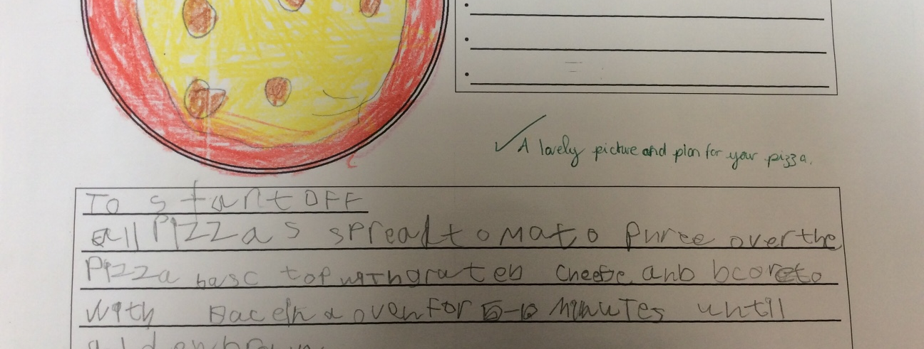

Conclusion
Our aims of this research project was to develop a consistent and meaningful approach to marking across the school. Through the action research in the Year Two classes it is felt that staff and children are beginning to use feedback more effectively. Children are becoming more involved in their own learning and through verbal feedback and importantly having time to improve their work and act on feedback given. From the work carried out so far we are beginning to see how to develop this throughout all the age groups in the school.
An important aspect that hasn’t been considered is that of feedback and its effect on self-esteem and motivation.
Through the project and action plan there was a set of outcomes that staff felt could be achieved from this work. These included improved attainment, greater pupil understanding of how to improve their work, an improved level of challenge and moving pupils forward in their learning as well as a greater understanding of feedback and assessment for learning. However the main outcome from developing marking and feedback was to have an effective marking policy that all staff understand and support to ensure consistency across the school to improve the learning experience of the children.

Recommendations

Marking and feedback needs to relate to the success criteria and learning outcomes.
More effective assessment for learning strategies need to be imbedded and to be developmental throughout the school.
Marking needs to happen with the children with time given to working on feedback
Challenge and showing understanding of a concept needs to be shown through feed forward tasks.
Develop the use of self and paired marking from Year Two to Year Six

References
Clarke, S. (2003) Enriching Feedback in the Primary Classroom. London, Hodder and Stoughton.
Hanson, A.(ed) (2012) Reflective Learning and Teaching in Primary Schools. London, Sage Publications
Hattie, J. (2012) Visual Learning for Teachers – Maximising Impact on Learning. Abbingdon, Routledge
Grigg, R. (2010) Becoming an Outstanding Primary School Teacher. Harlow, Pearson Education
Donaldson, G. (2015) Successful Futures, An Independent Review of Curriculum and Assessment Arrangements in Wales. Cardiff,
Young Wales,(2010), How to Develop Thinking and Assessment for Learning in the Classroom. Cardiff: Welsh Assembly Government
Bell, J. (2005) Doing your Research Project: A Guide for first time researchers in education, health and social science. Maidenhead, Open University Press
Black, P. and Wiliam, D. (1998) ‘Assessment and Classroom Learning’ Assessment in Education: Principles, Policy and Practice
Black, P. and Wiliam, D. (1998) Inside the Black Box: Raising Standards through Classroom Assessment
Black, P. and Wiliam, D. (2004) Working Inside the Black Box: Assessment for Learning in the Classroom
Hattie, J. and Timperley, H. (2007) ‘The Power of Feedback’ Review of Educational Research
Hattie, J. (2011) ‘Feedback in Schools’ Feedback: The Communication of praise, Criticism and Advice
Training: Coombes, G, (2017) High Quality Assessment for Learning, Working Smarter Not Harder
Professional Standards for Teaching and Leadership in Wales:
http://learning.gov.wales/docs/learningwales/publications/170901-professional-standards-for-teaching-and-leadership-en.pdf
BERA Guidelines:
https://www.bera.ac.uk/wp-content/uploads/2014/02/BERA-Ethical-Guidelines-2011.pdf

