

Course: BA (Hons) Business Management
Level 4 – Term 1 - Weekend
The Global Bussines Enviroment (LCBB4005)
Nadeem Mirza
Assignment – A2

Sandra Iulia Ghinescu
2118454

Table of Contents
Introduction 3
Impact of the pandemic on the automobile industry 3
The impact of Covid may continue for more than a couple of years 3
Impact of Covid on new as well as old car sales, aftersales and servicing 4
Survival as well as success factors for the industry 5
Conclusion 7
Reference List 9

Introduction
The following study will develop by focusing on the impacts of the pandemic on the UK automobile industry. A renowned British automobile brand named Rolls-Royce will be selected in the study to identify how the current pandemic has affected the business and operations of the respective brand. In the United Kingdom, the automobile industry has suffered more due to the outbreak of Covid-19. The pandemic has adversely affected the sales of new luxury cars due to the less disposable income of the people. Many manufacturing facilities have shut down their businesses completely due to huge losses. The study will identify and evaluate those impacts along with addressing several successes and survival for the industry in the post-pandemic world.

Impact of the pandemic on the automobile industry
The pandemic has affected the UK automobile industry adversely in terms of reducing sales, cutting jobs, financial crisis, additional expenses, and others. Some of the vital impacts of the pandemic on the automobile sector are as follows.
Sales reduction: Due to the pandemic, many people lost their jobs and their disposable income of people immensely reduced. In such a situation, people stopped spending on luxurious products, like luxurious and costly cars. Automobile brands that manufacture luxurious cars, like Rolls-Royce have experienced a reduction in their sales(Cengiz, et al., 2021).
An elaborate description of the above point would be useful to understand the impact in detail:

The impact of Covid may continue for more than a couple of years
Before the arrival of Covid, the automobile industry was continuing its marketing operations effectively in the country, providing the mobility sector with potential growth. The selling activities of the cars in the country reached 10.8 million units in the year 2017, and after that, there has been a significant drop in its numbers (Arribas-Ibar, et al., 2021). Due to the arrival of Covid in March 2020, the country experienced a 46 per cent down growth in car sales and a 97 per cent in April of the same year.it makes a huge impact on the economic activities of the country, resulting in the experience of economic instability prevailing throughout the country.
In April 2020 when the entire country was expecting a severe lockdown then it was the automotive sector that was the most affected compared to any other. In that month the new registration of care selling got disappeared and it was estimated that by September 2020, there was observed almost 33 per cent reduction in the selling of cars as compared to 2019 the same period (Boons et al., 2021). With time, several restrictions were minimized and subsequently reimposed depending on the situation, which resulted in the increasing uncertainty in the automobile sector, thereby making it more deplorable and pathetic for car sellers. The production of cars got reduced in the later month of the same year by 18.2 per cent due to which the automobile sector of the country needed the required clarity in terms of trading terms with other countries. Along with Covid, the Brexit issue also made an impact during that time which generated instability throughout the country (Lyons, 2021).
Due to the loss of jobs, many people did not have the power to buy cars whether it is expensive or inexpensive which turned out to be a negative aspect of the automobile industry. The government of the country was focusing on bringing innovation in transportation but due to the economic unrest, it did not have the scope to implement it effectively. At the same time, it tried to initiate several useful strategies meant to be beneficial for the automobile industry, for example introducing automation concepts along with using machine learning, Internet of Things, popularly known as IoT in vehicles which would be prolific for the car manufacturers of the country (Belhadi et al., 2021).

Impact of Covid on new as well as old car sales, aftersales and servicing
As per Mckinsey’s Global Automotive Consumer Survey held in May 2020, there was a considerable decrease in people willing to buy new or previously used cars in the UK. Almost two-thirds of the buyers who were thought to be potential in terms of money expressed that they wanted to delay a bit too, maybe half a year for things to get normalized, showing their health as well as economic concerns. According to the survey report, almost 27 per cent of people proposed that they are planning to invest less to purchase new cars. Only white-collar professionals looked to conserve their power of purchasing (Rosewell and Hargreaves, 2022).
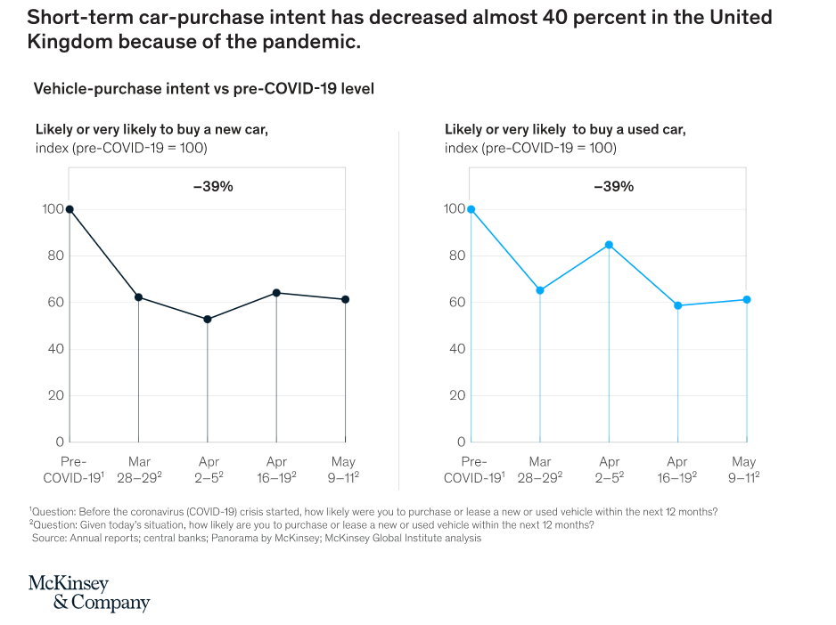
Figure 1: Graphical Representation of Mckinsey’s Global Automotive Consumer Survey
(Source: (Higham et al., 2021)
In fact, these workers tended to be remote work-oriented professionals who did not require private vehicles as much as others required. On the other hand, it might be the people working in hospitality or other relevant sectors, who require private transportation (Higham et al., 2021) However, the prevailing crisis of that time and the huge after-effects of that might pose problematic issues for them to buy their desired cars. In this way, there were observed changes in the needs and requirements of the people during the Covid period.
In that scenario, the best option for the car manufacturers of the UK or precisely for the automobile industry was to provide discounts on their cars for the people so that it should not become a heavy burden for them while purchasing. For example, in France, when the lockdown was over the automobile industry was very much willing to provide discounts to near about 30 per cent which created a temporary spike in the selling activities of the cars. However, if the buyer preserves low purchasing power then he or she might go for used cars from where also the automobile industry of the country could get the scope of making a little bit of profit, if not more. There is no doubt that the Covid had hit the automobile industry in a large way that it went beyond expectation in terms of generating revenue or continuing functional activities for the automobile industry.
It was expected that Covid would impact the after-sales along with servicing revenue of the cars starting from the second quarter of the 2020 year. From starting the period of lockdown and restrictions London experienced a 60 per cent decline in the usage of motor vehicles. However, there were cars that required servicing based on sufficient time and scope (Harrington and Hadjiconstantinou, 2022). Since the entire country was going through a phase of serious lockdown during the peak time of the Coronavirus pandemic many dwellers belonging to metropolitan cities showed reluctance in using public transport which once again proved to be a negative factor for the growth of the automobile industry in the country.
In the upcoming years, the aftermarket revenues belonging to the automobile industry are expected to be on the lower side. In fact, most of the dealers in the automobile sector closed their operations during the lockdown and pandemic period which also was a huge setback for the industry running its revenue on the negative side.

Survival as well as success factors for the industry
In this regard, it is high time for the automobile industry of the country to evaluate as well as analyze weekly success factors that would assist the industry to get back to its earlier phase of making profits like it was doing before Covid. Though it might take time to recover, it has to try to initiate several strategies by means of analyzing factors on a regular basis. Below are listed the success factors in detail:

Survival and Success Factors for Automobile Industry in the UK
Serial No | Factors | Description
1. | Market Positioning | The industry would require effective positioning in the market in terms of securing a competitive advantage. At the same time, market share spread in different segments of people would be helpful in manufacturing customer-specific products in the country (Buchanan and Wright, 2021). In this regard, it will be required for the industry to hold a strong market share which will be the key to the growth and success of the industry in determining the ability of the brands or products made by the manufacturers beginning the organization of the same automobile industry.
2. | Operational Management | It is true that covid has made the industry unstable in terms of operational activities. However, the industry leaders will need to make effective strategies related to business expansion and extension that would provide a healthy scope to flourish in its activities. At the same time, effective relationships with all its suppliers would strengthen the opportunity of generating loathsome profits, especially after the post-covid period (Vickerman, 2021). It would result in operational efficiency as well as flexibility based on which the automobile industry can secure a high revenue from its business operations in the future years effectively as well as efficiently.
3. | Providing Various Types Of Products | During the time of making products in the form of cars and other vehicles, the industry will require the use of effective technologies on a regular basis for the purpose of extracting smoothness in functional activities. Also, it would make an allowance for automobile manufacturers to produce a wide range of products depending on the needs and preferences of the customers (Nundy et al., 2021). Also, the pricing strategy needs to be affordable in the initial stage, especially after post covid time when the entire country is looking to come out of the devastating situation in every possible way.
4. | Conducting Market Analysis | It is one of the most important success factors for the automobile industry in the UK that would generate various opportunities to understand as well as realize what type of products the people present in the market do require from them. Along with this, the industry can take necessary business initiatives to proliferate its operational activities in the upcoming years (Higham et al., 2021). It will determine the growth in selling activities of the automobile industry thereby opening up several opportunities for business expansion.
5. | Fixing Strong Marketing As Well As Distribution Strategy | Network of marketing as well distribution would be vital for the Automobile industry in maintaining a smooth flow of operations. At the same time, it will prove to be beneficial for eminent car companies like Rolls Royce, Lamborghini, BMW, Audi, Benz etc to continue their production activities (Frederico et al., 2021). An extensive distribution network would look to offer geographic variety or diversity present in the country based on which the automobile industry could be able to form necessary business tactics to generate profits.

Table 1: Survival and Success Factors for Automobile Industry in the UK
The above-mentioned success factors considering the megatrends belonging to the automobile industry would not only provide stability but also flexibility in executing its marketing activities in an effective manner. At the same time, the industry will need to look after the changes in rules and regulations of the UK (if made by the government of the country) for carrying on its operational activities, thereby increasing its profitability.

Conclusion
It is concluded that the pandemic has strong adverse impacts on the UK automobile industry which has led many automobile brands to huge losses. Like any other company, Rolls-Royce has experienced worse losses than expected. The company has decided to cut a huge number of jobs to reduce their costs. Moreover, the company faced huge difficulties to manage the performance of their remote workers which led the company to additional expenses and even poor performance. The brand, therefore, needs to develop effective survival and success factors to recover its business condition and sales.

Reference List
Arribas-Ibar, M., Nylund, P.A. and Brem, A., (2021). The risk of dissolution of sustainable innovation ecosystems in times of crisis: the electric vehicle during the COVID-19 pandemic. Sustainability, 13(3), p.1319.
Belhadi, A., Kamble, S., Jabbour, C.J.C., Gunasekaran, A., Ndubisi, N.O. and Venkatesh, M., (2021). Manufacturing and service supply chain resilience to the COVID-19 outbreak: Lessons learned from the automobile and airline industries. Technological Forecasting and Social Change, 163, p.120447.
Boons, F., Doherty, B., Köhler, J., Papachristos, G. and Wells, P., (2021). Disrupting transitions: Qualitatively modelling the impact of Covid-19 on UK food and mobility provision. Environmental Innovation and Societal Transitions, 40, pp.1-19.
Buchanan, B.G. and Wright, D., (2021). The impact of machine learning on UK financial services. Oxford Review of Economic Policy, 37(3), pp.537-563.
Cengiz, K., Shanmuganathan, . V. & Nayak, J., (2021). An impact study of COVID‐19 on six different industries: Automobile, energy and power, agriculture, education, travel and tourism and consumer electronics. National Library of Medicine.
Frederico, G.F., Kumar, V. and Garza-Reyes, J.A., (2021). Impact of the strategic sourcing process on the supply chain response to the COVID-19 effects. Business Process Management Journal.
Harrington, D.M. and Hadjiconstantinou, M., (2022). Changes in commuting behaviours in response to the COVID-19 pandemic in the UK. Journal of transport & health, 24, p.101313.
Higham, J.E., Ramírez, C.A., Green, M.A. and Morse, A.P., (2021). UK COVID-19 lockdown: 100 days of air pollution reduction?. Air Quality, Atmosphere & Health, 14(3), pp.325-332.
Lyons, G., (2021). Reviewing transport in light of the pandemic. Transport Reviews, 41(6), pp.715-720.
Nundy, S., Ghosh, A., Mesloub, A., Albaqawy, G.A. and Alnaim, M.M., (2021). Impact of COVID-19 pandemic on socio-economic, energy-environment and transport sector globally and sustainable development goal (SDG). Journal of Cleaner Production, 312, p.127705.
Rosewell, B. and Hargreaves, J., (2022). UK infrastructure after Brexit. Oxford Review of Economic Policy, 38(1), pp.140-153.
Vickerman, R., (2021). Will Covid-19 put the public back on public transport? A UK perspective. Transport Policy, 103, pp.95-102.

