Jessica Crocker (2005510)

Public Perception On how religion and belief factor into shaping terrorist organsations and their operations.

Declaration

This work has not previously been accepted in substance for any degree and is not being concurrently submitted in candidature for any degree.

STATEMENT 1

This dissertation is being submitted in partial fulfilment of the requirements for the degree of BA/BSc.

STATEMENT 2

This dissertation is the result of my own independent work/investigation, except where otherwise stated.

Other sources are acknowledged in the reference section.

STATEMENT 3

I hereby give consent for my dissertation, if accepted, to be available for photocopying and for interlibrary loan, and for title and summary to be made available to outside organisations.

STATEMENT 4

I hereby give consent for my dissertation, if accepted, to be available on the university’s IT system to those who consent to use the system.

Student Name: Jessica Crocker

Acknowledgements
I want to express my gratitude to my family and friends for their support during this research. I would also like to mention Laura Knight who has offered her continuous support all throughout.

Abstract
The aim of this research is to research exiting literature to determine how religion is linked to terrorism and to determine how the general public perceives religion and belief in relation to how terrorist organisations are structured and function. Some of the findings from this research shows the likelihood is that religious organisations will commit more terrorist attacks than non-religious ones and religious ideology will have a considerable impact on how an organisation function.

Chapter One - Introduction
Researchers have long sought to understand the reasons behind terrorism. In order to combat terrorism effectively, we must first understand what its main trigger points consist of. Since the terrorist attack on the Twin Towers in New York September 11, 2001, incidences involving terrorism have received significantly greater attention. By causing violence, panic, and uncertainty across the globe, terrorism has an impact on many countries. The strong link among both religion and violence/terrorism poses the significant question of how religions, especially the Abrahamic religions, which are often regarded as holy institutions teaching about goodness, equality, and peace (Rieger, 2019), have struggled to place their own teachings into practise and, to some extent, have motivated actions that is at odds with them. The first questions that come to mind after a terrorist incident are who and why – who would commit such a crime and why would they want to do it? When religion enters the mix, the questions multiply. This is true whether the perpetrators are ISIS members who carried out the Paris attacks, supporters in the Syrian civil war, American Christians who bombed abortion clinics, or violent Israeli settlers (Juergensmeyer, 2017). There are many ways in which terrorist organisations differ from one another. Their political objectives' specifics as well as their ideology differ. Regarding religion and the organisations, they rely on for support, they have contrasting opinions. Their violent behaviour takes different turns over time. For instance, historically, most terrorist groups operated on a domestic level; a few groups started out locally and eventually spread over the world. But recent events suggest that local groups may be inspired by global conflicts to carry out terrorist activities (Richardson, 2013). Is there actually religious terrorism? Why does religion have a role in global terrorism? Does terrorism have a religious basis? The main discussion throughout this paper will be how religion and beliefs factor into shaping terrorist organisations and their operations. Focusing on engaging the public in Swansea to determine their perspective of whether they think that religion and beliefs have an impact on terrorist organisations.

Chapter Two – Literature Review
Investigate existing literature on the influence of religion on terrorism:
Some of the most significant findings from academic research in previous years include the fact that terrorists have a diversity of social backgrounds, go through several stages to become violent extremists, and are driven by a range of motivational pairings. This holds true for more recent manifestations of Islamist terrorism as well as right-wing, left-wing, and belief forms of these kind of violence acts that were previously observed in various European countries. For example, the bombers in London and Madrid varied in their country of birth, ethnic background, education levels and degree of assimilation within British and Spanish civilization, as well as their familial circumstances and criminal history. The very same holds true for anyone who has recently been convicted of offences related to Islamist terrorism in Europe. Additionally, there is a striking difference in the social characteristics of the mainly young male members of ETA as well as other comparable terrorist groups created in Europe during the 1960s and 1970s. In the public conversation which has followed September 11 in their respective fields, journalists, decision-makers, academic researchers, and observers have all vehemently disputed religion's place. However, the most important question whether religion is the cause of violence or only a willing collaborator is rarely settled. While some academics have claimed that terrorism is more frequently motivated by religious reasons (Berman and Laitin 2005; Hoffman 2003), others have disputed this claim (Bloom Militants and Martyrs / Sosis and Alcorta 3, 2005; Pape 2005). Do Ce'u Pinto (1999), argues that religious terrorists vary from those driven by ideologies because they are more inclined to sacrifice in order to accomplish their objectives. This idea of sacrifice, especially self-sacrifice, lies at the core of most, if not all, revolutionary ideologies. It is also a major role in the ideologies supported by individuals who choose to utilise violent extremism. Do Ce'u Pinto (1999), concludes that religious terrorists are more likely to engage in random violent acts. Religion is linked to the extreme brutality of these groups because of the framing that goes along with a particular religious worldview. As revolutionary socialist theorists have shown, framing the way in which groups explain their actions and complaints is an important component of a social movement (Benford and Snow, 2000).
Experts have noted that the theological architecture of violence by terrorist organisations is what causes the significant effects of religion. Even when motivated by political resentments, religious terrorist organisations factor in religious norms when calculating their chances of success. Religious organisations' specific terrorist actions are a form of expensive signalling that demonstrates allegiance to their principles (Bueno de Mesquita and Dickson, 2007). Although the group's ideology has an impact on the calculations, suicide bombs' religious underpinnings are not disregarded. It is not the intention of a suicide attack to commit suicide, but rather to massacre a large number of members of the targeted group in order to put pressure on the society's ruling body to change its customs. Terrorist groups frequently choose suicide terrorism because they have come to feel that such actions have the most coercive power in order to get a democratic state to remove its military assets from territory that the terrorists desire. There are two ways that a suicide attack could happen. Secondly, from an operational perspective, suicide attacks are more catastrophic since resulting in more fatalities per attack than other terrorist actions. In comparison to the ordinary terrorist attack, which claims the life of one person, the usual terrorist suicide attack claims the lives of 12 people. The second cause is that suicide terrorism signifies that more people, perhaps even many more, may follow if one individual or one group of individuals are willing to die for an assault. The terror is brought on by this second component (Suite, 2005).
Religious ideology will significantly affect how an organization operates because of the way it frames the world, regardless of the group's goals or organisational structure. This rules out organisational dynamics as a possible explanation for the apparent relevance of faith in terrorism violence, but it does not eliminate the significance of organisational factors or rivalry. This theory, which pertains to the region of the severity of terrorism violence by fusing it with research on social movement structure, supports and builds upon the studies on religion and violence that emphasise the significance of religious ideology. Even while it concurs with past research on religion's significant influence on terrorism, it contends that religion only acts as an ideologically driven proxy for disagreement when determining the level of violence committed by a party's attacks. It is proposed that framing attacks through a religious worldview may nevertheless result in serious violence even though individuals' intentions, practical concerns, and purposes may differ. As a result, religious organisations are far more likely than non-religious organisations to carry out more terrorist attacks; this effect cannot be attributed to group characteristics or structural causes.
To determine the focus of religious ideology, compare the literature on Islamic and Right-wing terrorism.
According to statistics, Islamic terrorism is to blame for most instances and the deadliest attacks around the world. In the top twenty most violent organisations since 2011, thirteen are Islamic (Oxon; Routledge 2016). Seventy-four percent of the fatalities brought on by terrorist activities in 2015 were caused by the Islamic State of Iraq and the Levant (ISIL), Boko Haram, The Taliban, and Al Qaeda. Despite having different political goals, they all exploit Islam to justify their extreme tactics (Institute for Economics and Peace, 2016). Two conflicting methods to date have been found so far to evaluate the origins of Islamic political violence. One viewpoint is that certain scholars have asserted that Islamic theology is the primary consequence of the radicalisation of Muslims, which in some extreme circumstances leads to their involvement in terrorist operations (University of California Press, 2003).
As a result, as more people listen to Islamist organisations discuss issues related to how to put Islamic teachings into practise, extremist attitudes about the use of violence and its support within Muslim communities will emerge (Paris, Gallimard, 2015). On the contrary, other researchers have argued that the rise of Islamic violence could be since radical people are converting to Islam in rising numbers as they look for an ideology that will support their perspective (Indiana University, 2004). The demands and goals of people who have become radicalised are outlined by Islamist organisations. Overall, neither interpretation has been strongly supported by the empirical data. Four significant figures who operate as the theoretical pillars of contemporary Islamist organisations are Hassan Al Banna and Sayyid Qutb in Egypt, Sayyid Maududi in Pakistan, and Ayatollah Khomeini in Iran (Cambridge, Belknap, 2003). While these four people had a variety of ideas, they all helped turn Islam into a religion of ideological warfare. Hassan el Banna, the leader of the Muslim Brotherhood, held that Islam was a fully democratic system of existence, and that the Quran was the only source of valid law for Muslims. Qutb, who criticised Western modernism and asserted that Muslim cultures were in a state of Godless oblivion, believed that Islam needed to be revived or recovered for itself. Qutb's influence can still be seen in organisations like Al Qaeda or the Islamic State. Studies show that the growth of extremist Muslim thinking is largely influenced by ideology. There is a correlation between the views and sermons of extreme religious groups and an increase in the justification of armed conflict and terrorist activities (Paris, Fondation Montaigne, 2018).
Right-wing ideology refers to the threat of "white genocide." Violence is used to deter immigration, scare potential adversaries, and, more broadly, to keep the white race aware of the threat it faces. The main objective is to start a racial war that ends in a country that is solely white or Aryan in order to correct the situation. Right-wing extremists may be more prone than other extremists to engage in political violence, according to research studies. Supporters of the right tend to be more ideological and narrow-minded than supporters of the left, as well as to have a larger desire for hierarchy, control, and intellectual coherence (H. Thórisdóttir, H. J. T. Jost, 2011). Since these characteristics have previously been shown to enhance in-group prejudice and generate a greater level of out-group animosity, conflict for a cause appears to be more likely among adherents of right-wing ideology (D. Webber et al, 2018). Right-wing authoritarianism (RWA; 13–15) has been studied from a variety of perspectives, and based on these methods, hostile qualities are a crucial part of this structural system, with those who score well on RWA being far more violent against others who break the rules than those who do not. This conclusion was corroborated by a recent meta-analysis that showed a link between right-wing ideology and unfavourable actions and behaviours (A. Van Hiel et al, 2020). Even while there are incidents of religious terrorism from all faiths, in recent years most of the scholarly and political attention has gone to Islamist terrorism (M. Mousseau, 2011). While religious motives for terrorist attacks have remained common in the past, their most recent incident is unique in that the religious element of the group has taken the initiative (B. Lincoln, 2010).
This is one of the main reasons for the surge in terrorism's severity during the past twenty years, according to various analysts (B. Hoffman, 2006). According to earlier beliefs, right-wing extremists and Islamist extremists may be more similar in their willingness to use violence. The main similarities between right-wing and Islamist extremism seem to be religious extremism, narrow-mindedness, dictatorship, and dogmatism. Consequently, one study characterised Islamist radical as "dedicated players" and highlighted the conservatism and narrow-mindedness of adherents (S. Atran, 2016).
Analyse how common perceived religiosity is between Islamic and Right-wing terror groups
Numerous studies suggest that the news media's recurrent linkages of Muslims and Islam with terrorism may contribute to the upkeep of negative perceptions about Muslims (Saleem et al. 2016, 2017; von Sikorski et al. 2017, 2018). Yet, less research has been conducted on how media coverage of terrorism that obscures the identity of the perpetrator influences how Muslims are perceived by the general public. News organisations often withhold information on the perpetrator in the early phases of a terrorist incident since official authorities are yet to confirm any specifics about the attacker's nation, religion, or motives. A basic reaction to terrorism information is likely to conjure images of a certain group of criminals who have frequently been featured in the media such as Islamist terrorists. This is brought on by the overwhelming number of criminals who self-identify as Muslims (Dixon and Williams 2015). (1997; Dixon 2007; Price and Tewksbury). Because terrorism is frequently associated with the Muslim faith, assaults towards Muslims have escalated in the U.S. and Europe as retaliation (The Guardian 2017). The 2017 massacre at the Quebec Mosque, that resulted in the deaths of six Muslims and the injuries of 19 others, is one example of a terrorist attack that was expressly directed against Muslims. In addition, a van attacked crowds just outside mosque in London, causing various injuries and one death. Witnesses said they overheard the driver remark, "I want to kill all Muslims" (The Independent 2017).
1.a. Studies regarding religiosity and extremist Islam:
Is religiosity a risk factor for radicalization? This question is debated particularly regarding Islamist extremism. The empirical evidence is incongruous. Aslan, Akklç, and Hämmerle (Wiesbaden: Springer VS; 2018), validated the idea that Islamic religion was one of the factors leading people to become Islamist extremists in a qualitative research study conducted between prisoners. Additionally, Beller and Kröger (Psychology of Religion and Spirituality, 2017; 10, 345–355) observed that increased backing for extreme violence was associated with more regular religious practise such as visiting mosques. Nevertheless, the findings indicated increased personal religious importance reduces acceptance for extreme viewpoints. The fact that radicals occasionally lack religious knowledge or are converts who haven't been subjected to Islamic religious culture should also be kept in mind (Freiburg: Herder; 2014). People may not be acquainted with Islam despite this, but they might still be highly devoted. The findings imply that different linkages among Islamism and Islamist extremism may differ on the way in which religion is practised. Furthermore, one could argue that Islamic religiosity appears to not be a particularly effective barrier to Islamist extremism (Freiburg: Herder; 2014).
1.b Findings on religiosity and right-wing terrorism
Since it arises from a clash of civilizations that, in the view of the Islamic movement, cannot coexist, Islamist terrorism is one of the deadliest forms of terrorism in recent years to the civilizations, values, and everyday lives of countries (Bakker, 2006). A recent analysis of terror activity records, however, suggests a different pattern. According to the Global Terrorism Database, Jihadi-Islamic ideology has not been a factor in the bulk of terror-related homicides that have occurred in the US since the 9/11 attacks but rather hate crimes and mass killings. As of February 2020, it is generally accepted that right-wing violence, rather than al-Qaeda or ISIS, represents the biggest danger facing the United States. Similar instances have occurred in the UK, where the British police announced in September 2019 that they were committed to battling right-wing terrorism, that has surfaced as the country's largest terror threat (Macfarquhar, 2020). Domestic terrorism actions and hate crimes are similar in that the assailants in both cases select the because of their racial, national, religious, sexual, and/or gender identities. These could be seen as irrational actions of street crime committed against defenceless people for the sheer thrill of scaring others. Most of these violent acts lack a distinct ideology, and they occasionally have a general racial or nationalist motivation. because right-wing violence receives significantly less media attention than Islamic terrorism, the issue is not widely known. There isn't an accepted definition of right-wing terrorism; it is an ill-defined concept. Due to its worldwide branching, right-wing terrorism has grown to be a concern on a worldwide scale, yet only Islamic terrorism is largely considered international terrorism. In recent years, right-wing parties and extreme-right organisations have grown increasingly outspoken about their hostility to Islam. In place of overtly racist, biological reasons, far-right organisations increasingly refer to Islam using theological nativism (Froio, 2018). Labelled as "Muslims," these individuals are perceived as a threat to democratic principles since they are thought to generally reflect Muslim backgrounds or viewpoints. Terrorists, extremists, populists, and conspiracy theorists on the right are concerned about an "Islamic takeover" of Europe, sometimes known as "Eurabia" or "the great replacement."

Chapter Three – Methodology
3.1 Introduction
Research is a method of study that entails acquiring new knowledge in a systematic way (Walliman and Walliman, 2011, p.7). An in-depth description of the research techniques, approaches, and styles used throughout the study is provided in the research methodology section of the research. It also explains the advantages and disadvantages of every strategy and design, keeping in mind how they might be applied in actual research, and justifies the choices made. O'Leary, (2004, p. 85) claims that methodology relates to the structure that will be employed to conduct research and is associated to a particular set of paradigmatic premises. A research method should correspond to the following two requirements, says Allan and Randy (2005). The strategy should, first and foremost, be ideal for attaining the objectives of the research. Second, the method used in a comparable study should be repeatable.
3.2 Research Onion
Depending on the goal of the study, the research onion design can be used to build a range of research techniques. The "Research Method for Business Students" book by Saunders et al. (2007) designed and describes the research onion. The model is composed of numerous layers that are organised in a manner reminiscent of an onion's layers. The Saunders Research Onion is among the most frequently used models in academia. While drafting the "methodology" chapter, researchers frequently use this strategy.
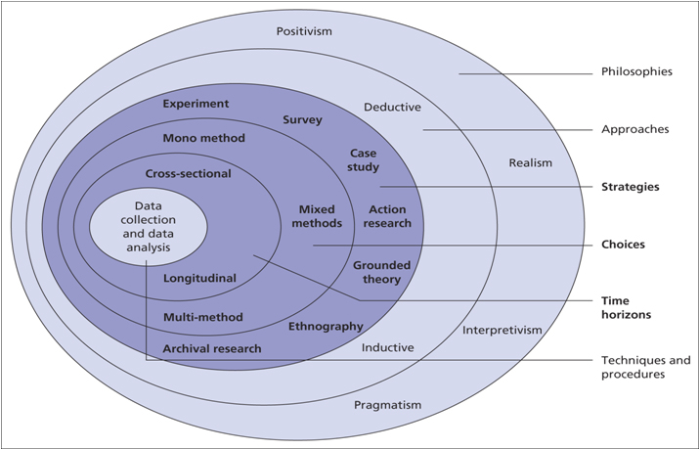
3.2.1 Philosophy
Interpretivism is useful in fields of study like sociology, which frequently include a wide range of unclear territory. Analysing data won't help you understand another person's motives or actions. Rather, it demands a careful examination of one's actions, comments, and attitudes. An interpretive investigator has an interest in people's perceptions of events and actions along with the processes they choose to do so (Stainton, D. H; 2003). A researcher who uses an interpretive approach also thinks that reality and the observer are equal. This is relevant because everyone’s worldview is shaped by their set of life experiences. For that reason, throughout this research interpretivism will be used since it is necessary to comprehend a certain context in order to correctly interpret the information gathered (Alharahshel & Pius, 2020; Bhattacherjee, 2012).
3.2.2 Research Approach
The inductive method, sometimes referred to as inductive reasoning, begins with observations, and conceptions are then put forth as a result of the research's conclusions (Goddard, W. & Melville, S. 2004). Employing a series of hypotheses, inductive research "requires the search for collecting facts and the construction of reasons - concepts - for those patterns" (Bernard, H.R. 2011). An inductive approach will be used throughout this study as it will allow for an approach that aims to produce interpretations from obtained data in order to identify patterns and correlations and create a hypothesis.
3.2.3 Strategies
A "research strategy" is a comprehensive action plan that guides the study's thought process. It makes it possible for individuals to finish their research in a structured and efficient manner (Walia and Chetty, 2020). This section's main objective is to introduce the study's essential components, including the study's topic matter, area of significance, focus, design, and research methodology. With the use of a research plan, a researcher can decide on the optimal data collection and analysis technique. So, it is essential to use the right strategy when conducting the research. A survey was chosen as the preferred strategy as it allows for the opportunity for both open and closed questions and allows for the gaging of public opinion.
3.2.4 Choice of Methods
The preferred choice of method when producing the survey was a mixed method approach. The advantages of both quantitative and qualitative research are combined, as are the advantages of each discipline, using mixed-method techniques. ‘’Studies that use both qualitative and quantitative methodologies at different stages of the research process and adhere to the pragmatic paradigm’’ (Tashakkori & Teddlie, 2008, p.22).
3.2.5 Time Horizon
In cross-sectional studies, a variable is described rather than measured. They can be helpful for providing a summary of a population or for capturing a picture of a group of people at a certain period. Cross-sectional studies are distinctive since they enable researchers to examine a wide range of features simultaneously (Simkus, 2023). Due to the research being an academic piece work, there wasn’t enough time to be able to collect data over a longer period. Therefore, a cross-sectional approach was taken, which allowed for data to be collected at one point in time.
3.3 Techniques for data correction, processes and analysis
Primary data is information that was created at the outset by the researcher using their own labour and experiences only for the goal of addressing their research topic. commonly referred to as first-hand information or original data. Since the institution or agency carrying out the research must spend in resources like money and labour, acquiring primary data has a relatively high cost. The investigator is in full control and charge of the data collection (Surbhi, 2016). The information can be gathered through a variety of techniques, including surveys, in-person and telephone consultations, group conversations, case studies, physical observations, and surveys completed and submitted by iterators. To gather the primary data required for this study, a survey was created and sent out to the general public. This was the preferred method as it was the most cost effective and was the most practical method within the required time frame for this study.
Information that has already been obtained and recorded by researchers for objectives that aren't now being considered is known as secondary data. Data that has been generated from a range of sources, such as published sources, surveys, internal organizational data, textbooks, published papers, websites, and reports, can be used to create information (BYJU, 2019). This method of data collection is accessible, affordable, and time and cost-effective. The sole negative is that the information may not be trustworthy or suit the present research goal because it was acquired for a different purpose. The secondary data that was collected throughout this research was produced through the literature review. The objectives necessary to finish the research served as the foundation for the literature review in this study.
3.4 Sampling
The process of sampling allows researchers to look at a smaller subset or sample of a larger population of prospective respondents and use the findings to draw inferences regarding the population in its entirety. The external validity of a study design can be determined by how well its results can be generalised or adapted to a wider population or group. The procedure for selecting a sample must be part of a strong study design. One needs to be quite familiar with the fundamentals of sampling design in order to produce research that has strong external validity (Fritz and Morgan, 2010). Theoretically, an accurate sampling procedure will produce samples that is reliable and without prejudice. A random probability sample was used by promoting the survey online to willing participants using such platforms as forums and social media.
3.5 Survey Design
Survey research is described as "the process of gathering data directly from a sample of respondents to questions" (Check & Schutt, 2012, p. 160). To find participants, gather data, and carry out the study in this type of research, various procedures might be used. The approaches employed in a survey study could be quantitative, including employing statistically scored survey items, qualitative, such applying open-ended questioning, or a mix of both for example using the mixed method approach. Due to the frequent use of surveys to characterise and analyse human behaviour in social and cognitive research, surveys are widely employed in these fields (Singleton & Straits, 2009). It was decided that a survey would be the best method to use. To be able to gather the necessary data for the research, a mixed method approach was adopted for the survey design.
3.6 Reliability and Validity
The term reliability is used to define the accuracy of the result. Reliability demonstrates how dependable a test result is. If employing various processes and sample groups, the offered data consistently delivers consistent results, the information is credible. Results will be trustworthy if the method is ethical (Troy, 2020). Validity describes how accurate a measurement is. Validity explains how a specific test is suitable in a specific situation. If the results support the researcher's hypotheses, arguments, and predictions, the study is valid. If the test method is precise, the results will be accurate. If a method can be trusted, it is valid. Yet if a method is unreliable, it is invalid. Respondents are more likely to address difficult topics and offer more thorough and frank feedback when a survey is anonymous. For this reason, the survey was completed anonymously by participants.
3.7 Limitations and Potential Hurdles
Research limitations and restrictions both refer to "limits" within a study, which is how they are comparable to one another. But they stand out as distinctive. Based on the practical or theoretical restrictions encountered, limitations highlight the research's shortcomings. Such factors could include things like availability of time, money, equipment, data, or involvement. (Jansen, 2020). One of the challenges this study has faced in its research is the execution of the study methodology due to the absence of extensive experience in primary data collecting. The sample size of the data obtained has also been acknowledged as a drawback. The study might have produced more results if it had used a larger sample.
3.8 Ethical Considerations
Ethical guidelines for research are a collection of guidelines that guide study techniques and hypotheses. Research ethics are essential for the morality of study, consideration for human rights and dignity, also collaboration between science and society. These principles ensure that study participants' participation is voluntary, informed, and secure (Bhandari, 2021). The reliability of the study is diminished if research procedures are morally questionable because individuals find it difficult to believe the findings. In order to determine whether this research would adhere to the necessary ethical standards, an ethics form had to be completed and returned prior to the study's start.
Chapter Four – Data Analysis
4.1 Introduction
Even if there are many different groups, organisations, and experts who approach data analysis, most of them may be summed up in one broad definition. In order to gain relevant, valuable information, data analysis is the act of changing, analysing, and filtering raw data (Kelley, 2020). The process provides valuable information and insights that reduce the risks involved in making decisions. These insights and statistics are usually displayed in charts, pictures, tables, and graphs. The task of a researcher includes a sizable amount of data sorting. This is what "research" entails, to put it simply. The relentless onslaught of data generated by the knowledge economy might easily overwhelm even the most diligent researcher. Analysing data plays a critical role in refining this data to make it more relevant and exact, facilitating the work of researchers, enables scholars to access a wide range of various methodologies, such as descriptive statistics, inferential analysis, and quantitative analysis and provides better data for academics to explore, as well as better methods for analysing that data.
4.2 Description
Question: ‘’ What gender do you identify yourself as?’’
The responses to this question were 26.1% identified as male, and 71.7% identified themselves as female. From these results, it’s evident the predominant gender from the sample was female. The male and female brains are very different from one another in terms of their anatomical, chemical, hormonal, and physiological makeup. It shouldn't come as a surprise that survey findings from men and women differ when compared because these discrepancies result in fundamentally distinct approaches to thinking, experiencing, and acting.
Question: ‘’ What age bracket do you fall under?’’
The data analysis revealed that participants between the ages of 25 and 34 accounted for 58.7% of all responses. Those who share the same generational background and were born within the same decade typically share characteristics and worldviews.
Question: ‘’Do you consider yourself to follow a religion?’’
39 out of the 47 respondents, or 84.8%, said that they did not practise any religion. The significant percentage of nonreligious respondents may have influenced how respondents perceived the connection between religion and terrorism. They could find it challenging to understand how someone decides to live out their religious beliefs and advance their religious views from a different angle. Through this response, it is possible to obtain understanding of the religious influences on the respondents' choices.
Question: ‘’ What is your ethnicity?’’
87% of the respondents indicated that they were white British, followed by 4.3% who were black or African Americans, 2.2% who were Asian, and 6.5% who identified their ethnicity as "other."
Question: ‘’Do you think religion is linked to the creation of terrorist organisations and why?’’
Some of the responses received were:
‘’ Not always, but in many cases, it is directly linked. Often terrorist believe that their religion allows /commands them to violence, to achieve religious glory. They are often under the impression that they will be rewarded in the afterlife’’
‘’ To an extent. I think a lot of terrorist organisations use religion to hide the real reasons behind what they do.’’
‘’ Yes, difference of opinion and people not agreeing as different 'gods' have different values’’
‘’Yes, due to bias cultural values which fail accept and tolerate the diversity of humanity.’’
‘’Most of the known terrorist organisations are built around religion, but I don't think it is the only reason because some acts of terror are caused by nonreligious groups. The media instead just shows these as extreme acts and does not refer to them as terrorism. Therefore, I think it can be linked but not always’’
‘’Yes, if there weren’t religions there wouldn’t be extremists’’
There were many detailed answers given in response to this topic, and they were met with mixed reviews. A relatively tiny percentage of the replies did not think that religion and politics were related, leaving a broad range of opinions that all concurred on this point. Different people's perspectives on the reasons they thought religion and terrorism were related were expressed in several of these responses. Many believe that terrorists' use of religion as justification for pursuing their extreme ideologies and for upholding a biased cultural standard that does not accept racial diversity. Some say that terrorists believe they must do violent acts in order to earn religious glory, because they are commanded to do so by their ideology. They will then be rewarded in the afterlife as a result of their violent acts against humanity. The view that religion is used by certain people to incite violence and push their beliefs on others was prevalent in several of the comments.
Question: ‘’ In your opinion, what is the main motive behind committing acts of terrorism?’’
The responses to this question were:
‘’ Truly believe it's what they were out on this earth to do to make it a "better place" they believe that God wants them to complete these acts of terror’’
‘’ Glory for their religion /identity’’
‘’The feeling of being unjustly treated, sense of community for isolated individuals and the perception that these acts are somehow aligned to a greater purpose/religious motivation.’’
‘’Money, ideological views and race’’
‘’ Brainwashed into believing something’’
‘’ They believe they are doing it for their God but that is an extremist view and not what their religion really teaches’’
The responses varied, but the majority had some characteristics. Several of the responses held the notion that the primary motivation for a terrorist act was religious. That by using violence to honour and carry out the will of their god, terrorists want to elevate their faith. The violence committed in these acts may be interpreted as a means of demonstrating a dominant, stronger, and more powerful god than other religions. That these actions in some way serve a higher good or stem from a religious impulse from their religious beliefs. Another prominent comment that was received is that terrorism is also primarily motivated by a desire for power. When advertising their identity, power could be perceived as a strong image. Power brings control. One could claim that terrorists need to feel in control in order to manipulate other people's opinions into accepting their ideology and beliefs. This, together with the overall responses given, suggest that the predominate belief on the motivations behind a terrorist attack would be for the need for power and control, and are acting upon what they believe to be their gods commands.
Question: ‘’ Do you think the media portrays a more negative image of Islamist terrorists compared to other well-known terrorist groups?
When asked whether the media presents Islamist terrorism in a more unfavourable light, 76.1% of the sample agreed with the statement.
Question: ‘’ Which kind of terrorism, in your opinion, poses the greatest danger to the UK? Please choose one.’’
After analysing the sample data gathered, it was discovered that 44.4% of the respondents believed that Islamist terrorism posed the greatest threat to the United Kingdom. The large number of respondents who concurred with the previous question's finding that media portrayals of Islamist terrorism are more unfavourable may influence the responses received for this question.
Question: ‘’ What do you think makes a terrorist?
Responses to this question were:
‘’A person/organisation which aims to inflict pain/suffering/oppression on individuals of a different perspective to that of their own.’’
‘’ Someone with extreme religious or political views that supersede general morals and values.’’
‘’ Someone that is isolated to their community besides those who share their extremist views with plans to commit a violent crime.’’
‘’ Killing innocent people in a suicidal manner. And having a belief of religion behind it. And mind control from leaders. And foreign people. And lastly where people think it’s bringing greatness to themselves and people within their circle of follows’’
‘’ Wanting to kill someone for not sharing their beliefs.’’

‘’ Any person from any religion who ideology and beliefs are inflicting pain,
suffering and death for a ‘god’. Or because they believe that is the only way they
can garner attention for what opinions they want to put across’’

Upon reviewing the comments that were submitted in response to this question, it became clear that the primary themes for the public's perception of what constitutes terrorism revolve around the desire to inflict suffering on people who hold different religious and philosophical beliefs than they do. Who wish to impose their extremist ideologies upon the public to manipulate and control. Also, it was said that a terrorist is someone whose mindset has been so manipulated by their religion and extreme beliefs, that they would kill themselves to carry out their god's demands to bring greatness and recognition to their religion.

Question: ‘’ How much influence do you feel that beliefs have in motivating the way terrorist organisations operate? ‘’
Participants were tasked with choosing a number between one and ten to represent the degree to which they believe beliefs have an influence on terrorist organisations and how they operate. The highest percentage of the sample, or 31.1 percent, selected the highest number on the scale, which ranged from 1 to 10, with 10 being the highest.
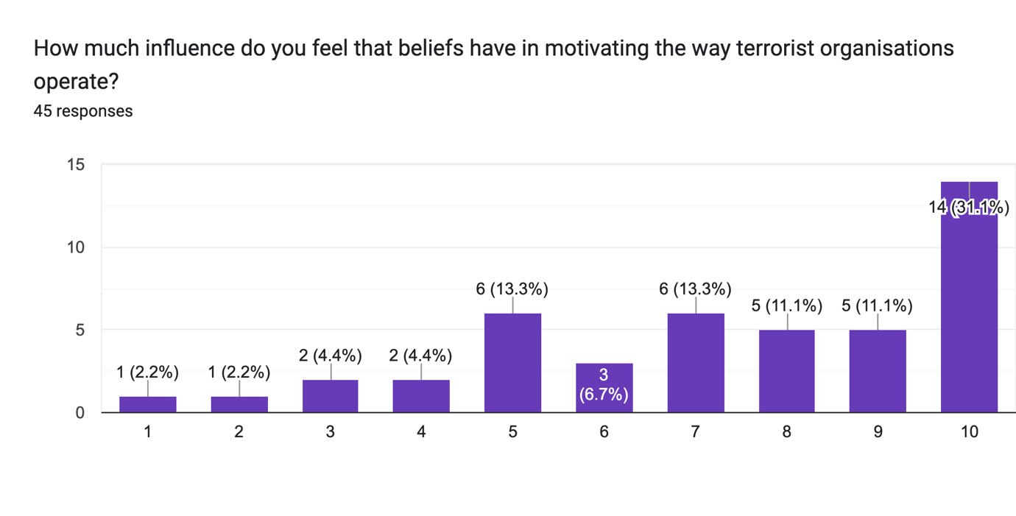
4.3 Synthesis
The role of religion in terrorism has been widely debated in the past and is still a current controversy. When comparing the primary data to the secondary data for analysis, similar characteristics can be found in both sets of data. There is a shared belief between both sets of data that religion is linked to extreme brutalities within terrorists’ groups because of the framing that goes along with a particular religious worldview, and that terrorist organisations are in fact built around religion and religious ideologies. The same idea that terrorist attacks are a means of signalling one's ideas and religion to people who do not share those values was shared by both sets of data. It was seen as a way for them to honour their god, while also demonstrating their devotion to the religious principles they uphold.
When comparing the severity of terrorism violence with other research from the primary data, it emphasises on the significance of religious ideology. Although the primary data does argue that religion merely serves as a motivated belief that allows for disagreement and conflict. The deadliest attacks worldwide, according to the primary statistics, were carried out by Islamist terrorists. Thirteen of the top twenty deadliest organisations are Islamic. This is consistent with the secondary data in which respondents indicated that they thought Islamist terrorism posed the greatest threat to the Kingdom. Both data shared resemblance as to how religious terrorist organisations are far more prepared to inflict harm on individuals and carry out terrorist/suicide attacks compared to non-religious organisations. Responses from the secondary data stated that if there was no such thing as religion, there wouldn’t be any extremists. Research based on primary sources demonstrates that one of the primary influences on people's decision to become Islamist extremists was their religious affiliation with Islam. Also, it was shown that such extreme violence was more frequently related to acts of religion, such as visiting mosques.
Both sets of data, when examined to determine whether Islamist terrorism is perceived more negatively in the media than other organisations, concurred that this was the case. According to research based on primary data, media coverage of Islamist terrorism is more prevalent than that of other organisations, which may help explain why there is a more negative perception of Muslims by the wider public. This relates to the survey result that was obtained from the secondary data, which revealed that a significant number of participants thought that Islamic terrorism was portrayed in a more unfavourable light. Attacks on Muslims may have increased as a result of the rising stigma associated with Islamic terrorism, which is possibly related to the fact that the media and news sources frequently associate terrorism with Islam.
Conclusion
The purpose of this study was to determine how the general public view the role that religion and beliefs play in terrorism and terrorist organisations.
The following were the main inquiries for this study:
- Investigate existing literature on the influence of religion on terrorism:
- To determine the focus of religious ideology, compare the literature on Islamic and Right-wing terrorism.
- Analyse how common perceived religiosity is between Islamic and Right-wing terror groups

One might get the conclusion that religion and belief are thought to play a role in the organisation of terrorist organisations based on a mixed method analysis and the examination of recent studies. The findings suggest that carrying out terrorist attacks is seen as a way of making one's beliefs and religion known to others who do not share them. It was also considered as a way for them to honour their god and show their adherence to the religious principles they follow. According to this study, religious organisations are more prone than non-religious organisations to carry out violent acts in the name of their religion. This suggests that religion does, in fact, play a significant role in why terrorists behave the way they do. It also demonstrates that the vast majority of respondents from the data sample gathered concur that terrorist organisations are based on religious and philosophical principles.
The research conducted for objective two revealed that religious extremism, narrow-mindedness and despotism appear to be the key commonalities among right-wing and Islamist extremism. Ideology has a significant impact on the development of extremist Muslim thought, and studies suggest that right-wing extremists may be more likely than that of other extremists to participate in political brutality. In addition to having a stronger need for authority, power, and cognitive coherence than followers of Islamist terrorism, right-wing followers frequently exhibit more ideological commitment and narrow-mindedness. According to this study's findings, right-wing and Islamic extremists may be more comparable in that they are both eager to use violence as a tool for political change.
In the research conducted for Objective three, Islamic religiosity was recognized as one of the factors influencing people to become Islamist radicals. It also found a connection between people engaging in religious activities, such attending mosques, and a rise in support for such extreme religiosity. When comparing this to the findings for religiosity within right-wing terrorism it was found that Right-wing terrorists often have a broad racial or nationalist motivation, but most of their violent acts lack a clear ideology. The problem is not well known since media coverage of right-wing violence is much less than that of Islamic terrorism.
Limitations
The data sample that was gathered is one of the restrictions that this study has identified. Despite the survey receiving a relatively good number of responses, a larger sample of data should be collected in the future. A bigger sample size would enable a better study of the findings. The lack of competence in creating questionnaires and gathering data samples was another drawback encountered during this study. The opportunity to acquire the best samples may have been slightly restricted due to lack of familiarity with these. This might have been because of a lack of knowledge of the platforms to use to market the survey for the best replies, or it might have been due to inexperience in developing survey questions that would effectively gather the data required to complement the research being done. It was discovered that another restriction was the amount of time necessary for this piece of research. Since this research was done for academic purposes, a schedule and a submission deadline were necessary.
Recommendations
For future use, recommendations are made in light of the limitations indicated that were experienced during this investigation. The first piece of advice would be to publicise the survey across multiple social media sites and find out which ones are known to increase survey answers. As a result, a larger sample of data can be acquired because more willing participants will be attracted to the survey. Gaining more expertise in survey design and enabling competitive questions about the research being conducted would be the second recommendation from this individual research. This may be achieved by ensuring that further reading from reliable sources would lead to a clearer grasp of the subject at hand. This would lead to the creation of better questions, which would broaden the understanding of the subject and would allow for a wider range of answers. Time management is yet another suggestion that is necessary for the future, gaining knowledge of effective time management and setting priorities. By doing so, it will be possible to meet the deadlines for each phase of the project and receive feedback before submitting.

Appendix
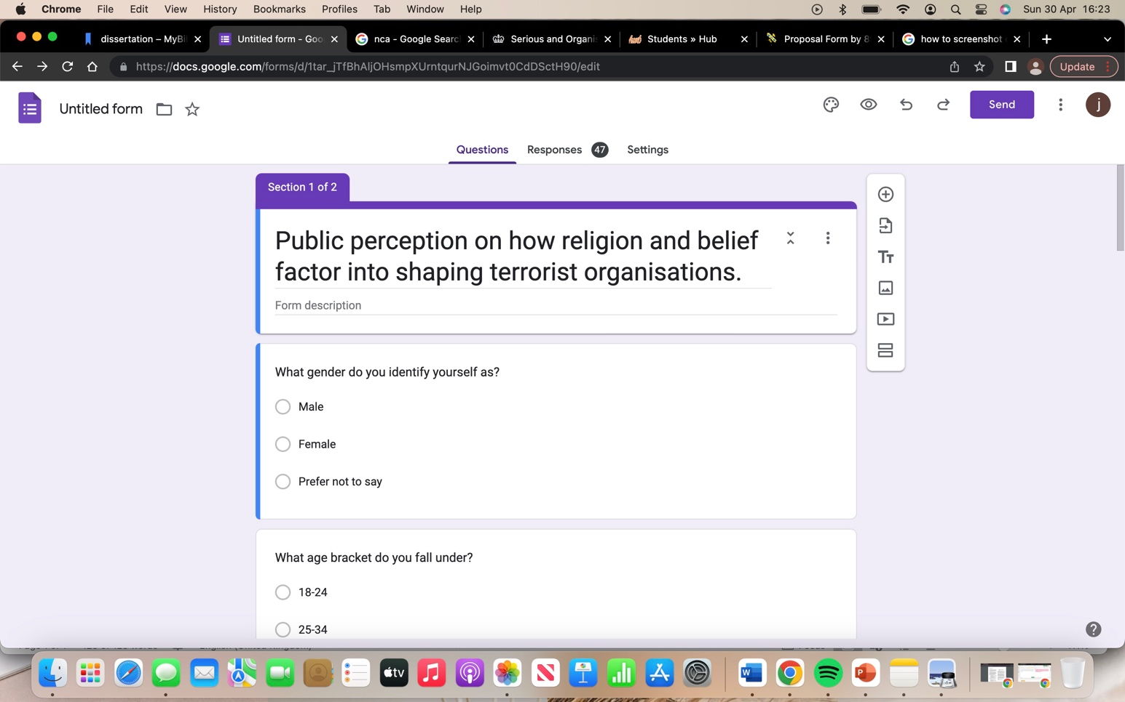

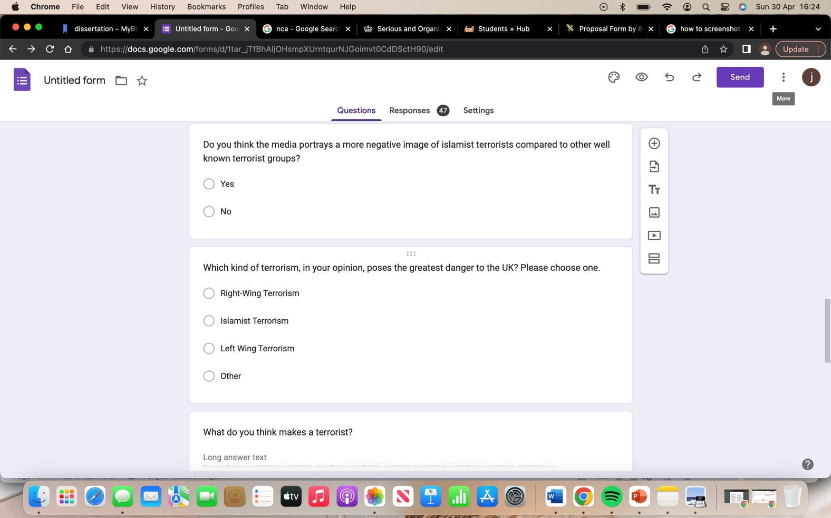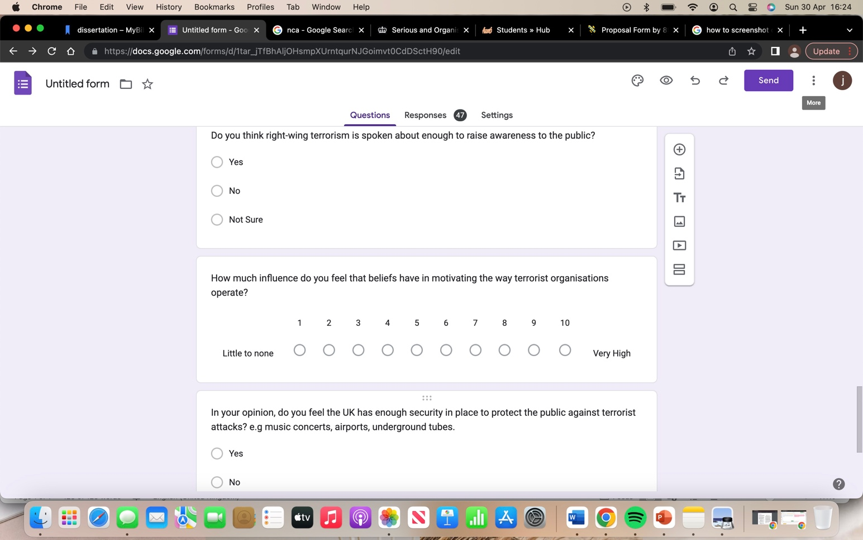

Reference list
Alamgeer, Z. (2022). Understanding Research Onion for Research Methodology. [online] The Innovidea. Available at: https://theinnovidea.com/understanding-research-onion-for-research-methodology/ [Accessed 8 Apr. 2023].
AllAssignmentHelpUK (2017). Research Onion - Made easy to understand and follow. [online] Allassignmenthelp.co.uk. Available at: https://www.allassignmenthelp.co.uk/blog/research-onion-made-easy-to-understand-and-follow/ [Accessed 8 Apr. 2023].
Auger, V.A. (2020). Right-Wing Terror: A Fifth Global Wave? Perspectives on Terrorism, [online] 14(3), pp.87–97. doi:https://doi.org/10.2307/26918302.
Badey, T.J. (2002). The Role of Religion in International Terrorism. Sociological Focus, 35(1), pp.81–86. doi:https://doi.org/10.1080/00380237.2002.10571222.
Bhandari, P. (2021). A guide to ethical considerations in research. [online] Scribbr. Available at: https://www.scribbr.com/methodology/research-ethics/#:~:text=considerations%20in%20research%3F- [Accessed 18 Apr. 2023].
Bhat, A. (2019). 22 Religion Survey Questions for Questionnaires. [online] QuestionPro. Available at: https://www.questionpro.com/blog/religion-survey-questions/#:~:text=What%20religious%20family%20do%20you [Accessed 24 Apr. 2023].
Business Research Methodology (2011). methodology - Research -Methodology. [online] Research-Methodology. Available at: https://research-methodology.net/research-methodology/ [Accessed 28 Mar. 2023].
Business Research Methodology (2019). Research limitations - research-methodology. [online] Research-Methodology. Available at: https://research-methodology.net/research-methods/research-limitations/ [Accessed 19 Apr. 2023].
BYJU'S (2019). Top 6 Difference Between Primary Data And Secondary Data. [online] BYJUS. Available at: https://byjus.com/commerce/difference-between-primary-data-and-secondary-data/ [Accessed 14 Apr. 2023].
Cleave, P. (2021). The Benefits of Anonymous Surveys. [online] SmartSurvey. Available at: https://www.smartsurvey.co.uk/blog/the-benefits-of-anonymous-surveys [Accessed 27 Apr. 2023].
Dudovskiy, J. (2011). Inductive Approach (Inductive Reasoning) . [online] Business Research Methodology. Available at: https://research-methodology.net/research-methodology/research-approach/inductive-approach-2/ [Accessed 12 Apr. 2023].
E. Fritz, A. and A. Morgan, G. (2010). SAGE Research Methods - Encyclopedia of Research Design. [online] methods.sagepub.com. Available at: https://methods.sagepub.com/reference/encyc-of-research-design/n398.xml#:~:text=Sampling%20occurs%20when%20researchers%20examine [Accessed 15 Apr. 2023].
Egger, C. and Magni-Berton, R. (2019). The Role of Islamist Ideology in Shaping Muslims Believers’ Attitudes toward Terrorism: Evidence from Europe. Studies in Conflict & Terrorism, 44(7), pp.1–24. doi:https://doi.org/10.1080/1057610x.2019.1571696.
European Commission's Expert Group on Violent Radicalisation (2008). Radicalisation Processes Leading to Acts of Terrorism A concise Report prepared by the European Commission’s Expert Group on Violent Radicalisation. [online] Available at: https://www.clingendael.org/sites/default/files/pdfs/20080500_cscp_report_vries.pdf [Accessed 22 Feb. 2023].
H, R. (2020). Far Right Terrorism Similarities and Differences vs. Islamic Terrorism. [online] www.ict.org.il. Available at: https://www.ict.org.il/images/Far%20Right%20Eng.pdf [Accessed 25 Feb. 2023].
Jansen, D. (2020). What Is A Cross-Sectional Study? A Simple Definition. [online] Grad Coach. Available at: https://gradcoach.com/what-is-a-cross-sectional-study-research/ [Accessed 13 Apr. 2023].
Jansen, D. (2022). Research Limitations vs Research Delimitations. [online] Grad Coach. Available at: https://gradcoach.com/research-limitations-vs-delimitations/#:~:text=Limitations%20reflect%20the%20shortcomings%20of%20your%20study%2C%20based%20on%20practical [Accessed 19 Apr. 2023].
Jasko, K., LaFree, G., Piazza, J. and Becker, M.H. (2022). A comparison of political violence by left-wing, right-wing, and Islamist extremists in the United States and the world. Proceedings of the National Academy of Sciences, 119(30). doi:https://doi.org/10.1073/pnas.2122593119.
Josephine (2019). Saunders research onion for effective research methodoloy. [online] allassignmenthelp. Available at: https://www.allassignmenthelp.co.uk/blog/saunders-research-onion/ [Accessed 8 Apr. 2023].
Juergensmeyer, M. (2004). Is Religion the Problem? escholarship.org, [online] Volume 6(Issue 1). Available at: https://escholarship.org/uc/item/4n92c45q [Accessed 24 Jan. 2023].
Juergensmeyer, M. (2017). Does Religion Cause Terrorism? [online] Cambridge University Press. Available at: https://www.cambridge.org/core/books/abs/cambridge-companion-to-religion-and-terrorism/does-religion-cause-terrorism/66647499C9CEDCE3044230DDB89702E4 [Accessed 27 Apr. 2023].
Kamenowski, M., Manzoni, P., Haymoz, S., Isenhardt, A., Jacot, C. and Baier, D. (2021). Religion as an influencing factor of right-wing, left-wing and Islamist extremism. Findings of a Swiss youth study. PLOS ONE, 16(6), p.e0252851. doi:https://doi.org/10.1371/journal.pone.0252851.
Kelley, K. (2020). What is Data Analysis? Process, Types, Methods and Techniques. [online] Simplilearn.com. Available at: https://www.simplilearn.com/data-analysis-methods-process-types-article#:~:text=The%20process%20of%20data%20analysis [Accessed 21 Apr. 2023].
Knupfer, H. and Matthes, J. (2021). An Attack against Us All? Perceived Similarity and Compassion for the Victims Mediate the Effects of News Coverage about Right-Wing Terrorism. Studies in Conflict & Terrorism, pp.1–26. doi:https://doi.org/10.1080/1057610x.2021.1923623.
Meierrieks, D. and Krieger, T. (2009). What Causes Terrorism? SSRN Electronic Journal, 147. doi:https://doi.org/10.2139/ssrn.1148682.
Niada, L. (2022). LibGuides: Dissertations 4: Methodology: Methods. [online] libguides.westminster.ac.uk. Available at: https://libguides.westminster.ac.uk/methodology-for-dissertations/methods [Accessed 13 Apr. 2023].
Nickerson, C. (2022). Interpretivism Paradigm & Research Philosophy. [online] Simply Sociology. Available at: https://simplysociology.com/interpretivism-paradigm.html [Accessed 8 Apr. 2023].
NW, 1615 L.S., Suite 800Washington and Inquiries, D. 20036USA202-419-4300 | M.-8.-8. | F.-4.-4. | M. (2005). In God’s Name? Evaluating the Links between Religious Extremism and Terrorism. [online] Pew Research Center’s Religion & Public Life Project. Available at: https://www.pewresearch.org/religion/2005/10/21/in-gods-name-evaluating-the-links-between-religious-extremism-and-terrorism/ [Accessed 28 Apr. 2023].
Ponto, J. (2015). Understanding and Evaluating Survey Research. Journal of the Advanced Practitioner in Oncology, [online] 6(2), pp.168–171. Available at: https://www.ncbi.nlm.nih.gov/pmc/articles/PMC4601897/#:~:text=Survey%20research%20is%20defined%20as [Accessed 18 Apr. 2023].
Richardson, L. (2013). The Roots of Terrorism. [online] Google Books. Routledge. Available at: https://books.google.co.uk/books?hl=en&lr=&id=X_SkcVk5oMMC&oi=fnd&pg=PT15&dq=does+religion+cause+terrorism&ots=NmrYQdFLfa&sig=nova5SSoAZ-yOj8X537nmUTE1O4&redir_esc=y#v=onepage&q=does%20religion%20cause%20terrorism&f=false [Accessed 27 Apr. 2023].
Rock, S. (2021). Gender Survey Questions - Voxco. [online] Survey Rock Online Surveys. Available at: https://www.voxco.com/blog/gender-survey-questions/#:~:text=Importance%20of%20Gender%20Questions%20in%20a%20survey&text=Asking%20gender%20questions%20in%20a [Accessed 24 Apr. 2023].
Schmuck, D., Matthes, J., von Sikorski, C., Materne, N. and Shah, E. (2018). Are Unidentified Terrorist Suspects Always Muslims? How Terrorism News Shape News Consumers’ Automatic Activation of Muslims as Perpetrators. Religions, 9(10), p.286. doi:https://doi.org/10.3390/rel9100286.
Setyawan, Y.B. (2021). Terrorism and religious fundamentalism. International Review of Mission, 110(1), pp.27–40. doi:https://doi.org/10.1111/irom.12352.
Simkus, J. (2021). Cross-Sectional Study | Definition, Designs & Examples - Simply Psychology. [online] www.simplypsychology.org. Available at: https://www.simplypsychology.org/what-is-a-cross-sectional-study.html [Accessed 13 Apr. 2023].
Sosis, R. and Alcorta, C., 2008. Militants and martyrs: Evolutionary perspectives on religion and terrorism. Natural security: A Darwinian approach to a dangerous world, pp.105-124.
Stainton, H. (2019). Positivism and Interpretivism: A Simple Explanation. [online] Tourism Teacher. Available at: https://tourismteacher.com/positivism-and-interpretivism-simple-explanation/ [Accessed 8 Apr. 2023].
Surbhi, S. (2016). Difference Between Primary and Secondary Data (With Comparison Chart). [online] Key Differences. Available at: https://keydifferences.com/difference-between-primary-and-secondary-data.html#Definition [Accessed 14 Apr. 2023].
Terrell, S. (2012). Mixed-Methods Research Methodologies. The Qualitative Report, [online] 17(1). Available at: https://files.eric.ed.gov/fulltext/EJ973044.pdf [Accessed 13 Apr. 2023].
Troy, C. (2020). Reliability and Validity in Research. [online] Research Prospect. Available at: https://www.researchprospect.com/reliability-and-validity/ [Accessed 18 Apr. 2023].
Vanaernum, Z. (2014). Article 12 VanAernum. Zach, [online] 11(2), p.12. Available at: https://fisherpub.sjf.edu/cgi/viewcontent.cgi?article=1341&context=verbum#:~:text=Religion%20can%20often%20help%20people [Accessed 24 Apr. 2023].
Walia, A. and Chetty, P. (2020). How to Formulate a Research strategy? [online] Project Guru. Available at: https://www.projectguru.in/how-to-formulate-a-research-strategy/ [Accessed 12 Apr. 2023].
Wibisono, S., Louis, W.R. and Jetten, J. (2019). A Multidimensional Analysis of Religious Extremism. Frontiers in Psychology, 10. doi:https://doi.org/10.3389/fpsyg.2019.02560.

