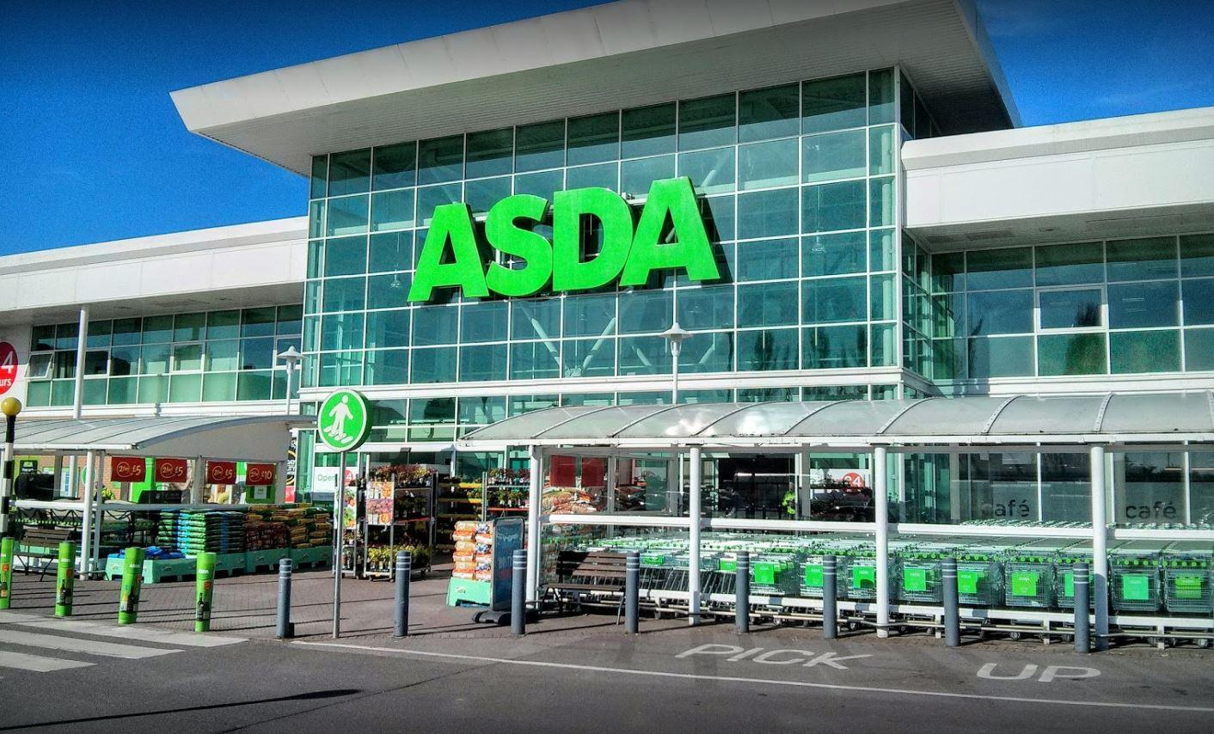
A Critical Perspective of ASDA in Relation to its CRM, Ethics, Sustainability and Quality Policies and Operations

Student Name: VERONIKA TOPOLCANYOVA
Student Number: 1806303
University of Wales Trinity Saint David
Submission Date: 27th March 2020

Executive Summary

Asda has faced many challenges through the years, from being nearly bankrupted in 1990’ to be criticised for discrimination and employees’ rights but they withstand their position on the market and currently they are 3rd biggest supermarket in the UK, following Tesco and Sainsbury’s. When German discounters Aldi and Lidl entered the market with low prices, Asda had to come with new strategies and ideas to keep their loyal customers. But after the unsuccessful merger with Sainsbury’s they struggled, and sales decreased. It was a difficult and uncertain time for Asda but also a challenge to introduce new structure and plan to their customers. How did they do it and did it work to gain their customers trust back? Using CRM models and wide secondary research this report is an analysis of how they treat their stakeholders, what is Asda strategy and mission and What barriers they had to remove to keep their customer relationship.

Table of Contents

Content Page No.

1.0 Introduction 4
2.0 Findings 5-19
2.1 Corporate Responsibility 5 - 9
2.2 Customer Relationship Management 10 - 13
2.3 McKinsey 7S Model 14 - 19
3.0 Conclusion 20
4.0 Recommendations 21
5.0 Reference List 22 - 24

- Introduction

This formal report has been requested by the Marketing and Operations senior managers of ASDA. The group of senior directors of ASDA are presently checking on advantages on moral trading and assembling sustainable methods to the stakeholder relationships.
The company’s review is also concentrating on the possible impact of quality measures and procedures on the client relationship.
The purpose of this report is to analyse previous customer experience from various supermarkets including ASDA based on the company's ethical and sustainable practices and measures. Secondly, using a critical discourse of a mixture of quality models examines how an organisation is enhancing its customer relationship management.
This report has been requested on 19th February 2020 and has been compiled by Veronika Topolcanyova, student of University of Wales Trinity Saint David.
Variable sources and secondary research e.g. reliable websites, e-books, journals and books were used to support and assemble this report.

2.0 Findings

2.1 Corporate Responsibility
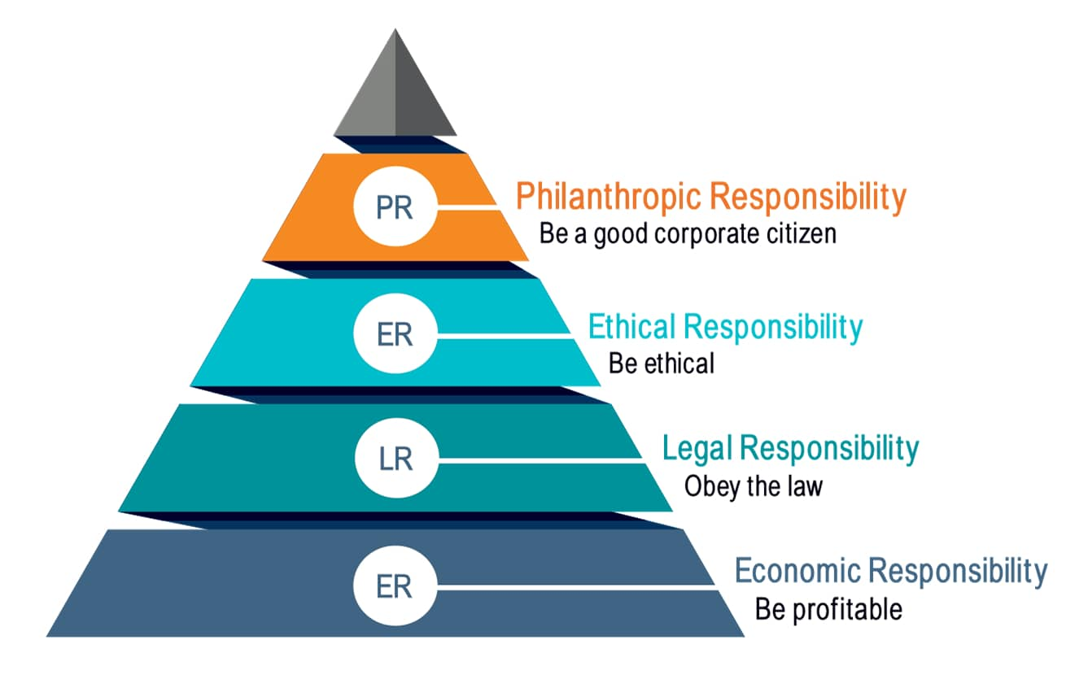
https://thecsrjournal.in/wp-content/uploads/2019/11/Carrols-Pyramid-of-CSR.jpg

Term ‘Corporate Responsibility ‘came first into business discussion in the early 1950 but companies started to understand importance, definition and impact immediately and slowly took action to implement CRM into their businesses. Later, in 1991 when professor Archie Carroll introduced his model of CSR, he described it as a list of company’s responsibilities compiled in a pyramid based on its importance to the business.
‘’Social responsibility can only become reality if more managers become moral instead of amoral or immoral.’’ Archie B. Carroll (Carroll, 1991)

The first level and the base of the pyramid belongs to Economic Responsibility because without a company making profit business wouldn't be able to survive, pay their employees, produce goods or provide services to their customers.
Second level represents government law they have to follow and is very important that companies obey rules and adhere to policies. Protecting employees by following health and safety procedures, paying tax, acting fair and legal with their competitors and practicing employment law is crucial for every company on the market.
Doing the right thing is Ethical and therefore it represents the third level of the pyramid. It is not statutory for a company to be Ethical, however it’s in every company's interest to act fair and moral toward their stakeholders and uphold the company's name and reputation.
Last level is an opportunity for a company to ‘give something back’ if they failed their stakeholders in the past and show their Philanthropic Responsibility to society. (Thacker, 2019)

Economic Responsibility
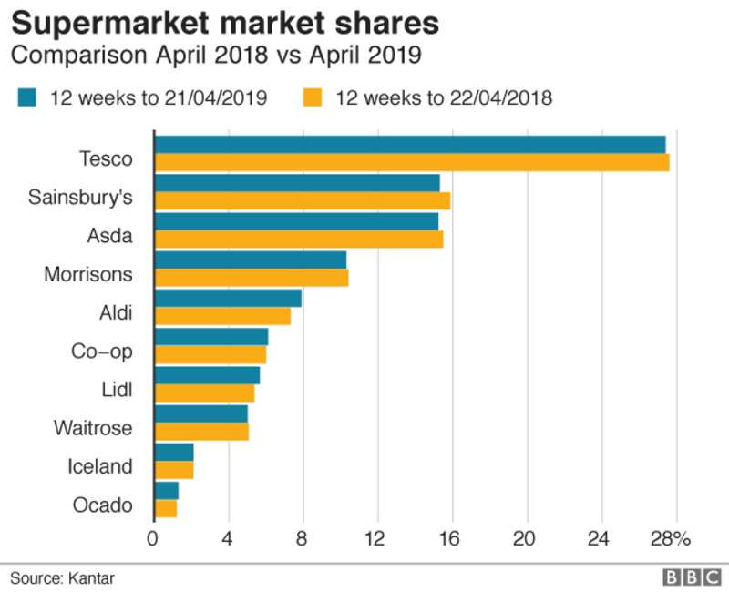
https://ichef.bbci.co.uk/live-experience/cps/800/cpsprodpb/vivo/live/images/2019/4/30/2f2751cf-f435-40eb-b1d4-37d48cf3511d.png
According to a web-article from BBC news from 30th April 2019 and based on the research from Kantar, Sainsbury’s has won back its 2nd place as UK’s greatest supermarket with a 15.4% share which put ASDA in 3rd place with 15.2% share. (Asda - BBC News, 2019). After unsuccessful merger with Sainsbury’s , when ASDA was stopped by CMA (The Competition and Market Authority) over fears that it would have impact on lower prices for groceries and petrol and also cause longer waiting time in queues, Asda’s President and CEO Roger Burnley worried that it would mostly affect consumers , company profits , name and sustainability.
Although merging these two successful companies would help in the price war with German discounters Aldi and Lidl, unfortunately both companies have to create plan B, and start new strategy how to prosper without merger and learn from this experience to build new and stronger relationships with their stakeholders. (Sainsbury's-Asda deal blocked on price fears, 2019)

Legal Responsibility
In November 2019 ASDA was criticised for their new employment contract which disadvantaged employees and put them in a hostage position in which case if they don’t sign the contract they will be dismissed from their job.
A former ASDA employee of 13 years Mr. Carson stated in the interview for inews.co.uk that he is suing the company for ignoring UK’s employment law and forced him to either sign an inflexible and completely unfair contract or lose his job. As a result of his refusal to sign he was made redundant.
Ethical Responsibility
In the suing case above ASDA was criticised for obeying employment law but also for unethical behaviour against their loyal employees. They commented that this decision was made by top management and no one took into consideration human cost and that company's profit was more important than people.
However Asda’s spokesperson official response was that company is looking to offer new benefits to their workers, including pay rise and send personal letters to the ones who couldn't decide if to sign new contract or not and give them more time to make decision with wish that they will stay with the company and Asda will be sad to see them leave. (Andersson, 2019)
Ethical behaviour also represents how companies are dealing with waste and according to an ethical corporation article from 2018, Asda has set an example to other UK’s supermarkets by sending zero food waste to landfill or burning without energy retrieval. (Balch, 2018). Following her mother company Walmart, an American multinational retail concern that owns and controls a line of grocery, discount stores and hypermarkets, Asda is focusing on reducing palm oil in their products and only uses sustainable palm oil certified by RSPO (Roundtable on Sustainable Palm Oil) scheme and PEFC (Programme for the Endorsement of Forest Certification) and FSC (Forest Stewardship Council) certified timber. (Asda.com, 2020)

Philanthropic Responsibility
Asda is supporting the grant programme and raising funds through their employees, George and Asda Houses to deliver financial support for Tickled Pink and Children in Need Charities. Asda is continuously supporting the communities creating green token giving programme opportunities for employees and customers to engage in projects with prices for winners and investment in the local community. Asda foundation is supporting local projects and changing lives by providing grants of up to £1250 for sport equipment for schools, kits or organising lunch for elderly people and helping communities in difficult times such as flooding or fire accidents. List goes on and it is great to hear that Asda is sponsoring people in sport activities such as Marathons, Fundraising events and Summer fairs. (Charity Details, 2020)

2.2 CRM - Customer Relationship Management
What is Customer Relationship Management and why is it so important for every company to manage CRM?
CRM is a complex of services you deliver to your customers, communication and interaction ways and the resources to satisfy and suit customer demands. It is a structure of how to build and keep good relationships with customers and stakeholders. If the company understands their customers, it is more likely to succeed and survive against their competitors. Building trust and loyalty between the company and the customer takes time and determination and could be easily broken or lost by company’s actions. (Bean, 2019). Managing CRM is beneficial for the company and there are many models companies can use such as IDIC, created in 2004 by Peppers and Rogers which navigates the companies to assess their customers and their value to the organisation.

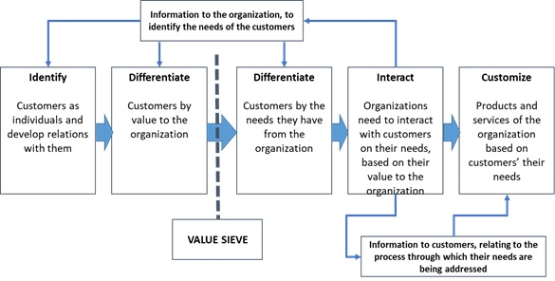
IDIC Model of customer relationship management (Buttle, 2009)

Identify customers
While Tesco spent millions on their Loyalty card scheme to collect customers data and identify their needs, Asda’s strategy was simple which was asking for customer’s postcode, later recorded on spreadsheet and used for demographic purposes to recognise the number of customers a day and week , how much people spend in certain area a week, what kind of products are they buying, but also manners and differences between high and low value customers. (BrandNewWay, 2020)
Differentiate
To meet customer expectations, it is significant to divide customers into two groups and that is by values and by needs.
‘All consumers should not be treated equally.’ G. Halberg
Garth Halberg (1995) stated in his book that retailers cannot put themselves in a position to be democratic to their customers. What he meant was that every company must make an effort and invest money into most valuable customers to enhance the company's profit and keep customers loyal. If a retailer will treat their high profit customers, the same way as low profit customers then customers will not treat the retailer differently from other competitors. Differential marketing is a strong instrument showing businesses how to give a brand's most important customers special care and with special benefits and better communication they will include customers in the brand -loyalty program.
‘Remember: Not all customers will have the same value to the business.’ (4 CRM Models That Boost Customer Loyalty | Lucidchart Blog, 2020)
Does Asda value their customers?
Yes, they do. Asda ‘s mission is to be Britain’s Best Value Retailer, exceeding customer needs, every day. Their values are to put customers always in the first place and they care about their employees. They make maximum effort to be best they can every day. They claim that customers always come first in everything and try to involve customers in business which have a positive impact on business performance and customer relationship. (All About ASDA, 2010)
How does ASDA collect and protect customers' data?
Firstly, by collecting data (name, e-mail, telephone number, address.) through customer touch points, Asda Privacy centre collects, controls, uses, shares and stores customer’s private information through online shopping, Asda competitions or customer service resolution centre. They are allowed by the government to do that and protected by law to process and use customer data and are obliged to follow legal obligations such as Data Protection Act, Privacy and Electronic Communication Regulations, Health and Safety at Work Act and other obligations. By respecting customer rights, they need customer’s consent (permission) to access databases and collect data to run business successfully and to be able to deliver orders to customer addresses, take payments, improve services and resolve customer’s issues and complaints. This contract is based on mutual trust and ASDA takes every technical, administrative and security procedures to protect and maintain customers data and identity.
How does ASDA know what their customers need and where does ASDA gather customer ‘s data from?
By collecting data ASDA is able to record customer’s online shopping list, habits, confectionery size, food allergy details, grocery choice, but also demographic location, how many customers are using petrol filling stations, optician and pharmacy services, click and collect service in their area.
Asda is using a security system and collects data through an online system, websites, cookies, Apps, surveys and feedback. If customers have given permission then also through Optician services, Pharmacies, Asda Mobile and Asda Money service. (Asda.com/privacy, 2020).
Asda takes their customer privacy very seriously and trying their best to protect them but in 2014 Asda had to deal with breach of the security when their website was hacked and customers details were in risk to be exposed, luckily that didn't happen due to quick Asda analytics action , however according to article from ITPro.co.uk although all customer information were safe Walmart and Asda were both criticized that they failed to fix this issue and just recommended their customers to not using site simultaneously with other websites when shopping online. (Lee, 2016)

Interaction with customers
Asda value their customer's opinion and have created an online site where customers can answer short survey about their shopping experience and even have a chance to win 1000 pounds cash. (Tell ASDA - Welcome, 2020)
Asda is using written communication in form of leaflets and catalogues and also through their website, customer resolution centre and recruitment agencies.
Customisation
‘Selligent’s contextual Personalization and engagement tools help us deliver on our mission to be Britain’s most trusted retailer’. Guy Smith, CRM Campaign Manager, ASDA
Asda used Selligent for her Easter Campaign in stores and online. Campaign was
promoting customized products in over 300 stores based by location. Company used Sir Tom Jones song ‘She is a lady ‘and made a relatively fun campaign with a giant chocolate hen laying massive chocolate eggs on Asda roof. That creative idea led to profit increase and sales of thousand chocolate eggs and also promoted the brand and showed that Asda’s advertising team have a great sense of humour. They won customers loyalty and improved communication channels through social media and it was a big success. They managed to reach more than 6 million customers, over 4 million online views and won back over 40% old and disengaged customers. (Asda, 2020)

2.3 McKinsey 7s model

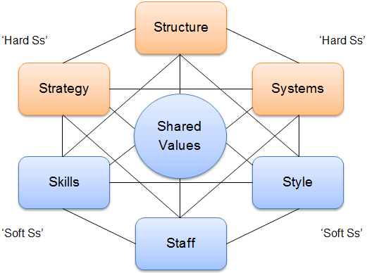
https://www.researchgate.net/profile/Sabin_Musinde/publication/312575943/figure/fig2/AS:667604008071169@1536180607157/The-McKinsey-7-S-model-Source-Strategic-Management-Insight.ppm
Strategy
Asda’s promoting low-price strategy which creates high sales volume and saves customer’s money. With their slogan: ‘Save money live better ‘, ‘Saving you money every day’ or ‘Asda smart price’ they target their customers via store signs, social media, and commercials every day. (Bhasin, 2018)
Structure
Asda is practising progressive and useful organisational structure and communal culture. The hierarchy in Asda is strong but the organisational structure in Asda is lacking communication between teams and each team works independently. Decision making is part of the job of the higher group, management and lower group feels left out and not being part of a dynamic team. However, employees work in a healthy environment and that motivates them to perform better in their daily tasks. (Zoe, 2016)
Systems
Typical Asda store is a large superstore with a variety of departments and available products and a range of services for everyone. easy and simple set up, hassle free and convenient for weekly family shopping with a Cafe, Pharmacy, Optician and tailored to the specific demographic location. Supermarkets are a little smaller with Click and Collect points, Petrol stations with either’ pay and go service’ or with convenience stores for quick grab n go food and basic essential products. Asda is restlessly working every day how to improve their operations and its impact on the environment. As an outcome of these measurements they successfully cut energy use in stores by 20%, reduced carbon footprint by 38% and saved over 200000 delivery miles. Currently operating zero waste policy due to their recycling strategy and maximum effort. By monitoring and recording energy 24/7 across their stores and installing saving LED bulbs they managed to tackle low prices and save the environment. (Asda, 2020)
Shared Values
Asda value their customers, they have changed their strategy over the past years and become more family orientated and planet friendly sustainable business. They thrive to deliver not just low price, but also best quality food without artificial colouring and from fair trade companies on customers' tables. Being a sustainable company means selling local source products and supporting communities, going extra mile for their customers and employees, supporting financially charities, looking after the environment and animals. (Asda.com, 2020)
‘Respect stakeholders, Appreciate employees hard work, Value and support Everyone inside and outside of organisation.’
Code of conduct
Following code of conduct for Asda means they have to treat their staff and customers in an ethical way and follow strict government regulations, restrictions and guidelines to deliver best quality food and services. Asda is proud of their employees and treats them fairly, delivering best training and supporting employees' families through company benefits. Management and leaders doing maximum to reach company goals and objectives and motivates employees every day to be more productive and more efficient for the business. (ASDA CASE STUDY – STRATEGIC BUSINESS ANALYSIS: DEVELOPING A PLAN FOR GROWTH – All Assignment Experts | Blog, 2020). As a reward employee work in a healthy environment, with competitive salary and flexible hours to fit family requirements. Great work-life balance is promoted, and employees’ beliefs are valued.

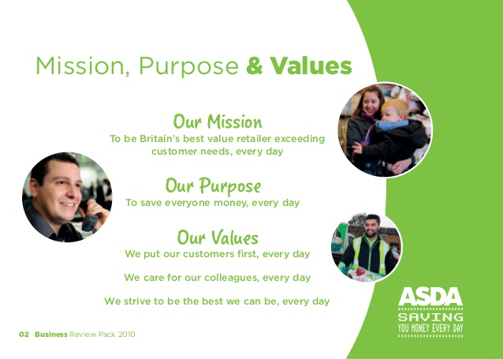
https://image.slidesharecdn.com/historybusinessreviewpack20101-140115030451-phpapp01/95/asda-history-business-review-pack-2-638.jpg?cb=1389755315

Style
Asda has strong hierarchy system and its starting from area manager at the top of pyramid, following by store manager, lower level represents finance manager, customer service manager, market research, IT and HR manager. Lowest level and the base are customer service, sales assistants, stock control, supervisors and warehouse workers. Asda has clear segmentation of various business functions and departments. This helps in establishing the accountability for each of its employees. Culture in the case of Asda is more formal in nature due to several layers of management which results in a less vibrant work environment (Brooks, 2009).
Skills
Asda is a supporter of learning style programmes when employees can improve and develop knowledge and skills while working and receive full pay. Giving opportunity to obtain qualification is not only beneficial for employees and their growth but has an impact on their productivity and company growth. Employees are happy to take part in this programme which can be useful in the future development. (Asda staff able to improve 'basic skills' while at work - Personnel Today, 2020)
Staff
‘Asda customers overwhelmingly want to be served by people who are respected and treated well in their jobs. ‘Gary Carter, GMB official
In November 2019 more than 120000 former employees of Asda felt pressure from employer to sign new inflexible contract and went demonstrating for their rights, but under the assurance from Asda they signed the contract at the end and only few refused, mostly people who chose to retire or took the opportunity and found new job. Asda increased salaries from £8.21 to £9 per hour and will increase again to £9.18 in April. Asda says workers will receive an enhanced package including an annual bonus. But the GMB union, which speaks for the employees, said the new contract expels paid breaks and gives permission to Asda to amend workers’ tasks, working hours, length of shifts, start and finish times as it pleases.
“We have always been clear that we understand people have responsibilities outside of work and we will always help them to balance these with their work life; we will not be asking them to constantly move the time they work, their days or departments.” (Doward, 2019)

Quality
2.4 Deming Cycle: The circle of Continuous Improvement

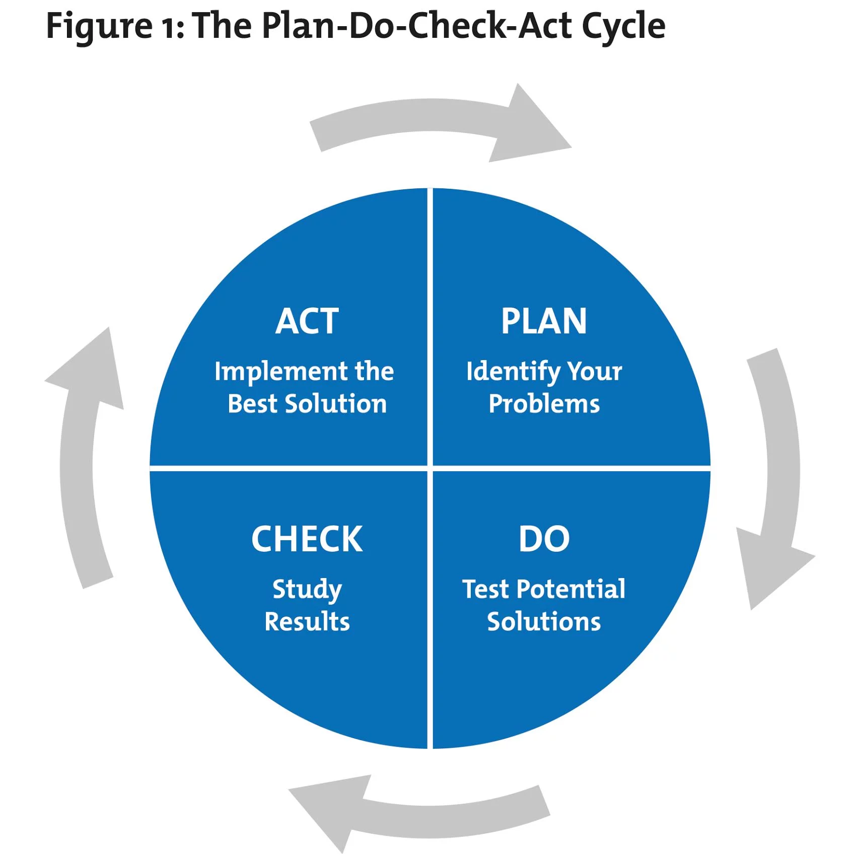

https://www.mindtools.com/media/Diagrams/PDCA2017.jpg

Deming’s model is designed to help companies improve their services by planning, analysing and organising every day actions and procedures, in second stage to testing and carry on trial their services to small group of customers, thirdly to analyse if process and trial worked for company and the customers and lastly by implementing process into organisation strategy. (Syed, 2009). Asda followed this model when they introduced a trial sustainability shop where customers could reduce use of plastic and refill their own containers with pasta, cereals, coffee or rice. Trial is success and only time will show how sustainable and effective Asda can work in cooperation with their customers. (Asda, 2020)
If a company encounters problems, they should reach for a quality marketing model because ‘Quality management is always based on customers’ needs and expectations. (Havlicek, 2009).
Quality is at Asda top priority and they make effort and take responsibility for continuous improvement.
ASDA ICT is concentrating on quality and innovation as the only means to comprehending corporate responsibility and sustainable procedures. They maintain an original and strict product design and development management procedure. Based on the principle of DFX (Design for manufacturing, assembling…etc.), at each development stage, R&D, production, technical, quality control, testing, and sales engineers and project managers work alongside each other to ensure appropriate manufacturability and reliability are designed into the product, and meet with regulations and customer requirements.

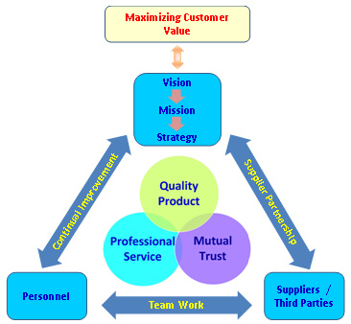

https://www.asdatech.com/images/image104.jpg

3.0 Conclusion
Every organisation and their management must act ethically. Customers are looking at Asda’s profile and the way they treat employees, what rules and practices they are using at the workplace and how much they value their employees and their families. It is necessary that organisations treat everyone equally and with respect regardless of their gender, sexual orientation, nationality, race, age, disability, religion, beliefs or political engagement. Discrimination at the workplace is prohibited and unacceptable and Asda proved in past how much they understand and support differences between their workers. Being keen to nature, they promote local businesses and flood their shops with locally sourced grocery products, working on reducing waste and carbon footprint.
Quality of products and excellent customer service are key elements of successful business and Asda is improving every day, regardless of their unsuccessful merger, they started and developed new strategies on how to be better and stronger in customer relationships. They learned from their mistakes in the past and stand with their original mission to be ‘Britain’s Best value supermarket and exceeding customers' needs every day.’

4.0 Recommendations
More concentration on communication between management and employees, keep employees motivated and involve them in business problem solving and decision making. Consider their new ideas and innovation beneficial for the business.
Avoid making the same mistakes and learn from the past, being all over the first page in the newspaper for environmental hazard, putting a bad name on the company, ruining her reputation and making customers question its sustainability and ethics.
Keep doing what the company is doing best, support local farmers, craftsmen and communities, show support to vulnerable and help society. Stay loyal to customers and value employees because without happy stakeholders there will not be profit and margins and business would be decreasing.

5.0 Reference List

1. Asda.com. 2020. Asda.Com - Online Food Shopping, George, & More. [online] Available at: <https://www.asda.com/creating-change-for-better/better-planet/farming-and-nature> [Accessed 19 March 2020].
2. Asda.com. 2020. Asda.Com - Online Food Shopping, George, & More. [online] Available at: <https://www.asda.com/privacy/> [Accessed 20 March 2020].
3. Asda, 2020. Quality Product Model. [image] Available at: <https://www.asdatech.com/images/image104.jpg> [Accessed 20 March 2020].
4. Andersson, J., 2019. I'm Suing Asda After Losing My Job Over the New Contract. [online] Inews.co.uk. Available at: <https://inews.co.uk/inews-lifestyle/work/asda-contract-6-dispute-changes-supermarket-legal-action-lost-job-920000> [Accessed 21 March 2020].
5. All About ASDA (2010). [pdf] Asda Stores Limited. Available at: <https://your.asda.com/system/dragonfly/production/2012/01/04/12_59_19_568_All_about_Asda.pdf> [Accessed 18 March 2020].
6. Allassignmentexperts.com. 2019. ASDA CASE STUDY – STRATEGIC BUSINESS ANALYSIS: DEVELOPING A PLAN FOR GROWTH – All Assignment Experts | Blog. [online] Available at: <https://allassignmentexperts.com/blog/asda-case-study-strategic-business-analysis-developing-a-plan-for-growth/> [Accessed 21 March 2020].
7. Asda.com. 2020. Asda.Com - Online Food Shopping, George, & More. [online] Available at: <https://www.asda.com/about/instore?cmpid=ahc-_-ahc-_-asdacom-_-about-asda-_-subNav-_-in-store-services> [Accessed 20 March 2020].
8. Balch, O., 2018. CSR Cheat Sheet: Millennials Driving Jump in Ethical Investment | Ethical Corporation. [online] Ethicalcorp.com. Available at: <http://www.ethicalcorp.com/csr-cheat-sheet-millennials-driving-jump-ethical-investment> [Accessed 19 March 2020].
9. BBC News. 2019. Sainsbury's-Asda Deal Blocked on Price Fears. [online] Available at: <https://www.bbc.com/news/business-48048596> [Accessed 20 March 2020].
10. Bean, J., 2019. B2C Business 2 Community. [online] What is a CRM Model? Available at: <https://www.business2community.com/sales-management/what-is-a-crm-model-02235682> [Accessed 20 March 2020].
11. Beta. Charity commission.gov.uk. 2020. Charity Details. [online] Available at: <https://beta.charitycommission.gov.uk/charity-details?regid=1124268&subid=0> [Accessed 19 March 2020].
12. Bhasin, H., 2018. Marketing Mix of ASDA - ASDA Marketing Mix Explain. [online] Marketing91. Available at: <https://www.marketing91.com/marketing-mix-of-asda/> [Accessed 19 March 2020].
13. Brand New Way. 2020. Discover How ASDA Finds Out More About Their Customers | Brand New Way. [online] Available at: <https://brandnewway.com/web-marketing-blog/discover-how-asda-finds-out-more-about-their-customers/> [Accessed 17 March 2020].
14. Brooks, I., 2009. Organisational Behaviour. 4th ed. Harlow: Pearson Education Limited.p. 32-34
15. Buttle, F. (2009). Customer Relationship Management: Concepts and Technologies. Oxford: Elsevier.
16. Carroll, A., 1991. The pyramid of corporate social responsibility: Toward the moral management of organizational stakeholders. Business Horizons, [online journal] 34(4), pp.39-48. Available at: <https://s3.amazonaws.com/academia.edu.documents/51915112/1991-The_Pyramid_of_Corporate_Social_Responsibity. [Accessed 20 March 2020].
17.Corporate - ASDA. 2020. Asda Links Up with Big Brands to Launch First Sustainability Trial Store. [online] Available at: <https://corporate.asda.com/newsroom/2020/01/16/asda-links-up-with-big-brands-to-launch-first-sustainability-trial-store> [Accessed 18 March 2020].
18. Doward, J., 2019. Asda Could Face Consumer Backlash as It Enforces New Contracts. [online] the Guardian. Available at: <https://www.theguardian.com/business/2019/nov/10/asda-faces-backlash-enforces-new-contracts> [Accessed 20 March 2020].
19.Deming PDCA Cycle.2020. [image] Available at: <https://www.mindtools.com/media/Diagrams/PDCA2017.jpg> [Accessed 19 March 2020].
20. Hallberg, G., 1995. All Consumers Are Not Created Equal. New York: John Wiley & Sons, p.8.
21. Kasik, M., Havlicek, K., 2009, Role of Marketing in Strategy Management’’, (University of Finance and Administration, Eupress, Prague)
22. Lee, A., 2016. Asda Website Bug Left Millions of Customers at Risk of Hacking - Supermarket Retailer Says Security Hole Has Been Fixed, With No Hacking Victims. [online] Itpro.co.uk. Available at: <https://www.itpro.co.uk/security/25891/asda-website-bug-left-millions-of-customers-at-risk-of-hacking> [Accessed 20 March 2020].
23. Lucidchart.com. 2020. 4 CRM Models That Boost Customer Loyalty | Lucidchart Blog. [online] Available at: <https://www.lucidchart.com/blog/crm-models> [Accessed 18 March 2020].
24. Mission, Purpose and Values. (2020) [image] Available at: <https://image.slidesharecdn.com/historybusinessreviewpack20101-140115030451-phpapp01/95/asda-history-business-review-pack-1-638.jpg?cb=1389755315> [Accessed 18 March 2020].
25. Personnel Today. 2020. Asda Staff Able to Improve 'Basic Skills' While at Work - Personnel Today. [online] Available at: <https://www.personneltoday.com/hr/asda-staff-able-to-improve-basic-skills-while-at-work/> [Accessed 19 March 2020].
26. Picture of Asda.2020 [online image] Available at: <https://nottstv.com/wp-content/uploads/2016/11/ASDA-WEST-BRIDGFORD.jpg> [Accessed 17 March 202
27. Selligent Marketing Cloud. 2020. ASDA. [online] Available at: <https://www.selligent.com/customers/retail/asda> [Accessed 19 March 2020].
28.Syed, F., 2009. Deming Cycle: The Wheel of Continuous Improvement. [online] Total Quality Management. Available at: <https://totalqualitymanagement.wordpress.com/2009/02/25/deming-cycle-the-wheel-of-continuous-improvement/> [Accessed 19 March 2020].
29. Tellasda.com. 2020. Tell ASDA - Welcome. [online] Available at: <https://www.tellasda.com/?AspxAutoDetectCookieSupport=1> [Accessed 18 March 2020].
30. Thacker, H., 2019. Understanding the four levels of CSR. [online] Available at: <https://thecsrjournal.in/understanding-the-four-levels-of-csr/> [Accessed 24 March 2020].
31. Zoe, E., 2016. Organisation Structure Of ASDA. [online] Articlesfactory.com. Available at: <http://www.articlesfactory.com/articles/business/organisation-structure-of-asda.html> [Accessed 19 March 2020].

