
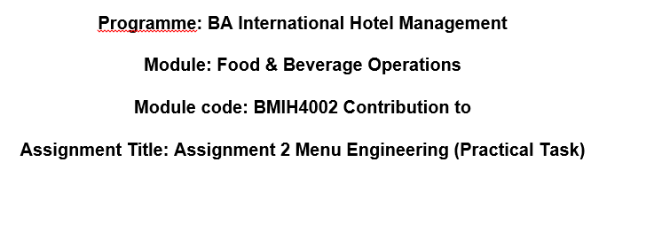

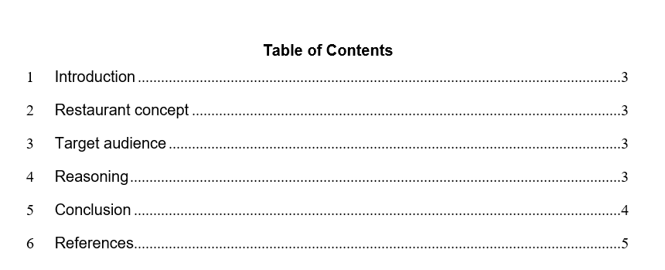

Introduction
This report is mainly about the Hotel Trinity, which is a four-city centre hotel, which is part of Trinity Hotel chain, It is located in the United Kingdom. Hence, the basic restaurant concept, target audience and reasoning will be provided in order to showcase the later part of this assignment, which is the menu.

Restaurant concept
The central restaurant concept is based on seafood in regard to the dining experience with sea taste in it (Tian et al., 2022; Tian et al., 2021). Therefore, the restaurant caters to seafood lovers and nature lovers and an immersive dining experience. Hence, the hotel tries to aim at delivering a dining experience when luxury meets with natural beauty in taste and area. Therefore, it will help to create unforgettable moments marked by seafood culinary and coastal charm. The restaurant concept mainly highlights the importance of the sea and seafood as people are engaging in seafood as their primary dish to incorporate in daily life (Zhang, 2018; Kang et al., 2018; Donlan et al., 2022).

Target audience
The primary target audience of this specific restaurant is couples, seafood enthusiasts, tourists and locals. Therefore, the goal is to create a seafood haven for the audience, which appeals highly in value and ambience in regard to food. As a result, couples are seeking romantic dinners, enthusiasts who want seafood and travellers looking for a local coastal taste in one place. Further, nature and sustainability will be parallel to each other. The general audience can be couples, individuals and small groups of people who want to enjoy the dining experience at the restaurant (Boguslavsky et al., 2016; Barclay and Miller, 2018; Carroll and Kovács, 2021).

Reasoning
The main reasoning behind this idea is to combine the idea of the ocean view and focus on the sustainably sourced seafood. Hence, it mainly sees the rising demand for the sea in order to showcase the culinary practices in order to provide a dining experience in a natural and serene setting. This restaurant idea mainly taps behind the idea of coastal locations and seafood by offering a menu that provides homage to the ocean. The primary commitment is to source fresh and sustainably caught seafood in order to provide a dining experience where luxury meets natural beauty and food (Wu et al., 2022; Mahardikaa, and Suprianaa, 2020).

Conclusion
In regard to this report, the main hotel idea is given, which is the provision of a seafood restaurant with a seafood menu that lures audiences to those who love the sea and want a dining experience in order to showcase the dining experience where luxury meets natural beauty and food. Further, the target audience is couples, seafood enthusiast, tourists and locals.


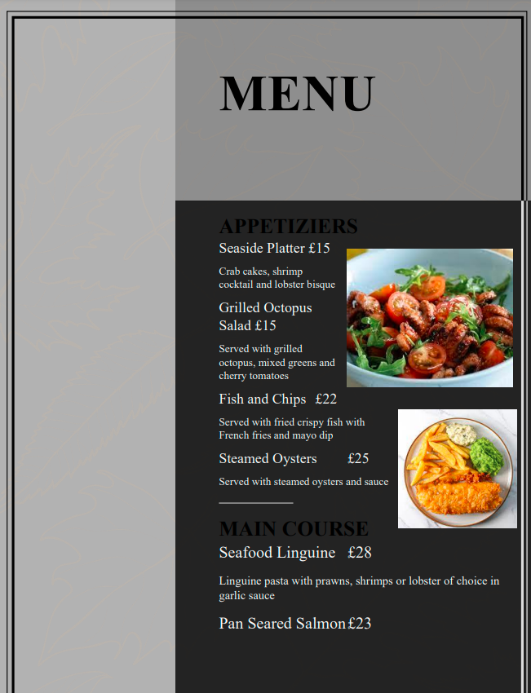
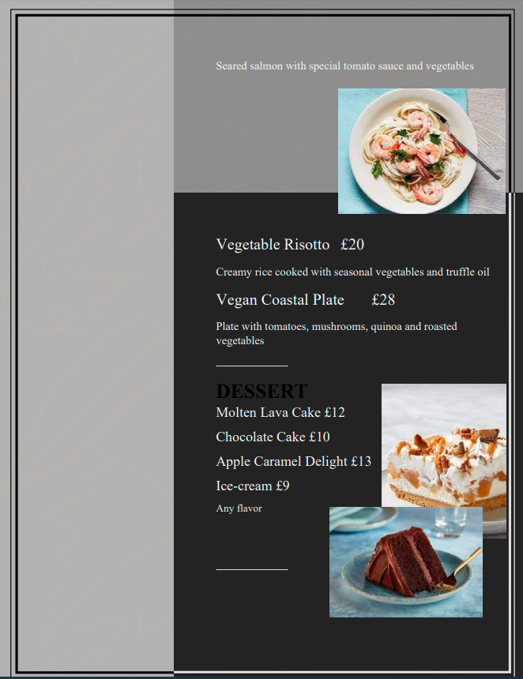
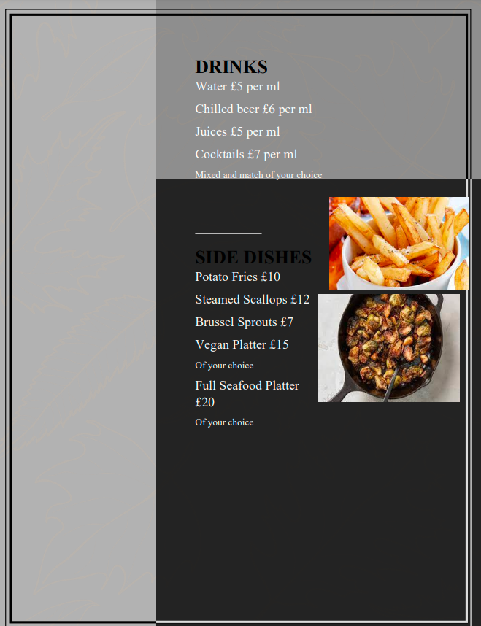

References
Barclay, K. and Miller, A., 2018. The sustainable seafood movement is a governance concert, with the audience playing a key role. Sustainability, 10(1), p.180.
Boguslavsky, I., Dikonov, V., Frolova, T., Iomdin, L., Lazurski, A., Rygaev, I. and Timoshenko, S., 2016. Plausible expectations-based inference for semantic analysis. In Proceedings on the International Conference on Artificial Intelligence (ICAI) (p. 477). The Steering Committee of The World Congress in Computer Science, Computer Engineering and Applied Computing (WorldComp).
Carroll, G.R. and Kovács, B., 2021. Authenticity: Meanings, targets, audiences and third parties. Research in Organizational Behavior, 41, p.100149.
Donlan, C.J., Sorice, M.G., Contreras-Drey, F.J., Oyanedel, R., Avila-Thieme, M.I. and Gelcich, S., 2022. Restaurateurs’ context, decisions, and views on supporting sustainable seafood: Insights from Chile. Frontiers in Marine Science, 9, p.1009130.
Kang, H.S., Kim, J.U. and Jang, Y.S., 2018. A Study of the Consumers' Lifestyle on Seafood Dining Market. The Journal of Fisheries Business Administration, 49(3), pp.15-28.
Mahardikaa, I.G.T. and Suprianaa, I.W., 2020. A Case Based Reasoning System For Recommendation Of Restaurant In Jimbaran Using K-Nearest Neighbor. Jurnal Elektronik Ilmu Komputer Udayana p-ISSN, 2301, p.5373.
Tian, C., Luan, W., Li, S., Xue, Y. and Jin, X., 2021. Spatial imbalance of Chinese seafood restaurants and its relationship with socioeconomic factors. Ocean & Coastal Management, 211, p.105764.
Tian, C., Luan, W., You, D., Su, M. and Jin, X., 2022. Seafood availability and geographical distance: Evidence from Chinese seafood restaurants. Ocean & Coastal Management, 225, p.106219.
Wu, Y., Liao, L., Zhang, G., Lei, W., Zhao, G., Qian, X. and Chua, T.S., 2022. State graph reasoning for multimodal conversational recommendation. IEEE Transactions on Multimedia.
Zhang, Z., 2018. Food and Service Quality, Price Value, and Restaurant Atmospherics Affecting Dinning Satisfaction at Seafood Restaurants of Chinese Tourists in Bangkok.

