DS 1 Assignment

My Screenshots/Photos

Screenshot/Photo 1
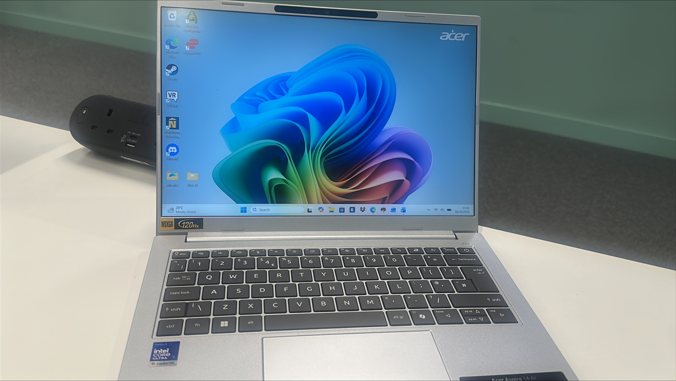
This picture shows the laptop that I use in my daily life that helps me complete and submit assignments given to me by my tutor. I feel good using this laptop because it’s very useful when saving, naming and organising files which makes them easy to find. I also feel good when using Moodle as it makes it easy to access and when finding information.

Screenshot/Photo 2
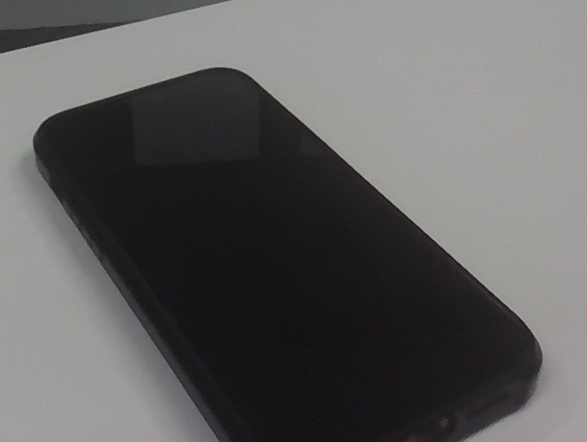
This picture shows my mobile phone which I use daily in my life to make calls, use social media, place orders, do research, and look for directions and times of buses/trains. I also use this phone when paying for stuff such as food, transport and even online banking. I feel good using this phone as it assists me with so much in my daily life making things so much simpler.

Screenshot/Photo 3
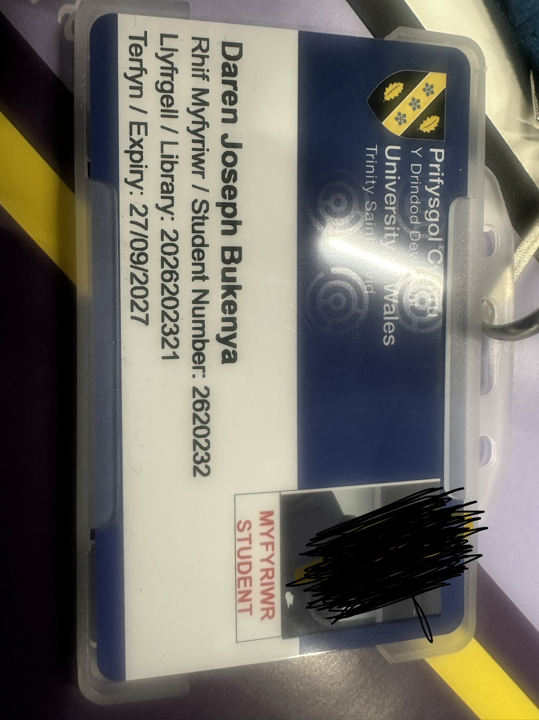
This picture shows my student ID which was given me to by the university. I use this student ID card to get access into the university building and into classes. This student ID is also used in my daily life to help students and members identify me easily.

Screenshot/Photo 4
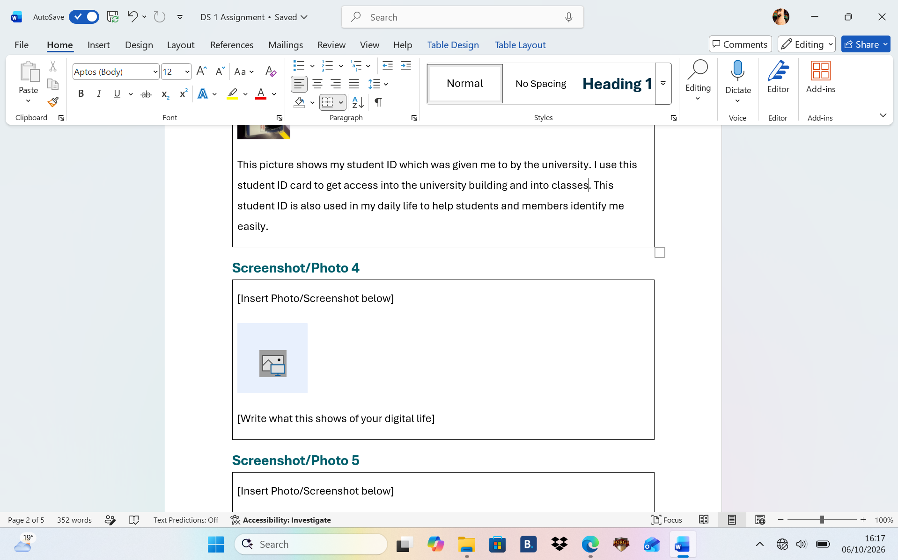
This picture shows me using Microsoft word. I use Microsoft word to complete assignments given to me that can be found on Moodle. I feel good using Microsoft word because I can format answers to the academic standard. I am also able to stay organized when using word and I am also able to save hours’ worth of manual editing to the correct folder.

Screenshot/Photo 5
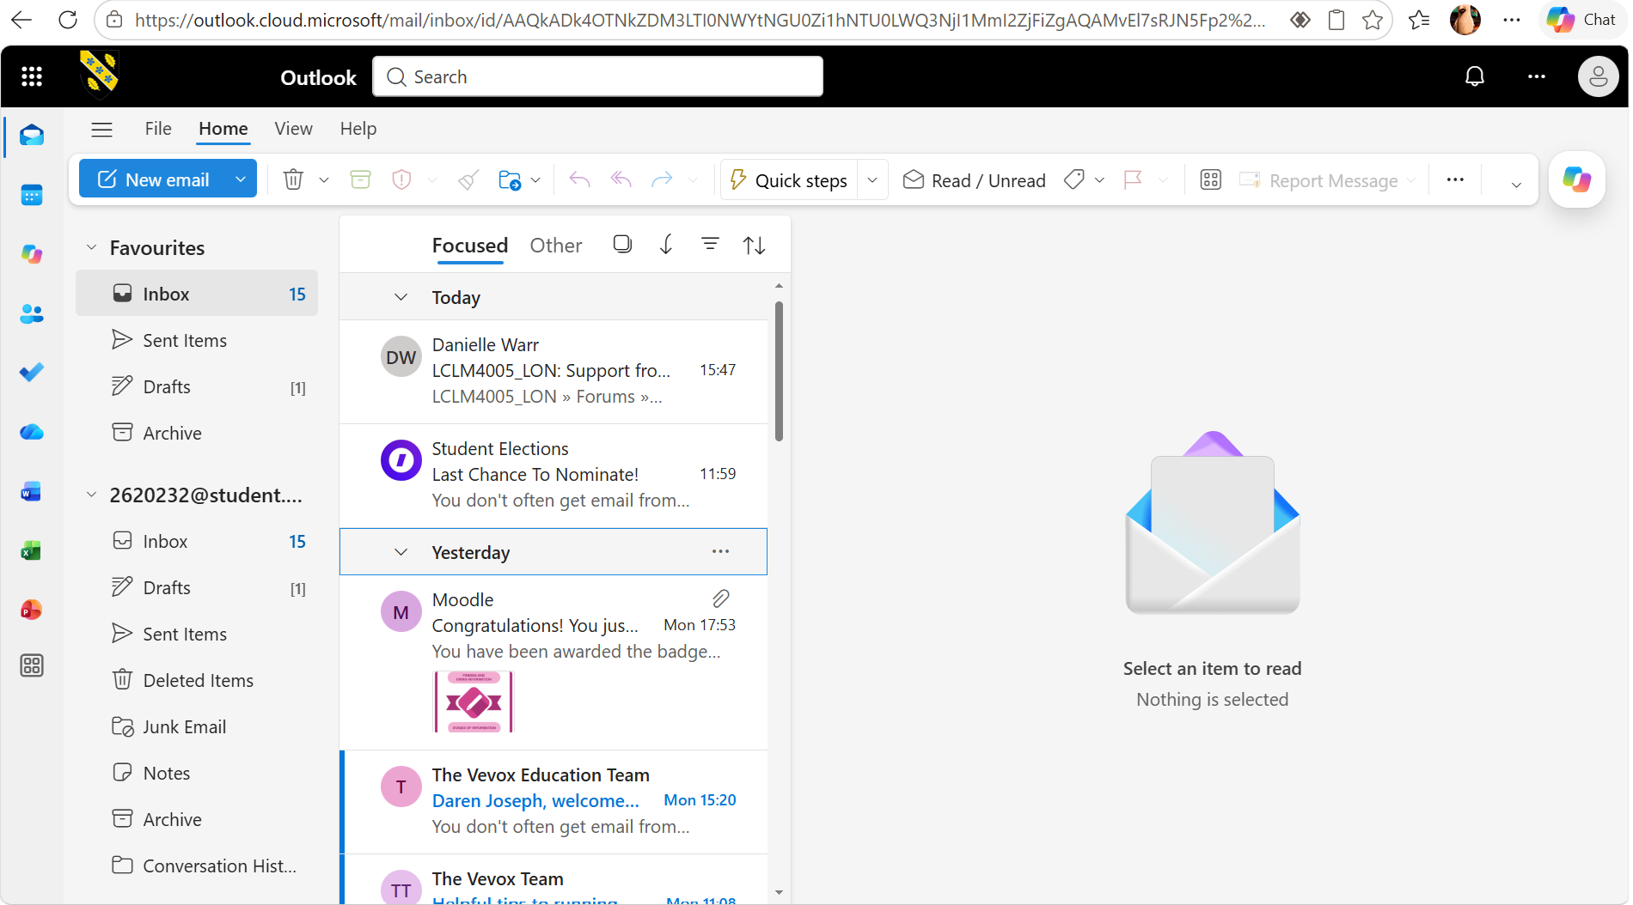
This picture shows me logged into my email on outlook. This is one of my daily digital uses that I use to check and send emails. Outlook is important to in my daily digital life as it is my main way of communicating with important people such as tutors and employees. I have used outlook several times to send CVs to work companies and to also send/submit work to tutors.

Screenshot/Photo 6
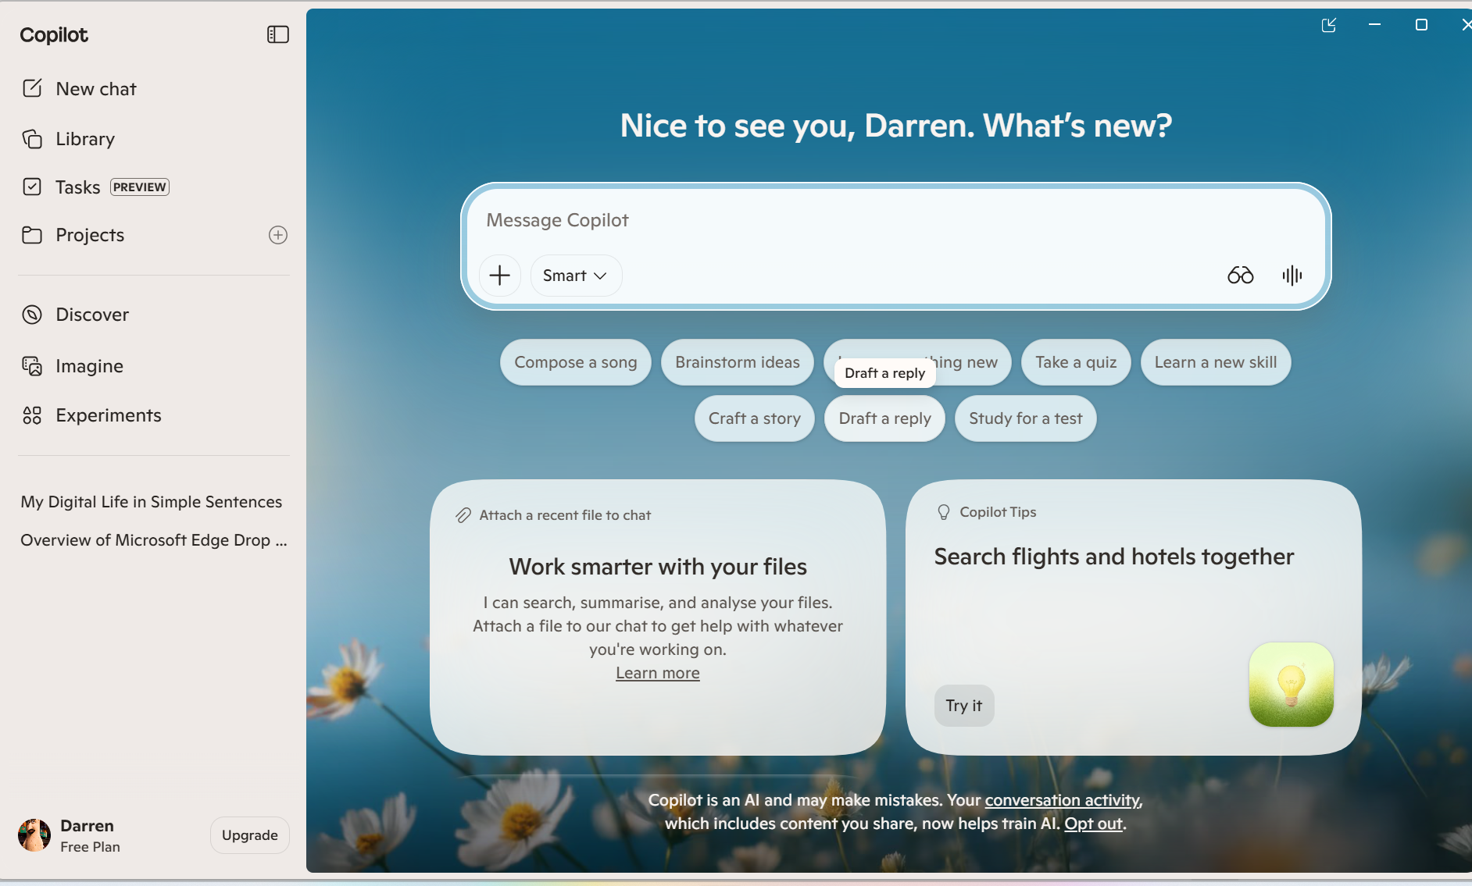
The picture shows me using an AI app called copilot. I use Copilot in my digital life when I need to search for answers or if I need writing assistance when answering questions. I feel confident finding information and creating quick messages, but I want to improve my skills in planning, analysing content, and producing more polished work. These skills matter because the better I use Copilot the more I can learn, create, and manage everything I do online.

My Short Reflection
- Write 5–8 simple sentences about your digital life.
- You can use the sentence starters below if helpful.
In my digital life I use my phone every day to stay connected with friends and family, and I enjoy watching videos or listening to music when I’m travelling to places or I’m at the gym. I often play games online to also connect with my friends which helps me unwind after a long day. I keep my important files stored in other files so I can reach them whenever I need to. When I’m curious about something, I search the internet to learn more. Sometimes I use AI to get help me with more detailed topics if I am struggling to find answers on my own. Digital skills are important to me because they contribute to a big part of my everyday life and help me to go through my day with no worries.

Sentence starters
- I use digital tools to …
- I feel confident when I …
- I want to improve …
- I often use these tools: …
- I sometimes feel nervous about …
- I hope this module will help me …
- Digital skills are important for me because …
You can write more if you want.

Submission Checklist
Before you submit, please check:
​​​ ☐ I added 4–6 screenshots
☐ I wrote short sentences for each screenshot
☐ I wrote my short reflection
☐ My work is my own
☐ My file opens correctly
​​

