
COMPONENT 1: DESIGN AND IMPLEMENTATION OF A RELATIONAL DATABASE SYSTEM
Introduction to Web and Database Concepts - ACCA4023

Lecturer: SADHANA JHA
Assignment title: Design and Implementation of a Relational Database System
Student: Assadullah Gulamhussein (2509693)

UNIVERSITY OF WALES TRINITY SAINT DAVID

Table of Contents
List of Figures 2
List of Tables 3
1. Scenario Analysis 4
2. Entity Relation Diagram (ERD) 5
2.1. List of attributes and their descriptions 5
2.2. List of relationships and their meaning 8
2.3. ER diagram 9
3. Normalisation 11
4. Sample Data Population 14
5. Query Development 18
Query 1: Complete Booking Details 18
Query 2: Revenue per Site 19
Query 3: Most Demanding Site Name 20
Query 4: Vehicle Parked at Particular Time 21
Query 5: Vehicle Parked in a Particular Slot 22
6. Validation and Testing 23
Test 1: Slot Type Rule 25
Test 2: Email Rule 26
Test 3: Payment Method Rule 26
Test 4: No Zero Rule 27
Test 5: Non-Negative Amount 28
Test 6: Referential Integrity 28
Test 7: Required Field 28
7. Design Decision 29
8. Future Work 29
9. References 30

List of Figures
Figure 1: Relationship Window in Microsoft Access 9
Figure 2: Relationship Window and Summary 10
Figure 3: Evidence of Parking Site Data 14
Figure 4: Evidence of Parking Slot Data 15
Figure 5: Evidence of Customer Data 15
Figure 6: Evidence of Vehicle Data 16
Figure 7: Evidence of Booking Data 17
Figure 8: Evidence of Payment Data 17
Figure 9: Query Execution for Booking Details 18
Figure 10: Result of Bookings Details 18
Figure 11: Query Execution for Revenue per Site 19
Figure 12: Results for Revenue per Site 19
Figure 13: Query Execution for Most Demanding Site 20
Figure 14: Result for Most Demanding Site 20
Figure 15: Query Execution for Vehicle Parked at Particular Time 21
Figure 16: Result for Vehicle Parked at Particular Time 21
Figure 17: Query Execution for Vehicle Parked at a Particular Slot 22
Figure 18: Result for Vehicle Parked at a Particular Slot 22
Figure 19: Testing for Slot Type Rule 25
Figure 20: Testing for Email Rule 25
Figure 21: Testing for Payment Method Rule 26
Figure 22: Testing for No Zero Rule 26
Figure 23: Testing for no Negative Amount 27

List of Tables
Table 1: ParkingSite: the car parks that the company own. 6
Table 2: ParkingSlot (the individual spaces inside a site) 6
Table 3: Customer (the registered users of the car parks) 6
Table 4: Vehicle (the cars owned by customers) 7
Table 5: Booking (one slot reserved by one customer and vehicle) 7
Table 6: Payment (the money taken for a booking) 8
Table 7: List of Relationships 8
Table 8: Description on Validation and Testing 23

Scenario Analysis
The current “AutoPark Management System” is a database which is named after a company. This database is designed for the same company that operates more than one public car park. The company demands a single source of true and accurate database where they can store information like their parking spaces, who is parking, what cars they park, when cars arrive at the parking, when they leave and how much they pay. Otherwise, these pieces of information are often posted in disassorted lists containing repeated information, and quickly outdated, which wastes time and results in errors. In a well-designed relational database, it is possible to tackle this problem by storing each fact only once and then linking related facts together, thereby maintaining consistency and accuracy of information [1]. This will reduce data duplication, ensure data integrity and provide smooth scalability to the business as it grows [2].
In this case, the company has multiple parking spots and each individual parking spot is segmented into multiple spaces of various types, including standard, disabled, and electrically powered parking spots. The public registers and adds details about their vehicles. When a particular slot is booked by a customer, their entry and exit time is indicated and each booking is settled by a payment. All these facts are stored in the database and between these facts, all these rules need to be applied, e.g., a booking cannot refer to an existing customer, booked slot, or to a non-existent slot. The system consists of 6 related tables: ParkingSite, ParkingSlot, Customer, Vehicle, Booking and Payment. The relationships between the tables mean that the company can answer key questions such as which slots are available in a site, what vehicles a customer owns, and how much income a booking produces. So, the purpose of this database is to bring all information into one database, which should be organised so that each fact is stored accurately and only once. With context to this assignment, this work produced a database in Microsoft Access [3] rather than a complete software application.

Entity Relation Diagram (ERD)

List of attributes and their descriptions
The system contains six entities. The tables below describe every attribute, state what it stores, and identify the primary key (PK) that gives each record a unique identity, along with the foreign keys (FK) that link the tables [2].

Table 1: ParkingSite: the car parks that the company own.
Attribute | Data type | Description | Key
SiteID | AutoNumber | Unique number for each site. | PK
SiteName | Short Text | Name of the car park.
Address | Short Text | Street address of the site.
City | Short Text | City or town the site is in.
ContactNumber | Short Text | Contact phone number.

Table 2: ParkingSlot (the individual spaces inside a site)
Attribute | Data type | Description | Key
SlotID | AutoNumber | Unique number for each slot. | PK
SlotNumber | Short Text | Label of the space, e.g. A01.
SlotType | Short Text | Standard, Disabled or Electric.
HourlyRate | Currency | Price charged per hour.
SiteID | Number | Site the slot belongs to. | FK

Table 3: Customer (the registered users of the car parks)
Attribute | Data type | Description | Key
CustomerID | AutoNumber | Unique number for each customer. | PK
FirstName | Short Text | Customer's first name.
LastName | Short Text | Customer's last name.
Phone | Short Text | Contact telephone number.
Email | Short Text | Email address.
Address | Short Text | Home address.

Table 4: Vehicle (the cars owned by customers)
Attribute | Data type | Description | Key
VehicleID | AutoNumber | Unique number for each vehicle. | PK
RegistrationNumber | Short Text | Number plate.
Make | Short Text | Manufacturer, e.g. Ford.
Model | Short Text | Model name, e.g. Focus.
Colour | Short Text | Colour of the vehicle.
CustomerID | Number | Owner of the vehicle. | FK

Table 5: Booking (one slot reserved by one customer and vehicle)
Attribute | Data type | Description | Key
BookingID | AutoNumber | Unique number for each booking. | PK
BookingDate | Date/Time | Date the booking is for.
EntryTime | Date/Time | When the vehicle enters.
ExitTime | Date/Time | When the vehicle leaves.
CustomerID | Number | Customer making the booking. | FK
VehicleID | Number | Vehicle being parked. | FK
SlotID | Number | Slot being booked. | FK

Table 6: Payment (the money taken for a booking)
Attribute | Data type | Description | Key
PaymentID | AutoNumber | Unique number for each payment. | PK
Amount | Currency | Amount paid.
PaymentDate | Date/Time | Date of payment.
PaymentMethod | Short Text | Card, Cash or Mobile App.
BookingID | Number | Booking being paid for. | FK

List of relationships and their meaning
The six entities are joined by six one-to-many relationships. In each one the "one" side holds the primary key and the "many" side holds a matching foreign key. Referential integrity is enforced on every relationship, so a record on the many side can only be saved when the parent it refers to already exists [1], [4], [5]. Participation is total on the child side as every slot must belong to a site, every booking must have a customer, vehicle and slot, and every payment must belong to a booking, because those foreign key fields are required.
Table 7: List of Relationships
Relationship | Cardinality | Meaning
ParkingSite with ParkingSlot | 1 : Many | A site contains many slots; each slot belongs to one site.
Customer with Vehicle | 1 : Many | A customer owns many vehicles; each vehicle has one owner.
Customer with Booking | 1 : Many | A customer makes many bookings; each booking has one customer.
Vehicle with Booking | 1 : Many | A vehicle appears in many bookings; each booking uses one vehicle.
ParkingSlot with Booking | 1 : Many | A slot is booked many times; each booking is for one slot.
Booking with Payment | 1 : Many | A booking can have one or more payments; each payment settles one booking.

ER diagram
The ER diagram below (Figure 1), taken from the Relationships window in Microsoft Access, shows all six entities with their attributes, the lines joining them, and the "1" and "∞" symbols that mark the cardinality and confirm that referential integrity is enforced throughout. Figure 2 is designed using another Microsoft PowerPoint, also presents the same things but in a more enhanced way.
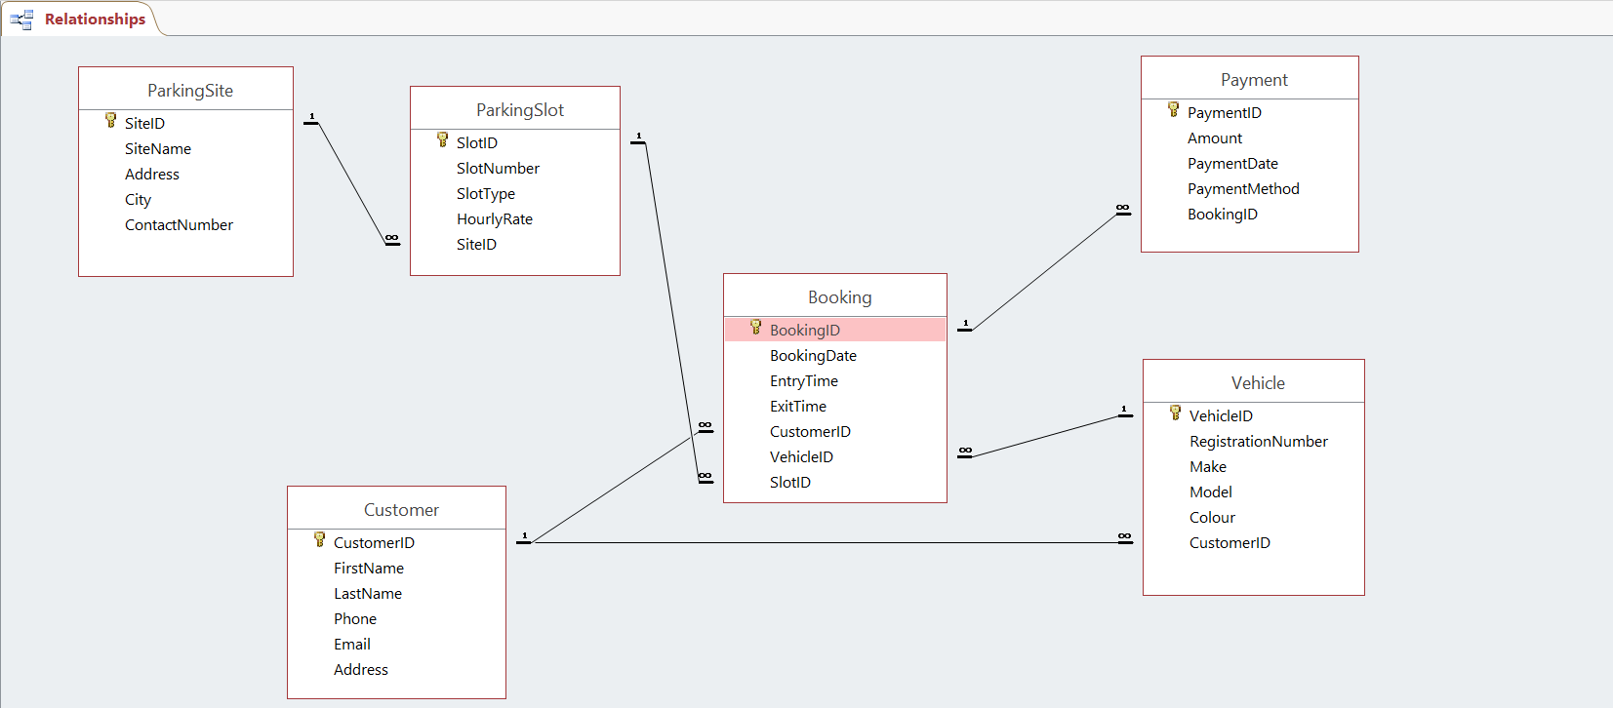
Figure 1: Relationship Window in Microsoft Access

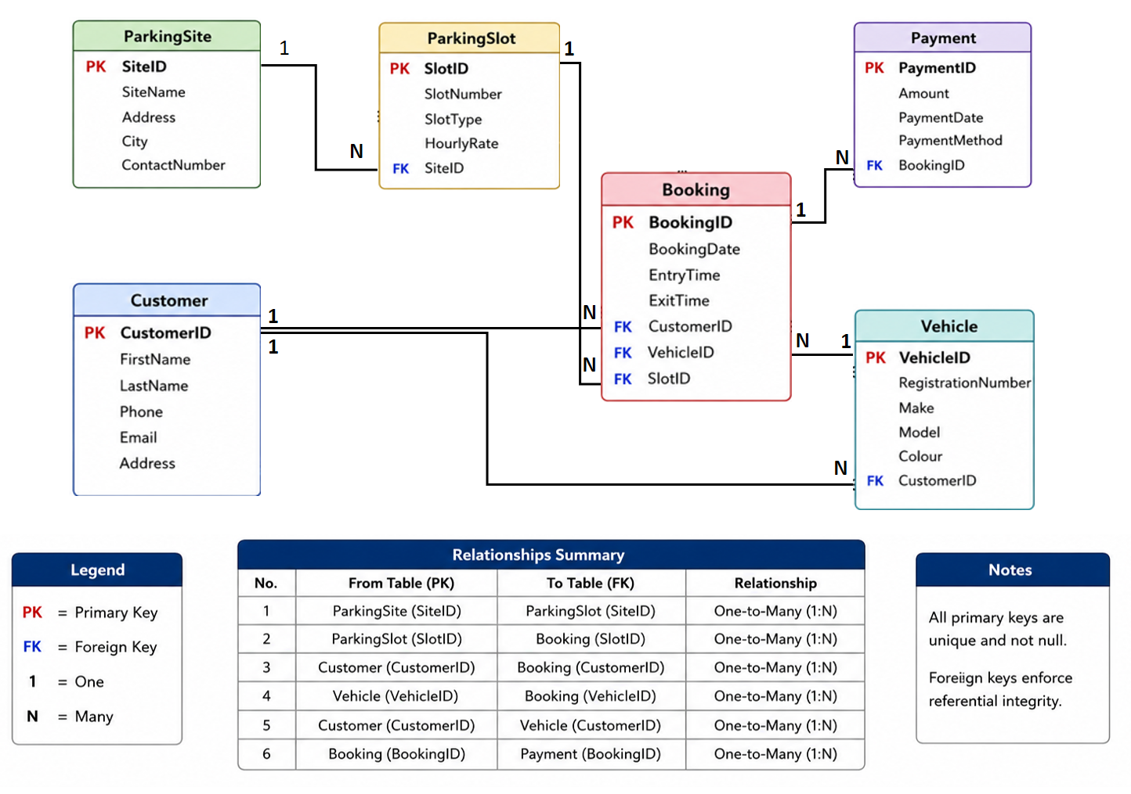
Figure 2: Relationship Window and Summary

Normalisation
Normalization is a design step carried out on roughly before the tables were built in Access. Its purpose is to organise the data so that each fact is stored only once and the tables are free of avoidable errors.
Step 1-Turn the ER diagram into a relational schema (reduction rules):
The ER diagram was converted into a set of tables using the standard reduction rules:
Entities become tables: Each entity became a table, its attributes became the columns, and one field was chosen as the primary key (for example, Customer became the Customer table with CustomerID as its key).
One-to-many relationships become foreign keys: For each relationship, the primary key from the "one" side was added to the "many" side as a foreign key. This is why SiteID sits in ParkingSlot, and Booking holds CustomerID, VehicleID and SlotID.
Attribute types: The design has no multivalued or derived attributes, so no extra tables or calculations were needed. The only composite attribute, Address, was kept as a single text field for simplicity.
Applying these rules produced the following schema (primary keys underlined, foreign keys marked with *):
ParkingSite (SiteID, SiteName, Address, City, ContactNumber)
ParkingSlot (SlotID, SlotNumber, SlotType, HourlyRate, SiteID*)
Customer (CustomerID, FirstName, LastName, Phone, Email, Address)
Vehicle (VehicleID, RegistrationNumber, Make, Model, Colour, CustomerID*)
Booking (BookingID, BookingDate, EntryTime, ExitTime, CustomerID*, VehicleID*, SlotID*)
Payment (PaymentID, Amount, PaymentDate, PaymentMethod, BookingID*)
Step 2- First Normal Form (1NF):
To reach 1NF, every field must hold a single value and each row must have a primary key [6]. The combined CustomerName is split into FirstName and LastName, and BookingID is used as the primary key so every row is unique. The data is now flat, but the customer and site details still repeat, which is fixed later.
ParkingData (BookingID, BookingDate, EntryTime, ExitTime,
FirstName, LastName, Phone, Email, CustomerAddress,
VehicleReg, Make, Model, Colour, SlotNumber, SlotType,
HourlyRate, SiteName, SiteCity, Amount, PaymentMethod)
BookingID | FirstName | LastName | VehicleReg | SlotNumber | SiteName | Amount
1 | Ethan | Byrne | ME39 NKE | B05 | Riverside Car Park | £18.00
2 | Oscar | Wells | KE43 KRT | F05 | Market Square Parking | £15.00

Step 3- Second Normal Form (2NF):
A table is in 2NF if it is in 1NF and no field depends on only part of the primary key [6]. This problem can only happen when the key is made of two or more fields joined together. Here the key is a single field, BookingID, so there is no “part” of the key for a field to depend on. The table is therefore already in 2NF, and no change is needed at this stage.
Step 4- Third Normal Form (3NF):
To reach 3NF, fields that describe something other than the booking are moved into their own tables [6]. The customer, vehicle, slot, site and payment details each become a separate table, linked back by foreign keys. This removes all repetition and produces the six final tables of the database, shown below with the sample data.
ParkingSite
SiteID | SiteName | Address | City | ContactNumber
2 | Riverside Car Park | 95 Church Road | Salford | 01615551111
6 | Market Square Parking | 12 Market Road | Oldham | 01615551555

ParkingSlot
SlotID | SlotNumber | SlotType | HourlyRate | SiteID *
10 | B05 | Electric | £3.00 | 2
30 | F05 | Electric | £3.00 | 6
Customer
CustomerID | FirstName | LastName | Phone | Email | Address
41 | Ethan | Byrne | 07700900040 | ethan.byrne@email.com | 92 Maple Ave, Oldham
35 | Oscar | Wells | 07700900034 | oscar.wells@email.com | 77 Ash Ave, Manchester
Vehicle
VehicleID | RegistrationNumber | Make | Model | Colour | CustomerID *
51 | ME39 NKE | Kia | Niro | Black | 41
45 | KE43 KRT | Honda | Jazz | White | 35
Booking
BookingID | BookingDate | EntryTime | ExitTime | CustomerID * | VehicleID * | SlotID *
1 | 14/06/2026 | 08:30 | 14:30 | 41 | 51 | 10
2 | 14/06/2026 | 17:30 | 22:30 | 35 | 45 | 30
Payment
PaymentID | Amount | PaymentDate | PaymentMethod | BookingID *
1 | £18.00 | 14/06/2026 | Card | 1
2 | £15.00 | 14/06/2026 | Mobile App | 2

Sample Data Population
Although the data was hypothetical, it was added in a realistic way, so the system could be tested against meaningful records. For this purpose, this work used parent-before-child criteria: parking site, parking slot, customer, vehicle, booking and then payments. The database holds 8 sites, 40 slots, 50 customers, 65 vehicles, 150 bookings and 150 payments. The screenshot below shows the content of each table, but due to a huge number of rows, only a limited row can be seen in the screenshot (The complete data is given in the Microsoft Access file “AutoPark Management System”).
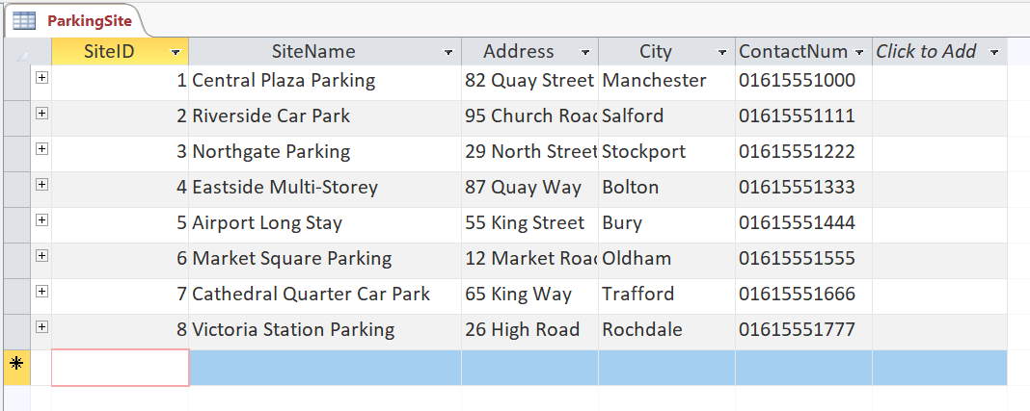
Figure 3: Evidence of Parking Site Data
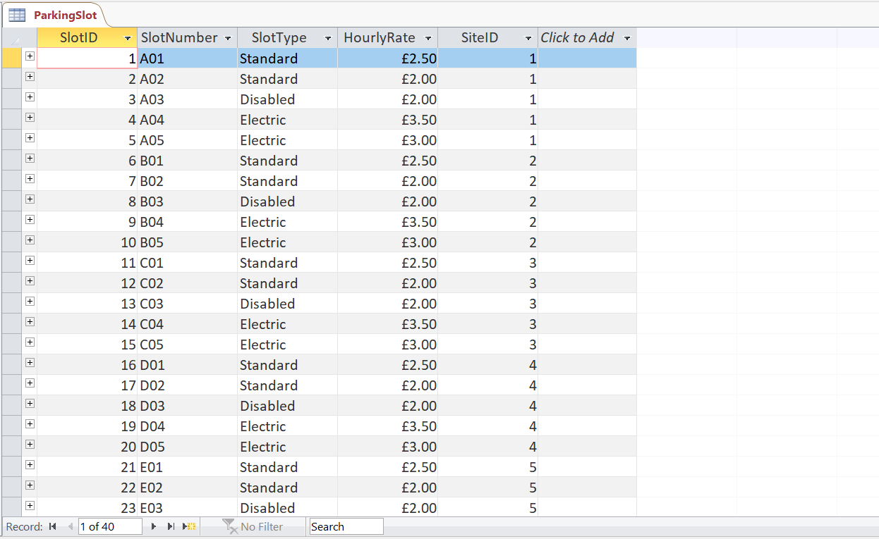
Figure 4: Evidence of Parking Slot Data
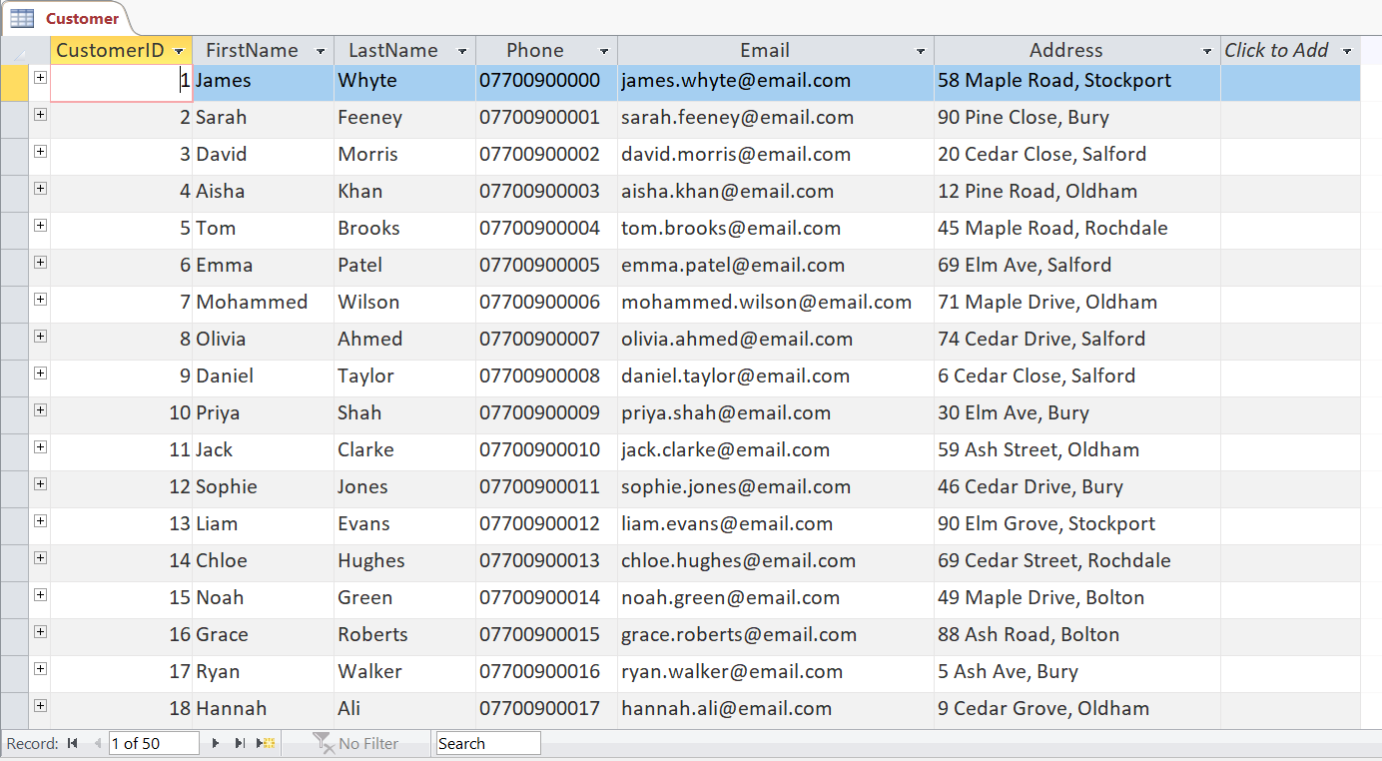
Figure 5: Evidence of Customer Data
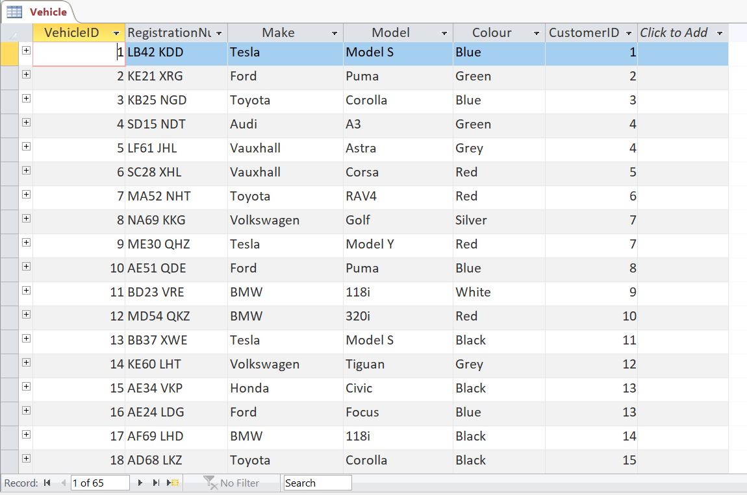
Figure 6: Evidence of Vehicle Data
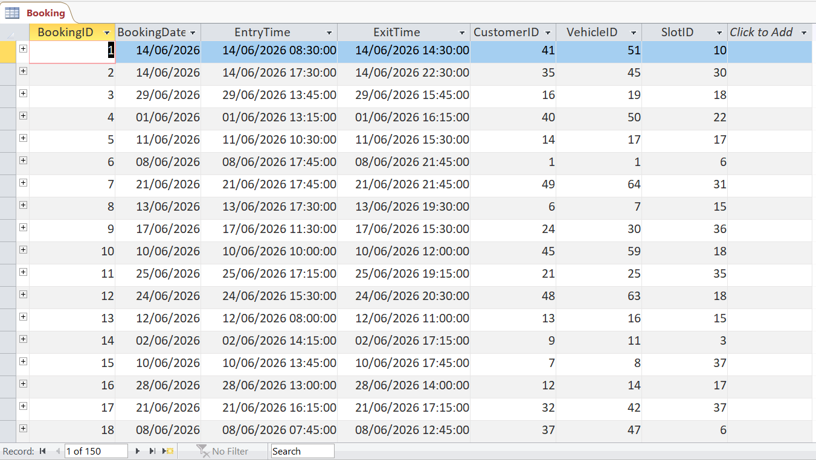
Figure 7: Evidence of Booking Data
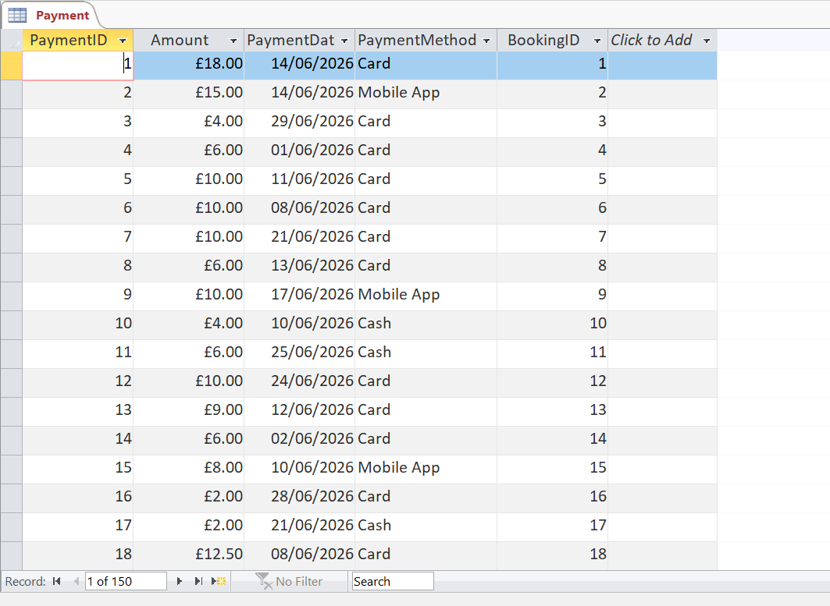
Figure 8: Evidence of Payment Data

Query Development

Query 1: Complete Booking Details
This query displays complete booking information by combining customer, vehicle, parking slot, and payment details into a single view.

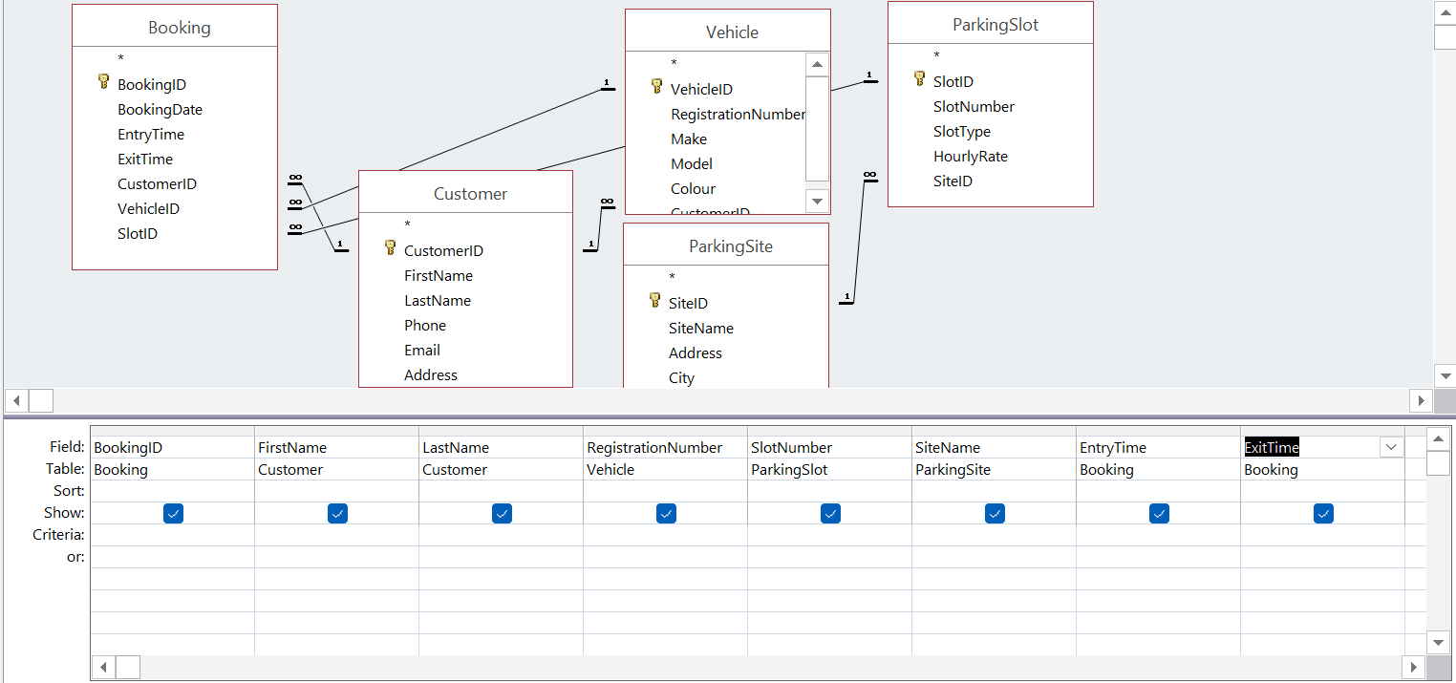
Figure 9: Query Execution for Booking Details
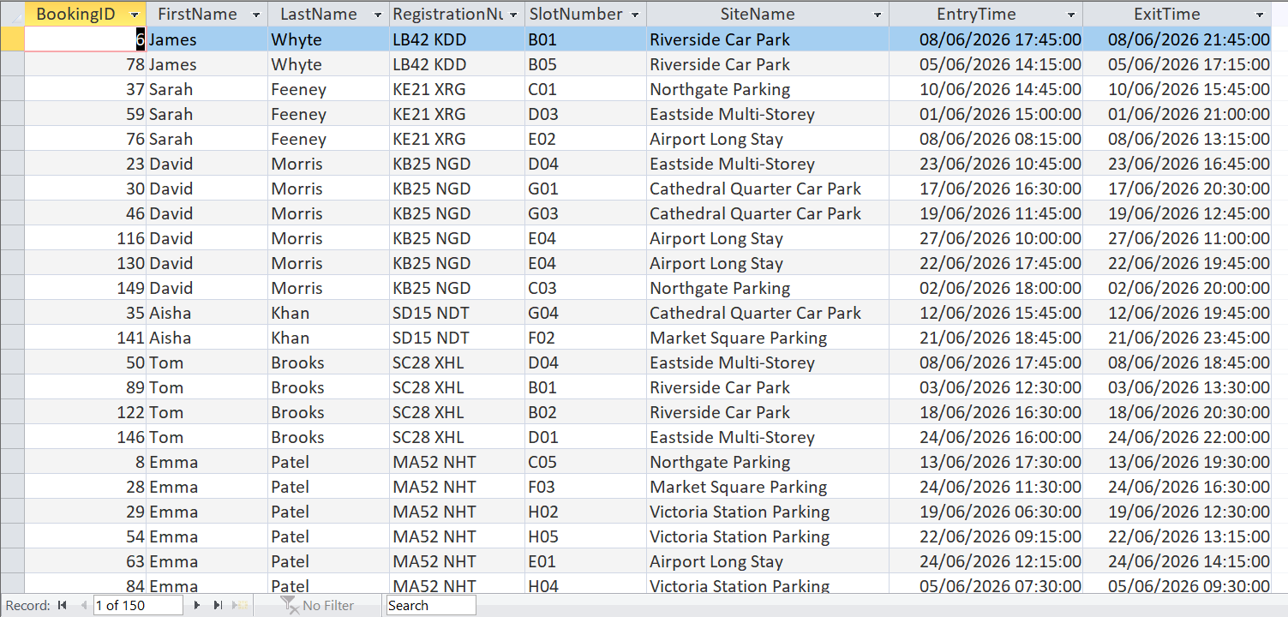
Figure 10: Result of Bookings Details

Query 2: Revenue per Site
This query calculates the total revenue generated by each parking site. This will help in evaluating its financial performance.
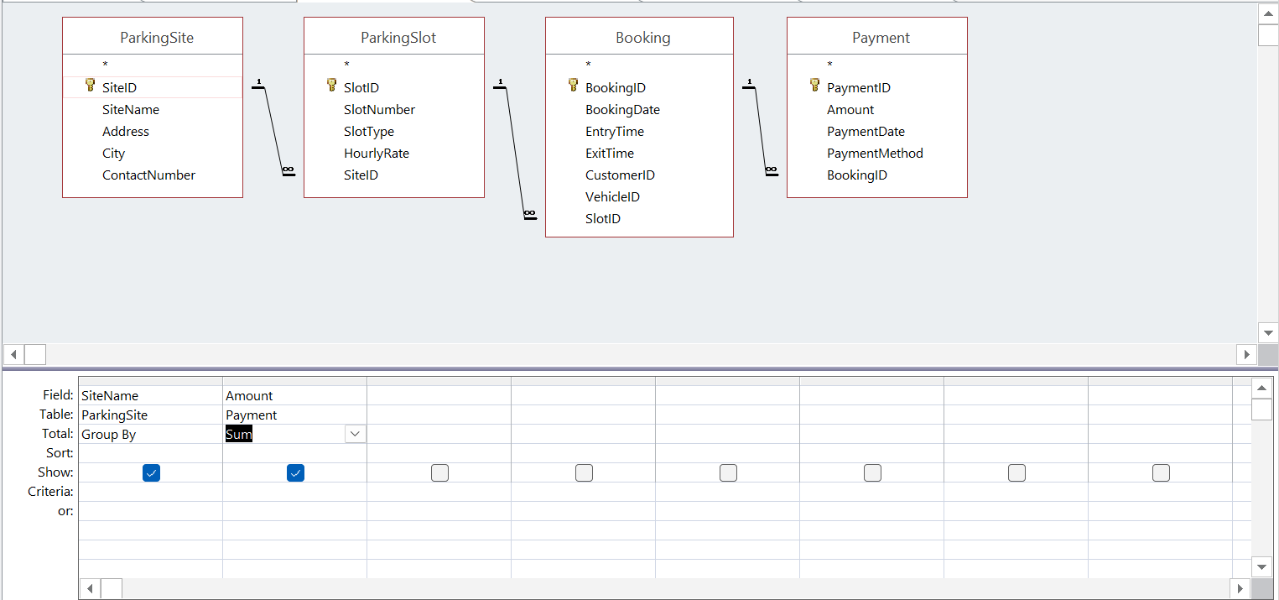
Figure 11: Query Execution for Revenue per Site
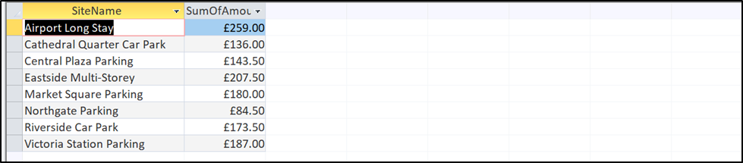
Figure 12: Results for Revenue per Site

Query 3: Most Demanding Site Name
This query identifies the parking site with the highest number of bookings, which means the most frequently used location.
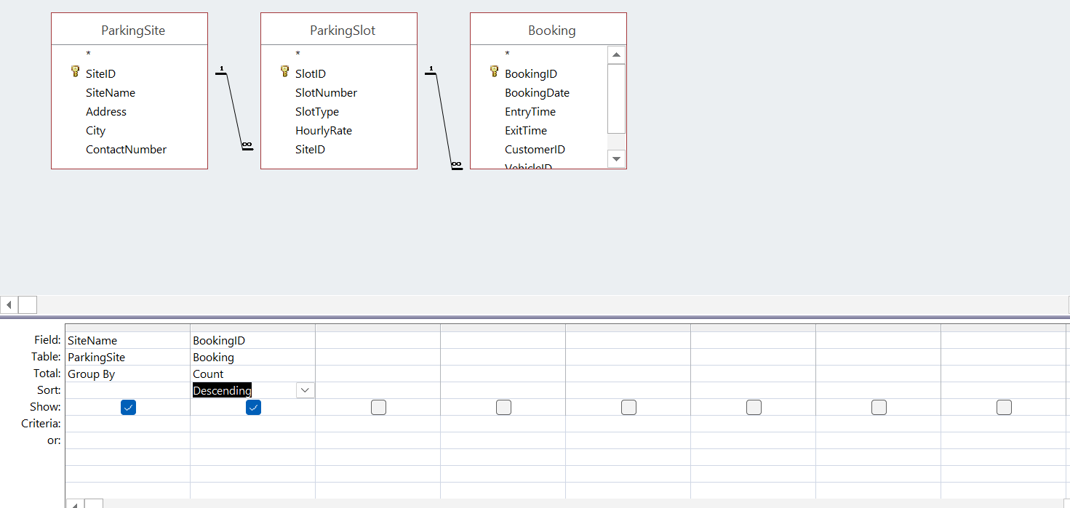
Figure 13: Query Execution for Most Demanding Site
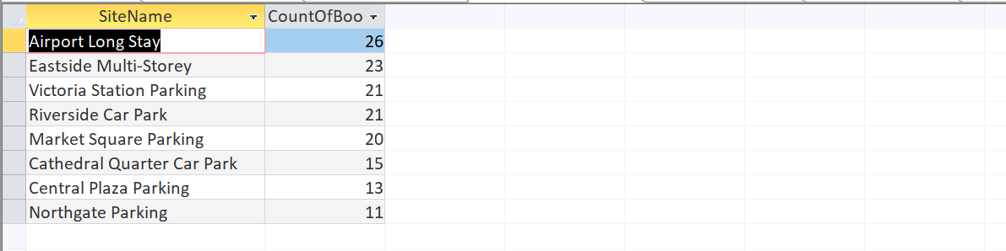
Figure 14: Result for Most Demanding Site

Query 4: Vehicle Parked at Particular Time
This query displays vehicles that were parked during a specified time period based on their entry and exit times.
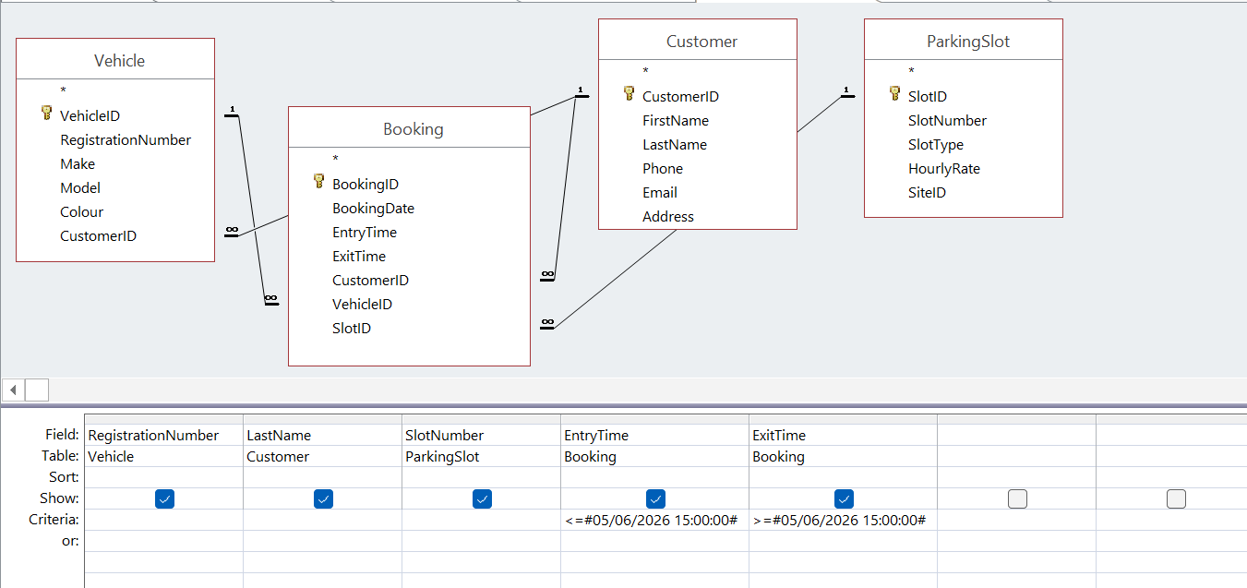
Figure 15: Query Execution for Vehicle Parked at Particular Time
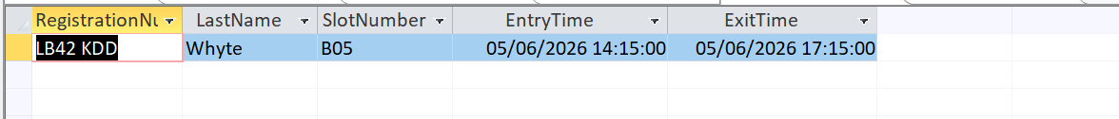
Figure 16: Result for Vehicle Parked at Particular Time

Query 5: Vehicle Parked in a Particular Slot
This query retrieves the details of the vehicle parked in a selected parking slot for easy identification and slot management.
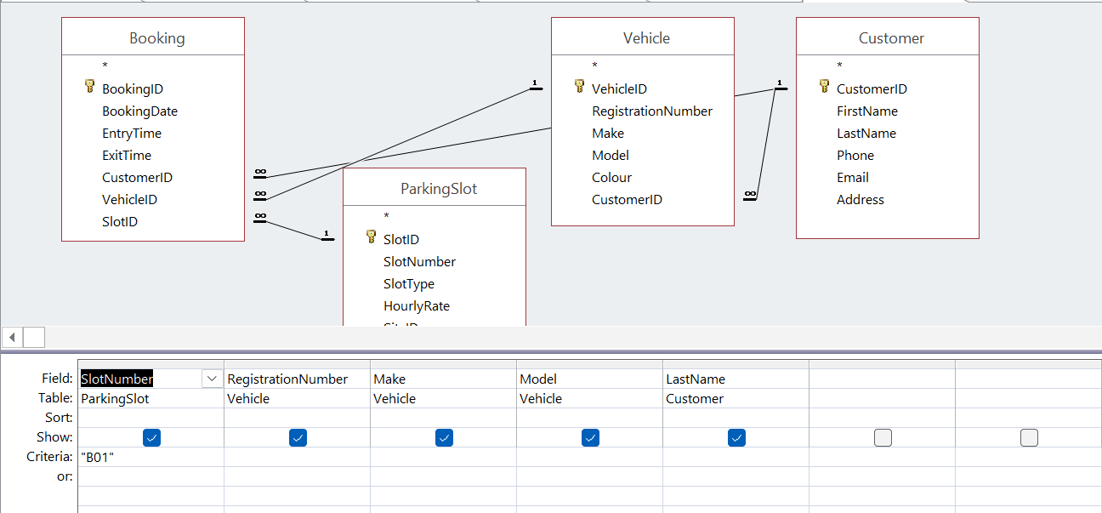
Figure 17: Query Execution for Vehicle Parked at a Particular Slot
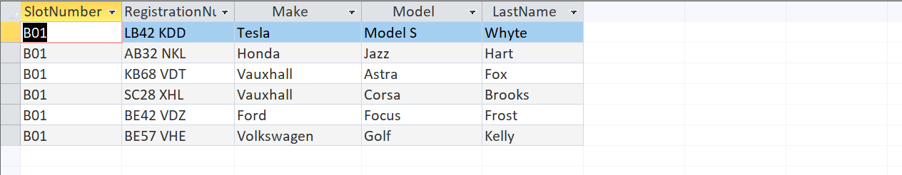
Figure 18: Result for Vehicle Parked at a Particular Slot

Validation and Testing
The database was tested to verify that it met the functional requirements [5]. Various test cases were performed by entering valid and invalid data to ensure that validation rules, required fields, and referential integrity worked correctly. The results of the testing are shown in the table and Figure below.
Table 8: Description on Validation and Testing
Test No. | Functional Requirement | Test Performed | Expected Result | Actual Result | Status
Test 1 | Slot Type Validation | Entered "Gold" as the Slot Type. | The system should reject any value other than Standard, Disabled, or Electric. | Access displayed the validation message and prevented the record from being saved. | Pass
Test 2 | Email Validation | Entered an email address without the @ symbol. | The system should reject invalid email formats. | Access displayed an error message requesting a valid email address. | Pass
Test 3 | Payment Method Validation | Entered "PayPal" as the payment method. | Only Cash, Card, or Mobile App should be accepted. | Access displayed a validation message and rejected the entry. | Pass
Test 4 | Hourly Rate Validation | Entered 0 as the hourly parking rate. | The hourly rate should be greater than zero. | Access displayed an error message and prevented the record from being saved. | Pass
Test 5 | Amount Validation | Entered a negative payment amount (-4). | Payment amount should not be negative. | Access displayed an error message and rejected the value. | Pass
Test 6 | Referential Integrity | Entered a BookingID (999) that does not exist in the Booking table. | The system should prevent creation of orphan records. | Access displayed a referential integrity error and prevented the record from being added. | Pass
Test 7 | Required Field Validation | Attempted to save a ParkingSite record without entering SiteID. | Required fields must not be left blank. | Access displayed a message requiring the SiteID before saving the record. | Pass

Test 1: Slot Type Rule
Slot type accepts only Standard, Disabled or Electric. Let’s try Slot Type “Gold”
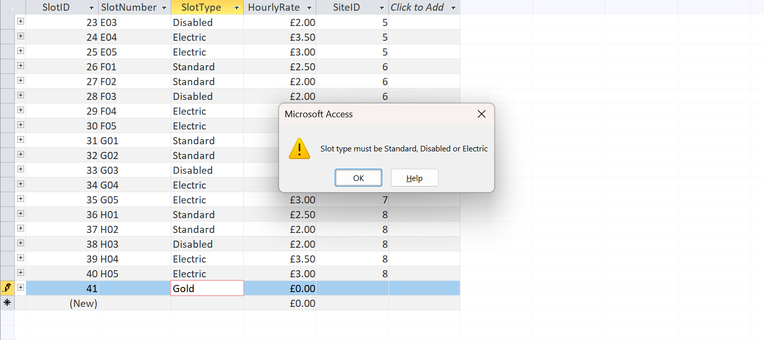
Figure 19: Testing for Slot Type Rule

Test 2: Email Rule
Email must contain a “@” sign. Let’s try an email without “@”
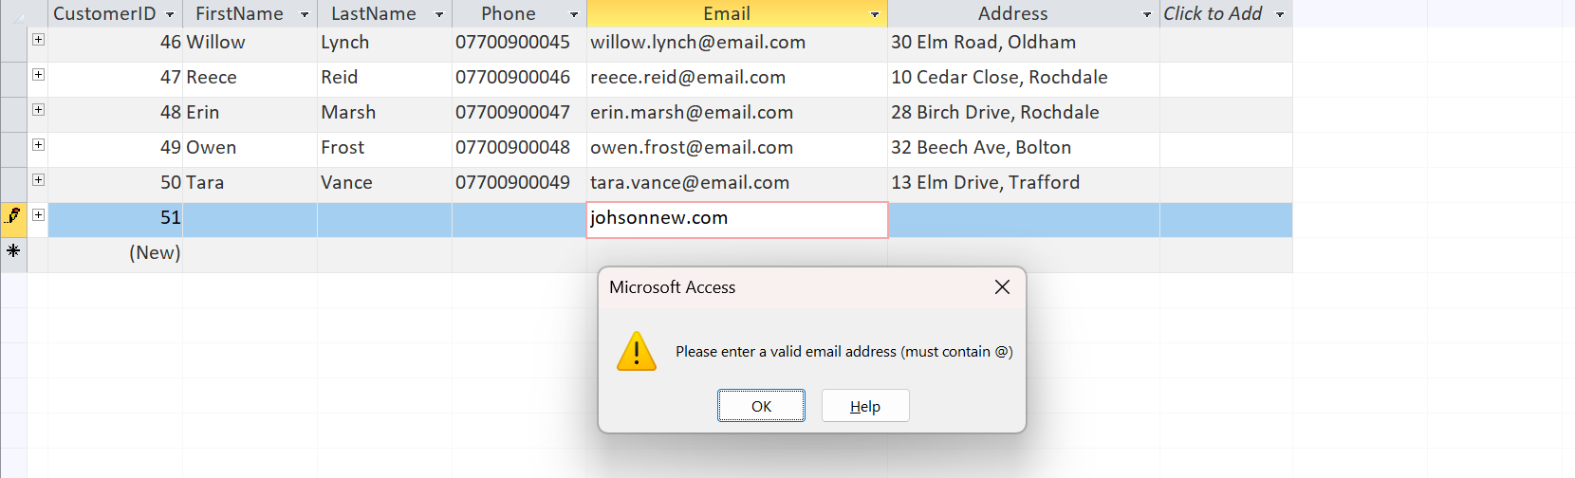
Figure 20: Testing for Email Rule

Test 3: Payment Method Rule
Payment method accept only Card, Cash or Mobile App. Let try another word such as “PayPal”.
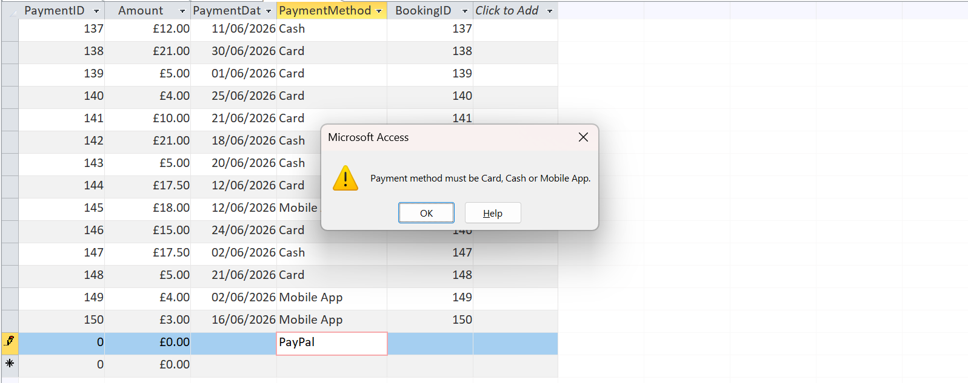
Figure 21: Testing for Payment Method Rule

Test 4: No Zero Rule
Hourly rate and amount must be greater than zero. Let’s add “0”
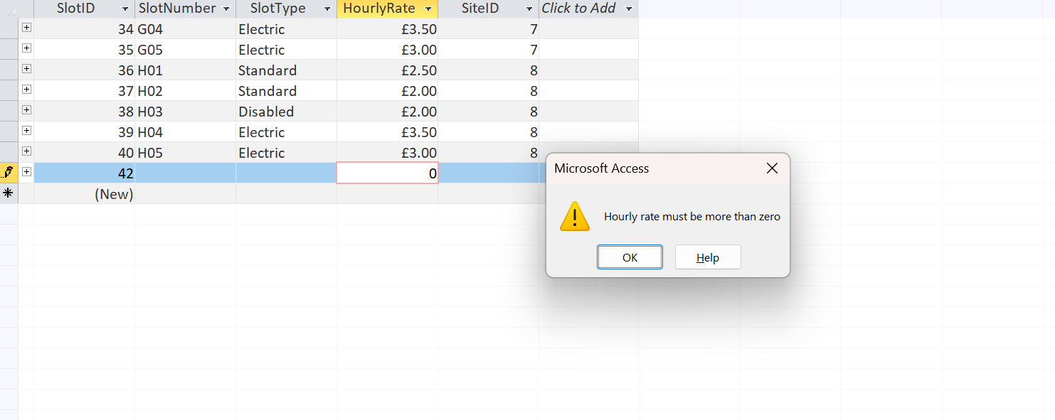
Figure 22: Testing for No Zero Rule

Test 5: Non-Negative Amount
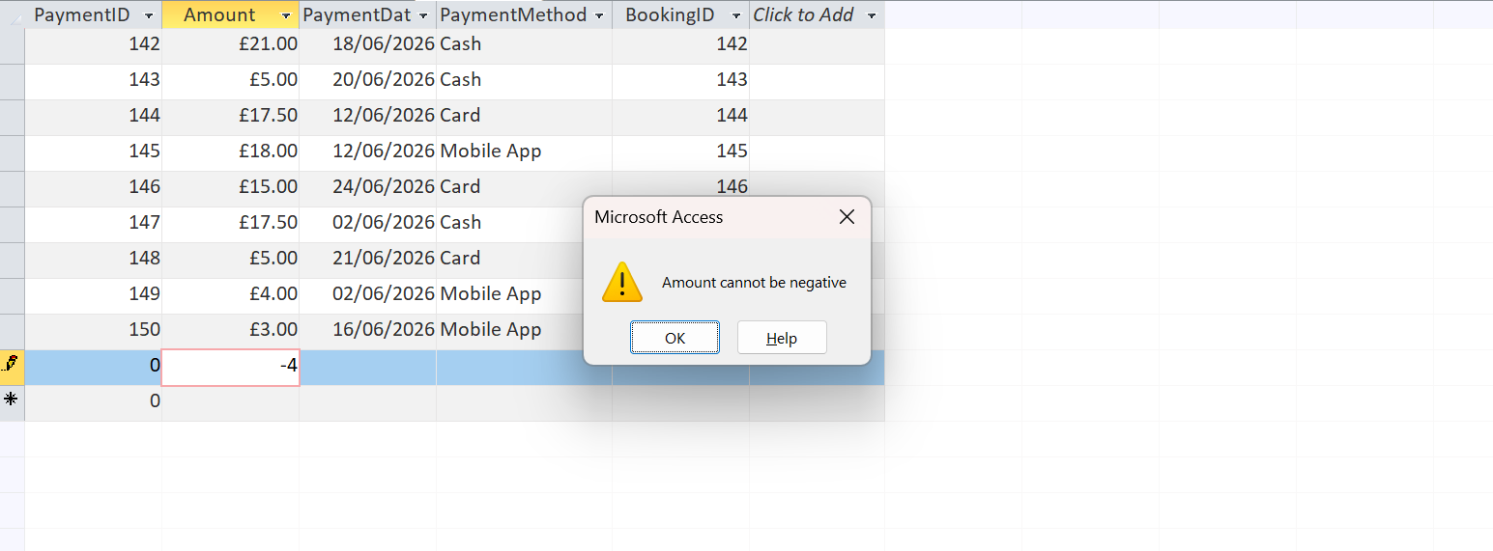
Figure 23: Testing for no Negative Amount

Test 6: Referential Integrity
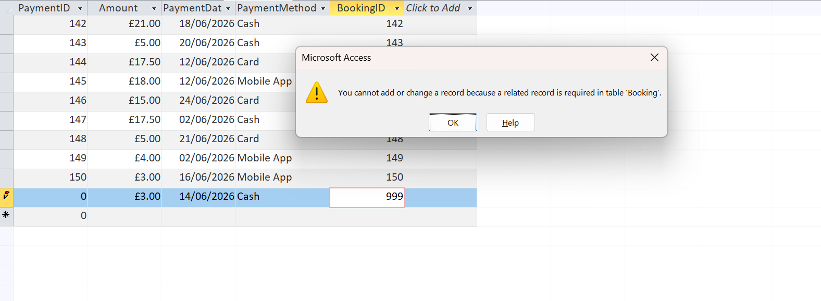

Test 7: Required Field
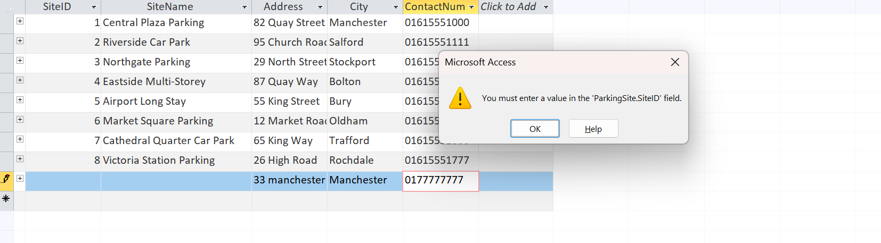

Design Decision
The data has been split into six tables, each representing one of the topics, so that there is no repetition and the data is kept tidy [1]. AutoNumber fields give a unique identity to each record, irrespective of the value in the field; the identity is guaranteed by the field type AutoNumber. Foreign keys have been added as a Number (Long Integer) field and then added to the Relationships window with referential integrity enforced, as a result of which the tables cannot fall out of step [4]. Validation rules have been introduced to eliminate bad data at the input stage instead of correcting it afterwards. The link between Booking and Payment was deliberately modelled as one-to-many rather than one-to-one: although each booking currently has a single payment, this leaves room for realistic situations such as a part-payment followed by a balance, or a later refund, without having to redesign the database [1].
The biggest problem I had was that I had to learn that the simple addition of a Number field is not sufficient to make it a foreign key, but that the relationship line between tables had to be drawn. One more helpful lesson was learned when performing a search that was denoted by a query but returned nothing: First, determine what values actually exist in the data before assuming that the query was incorrectly written. Addressing these problems helped to gain a better understanding of how a relational database operates.

Future Work
Several improvements can come in the future. The calculated field might be able to return the fee as the length of stay, and the hourly slot rate will be entered, rather than being entered by hand. A data entry form would allow staff to not manually access the tables and help to prevent errors. A check could be used to make sure the same slot is not reserved for concurrent times. Lastly, it would be beneficial to have a report that is a summary of the income by site and by month, so the company could get a glimpse of which car park is busiest [1].

References
[1] T. Connolly and C. Begg, Database Systems: A Practical Approach to Design, Implementation, and Management, Global Edition. Pearson Education, 2015.
[2] R. Elmasri and S. B. Navathe, Fundamentals of Database Systems. Pearson Education, 2015.
[3] Microsoft, “Video: What is Access? | Microsoft Support.” Accessed: Jul. 09, 2026. [Online]. Available: https://support.microsoft.com/en-us/access/training/video-what-is-access
[4] A. Silberschatz, H. F. Korth, and S. Sudarshan, Database System Concepts. McGraw-Hill Education, 2020. [Online]. Available: https://books.google.com.pk/books?id=5xbQuwEACAAJ
[5] C. J. Date, An introduction to database systems. Boston : Pearson/Addison Wesley, 2004. Accessed: Jul. 09, 2026. [Online]. Available: http://archive.org/details/introductiontoda0000date
[6] E. F. Codd, “A relational model of data for large shared data banks,” Commun. ACM, vol. 13, no. 6, pp. 377–387, Jun. 1970, doi: 10.1145/362384.362685.

