Data Analytics Part 1
Descriptive Statistics
 | N | Minimum | Maximum | Mean | Std. Deviation
% with Health Status is Poor or Fair | 94 | 14 | 34 | 21.47 | 5.054
% with Respiratory Illness | 94 | 8 | 20 | 13.76 | 2.430
% with Diabetes | 94 | 3 | 10 | 5.94 | 1.343
% with BMI is Overweight or Obese | 94 | 48 | 63 | 55.81 | 3.952
% with Mental Illness | 94 | 4 | 14 | 9.62 | 2.338
% are Smokers | 94 | 14 | 36 | 25.37 | 4.207
Valid N (listwise) | 94

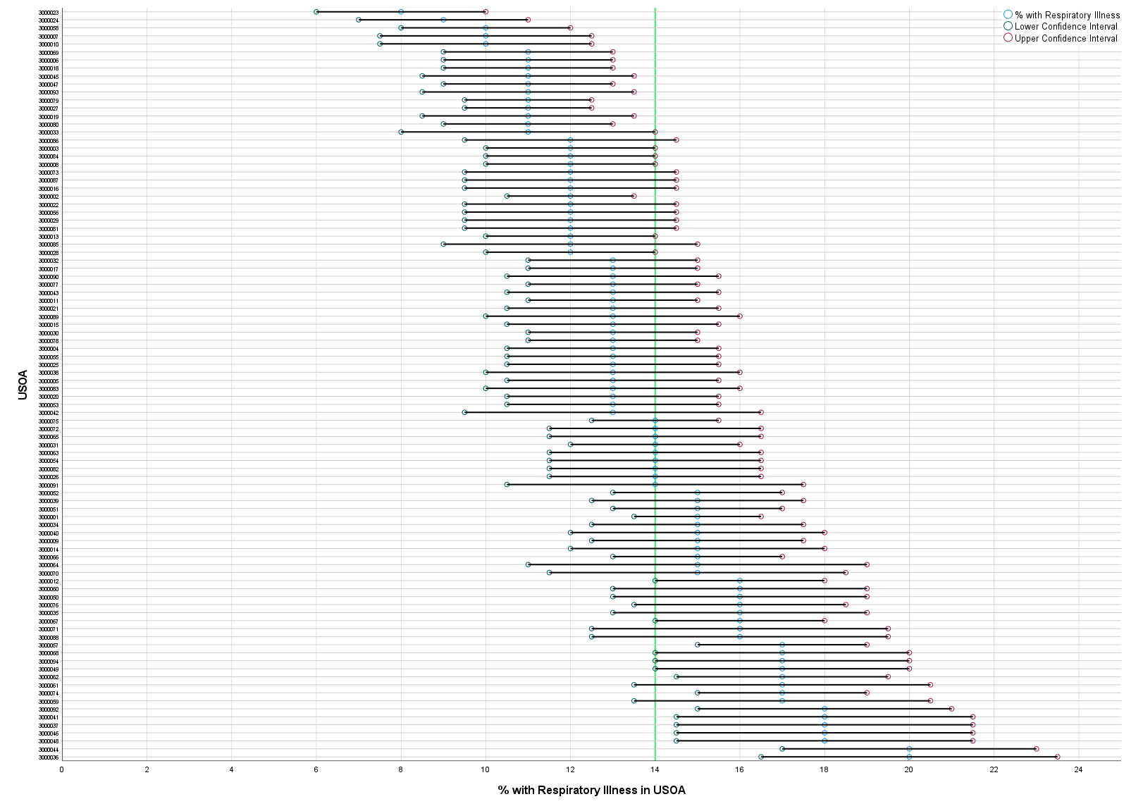

Explanatory Commentary
By itself this the table and graph do not contribute much to describing of prevalence of disease in Wales. Whilst “% with Health Status is Poor or Fair” and “% are Smokers” have similar ranges and means, the standard deviation is different and suggests a different spread in data points. Further analysis of this table would need to be completed to identify trends between datasets than suggests congruence. For example, normalising results may make for more suggestive data.
In the chart, the data shows that 26 of the 94 USOA have values that statistically significant to the index line for Wales. Therefore, there are other variables to be explored in these areas that differ to the remainder of Wales. One of these variables will be quality of air. Air pollution data could be used to see if there is a correlation between respiratory illness incidences as the quality of the air. Deprivation data such as education level and household incomes in the USOA could also be used to see if there are similar correlations with health data. The prevalence of smokers could also be compared with the data at a USOA level. The hypothesis would be that higher prevalence of respiratory illness is linked to higher prevalence of smokers.
The access to recreational amenities and adoption of the amenities will also be factor that could be explored. For examples, USOAs with a higher ratio of gyms per 100,000 (highlighting demand) should have a lower incidence of respiratory illness.

Data Analytics Part 2 – Dissertation Design: Research into the impacts of a digital onboarding process and how it can be improved upon
A fundamental part of the staff onboarding process is the creation and provisioning of digital services. Over the decades the access to ICT has evolved from the privilege of a few to an essential resource for all. Now, every staff member is expected to be able to access a digital resource from any location, on any device, at any time. The creation of identities, provision of assets, configuration of access roles and introduction to the ecosystem of digital services is the digital onboarding process.
To enable this an organisation must manage who has access to its digital resource, what assets are available to them to access these resources. They also need to ensure staff or other individuals are able to access support to use these resources and assets effectively. To manage access to digital resources a digital identity must be created. The identity can be provided security credentials that both enable access and function for a resource. This identity can then be used across multiple other resources, but not all. Therefore, a single employee may have several digital identities they can use to access the various resources.
The digital identity is only one facet of the digital experience for an employee. The employee will need equipment to access digital services, knowledge of how programs and services are used by the Health Board, and the competency to use these systems. For example, the digital resources required by an Executive Director will differ to those of a Porter. The creation of a digital identity, provision of resource and support for employees is principally managed by four service desks (ICT, Digital Services, Human Resources and Powys Applications Team) that each action elements of the new employee process. The ICT service desk is managed by the local council and the Health Board manages the remaining service desks.
Figure 1 illustrates the interaction of the elements described so far to show a simple schematic of the onboarding process. A failure at any point has downstream consequences on patient care and employee productivity.
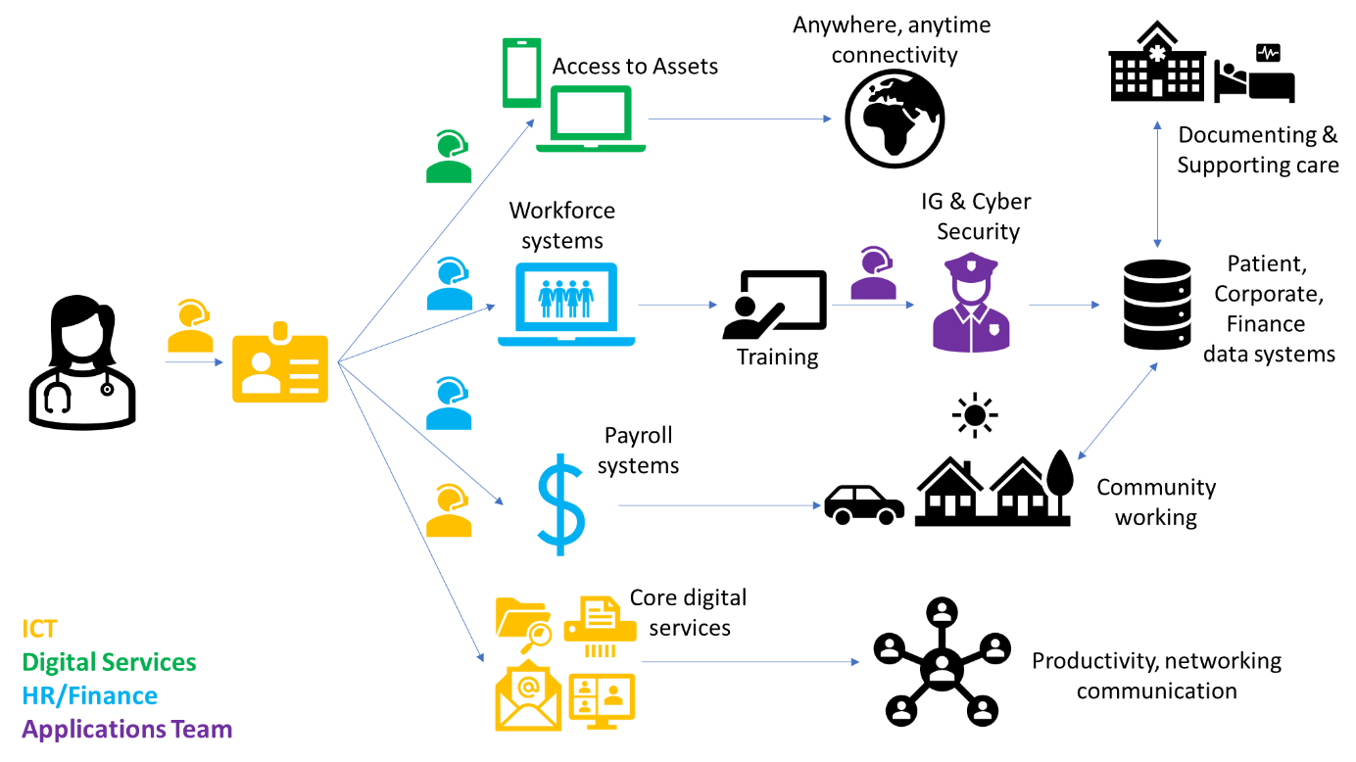
Figure 1 - Simplified rich picture of the onboarding process. Not every employee is a clinician and not every employee needs the same access to systems or assets. However, the impact of a service desk failure or failure to contact a service desk can have consequences
The chart below illustrates the number of requests received by the ICT service desk for the creation of a NADEX identity. On average, the ICT service desk will receive 5/6 requests on each business day. The action of fulfilling the request is around 10 minutes, therefore these requests represent 1 hour of operational time prior to the actioning of any further requests. This work is done in tandem with requests from employees for support with digital resources that they are unable to use or that are not functioning correctly.

Figure 2 - Requests received by the ICT ServiceDesk for new accounts (NADEX), access to a clinical system and access to a VPN
The challenges are ensuring:
- the requestor provides actionable intelligence and knows where to provide it to enable the completion of all requests prior to the start date
- the requirement for digital assets is identified early enough so that equipment like laptops and mobile phones are in ordered, provisioned, tested, and delivered ready for the employee start
- the delay between accessing the organisational training system (ESR) is as short as possible so that required training is completed to then request access to clinical systems
- providing new employees with a relevant onboarding experience that enables them to understand the digital resources available to them and how to use them within their role
If any of these do not occur there is an avoidable operational impact because the new employee is unable to undertake their role or utilise the resource, they are provided. This impact is cost wasted on staff not performing their role, pressures on resource as other staff support resolving the ICT issues, apathy using digital systems, growing cyber security risk and more service tickets for ICT.
The scope of this project is to look at:
- The digital systems are available to employees in the Health Board
- Employees will only include those who are directly employed by the Health Board and exclude contractors or commissioned services
- The types of digital employees/personas present in the Health Board and their requirements
- The dataset required to action requests, dependencies, and routes to making the request
- Employee experience
- Trends in tickets generated by newly created employees
The project will not look at managing the removal of digital identities and return of equipment.
Project aim and Research Objectives
The aim of this project is to critically review the current digital onboarding process for new employees and see if it is responsible for operational issues that could be averted in the short and long term. By understanding what needs to be completed when creating a new employee, supporting requestors through this process and providing new employees with a knowledge resource that actively supports them should reduce the likelihood a new employee is not delayed in undertaking their role because of ICT issues.
The importance of effective employee onboarding is summarised and discussed by Caldwell and Peters (2018). Whilst the paper looks at the larger onboarding process from a macro perspective, the digital onboarding process contributes to the success of the total onboarding process and therefore insights are applicable. Caldwell and Peters (2018) build on prior research and experience to:
- highlight twelve ethical perspectives that new employees will feel are owed to them when joining a new organisation
- show how not catering to these perspectives erodes trust and delays the generation of value
- define ten elements that should be included in any good onboarding process
It is valid to look at the digital onboarding process, whilst part of the wider organisational process, as a distinct process that requires specific focus and research. For many roles within the Health Board, it can be expected that the knowledge of how to undertake a role already exists in a new employee. For example, we can assume that technical competency in placing a catheter has been assessed during the recruitment of a district nurse. This process will be the same amongst organisations. However, the digital ecosystem is likely to vary between organisations due to differing priorities in adopting specific technologies. Nonetheless, the competency in using digital technology and adopting new ways of working digitally is the greater equaliser in the organisation.
It is important to state that the aim is focusing on what can be controlled and not what cannot be. For example, the requirement for creating new employees in various systems and how they interact with each other is not within the scope of this project. However, it is possible to change the quality and interactivity of guidance that supports employees with making requests and understanding the tools available to them is.
The objectives of the research will be to determine:
- What is the experience of staff and services involved in the digital onboarding process and what is needed to improve it?
- On implementing a resource to improve the process, is the resource usable and an improvement on the previous experiences?
- What are the initial impacts of this new digital onboarding process and is there an opportunity for further investment?
Therefore, the primary research question needs to represent the research objectives and allow for the design of a study to answer it. It is suggested this is “Can operational burdens caused by digital services be reduced by redesigning the digital onboarding process for a new employee in a Welsh Health Board?”
To ensure this primary research question is both feasible and going to provide reliable results it needs to adhere to the PICOT framework. This reduces the likelihood that during the design and conduct of the study there are no methodological difficulties (Fandino, 2019). The PICOT framework is an acronym for Population or Problem, Intervention or Exposure, Comparison or Control, Outcome, Time (Aslam and Emmanuel, 2010; Fandino, 2019; John Hopkins University & Medicine, 2022). Below, the PICOT framework is applied to the research question.
Population - The population will be the employees of a Welsh NHS Health Board.
Intervention - The intervention will be the redesign of the digital onboarding process to address operational impacts that the current process causes.
Comparison - The study will compare historical data and qualitative data from existing staff with new data after the intervention is implemented.
Outcome - The outcomes measured will be the occurrence of identified operational impacts.
Time- The study will be longitudinal and evaluate the impacts of the onboarding process both prior to and after the implementation of a new digital onboarding process.
The practicality of wording a research question to direct a study is only part of what makes for a good research question (Aslam and Emmanuel, 2010; Fandino, 2019). It must also be practical so it can be answered with the resources available, will contribute to the knowledge base and can be conducted ethically. The FINER criteria (feasible, interesting, novel, ethical and relevant) are used be researchers to make sure the study design and methodology is appropriate (Aslam and Emmanuel, 2010). How the FINER criteria apply is described below.
Feasible - The author is currently in the role of ICT Service Delivery Manager and therefore reviewing the digital experience for staff in the Health Board is within their responsibility and authority. Additionally, the ICT service delivery is under review and changes are required to be made to better meet the needs of the Health Board against a backdrop of budgetary constraints and growing demand. Technically, identifying new staff and engaging them to provide information about their experience can be conducted automatically as well as surveying recruiting managers. Further, engagement with system managers is within the gift of the author by the nature of the role.
Interesting - The process of creating new digital employees is one part of the larger joiner, mover, and leaver process in the Health Board. It is identified as a weakness in an auditing report and therefore detailed analysis will provide vital intelligence on how best to direct resource to improve the current processes.
Novel - Initial indications suggest that little evidence has been produced on the impact of the digital onboarding process on operations in a Health Board and the digital service.
Ethical - There are no significant ethical issues with the subject and any issues that do exist will be manageable. There is greater risk of not having this information given the theory it can impact patient care.
Relevant - Understanding the impacts, being able to quantify them and testing the impacts of improvements will help guide the development of processes that are being looked at nationally.
Data Collection and Analysis Methods
The study will be broken into three phases, each utilising a different type of study to answer the research objectives and feed into fulfilling the primary research question.
These three phases will be:
- A needs assessment study that aims to clarify if there is problem experienced by staff and services in the digital onboarding process and what requirements a solution would need to meet
- A usability study to assess the ability of staff and services to adopt and use a solution that contributes to resolving the problem identified
- A problem impact study that seeks to determine how far the new solution addresses the existing problem and the scope for future investment.
Phase 1 – Needs Assessment
The first phase will be a qualitative study into the experiences of staff and services who are either involved in the delivery of the digital onboarding process or have experienced it within the last 12 months. A qualitative study is important here as little is known about the detail of the problem experience short of there is assumed to be an issue. Therefore, as a theory is not being tested but instead developed and inductive approach is called for (Friedman, Wyatt and Ash, 2022).
Initially interviews will be conducted with staff that are involved in the delivery of the digital onboarding process. For example, members of the ICT service desk. These interviews will be semi-structured to allow for exploration of the issue whilst maintaining a focus on the problem. These will be recorded to allow for analysis of the data and identify if there are any common themes or lines of enquiry that could be followed further. A further reason for these interviews to be semi-structured is that for this to be an inductive process there needs to be little in the way of theories to be tested. Additionally, semi-structured interviews rather than fully open allows for the interviewer to maintain focus on the digital onboarding process and reduce the time taken to conduct the interviews. The focus of these interviews will be to understand:
- What are the common issues the staff member/service experience while actioning requests in the onboarding process?
- What do they feel is lacking in the existing process and is in the capability of the Health Board to provide?
Once complete, the next round of data collection will be interviews with staff recently employed by the Health Board and those involved in the onboarding of new employees. To ensure the availability of a good sample of individuals the pool of eligible staff will be those employed or involved in the employment of someone in the last 12 months. Restricting the sample to staff employed from 1st September 2022 ensures that there is a large enough pool of staff available, that impacts of the pandemic are minimised, and to remove the operational impacts of digital projects that were delivered prior to this date. This will ensure that information is transferable and not influenced by the fact that a core service was changed between February 2022 and August 2022.
These interviews will be more structured than the first round. The questions will be determined by the outputs of the first interviews. The aim will be to confirm the findings of the initial interviews, identify a new perspective on the problem and identify requirements that a potential solution could attempt to meet. If a potential solution is known at this point, then this will be presented to the interviewees to comment on.
To assess whether saturation is achieved, the interview responses will be coded into themes. Initially, ten interviews will be conducted in both rounds. The occurrence of themes will be assessed to see if the chances of those themes occurring are by chance or if there are any statistically significant occurrences. If there are not any obvious themes or it cannot be determined that the occurrences are statistically significant then more interviews will be conducted. To add further weight to the themes elucidated from the interviews, the interviewees will be provided a copy of outcome of their interview and invited to approve and/or make clarifications. Seale recommends such an approach, and it is felt this will help resolve issues with not having a fully resourced interview team and improve the validity of the results (1999, cited in Johnson and Senges, 2010).
Phase 2 – Usability
In phase 2 a new solution will have been designed, constructed and the study will then look to show that the solution can be used by those involved in the onboarding process. The data collection will follow a mixed method approach that uses a qualitative approach to ensure that the solution is usable and ready for deployment and then a quantitative approach upon implementation to evidence that it is being used.
This would be a mixed methods approach; the data strategy would be sequential with a qualitative element followed by a quantitative element. A greater emphasis will be placed on the quantitative elements (therefore qual QUAN) as this element will be easier to collect and will come from several data sources.
The initial data collection will be conducted through a focus group of potential users to identify potential flaws in the solution that would prevent adoption. Nielsen suggests that five users could effectively identify around 80% of software problems (1993, cited in Friedman, Wyatt and Ash, 2022). The focus group can be run again if substantial changes are made to the solution. This is a crucial step in answering the primary research question as evidencing the development process will improve the transferability of the results. It would allow others to replicate a similar system by learning from key decisions and aid in a reproducibility study.
The focus group will be shown a demonstration of the new solution and then asked questions afterwards. The session could be conducted to make it easier to ensure all participants have the same visual experience and to aid in the recording and transcription of the group. Questions would be guided by the principles of the System Usability Scale (SUS), created by Brooke (1996), but not assessed in the same way lest it become a quantitative approach. Instead, the questions will be worded more openly. For example, “I found the system very cumbersome to use” would become “Why might someone feel this solution is cumbersome to use?”.
The next elements of this phase will be quantitative in nature to enable scaling up the amount of data being collected and manage resource. This would occur upon implementation of the new system and make use of passive data collection and surveys directed at those who use the system. This data collection would occur over two months to ensure a good sample size whilst not placing pressure on timelines for analysing results and completing the study.
Data will be collected from the Human Resources team to identify recruiting managers and recruited employees who would be expected to use the new solution. To assess the usability of the solution when in production staff will be asked to complete an online survey.
One element of this survey will include questions from the System Usability Scale. The score from these questions will be normalised to produce a percentile ranking (Department of Health and Human Services, 2013). Research suggests that a score of 68 is accepted that a system is usable. This score for the solution will be an average of the normalised scores collected. To support the significance of the results the data will be displayed as both descriptive statistics and a chart that illustrates the average score and 95% confidence intervals. These will be calculated per question and compared to the average score for the solution. This will provide opportunity for discussion on whether trends in responses confirm the usability of the solution.
The second element of this survey will be to determine if the solution was not used and potential reasons it was not used. This will be done to ensure that that the solution meets the requirements first identified in phase 1 and therefore the solution is valid for further analysis. The questions in this survey will be determined by the requirement identified in Phase 1. If the data suggests an issue, then improvements to the solution will need to be made. This is because any final analysis on the impact of the solution will only reflect the capabilities of the version in production, if further significant improvements must be made then the data will no longer be valid.
Phase 3 – Problem Impact
The third phase will involve assessing whether the implementation of a new solution has a significant impact on the original problem. This will be a quantitative approach and whilst is referred to as phase 3, it will run during phase 2. Phase 1 will look to identify what the impacts are for staff and identify quantifiable variables that can be tracked across the study. Prior to the start of phase 2, data will be collected to create a comparable dataset of the reality prior to the intervention and after.
To understand the perspective of users, there will be two surveys. The first survey will be for appointing managers who submit a “New Appointment Form”. This is an electronic form that traditionally initiates the creation of a new staff member and requests the creation of a digital identity. The form offers a valuable opportunity because it arrives via email and therefore provides the opportunity to automate the surveying process and provide timestamped metadata. This survey will be sent several weeks after submission to ensure that time has been provided for an account to be created and other elements of the process to be completed. The lag time from offer to employment will be retrieved from the Human Resources department and rounded to the next whole week. The survey will look to understand whether the manager experienced any of the impacts identified in phase 1 and the extent to which they were impacted. The manager will also be asked closed questions about their satisfaction levels with the process, using Likert and net promoter score elements. The outcomes of these surveys prior to and after the implementation of the solution will be compared. To measure statistical significance, a paired t-test will compare the two datasets to a significance of 0.05. If the p-value is below this, then this will lend weight that the solution has had an impact on the impacts experienced by requesting managers. This will be calculated using the relevant feature in SPSS.
The second survey will be to new employees of the Health Board. These employees will be detected by the emergence of new digital identities that are provided a Microsoft 365 licence. This detection can be automated, and the staff member can be sent a link to an online survey. No attempt will be made to contact the staff member through others means as whilst this would boost survey participation, the lack of participation may be an indicator that the staff member is not able to use the digital resource(s) provided. Similarly, to the first survey, data will be continuously collected from new employees and variables compared either side of the intervention. Further, data from both surveys will be used to confirm impacts. This can be done by using an independent t-test because they are two populations, in this case the null hypothesis would be that there are differences in how the solution improves the onboarding process for both groups. The aim would be to ensure that the solution provides a beneficial impact for both groups.
The final dataset would be to review ticket incidence amongst the four service desks to see if the new solution provides a measurable impact on the workloads for these teams. This dataset will allow for the confirmation of the survey data received. Additionally, because the size of the survey data will not include all staff members the ticket data allows for impacts to be measured on a larger scale. Data would be retrieved from the respective service management tools to assess various performance indicators. The first indicator would be the total number of requests for support being received by the desks. Depending on the quality of the data being stored, the tickets can be categorised to perform more intricate analysis of the specific impacts being felt. For example, a specific reduction in the number of requests to provide access to file storage locations. Second, if impacts can be seen in the ticket data, then this impact can be linked to employment data such as job role and salary. This would allow for impacts to be quantified in terms of money saved and proximity of these impacts to direct patient care. For example, knowing that the impact is limited to administration staff shows that improving the digital onboarding process is unlikely to impact patient care but if the impacts were limited to District Nurses, then improvements to community care could be linked. Another example is that knowing tickets for Band 4 staff took a specific amount of time to resolve and prevented the staff member from working will have a financially quantifiable impact on the Health Board. Regression analyses of the data that can be constructed would help to identify potential trends that could be explored through the data.
Ethical and Information Governance considerations
Voluntary participation
One of the ethical issues with this study is the ability to enable voluntary participation. This is within the gift for only part of the data.
Where it is possible to enable voluntary participation is when recruiting participants for the interviews, focus groups and surveys. For each of these activities’ participants will have the option to engage with the investigator or not. Potential participants will be engaged in two ways:
- Active engagement – The participant may be contacted directly because they are either known to have relevant knowledge by virtue of their job role or have relevant knowledge because they have experienced the problem environment or intervention. For example, emails inviting a staff member to complete a survey on their experience of the process 3 weeks after starting with the Health Board.
- Passive engagement – The all-staff ICT email list and SharePoint intranet will both be used to publicise the study and invite staff members to volunteer to be included in the initial phase 1 interviews and phase 2 focus groups.
The difficulty lies with managing participation where data from the service management tools is being used. On one hand there is a need to ensure a wide dataset of the problem environment whilst allowing the staff member to control the use of their data. However, there should be a reasonable expectation that the Health Board would use internally generated and stored data to improve services. To resolve this, the author intends to support an application to the institutional review board by:
- Discussing the proposed use of the data with the local Data Protection Officer (DPO) to ensure there is the required purpose and lawful basis for using the data
- Provide staff and advertise the opportunity for them to be excluded from analysed dataset. Doing so would mean the investigator is able to ensure requests for data exclude any references to specific individuals or the data is removed at the earliest opportunity.
Emails requesting participation will also be sent from a generic mailbox, rather than the personal address of the investigator. This would remove the impact of bias generated by the relative position of the investigator compared to other staff and any feelings of “owing” the investigator by participating. This will ensure that participants are drawn from those who have their own motivation and views on the problem being studied.
Consent
Similarly, to voluntary participation, providing informed consent is challenged by using data from the ICT service management tools. Asking all staff to review and complete a consent form would not be possible for several reasons. These are:
- The coordination of gaining the consent of 2600+ individuals within a short timescale
- The ethics of asking staff to take the time out of their usual workload to review and fully understand the implications of the study to then provide informed consent
An alternative will be to produce a SharePoint site that communicates the purpose of the study, the benefits, and potential risks relevant to staff. If, upon review, that a staff member wishes to withdraw consent of their data being used they can complete a form to communicate this.
Anonymity and Confidentiality
Maintaining confidentiality and anonymity is important because there is a risk that personal identifiable information present in the ICT service management tool. Moreover, because the risk is being assessed on behalf of staff and assuming consent there is a greater need to ensure that data is secure, minimised and spends the least amount of time in a non-anonymous state. Much of this risk can be reduced by pseudonymising the data at rest. This can be accomplished by using a tool like OpenPseudonymiser (Hippisley-Cox, 2011). As data is created the primary identifier would be pseudonymised using the tool and a consistent salt. The salt allows for the use of the same tool but without the ability of another organisation or actor being able to reverse the pseudonymisation (Hippisley-Cox, 2011).
Full anonymisation is potentially not possible given the dataset will contain a summary of the ICT request. This summary may contain details that would allow for someone to reverse the pseudonymisation. However, this summary data will not be included in any final datasets.
Information Governance
The data being used is created during employees performing a functioning within a public organisation. Therefore, there are only a few information governance implications to consider.
The main solution to the issues is the pseudonymisation of any personal identifiers. By removing the ability for a staff member to identify themselves the data is no longer personal, and the data protection act implications are reduced.
The greatest risk is when requesting data from the ICT service management tools and human resources to match to records. To resolve this issue the data being requested needs to be limited and anonymised. Therefore, the request for an extract will need to be restricted to data for which the study has a purpose, and the primary identifier needs to be pseudonymised prior to sharing with the investigator. A further step would be to remove data rows from this extract where the pseudonymised string is not present in the study database.
However, as described, there is not a guarantee that the summary data taken to describe the ticket request will not contain personal identifiable information and therefore the data is not truly anonymised. A solution to this issue would be to remove the summary data early in the data transformation process and leave only metadata that highlights the nature of the request. Once complete the data could then be analysed for trends.
Finally, the ICT service desk is provided by a Section 33 agreement between the Health Board and a local council. To ensure there is lawfulness in using the data the local council will need to be contacted to ensure existing data sharing agreements allow for the transfer of data for this purpose. To support this a high level Data Protection Impact Assessment (DPIA) will need to be completed.

Appendix
Ethics Approval Form
References
Aslam, S. and Emmanuel, P. (2010) “Formulating a researchable question: A critical step for facilitating good clinical research,” Indian Journal of Sexually Transmitted Diseases and AIDS, 31(1), p. 47. Available at: https://doi.org/10.4103/0253-7184.69003.
Brooke, J.H. (1996) “SUS: A ‘Quick and Dirty’ Usability Scale,” in CRC Press eBooks, pp. 207–212. Available at: https://doi.org/10.1201/9781498710411-35.
Caldwell, C. and Peters, R.J.G. (2018) “New employee onboarding – psychological contracts and ethical perspectives,” Journal of Management Development, 37(1), pp. 27–39. Available at: https://doi.org/10.1108/jmd-10-2016-0202.
Department of Health and Human Services (2013) System Usability Scale (SUS) | Usability.gov. Available at: https://www.usability.gov/how-to-and-tools/methods/system-usability-scale.html (Accessed: May 20, 2023).
Fandino, W. (2019) “Formulating a good research question: Pearls and pitfalls,” Indian Journal of Anaesthesia, 63(8), p. 611. Available at: https://doi.org/10.4103/ija.ija_198_19.
Friedman, C.P., Wyatt, J.C. and Ash, J.S. (2022) Evaluation Methods in Biomedical and Health Informatics, Computers in health care. Springer International Publishing. Available at: https://doi.org/10.1007/978-3-030-86453-8.
Hippisley-Cox, J. (2011) “OpenPseudonymiser.” University of Nottingham. Available at: https://www.openpseudonymiser.org/OpenPseudonymiser_Software.aspx.
John Hopkins University & Medicine (2022) Welch Medical Library Guides: Expert Searching: Formulating Your Research Question. Available at: https://browse.welch.jhmi.edu/searching/formulating-research-question (Accessed: May 20, 2023).
Johnson, M. and Senges, M. (2010) “Learning to be a programmer in a complex organization,” Journal of Workplace Learning, 22(3), pp. 180–194. Available at: https://doi.org/10.1108/13665621011028620.

