Data Handling and Business Intelligence component 2
Part 1

By

Student name: Toader Ionica

Institutional Affiliation: University of Wales Trinity Saint David
Lecturer: Zahra Mohammadnazari
Model Code: LCBB5000
Date: November 18, 2023

Table of Contents
Part 1 3
a) Using Excel to discuss and analyse the GreenMed_Healthcare_2023 Dataset. 3
1. Mean processing time when using Hadoop. 3
2. Median Processing time when using Spark. 3
3. Highest processing time in R. 3
4. Standard Deviation for processing time using Python. 4
5. Lowest average processing time across the dataset. 4
6. Interpret the difference in processing times across different tools or platforms. 4
b) Using MS Excel - Charts and Graphs 5
i. Pie Chart. 5
ii. Bar graph 7
iii. Scatter chart 8
c) Using SPSS, 10
1. To find the correlation between processing times of Hadoop and Tableau. 10
2. To produce a scatterplot for the two variables. Using Hadoop on the Horizontal axis and Tableau on the vertical axis. 11
References 14

Part 1

Using Excel to discuss and analyse the GreenMed_Healthcare_2023 Dataset.

Mean processing time when using Hadoop.
Mean is the average value in a given dataset. To calculate the mean/ Average in a dataset using Excel, we use the formula =AVERAGE(Range) function. Where Range is values in that specific range. In this case, we are required to find mean processing time when using Hadoop, so we use the second column range. As shown in the Excel, formula =AVERAGE(B2:B51) hence the Mean/Average is 2.776889208.

Median Processing time when using Spark.
Median is found by arranging the all the data points in ascending order and pick out the one in the middle. In cases where, there are two numbers in the middle, you find the average of the two. The median serves as a robust measure of central tendency, particularly in scenarios where extreme values or outliers might skew the data. Its calculation involves arranging all data points in ascending order and identifying the middle value. When there's an even number of data points, resulting in two values at the center, the median is determined by calculating the average of these two middle values.
This statistical method is particularly useful because it isn't influenced by extreme values, unlike the mean, which can be significantly affected by outliers. The median's resilience to outliers makes it a valuable measure in skewed distributions or datasets with irregularities. Its calculation relies solely on the middle position of the data, providing a representative value that accurately reflects the central tendency of the dataset.
To find the Median of a dataset using Excel, use the formula =MEDIAN(range) and select the range of values on the second column, that is Spark processing time. As shown in the Excel document, =MEDIAN(C2:C51) therefore the median is 2.746910366.

Highest processing time in R.
To get the highest figure in a specific dataset in Excel. In a cell, type =MAX(range), range=(D2:D51) then select a range in the R processing column, then close the parenthesis and press ENTER. In this case, =MAX(D2:D51), the Highest or maximum value is 4.867451715 in cell D17. Therefore, on 2023-01-16 is when we had the highest processing time.

Standard Deviation for processing time using Python.
The standard deviation gives you how much the data deviates from the mean of the data set. So, in this case, we use the formula for a Population, that is, =STDEV.S(E2:E51). Then press enter, the value for Standard Deviation in Python column is 1.297205735.

Lowest average processing time across the dataset.
To find the lowest average across the dataset, we first find the mean/ average of each dataset. Then we identify the lowest from the average. In a cell, use the formula to find the Average, =AVERAGE(range) then click enter, in this case the range would be (B2:B51). Once you get the value, you drag it across the entire row to the last category (Tableau processing time). Using the values from the Average on each column, use the formula =MIN(range), where range(B57:F57). Then click enter, the value you get 2.573181096. Therefore, Spark processing time has the lowest average value across the dataset.

Interpret the difference in processing times across different tools or platforms.
As a Data analyst intern at GreenMed Innovations and based on the data provided, in order to interpret the differences in processing times across these platforms, that is, Hadoop, Spark, R, Python and Tableau for the period 01/01/2023 to 02/19/2023. We can use the following approach:

Mean/ average processing times for the five tools.
We can use Excel to find the average across the platforms. The formular =AVERAGE(range) then drag across the other values to get the average for each tool.
- Hadoop processing time– 2.7768
- Spark processing time – 2.9322
- R-processing time – 2.7548
- Python processing time – 2.5732
- Tableau processing time – 2.8303
From the average processing time, Spark has the highest average time 2.9322 while Python has the lowest average of 2.5732. Therefore, Python is the fastest on average, followed closely by Tableau then Hadoop and R almost at tie. Spark is the slowest on average and hence the least recommended for data analysis.

Standard Deviation
We can use Excel to find the standard deviation across the platforms. The formular =STDEV.P (range) then drag across. The values are as follows,
- Hadoop (1.202)
- Spark (1.304)
- R (1.261)
- Python (1.284)
- Tableau (1.122)
Tableau with the lowest indicates the most stable or consistent processing time whereas Spark with the highest indicates a less consistency. Therefore, as a data analyst the most recommended is the one with the lowest standard deviation since it has the most consistent and stable processing time.

Using MS Excel - Charts and Graphs
Excel is a tool that is widely used in data management by most organizations for data analysis and interpretation. A graph is an Excel tool that is used to visualize data in a worksheet. There are different types of graphs and charts that is used to represent data. There are different types of graphs and charts available in excel, include Pie Chart, Bar/Column graph, Line graphs, area chart among other. In this case we will talk about Pie chart and Bar/Column graph (Simplilearn, 2023).

Pie Chart.
As the name suggests, it is used to visualize data as a circle and show proportions as a whole. It is used to compare data in an easy way. There are other different pie graphs such as 3D pie chart, pie of pie, bar of pie or doughnut graph (Thakur, 2023). Using the data provided in Excel for GreenMed Healthcare. Select the data provided in the worksheet. Click insert to select the type of chart you’d like to insert, in this case, we select a 2D-pie chart. Alternatively, you can use select the data and click on recommended charts, it will give you the best options in relation to the data.
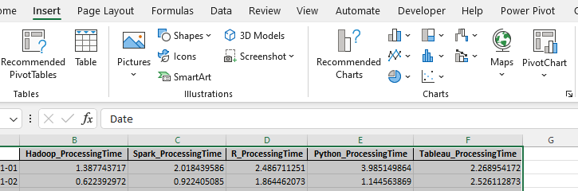
Figure 1: Snapshot from Microsoft Excel
From the drop-down menu, select the specific style to be applied. Based on the data selected, Excel will automatically generate the Pie chart.

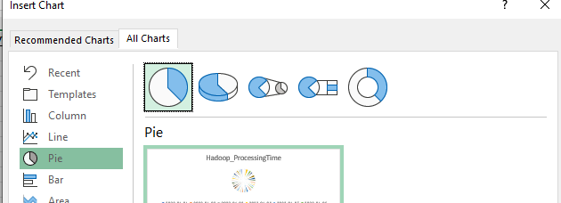
Figure 2: : Snapshot from Microsoft Excel
To change the design, format or layout of the pie chart, click on it and select tools. To change the title of the pie chart, click on the existing title and type and new one. To edit the chart elements, such as the labels select “Add Chart Element’ from the design tab. Adjust the labels to show the category and percentage.
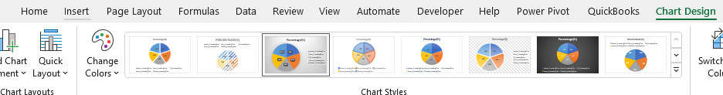
Figure 3: Snapshot from Microsoft Excel
To change the visual style, use the ‘Format Tab’. Then review the pie chart to ensure that the data is accurate, clear and easy to interpret.

Figure 4: Snapshot from Microsoft Excel

Bar graph
Bar graphs, also referred to as column graphs, serve as effective tools for comparing values within a specified range or category. Their versatility lies in depicting various types of data relationships. Different forms of bar graphs exist, each catering to distinct visualization needs. Among these types are clustered columns, stacked columns, and 3-D columns, each offering unique ways to present and interpret data. Clustered columns portray multiple sets of data, allowing easy comparison between different groups or categories within a single bar for each group. Stacked columns, on the other hand, show parts of a whole by segmenting each column into sections representing different components, enabling viewers to visualize both individual values and their contribution to the total.
The 3-D column graph introduces depth to the traditional two-dimensional representation, providing a visually enhanced perspective. This type adds a sense of dimensionality, making the comparison more visually engaging, especially for larger datasets. These various forms of bar graphs are particularly advantageous for expanded datasets. Their ability to handle and display a wide range of data points or categories makes them useful tools for visualizing complex information. By presenting data in a structured, comparative manner, these graphs facilitate easier analysis and comprehension of trends or patterns within the dataset (Thakur, 2023).
Using the data provided in Excel for GreenMed Healthcare.
Select the data provided in the worksheet and click insert. Click on the Recommended charts and select bar/column graph from the list. Select from the list of column graphs provided, for this case we choose clustered column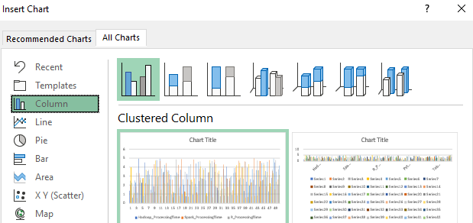
Figure 5:Snapshot from Microsoft Excel
To format the graph, double click on the graph or click on the chart design.
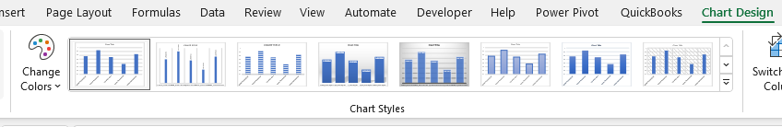
Figure 6:Snapshot from Microsoft Excel
There are two axes, that is the horizontal axis (x-axis) and the Vertical axis(y-axis).

Figure 7:Snapshot from Microsoft Excel

Scatter chart
It is used to compared two or more sets of data in a worksheet. It shows the relationship between sets of data. Using the data provided in Excel for GreenMed Healthcare. Highlight the data provided in the worksheet, you can select two columns or all the five columns, Click insert then Recommended chart and select Scatter chart from the drop-down list. Alternatively, you can choose scatter from the options available on the chart group.
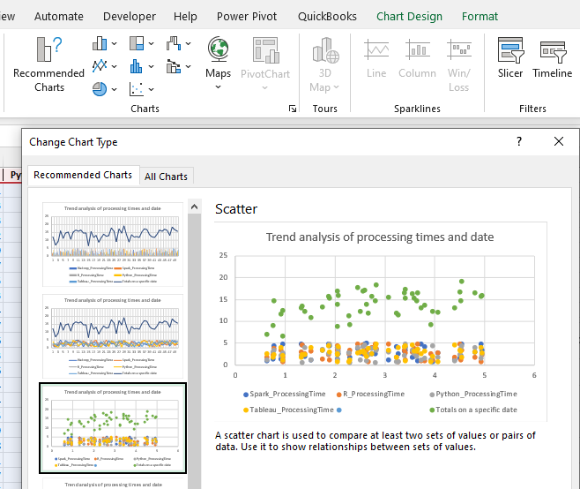
Figure 8:Snapshot from Microsoft Excel

To format the chart, double click on the graph or click on the chart design.

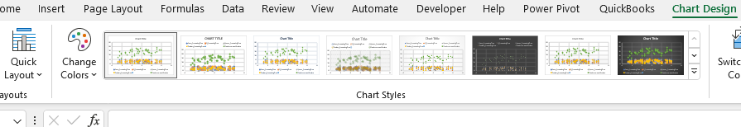
Figure 9:Snapshot from Microsoft Excel

Figure 10:Snapshot from Microsoft Excel

Using SPSS,

To find the correlation between processing times of Hadoop and Tableau.
- Open SPSS software and import the GreenMed Healthcare data.
- On the top menu bar, click on ‘Analyze’ and select ‘Correlate’ from the drop-down menu.
- Click on ‘Bivariate’ from the submenu. In the Bivariate correlations dialog box, select the two variable Hadoop and Tableau processing times.
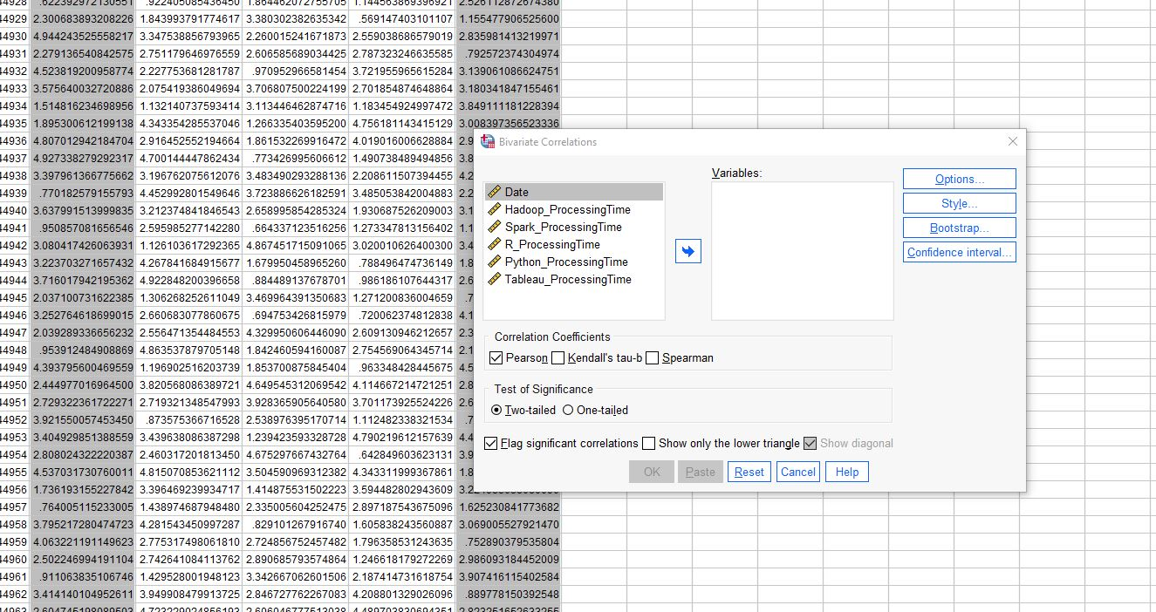
Figure 11: Snapshot from SPSS
- Click on “Options’ to open another dialog box, ‘Correlation Coefficients’ then select Pearson as the correlation coefficient. Continue to close the dialog box.
- To run the analysis, click OK.
Therefore, Using Pearson correlation from the dataset the correlation between Hadoop and Tableau is 0.178. It shows that, as the processing time of Hadoop increases, there is a slight increase in the processing time of Tableau.
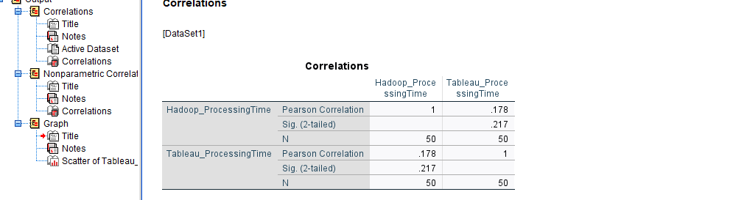
Figure 12: Snapshot from SPSS
According to Statistics Solutions (2021), coefficient values can range from +1 to -1, where +1 indicates a strong correlation and a -1 indicates a strong negative correlation. 0 indicates a no relationship between the variables. The degree of correlation is determined by the values between -1 to 0 and 0 to 1. A high degree ranges from ±0.5 and ±1 and this shows it’s a strong correlation. A moderate degree ranges from ±0.30 and ±0.49 and this represents a medium correlation. A low degree ranges from ±0.29 and below and is said to be a weak or small correlation. Therefore, from our correlation value of 0.178, we can confidently say that it’s a weak or small positive correlation.

To produce a scatterplot for the two variables. Using Hadoop on the Horizontal axis and Tableau on the vertical axis.
A scatterplot is used to show the relationship between two variables. It helps visualize the strangle and direction of the two variables (Zach, 2020). To create a scatterplot in SPSS, using the data available for Hadoop and Tableau processing times. From the top menu, click graph then select Scatter/ Dot from the drop-down menu.
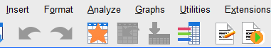
Figure 13: Snapshot from SPSS
Then Select Simpler Scatter, in the dialog box, select Hadoop on the horizontal axis and Tableau on vertical axis. Then click OK.
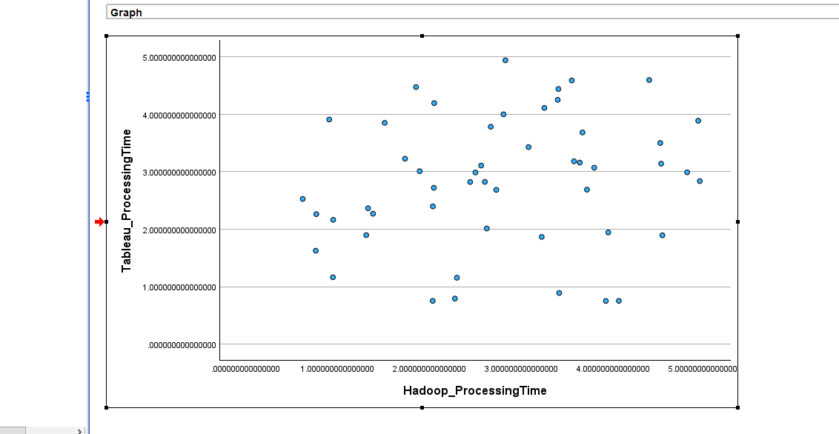
Figure 14: Snapshot from SPSS
Understanding the relationship depicted in a scatterplot involves evaluating both direction and strength. Direction refers to whether the variables move together (positive association) or move in opposite directions (negative association), while strength indicates the degree of correlation, whether it's strong, moderate, or weak.
In a positive association, higher values of one variable typically align with higher values of the other, and lower values correspondingly pair together. A weak relationship occurs when the slope of the trend line deviates from a perfect correlation of 1(Moore, et al 2013). This implies that when one variable increases by a certain amount, the other variable increases by less than that amount.
Upon observing the scatterplot, the depiction doesn't reveal a distinct pattern. While there's a tendency for above-average values to coincide, the overall pattern lacks a definitive trend. Consequently, this leads to the conclusion of a very weak positive correlation between Hadoop and Tableau processing times. This weak correlation suggests that changes in Hadoop processing times don't significantly correspond to proportional changes in Tableau processing times. Therefore, from what is observed on the scatterplot above, there is not clear pattern in the scatterplot. The values of the above average tend to accompany each other. Hence, we conclude a very weak positive correlation between the Hadoop and Tableau processing times.

References
Beard, L., & Aghassibake, N., 2021. Tableau (version 2020.3). Journal of the Medical Library Association, 109(1), pp.159-161. https://doi.org/10.5195%2Fjmla.2021.1135
Simplilearn. 2023, May 4. A Step-by-Step guide on how to make a graph in Excel. Simplilearn.com. https://www.simplilearn.com/tutorials/excel-tutorial/how-to-make-a-graph-in-excel
Statistics Solutions. 2021, June 9. Pearson’s Correlation Coefficient - Statistics Solutions. https://www.statisticssolutions.com/free-resources/directory-of-statistical-analyses/pearsons-correlation-coefficient/
Thakur, M. 2023, August 24. Excel Types of graphs. EDUCBA. https://www.educba.com/excel-types-of-graphs/
Zach. 2020, May 28. How to create and interpret scatterplots in SPSS. Statology. https://www.statology.org/scatterplots-spss/

