

MODULE CODE: Digital Skills for Personal Development and Business Growth BMSW4008

ASSESSMENT COMPONENT: PORTFOLIO

STUDENT NAME: Natalie Brown

STUDENT NUMBER: 2524431

LECTURER: Phillippa Fitzgerald

DATE:16.03.2026

AI Acknowledgement Statement:
Examples of statements If you have not used AI
I confirm that I have not presented any AI generated materials as my own work.
I confirm that I have copies of my drafts, notes, and other resources I used, which I may be asked to provide in evidence.
Examples of AI statements if you have used AI
I acknowledge the use of Grammarly (https://www.grammarly.com/) on Date to check my work using the prompt(s):
1. Please check the following text for readability, grammar and syntax.
I confirm that I have not presented any AI generated text as my own work. I confirm that I have copies of my drafts, notes, and other resources I used before, and after the use of AI tools which I may be asked to provide in evidence.

Importance of Digital Skills
it is important for digital skills necessary for employment and students. In addition, together with changes in the job markets, digital skills such as searching and evaluating information, solving problems, exchanging information or developing ideas in a digital context are very important. These developments ask for increased attention to the identification and for all one’s individuals need to actively and effectively participate in the knowledge of digital skills for personal and work life.
Computers in Human Behaviour July 2017, Pages 577-588
Ester van Laar. Alexander j.A.M, Van deursen, Jan A.g.M van Dijik .

Overview of the JISC Digital Capability Tool

The JISC Digital Capability Tool is an online self-assessment tool is to help students understand their digital skills and confidence levels. It shows clear chart of your strengths and weakness, which shows the key skills needed for effective digital learning and working (Jisc, 2023).

The JISC Digital Capability Tool was used to evaluate my current digital abilities and identify strengths and areas for improvement. The self-assessment involved answering a range of questions about how confident I feel using digital tools for different tasks. Once completed, the tool produced a visual results graph showing my capability levels across several digital skill areas. (Jisc.2023.)

Summary of JISC Results
The results from my Jisc report shows more weakness than my strengths, as I started this course only, I had never used a laptop using my mobile phone for everyday calls and text messages. My Jisc report shows clearly how much I didn’t know and my confidence knowledge in the digital skills are both very low.
Cinthia Rosales-Márquez et al. (2025) “Self-confidence as a predictor of digital skills: a fundamental pillar for the digitalization of higher education,” Frontiers in education (Lausanne), 9. Available at: https://doi.org/10.3389/feduc.2024.1515033.
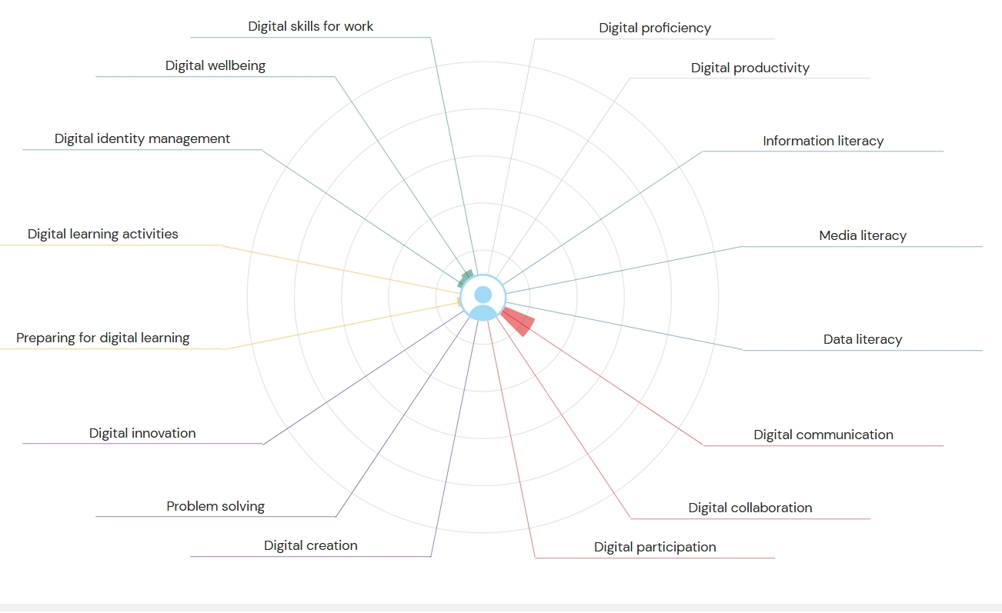
Strengths in Digital Skills my only strength was digital communication such as email messages, and that wasn’t very strong at all, since this Jisc report I have a became a little strong in confidence with sending emails and using teams but still always looking for a second opinion for help. Understanding that digital communication is important to the workplace, education and highly important to my future professional success. I will continue to try my hardest to get better Jisc report next time I do one. I must work on my confidence and learning abilities.

Areas for improvement are on all digital platforms.
Finding and evaluating information online, well understanding that not all sources are credible and true, managing and keeping my work and information is safe spaces and easily accessible. Digital creation and problem solving I need to work harder on editing digital media.

Action Plan Using SMART Goals
To improve my weaker areas, I have developed the following SMART goals:
Specific: improve all my weaknesses and not let my overthinking make me believe I cannot do the task I have been given.
Measurable: using the pomodoro and overspending time on the laptop using shorts breaks frequently.
Achievable: during the break from university, I will use this time to go over the digital and academic modules I have learnt starting this course.
Relevant: improving all my weaknesses and my strengths and working on my confidence on using the digital tools.
Time bound: four weeks. 27th April 26.
To improve all my digital skills, I will go over all my modules also other platforms to build confidence with help from online courses on LinkedIn. and information from books
Najlaa, N. (2025) The Complete Guide to Adobe Premiere Pro 2025: Master Video Editing with Expert Tips, Techniques, and Workflows. First edition. Birmingham, England: Packt Publishing.

Reflection and Conclusion
In conclusion:
- Digital skills are important for learning, work, and everyday life
- My JISC results helped me understand my strengths and weaknesses
- I’ve already made progress in confidence and communication
- My SMART goals will help me continue improving
I am proud of how far I’ve come and motivated to keep going.
Ashfaq, H. and Ansari, M.N. (2018) “Impact of Online Reading on Skills of Professionals,” Library philosophy and practice, p. 1.
Metić Admir (2026) “Improving teachers’ digital competences: E-learning as the key to modern professional training,” Univerzitetska misao, 2026(25), pp. 57–67. Available at: https://doi.org/10.5937/univmis2525057M.

Badges
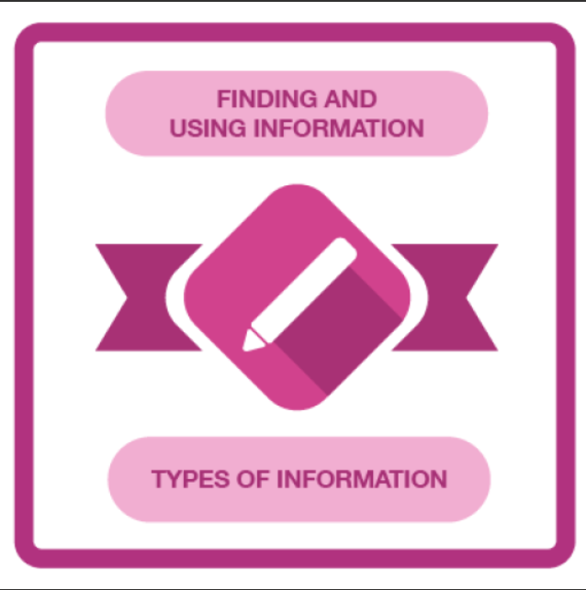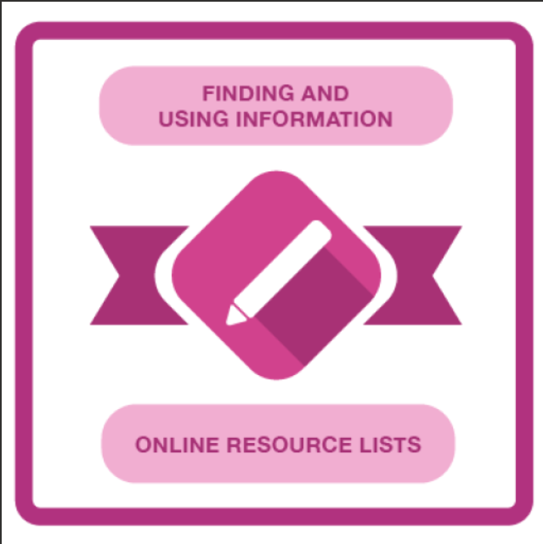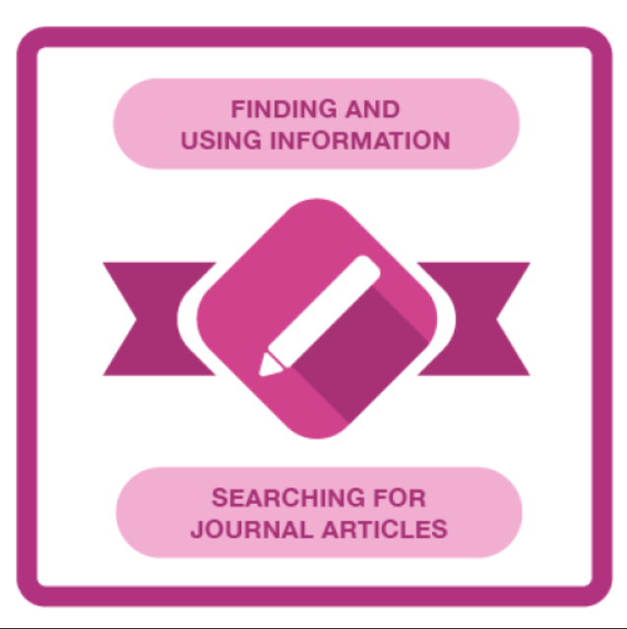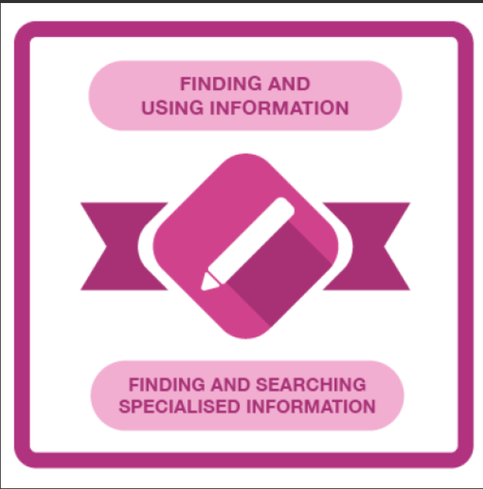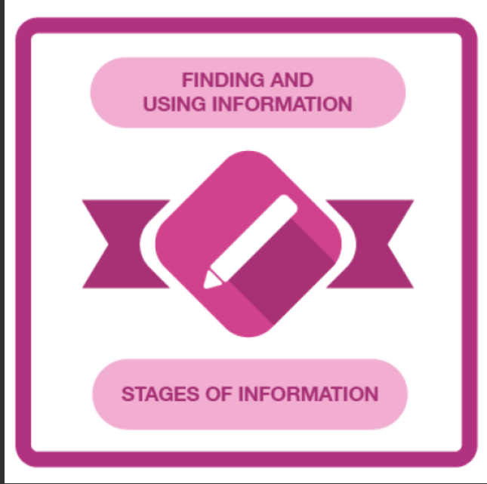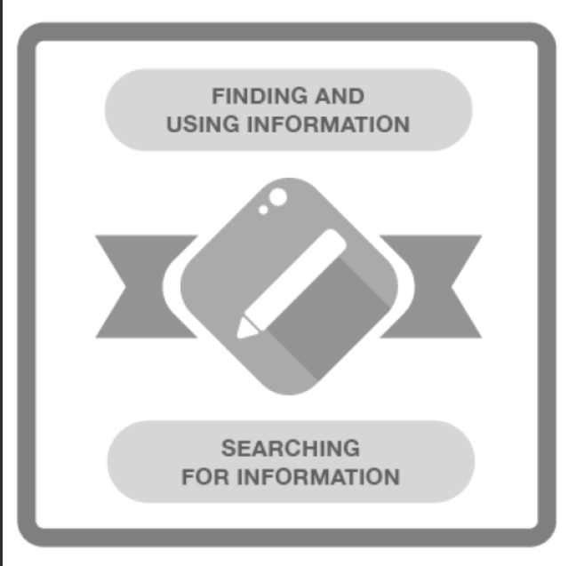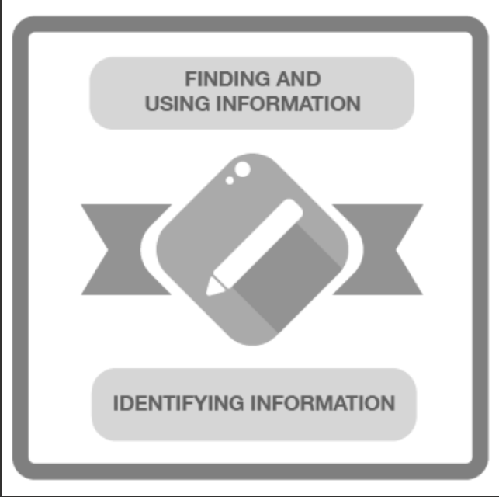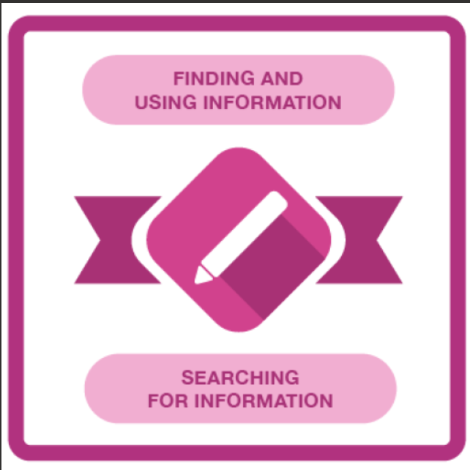
Grix, J. and Watkins, G. (2010) Information skills : finding and using the right resources. Basingstoke: Palgrave Macmillan.
Bootham, L. (2014) “Finding and using information - a journalist reflects,” English in Aotearoa, (83), pp. 28–31.

LinkedIn Learning Certificates for Office36
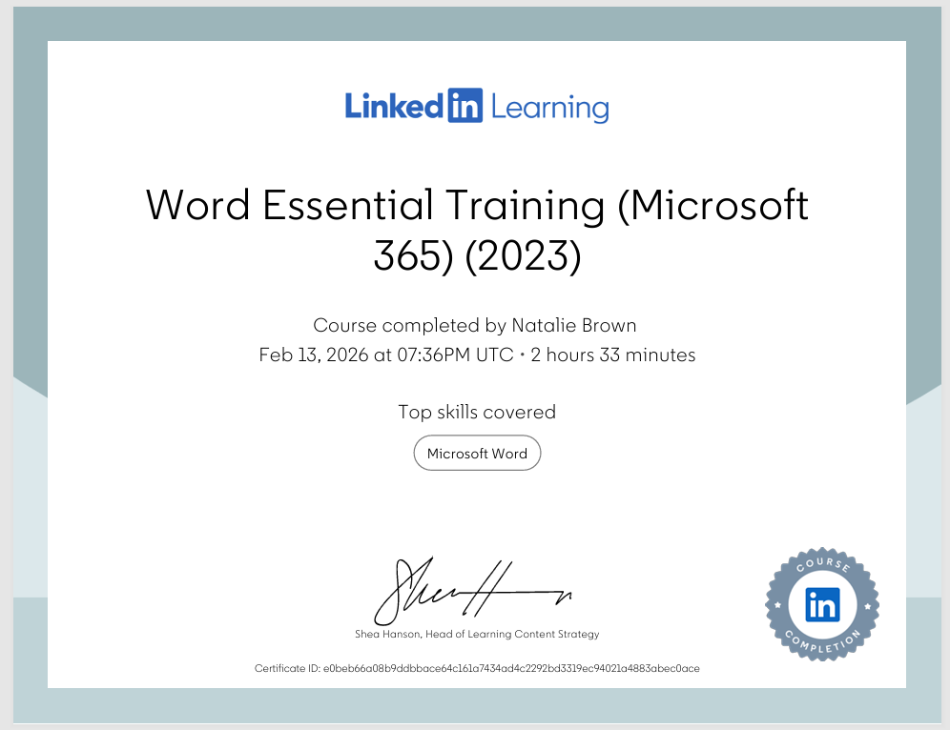
Rivers, D. and linkedin.com (2023) Word Essential Training (Microsoft 365). Carpenteria,
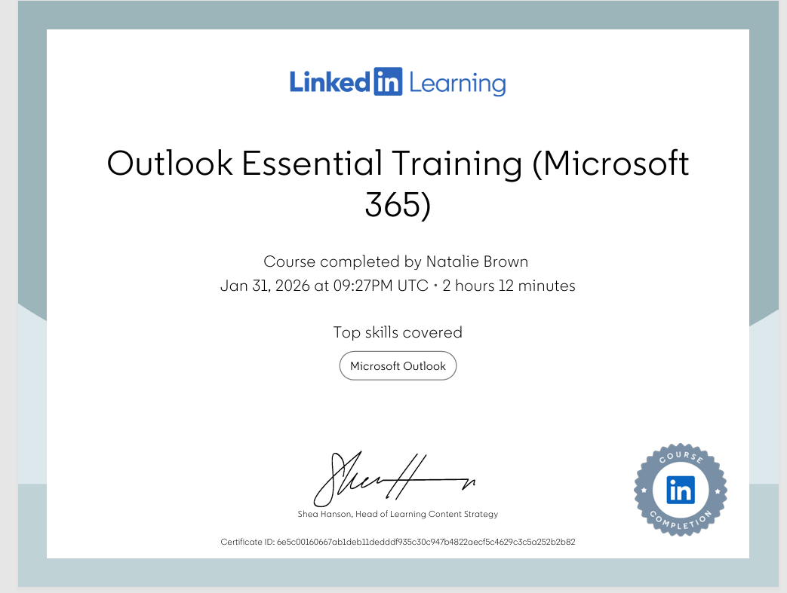
Stratton, J. and linkedin.com (2022) Outlook Essential Training (Microsoft 365). Carpenteria, CA: linkedin.com. Available at: https://www.linkedin.com/learning/outlook-essential-training-microsoft-365?u=77966930&auth=true.

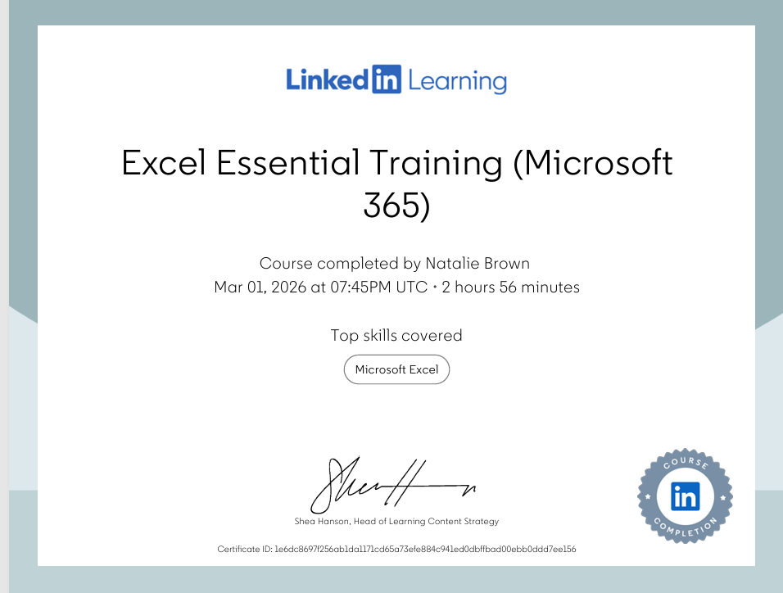

Taylor, D. and linkedin.com (2022) Excel Essential Training (Microsoft 365). Carpenteria, CA: linkedin.com. Available at: https://www.linkedin.com/learning/excel-essential-training-microsoft-365-17231101?u=77966930&auth=true.

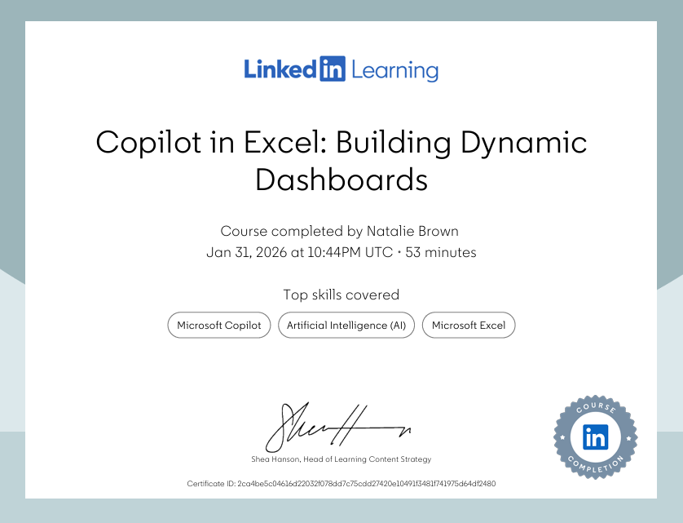

Callari, T.C. and Puppione, L. (2025) “Can generative artificial intelligence productivity tool.

Essay on Relevance of Excel in professional and personal life.
Microsoft Excel is one of the most useful computer programs in the world, and it plays a big role in both professional life and everyday personal life. Even though some people think Excel is only for very technical jobs, that is not true. Excel is used in almost every workplace, and it is also very helpful at home for keeping life organised. Learning Excel can make work easier, save time, reduce stress, and help people make better decisions. Because of this, Excel is now seen as an essential digital skill for many careers and daily tasks.
Excel is extremely important in professional life because almost every job requires some level of data organisation. A common reason workplace use Excel is for data management and organisation, where employees can store large amounts of information in a clear way. Sorting and filtering help people find data quickly, which is helpful for teams like sales, finance. One article explains that Excel is often used by sales teams to organise customer details and sales figures.
Excel in personal life
One of the most common personal uses of Excel is budgeting and tracking monthly expenses. Excel allows families to record income, bills, shopping. travel costs, and other spending in one place. This makes it easier to see where money is going and where savings can be made. A source explains that Excel can clearly show a household’s financial picture and help people make better choices about their One of the most common personal uses of Excel is budgeting and tracking monthly expenses
• It helps organise information clearly and simply.
• It helps save time.
• It reduces errors
• It builds confidence,
• It improves decision-making
• It is flexible
Marini, J. and linkedin.com (2024) Advanced Hands-On Python: Working with Excel and Spreadsheet Data. Carpenteria, CA: linkedin.com. Available at: https://www.linkedin.com/learning/advanced-hands-on-python-working-with-excel-and-spreadsheet-data?u=77966930&auth=true.
Brusco, M. (2022) “Logistic Regression via Excel Spreadsheets: Mechanics, Model Selection, and Relative Predictor Importance,” Transactions on education, 23(1), pp. 1–11. Available at: https://doi.org/10.1287/ited.2021.0263.
Michael Brusco (2019) “An Excel Spreadsheet and VBA Macro for Model Selection and Predictor Importance Using All-Possible-Subsets Regression,” Spreadsheets in education [Preprint].
Michael Brusco (2019) “An Excel Spreadsheet and VBA Macro for Model Selection and Predictor Importance Using All-Possible-Subsets Regression,” Spreadsheets in education [Preprint].
Gunnlaugsson, H.P. (2016) “Spreadsheet based analysis of Mössbauer spectra,” Hyperfine interactions, 237(1). Available at: https://doi.org/10.1007/s10751-016-1271-z.
Brusco, M. (2022) “Logistic Regression via Excel Spreadsheets: Mechanics, Model Selection, and Relative Predictor Importance,” Transactions on education, 23(1), pp. 1–11. Available at: https://doi.org/10.1287/ited.2021.0263.
Alvarez, M.M., Bravo-González, S. and Trujillo-de Santiago, G. (2021) “Modeling vaccination strategies in an Excel spreadsheet: Increasing the rate of vaccination is more effective than increasing the vaccination coverage for containing COVID-19,” PloS one, 16(7), p. e0254430. Available at: https://doi.org/10.1371/journal.pone.0254430.

8 references
Use the following information create an Excel spread sheet, looking at income and expenditure of a typical family of 4 over the course of a year. Use formulars to achieve answers and add headings and highlight the different aspects of the finances, be realistic with the monetary amounts used for each area.
Income | Amount per month £££ | Expenditure | Amount per month £££
Wage 1 |  | Rent/Mortgage
Wage 2 |  | Council tax
Trust Funds |  | Electric
Stocks/Share payouts |  | Gas
Universal credit |  | Water rates
Student Finance |  | Food
Other |  | Car insurance
 |  | Car Tax
 |  | Fuel
 |  | Child Care Costs
 |  | Loans/credit cards
 |  | Other e.g. Birthdays/savings/holidays

Embed you excel here

Digital_Skills_Reflective_Presentation.pptx

References

Task 4

5 Minute Reflective Presentation

Hello, in this presentation I will reflect on my digital skills journey, what I learned from the JISC Digital Capability tool, and how my confidence has changed since starting this course.
When I started the course, my digital skills were very limited.
I only used my phone for calls and messages, and I had never really used a laptop.
Because of this, I didn’t feel confident at all.
The JISC assessment showed that I had more weaknesses than strengths.
This didn’t surprise me, but it did help me understand exactly where I needed to improve.
My confidence and knowledge in digital skills were both very low.
Digital skills are important for everyday life, studying, and future jobs.
They don’t just mean knowing how to use a computer; they include things like:
- Finding the right information
- Communicating online
- Staying safe
- Solving problems
- Being confident using different tools
My one small strength was digital communication, mainly emails.
Even though it wasn’t very strong, it was something to build on.
Since starting the course, I’ve become more confident using email and Microsoft Teams.
I still ask for help, but I am improving.
• Finding reliable information online
• Storing and managing files
• Using digital platforms
• Editing and creating digital content
I had many areas that needed improvement, including:
I learned that self-confidence plays a big role in improving digital skills.
Research shows that believing in yourself helps you learn better and use digital tools more effectively.
This helped me realise that my overthinking was holding me back.

- Finding reliable information online
- Storing and managing files
- Using digital platforms
- Editing and creating digital content
- I learned that self-confidence plays a big role in improving digital skills.
Research shows that believing in yourself helps you learn better and use digital tools more effectively.
This helped me realise that my overthinking was holding me back.
- I learned that self-confidence plays a big role in improving digital skills.
Research shows that believing in yourself helps you learn better and use digital tools more effectively.
This helped me realise that my overthinking was holding me back.
- I learned that self-confidence plays a big role in improving digital skills.
Research shows that believing in yourself helps you learn better and use digital tools more effectively.
This helped me realise that my overthinking was holding me back.
- This journey has shown me that learning digital skills takes time.
It’s okay to ask for help and make mistakes.
The more I practise, the better I become.
- Slide 13 – Conclusion
- In conclusion:
- Digital skills are important for learning, work, and everyday life
- My JISC results helped me understand my strengths and weaknesses
- I’ve already made progress in confidence and communication
- My SMART goals will help me continue improving
- I am proud of how far I’ve come and motivated to keep going.

References

