Table Of contents:
Page 2: title page
Page 3: introduction
Page 3-8: Primary Data
Page 8-11: Secondary Data QUOTES only/All Cited Page11-12: What I gathered from the secondary data:
Page 13-14: references
Page 15: Note page, please read.

Title Page:

Module Title: Digital Skills and research methods
Module Code: BMSW4003_LON
Tutor- Alfred Mensah Module
Name: Khaled Kbies 2017907
University Name: University of Wales Trinity Saint David

Introduction:

As a pandemic occurs, there are numerous methods for teachers and students to engage among each other. There are asynchronous and synchronous teaching systems that can also be used in what are considered as virtual classes. A virtual class is a current online communication and collaboration system that enables students and professors to connect and participate. There are various virtual classrooms available, like Google Meet, Zoom, and Microsoft Teams, that use video conferencing, online whiteboards, and screen sharing to enable professors to do online lectures, virtual office hours, and interactive discussions with students regardless of the crisis. In contrast to on-campus or face-to-face classes, students are permitted to use devices such as laptops, smartphones, and personal PCs. Synchronous virtual classrooms have the opportunity to profoundly improve distance classes by acknowledging learners' needs in terms of social interaction and psychological safety. Individuals can also set a new standard for gaining knowledge that would go well beyond the physical environment of the school setting and methods of teaching. In this type of communication, the teacher serves as a moderator, leading the learning process and facilitating group activities and conversations.

As we conducted research on the effect of Virtual Learning Experience on students at the University of Wales Trinity Saint David, we obtained data that might assist us improve knowledge of the value and impact of virtual classes in each student.

Primary Data

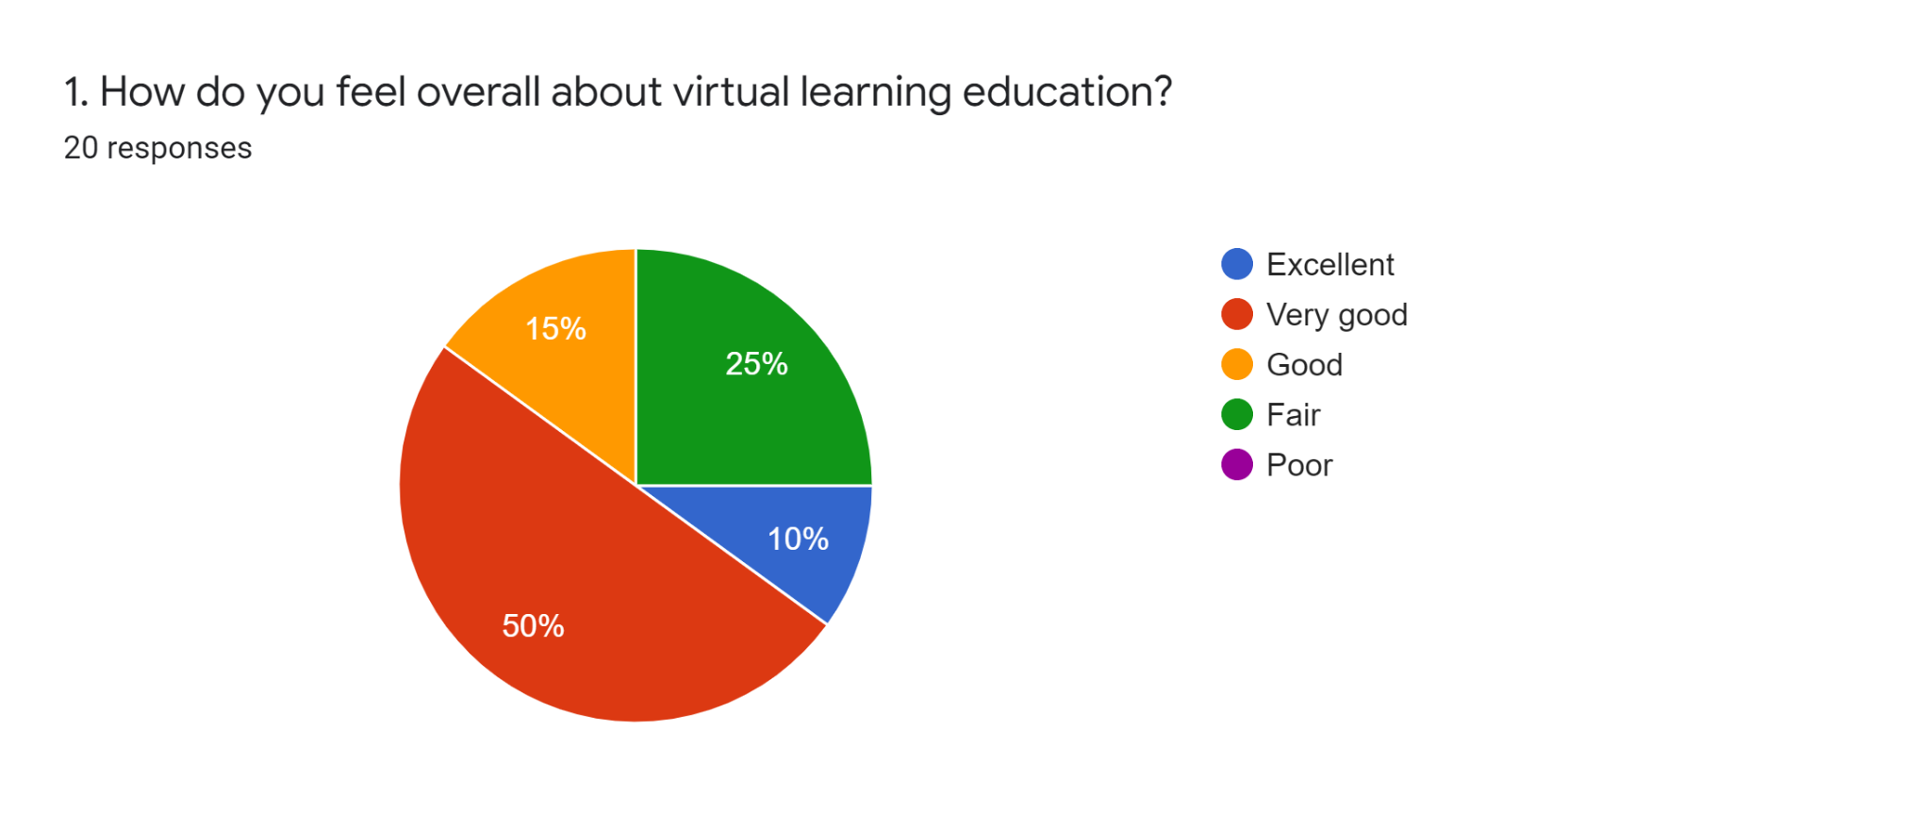

In Data 1, we asked participants how they feel about virtual learning education in general, and 50% said it was very good, with the rest saying it was good and fair, but barely excellent. Some students stated that they are unprepared for the unexpected changes in the new learning platform over the next two years. Others are having difficulty adjusting to new situations because they have only recently begun their first year at university.

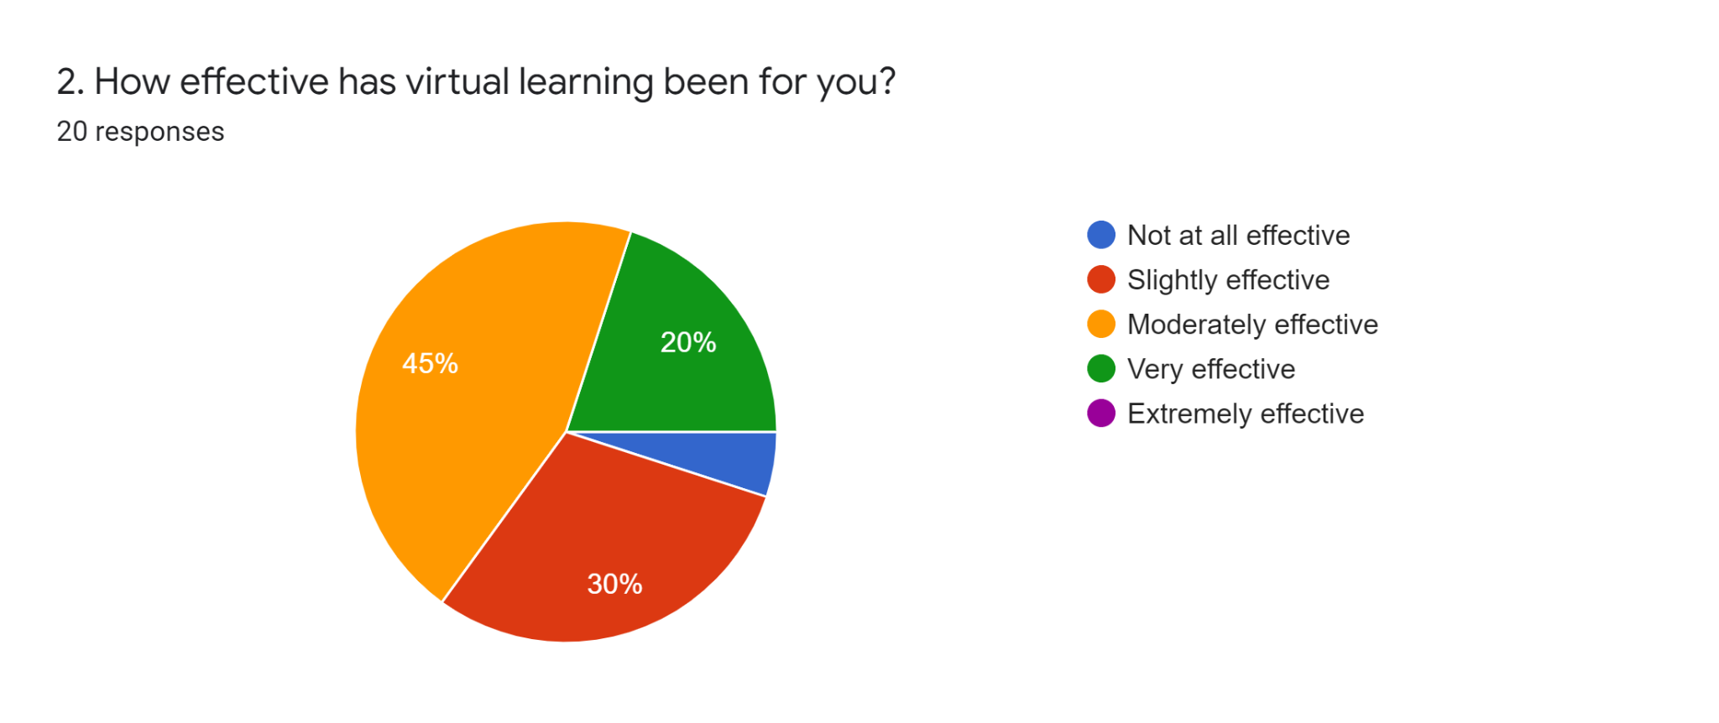

Data 2 clearly demonstrated the effectiveness of Virtual Learning, and we can see that only 9 of the 20 participants claimed it was moderately effective, despite the fact that Data 1 described how they felt about the new learning system. Students are still learning and making adjustments over time, as we are all used to face-to-face classes due to the different learning styles of all students in the past two years.

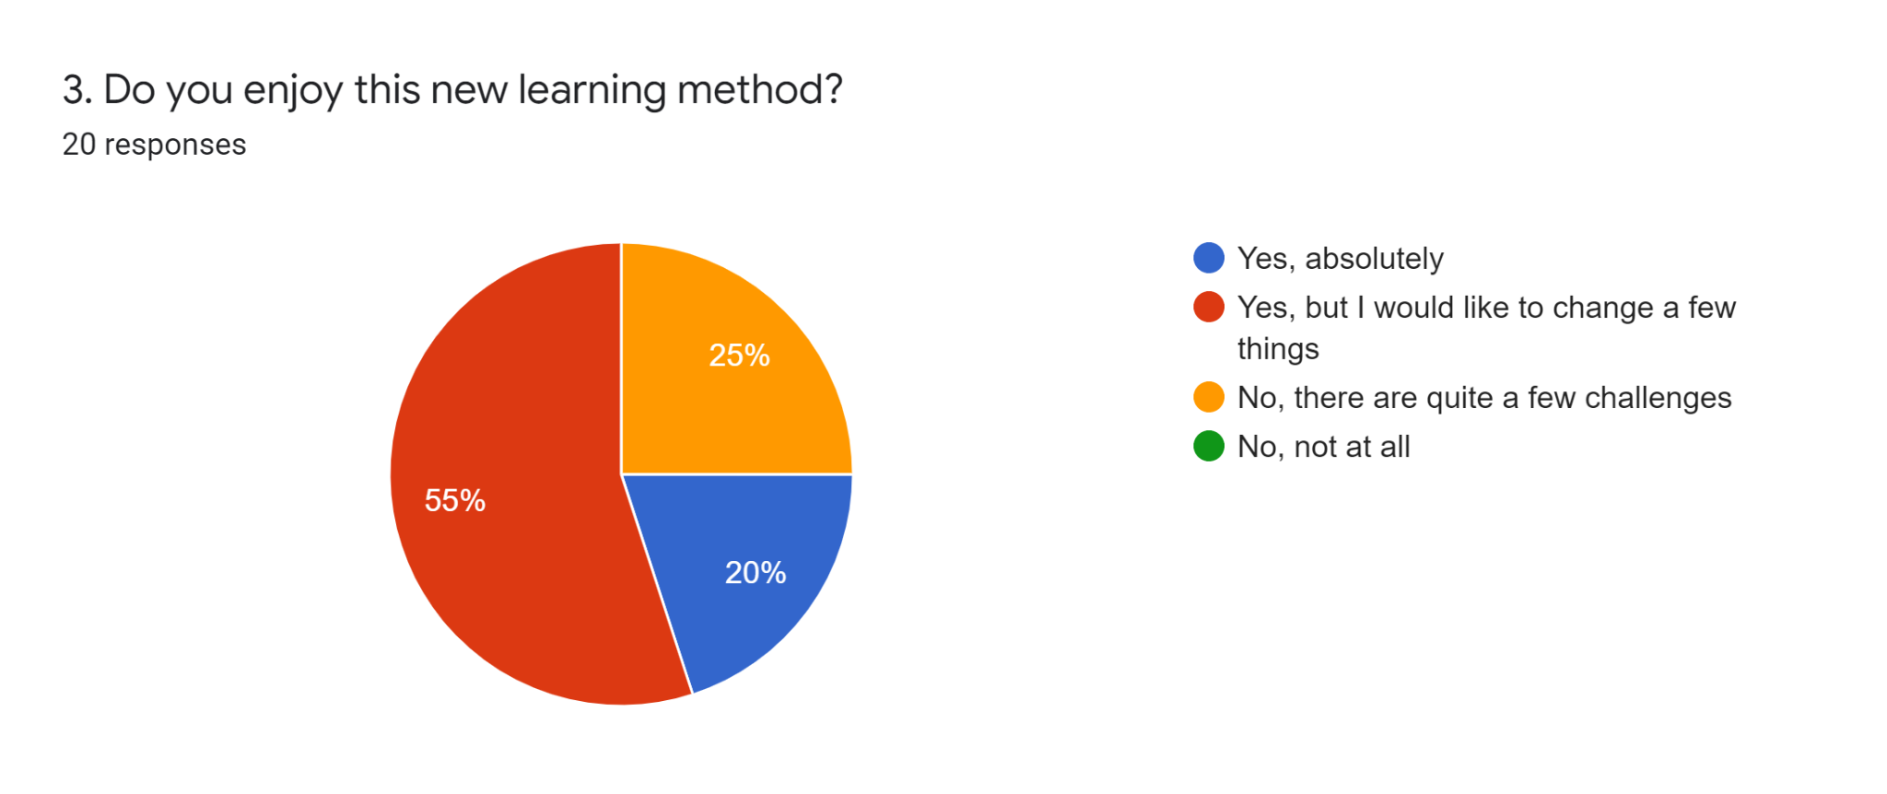

In Data 3, we asked the 20 participants if they enjoy this new learning method, 55 % say Yes but they would like to change a few things. From the participants we interview online, the things they want to change is the group activities that their professors give to them. Some of it can be done in face to face classes so they can collaborate with their peers well. They are having a quiet issue when it comes to online works because members are not participating that much unlike the other members that are willing to collaborate with the group leader.
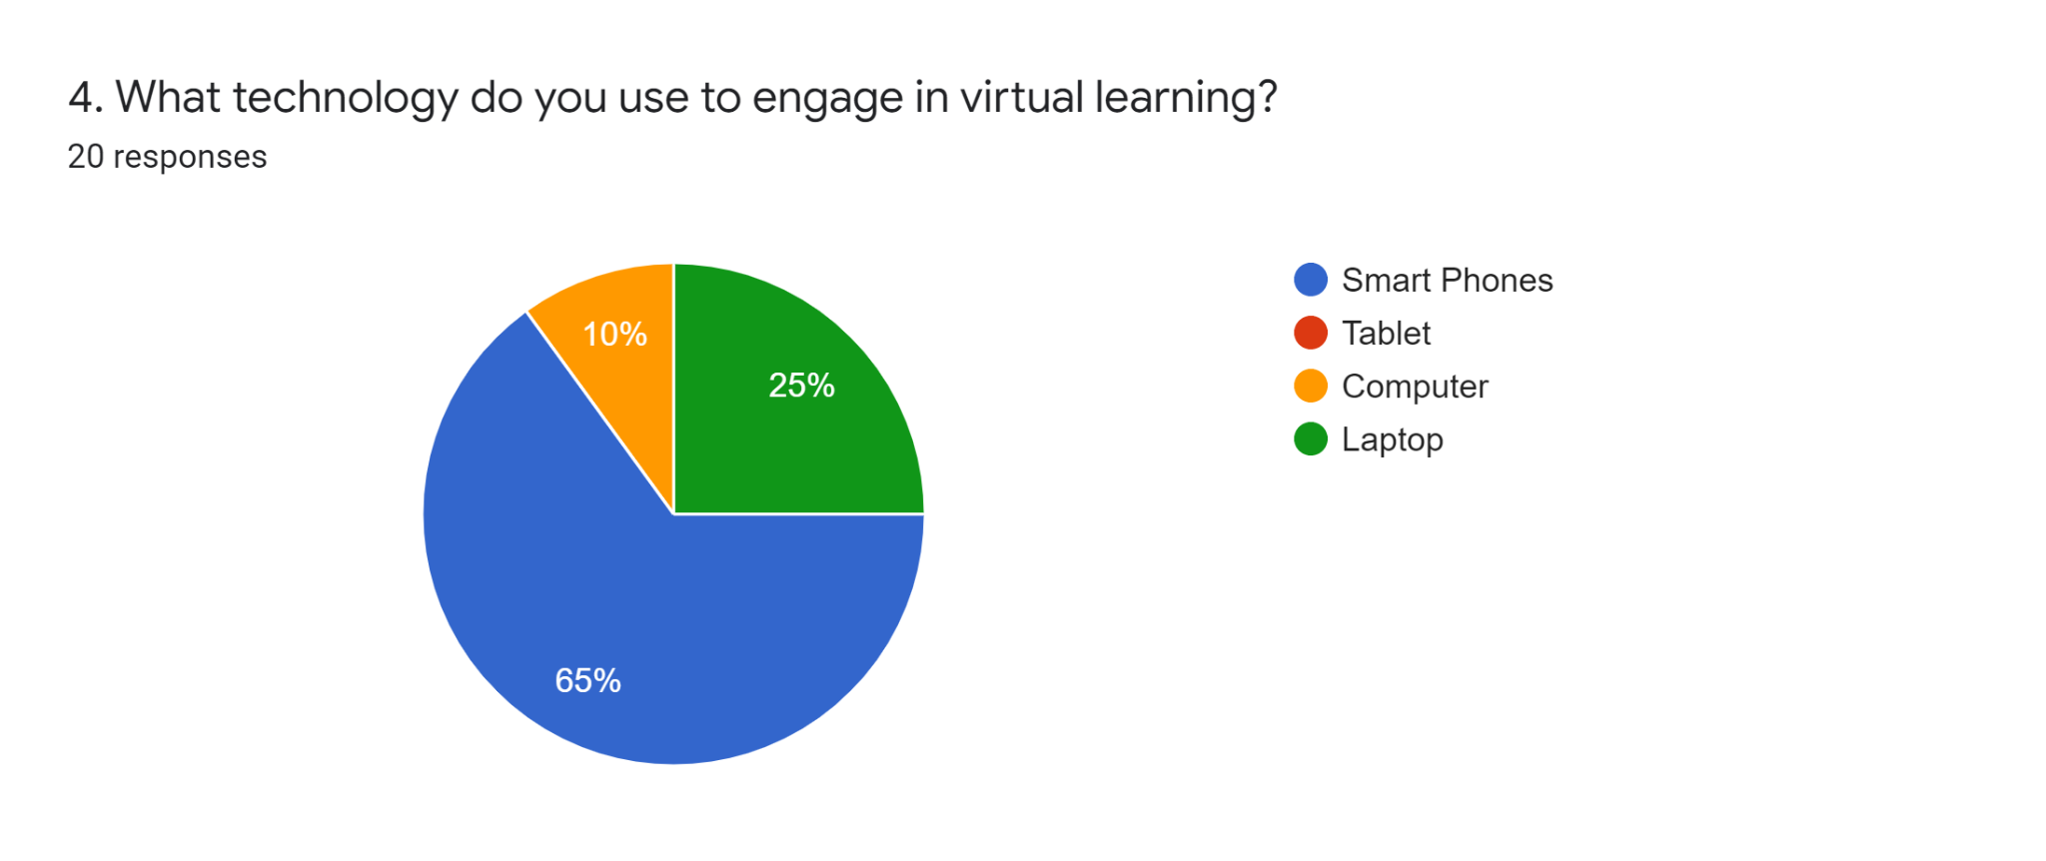

Data 4 it stated that tools they use to engage in virtual learning or online classes. Almost 65% of the participants are using smartphones in attending their classes in Microsoft Teams and other online platforms.

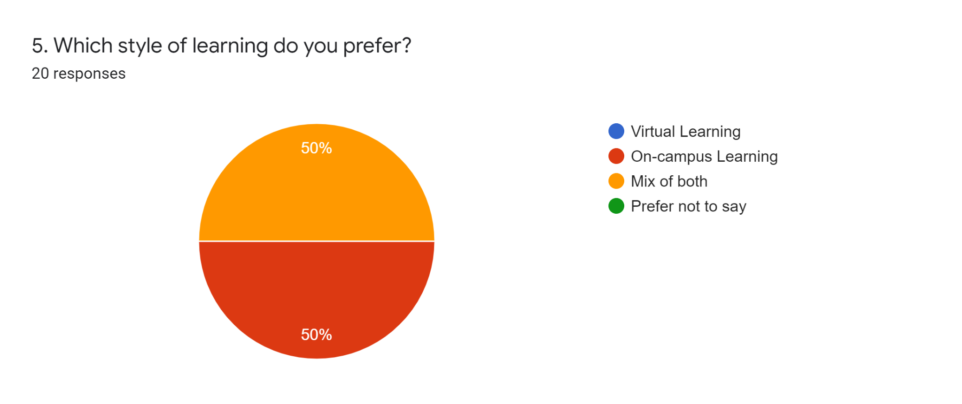

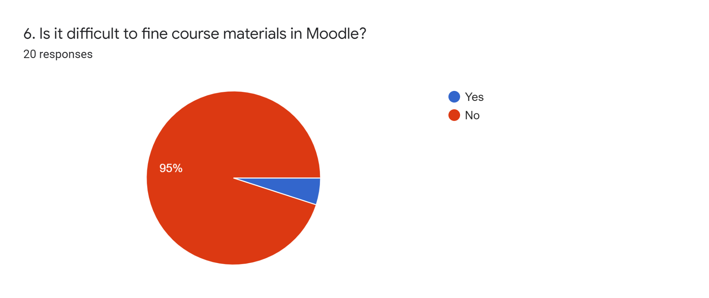
As we can see in Data 5, half of them prefer on-campus learning, while the other prefers a combination of virtual and on-campus learning. Participants clearly agreed that there are advantages and disadvantages to attending virtual classes over on-campus classes. Virtual learning is more efficient than on-campus classes because all we have to do in virtual classes is log in on the desired device rather than attending class inside the university because you have to commute and spend money on trains. Others stated that on-campus learning allows them to collaborate and learn from professors.

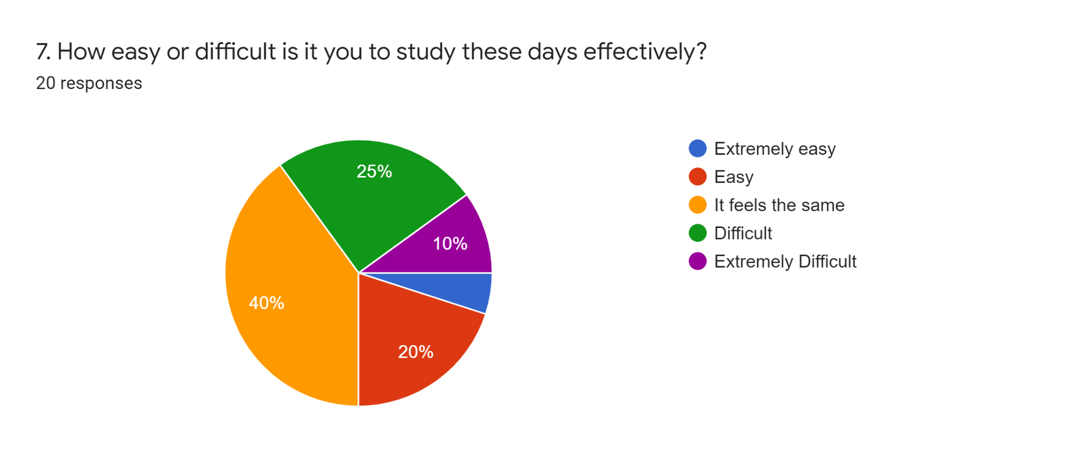
In Data 6, Moodle is a learning platform for the students and 95% of the participants are not having a difficulty in finding materials designated by all the professors to them.

Data 7, 45 percent, suggests that despite the new learning technique of Virtual Online Classes, it still feels the same to study well, because students may still progress and pass each semester for the entire year. Only one person had problems in the virtual lesson.
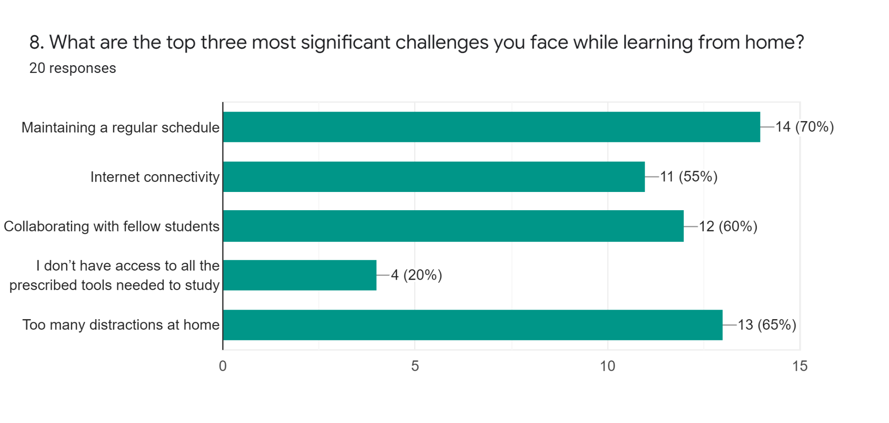

Data 8

According to data 8, in the survey that we performed, the top three most significant obstacles that all participants have while learning from home are maintaining a regular schedule (70 percent), too many distractions at home (65 percent), and collaborating with fellow students (60 percent).

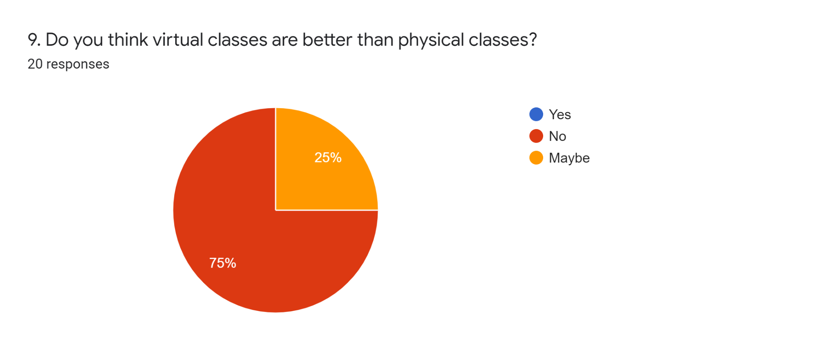

In this Data 9, 75% of those polled said no to the question, "Do you think virtual classes are better than physical classes?" Participants preferred on-campus classes because, prior to the pandemic, classes were held inside the university, where each student took their lectures, activities, and group projects.

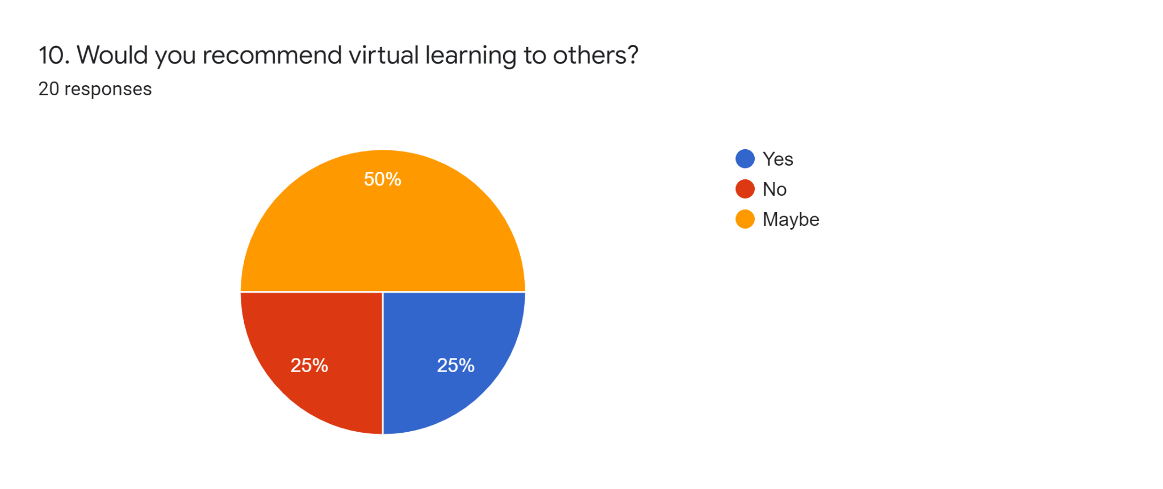

In Data 10, 50% states maybe if they would recommend virtual learning to others.

Secondary Resources: These are QUOTED only in this section. I have cited all the authors words. I interpreted the secondary data in the “What I gathered from the secondary data:” section.

COVID-19 has dramatically influenced the emergence of virtual classrooms. ( As cited in Racheva - 2018) defines the virtual classroom as an online learning environment that enables live teaching and interaction between teachers and students. The most common tools in a virtual classroom include videoconferencing, online whiteboards, instant messaging tools and breakout rooms. Rather than looking at the present-day situation as an obstacle to learning, instructors can utilize virtual classrooms as an opportunity to learn to teach in an alternate mode so that, when classrooms are re-opened, learners can experience the advantages of blended approaches (As cited in, Bernard et al., 2014; Means et al., 2013).

Individuals learn to apply tools and knowledge in new domains and different situations within a REAL. Students are given the skills to become successful citizens, they are engaged in knowledge construction and problem-solving activities, as well as thinking and learning processes they will be expected to engage in once they are on the job. (As cited in, Grabinger et al., 1997).

Social interactions in a classroom are expected to lead to improvements in higher order thinking (As cited in, Palincsar, 1998). As cited in, Vygotsky, (1978) he believed “all the higher functions originate as actual relations between human individuals” (p. 57). Research- ers in Turkey recently analyzed problem solving skills and metacognition of teacher candidates, university students who have been accepted in a teacher education program, and concluded social constructivist approaches increased both problem solving skills and metacognition awareness over students in traditional classroom instruction (As cited in, Bay, Bagceci, & Bayram, 2012). Teacher candidates in Taiwan described the social constructivist classroom as a “rich, interesting, and superior” learning experience compared with the traditional classroom (As cited in, Syh-Jong, 2007).

In an online course, therefore, students should learn through their interaction with the material, the instructor, and other students. As learners embark “on a process of discovery with one another, rather than being told what they need to memorize or know, the outcome is a deepen- ing of the learning experience and satisfactory achievement of learning objectives” (As cited in, Palloff & Pratt, 2001, p. 3)

Activities that connect learners’ interests with real-life experiences are the foundation of learning engagement (Kilpatrick, 1918). Digital storytelling is only one pedagogical approach that can engage students in deep and meaningful learning (As cited in, Smeda et al., 2014). The technique can be used to integrate instructional messages with learning activities to create more exciting learning environments (As cited in, Saritepeci, 2020; Smeda et al., 2014). This teaching approach enhances emotional interest and cognitive attention, and reflects consistent and reliable transfer of knowledge in line with modern learning theories. Educational technology enables learners to conduct research, write a script, and turn text, audio narration and visuals into a short video story. Learners can use Powtoon or Articulate Storyline (see appendix) to create web-based animation presentations by manipulating freely available graphic resources, imported images, music, and user-created voiceovers and tell their digital story of a particular topic. Students generally found that the majority of online class experiences were unengaging. The same survey indicated that over a quarter of students are questioning whether to return to their current institution for the fall 2020 term (As cited in, Saritepeci, 2020; Smeda et al., 2014).

True engagement in virtual classrooms happens when each learner becomes part of a learning community. All students possess unique skills, experiences and backgrounds that they can share with others to enrich everyone’s learning (Vygotsky, 1978). Most videoconferencing tools have breakout rooms that can be set for project-based group work in real-time or within an LMS asynchronously. A clear and lean structure in the virtual classroom improves interactions and learning experiences by reducing the learner’s cognitive load (Saritepeci, 2020; Smeda et al., 2014). As with traditional classroom teaching, in virtual sessions, the learning path needs to be clearly communicated to learners so they can stay on task and manage their time.
Online courses can offer the flexibility for stu- dents to select the content they feel will benefit their learning and achievement most (Murray, Pérez, Geist, & Hedrick, 2012). However, collaborating can be challenging in this environment. When a student does not have the instructor in class to answer questions and must wait for a response to the communication and feedback, this can be a barrier to learning (Vonderwell & Turner, 2005). Additionally, interacting with team members who are not actively involved and collaborating, wait- ing for group member responses, and attempting to develop interpersonal relationships with the instructor and team members may also be barriers to learning (Vonderwell & Turner, 2005).
Students collaborate using tools such as discussion groups, electronic mail, or chat; instructors may need to give students a focus or project for the discussions (Dunlap, 1999). “Self-reflection implies observing and putting an interpretation on one’s own actions” (Von Wright, 1992, p. 61). As Wade, Fauske and Thompson (2008) explained in a literature review, written instead of oral reflection is more effective because it takes more thought to produce and the audience can take more time to receive the reflection; writing for oneself (as in a private journal) can produce a more shallow reflection than writing publicly, as in a blog or discussion group—possibly more so with a discussion group because the writer expects a reply.

What I gathered from the secondary data:

Social collaboration helps to improve learning procedures and empowers students to identify the circumstances that are troubling the individual in question. Along these lines, one is empowered to adjust their practices in order to recognize favorable effects. Social interaction in the classroom enables an individual to comprehend the practices of others, and as a result, a student can improve their learning systems by modifying their negative practices. Another way that social collaboration can help one improve their learning procedures is that it teaches one how to be a good audience as well as how to accept responsibility for actions that one takes. In terms of learning, the fundamental method of teaching is critical. It has been utilized in education for many years to improve positive interactions among pupils. In terms of learning, social connection is critical. Most people have benefited by discussing their difficulties with their peers or teachers while in school. This indicates that one learns from others and that others learn from oneself. When it comes to obtaining knowledge, the simple act of sharing ideas and information is typically significant. Discussions with the other students frequently allow them to gain a lot of knowledge, which helps them improve their grades. Social connection also ensures that beneficial changes are instilled to improve the individual development of the pupil.

Conclusions:

The lecture, a traditional teaching format, often makes students more passive because the emphasis is on the content and students must work independently with little opportunity for collaboration. This method is appropriate for asynchronous virtual teaching, in which the tutor creates video lectures and self-directed activities that students complete through their own pace. Synchronous virtual classes necessitate student-centered instruction in which learners and tutors communicate equally – in this type of classroom, active participation, collaborative work, and communication are encouraged. The tutor provides opportunities for both independent and collaborative learning and guides the students in improving and applying the necessary skills. This increases the learners' motivation as well as their interest in the learning activities.

Learning online helps to improve digital literacy since it teaches students how to be effective online and communicate with content, peers, and lecturers. Similarly, teaching online will help all educators communicate more effectively using various digital mediums. Online classes allow students to learn from anywhere as long as they have access to the internet. The disadvantage is that some students may grow sluggish or complacent in their studies. Although online learning has the potential to increase comfort, teachers should encourage students to study in an atmosphere that is conducive to learning and free of distractions.

References

Bernard, R. M., Borokhovski, E., Schmid, R. F., Tamim, R. M., & Abrami, P. C. (2014). A meta-analysis of blended learning and technology use in higher education: From the general to the applied. Journal of Computing in Higher Education, 26(1), 87–122. https://doi.org/10.1007/s12528-013-9077-3
Capp, M. J. (2017). The effectiveness of universal design for learning: A meta-analysis of literature between 2013 and 2016. International Journal of Inclusive Education, 21(8), 791–807.
https://doi.org/10.1080/13603116.2017.1325074
ECampusOntario Open Library Portal. (n.d.). Welcome to the Open Library The Home of Open Educational Resources (OER) in Ontario. Retrieved April 21, 2020, from https://openlibrary.ecampusontario.ca/
Fenesi, B., Heisz, J. J., Savage, P. I., Shore, D. I., & Kim, J. A. (2014). Combining best-practice and experimental approaches: Redundancy, images, and misperceptions in multimedia Learning. The Journal of Experimental Education, 82(2), 253–263. https://doi.org/10.1080/00220973.2012.745472
Hill, P. (2020, March 31). Revised Outlook for Higher Ed’s Online Response to COVID-19. PhilOnEdTech. https://philonedtech.com/revised-outlook-for-higher-eds-online-response-to-covid-19/
Kilpatrick, W. H. (1918). The Project Method: The Use of the Purposeful Act in the Educative Process. Teachers College, Columbia University. http://archive.org/details/projectmethodus00kilpgoog
Mayer, R. E., & Moreno, R. (2003). Nine ways to reduce cognitive load in multimedia learning. Educational Psychologist, 38(1), 43–52. https://doi.org/10.1207/S15326985EP3801_6
Means, B., Toyama, Y., Murphy, R., & Baki, M. (2013). The effectiveness of online and blended learning: A meta-analysis of the empirical literature. Teachers College Record, 115, 47.

References:
Racheva, V. (2018, May 9). What is a Virtual Classroom? – Definition. VEDAMO. https://www.vedamo.com/knowledge/what-is-virtual-classroom/
Saritepeci, M. (2020). Students’ and Parents’ Opinions on the Use of Digital Storytelling in Science Education. Technology, Knowledge and Learning. https://doi.org/10.1007/s10758-020-09440-y
Slemmons, K., Anyanwu, K., Hames, J., Grabski, D., Mlsna, J., Simkins, E., & Cook, P. (2018). The impact of video length on learning in a middle-level flipped science setting: Implications for diversity inclusion. Journal of Science Education and Technology, 27(5), 469–479. https://doi.org/10.1007/s10956-018-9736-2
Smeda, N., Dakich, E., & Sharda, N. (2014). The effectiveness of digital storytelling in the classrooms: A comprehensive study. Smart Learning Environments, 1(1), 6. https://doi.org/10.1186/s40561-014-0006-3
Vygotsky, L. (1978). Mind and society: The development of higher mental processes. Harvard University Press.

NOTE PAGE:
The secondary data section “Secondary Resources:” is QUOTED only, it is not my work, its purely secondary data. Anything in that section is not part of my writing, its just data.

The section “What I gathered from the secondary data:” is where I talk about my views, on the secondary data I have presented. Using my OWN cards.
I am clarifying this to avoid confusion.
Thank you

