CAE Simulation In Engineering industry
+ gearbox design & simulation
CAE & Stress Analysis Coursework

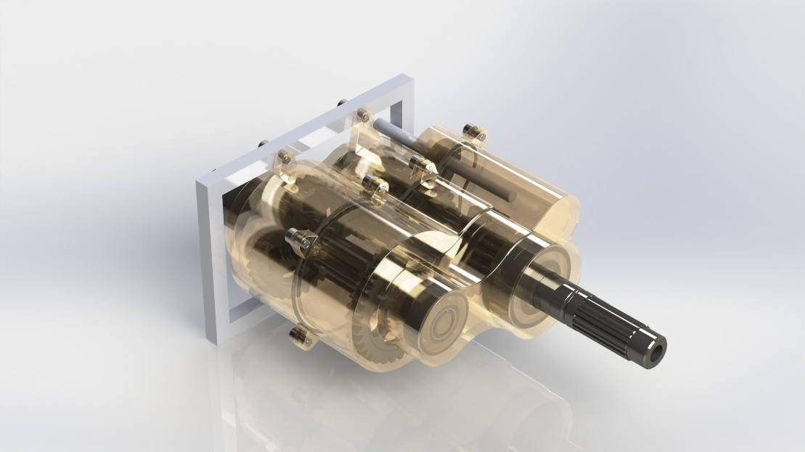
Benjamin Andrew Woodhead
P151944
Contents
CAE Simulation in Engineering Industry 2
Gearbox Design Analysis 5
Gearbox Housing Design; 5
Assembly; 6
Motion Simulation; 6
References 9

CAE Simulation in Engineering Industry
Computer Aided Engineering simulation technology has become a key process in engineering design in the modern era. The ability to analyse a system design without having to spend time and money building physical prototypes means design companies can now deliver products faster to market, and with greater confidence that their designs will be adequate for the intended environment. CAE simulation is now a $5.3 billion market (Engineering.com, 2017), which shows that engineers are now heavily relying on these tools - this study will address the role that CAE simulation plays in the modern engineering climate, the different types that are used by designers as well as the advantages and limitations of the processes.
There are multiple types of CAE simulation, each focused on assessing and optimising a specific aspect of a design. In many cases a design engineer will not need to employ all of the available techniques, but rather will focus on those most critical to the design. The main types of CAE available are;
- Finite Element Analysis – this focuses on simulating static and dynamic stresses on systems by breaking the design in to a number of tetrahedral regions and solving the partial differential equations for each region using the given input values, the material selection and geometry (SimScale, 2019). By doing so, the technique can show the user areas where the design is over-stressed and liable to break, or areas that are weakly stressed and could stand to lose material to weight-saving. In applications such as aerospace or performance automotive, these calculations are invaluable where any and all weight saving is welcomed.
- Computational Fluid Dynamics – this technique focuses on the thermal properties and the fluid flow simulation of a given system, focusing on properties such as velocity, pressure, temperature, density and viscosity. These properties are found by using the conservation of mass, conservation of momentum and conservation of energy equations applied to the chosen body (SimScale, 2019).This often takes the form of aerodynamic analysis, where simulations are used to reduce the level or drag experienced by a body to increase speed and reduce heat build up from air resistance, as well as being used to optimise fluid flow by helping to shape the geometry of a part to ensure laminar flow of a fluid through a system.
- Multibody Dynamics/Rigid Body Dynamics – this is the analysis of moving bodies within a system, used to define the mechanical links between different parts of a system. These include the velocities, positions, accelerations, joint reactions and power requirements of systems (Solidworks, 2019). These are applicable to any mechanical system, and so multibody dynamics is the most widely used of the CAE simulation techniques.
- Magnetic Flow Analysis – similar to CFD, there are software packages available that focus on the magnetic flux flow of systems. Similarly to CFD, they focus on optimising the flow of flux through a ferritic system from a given magnetic source, but can also offer the user an accurate estimation of the available magnetic strength that can be utilised. This is key in industries such as Non-Destructive Testing, where techniques such as Magnetic Flux Leakage are used to accurately locate and size corrosion defects in ferritic surfaces, where the available magnetic flux is directly correlated to the thickness of surface that can be inspected. The main benefit of using this simulation technique is to be able to locate areas of material that can be removed to save weight without greatly affecting the flux flow and magnet strength of a system; this is key in systems that have to be manually operated and moved about an inspection area.
The main benefits of simulation are to save time and money for engineering companies, and improve design efficiencies for engineers. This is achieved through the following aspects;
- Material selection; by using stress analysis designers can test their designs in vastly more materials than when they relied on physical prototypes. A design can be changed between materials with simulations performed on each in a matter of hours, which allows the designer to rapidly select a material based upon the project priorities such as cost, strength, mass or manufacturing technique.
- Geometric improvement – by running CAE analysis on a part a user can make changes to the geometry of parts and assemblies in order to achieve improvements in properties such as the ability to deal with certain loads, heat accumulation and dissipation in problem areas and potential clashes between moving parts. Making these improvements can increase both the performance and lifespan of the final product.
- Reduction of physical prototypes – being able to run initial analysis in a virtual environment reduces the number of initial prototypes that would be traditionally written off under development costs, and improves the ability of the physical prototypes that are produced. Machined parts are often costly in terms of both time and money, so CAE is incredibly useful for design teams with tight time and budget constraints.
CAE simulation offers a multitude of advantages to engineering design teams, not just at the development stage of a product, but through the whole product lifecycle. The ability to employ virtual simulation saves both time and cost in the development stage as it reduces the need for physical prototyping which is a costly and time-consuming process (Bahman & Iannuzzo, 2019). Companies requiring machined parts for prototypes have to sacrifice in either time spent waiting for long lead time cheaper machining work, or in cost by paying much higher prices to rapid prototyping companies to have machined parts for test in a reduced lead time. By employing CAE simulation, designers can perform the tests required for the prototype, and make any necessary resulting changes without having to commit large quantities of time or money to the project. It also allows them to use their purchased material in the final products more efficiently; CAE helps to not only find weaknesses in a system, but also to improve and refine existing working designs as these can be implemented, evaluated and improved upon using the results of various CAE studies (Bahman & Iannuzzo, 2018). This helps to reduce the risk of failure of a product in the field, which in turn improves customer satisfaction and helps to build the reputation of a manufacturing company (SimScale, 2019). This can be achieved by simulating extended use of a product over a longer period of time than is often available to Research and Development teams for testing. This will provide data on how to extend the lifespan of the product and reduce costs to both the customer and manufacturer incurred through unexpected maintenance.
There are however limitations to CAE simulation. While providing a range of valuable benefits to design teams, it does come at a considerable cost; taking D’Assault Systemes Solidworks package as an example, the Premium package that includes basic FEA stress and motion analysis costs $4000 more than the standard package, while the Simulation Premium package costs $11,995 and the Flow Simulation package costs $13,995 (Scan2Cad, 2018) per seat. This is a large sum of money for any company to pay, so companies must assess their own individual requirements and calculate if they will fully benefit from the tools. Should a company decide to purchase a package, the software itself is also then very costly in terms of computing power; even basic simulation analysis requires powerful computers to run, and advanced simulation on complex systems should be run on dedicated servers. The recommended system requirements for Solidworks Simulation packages are a 4.0GHz processor, 32Gb of RAM and a Solidworks-approved professional graphics card (Javelin, 2019), which means an individual PC cost of approximately £2000 on the current market; if a company has multiple engineers requiring these systems, the cost will become very high very fast. This will mean substantial investment in computing hardware to offer the full benefit of the software, which again the company will have to assess the viability of over outsourcing their CAE work. All of this investment does not completely reduce the cost of physical prototyping either, as no matter how powerful the computer or how advanced the simulation, no sensible company would ever bring a product to market without physical testing. This is because it would be impossible to simulate a product completely within a given environment, and the simulation itself is only as good as the data input by the human operator.

Gearbox Design Analysis

Gearbox Housing Design;
The idea behind the main body of the gearbox housing was to create a model that replicated the geometry of the gearbox internals and use the Shell feature to create a castable relief model that would mimic the parts inside. This way the minimal amount of material would be used to contain the internals, saving weight on the assembly – one of the main aims of the design. As motorcycles have such a high power-to-weight ratio, even small amounts of excess material can have large effects on the overall performance of the machine so the target weight was 1 kilogram for the entire casing. This target was successfully met and exceeded; by using form-fitting geometry and cast magnesium alloy as the casing material, the two sections measured 224g and 271g respectively, for a total weight of just 495g.
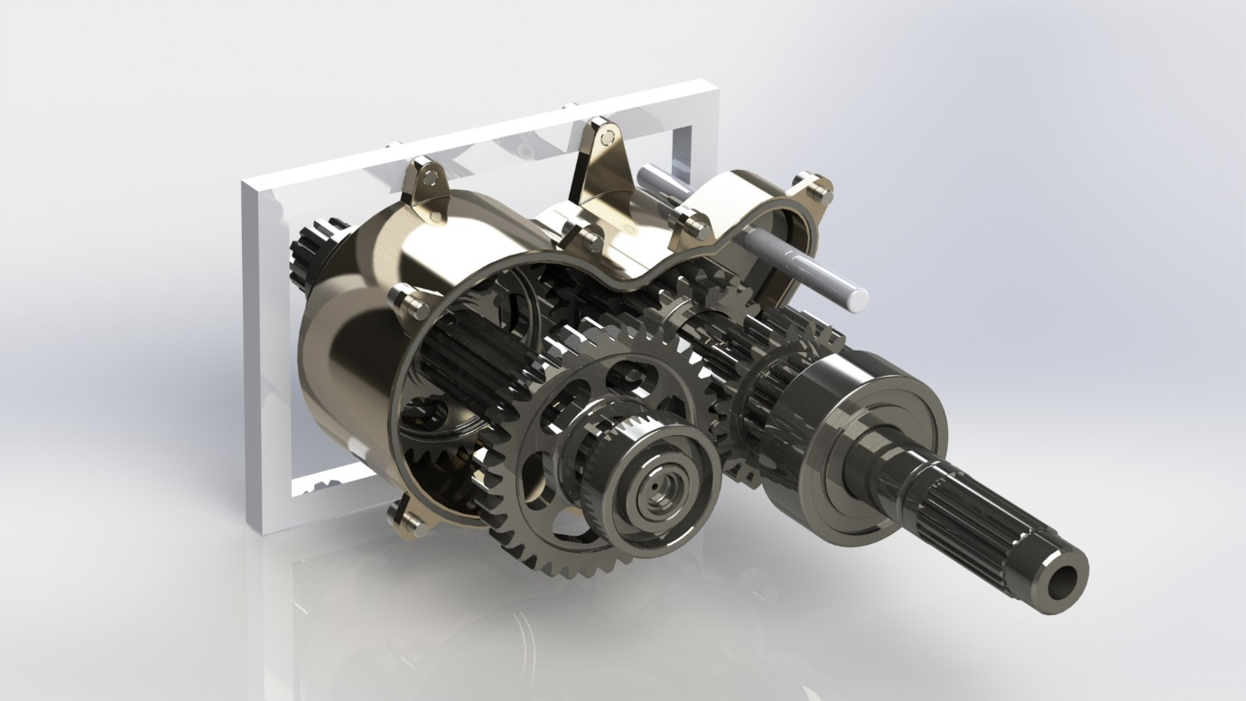
Figure 1 - Housing Profile View
As the casing parts would be cast and then post-machined in required areas (bearing seats etc.), the design could not feature any undercuts or other aspects that would prevent removal from a mould tool, and fillets would have to be allowed for on all sharp corners – these can be seen in the design.
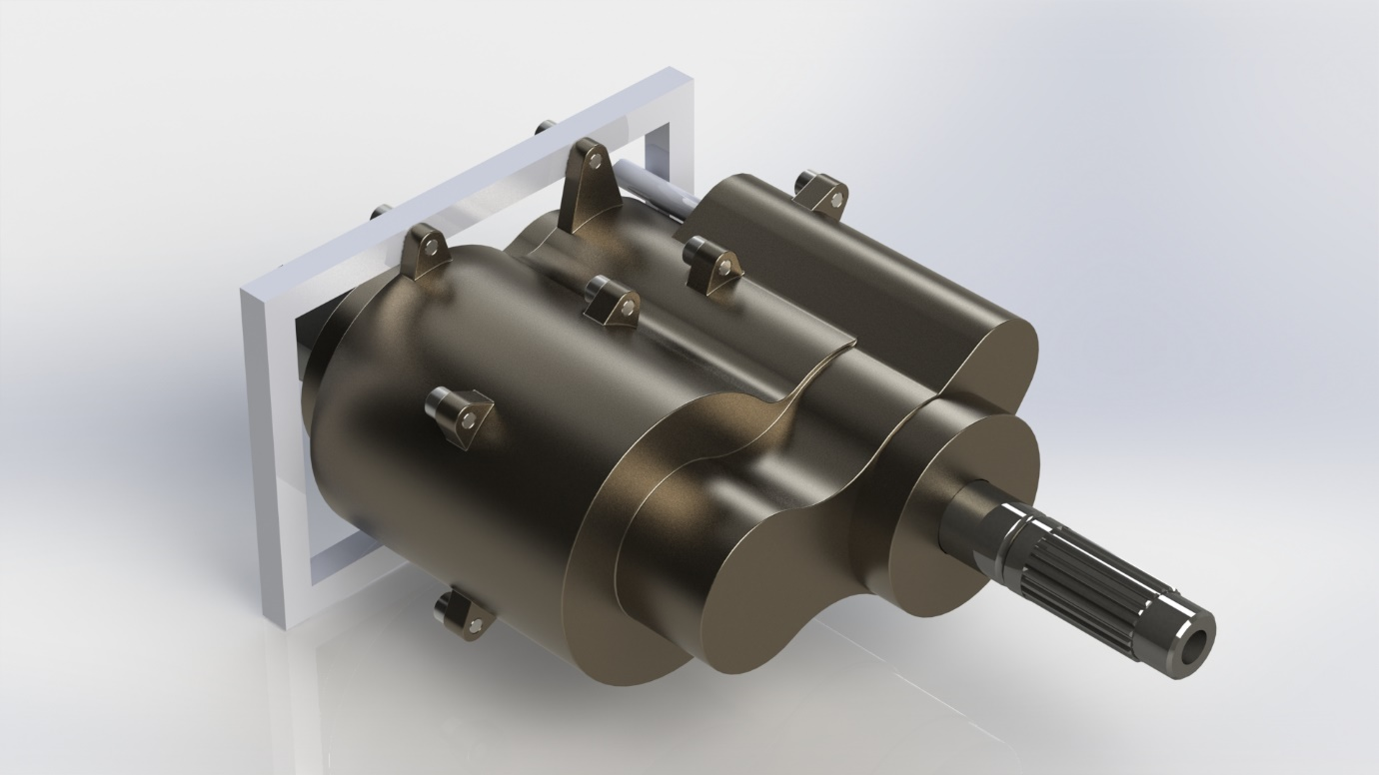
Figure 2 - Complete Housing View
Lug bosses would also have to be added to allow the case to be securely assembled and additional mounting lugs were added to mount the whole assembly to the gearbox frame. A continuous-profile gasket cut in one half to allow for proper sealing of the gearbox oil. Although not featured in the final assembly model, lip-seal shaft seals would be applied to all exit holes to ensure no leakage from the casing.

Assembly;
The assembly was split in to 3 main areas; the frame and housing, the primary shaft and the output shaft. The main frame section was fixed into the 3D environment to provide model stability and orientation, the housing section was attached to this and finally the gear shafts were fixed into the housing. By using hinge mates as opposed to standard concentric/coincident partnerships where possible, the number of total mates could be reduced – this would prove useful for the motion simulation. A number of standard mates did have to be added that would appear as redundancies, such as the distance limit for the combined gear, and a standard concentric mate on the first output gear; while not ideal, if the total number of redundancies in the simulation could be kept to approximately 10 then the simulation would still run effectively.

Motion Simulation;
In order to produce motion data, the simulation would have to be setup within the assembly with the following process;
- Insert motor – a rotary motor was added to the input shaft at 60rpm. While this is not a speed at which a motorcycle drive shaft would typically run, it put less pressure on the simulation computer and produced a quicker, smoother result.
- Add contact force between the primary combined gear and transmission gears – this would provide the relationship required to move the engaged transmission gear based on body-contact with the combined gear.
- Add contact force between primary and output transmission gears – this would be the relationship that would drive the output shaft at a speed relative to the modulus of the engaged gear.
- Add holding force to selector fork – this small force prevents the primary combined gear from sliding down the primary shaft and disengaging, and represents the forces experienced by the selector fork spring and gearbox oil.
- Add the selector fork motion force – this force represents the force applied by the rider via the gear lever to change the gear, and then acts as the holding force to keep the primary combined gear engaged to the second gear.
Once this setup had been completed, a plot could then be created by measuring the angular velocity of the output shaft;
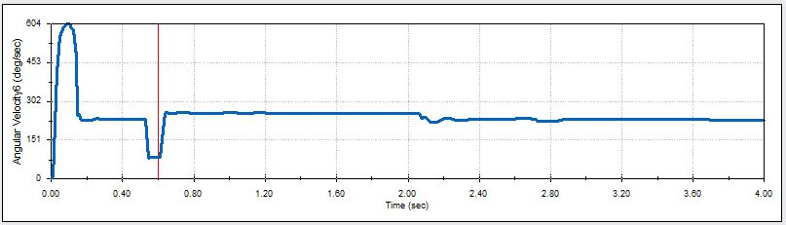
This graph shows the steady angular velocity of the output shaft in second gear, before dropping down slightly as first gear is engaged as expected. The velocity of the shaft in the first 0.3s was unexpected however, and after investigation it was found that at the start of the simulation two of the gears were not properly meshed and the teeth were occupying the same space – this would likely be the cause of the anomaly. This was confirmed by measuring the angular acceleration of the output shaft and seeing a spike to 9429deg/sec^2 at the same time as my anomalous velocity, which would be an impossible figure and thus more likely resulting from an assembly error.
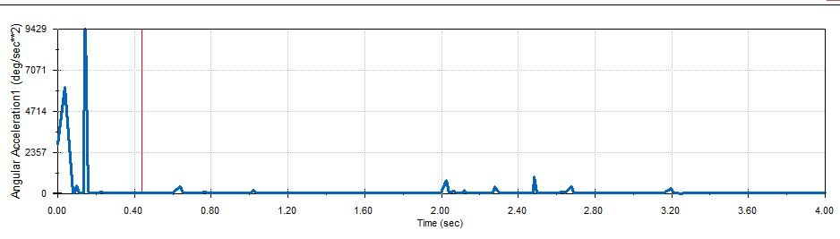
This incorrect meshing arose because standard gear mates are not compatible with motion analysis, and while solid body contacts would replicate a true gear mate during simulation, they do not position the gears correctly in the model view.
The final step was to reduce redundant mates in the motion study by adding rigid bodies within the motion study; by grouping relatively-fixed parts together within these rigid groups, it allows the simulation to ignore the mates between them and so calculate more effectively. This has to be performed with care, and with regular recalculation of the simulation in order to ensure that the assembly remained stable and no unexpected movements occurred. The original assembly had 61 redundant mates, which was reduced down to 9 in the final simulation; this exceeded the target value of 10, and greatly increased the efficiency of the simulation. The end result was a simulation that ran smoothly, recalculated quickly when input parameters were changed and allowed useful motion data to be gathered.
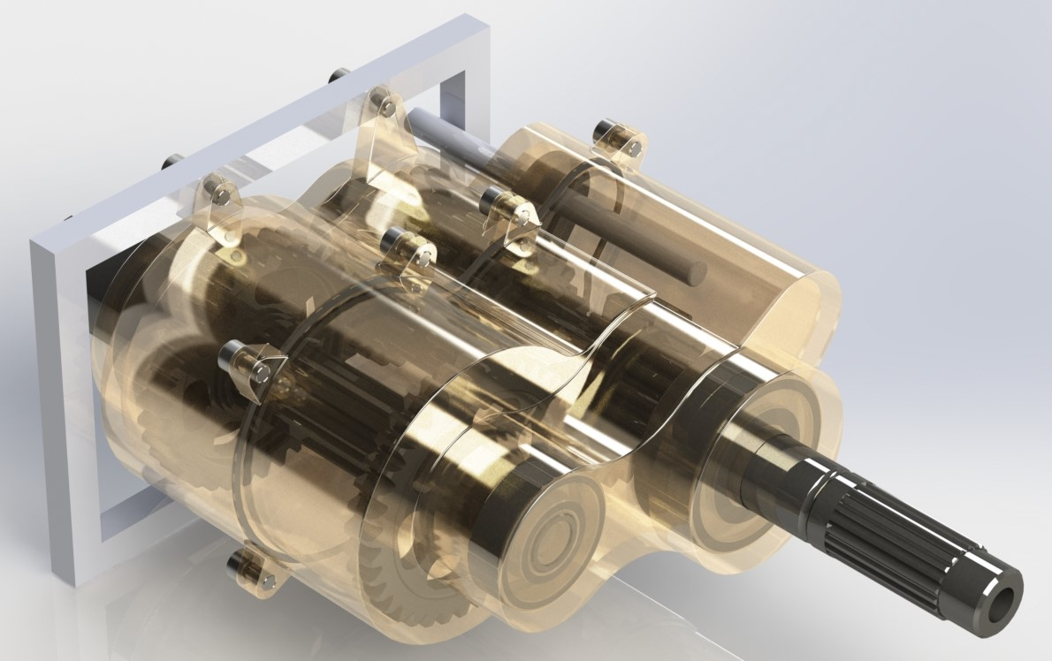
Figure 3 - Transparent View of Final Assembly

References

Autodesk, (2019), ‘Four Ways Every Engineer Should Use Simulation Models’, [12-06-19], Available: https://www.autodesk.com/industry/manufacturing/resources/mechanical-engineer/simulation-models-ebook
Bahman, Amir Sajjad; Iannuzzo, Francesco, (2018), ‘Computer-Aided Engineering Simulations’, Wide Bandgap Power Semiconductor Packaging, Vol. 2018, Pg 199-223
Crahmaliuc, Radu, (2019), ‘What Everybody Needs to Know About CAE’, [12-06-19], Available: https://www.simscale.com/blog/2016/04/what-everybody-needs-to-know-about-cae/
D’Assault Systems Solidworks Corp, (2008), ‘Understand Motion Simulation’, Concord, MA: D’Assault Systems
Engineering.com, (2017), ‘CAE Simulation Industry Hits $5.37 Billion Globally’, [12-06-19], Available: https://www.google.co.uk/amp/s/mobile.engineering.com/amp/14822.html
Harish, Ajay, (2019), ‘Finite Element Method – What Is It? FEM and FEA Explained’, [12-06-19], Available: https://www.simscale.com/blog/2016/10/what-is-finite-element-method/
Javelin, (2019), ‘Hardware Recommendations for Solidworks Simulation’, [13-06-19], Available: https://www.javelin-tech.com/blog/2016/09/solidworks-simulation-hardware-recommendations/
Kurowski, Paul, (2002), ‘When Good Engineers Deliver Bad FEA’, [12-06-19], Available: https://www.machinedesign.com/fea-and-simulation/when-good-engineers-deliver-bad-fea
Moser, Alfred; Schweiger, Raimund, (2018), ‘Prospects and Barriers For Up-Front CAE Simulation in the Automotive Development’, [12-06-19], Available: https://pdfs.semanticscholar.org/aa4c/c89c9e874d2637632f03a7bfa74b51993617.pdf
PES Performance, (2019), ‘Finite Element Analysis’, [12-06-19], Available: https://www.pes-performance.com/analysis-and-simulation/finite-element-analysis/
Scan2CAD, (2018), ‘How Much Does Solidworks Cost? Pricing Explained’, [12-06-19], Available: https://www.scan2cad.com/cad/solidworks-pricing/
SimScale, (2019), ‘What Is CFD | Computational Fluid Dynamics?’, [12-06-19], Available: https://www.simscale.com/docs/content/simwiki/cfd/whatiscfd.html

