(2309258)
ACMA6013
Reliability & Optimization of Critical Spare Parts Within Defence Manufacturing Sector

Adam Willstead

Abstract:

Readiness and supportability are central to mission success in defence manufacturing, where production of ammunition, aircraft, and armoured vehicles depends on supply chains of high cost, long lead time, and frequently repairable components. Unexpected spare part shortages can halt manufacturing and threaten operational readiness, while excessive inventory immobilises capital in low usage items. Conventional inventory practices in this sector often neglect component reliability, maintenance strategies such as reliability centred maintenance, and practical repair constraints including limited depot capacity and field service resources.

This thesis addresses these limitations by developing an approach to spare parts optimisation that integrates reliability characteristics, maintenance policy, and repair capability into inventory decision making. The study is grounded in a case analysis of Building Z within a defence manufacturing site, where obsolete parts and recurring downtime have adversely affected building output. Focusing on site wide spares management with detailed examination of three high risk areas vulnerable to future obsolescence driven downtime leading to reduced building efficiency. The research proposes a structured framework for balancing stockholding cost against the operational risk of manufacturing disruption. The findings aim to provide a practical, reliability informed method for improving spare parts provisioning and sustaining production readiness in defence manufacturing environments.

​​Contents:

List of Figures: 5
Project Introduction & Relevancy: 6
Project Aims, Problem & Timescales: 7
The current Problem in Building ‘Z’: 7
Specific Aims: 7
Scope & Limitations: 7
Projected Timescales: Planned 8
Literature Review: 9
Reliability Engineering & Maintenance introduction: 9
Relevance to your research: 9
Scope of the review and the key themes to be covered: 9
Body: 10
Section 1: Spare parts & Stores management criticality in defence systems. 10
Importance of Spare Parts in Complex Systems: 10
Inventory Management within Defence Supply Chains: 10
Inventory Control and Demand Forecasting: 11
Supply Chain Challenges in Defence Organisations: 11
Section 2: Lack of Spare Parts and Component Obsolescence in Defence Systems 12
Section 3: Failure Rate Models and Spare Parts Decision Making 14
Modelling of Failure Driven Demand: 14
Link Between Failure Behaviour and Maintenance Strategy: 14
Robust Optimisation and Adaptive Decision Models: 15
Forecasting and Decision Models in Spare Parts Management: 15
Synthesis and Critical Perspective: 16
Literature review Conclusion: 16
Research Gap: 17
Research Aim and Objectives: 18
Research Aim: 18
Research Objectives: 18
Methodology: 19
Reliability Centred Maintenance (RCM): 19
Development of the RCM Analysis Tool: 20
Development of the Spares Decision Matrix: 27
Spares Supply Considerations: 27
Demand and Operational Impact: 27
Output/Spares stocked using SDM: 28
Method Validation: 28
Method Limitations: 29
Stores Management Improvements: 29
Rationale for Improving Stores Management: 29
Implementation of the CribMaster Inventory Management System: 29
Contribution to Spare Parts Optimisation: 30
Benefits to Building Z: 30
Spares Optimisation and Obsolete Parts Management: 33
Methodological Rationale for Spares Optimisation: 33
Integrated Obsolescence Case Study Framework (Building Z): 33
Reverse Engineering and Remanufacturing (X-Ray Conveyor Hangers): 33
Design Redesign for Reliability (Trolley Tailgates): 36
Standardisation and Interface Optimisation (Speed Sensor System): 41
Cross Case Methodological Integration: 44
Overall Operational Impact: 44
Results: 45
Overview of Results: 45
RCM Analysis and Spare Parts Outcomes: 45
X-Ray Conveyor Hanger System: 45
Transport Trolley Tailgate System: 46
Speed Sensor Standardisation: 47
CribMaster Inventory System Outcomes: 47
Summary of Results: 48
Discussion, Conclusion and Evaluation 49
Discussion of Reliability Centred Maintenance and Spare Parts Optimisation: 49
Evaluation of the Critical Spares Decision Matrix: 49
Impact of Obsolescence Management: 50
Evaluation of Equipment Standardisation: 50
Stores Management and Inventory Visibility: 51
Overall Contribution to Knowledge and Practice: 51
Addressing the Research Gap: 52
Limitations: 52
Recommended further work: 53
References 54

List of Figures:
Figure 1 - Timescale Figure A. 8
Figure 2 - Timescale Figure B. 9
Figure 3 - RCM Process Improvements Chart 23
Figure 4 - Issues Record Section of RCM Form 24
Figure 5 - Header Sheet Section of RCM Form 25
Figure 6 - Asset Section of RCM Form 25
Figure 7 - Transfer Trolley Failure Modes Section of RCM Form 26
Figure 8 - X-Ray Machine Failure Modes Section of RCM Form 27
Figure 9 - Hot Vessel Failure Modes Section of RCM Form 28
Figure 10 - Transport Trolley Spares Section of RCM Form 29
Figure 11 - X-Ray Machine Spares Section of RCM Form 29
Figure 12 - Hot Vessel Spares Section of RCM Form 29
Figure 13 - SDM Model 30
Figure 14 - Weighting Analysis Table 31
Figure 15 - Problems solved By Installing Cribmaster System 34
Figure 16 - Example of Cribmaster System stock 34
Figure 17 - Inventory Management System Improvements (Barcode Scanner) 35
Figure 18 - Barcode Stocking System Example 35
Figure 19 - Snapped/Broken X-Ray Hanger 37
Figure 20 - Hanger sketched (AutoCad) from original 38
Figure 21 - Complete Hanger With Insert 38
Figure 22 - 2D Drawing of Hanger Measured from Original Obsolete Part 39
Figure 23 - Complete Stainless Steel Part 40
Figure 24 - Cross Reference of Hanger Back to RCM Form 40
Figure 25 - X-Ray Hanger Spare Recorded on Cribmaster System 40
Figure 26 - Orignal Model of Tailgate design. 41
Figure 27 - 2D Drawing of Original Tailgate 42
Figure 28 - Orignal 'non locking' Tailgate Catch. 42
Figure 29 - Example 1 of New Tailgate Design 43
Figure 30 - Example 2 of New Tailgate Design 43
Figure 31 - Example 3 of New 'Locking' Catch and Tailgate Design 44
Figure 32 - Example 4 of New Tailgate Design. 44
Figure 33 - Example 5 of New Catch and Tailgate Design. 44
Figure 34 - Example of New 'Lockable' Catches 45
Figure 35 - RCM Spares section of Tailgate Catches 45
Figure 36 - Catches and Latches Stock 45
Figure 37 - Old obsolete Sensor Diamentions 46
Figure 38 - Example of Obsolete Speed Sensor 46
Figure 39 - New Design (Bush/Reducer) 46
Figure 40 - New Sensor Bush/Reducer 2D Drawing 47
Figure 41 - Bush/Reducer used alongside sensor currently in stock (Standardisation Example) 47
Figure 42 - Complete New Sensor Design 48
Figure 43 - Sensor Spares Section of RCM 48
Figure 44 - Case Performance Summary 53
Figure 45 - Data Collection of Building Z output 53

Project Introduction & Relevancy:
In the defence manufacturing sector, readiness and supportability are critical to mission success. Manufacturing of ammunition, aircraft, and armored vehicles rely on a complex supply chain of high cost, long lead time, and frequently repairable components. Unexpected part shortages can jeopardize manufacturing linked to operational readiness, while excessive inventory ties up valuable capital in low usage items.
Spare parts inventory management must navigate these constraints, balancing the high cost of stockholding with the even greater cost of manufacturing failure and machine downtime.
Traditional inventory management practices in defence manufacturing often fail to account for component level reliability, maintenance strategies (condition based maintenance, RCM’s), and repair constraints. This thesis aims to address that gap starting with a building Z.
This report will focus on Building Z based within defence manufacturing. Building Z is currently suffering due to obsolete parts, downtime and as a result output of artillery within Building Z has reduced. This report aim is to optimize spares in general throughout the site but will firstly focus on three main key areas where obsolete parts could result in downtime and therefore reduced product output.

Project Aims, Problem & Timescales:

The current Problem in Building ‘Z’:
- Building currently has no planned maintenance so all equipment within is run to fail (RTF)
- Lack of spare parts which adds to machine downtime when a part is needed/a breakdown occurs. Some parts have long lead times/are prone to failure/are general wear parts and these are not identified.
- Various parts/spares within the building are obsolete due to old machinery that was installed many years ago (Some machinery around 30-40 years old).
- High breakdown rate in Building Z due to the above issues.
- Lack of structure within the organization to monitor spare part inventory overall.
- Building Z is not running at full production efficiency which needs improvement.

Specific Aims:
The aim of this research/report is to improve reliability and optimize spares within Building Z to prove that overall building output/efficiency has increased by doing so.
Objectives:

This report covers the development of a Reliability Centred Maintenance (RCM) model that integrates reliability and inventory optimization for critical spare parts in a given area (Building Z). It also covers various other improvements within the maintenance department that were addressed.
- Develop model. (RCM Form/Spares decision matrix)
- Identify criteria/prioritization for “critical spare parts” and obsolete parts in Building Z. (RCM Form)
- Site/maintenance department improvements. (Cribmaster stores inventory system)
- Stocking parts/solving obsolete spare part issues within Building Z. (X3 Obsolete part issues rectified).

Scope & Limitations:
- Focus on single inventory systems (Building Z) to reduce complexity initially before branching out to other buildings that need the same work throughout the production site.

Projected Timescales: Planned
Figure 1 was the planned timescale for the project which changed slightly due to NDA and data capture issues which can be seen in Figure 2. Project submission moved into the month of July.
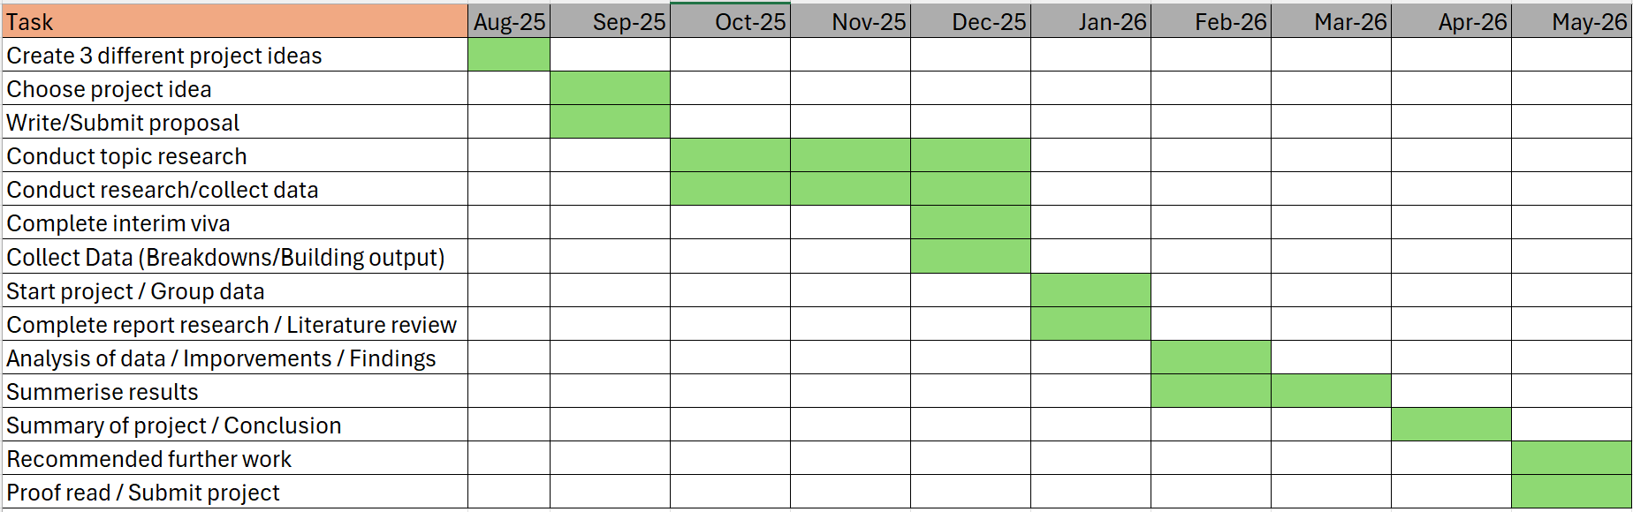
Figure 1 - Timescale Figure A.
Actual:
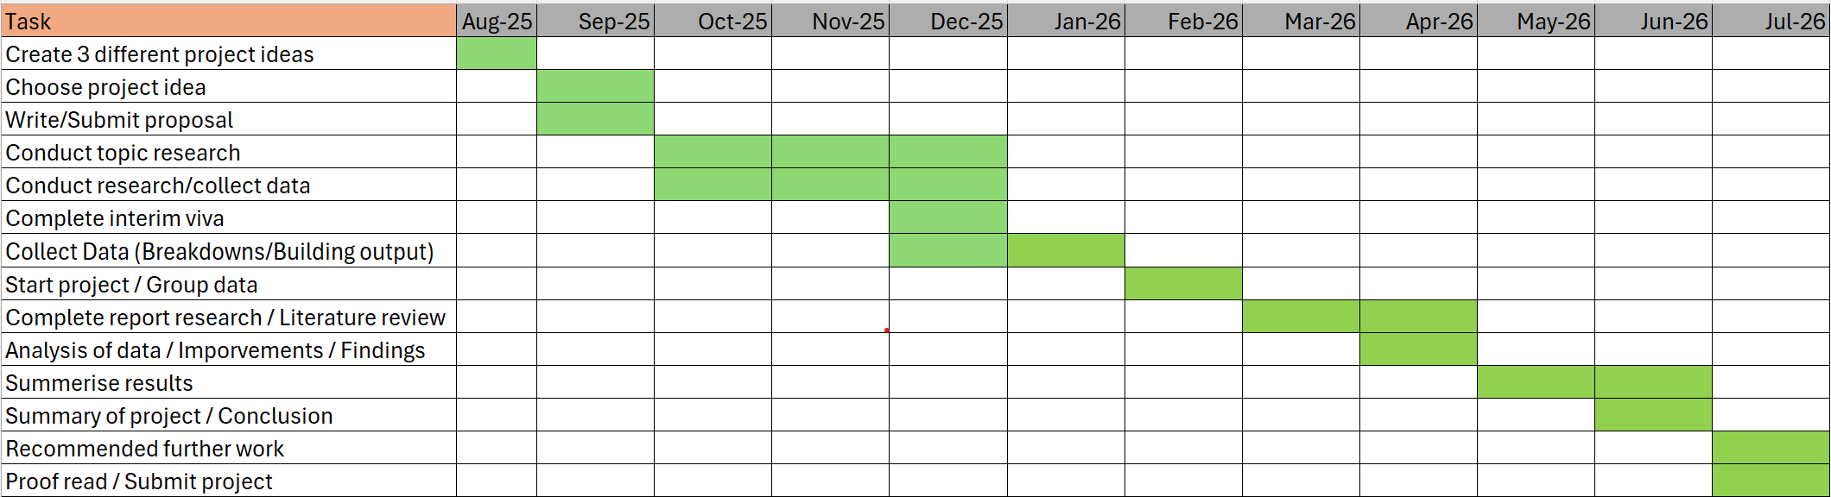
Figure 2 - Timescale Figure B.

Literature Review:

Reliability Engineering & Maintenance introduction:
In defence systems, the operational readiness of equipment is highly dependent on effective spare parts and stores management. Military platforms such as naval vessels, aircraft, and ground systems operate in demanding environments and are expected to maintain high levels of availability over extended service lives. As a result, the ability to ensure the timely availability of critical spare components is a fundamental aspect of defence logistics and maintenance strategy (Hu et al., 2018). Ineffective inventory management, delays in procurement, or insufficient forecasting can significantly reduce system availability and increase maintenance downtime (Hu et al., 2018). Consequently, spare parts and stores management has become a key area of research within defence engineering and logistics, particularly as systems become increasingly complex and technologically advanced.
A major challenge associated with spare parts management is the lack of availability of critical spares and the increasing prevalence of obsolete components. Defence systems often remain in service for several decades, during which time manufacturers may discontinue parts or cease production entirely. This creates significant sustainment challenges, including increased lead times, higher procurement costs, and the need for redesign or reverse engineering of components (Romero Rojo et al., 2013; Saygin & Onay, 2024). The absence of essential spare parts can therefore lead to prolonged equipment downtime, reduced operational capability, and increased lifecycle costs (Hu et al., 2018; Romero Rojo et al., 2013). Understanding the causes and implications of spare shortages and component obsolescence is therefore essential for improving long term system supportability.

Relevance to your research:
To address these challenges, organisations employ various reliability and failure rate models to inform spare parts planning and inventory decisions. Analytical approaches such as reliability modelling, statistical failure analysis, and predictive maintenance techniques are commonly used to estimate component failure rates and determine appropriate stock levels (Hu et al., 2018; de Jonge and Scarf, 2020). These models support decision making processes by helping organisations balance the trade off between inventory costs and system availability through the prediction of component failures and optimisation of maintenance schedules (Kennedy et al., 2014; Alaswad and Xiang, 2017). As maintenance strategies have evolved, predictive and condition based maintenance approaches have become increasingly important, enabling organisations to use condition monitoring and historical failure data to improve maintenance planning, reduce unplanned downtime and optimise spare parts provisioning (Alaswad and Xiang, 2017; Zhu et al., 2020).

Scope of the review and the key themes to be covered:
This literature review therefore examines existing research across three key areas: the critical role of spare parts and stores management in defence systems, the operational challenges caused by spare shortages and component obsolescence, and the failure rate models and decision making frameworks used by organisations to optimise spare parts management.

Body:

Section 1: Spare parts & Stores management criticality in defence systems.

Importance of Spare Parts in Complex Systems:
Spare parts and stores management is a fundamental element of maintenance engineering, particularly within asset intensive industries where equipment availability directly influences operational performance. Defence organisations rely on complex systems such as aircraft, naval vessels and armoured vehicles that are expected to operate reliably over extended service lives, often in demanding environments. Consequently, maintaining the availability of critical spare parts is essential to achieving high levels of operational readiness and minimising equipment downtime (Zhang, 2021).
Maintenance activities represent a significant proportion of the total lifecycle cost of complex engineering assets. (Zhang 2021) notes that maintenance expenditure can account for between 70 and 80 per cent of ownership costs, highlighting the importance of effective spare parts inventory management in controlling long term operational expenses. The availability of replacement components directly affects system reliability, as shortages can delay maintenance activities, reduce equipment availability and compromise mission capability. These findings demonstrate that spare parts management should be regarded as a strategic engineering function rather than simply an inventory control process.
The importance of spare parts management is further reinforced within defence environments, where equipment failure may have operational consequences beyond financial cost. (Kang 2025) argues that even relatively small shortages of critical components can significantly reduce system readiness because defence assets often depend upon a limited number of mission critical parts with long lead times. This suggests that maintaining appropriate inventory levels is essential for balancing availability against the financial side of excessive stock holding.

Inventory Management within Defence Supply Chains:
Traditional defence logistics systems have historically relied upon maintaining large inventories of spare parts to guarantee equipment availability. (Zhang 2020) explains that this approach, sometimes described as a guaranteed supply strategy, prioritises operational readiness through extensive stockholding. While this reduces the likelihood of stock shortages, it also results in considerable inventory costs and inefficient utilisation of financial resources.
More recent research advocates the application of modern supply chain management principles to defence logistics. (Zhang 2020) proposes that demand driven inventory management and integrated supply chain planning enable organisations to predict spare part requirements more accurately while reducing unnecessary stock levels. Multi echelon inventory systems are commonly adopted within defence organisations, where demand originates at operational units before being aggregated through successive levels of the supply chain for procurement and distribution. Such hierarchical inventory structures improve coordination between maintenance facilities, warehouses and suppliers while supporting more efficient inventory control.
(Similarly, Yavuz 2023) identifies inventory management as a strategic process that seeks to maximise equipment availability while minimising unnecessary inventory investment. Unlike production inventory, spare parts exist primarily to support maintenance activities and sustain operational capability. Consequently, effective inventory management requires organisations to maintain sufficient stock to satisfy maintenance demand without incurring excessive holding costs. This balance is particularly important within defence systems where many components are expensive, have long lead times and may only be available from a limited number of suppliers.

Inventory Control and Demand Forecasting:
A recurring theme throughout the literature is the importance of inventory classification and demand forecasting in improving spare parts management. (Yavuz 2023) highlights several widely adopted inventory management techniques, including ABC classification, VED (Vital, Essential and Desirable), RCM (Reliability Centered Maintenance) analysis and multi criteria classification methods. These approaches enable organisations to prioritise critical components according to operational importance, demand characteristics and procurement risk, thereby supporting more effective allocation of inventory resources.
Demand forecasting models also play an important role in determining appropriate inventory levels. Inventory control techniques such as Economic Order Quantity (EOQ), reorder point analysis and safety stock calculations assist organisations in balancing inventory costs against service level requirements. However, while these methods perform effectively under relatively stable demand conditions, their accuracy may decline when failure patterns become highly variable or operational requirements change unexpectedly. This limitation is particularly relevant within defence organisations, where equipment utilisation often fluctuates according to operational tempo.
(Kang 2025) addresses these limitations by proposing robust techniques that explicitly account for uncertainty within spare parts demand. Rather than relying solely on deterministic forecasting methods, optimisation seeks to maintain required service levels across a range of possible scenarios. Although these approaches offer greater resilience under uncertain operating conditions, their implementation depends upon accurate estimation of uncertainty parameters and reliable maintenance data, which may not always be available for ageing defence assets.

Supply Chain Challenges in Defence Organisations:
Effective spare parts management becomes increasingly complex as supply chain networks expand. (Li, 2008) argues that central warehouses play a critical role in supporting maintenance operations by ensuring that required components are available throughout the supply chain. However, maintaining high service levels frequently requires substantial safety stock, increasing inventory holding costs and reducing overall supply chain efficiency.
(Li, 2008) further identifies demand uncertainty as one of the principal challenges within multi echelon spare parts supply chains. As demand information moves upstream from operational units to central warehouses and suppliers, variability can increase due to the bullwhip effect, causing inventory decisions to become less representative of actual maintenance requirements. Furthermore, limited visibility of inventory levels across different supply chain tiers often encourages organisations to maintain excessive stock as a precaution against shortages.
Collectively, these studies demonstrate that effective spare parts and stores management depends upon achieving an appropriate balance between operational readiness, inventory investment and supply chain efficiency. While traditional defence logistics prioritised high stock availability through extensive inventory holding, contemporary research increasingly supports the adoption of demand driven forecasting, integrated supply chain management and advanced inventory optimisation techniques. Nevertheless, accurately forecasting demand for low volume, critical components remains a significant challenge, particularly within defence organisations operating ageing equipment with long service lives. These issues provide a strong foundation for further investigation into methods that improve spare parts decision making while maintaining operational readiness.

Section 2: Lack of Spare Parts and Component Obsolescence in Defence Systems
Long operational life of defence equipment presents significant challenges for spare parts management, particularly with component obsolescence and availability of replacement parts. Unlike commercial products, military platforms remain in service for decades, during which time equipment manufacturers may discontinue production or withdraw technical support for components. As a result, defence organisations must maintain ageing systems despite increasingly constrained supply chains and diminishing availability of critical spare parts (Zhang, 2021).
Component obsolescence is recognised as one of the most significant factors affecting long term supportability of complex engineering assets. (Zhang 2021) explains that obsolescence occurs when manufacturers cease production of components as newer products replace legacy technologies. Once production has ended, suppliers are unwilling to recommence manufacturing because of the high costs associated with retooling and relatively low production volumes. Consequently, organisations responsible for maintaining ageing assets experience increasing procurement lead times, reduced supplier availability and greater difficulty sourcing replacement components.
The complexity of spare parts management is further increased by the characteristics of spare parts demand. Unlike production inventory, demand for replacement components is highly intermittent and depends upon equipment utilisation, failure behaviour and maintenance schedules. (Zhang 2021) argues that these characteristics make inventory planning particularly difficult, increasing the likelihood of shortages of critical components and the accumulation of obsolete stock. Excess inventory may eventually become unusable as systems evolve or are retired, resulting in unnecessary storage costs, capital tied up in inventory and significant financial waste.
Several authors identify the shortage of critical spare parts as one of the primary causes of reduced operational availability. (Kang 2025) argues that conventional deterministic inventory models often fail to account adequately for uncertainty in both demand and supply, increasing the probability of shortages for critical components. Rather than considering only inventory costs, (Kang 2025) proposes robust techniques that incorporate uncertainty into inventory planning, reducing the risks associated with demand. This approach is particularly relevant within defence environments, where the unavailability of a critical component can prevent an entire system from returning to service.
The consequences of spare parts shortages extend well beyond financial performance. Delays in obtaining replacement components increase maintenance downtime, reduce equipment availability and may ultimately compromise operational readiness. (Zhang 2020) argues that traditional defence logistics systems have historically attempted to avoid shortages by maintaining extensive inventories. While this strategy improves the likelihood of component availability, it frequently results in excessive stockholding, increased warehousing costs and the accumulation of obsolete inventory that provides little operational benefit. These findings suggest that maintaining large inventories alone does not guarantee equipment readiness if the stored components no longer reflect actual maintenance requirements.
A further challenge identified within the literature concerns the effectiveness of information flow throughout defence supply chains. (Zhang 2020) notes that inventory decisions are frequently made across multiple organisational levels, with demand information passing from operational units through maintenance organisations to central warehouses before procurement decisions are made. Each stage introduces delays and uncertainty, reducing the responsiveness of the supply chain to changing operational requirements. Consequently, shortages experienced at operational level may not be reflected rapidly enough within procurement decisions, while excessive inventory held elsewhere within the supply chain remains underutilised.
Similar conclusions are presented by (Yavuz 2023), who argues that the primary objective of spare parts management is to balance component availability against inventory investment. Poor forecasting, inaccurate inventory records and extended procurement lead times all increase the likelihood of both stock shortages and obsolescence. (Yavuz 2023) suggests that obsolete inventory not only occupies warehouse space but also reduces efficiency by tying up financial resources in components that no longer support operational requirements. These challenges become particularly significant within defence organisations, where many components have long procurement lead times and limited sources of supply.
(Li, 2008) also identifies demand uncertainty as a major obstacle to effective spare parts management. Demand for replacement components is influenced by numerous factors, including equipment reliability, operational usage, maintenance policies and seasonal variation, making accurate forecasting difficult. (Li, 2008) highlights the influence of the bullwhip effect, whereby relatively small changes in demand at operational level become increasingly amplified as information moves upstream through the supply chain. This distortion reduces forecasting accuracy and can result in either shortages of critical components or excessive inventory throughout the logistics network.
Collectively, the literature demonstrates that shortages of spare parts and increasing levels of component obsolescence represent major barriers to maintaining operational readiness within defence systems. Although traditional inventory strategies have sought to minimise shortages by maintaining high stock levels, research suggests that this approach is financially unsustainable and does not address demand uncertainty or component obsolescence. Instead, effective spare parts management requires organisations to integrate accurate demand forecasting, robust inventory optimisation and improved supply chain visibility to achieve an appropriate balance between operational availability and inventory cost. These findings provide the foundation for investigating maintenance centred approaches that support more effective spare parts decision making within long life defence assets.

Section 3: Failure Rate Models and Spare Parts Decision Making
Spare parts demand is driven by equipment failure behaviour and maintenance requirements over the lifecycle of engineering assets. Unlike conventional products with stable demand patterns, spare parts exhibit intermittent and stochastic demand due to the nature of component failures. As a result, forecasting spare parts requirements is more complex and requires modelling approaches that reflect uncertainty in failure processes (Zhang, 2021).

Modelling of Failure Driven Demand:
An approach to modelling spare parts demand is through stochastic processes, which represent the nature of equipment failure over time. (Zhang 2021) identifies that failure related demand is commonly modelled using probabilistic frameworks that capture both the frequency and timing of component failures.
Stationary stochastic processes are frequently used under the assumption that failure rates remain constant over time. The Poisson process is one of the most common examples of this approach and is typically applied in situations where the installed base of equipment is stable and failure behaviour does not vary significantly across the lifecycle. However, this assumption may be overly simplistic in many real world defence applications, where equipment usage and operational intensity fluctuate over time.
To address these limitations, non stationary stochastic processes are used to model situations where demand varies across different lifecycle phases. (Zhang 2021) highlights that these models are particularly relevant when systems are introduced into service, modified during operation as the installed base and associated failure rates change over time. This makes non stationary models more suitable for long life defence assets, where conditions evolve significantly across decades of service.
In addition to stochastic process models, probability distribution approaches are also widely used to characterise spare parts demand. These models rely on historical maintenance data to fit statistical distributions that represent observed failure behaviour. While such methods can capture demand patterns more effectively than simple models, their accuracy depends heavily on the availability and quality of historical data, which is often limited in defence contexts due to low failure frequencies and changing operational conditions.

Link Between Failure Behaviour and Maintenance Strategy:
Failure modelling is closely linked to maintenance strategy, as the timing and nature of maintenance interventions directly influence spare parts demand. (Zhang 2021) distinguishes between preventive maintenance, where components are replaced before failure occurs, and corrective maintenance, where replacement takes place after a failure has occurred. Preventive maintenance typically results in more predictable demand patterns, whereas corrective maintenance generates more stochastic and intermittent demand.
The interaction between maintenance strategy and failure behaviour is therefore a key driver of spare parts inventory requirements. Organisations adopting condition based or preventive maintenance strategies may benefit from improved demand predictability, whereas those relying heavily on reactive maintenance face greater uncertainty in spare parts planning. This relationship highlights the importance of integrating reliability analysis with maintenance planning to improve inventory decision-making.

Robust Optimisation and Adaptive Decision Models:
Traditional stochastic inventory models are typically based on expected failure rates and assumed demand distributions. However, (Kang 2025) argues that such approaches may perform poorly in highly uncertain or volatile environments, particularly when demand distributions are difficult to estimate accurately. To address this limitation, robust optimisation methods have been developed to account for uncertainty by considering worst case scenarios within defined uncertainty sets.
(Kang 2025) demonstrates that robust models can improve inventory performance by dynamically adjusting reorder points and stock levels in response to observed changes in demand and failure behaviour. This adaptive approach enables organisations to respond more effectively to variability in both demand and supply conditions. Simulation results and case study evidence presented in the literature indicate that robust optimisation can reduce stock out risk while maintaining acceptable inventory costs, making it particularly suitable for complex and high reliability systems such as those found in aerospace and defence applications.
However, while robust optimisation techniques offer improved resilience, their effectiveness depends on the accurate definition of uncertainty boundaries and the availability of reliable operational data. In environments where data is limited or failure events are rare, such as many defence systems, defining appropriate uncertainty sets can present a significant challenge.

Forecasting and Decision Models in Spare Parts Management:
In addition to stochastic and robust optimisation approaches, a wide range of forecasting and decision support methods are used in spare parts management. (Li, 2008) notes that many organisations rely on statistical forecasting techniques, such as Poisson based models, to represent infrequent equipment failures and estimate future spare parts demand. These models are primarily designed to minimise inventory costs while maintaining acceptable service levels.
More advanced approaches incorporate time series analysis, regression models and multi criteria decision making techniques such as the Analytic Hierarchy Process (AHP). These methods allow organisations to evaluate spare parts based on factors such as criticality, demand frequency and operational importance. Classification techniques such as ABC, FSN and VED analysis are also widely used to prioritise inventory management efforts based on value, usage rate and mission criticality.
Recent developments in the literature have focused on the application of artificial intelligence techniques to improve forecasting accuracy. (Li, 2008) highlights the use of artificial neural networks (ANNs) to identify complex relationships in historical demand data that may not be captured by traditional statistical models. More advanced hybrid approaches, such as Enhanced Fuzzy Neural Networks (EFNN) combined with genetic algorithms and AHP, have been proposed to integrate expert knowledge with data driven forecasting. These approaches have demonstrated improvements in inventory performance by reducing stock outs and lowering overall inventory costs while maintaining service levels.

Synthesis and Critical Perspective:
Collectively, the literature demonstrates a progression from traditional statistical forecasting methods towards more adaptive, data driven and uncertainty aware decision models for spare parts management. While stochastic models provide a foundation for understanding failure driven demand, their effectiveness is constrained by assumptions regarding distribution stability and data availability. Robust optimisation approaches offer improvements in handling uncertainty but require careful calibration of model parameters, which may not always be feasible in defence environments.
Similarly, AI based forecasting methods show promise in improving prediction accuracy, but their performance is heavily dependent on the availability of high quality historical data and may be limited in applications involving rare failure events or long life systems. This suggests that no single modelling approach is sufficient in isolation. Instead, effective spare parts decision making requires the integration of reliability modelling, forecasting techniques and adaptive optimisation methods to address the inherent uncertainty in failure driven demand.
These limitations highlight the ongoing challenge of balancing model complexity, data availability and operational applicability in defence spare parts management. This provides the basis for further investigation into integrated approaches that combine reliability analysis with practical inventory decision frameworks for long life engineering systems.

Literature review Conclusion:
The literature consistently demonstrates that spare parts and stores management is a critical determinant of operational readiness in defence systems. Unlike conventional inventory, spare parts exist primarily to support maintenance activities and ensure system availability rather than to satisfy production demand. This creates a fundamentally different inventory problem characterised by intermittent demand, long procurement lead times and high consequences of stock unavailability.
Across the literature, there is broad agreement that traditional defence logistics approaches, which prioritise high stock levels to avoid shortages, are increasingly inefficient. While such strategies can reduce the immediate risk of stock outs, they also generate significant inventory holding costs, contribute to obsolete stock accumulation and do not fully eliminate the risk of unavailability of critical components. In complex systems, these issues are exacerbated by limited supplier support and obsolescence.
A key finding is that spare parts demand is fundamentally driven by failure behaviour and maintenance strategy. As a result, effective inventory planning must be grounded in reliability based information rather than historical consumption. The literature identifies a range of approaches to address this, including stochastic failure modelling, statistical forecasting, classification techniques such as ABC and VED analysis, and inventory control methods such as safety stock and reorder point optimisation.
More recent research highlights the limitations of traditional deterministic and static approaches, particularly under conditions of uncertainty. Robust optimisation methods and data driven forecasting techniques have been shown to improve performance by explicitly accounting for variability in demand, lead times and system behaviour. However, the literature also indicates that these approaches are highly dependent on data availability and model assumptions, which can be restrictive in defence environments where failure data is sparse and systems have long and irregular operating lifecycles.
Overall, the literature suggests that effective spare parts management requires an integrated approach that combines reliability analysis, forecasting and adaptive inventory decision models. However, there remains a gap in the application of these integrated approaches within long life defence platforms, particularly in operational environments where data limitations and obsolescence risks constrain the effectiveness of existing models. This highlights the need for further investigation into practical decision support approaches that can improve spare parts availability while maintaining cost efficiency in real defence contexts.

Research Gap:
Although the literature provides extensive coverage of spare parts inventory theory, reliability modelling and supply chain optimisation, a significant gap remains in the practical integration of these approaches within operational defence maintenance environments.
Existing studies tend to address these domains in isolation. Inventory management research predominantly focuses on stock optimisation techniques, forecasting methods and cost reduction strategies. Reliability engineering literature concentrates on failure behaviour modelling and maintenance planning, while supply chain research examines multi echelon systems, information flow and demand variability. However, there is limited research demonstrating how these areas can be effectively combined to improve production output.
In particular, the literature does not sufficiently address the translation of reliability outputs such as failure rates, MTBF values and maintenance strategies into actionable spare parts stocking decisions within real world defence maintenance systems. This disconnect limits the practical application of existing theoretical models.
Key gaps identified include:
- Insufficient application of structured decision tools, such as spares decision matrices, to prioritise components based on failure consequence, criticality and lead time within defence contexts.
- Lack of empirical case studies demonstrating how organisations can simultaneously reduce stock outs, excess safety stock and obsolete inventory while maintaining operational readiness.
- Limited investigation into how data visibility constraints between maintenance units and central stores impact the effectiveness of failure based forecasting methods.
- Insufficient evidence on the performance of modern optimisation and forecasting techniques when applied to long life defence systems characterised by obsolescence and irregular failure patterns.
Overall, while significant advances have been made in reliability modelling and inventory optimisation independently, the literature lacks a unified, applied framework that integrates these approaches into a practical decision support system for spare parts management in defence maintenance operations. This highlights the need for research into integrated, reliability informed spare parts decision making approaches within operational defence environments.

Research Aim and Objectives:

Research Aim:
The aim of this research is to develop a structured, reliability informed approach for spare parts and stores management within a defence maintenance environment, integrating Reliability Centred Maintenance (RCM) principles with spare parts decision making tools to improve inventory efficiency and operational readiness within Building Z.

Research Objectives:
To achieve this aim, the following objectives will be addressed:
- To critically review existing literature on spare parts management, reliability modelling, and inventory optimisation within defence and asset intensive industries.
- To analyse how failure behaviour and reliability data (e.g., failure rates, MTBF, maintenance strategies) influence spare parts demand and inventory requirements.
- To evaluate existing spare parts decision making approaches, including forecasting methods, inventory classification techniques and optimisation models.
- To investigate the limitations of current approaches in managing obsolescence, demand uncertainty, and supply chain visibility within defence maintenance environments.
- To develop a structured decision support approach (e.g., RCM informed spares decision matrix) that links reliability analysis to spare parts stocking decisions.
- To apply the proposed approach to a defence maintenance context and assess its potential to reduce stock outs, excess inventory, and obsolescence while maintaining operational readiness/improving building efficiency.

Methodology:
This research adopted an applied engineering case study approach to investigate how Reliability Centred Maintenance (RCM) can be used to improve spare parts and stores management within Building Z. The methodology was developed in response to the research gap identified in the literature, which highlighted the lack of practical integration between reliability analysis and spare parts inventory decision making in defence maintenance environments.
The research focused on developing a structured RCM model that identifies critical equipment, analyses potential failure modes and determines appropriate maintenance actions. The outputs from the RCM analysis were subsequently used to develop a weighted Spares Decision Matrix (SDM), providing an evidence based method for determining which spare parts should be held in inventory. Unlike traditional approaches that rely primarily on historical demand or engineering judgement, the proposed methodology integrates equipment reliability, operational criticality and supply chain risk into a single decision making framework.
The methodology consists of five principal stages:
- Identification of assets within Building Z.
- Reliability Centred Maintenance (RCM) analysis of each asset.
- Identification of critical spare parts.
- Assessment of each spare using the Spares Decision Matrix.
- Development of an optimised critical spares inventory.
This process provides a repeatable methodology that links maintenance engineering with inventory management.

Reliability Centred Maintenance (RCM):
Reliability Centred Maintenance (RCM) is a structured engineering methodology used to determine the most appropriate maintenance strategy for physical assets operating within a specific environment. Moubray (2001) defines RCM as "a process used to determine the maintenance requirements of any physical asset in its operating context." Rather than applying identical maintenance strategies to all equipment, RCM evaluates each asset according to its function, failure characteristics and operational importance.
The RCM analysis followed the sequence and consisted of:
- identification of equipment and system functions;
- identification of functional failures;
- identification of failure modes and causes;
- assessment of failure consequences;
- selection of the most appropriate maintenance strategy; and
- identification of critical spare parts required to support maintenance activities.
This process establishes a direct relationship between equipment reliability and spare parts inventory decisions.
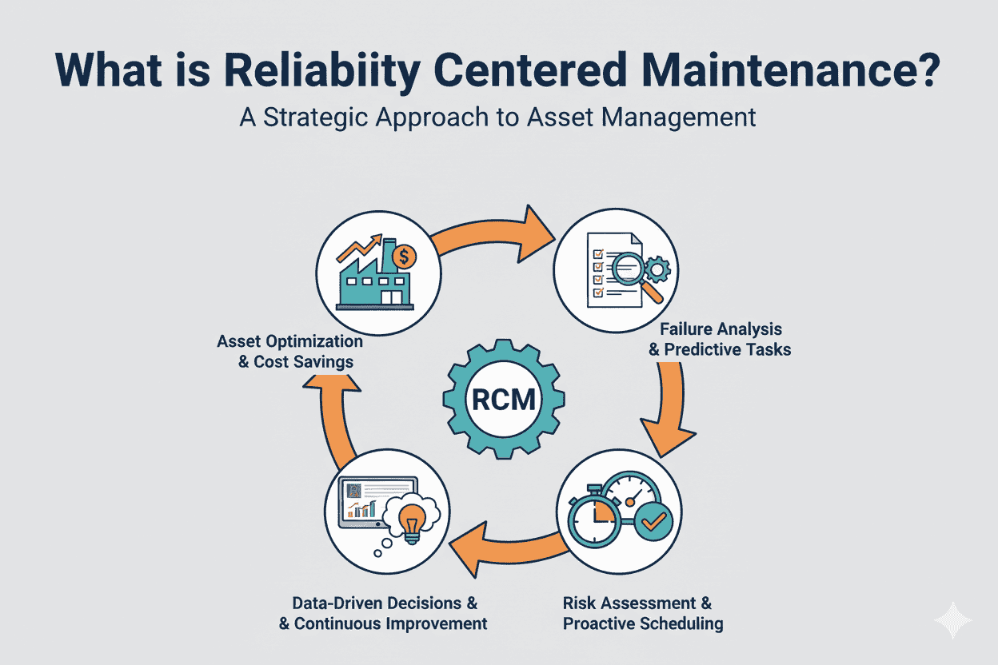
Figure 3 - RCM Process Improvements Chart

Development of the RCM Analysis Tool:
To implement the methodology, a bespoke Microsoft Excel based RCM tool was developed specifically for Building Z.
The tool consists of five integrated worksheets:
Sheet 1: Issue Record
The Issue Record provides document control by recording revisions, issue numbers and approval history, ensuring traceability throughout the development of the RCM model.
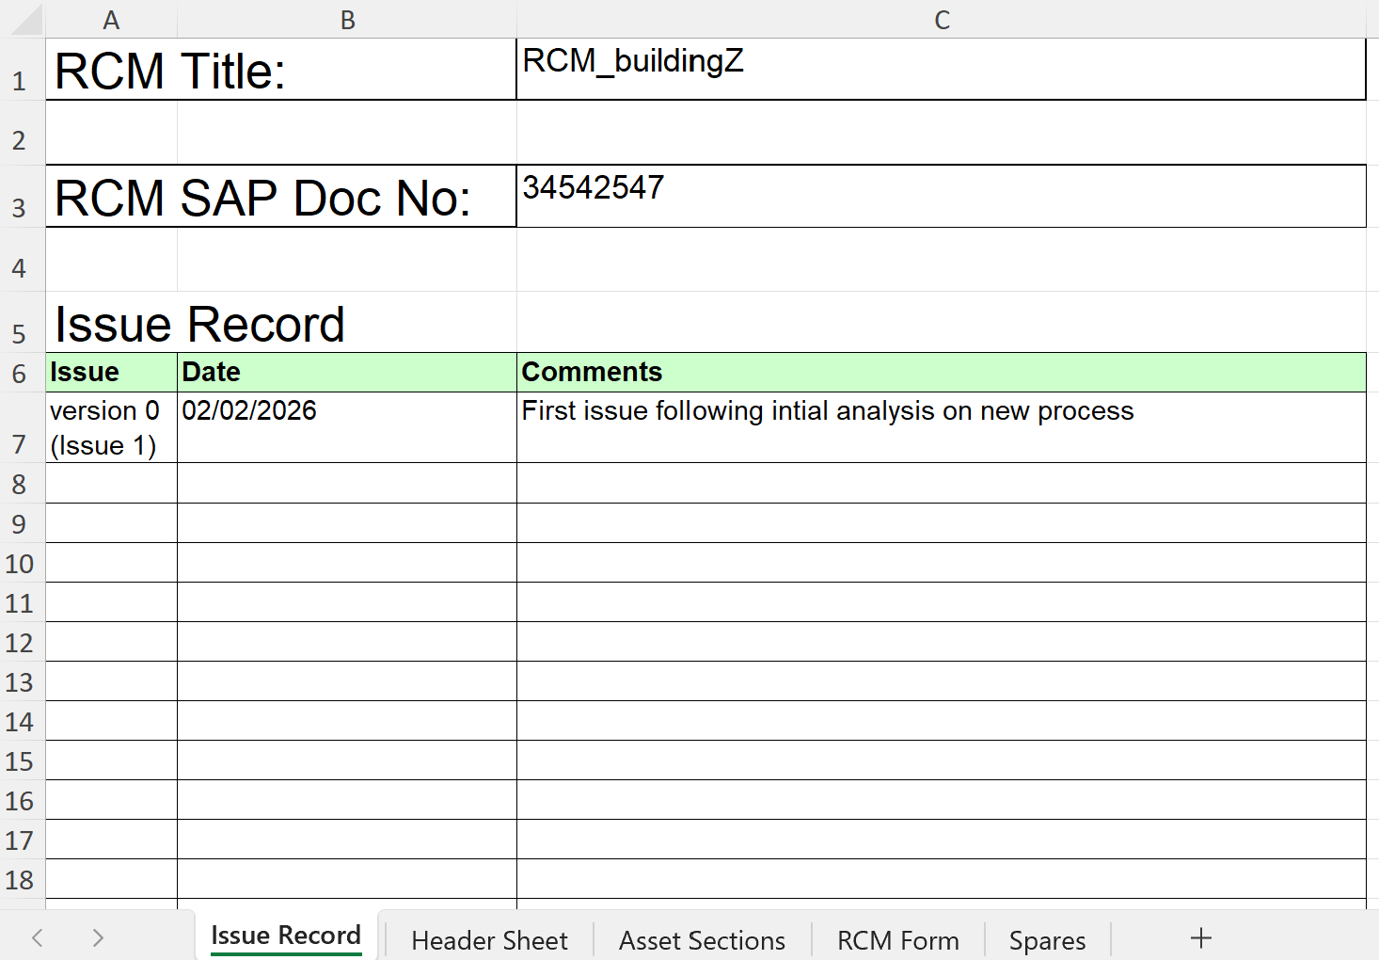
Figure 4 - Issues Record Section of RCM Form
Sheet 2: Header Information
The header sheet records the operating context of the analysis, including:
- scope of the assessment;
- asset identification numbers (SAP);
- personnel involved in the assessment;
- equipment functions;
- secondary functions;
- operating assumptions;
- failure consequence criteria.
This information establishes the operating context required by the RCM process.
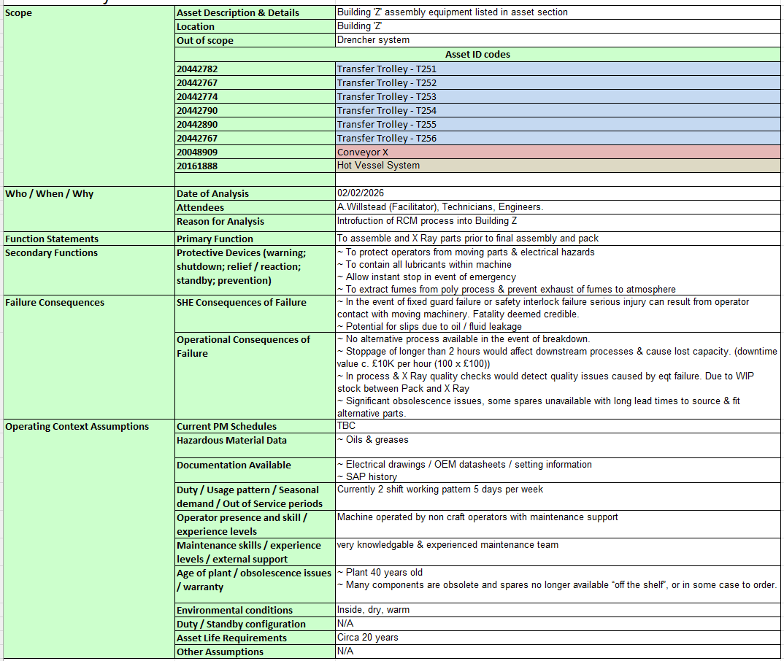
Figure 5 - Header Sheet Section of RCM Form
Figure 5 shows ‘Operational Consequences of failure in the event of a breakdown.
~ Stoppage of longer than 2 hours would affect downstream processes & cause lost capacity. (downtime value estimated around £10K per hour).
Sheet 3: Asset Register
All equipment within Building Z was divided into logical asset groups before analysis. Major equipment included:
- Transfer Trolleys;
- X-Ray Machine;
- Hot Vessel.
Each asset was broken down into its principal components to allow individual failure modes to be assessed.
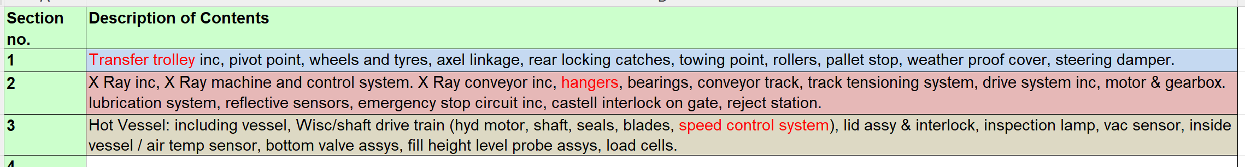
Figure 6 - Asset Section of RCM Form
Sheet 4: Failure Mode Analysis
Each component was analysed using an RCM worksheet that records:
- component function;
- potential failure mode;
- likely cause of failure;
- failure detectability;
- Mean Time To Failure (MTTF);
- safety consequences;
- operational consequences.
Following assessment, an appropriate maintenance strategy was assigned to each failure mode. These included preventive maintenance, condition based maintenance, redesign recommendations or run to failure strategies where appropriate.
The effectiveness of each maintenance action was then reassessed by reviewing the revised consequence scores after implementation.
This stage forms the core of the RCM methodology and generates the information required for spare parts decision making.
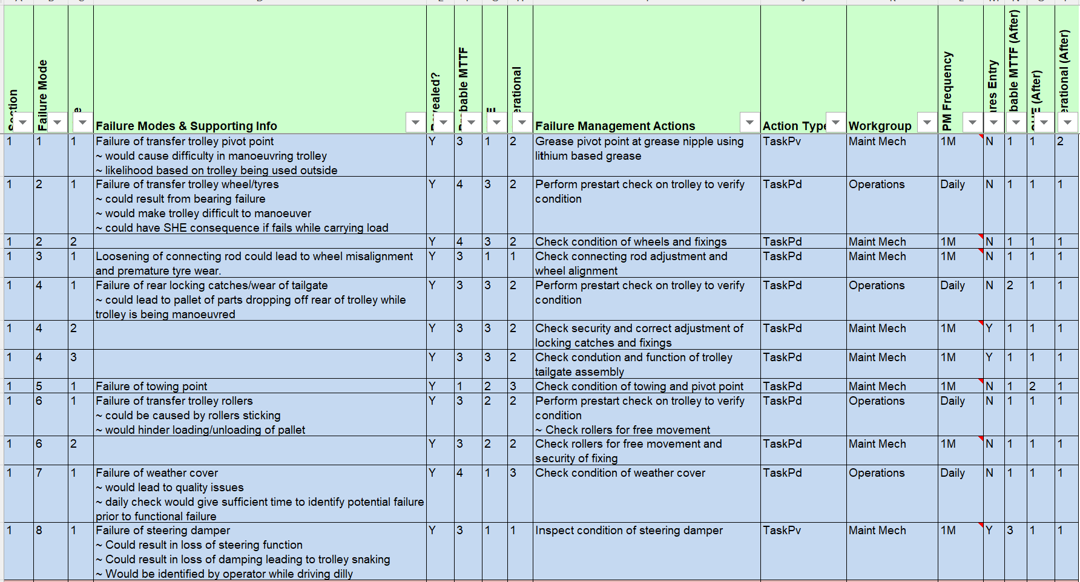
Figure 7 - Transfer Trolley Failure Modes Section of RCM Form
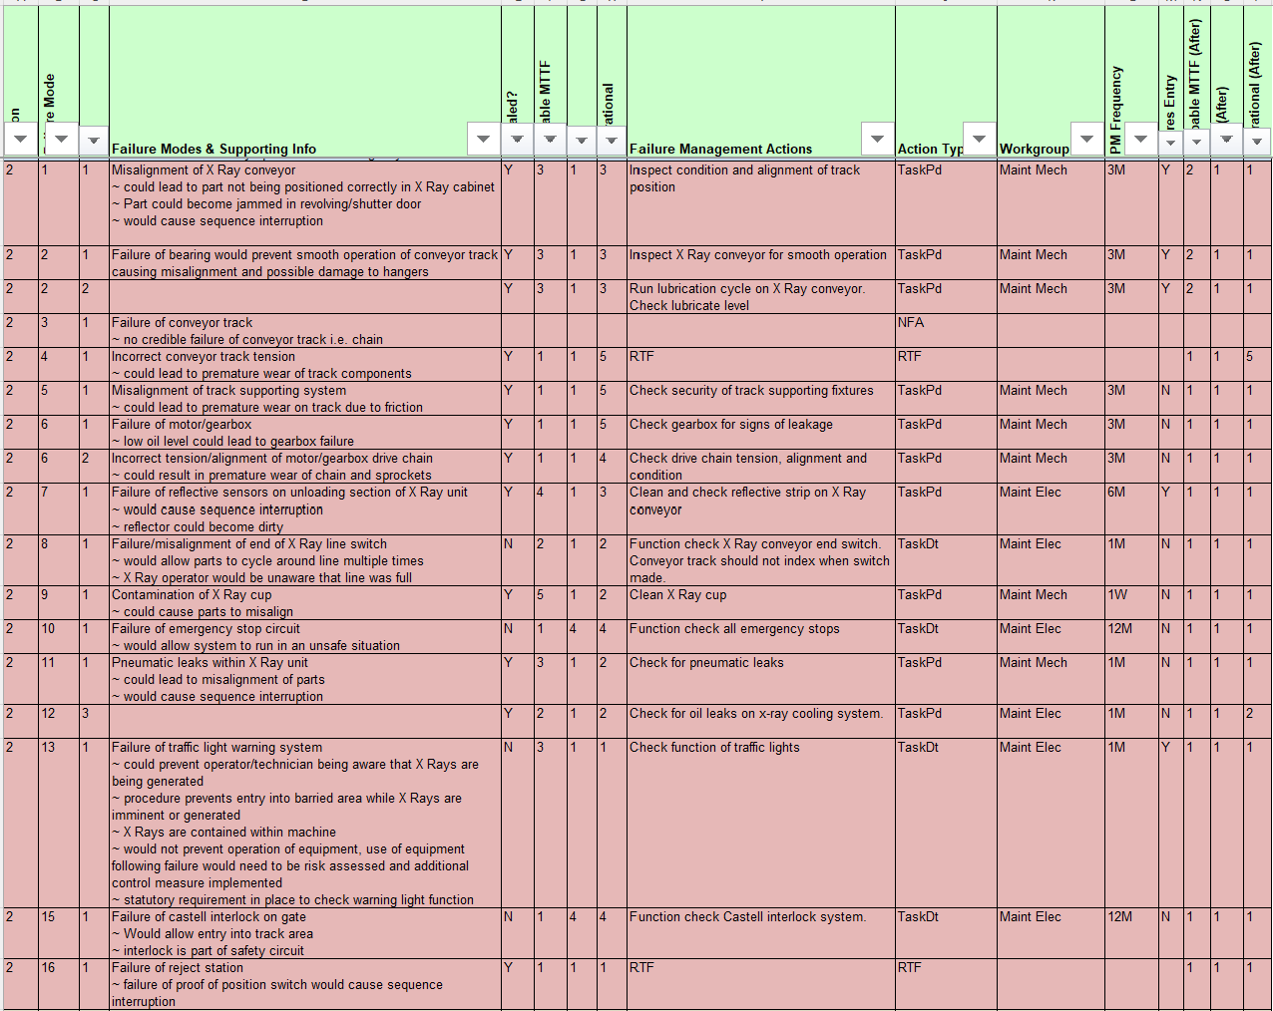
Figure 8 - X-Ray Machine Failure Modes Section of RCM Form

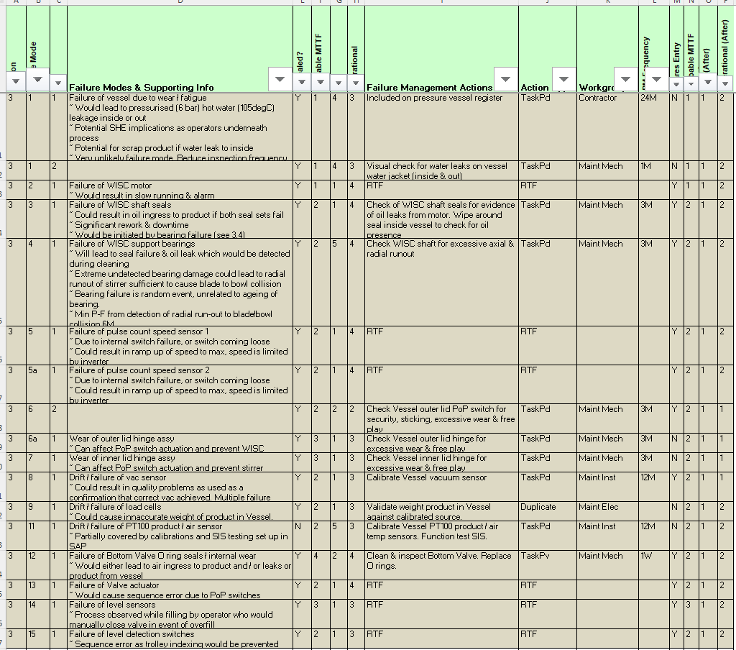
Figure 9 - Hot Vessel Failure Modes Section of RCM Form
Sheet 5: Identification of Critical Spare Parts
The outputs generated by the RCM analysis were used to identify components requiring inventory support.
Unlike traditional inventory planning, which often relies on historical consumption, this methodology identifies spare parts based upon the consequences of equipment failure.
A component was considered a potential critical spare where failure would result in significant operational disruption, extended downtime, safety implications or excessive replacement lead times.
The RCM analysis therefore provides an engineering justification for holding inventory rather than relying solely on previous purchasing practices.

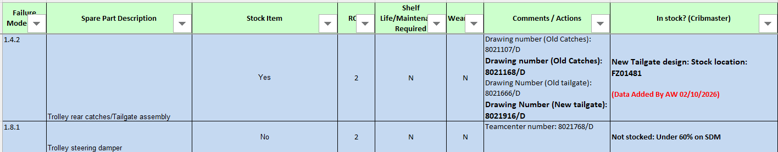
Figure 10 - Transport Trolley Spares Section of RCM Form
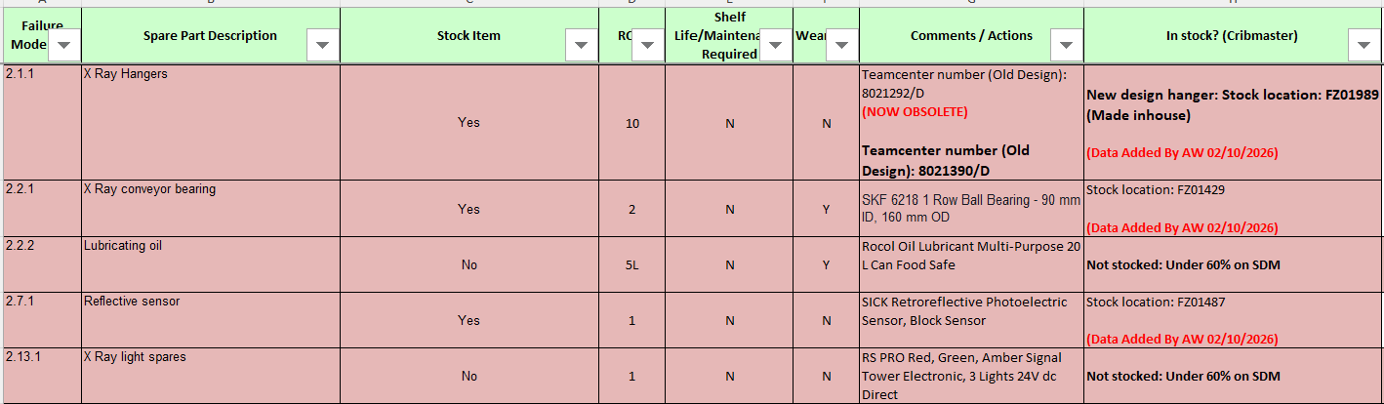
Figure 11 - X-Ray Machine Spares Section of RCM Form
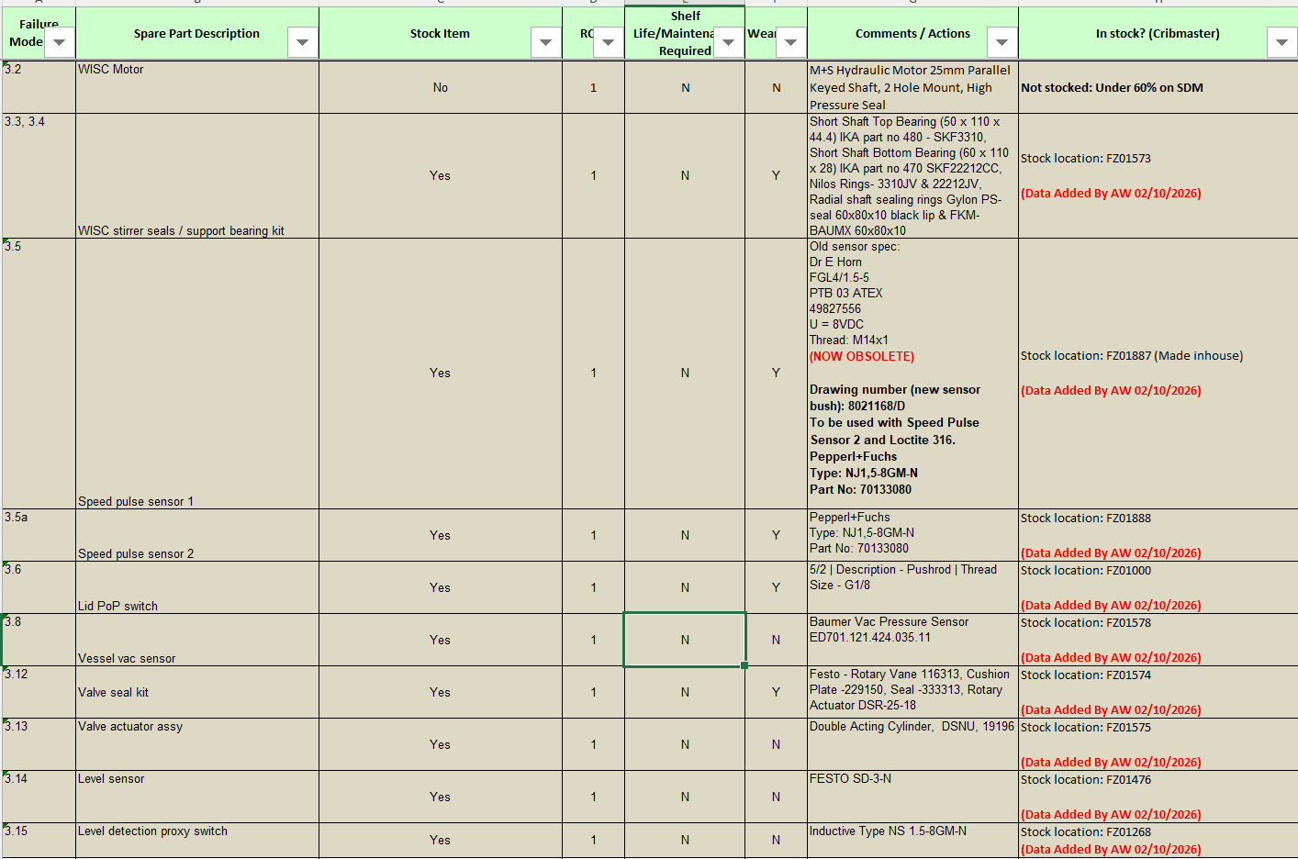
Figure 12 - Hot Vessel Spares Section of RCM Form

Development of the Spares Decision Matrix:
Following identification of candidate spare parts, a weighted Spares Decision Matrix (SDM) was developed to prove each component should be held.
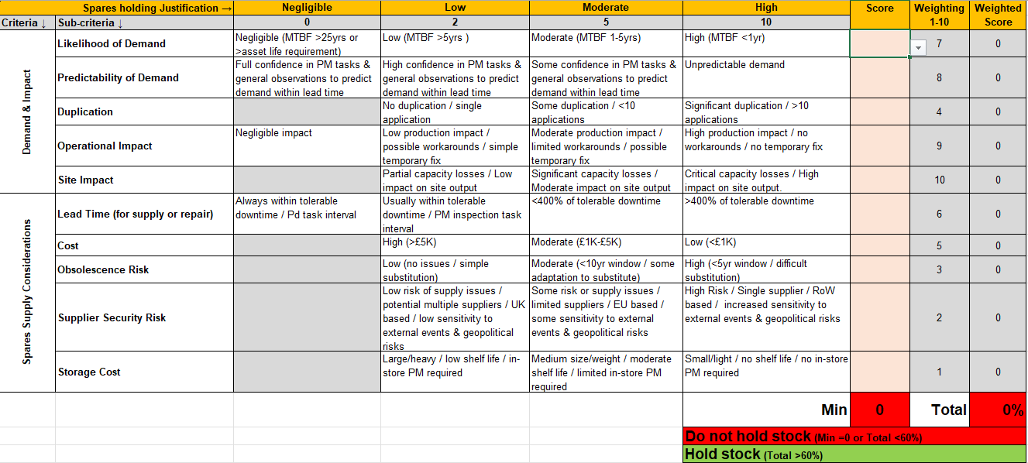
The matrix evaluates each spare against two principal categories.
Figure 13 - SDM Model

Spares Supply Considerations:
These criteria assess the difficulty of obtaining replacement components and include:
- procurement lead time;
- purchase cost;
- supplier availability;
- obsolescence risk;
- storage requirements.

Demand and Operational Impact:
These criteria evaluate the operational consequences of not holding the spare and include:
- operational impact;
- site impact;
- equipment redundancy;
- predictability of demand;
- likelihood of demand.
Each criterion was assigned a weighting to reflect its relative importance to operational continuity. Greater weighting was allocated to operational impact, site impact and lead time, reflecting the significant consequences of equipment downtime within defence manufacturing environments. Lower weighting was assigned to storage cost and supplier risk, as these were considered secondary to maintaining equipment availability.
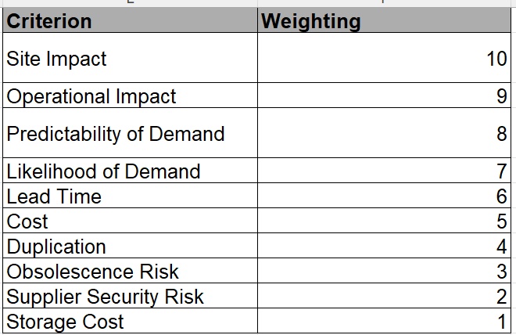
Figure 14 - Weighting Analysis Table
Each spare part was scored against every criterion using a predefined scoring scale. The weighted scores were then summed to produce an overall criticality score. Components achieving the highest scores were classified as critical spares and recommended for inventory holding, while lower scoring items were identified as suitable for procurement on demand.
This methodology provides an objective and repeatable process for inventory decision making and reduces reliance on subjective engineering judgement.

Output/Spares stocked using SDM:
From figures 10,11 and 12 it can be seen what spares generated from the RCM form were stocked for Building Z. Some critical spares generated from the RCM form generated a high risk score of >60% due to demand of the process, site impact and lead times needed for each item to ensure Building Z is constantly operational. Other generated a lower risk score <60% due to costs, lead times and site impact weighting. Previously other within the site buildings had no spares management or manufacturer ‘recommended’ spares were purchased which were not optimized leading to no spares or unneeded spares within the stores. With this method of identifying critical spares through the RCM process and proving the need for the spares using a SDM weighted scoring system several key improvements have been made. This system will help reduce costs due to only buying spares that are needed, will free up space within the general stores and improve any future issues with part lead times. Each part is looked at with detail to identify costs, lead times, obsolescence to ensure the stores spares system for the building is optimized. This in turn will increase building availability, decrease repair/downtime and overall improve building product output.

Method Validation:
The proposed methodology was applied to the principal manufacturing assets within Building Z, including the Transfer Trolley, X-Ray Machine and Hot Vessel.
For each asset, failure modes were analysed, maintenance strategies assigned and critical spare parts identified. The resulting spare parts recommendations were subsequently evaluated using the Spares Decision Matrix to determine the optimum inventory strategy.

Method Limitations:
Several limitations should be acknowledged.
The effectiveness of the methodology depends upon the quality of maintenance records, equipment history and engineering knowledge available during the RCM analysis. Where historical failure data were limited, engineering judgement was required to estimate component criticality.
The Spares Decision Matrix also reflects current organisational priorities through its weighting factors. Although these weightings were selected to represent operational requirements within Building Z, they may require adjustment if production priorities or business objectives change.
Finally, while the methodology considers operational consequences, supply risk and obsolescence, it does not explicitly quantify environmental or regulatory impacts. Future development could incorporate these factors to provide a more comprehensive assessment of spare part criticality.

Stores Management Improvements:

Rationale for Improving Stores Management:
The literature review identified that effective spare parts management depends not only on selecting the correct inventory to hold but also on maintaining accurate inventory records, ensuring stock visibility, and providing timely replenishment of critical components. Studies by Zhang (2021), Li (2008) and Yavuz (2023) demonstrate that poor inventory visibility and inaccurate stock information contribute to stock outs, excess inventory and increased maintenance downtime. Consequently, improvements to the stores management system formed an essential part of this research alongside the development of the Reliability Centred Maintenance (RCM) methodology for Building Z.
Prior to this project, several limitations were identified within the stores operation in Building Z. Inventory transactions were largely manual, stock accuracy relied heavily on periodic inspections, and limited visibility of spare parts increased the likelihood of both stock shortages and unnecessary inventory holdings. These issues reduced confidence in inventory records and limited the ability of maintenance personnel to identify whether critical spare parts were immediately available.
To address these limitations, the CribMaster inventory management system was implemented as part of the overall spare parts optimisation strategy.

Implementation of the CribMaster Inventory Management System:
CribMaster is a computerised inventory management system designed to improve the control, monitoring and replenishment of indirect materials, including maintenance spare parts, tools and consumables. The system combines inventory management software with barcode technology to provide real time visibility of stock levels and automate inventory transactions (Stanley Black & Decker, 2026).
The implementation of CribMaster within Building Z was intended to support the reliability based inventory strategy developed through the RCM analysis. Rather than relying solely on historical purchasing practices, the system enables spare parts identified as critical through the RCM process to be monitored continuously and replenished when predefined stock levels are reached.
The implementation included:
- creation of electronic inventory records for all identified spare parts;
- introduction of barcode identification for inventory transactions;
- allocation of unique stock locations;
- monitoring of stock movements in real time;
- automated replenishment based on minimum and maximum stock levels.
This provides significantly greater inventory visibility than the previous manual process and establishes a structured inventory management system capable of supporting future maintenance activities.

Contribution to Spare Parts Optimisation:
The implementation of CribMaster supports several of the objectives identified within this research.
Firstly, real time inventory visibility improves stock accuracy by ensuring that maintenance personnel can immediately determine whether critical spare parts are available. This reduces unnecessary delays during equipment failures and improves maintenance response times.
Secondly, automated inventory transactions improve accountability by recording the movement of spare parts throughout the stores operation. This reduces the likelihood of inventory discrepancies and improves confidence in stock records.
Thirdly, the automated replenishment functionality assists inventory optimisation by triggering replenishment only when predefined inventory thresholds are reached. This supports the objective of maintaining sufficient inventory to sustain operational readiness while avoiding excessive stock holding and unnecessary inventory costs.
Finally, the system provides historical inventory usage data that can be used to support future forecasting activities and continuous improvement/reviews of the RCM process to again increase reliability.

Benefits to Building Z:
The introduction of the CribMaster system produced several operational improvements within Building Z.
These include:
- improved inventory accuracy through real time stock visibility;
- reduction in manual stock recording and inventory administration;
- improved traceability of spare part usage;
- faster issue and return of maintenance components;
- improved inventory replenishment through automated stock level monitoring;
- reduced risk of stock-outs for critical spare parts identified during the RCM analysis.
Collectively, these improvements strengthen the relationship between maintenance engineering and stores management by ensuring that reliability based spare parts decisions are supported by an effective inventory control system.
Figures 15-18 illustrate the principal improvements introduced through the implementation of CribMaster, including barcode identification, inventory monitoring and automated stock management.
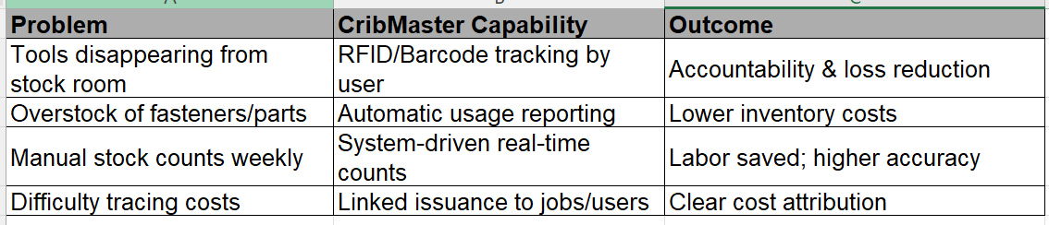
Figure 15 - Problems solved By Installing Cribmaster System
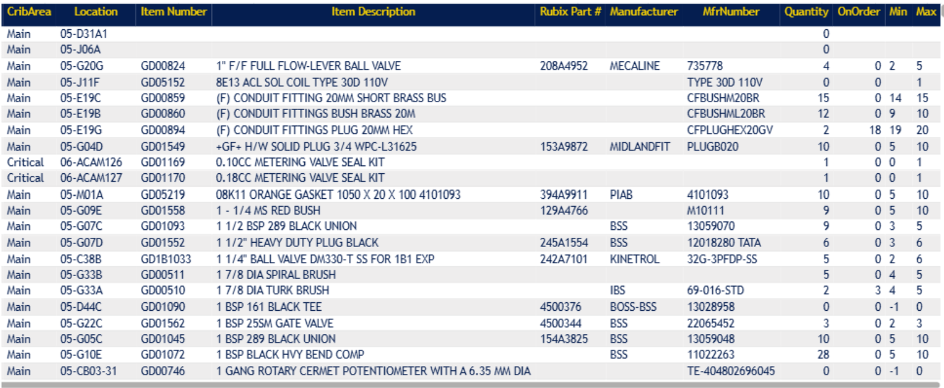
Figure 16 - Example of Cribmaster System stock

Figure 17 - Inventory Management System Improvements (Barcode Scanner)
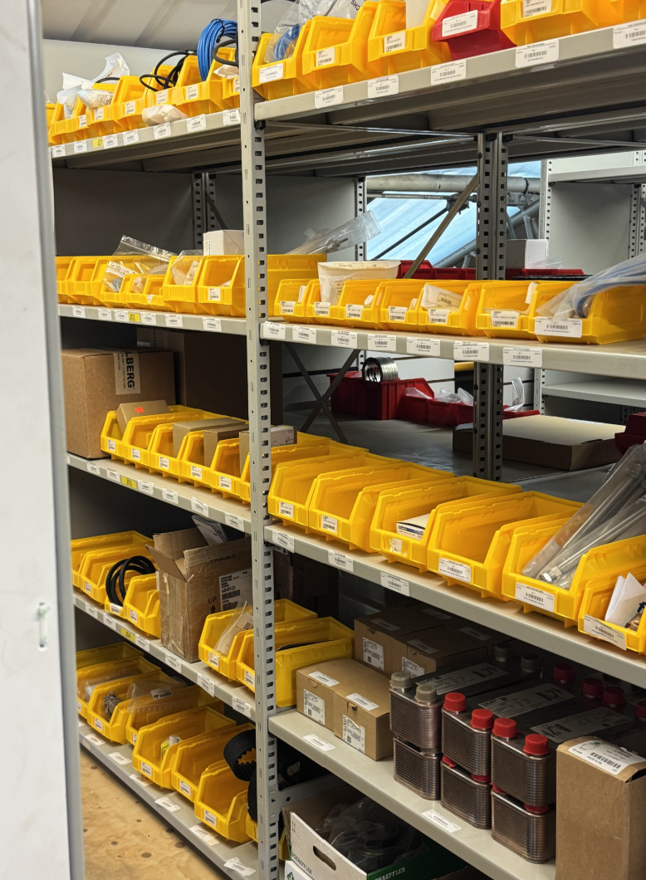
Figure 18 - Barcode Stocking System Example

Spares Optimisation and Obsolete Parts Management:

Methodological Rationale for Spares Optimisation:
The literature consistently identifies spare parts obsolescence as a critical driver of downtime in long life industrial assets, particularly where equipment exceeds original design life and OEM support is no longer available (Zhang, 2021; Li, 2008). In such environments, maintenance performance becomes increasingly constrained not by physical asset degradation alone, but by the availability, standardisation, and manufacturability of replacement components.
Within Building Z multiple assets were identified as being affected by obsolescence driven failure modes, including unavailable components, long procurement lead times, and undocumented legacy designs. These constraints directly contributed to extended downtime events and reduced operational resilience across the artillery manufacturing process.
In response, this research adopts an integrated spares optimisation methodology embedded within the Reliability Centred Maintenance (RCM) framework. Rather than treating spares management as a standalone logistical function, spare parts are treated as engineered reliability enablers. This enables obsolescence to be addressed through a combined strategy of reverse engineering, redesign, standardisation, and digital inventory integration.

Integrated Obsolescence Case Study Framework (Building Z):
Three representative case studies were selected within Building Z to evaluate and validate the spares optimisation methodology across different failure and obsolescence conditions:
- X Ray conveyor hanger system (reverse engineered remanufacture)
- Heavy duty trolley tailgates (design robustness and structural redesign)
- Speed sensor system (standardisation and interface adaptation)
These cases collectively represent a progression from component recreation, through mechanical redesign, to systems level standardisation, enabling evaluation of spares optimisation at increasing levels of design intervention.

Reverse Engineering and Remanufacturing (X-Ray Conveyor Hangers):
The X-Ray conveyor hanger system represents an obsolescence condition, where legacy components were no longer supported and original design documentation was unavailable. Of 52 designed hanger positions, only 41 were operational due to missing or failed components, resulting in reduced system capacity and uneven load distribution.
From a reliability perspective, this created a degradation mechanism in which missing hangers increased load concentration on remaining units, accelerating fatigue failure and further reducing system availability.
To resolve this, a reverse engineering methodology was applied. Physical metrology of surviving components was used to reconstruct the geometry via CAD modelling, enabling functionally equivalent reproduction of the part. This process established a validated digital representation of both the hanger and its protective insert, forming the basis for manufacturing evaluation.
Three manufacturing routes were then assessed:
- Additive manufacturing for rapid prototyping and geometric validation
- CNC machining from billet for high integrity structural reproduction
- Fabricated stainless steel assembly with polymer insert for lifecycle durability
This structured comparison ensured that material selection and manufacturing method were aligned with functional requirements rather than defaulting to legacy replication.
The selected intervention restored full conveyor capacity and eliminated a documented production constraint associated with reduced hanger availability.
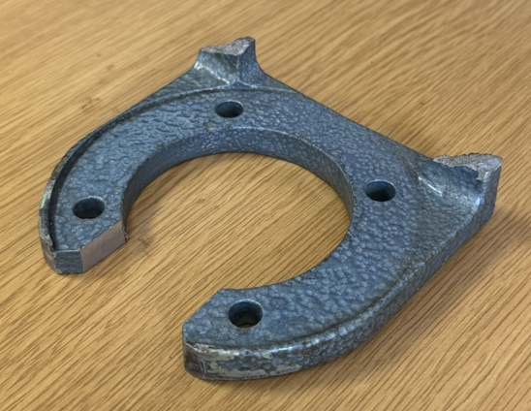
Figure 19 - Snapped/Broken X-Ray Hanger

Figure 20 - Hanger sketched (AutoCad) from original
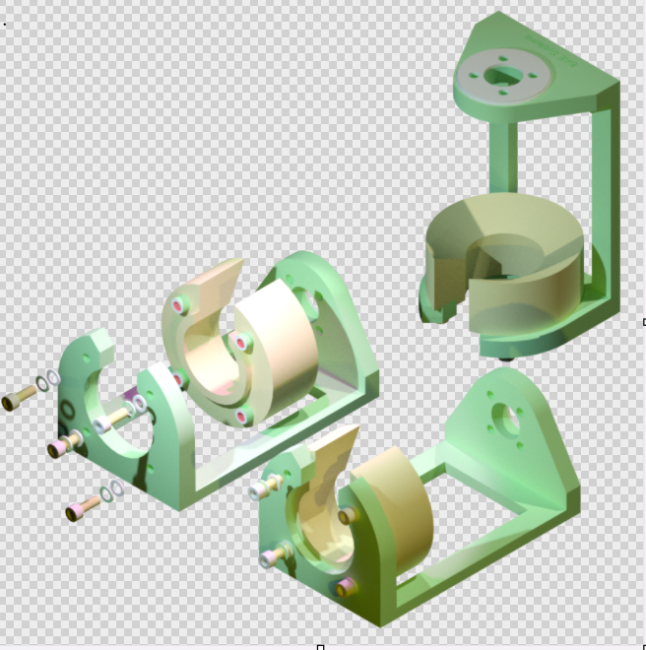
Figure 21 - Complete Hanger With Insert
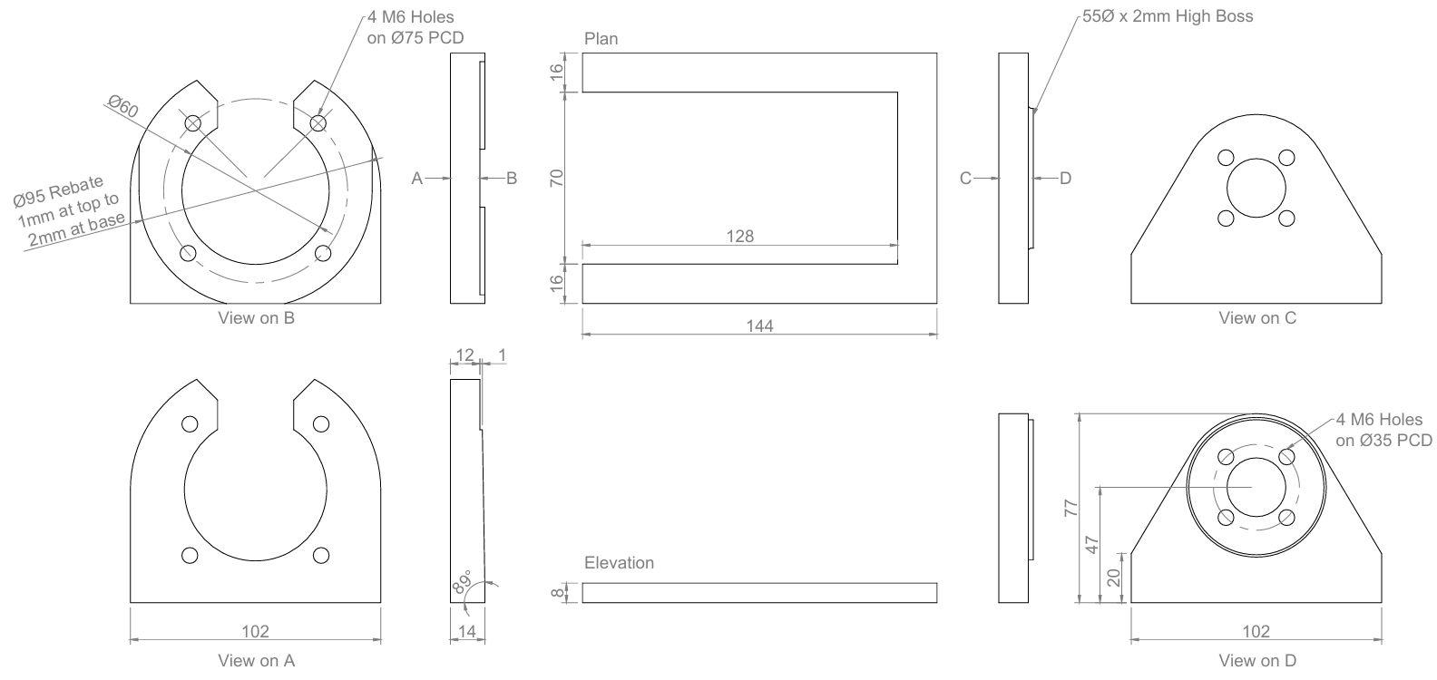
Figure 22 - 2D Drawing of Hanger Measured from Original Obsolete Part
Hanger was remade from stainless steel/welded together with a nylon insert. This was chosen as they could be made inhouse by the companies machinists.
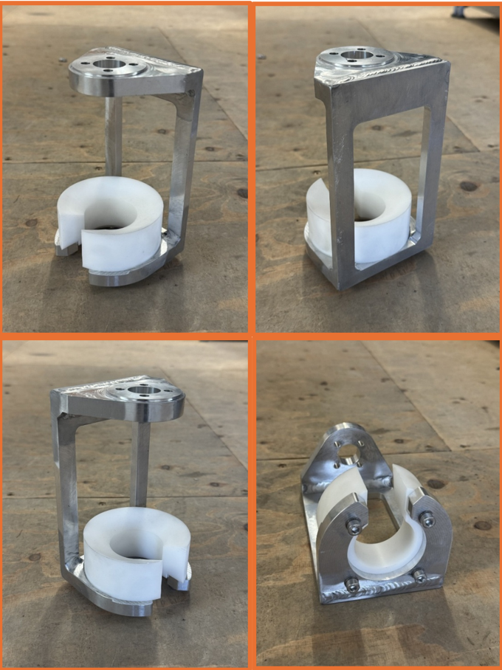
Figure 23 - Complete Stainless Steel Part
Figure 24 - Cross Reference of Hanger Back to RCM Form
Figure 25 - X-Ray Hanger Spare Recorded on Cribmaster System

Design Redesign for Reliability (Trolley Tailgates):
The trolley tailgate system represents a failure mode driven not by obsolescence alone, but by inadequate design robustness relative to operational loading conditions. The existing system utilised a thin aluminium tailgate mounted to a steel trolley frame, creating a structural mismatch that resulted in repeated bending, fracture of joints, and latch failure.
Operationally, this resulted in only 6 of 10 trolleys being available for use, reducing transport capacity and introducing delays into material handling workflows.
Unlike the hanger system, where functional equivalence was required, this case required a redesign. The methodology therefore focused on eliminating identified failure modes through:
- Material upgrade from aluminium to stainless steel
- Introduction of structural bracing to improve load distribution
- Redesign of latch mechanism to prevent in transit opening
- Correction of unsafe geometric orientation in the original latch configuration
This represents a transition from remanufacture to engineered improvement, where the objective is not replication of the original design, but elimination of systemic weakness identified through operational failure analysis.
The redesigned system directly addresses the dominant failure modes and increases fleet availability from approximately 60% to full operational capacity under normal conditions.
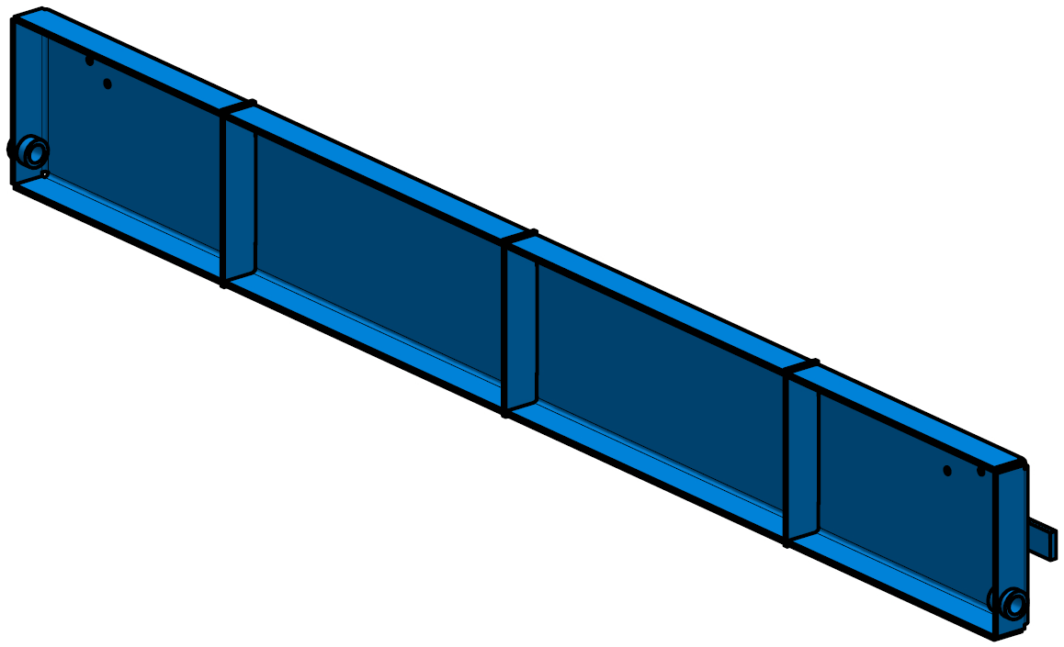
Figure 26 - Orignal Model of Tailgate design.
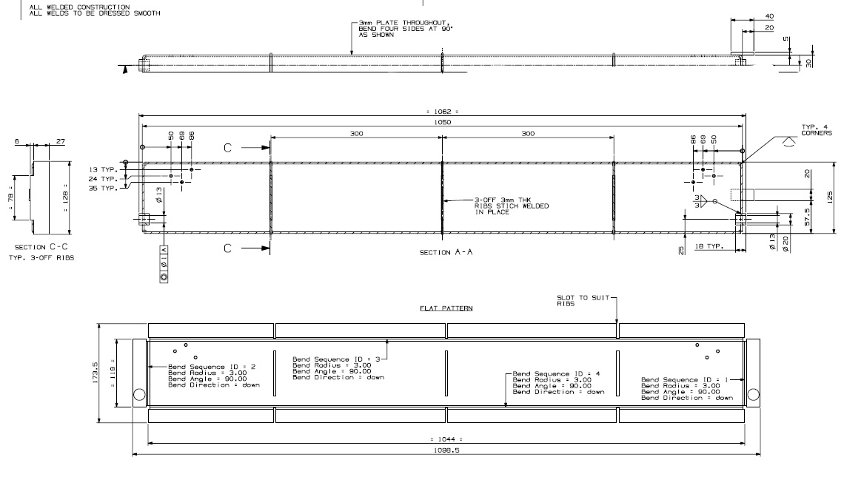
Figure 27 - 2D Drawing of Original Tailgate
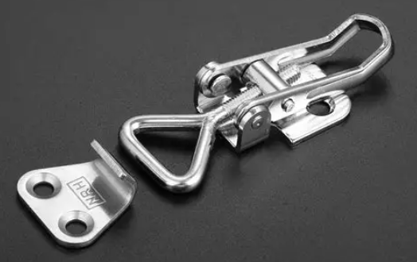
Figure 28 - Orignal 'non locking' Tailgate Catch.
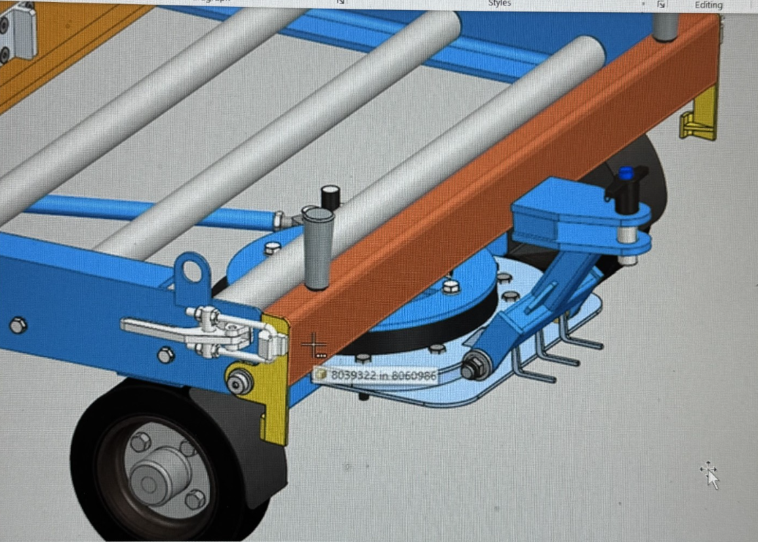
Figure 29 - Example 1 of New Tailgate Design
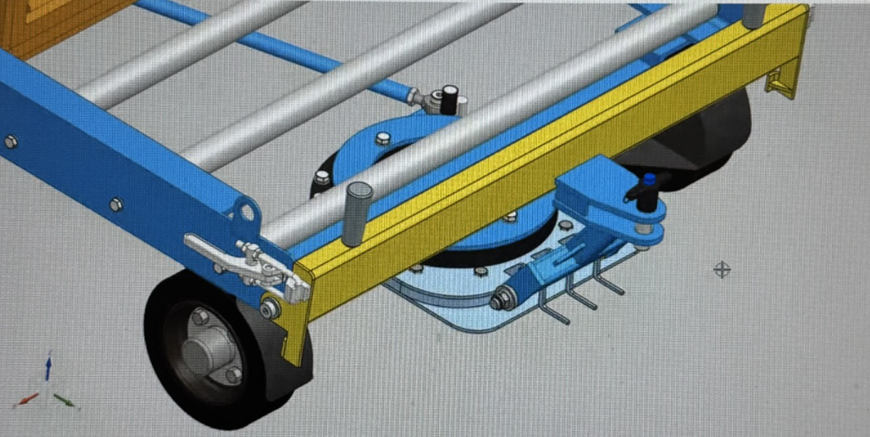
Figure 30 - Example 2 of New Tailgate Design
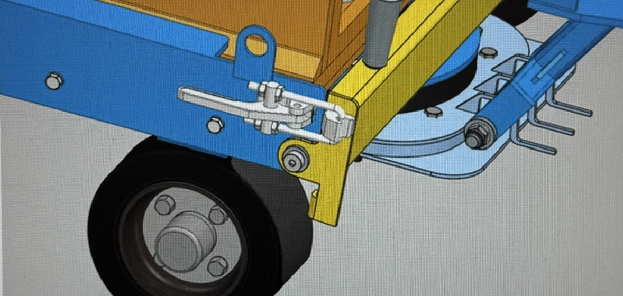
Figure 31 - Example 3 of New 'Locking' Catch and Tailgate Design
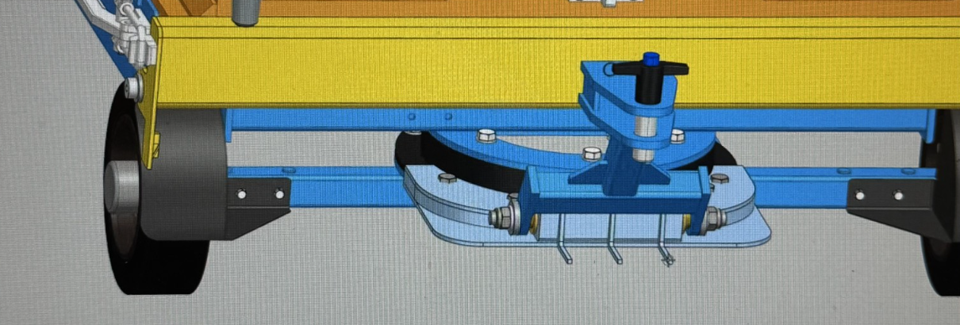
Figure 32 - Example 4 of New Tailgate Design.
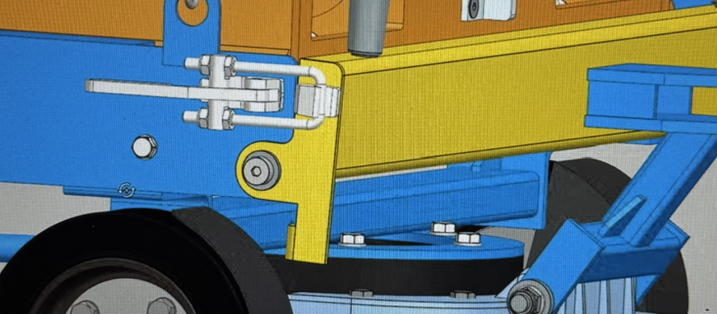
Figure 33 - Example 5 of New Catch and Tailgate Design.
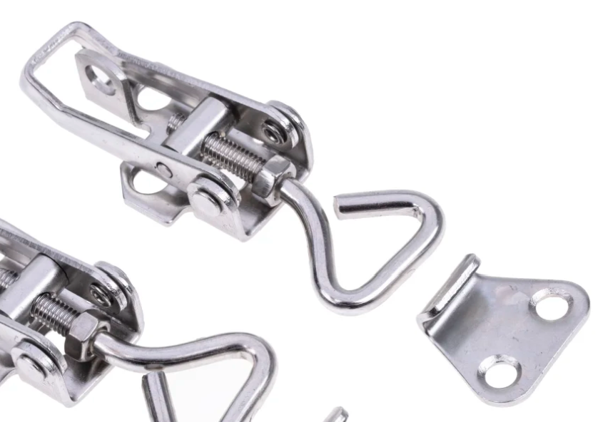
Figure 34 - Example of New 'Lockable' Catches
RCM Spares Reference:
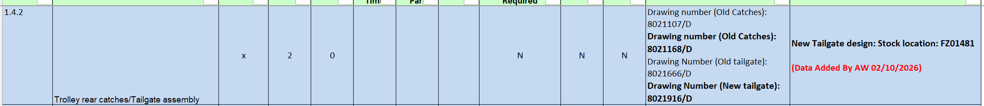
Figure 35 - RCM Spares section of Tailgate Catches
Figure 36 - Catches and Latches Stock

Standardisation and Interface Optimisation (Speed Sensor System):
The speed sensor system illustrates a different type of spares related inefficiency: component duplication and obsolescence risk due to non standardised interfaces.
The system utilised two sensor types performing identical functional roles but with differing thread geometries. This introduced unnecessary complexity into:
- Spare parts inventory (multiple SKUs for identical function)
- Procurement systems (duplicate supplier pathways)
- Maintenance operations (increased risk of incorrect installation)
Additionally, one sensor type had become obsolete, creating a single point failure risk with no available replacement stock.
To resolve this, a standardisation strategy was implemented using a mechanical interface adapter (reducing bush). This enabled consolidation onto a single sensor type already held within stores, while maintaining functional equivalence in sensing position and performance.
This intervention represents a systems level optimisation rather than a component level redesign, targeting maintainability, inventory efficiency, and risk reduction across the asset base.
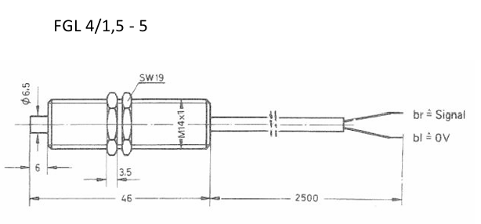
Figure 37 - Old obsolete Sensor Diamentions
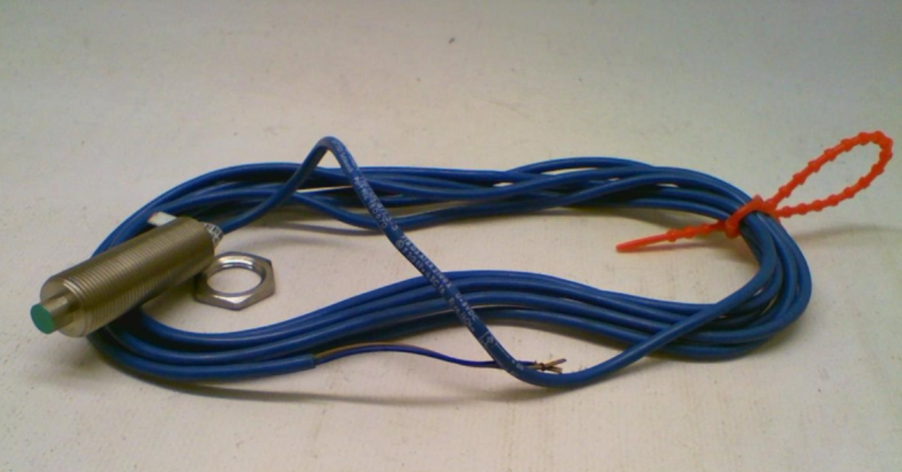
Figure 38 - Example of Obsolete Speed Sensor
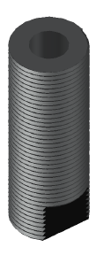
Figure 39 - New Design (Bush/Reducer)
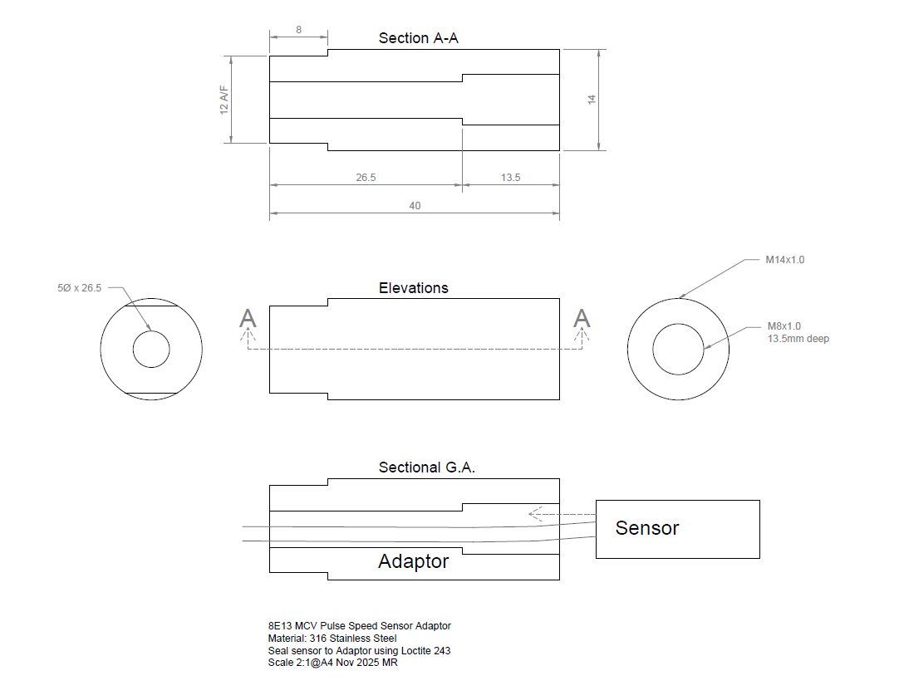
Figure 40 - New Sensor Bush/Reducer 2D Drawing
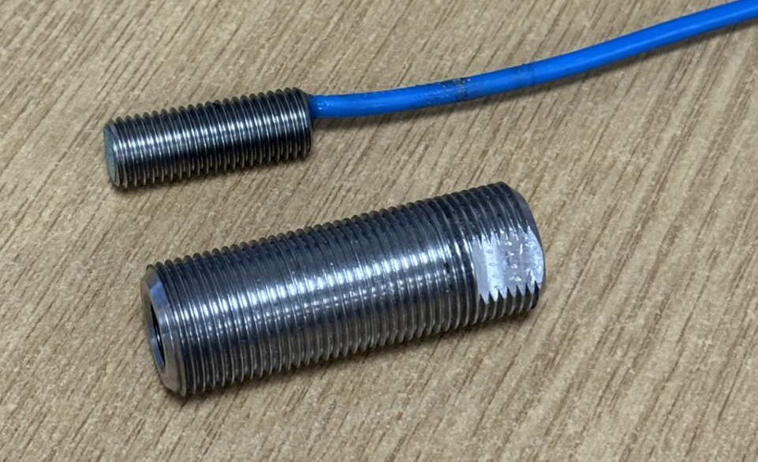
Figure 41 - Bush/Reducer used alongside sensor currently in stock (Standardisation Example)
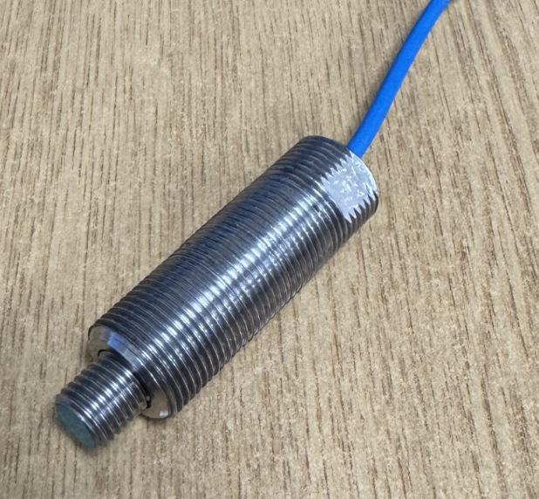
Figure 42 - Complete New Sensor Design
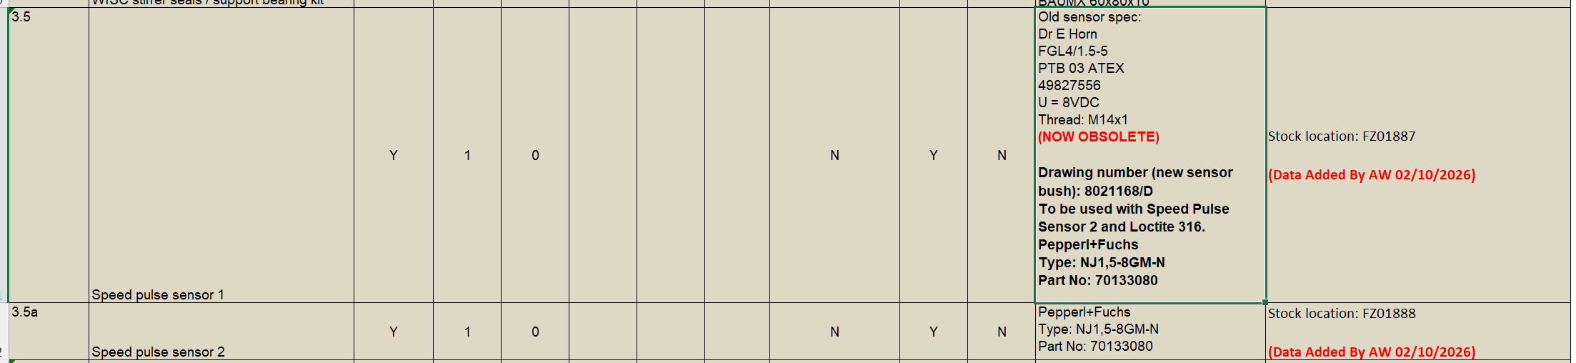
Figure 43 - Sensor Spares Section of RCM

Cross Case Methodological Integration:
Across all three case studies, a consistent spares optimisation methodology was applied, structured around escalating levels of intervention:
- Obsolescence-driven reconstruction (X-Ray hangers) -> Reverse engineering and remanufacture of missing components
- Failure driven redesign (trolley tailgates) -> Structural and functional redesign to eliminate recurring failure modes
- System level standardisation (speed sensors) -> Interface harmonisation to reduce inventory complexity and failure risk
These interventions were unified through integration with:
- RCM analysis outputs, which defined criticality and failure mode behaviour
- Manufacturing feasibility assessment, which determined viable production routes
- Digital inventory control (CribMaster), which enabled lifecycle tracking and spares governance
This establishes a closed loop spares optimisation system in which failure data informs design intervention, which is then controlled through structured inventory management.

Overall Operational Impact:
Collectively, the interventions produced measurable improvements in system availability and operational resilience:
- X-Ray conveyor system restored to full hanger capacity, removing a production bottleneck
- Trolley fleet availability increased from approximately 60% toward full operational readiness
- Sensor standardisation eliminated obsolescence risk and reduced maintenance complexity
More importantly, the primary methodological contribution is the shift from reactive spare part replacement to engineered obsolescence management, where components are analysed, redesigned, or standardised based on reliability requirements rather than historical patterns.

Results:
The findings of this research demonstrate that integrating Reliability Centred Maintenance (RCM) with structured spare parts decision making provides a practical framework for improving equipment availability in ageing defence manufacturing systems. Rather than treating spare parts management as an isolated inventory function, the proposed methodology links component reliability, maintenance strategy, engineering redesign, and inventory optimisation into a single decision support process. Application of the framework within Building Z restored equipment availability, reduced obsolescence risk, and established a repeatable methodology that can be deployed across similar manufacturing environments.

Overview of Results:
This section presents the outcomes of the applied Reliability Centred Maintenance (RCM) analysis, spare parts optimisation framework, stores management improvements, and obsolescence mitigation strategies implemented within Building Z.
The results are structured across three primary case studies: the X-Ray conveyor hanger system, the transport trolley tailgate system, and the speed sensor standardisation case. Additional outcomes from the RCM analysis and CribMaster implementation are also presented to demonstrate system wide improvements in reliability, maintainability, and spare parts availability.

RCM Analysis and Spare Parts Outcomes:
The RCM analysis applied across the major assets within Building Z resulted in the identification of critical components whose failure would have significant operational consequences.
Prior to implementation, spare parts decisions were largely based on historical usage and engineering judgement, with no formalised risk based classification.
Following implementation of the RCM framework and Spares Decision Matrix:
Operational Outcomes:
- Critical spare parts formally identified across key assets (Transfer Trolleys, X-Ray system, Hot Vessel)
- Spare parts classification transitioned from reactive to risk based evaluation
- Components linked to failure consequences rather than historical consumption
- Structured critical spares register established for Building Z
Impact:
The introduction of a structured RCM based approach enabled maintenance decisions to be directly linked to equipment function and failure consequences. This improved visibility of high risk components and provided a consistent basis for spare parts selection and inventory justification.

X-Ray Conveyor Hanger System:
Prior to implementation, the X-Ray conveyor system operated with only 41 of its 52 designed hanger positions, reducing effective conveyor capacity to approximately 79%. Investigation identified component obsolescence as the primary cause of this reduction, with failed hanger assemblies unavailable through the original manufacturer. Consequently, the conveyor was unable to operate at its intended throughput, creating a persistent production constraint within the inspection process. Following redesign and implementation of replacement components:
Operational Results:
- Hanger positions restored: 41 → 52
- Conveyor capacity restored: 79% → 100%
- Obsolescence status: Active risk → Eliminated
- Replacement availability: None → Controlled stock introduced
- Manufacturing support: No drawings → Full CAD model available
- Recovery capability: No replacement possible → Immediate replacement enabled
Impact:
Restoration of full hanger capacity removed a persistent throughput constraint within the X-Ray inspection process. Previously, each component failure resulted in permanent capacity degradation due to lack of replacement availability.
The introduction of controlled stockholding (2–4 units) ensures that future failures can be addressed without loss of system capacity, improving long-term operational resilience.

Transport Trolley Tailgate System:
The transport trolley fleet was affected by recurring structural failures of the aluminium tailgate assembly, resulting in reduced operational availability.
Prior to intervention, only 6 of 10 trolleys were operational.
Following redesign and implementation of a stainless-steel reinforced tailgate:
Operational Results:
- Fleet availability restored: 6/10 -> 10/10
- Equipment availability: 60% -> 100%
- Structural failures: Frequent -> Eliminated
- Latch reliability: Failure-prone -> Redesigned secure locking system
- Maintenance requirement: High -> Reduced
- Manufacturing support: No replacement design -> Standardised in-house production enabled
Impact:
The redesigned tailgate eliminated the failure modes responsible for unavailability. Full restoration of the trolley fleet improved material handling capacity across Building Z and reduced dependency on a limited number of transport assets.
The improved structural design also enhanced operational safety by preventing accidental opening during transport.

Speed Sensor Standardisation:
The speed monitoring system contained duplicated functionality across two sensor types, one of which had become obsolete with no available replacement stock.
Following implementation of a standardised sensor system using a reducing bush interface:
Operational Results:
- Sensor variants reduced: 2 -> 1
- Obsolescence risk: Present -> Eliminated
- Spare parts requirement: Dual stock -> Single stocked component
- Procurement complexity: High -> Reduced
- Maintenance procedure: Multiple variants -> Standardised process
- System supportability: Obsolete dependency -> Fully standardised system
Impact:
Standardisation removed the dependency on obsolete components and reduced the risk of extended downtime due to unavailable spares. Maintenance activities were simplified through the use of a single replacement component, improving consistency and reducing the likelihood of incorrect part selection.
Inventory complexity was also reduced, improving spare parts management efficiency across Building Z.

CribMaster Inventory System Outcomes:
The implementation of the CribMaster inventory management system resulted in measurable improvements in stock control, traceability, and inventory visibility.
Operational Results:
- Stock visibility: Manual -> Real time digital tracking
- Inventory accuracy: Inconsistent -> Improved consistency
- Transaction traceability: Limited -> Full audit trail enabled
- Stock management: Manual -> Barcode-based system introduced
- Replenishment control: Manual -> Automated min/max system
Impact:
The system significantly improved inventory accuracy and reduced reliance on manual stock control processes. Real time visibility of spare parts enabled faster identification of available components, improving maintenance responsiveness and reducing delays associated with stock uncertainty.
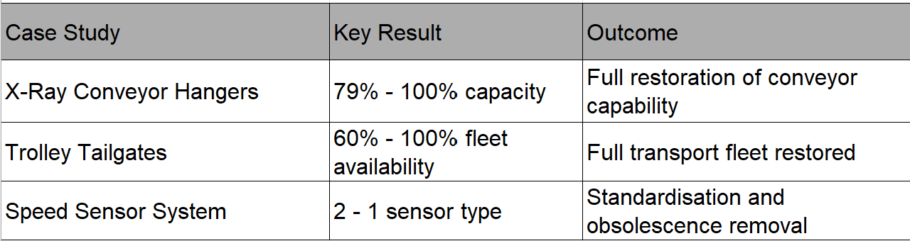
Figure 44 - Case Performance Summary

Summary of Results:
The results demonstrate that the integrated application of RCM analysis, spares optimisation, redesign interventions, and inventory system improvements delivered measurable enhancements in equipment availability, maintainability, and spare parts resilience within Building Z. Figure 45 Shows to uplift in building efficiency stating products per day produced through Building Z before and after optimization. This uplift is due to the improvements made and downtime saved within the building.
Figure 45 - Data Collection of Building Z output
Legacy data shows at full efficiency when the plant was first installed around 650-680 parts per month were produced through Building Z. Over years of neglect and the lack of correct maintenance strategy, products per month have significantly reduced. After several improvements/optimisation throughout the facility it is now back running at full efficiency.
Profit per product produced = £76. From months Aug 25 to July 26 products per month through Building Z increased by 92 units (678-586=92units). This means at full efficiency Building Z’s profit has increased by £6992 per month. From months May-july 2026 Building Z has produced above 678 parts per month verses 586 in month Aug 2025 before any improvements.
Across all case studies, obsolescence risks were either eliminated or significantly reduced, while system availability was restored to full operational capacity where previously constrained. The implementation of CribMaster further strengthened inventory control and ensured that the improvements in reliability engineering were supported by an effective spares management infrastructure.
Collectively, these results demonstrate that the proposed framework achieved improvements across four key performance areas: equipment availability, spare parts availability, inventory standardisation and obsolescence management. Unlike traditional reactive maintenance approaches, the integrated methodology linked reliability analysis directly to engineering redesign and inventory decision making, providing a repeatable process for improving operational readiness within defence manufacturing.

Discussion, Conclusion and Evaluation

Discussion of Reliability Centred Maintenance and Spare Parts Optimisation:
The primary aim of this research was to develop a structured, reliability informed approach to spare parts management within Building Z by integrating Reliability Centred Maintenance (RCM) with a structured Spare Parts Decision Matrix and improved inventory management practices. The findings demonstrate that adopting reliability maintenance principles provides a more systematic and operationally effective method of managing spare parts than traditional reactive maintenance approaches.
The literature review established that many organisations continue to determine spare parts requirements primarily through historical consumption data and run
to failure maintenance strategies (Zhang, 2021; Yavuz, 2023). Whilst these approaches may minimise short term inventory expenditure, they frequently fail to account for equipment criticality, component reliability and the operational consequences of spare part shortages. Prior to this project, Building Z largely reflected these characteristics, operating under a predominantly reactive maintenance philosophy with limited visibility of component criticality and no formal process for identifying critical spare parts. This resulted in prolonged equipment downtime, increased dependence on obsolete components and inconsistent inventory decisions.
The implementation of the RCM methodology directly addressed these shortcomings by introducing a structured process for identifying equipment functions, analysing failure modes, assessing failure consequences and selecting appropriate maintenance strategies. This approach aligns with the principles established by Moubray (2001), who argues that maintenance activities should be determined by the consequences of failure rather than applying identical maintenance strategies across all assets. Within Building Z, this enabled maintenance effort to be prioritised towards equipment with the greatest operational impact, improving maintenance planning while simultaneously providing a rational engineering basis for spare parts provisioning.
Importantly, the project demonstrated that Reliability Centred Maintenance should not be viewed solely as a maintenance planning tool. Instead, its outputs can be used to inform wider engineering decisions relating to spare parts management, equipment redesign and long term asset supportability. This represents a practical extension of traditional RCM methodology by integrating reliability analysis directly into inventory decision making.

Evaluation of the Critical Spares Decision Matrix:
One of the principal contributions of this research was the development of a weighted Spare Parts Decision Matrix to support evidence based inventory decisions. Although previous studies have proposed sophisticated optimisation models and forecasting techniques (Kang, 2025; Zhang, 2021), comparatively little research demonstrates how maintenance organisations can convert reliability information into practical spare parts decisions within operational environments.
The decision matrix developed during this project sought to address this gap by combining supply side factors including procurement lead time, supplier availability and obsolescence risk with operational considerations such as equipment criticality, production impact and redundancy. Unlike conventional inventory approaches that rely primarily on historical demand, the proposed framework prioritises the operational consequences of component failure.
The weighting structure intentionally favoured operational continuity over inventory holding cost. Within a defence manufacturing environment, the cost of unplanned production downtime may significantly exceed the financial cost of carrying additional critical inventory. Consequently, prioritising availability represents an appropriate engineering decision rather than simply an inventory decision. This finding supports Kang (2025), who concluded that organisations operating within uncertain environments benefit from inventory strategies focused on resilience and service availability rather than cost minimisation alone.
An additional strength of the decision matrix is its transparency and repeatability. Inventory decisions become supported by defined engineering criteria rather than individual experience or subjective judgement, increasing consistency across maintenance activities. Nevertheless, the weighting factors remain dependent upon organisational priorities and should therefore be periodically reviewed as production requirements, operational risk or business objectives evolve.

Impact of Obsolescence Management:
The literature consistently identifies component obsolescence as one of the greatest challenges associated with supporting long life engineering assets (Zhang, 2021). The findings from Building Z strongly support this conclusion, with obsolete components representing a significant source of equipment downtime and reduced operational resilience.
The reverse engineering and remanufacture of the X-Ray conveyor hanger assemblies demonstrated how engineering redesign can provide an effective alternative where original manufacturer support no longer exists. Rather than accepting progressive degradation in system capacity, the project evaluated alternative manufacturing routes before producing a redesigned replacement component capable of restoring full operational performance.
This intervention demonstrates that effective obsolescence management extends beyond maintaining larger inventories of legacy components. Instead, it requires organisations to adopt proactive engineering solutions that improve long term maintainability while reducing dependence upon obsolete supply chains. The resulting approach aligns with recommendations within the literature advocating lifecycle focused asset support rather than reactive component replacement.
Similarly, the redesign of the trolley tailgate system illustrates how reliability improvement can be achieved through engineering modification rather than replacement alone. The project moved beyond reproducing the original design by identifying the dominant failure mechanisms and eliminating them through material selection, structural reinforcement and improved latch design. This demonstrates the value of integrating reliability analysis with engineering design to improve both equipment availability and maintainability.

Evaluation of Equipment Standardisation:
The standardisation of the speed sensor system further demonstrated the practical benefits of integrating reliability engineering with spare parts optimisation. Prior to modification, two sensor variants performed identical operational functions whilst requiring separate inventory holdings. This unnecessary duplication increased procurement complexity, maintenance variability and exposure to obsolescence risk.
The introduction of a reducing bush enabled standardisation onto a single sensor type without affecting operational performance. Although technically straightforward, this modification generated wider organisational benefits by simplifying procurement, reducing stockholding complexity and improving maintenance consistency. These outcomes support previous findings by Yavuz (2023) and Li (2008), who identify inventory simplification as an effective means of improving forecasting accuracy and reducing inventory costs.
More importantly, this case demonstrates that spare parts optimisation is not solely concerned with determining stock quantities. In many situations, engineering redesign and standardisation may provide greater long term benefits than attempting to optimise inventory for increasingly obsolete components.

Stores Management and Inventory Visibility:
The literature review identified inventory visibility as a critical determinant of effective spare parts management (Li, 2008; Zhang, 2020). Similar deficiencies were evident within Building Z, where manual inventory recording reduced confidence in stock accuracy and increased the likelihood of unexpected stock shortages.
The implementation of the CribMaster inventory management system complemented the reliability maintenance framework by providing real time inventory visibility, improved traceability and automated stock replenishment. These improvements strengthened the practical application of the proposed methodology by ensuring that critical spare parts identified through the RCM process could be effectively managed throughout their operational lifecycle.
Whilst the introduction of digital inventory management significantly improved stores control, its long term effectiveness will depend upon consistent data quality and continued user compliance. Digital systems improve decision making only when inventory transactions are accurately recorded and maintained. Consequently, successful implementation requires organisational commitment alongside technological investment.

Overall Contribution to Knowledge and Practice:
A significant contribution of this research is the demonstration that spare parts management within defence manufacturing should not be treated solely as an inventory optimisation problem. Instead, effective spare parts provisioning requires integration of equipment reliability, maintenance strategy, engineering redesign and inventory management within a unified decision support framework.
By combining Reliability Centred Maintenance, a weighted Spare Parts Decision Matrix, targeted engineering redesign and digital inventory management through CribMaster, this research developed and applied an integrated methodology capable of improving equipment availability whilst reducing obsolescence risk. Unlike many approaches identified within the literature, the proposed framework was implemented and validated within a live defence manufacturing environment rather than remaining a theoretical optimisation model.
The findings therefore contribute to both engineering practice and maintenance management by demonstrating how reliability outputs can be translated directly into practical inventory decisions. Furthermore, the methodology provides a repeatable framework capable of supporting future maintenance activities across other manufacturing areas within the site.

Addressing the Research Gap:
The literature review identified a lack of practical frameworks linking reliability analysis with operational spare parts decision making in defence maintenance environments. Existing research has largely examined reliability engineering, inventory optimisation and supply chain management as separate disciplines, with limited evidence demonstrating how these approaches can be integrated within industrial practice.
This research addresses that gap by developing and validating a practical framework that links Reliability Centred Maintenance outputs directly with spare parts management decisions. Rather than relying solely upon theoretical optimisation techniques, the proposed methodology integrates failure mode analysis, equipment criticality assessment, engineering redesign, structured inventory evaluation and digital inventory management into a single decision support process.
The successful implementation within Building Z demonstrates that reliability informed spare parts management can improve operational readiness whilst simultaneously reducing obsolescence risk and inventory complexity. Consequently, the research provides both academic and industrial evidence supporting the practical integration of reliability engineering with inventory management.

Limitations:
Several limitations should be acknowledged when interpreting the findings. The research focused on a single manufacturing area and therefore may not fully represent the operational characteristics of other production facilities or defence organisations. Whilst the methodology was designed to be transferable, implementation within alternative environments may require adjustment to reflect different asset criticalities, production priorities and organisational objectives.
The proposed Spare Parts Decision Matrix also relies upon weighting factors selected to reflect the operational priorities of Building Z. Although these weightings were developed through engineering judgement and practical experience, future applications may require recalibration to accommodate changing operational requirements or different business objectives.
A further limitation concerns the availability of historical reliability data. Several assets lacked comprehensive maintenance records, restricting the ability to perform more sophisticated statistical reliability modelling. Consequently, elements of the RCM analysis relied upon engineering expertise alongside the available maintenance history. Future implementation would benefit from more extensive condition monitoring and improved reliability data collection to further strengthen evidence based decision making.
Finally, whilst the research successfully addressed several examples of component obsolescence, obsolescence management should be regarded as an ongoing engineering process rather than a one time intervention. Continued monitoring of supplier support, component availability and equipment condition will be essential to sustain the long term benefits achieved during this project.

Recommended further work:
The methodology developed during this research demonstrated that integrating Reliability Centred Maintenance (RCM), structured spare parts decision making and digital inventory management can significantly improve equipment availability and reduce obsolescence risk within Building Z. Whilst the results provide strong evidence of the framework's practical value, further work would strengthen its wider applicability and long term effectiveness.
The first priority should be the deployment of the proposed methodology across additional manufacturing areas. Applying the framework to a broader range of assets/buildings would enable its repeatability and scalability to be evaluated while establishing a site wide/buinesss wide approach to reliability informed spare parts management. This would also provide opportunities to refine the weighting criteria within the Spare Parts Decision Matrix to reflect differences in equipment criticality, production priorities and operational risk.
Future work should also incorporate more comprehensive reliability data collection through condition monitoring, maintenance history analysis and failure trend monitoring. Improved data availability would support more accurate estimation of reliability metrics such as Mean Time Between Failures (MTBF) and Mean Time To Failure (MTTF), enabling increasingly data driven maintenance and inventory decisions.
Although this research successfully addressed several examples of component obsolescence through reverse engineering, redesign and standardisation, obsolescence management should be viewed as a continuous engineering activity. Future studies could investigate formal lifecycle planning, digital obsolescence monitoring and supplier risk assessment to enable organisations to identify vulnerable components before operational failures occur.
Further research could also evaluate the integration of predictive maintenance technologies, machine condition monitoring and artificial intelligence based forecasting techniques with the proposed framework. Combining reliability analysis with predictive analytics may improve the accuracy of spare parts forecasting while further reducing unnecessary inventory and unplanned downtime.
Finally, the methodology developed during this research should be validated across other defence manufacturing environments and asset intensive industries. Application within alternative operational settings would enable assessment of its generalisability and provide further evidence of its effectiveness as a practical decision-support framework for reliability informed spare parts management.

References
Alaswad, S. a. (2017). A review on condition-based maintenance optimization models for stochastically deteriorating system. Reliability Engineering & System Safety, 54-63.
de Jonge, B. a. (2020). A review on maintenance optimization. European Journal of Operational Research, 805-824.
Dr.E.Horn. (2015, January 06). mar-el.no. Retrieved from Marelno: https://www.mar-el.no/produkter/sensorer/hastighetsensorer/oscillator-pulse-sensor-type-fgl-411-and-fgl-4-1-5-5/_/attachment/inline/da6432e4-899b-4b33-b0c7-4351b539f068:efbb40b1b18a51d8a85bccee873aa01c2bf9a05f/Oscillator-Pulse-Sensor-DK002606-Rev.2-FGL4_1
Hu, Q. B. (2018). OR in spare parts management: A review. European Journal of Operational Research, 395–414.
Kang, Z. (2025). Robust Spare Parts Inventory Management. Eindhoven: Eindhoven University of Technology.
Kennedy, W. P. (2014). System-oriented inventory models for spare parts. Surveys in Operations Research and Management Science, 102–116.
Li, S. (2008). The inventory management system for automobile spare parts in. Expert Systems with Applications , 1-10.
Moubray, J. (2001). Reliability-centered Maintenance. Industrial Press Inc.
Research Gate. (2024, Febuary 6). Components of a reliability centered maintenance programme. Retrieved from Research Gate: https://www.researchgate.net/figure/Components-of-a-reliability-centered-maintenance-RCM-program_fig4_328549342
Romero Rojo, F. J. (2013). Obsolescence risk assessment process best practice. Journal of Physics: Conference Series, 012095.
Saygin, N. &. (2024). An obsolescence management framework for a defense industry company. Procedia CIRP, 686–691.
Spelzhausen, S. (2026, January 13). Makula. Retrieved from What is Reliability Centered Maintenance? RCM Methodology & Process: https://www.makula.io/learning-center/what-is-reliability-centered-maintenance
Stanley Black & Decker. (2026). Inventory Management & Automated Dispensing Systems. Retrieved from Cribmaster smart storage solutions: https://storage.stanleyblackanddecker.com/cribmaster
Yavuz, A. (2023). SPARE PART CLASSIFICATION AND INVENTORY CONTROL . Lappeenranta: Lahti University of Technology LUT.
Zhang, J. (2020). Study on the Supply Chain-based Spare Store Management in the Military . International Conference on Big Data Application & Economic Management, 1-6.
Zhang, S. (2021). Spare Parts Inventory Management: A Literature Review. Sustainability 2021, 1-23.
Zhu, T. R. (2020). A survey of predictive maintenance. Systems, purposes and approaches.
Dekker, R. (1996). Applications of maintenance optimization models: A review and analysis. Reliability Engineering & System Safety, 51(3), 229–240.
Jardine, A. K. S., Lin, D., & Banjevic, D. (2006). A review on machinery diagnostics and prognostics implementing condition-based maintenance. Mechanical Systems and Signal Processing, 20(7), 1483–1510.
Sherbrooke, C. C. (2004). Optimal Inventory Modeling of Systems: Multi-Echelon Techniques (2nd ed.). Springer.
Tsang, A. H. C. (2002). Strategic dimensions of maintenance management. Journal of Quality in Maintenance Engineering, 8(1), 7–39.
Wang, H. (2002). A survey of maintenance policies of deteriorating systems. European Journal of Operational Research, 139(3), 469–489.
Mobley, R. K. (2002). An Introduction to Predictive Maintenance (2nd ed.). Butterworth-Heinemann.
Fortuin, L. (1980). The all-time requirement of spare parts for service after sales—Theoretical analysis and practical results. International Journal of Operations & Production Management, 1(1), 59–70.
Teunter, R., Babai, M. Z., & Syntetos, A. A. (2011). ABC classification: Service levels and inventory costs. Production and Operations Management, 19(3), 343–352.

