
Marriott International
Financial analysis 2020-2021

December 5, 2022
University of Wales Trinity Saint David

Ioana Loredana Dinu
2025758
Lecturer: Dale Clarke
BMIH5007

Executive Summary
Since assessing a company's performance is crucial in the hospitality industry, this research analyses financial parameters for Marriott International to do so. This report's objective is to analyse Marriott's shortcomings and recommend a course of action that will enable the corporation to preserve its confidence in its ability to achieve its financial goals. The examination is going to concentrate mostly on the performance of the company's finances, and which may be used as a pointer for acknowledging the forthcoming economic performance.

Table of Contents
Executive Summary 1
Introduction 3
Financial Analysis Trends 4
Profitability 5
Liquidity 7
Gearing 8
Knowledge from Ratio Analysis 9
Benefits and Limitations of Ratio Analysis 10
Conclusion 11
Bibliography 12

Introduction
The objective of this assignment is to compare actual financial outcomes with Marriott International's forecasted outcomes and determine the factors at play. First, it's important to establish that the profitability ratios, the liquidity ratio, and the gearing ratio are the three ratios to be employed in the analysis of the data. Financial analysis relies heavily on locating the outliers, determining their magnitude, and understanding the factors that led to them. The future of Marriott will be determined by a financial study comparing the company's performance in 2020 and 2021. A company's financial performance may be described and evaluated using percentages and ratios, and patterns can be used to draw conclusions about the company's present financial performance. (Marriott International, 2021).
Marriott operates, franchises, and licences hotels, apartments, and timeshares under a broad range of brand names and pricing ranges across the globe. In keeping with its emphasis on management, franchising, and licencing, Marriott owns just a small percentage of its hotel locations. Here is a look at the Marriott brand portfolio in 2021:

Fig1 Marriott brand portfolio
Because of its global reach, Marriott is vulnerable to the impacts of economic, legislation (especially in areas like trade, tourism, mass migration, medical, and related issues), geopolitical, and social upheavals across the globe. Fragile economies, travel warnings, shifting energy costs and currency values, technology that give solutions to geopolitical conflict in-person meetings and events, instability, heightened travel security measures, interruptions in air travel, and fears regarding sickness, terrorism, war or violence are only some of the factors that affect business travel. These factors have already had a statistically significant influence, and their continued existence, their appearance at an unexpected time, their lengthier duration than anticipated, or the development of additional, as-yet-unknown events, could have an even more significant effect. (Marriott, 2022).
Although the effects of COVID-19 are expected to lessen, the firm, markets, development trends, and marketing strategy may still be significantly impacted or transformed for some time. Consequently of the COVID-19 pandemic, travel and demand for hotel rooms have dropped significantly, which has had and may continue to have negative effects on Marriott's business, operational processes, and financial results. These include slowing the pace of new project development and lowering the worth of Marriott's owned and leased properties and investments.

Financial Analysis Trends
With the help of this research, Marriott will be able to evaluate its prospects for success in 2021 in contrast to those of the year 2020.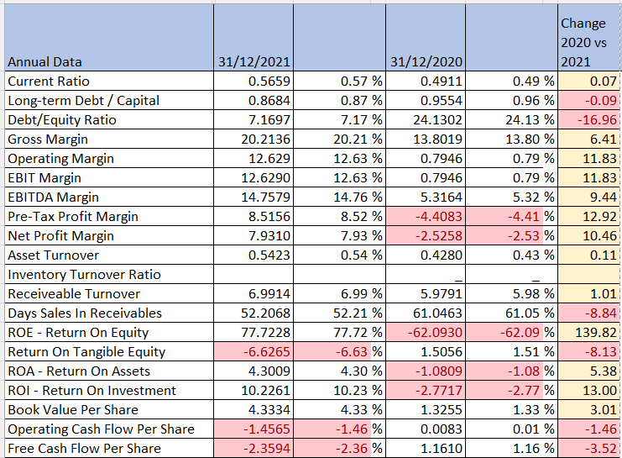
Fig 2, Marriott ratios
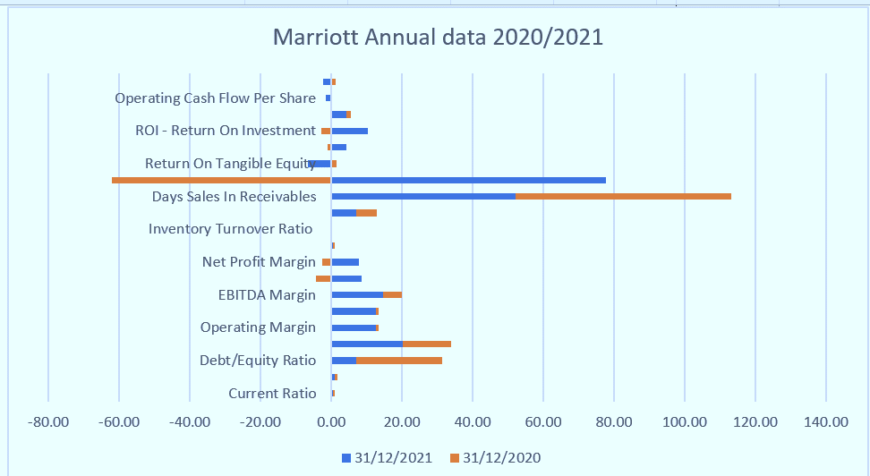
Fig 3. Marriott financial analysis 2020-2021

As seen on Fig 2 considering the Covid-19 impacts, overall Marriott International has done better than other companies as the Net Profit Margin has increased in 2021 by 10.46%

Profitability
Financial analysts and investors use profitability ratios to evaluate a company's profitability during a certain time period in relation to other important financial indicators including revenue, assets on the balance sheet, operating expenditures, and shareholders' equity. (Guilding, C. (2013). Those numbers show how well a company converts its resources into profits for its shareholders. Return on equity (ROE) is the yearly return (net income) of a firm represented as a percentage of its total shareholders' equity. As per below analysis Marriott had a negative percentage of -62.09 at 31st December 2020 due to Covid-19 and increased by 140% in difference at the end of 2021 reaching 77,72%, this position Marriott on a competitive advantage.
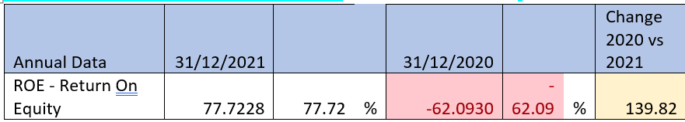
In terms of business metrics, return on assets is one of the most used measurements of success. The ratio reflects how well a firm is functioning contrasting the net income or profit it’s earning to the entire capital deposited in asset. The greater the rate of return, would result in more effectively and efficiently the economy will be managed. At the end of 2020, Marriott International had a negative number of return on assets of -1.08; this increased by 5.38% by 2021, to a positive 4.30%.
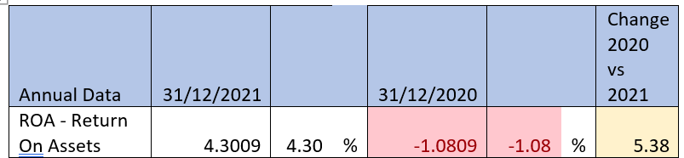
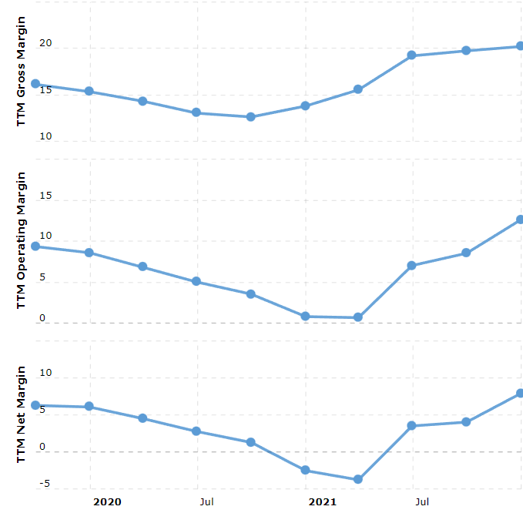
https://www.macrotrends.net/stocks/charts/MAR/marriott/profit-margins
Current and historical operating margin, gross margin, and net profit margin for Marriott over 2020 to 2021 shows a positive increase, proving that Marriott’s experts have found ways to overcome the situation created by pandemic. Profit margin refers to the amount of money left over after costs have been subtracted from sales revenue. Marriott net profit margin as of December 31st , 2021 is 7.93%, and the Gross Margin is 20.21 %, while the Operating Margin is12.63%. At 31st December 2020 net profit margin was -2.53% and the Gross Margin was 13.80%, while the Operating Margin was 0.79%.
The operating profit margin is measuring the company's profitability taking into account its operations before deducting the effects of things like taxes and interest. The 11.83% increase in Marriott's operating profit margin from 2020 to 2021 is indicative of the success with which the firm operates, and the efficiency with which it controls costs to maximise profits.
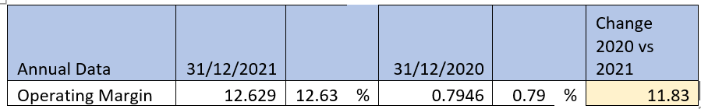
The net profit margin ratio, often known as net profit margin, is a measure of a company's profitability as a proportion of its sales. It evaluates the level of profitability a firm earns per dollar of sales acquired. (Guilding, C. (2013). The net profit divided by total revenue will show the net profit margin. With a net profit margin of -2.53% in 2020 and a positive 7.93% in 2021, Marriott saw a growth of 10.46%.
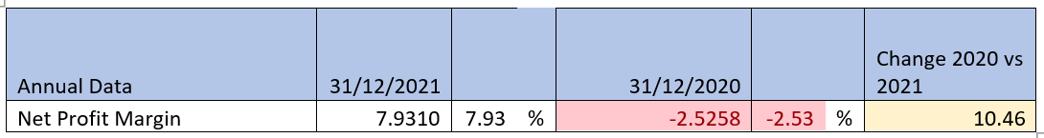

Liquidity
Liquidity ratios are used by banks, creditors, and other suppliers of short-term loans to evaluate a company's financial stability of an organisation and determine whether or not they should provide credit. One way to evaluate a company's liquidity situation is by looking at its current ratio, which is also known as its working capital ratio, and comparing it to its short-term debts that are payable within a year. The current assets in total are compared to total current liabilities to determine the ratio. Using a firm's immediately accessible liquid assets as a benchmark, the current ratio determines whether or not the company is able to meet its short-term financial obligations.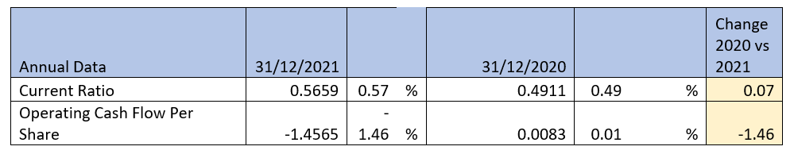
Evaluating current ratio in the financial soundness of Marriott, the ability to repay short-term debt obligations is positive, meaning Marriott is able to repay its debts but also is not leaving a large amount of excess cash unused and it is reinvesting the money into initiatives that will contribute to the expansion of the firm. The operational cash flow ratio is a more realistic estimate of a company's short-term liquidity than earnings ratios, which may be influenced by management. This is because earnings ratios are calculated using a company's operating cash, and Marriott stands on a negative balance at the end of 2021 of -1.46% which shows that the company cannot settle its existing obligations using the cash flow produced by its core business activities.

Gearing
The ratio of a company's equity to its debt is known as its gearing ratio. To what extent a company's operations are financed by owner money as opposed to creditor funds may be shown by calculating its gearing, which is a metric of financial leverage. In finance, a leverage ratio is any metric that compares one or more accounts on a company's income statement, cash flow statement, , or balance sheet to provide insight into the relative importance of debt to overall financial health. Financial leverage and equity funding of assets and activities may be inferred from these measures. Total shareholders' equity as a percentage of total assets is referred to as the equity ratio. The ratio is used to calculate the value of shareholders' remaining stake in a company. It establishes the potential claim of each shareholder in the case of the company's collapse.
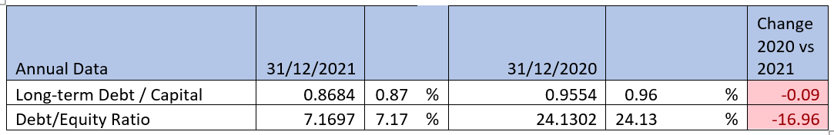
When long-term debt is divided by shareholders' equity, the resulting ratio is an indicator of a business's financial leverage. When comparing the debt to equity ratio at Marriott at the end of 2020 (at 24.13) and the end of 2021 (at 7.17), a difference of almost -16% may be seen.
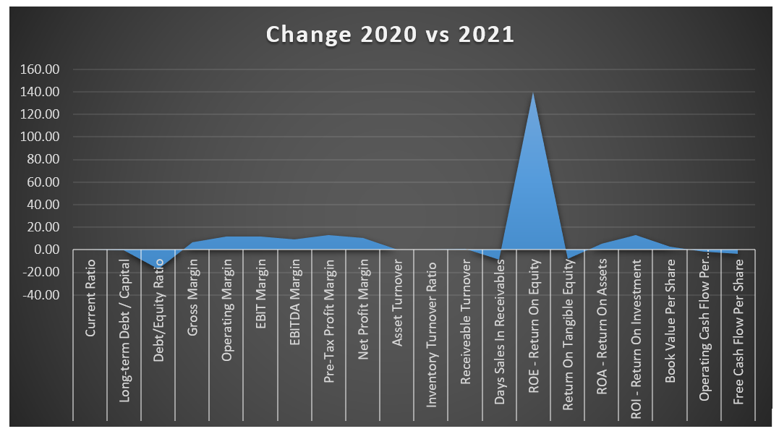

Net debt for Marriott was $8.7 billion at the end of 2021, when adjusted for changes in cash and equivalents, the company had $10.1 billion in debt but only $1.4 billion in liquid assets. Company net debt totalled $9.5 billion at the end of 2020, or $10.4 billion minus $0.9 billion in cash and equivalents. (Marriott International, 2021). It is in the context of comparison that gearing ratios become most useful to businesses. A gearing ratio could be meaningless when considered in isolation. Everyone, both within and outside of an organisation, may benefit from knowing the gearing ratio. Since regulated businesses are allowed to carry more debt, their gearing ratios tend to be greater. Further, monopolistic enterprises often have larger gearing ratios because their appropriate marketing position makes default less likely. Last but not least, industries that are very reliant on expensive fixed assets have a greater propensity to have higher gearing ratios due to the fact that such assets are often financed via debt. (Horner, D., 2017).

Knowledge from Ratio Analysis
Company performance may be evaluated quantitatively with the use of corporate finance ratios. For the purpose of making more informed investment choices, these measures are utilised by financial analysts, stock financial experts, asset managers and investor to assess the overall financial health of organisations. Financial advisors and executives rely extensively on corporate finance ratios to get insight into the health of their organisations.
When comparing businesses with very diverse sizes, operations, and management styles, a ratio study is invaluable. It's also a terrific tool for gauging the effectiveness of a company's operations and the viability of its current business model. A firm's solvency may be evaluated, for instance, with the use of solvency ratios. Financial statement analysis makes extensive use of ratios because of their predictive value. In order to assess a company's strengths and weaknesses, as well as its present financial condition and past performance, financial statement analysis calculates the quantitative or numerical connection between two data. The report is useful for investors, creditors, and other stakeholders in assessing the health of a company. (Woogon.K , Baxter. A., 2005).

Benefits and Limitations of Ratio Analysis
Horizontal analysis, in which the evolution of one firm metric is tracked through time, is greatly aided by ratio calculations. There may be changes in the size and character of a company's activities as it develops through time. Comparisons may be maintained with the use of ratios. Ratio analysis is described as the methodical use of ratios to the interpretation of financial data in order to ascertain the relative merits of various hypotheses on the health, performance, and financial status of an organisation.
Performance evaluation in any organisation may benefit greatly from the use of ratio analysis, a very effective analytical method. There is a possibility that accounting ratios are only a symptom, much like blood pressure, heart rate, body temperature, and so on. As a result of analysing this data, the doctor may better understand the origins of sickness. An accountant's ratios are another indicator of a company's financial health that ought to be examined by the financial analyst.

Conclusion
Consequently of the COVID-19 pandemic, travel and demand for hotel rooms have dropped significantly, which has had and may continue to have negative effects on Marriott's business, operational processes, and financial results. Overall Marriott International has done better than other companies as the Net Profit Margin has increased in 2021 by 10.46%.
In 2020, Marriott International had a negative number of return on assets of -1.08; this increased by 5.38% by 2021, to a positive 4.30%. Marriott net profit margin as of December 31st , 2021 is 7.93%, and the Gross Margin is 20.21%, while the Operating Margin is12.63%. The 11.83% increase in Marriott's operating profit margin from 2020 to 2021 is indicative of the success with which the firm operates, and the efficiency with which it controls costs to maximise profits. With a net profit margin of -2.53% in 2020 and a positive 7.93% in 2021, Marriott saw a growth of 10.46%. Net debt for Marriott was $8.7 billion at the end of 2021, when adjusted for changes in cash and equivalents, the company had $10.1 billion in debt but only $1.4 billion in liquid assets. Everyone, both within and outside of an organisation, may benefit from knowing the gearing ratio. Financial statement analysis makes extensive use of ratios because of their predictive value.

Bibliography
Bhimani, A (Ed) (2006), Contemporary Issues in Management Accounting, Oxford: Oxford Press
Bromwich, M. and Bhimani, A. (1994), Management Accounting, Pathways to Progress, (2nd Ed), London: CIMA
Drury, C. (2008). Management and Cost Accounting, (7th Ed), London: Prentice Hall
Guilding, C. (2013), Accounting Essentials for Hospitality Managers, London: Taylor and Francis.
Hayes, M. & Miller, A. (2012), Revenue Management for the Hospitality Industry, London: Wiley
Horner, D. (2017), Accounting for Non-Accountants, (11th Edition), London: Kogan Page
Horngren, C. T. and Forster, G. (2003), Cost Accounting, A Managerial Emphasis, (11th Ed), London: Prentice Hall International
Marr, B. (2012), Key Performance Indicators – The 75 Measures Every Manager Needs to Know, Harlow: Pearson
Marriott International (MAR), (2021) Analyst Ratings, Estimates & Forecasts. Yahoo! Finance. Available at: https://finance.yahoo.com/quote/MAR/analysis/. , accessed at 05th December 2022
Marriott International, (2022), Profit margin, Stocks, available at: https://www.macrotrends.net/stocks/charts/MAR/marriott/profit-margins, accessed 02nd December 2022
Marriott International, Inc. (2020). Annual Report 2020., available at: https://marriott.gcs-web.com/static-files/c5e1faeff1e5-40e3-bd70-5efbbb929a7f, accessed at 25th November 2022
Marriott International, Inc. (2021), Form 10-K 2021, available at: https://marriott.gcs-web.com/static files/9fb40a9dd54f-41d8-b36d-f9c924ecf7db, accessed 27th November 2022.
Saleem.Q. (2011). Impacts of liquidity ratios on profitability. Interdisciplinary Journal of Research in Business.
Seal, W., Garrison, R. H. and Noreen, E. (2008), Management Accounting, UK: McGraw Hill
Walsh, C. (2008), Key Management Ratios – The 100+ Ratios Every Manager Needs to Know, (4th Edition), Harlow: Prentice Hall
Woogon.K , Baxter. A. (2005). Ratio Analysis for the Hospitality Industry: A cross Sector Comparison of Financial Trends in the Lodging, Restaurant, Airline and Amusement Sectors. Journal of Hospitality Financial Management

