Professional Career Development

Student Name: Anghelina Marius Gabriel
Student ID:2421968

Table of Contents
Part 1 3
Introduction 3
Main body 3
Conclusion 6
Part 2 8
Job Description 8
Cover letter 9
CV 11
Interview questions 13
References 15
Appendix 18

Part 1

Introduction
Acquiring professional career development skills remains fundamental for individual enhancement as well as total professional achievement within the worldwide workplace competition. The development of employability skills enhances career readiness dimensions while matching natural abilities to organisational mission statements (Viterouli et al., 2024). This paper includes an assessment of my professional experience supported by Rolfe’s reflective cycle while reflecting on personal and skill development. Through the Johari Window approach, we will examine my insights about myself as well as the skills I need to improve. The main purpose is to examine gained skills together with employability preparedness while creating a detailed roadmap for growth.

Main body
Reflection using Rolfe’s reflective cycle:
What? (Description of the experience)- My career experience has developed various skills shown in my CV such as hospitality management and stock control. Before shifting to my current role, I worked at Slug & Lettuce as an assistant manager, which exposed me to hands-on training in business operations as well as customer relations and strategic planning (Woodward et al., 2023). Effective service delivery improvement was my responsibility at the same time as I managed staff coordination facilitated the flow of information between teams, and boosted customer pleasure. Through my work on special client offers, I boosted satisfaction rates by 30%. Stock control duties helped develop my analytical and problem-solving abilities to a stronger level. Working as a PI Stock Control specialist allowed me to master inventory management while developing my skills for lost stock tracking and supply chain optimisation (Nicho et al., 2021). Working at this position let me improve my ability to foretell demand from data along with enhancing my observational precision. The accumulation of professional experience has shown me the need to focus on two main areas regarding improved leadership methodologies and advanced methods of handling conflicts. Running diverse workforces alongside handling operational problems demanded refined leadership methods for successful management (Do et al., 2024). Interpersonal skills development along with leadership models Johari Window and employability skills framework became the focus of my professional training to build my capabilities better (P.J. Robertson et al., 2020). The acquired knowledge set the base for my ongoing career advancement through a deeper understanding of my capabilities as well as potential areas to work on.
So what? (Analysis and significance of the experience)- Through the application of Rolfe’s reflective cycle together with the Johari window I improved my understanding of my expertise along with my developmental opportunities. Proficient skills I possess in Microsoft Word and PowerPoint, and my multilingual skills include Romanian, English and Italian positions within the open domain because my coworkers deem these capabilities essential to my role (Gallagher, 2022). My competencies enable effective inventory management and operational efficiency in stock control roles because they help produce significant documentation and reporting outcomes. Through club management experience, I strengthened my abilities to lead teams while directing stock levels and providing ideal service, which enhanced my leadership skills and decision-making abilities. Feedback highlights my error in understanding how well I would achieve both morale increases and teamwork development. The Johari window defines this quality as part of my blind zone because others observed it, although I did not realise its importance. Stock control efficiency has improved due to these essential leadership traits that simultaneously improved teamwork and minimised operational shortcomings. Awareness of the importance of these abilities now drives me to enhance both leading people and interacting with others through skill improvement (Cottrell, 2021). My knowledge of Mandarin exists in the hidden professional area since these personal linguistic skills are dormant within my workplace. I am evaluating methods to use my Mandarin skills in multinational business operations, especially when international supply chain coordination becomes necessary. My career path should include the exploration of data analytics combined with strategic decision-making as two unexplored yet powerful professional opportunities for me. Through data analytics training, I decided to pursue this since the job market shows an increasing need for inventory forecasting and data-driven stock control (Puyt et al., 2023). Application of theories and models- Through the Johari Window model, I have undergone significant professional development by understanding how self-awareness helps both leadership performance and operational efficiency. Through evaluations by supervisors and mentorship participation, I discovered my hidden weaknesses, so I improved my inventory management skills. Seeking constructive feedback helped me address underserved areas in my abilities, which then improved my capability to work effectively in professional environments (Toufaily et al., 2021). The framework of employability skills supports stock control system optimisation through its requirements for problem-solving effectiveness combined with adaptability and strong communication abilities. The development of these competencies allowed operations to become more efficient and established better inventory management practices. The development of my networking abilities through professional events and coursework will establish new career opportunities within the logistics and supply chain management sector. Research partnerships with practical applications have allowed me to understand more effectively how my professional abilities relate to specific industry demands. My approach enabled me to merge my expertise with interpersonal abilities to create a complete professional identity. The strategic employment of these models throughout my career development will promote ongoing organisational growth within an industry that continually changes.
Now what? (Action plan and future development)- Personal objectives using the SMART structure form my professional development plan to reach measurable targets for self-improvement. Effective leadership skills represent my primary focus because these abilities help progress careers and produce better management outcomes. The structured leadership training I seek offers me the opportunity to develop my skills after conducting work at Pi stock control and assistant management (Mumuni et al., 2024). The completion of an appropriate program starting in March 2025 and finishing by December 2025 will teach me better conflict management and task assignment techniques, which build better team results. Network building stands as an essential pathway for career development especially when working in the hospitality field along with inventory management disciplines. I will regularly attend three business networking conferences each year which must result in establishing at least five new business connections that will boost my professional growth and mentoring potential. The implementation of data analysis skills represents a fundamental requirement in both stock control and operations management fields (Heffernan, 2021). I will complete a data analytics certification in six months, followed by weekly studies of two hours to develop practice skills. The educational program during July 2025 will transform my capacity to read stock information and drive improved inventory system operations. I will improve my knowledge of Microsoft Excel and inventory management software to guarantee operational effectiveness. Setting SMART goals gives me a methodical approach to personal growth which allows my leadership and networking abilities and analytical capabilities to contribute to supply chain simplification and career progression (Pelletier et al., 2022). I will enhance my ability to improve business efficiency together with career advancement in stock control and management through ongoing learning combined with strategic goal development.
Critical evaluation of recruitment and selection- During my recruitment and selection experiences, I understood how essential it is for individuals to match their skills with what organisations require. Job targeting through my applications led to achievement by fulfilling the described requirements, and my interview success depended on presenting my core abilities convincingly. I utilised my experience in stock control together with my operational management skills under pressure during my managerial application. By implementing the STAR method, I could guide my answers to reveal my problem-solving and leadership capabilities to recruiters. My interview experience exposed difficulties I faced when confirming my communication approach to corporate norms and workplace culture expectations. My professional development required me to know myself well and explain why I brought value to my profession. Through Johari Window model and technical assessment techniques I have integrated my specialised area knowledge with vital social competencies. My previous work experiences have enhanced my ability to understand personal branding, which matches employer requirements.

Conclusion
In conclusion the professional career advancement ever extends into the future because it combines continuing self-assessment along with workable readiness and known pursuit of ongoing education. The assessment allowed me to know my professional strengths and areas demanding attention towards improvement by using Rolfe's reflective cycle alongside the Johari window. After finishing the professional development lecture I gained important skills which will strengthen my employability capability and help me achieve my aims for career. I will take on my created implementation plan and address any skill gaps to attain the greatest professional development capability during the upcoming years. Also, I learned about both my weaknesses and how this experience strengthens my commitment to ignore professional crashes. The implementation of current competence development combined with performance deficiency remediation gives me with the necessary confidence to manage workplace challenges while delivering high value to future work organisations.

Part 2

Job Description
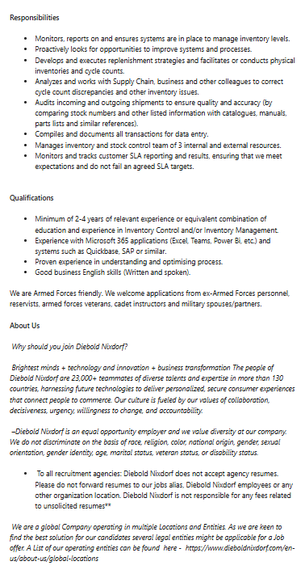
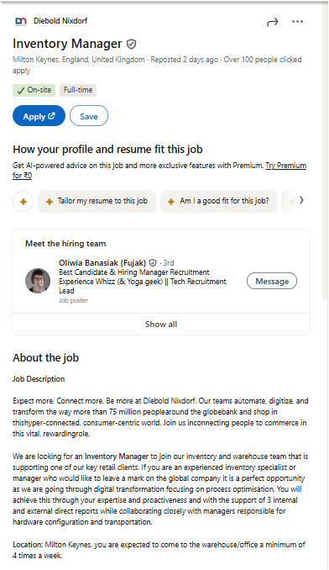

Cover letter
Marius Anghelina
17 Corelli Street
Newport, Gwent NP19 7AR
07919245369
anghelinamarius7@gmail.com.
Date:-
Hiring Manager
Diebold Nixdorf
Milton Keynes, England, United Kingdom
Subject: Application for Inventory Manager Position
Dear Hiring Manager,
My application is directed toward earning the Inventory Manager position at Diebold Nixdorf. My experience as a Pi stock control professional and four years in managerial duties assure me that I enhance inventory systems while driving both operational performance and organisational expansion.
I delivered more than 50 customer-focused projects at Slug and Lettuce Bristol while my team and I accomplished a 30% growth in satisfaction scores from clients as assistant managers. Through my process simplification work I cut down response times by 20% while managing strategic projects that brought 15% business growth. These accomplishments demonstrate my manner of quick problem-solving through data-focused choices and my talent for building relationships with multiple departments.
My role as Pi stock control specialist emphasises the ability to manage inventory accurately while making demand forecasts and reducing all types of waste. My detailed focus, together with my strong dedication to quality excellence, enables both streamlined supply chain performance and effective product distribution. These skills from my previous work experience make me excel in changing conditions requiring precise response abilities, and I believe they will successfully settle into the Diebold Nixdorf Inventory Manager position.
I feel enthusiastic about joining Diebold Nixdorf since it represents a globally recognised leader dedicated to innovative solutions and outstanding performance. The prospect of working with your team excites me since I aim to demonstrate how my abilities match your business objectives.
Thank you
Sincerely
Marius Anghelina

CV

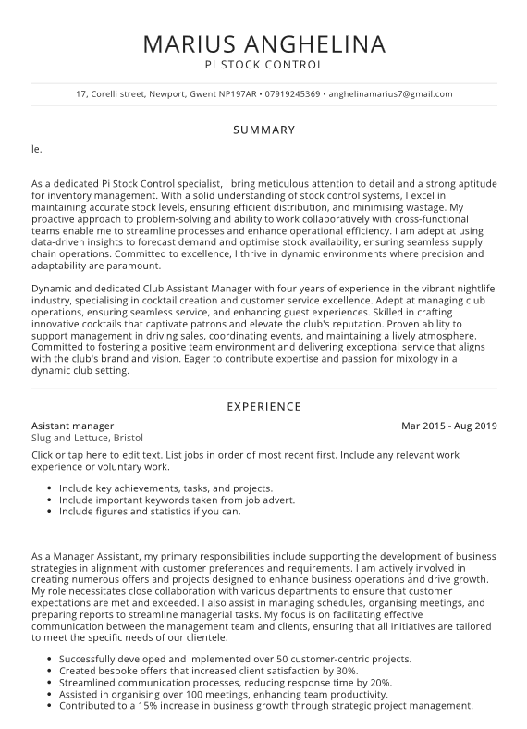
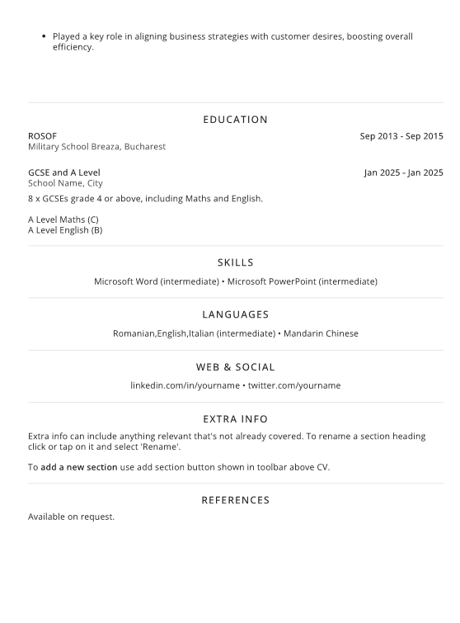

Interview questions
Can you, briefly, describe this role that you have applied for? (Duties, person specification, etc.)
As part of the Inventory Manager position an individual must handle inventory systems for maintaining precise stock records alongside supply chain optimisation tasks. This position involves two main areas of responsibility which are forecasting demand as well as managing stock distribution tasks with minimum wastage alongside collaboration with cross-functional teams. A successful inventory manager demonstrates analytical abilities together with detailed focus while showing evidence of working with inventory management systems. The ability to solve problems effectively, along with the flexibility to adapt to changing environments, ensures the streamlining of processes that drive operational efficiency growth.
What do you know about our company? (E.g. staff numbers, organisation, structure, values, mission statement, services/products etc.)
Diebold Nixdorf stands as a worldwide IT Services and IT Consulting Company that automates digitises, and transforms the way people bank and shop alongside point-of-sale terminals and software services. The company operates from more than 130 different markets worldwide through its global workforce that exceeds thousands of employees. It places priority on innovation combined with reliable solutions while addressing customer needs. The company Diebold Nixdorf dedicates itself to transforming connected commerce by merging advanced technology solutions with end-to-end integration for the future. As a company, the organisation values integrity as well as collaboration and excellence, which guides its mission to deliver secure, efficient and sustainable solutions to clients.
What is your typical way of dealing with conflict? Give me an example.
When dealing with conflicts, I first stay composed, then listen intently and truly comprehend all involved viewpoints until I can discover an acceptable resolution. The staff scheduling mismatch at Slug and Lettuce created discord among employees. I scheduled a gathering which promoted truthful discussions until we reached arrangements for harmonising their requirements with business requirements. The proactive approach established a cooperative setting, which both stopped future communication issues from arising and boosted both worker spirit and work output. Effective conflict resolution requires both good communication and empathy to reach satisfactory results.
What specific skills, qualifications and experience do you have for this role?
As Pi Stock Control specialist I gained strong inventory management expertise through my work based on three elements: accurate stock levels optimisation of supply chain processes and efficiency-focused inventory reduction. My time as assistant manager at Slug and Lettuce resulted in a 15% business expansion because I developed solid leadership abilities combined with problem-solving strengths and project management competencies. My expertise includes Microsoft Office applications, and I have fluid communication abilities in English, Romanian, and Italian to help foster communication across different teams.
What is your greatest achievement in your professional or personal life?
During my time as an Assistant Manager at Slug and Lettuce, I successfully introduced more than 50 projects that prioritised customers, which resulted in client satisfaction reaching 30% higher. I established new communication systems that resulted in 20% faster responses. My ability to fulfil customer needs and boost business performance and operational effectiveness led to this accomplishment. The mastery of Mandarin Chinese with other languages allows me to enhance my social abilities while deepening my knowledge of different cultures.
Give me an example of a time when something you tried to accomplish and failed.
The promotion launch for Slug and Lettuce lacked effective targeted marketing because I had failed to comprehend its critical importance for better results. The promotional campaign received fewer customers than its original projections. This experience taught me how vital it is to analyse customer population data for developing effective marketing changes. My work with the marketing team produced better promotional outcomes that reduced failed performance during subsequent marketing events. Experiencing this situation demonstrated to me the importance of learning to adjust and make constant betterments.

References
Cottrell, S., (2021) ‘Skills for success’: Personal development and employability. Bloomsbury Publishing. Available at: https://books.google.co.in/books?hl=en&lr=&id=Q_RgEAAAQBAJ&oi=fnd&pg=PT17&dq=Cottrell,+S.+(2021)+Skills+for+success:+personal+development+and+employability+.+4th+edition.+London+:,+Red+Globe+Press&ots=QnDGieW4hO&sig=HFDwVe7NsFVdbPLlJZDFPamBmPM&redir_esc=y#v=onepage&q&f=false.
Do, N.X.B., An, T.S. and Krauss, C., (2024) May. ‘SMART-Goal-Buddy’: Goal-Setting Oriented Adaptive Learning Paths. In International Workshop on Learning Technology for Education Challenges (pp. 319-331). Cham: Springer Nature Switzerland. Available at: https://doi.org/10.1007/978-3-031-61678-5_23.
Gallagher, K. (2022) ‘Essential study and employment skills for business and management students’. Fourth edition. Oxford:, Oxford University Press. Available at: https://books.google.co.in/books?hl=en&lr=&id=61vMDwAAQBAJ&oi=fnd&pg=PT8&dq=Gallagher,+K.+(2022)+Essential+study+and+employment+skills+for+business+and+management+students+.+Fourth+edition.+Oxford+:,+Oxford+University+Press.&ots=MwwKgRKoto&sig=mAlx-9_DFoERiv8GCsYT4KyrrFE&redir_esc=y#v=onepage&q&f=false.
Heffernan, T., (2021) ‘Academic networks and career trajectory’:‘There’s no career in academia without networks’. Higher Education Research & Development, 40(5), pp.981-994. Available at: https://doi.org/10.1080/07294360.2020.1799948.
Mumuni, A.N., Hasford, F., Udeme, N.I., Dada, M.O. and Awojoyogbe, B.O., (2024) ‘A SWOT analysis of artificial intelligence in diagnostic imaging in the developing world’: making a case for a paradigm shift. Physical Sciences Reviews, 9(1), pp.443-476. Available at: https://doi.org/10.1515/psr-2022-0121.
Nicho, M., Fakhry, H., Bataineh, E. and Girija, S., (2024) ‘A Strategic Evaluation of Educational Continuity for Accessibility During Uncertainty in an Educational Practicum’. International Journal of Information and Communication Technology Education (IJICTE), 20(1), pp.1-31. Available at: 10.4018/IJICTE.342111.
P.J. Robertson, T. Hooley, & P. McCash (eds.) (2020) ‘The Oxford handbook of career development / [electronic resource]’. New York :, Oxford University Press. Available at: https://books.google.co.in/books?hl=en&lr=&id=7BQuEAAAQBAJ&oi=fnd&pg=PP1&dq=P.J.+Robertson,+T.+Hooley,+%26+P.+McCash+(eds.)+(2020)+The+Oxford+handbook+of+career+development+/+%5Belectronic+resource%5D.+New+York+:,+Oxford+University+Press.&ots=j4Sh0IB7MF&sig=YyOMs51ZW_HclmbxVZbKln1aYYs&redir_esc=y#v=onepage&q&f=false.
Pelletier, K., Mccormack, M., Reeves, J., Robert, J., Arbino, N., Dickson-Deane, C., Guevara, C., Koster, L., Sanchez-Mendiola, M., Bessette, L.S. and Stine, J., (2022). ‘2022 educause horizon report teaching and learning edition’ (pp. 1-58). EDUC22. Available at: https://www.learntechlib.org/p/221033/.
Puyt, R.W., Lie, F.B. and Wilderom, C.P., (2023) ‘The origins of SWOT analysis’. Long Range Planning, 56(3), p.102304. Available at: https://doi.org/10.1016/j.lrp.2023.102304.
Tan, L.M., Laswad, F. and Chua, F., (2022) ‘Bridging the employability skills gap’: going beyond classroom walls. Pacific Accounting Review, 34(2), pp.225-248. Available at: https://doi.org/10.1108/PAR-04-2021-0050.
Toufaily, E., Zalan, T. and Dhaou, S.B., (2021) ‘A framework of blockchain technology adoption’: An investigation of challenges and expected value. Information & Management, 58(3), p.103444. Available at: https://doi.org/10.1016/j.im.2021.103444.
Viterouli, M., Belias, D., Koustelios, A., Tsigilis, N. and Papademetriou, C., (2024) ‘Time for change: designing tailored training initiatives for organizational transformation’. In Organizational Behavior and Human Resource Management for Complex Work Environments (pp. 267-307). IGI Global. Available at: 10.4018/979-8-3693-3466-9.ch014.
Woodward, D., Booth, S., Allen, E., Forbes, A. and Morton, C., (2023) ‘REFLECTIVE PRACTICE FOR EDUCATORS AND LEARNERS, AND THE BENEFITS OF BEING A REFLECTIVE PRACTITIONER’. Contemporary Research Topics, p.96. Available at: https://thescopes.org/assets/Uploads/SCOPE-LT-12-Whole-issue-LQ.pdf#page=98.

Appendix
Johari Window


