Leadership skills In Entrepreneurship

Product Design
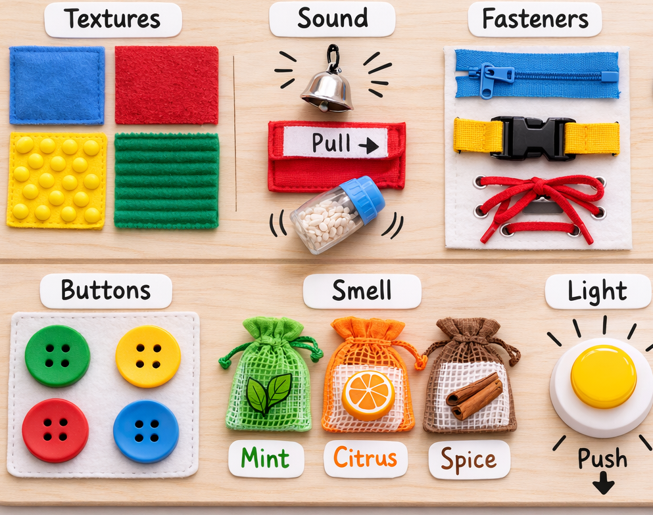

Word count Part 2A - 1541
Word count Part 2B – 1227

Contents Page

AI Statement – Page 3

Business plan – Pages 4-8

Research – Pages 9-12

References – Page 13

AI Statement
I acknowledge the use of Chat GPT on 21/02/26 to design an image of my product design.
I used the prompts:
1. Sensory Board
2. Five Senses
I confirm that I have not presented any AI generated text as my own work
I confirm I have copies of my drafts, notes, and other resources I used before, and after the use of AI tools which I may be asked to provide in evidence.

Business Plan
Introduction
My name is Bobbie-Jayne Rees. Currently I am the manager of a daycare setting however I have 16 years’ experience working in a variety of childcare and education settings from early years settings, to PRU units and residential children’s homes. I have provided 1:1 support to many children where I developed in depth knowledge and understanding of additional learning needs. I am extremely passionate about finding ways to support child development and have a particular interest in raising awareness and understanding of visual impairments. This passion has led me to thoughtfully design a sensory board exclusively designed for visually impaired children aged one to two. At this stage of development, touch, sound, and movement are children’s gateways to understanding the world around them. Every child regardless of their ability to see deserves the opportunity to explore, play and learn. This belief aligns strongly with the Equality Act 2010 and the United Nations Convention on the Rights of the Child (UNCRC), particularly Article 23, which states that children with disabilities have the right to special care and support, and Article 31, which recognises every child’s right to play (UNICEF 1989).
My product design is driven by my commitment to early identification of visual impairments and a strong understanding of how crucial the first months of life are for a child’s visual development. Research by Atkinson and Braddick (2012) highlights that that the period from birth to 7 months is especially critical for visual development, with the first 18 months of life being significantly important. Children with additional learning needs, disabilities, or conditions including downs syndrome and cerebral palsy are at a higher risk of developing visual problems. Furthermore, research identifies a significant concern that myopia more commonly known as short sightedness is on the increase due to screen time, lifestyle and genetics (Kynman-Sprinks et al., 2025). By 2050, almost half of all young people and adults are expected to be myopic. Sharing this information and raising awareness is paramount as early identification will ensure better outcomes for future generations. The biggest challenge for practitioners and parents/carers is that visual impairments are not always visible and there are not always signs. Therefore, the tools we offer families and practitioners must be purposeful, accessible, and developmentally meaningful. My sensory board is designed with this mission at its core.
Purpose
This product is more than just a design, it has significant intention behind it. My passion for raising awareness of visual impairments means that this is more than just a product it is also a purposeful learning tool. I have designed opportunities for children which develop learning, exploration, and confidence-building. My experience as a practitioner means that I know what signs families need to look for, what sensory experiences are developmentally meaningful, and how to create materials that are safe, accessible, and supportive to holistic development. This sensory board supports children’s development whilst also helping adults recognise how a child responds to different sensory experiences, making it a powerful resource for both play and early identification. By combining evidence-based design with sincere purpose, I am creating a product that has the potential to make a meaningful difference in the lives of visually impaired children and their families.
Market Research
To collect further input for my product design, I provided the parents in my setting with a questionnaire. I also had face to face discussions during drop off and pick up with the parents of visually impaired children who attend my setting. I had discussions with over 25 practitioners on the shop floor in my setting. The feedback provided was that there is are not enough toys/resources on the current market which support visually impaired children. The feedback also included that specialised resources are usually expensive and they cannot afford them. There are generic sensory boards available on the market ranging from £21.99 to £59.99 on Amazon to but they are not all inclusive for visually impaired children. Upon further research, I discovered that generic sensory boards rely heavily on visual stimulation using bright colours, pictures, lights. They are not designed around tactile or auditory learning, leaving visually impaired children excluded. Visually impaired children rely on touch, sound and movement, not sight. My market research proves that there is a demand for a resource like my unique design.

This product has been carefully centered on children’s direct experiences.Through direct observations and carefully planned sensory activities, I have been able to see firsthand how children respond to different types of sensory stimulation. This has given me an insight to which textures were liked the most, which textures were liked the least. I discovered what children could explore confidently and independently with their hands, unaided by staff members to promote independence. The importance of exploring independently is highlighted in the 0-3 child developmental pathways to develop cognitive skills and problem solving skills (Welsh Government, 2022). Additionally I have also been able to identify what sounds and smells caused children to feel overwhelmed or overstimulated. This ensures the product supports children’s wellbeing.
This purpose built sensory board designed for visually impaired children fills a genuine, unaddressed gap in the early years sector. My current job role provides me with a strong target audience as there are 180 children on my books. The primary audience is all children aged between 1 and 2. There is a wide secondary audience including parents, early years practitioners and health professionals including health visitors and paediatric specialists. In my current job we already have an ap and Facebook page that reaches parents and educators. I could initially advertise this product on these platforms at no additional cost. I also have strong links with other settings and multi agencies to further promote this product. I work closely with flying start who are happy to support and promote my product to all their settings across Wales. Another method of marketing is to share testimonials from parents and practitioners.
This product is a carefully developed, child-safe sensory board that transforms everyday exploration into meaningful developmental progress. With rich tactile materials, gentle auditory feedback, and simple cause-and-effect mechanisms, it empowers children to build fine-motor skills, spatial awareness, and confidence independently and joyfully. This board has been designed with a holistic developmental approach. I have specifically chosen textures, sounds, and mechanisms to support fine-motor development, spatial awareness, early problem-solving and independent exploration.

Challenges and Barriers
This product is designed for a more specialised audience than generic sensory boards, as the number of children with diagnosed visual impairments is smaller than the wider early years population. This naturally limits the size of the immediate target market compared to generic sensory boards. A barrier is that many people are unaware of the signs or the understanding of how early visual impairments can occur. However, increasing awareness of early visual development has the potential to expand demand over time, particularly as early identification becomes more widely recognised as essential to improving long term outcomes.
Another barrier is that many families and businesses are facing a cost of living crisis and rising inflation. Since 2021, families all across the UK have endured a rising increase in food, energy and housing. Inflation has also had a significant impact on early years settings as they face a continuous rise in operational costs. The challenge will be to ensure that this product is low cost to make and affordable for parents/carers and educators.
Financial Feasibility
To launch the business, I intend to use personal savings to fund the first production cycle. Each sensory board currently costs £35 to manufacture, including materials and assembly.
Cost Breakdown per Sensory Board:
- MDF board — approximately £3.50 per board (Based on using around 0.2–0.25 m² of 12mm MDF)
- Sensory components approximately £16.50
(wooden buttons, bell, push light, textured fabrics, lace, zip fastener, scent bags)
- Finishing materials — approximately £1.70
(Non‑toxic paint or stain, child‑safe varnish, sandpaper)
- Fixings and hardware — approximately £1.30
(Screws, bolts, wood glue)
- Packaging — approximately £1.50
(Cardboard box and printed instructions/branding)
- Labour — approximately £10.50
The planned retail price is £45 per unit, resulting in a profit margin of 22.22% and a profit of £10 per unit. This is a low profit margin as my aim is to have an affordable product which parents/carers and early years educators can afford.
Based on an initial production run of 100 units, the financial breakdown is as follows:
- Total production cost: 100 units × £35 = £3,500
- Total projected revenue: 100 units × £45 = £4,500
- Projected net profit: £4,500 – £3,500 = £1,000
This initial phase will allow the business to gather customer feedback and refine the product whilst raising awareness of visual impairments. I feel this has a low financial risk. Looking ahead, my intention is to increase production by 100 units per year, enabling steady and sustainable growth. Based on this model, I project that the business will generate a cumulative net profit of approximately £15,000 over five years. This projection reflects consistent annual increases in production and sales, supported by growing brand awareness and demand within early years settings and among families. It is not my intention to profit a large sum of money from this business, my goal is to raise awareness for noticing, understanding, and supporting visually impaired children from the very start of life.

Research
This sensory board supports early years development in a holistic approach as it supports physical, cognitive, social, emotional, and sensory skills. The product is intentionally designed around how children aged one to two learn best, through exploration and play. This board promotes the use of touch, sound, movement, repetition, and exploration. The Welsh Government (2024) highlight the importance of providing opportunities to developing these senses. For visually impaired children, these sensory pathways are not just a part of development they are essential for understanding the world around them. The product design has been influenced from real life observations ensuring it reflects children’s development needs and preferences. The Curriculum for Wales highlights the importance of observing children to understand their likes/dislikes and induvial needs (Welsh Government 2022).
This product strongly supports physical development, in particular fine and gross motor skills. Theorist Piaget identifies how children aged one to two refine their hand–eye coordination, grasp, reach, and body awareness through hands-on exploration. Visually impaired children rely heavily on touch and movement to build these skills. The different textures encourage movements including grasping, pinching, patting, and stroking. Buttons, spinners, and moving parts strengthen finger control and muscle strength. The sound-producing elements encourage children to reach, push, and explore. Repeated physical interaction builds muscle memory and confidence. The sensory board therefore provides a developmentally meaningful way for visually impaired children to practise essential motor skills while enabling adults to observe their responses to different sensory experiences.
This product reflects the principles of the Equality Act 2010 by promoting inclusion, accessibility and equal opportunities to play. It removes barriers to play for visually impaired children allowing the opportunity to discover curiosity and engage in meaningful learning experiences. Removing barriers will promote inclusive practice across early years settings supporting the Welsh Government’s Early Childhood, Learning and Play Care plan (Welsh Government, 2024). Furthermore, this product promotes all children’s rights by ensuring children with additional needs can access meaningful sensory experiences aligning with article 31 of the UNCRC (UNICEF1989). Inclusive practice is fundamental to supports children’s emotional wellbeing by helping them feel valued, accepted, and understood, which strengthens their sense of belonging and confidence.
The sensory board aligns with early years safety regulations by ensuring that all materials, fixtures, and sensory elements meet the standards required for children under two. Early years settings must comply with the Statutory Framework for the Early Years Foundation Stage (EYFS), which requires providers to ensure that equipment is safe, age-appropriate, and suitable for children’s developmental needs (Department for Education, 2025). This sensory board supports these requirements by ensuring materials used are durable, nontoxic, securely fixed components, no sharp edges, and sensory features that prevent choking hazards.
The early years sector operates within a VUCA environment shaped by volatility, uncertainty, complexity and ambiguity, where children’s needs, family circumstances, and professional expectations can change quickly (Kaz, 2017). Early Years settings require practitioners to adapt, think creatively, and respond to developmental differences. This product provides a flexible, evidence-informed resource that will enable adults to identify visual impairments with stronger confidence. The sensory board not only raises awareness of visual impairments but also contributes to early identification and better outcomes for future generations. According to Bountziouka et al. (2023) childhood visual impairment has a significant impact on development, reinforcing the importance of early detection.
A significant barrier for this business idea is the current lack of awareness among parents and early years practitioners regarding the signs of visual impairment and the importance of early detection. Many visual difficulties are subtle, not immediately visible, and often misunderstood. As a result, some parents and educators may initially perceive this product as suitable only for children with an existing diagnosis, rather than recognising its broader developmental value. A key aim of this product is therefore to challenge this misconception. The sensory board is designed to support all children, not only those with diagnosed visual impairments. It provides meaningful sensory experiences that promote early development while also helping adults observe how children respond to tactile and auditory stimulation. This dual purpose of supporting play and enabling early identification will be central to overcoming awareness related barriers.
In order for a business to succeed long term sustainability it requires financial support. A purpose-led product faces unique funding pressures because the goal is social impact rather than profit. This results in long-term sustainability coming from external support rather than relying solely on sales. Grants, charitable partnerships, early-years organisations, and community funding often become essential sources of financial stability. This is essential to helping to cover production costs, outreach work, and the wider awareness-raising mission. However the childcare sector in Wales is currently facing long term funding issues which is jeopardising the future of many Nurseries. National Day Nurseries Association (2024) Identifies that despite significant increases in staffing, energy, food, and operational costs, Government funding for the Childcare Offer and early education has not changed since 2022. This widening gap means that many settings are at risk of being unable to cover their full operating costs. Furthermore, the National Minimum Wage continues to rise every year increasing staffing costs. This means that wages are increasing however the funding for children is not, resulting in settings loosing money on every funded child. This is not sustainable, placing all Early Years Settings at risk of closures.
Pulse surveys carried out in 2024-2025 highlights that providers do not have the money to expand their locations, invest in new resources, or prepare for regulatory changes (Department for Education, 2025). This means that despite this product design being recognised as a valuable and inclusive resource, early years settings have limited money to spend. Restricted budgets also means settings are not able to provide specific staff training. This has a direct impact on children with additional needs as it limits early identification and creates a barrier for practitioners to provide adapted resources.
Another challenge for many businesses in the childcare sector is being largely associated as a highly feminised sector. As a result, childcare businesses often face the same structural limitations commonly experienced by women-owned enterprises more broadly (Nadin, 2007). These limitations include limited financial support and undervaluation of care work. However, this particular business proposal strongly aligns with the Welsh Government’s commitment to supporting women entrepreneurs and creating a fairer, more inclusive Wales. As stated in their action plan, Wales is ‘serious about supporting women entrepreneurs’ (Welsh Government 2019).
Conclusion
This product has the potential to promote inclusive and developmental practice across the early years sector. It is clear that it strongly aligns with national priorities around early identification and reducing inequalities in childhood outcomes. The concept opens the door to significant opportunities which benefit children, families and educators. There is potential to develop a full range of sensory resources tailored to different ages, developmental needs, and learning styles. These could include portable sensory kits and age‑progressive boards that support children as they move from infancy into preschool. Training packages could be created to help practitioners understand early visual development and how to use sensory tools to support early identification. Collaborating with nurseries, Flying Start teams, health visitors, early intervention services, and specialist visual impairment teams would ensure that the resources reach the children who need them most. Working with charities, local authorities, and educational suppliers could support wider distribution, while also helping to secure the long‑term sustainability of this business idea.

References

Atkinson, J. and Braddick, O. (2012), Visual attention in the first years: typical development and developmental disorders. Developmental Medicine & Child Neurology, 54: 589-595. https://doi.org/10.1111/j.1469-8749.2012.04294.x
Bountziouka, V., Horvat-Gitsels, L.A., Cortina-Borja, M. and Rahi, J.S., (2023). Trends in the long-term impact of childhood visual impairment on health and social outcomes in the UK: a cross-cohort study across three decades of disability-related legislation and policy implementation. European Journal of Public Health, 33(6), pp.1035-1042. https://doi.org/10.1093/eurpub/ckad162
Department for Education (2025) Pulse surveys of childcare and early years providers. Available at: (Pulse surveys of childcare and early years providers, 2024 to 2025 Accessed 28/02/26)
Department for Education 2025) Early Years Foundation Stage Statutory Framework Available at: EYFS statutory framework for group and school-based providers (Accessed 27/02/26)
Kaz (2017) ‘VUCA Contexts in Children’s Centres Demands Systems Leadership’ Children’s Centre Leadership pp: 10-14

Kynman-Sprinks, D., Biswas, S., Logan, N.S. and Wolffsohn, J.S., 2025. 125959 Future projections of myopia in the UK and Ireland: trends in prevalence, progression, and pathology through 2050. https://doi.org/10.1136/bmjophth-2025-BIPOSA.45
Nadin S, (2007), “Entrepreneurial identity in the care sector: navigating the contradictions” Women in Management Review 22 456–467
National Day Nurseries Association (2024) Available at: Wales Childcare Crisis: Nine in ten nurseries expect to make a loss or break even - NDNA (Accessed 25/02/26)
UNICEF. (1989) The United Nations Convention on the Rights of the Child. Available at: UN Convention on Rights of a Child (UNCRC) - UNICEF UK (Accessed 19/02/26)
Welsh Government (2019) Supporting Entrepreneurial Women in Wales Available at: Supporting Entreprenerial Women in Wales (Accessed 23/02/26)
Welsh Government (2022) The Curriculum for Wales. Available at: Curriculum for Wales - Hwb (Accessed 23/02/26)
Welsh Government (2024) Early Childhood Play, Learning and Care. Available at: Early Childhood Play, Learning and Care Plan in Wales (Detailed version) (Accessed 22/02/26)

