University of Wales Trinity Saint David
School of Engineering
Transient Thermal Diffusion Model using the Finite Difference Method
Christopher Hopkins
149588
24/01/2020
Advanced Computational Methods M6X00408
Dr A. Marotin
Contents
1 Introduction 1
1.1 Aims 1
2 Background Research 2
3 Initial and Boundary conditions. 4
3.1 Linear script 4
3.2 Gaussian Distribution script 4
4 Methodology 5
5 Results 12
5.1 Fixed time step, fixed convergence criterion, multiple grid spacing 13
5.2 Fixed grid spacing, fixed convergence criterion, multiple time step 16
5.3 Fixed time step, fixed grid spacing, multiple convergence criterion 18
6 Discussion 22
6.1 Limitations of the model 22
6.2 Potential Improvements 22
7 Conclusion 23
8 References 24

Figure 3.1 Linear distribution Initial and Boundary conditions 8
Figure 3.2 Gaussian distribution Initial & Boundary conditions 9
Figure 4.1 Thermal diffusivity calculation 10
Figure 4.2 User Inputs 11
Figure 4.3 User input 1 13
Figure 4.4 User input 2 13
Figure 4.5 Confirmation & input checks 14
Figure 4.6 Node spacing error 14
Figure 4.7 Time spacing error 15
Figure 4.8 User check 15
Figure 4.9 Initial and Boundary conditions 16
Figure 4.10 Calculation Loops 18
Figure 4.11 Node conditions 20
Figure 4.12 Equilibrium or Plot 21
Figure 4.13 Elapsed time calculations 22
Figure 4.14 Example time output 23
Figure 5.1 Final temperature display 25
Figure 5.2 Grid Spacing Results Graph 27
Figure 5.3 Time Interval Results Graph 31
Figure 5.4 Example of Time interval increase 33
Figure 5.5 Convergence Criterion Results Graph 36
Figure 5.6 Temperature results for 1e-1 39
Figure 5.7 Temperature results for 1e-2 39
Figure 5.8 Temperature results for 1e-3 40
Figure 5.9 Temperature results for 1e-4 40

Table 1 Varied Grid Spacing Results 26
Table 2 Variable Grid Spacing Results Differences 28
Table 3 Varied Time Interval Results 30
Table 4 Variable Time Interval Results Differences 32
Table 5 Varied Convergence Criterion Results 35
Table 6 Variable Convergence Criterion Results Differences 37

Introduction
This report outlines the steps taken to calculate the temperature distribution throughout a 2D aluminium plate over time. The plate will be investigated by implementing the explicit finite difference method in MATLAB to investigate thermal diffusion. A uniform grid will be used with equal X and Y dimensions spacings. Initial and boundary conditions will be set depending on the problem at hand. In order to verify the model a second script will be created with set boundary conditions with a known equilibrium outcome. If the results of this test script match those expected it can be assumed that the script is correctly input. The report will include an investigation into the finite difference method, breakdown of the MATLAB script used, analysis of the results followed by limitations and improvements of the model.

Aims
Create a MATLAB script capable of calculating thermal diffusion up until equilibrium
Analyse results obtained over a range of input variables to identify trends
Suggest improvements that can be made to the model

Background Research
Finite difference approximations are a simple method to solve differential equations. It consists of approximating the differential operator by substituting the derivatives with differential quotients. However, there is some error in these approximations as only a finite part of a Taylor series can be used. (Fabugba, et al., 2013)
According to (Dehghan, 1999) the explicit scheme used the old-time step conditions neighbouring the node to calculate the temperature in the future. However, has great restrictions on stability and are only useful over small time steps. Whereas, the implicit finite difference model is backwards time centred. Meaning the conditions must be known in the forward timestep. The scheme is unconditionally stable so overcomes the limitations of the explicit method. This scheme does however require more CPU power and therefore tales a lot longer
According to (Marotin, 2019) the governing equation for heat diffusion in a conductor is
$\frac{∂T}{∂t}.\frac{1}{α}=T^{2}∇$ (1)
Using the finite difference technique to substitute the derivatives within the equation (2) with differences generated from Taylor series using forward, backwards and central differences.
$\frac{∂T}{∂t}.\frac{1}{α}= \frac{∂^{2}T}{{∂x}^{2}}+\frac{∂^{2}T}{{∂y}^{2}}$ (2)
$\frac{∂T}{∂t}$ uses the first derivative of forward differences as a substitute where as $\frac{∂^{2}T}{{∂x}^{2}}\&\frac{∂^{2}T}{{∂y}^{2}}$ use the second derivative of the central differences.
Forward approximation states that:
$f\left(x_{o}+h\right)=f\left(x_{o}\right)+h.f^{1}(x_{o})$ (3)
1st Derivative
$f^{1}(x_{o})≈\frac{f\left(x_{0}+h\right)-f(x_{o})}{h}$ (4)
Meaning $\frac{∂T}{∂t}$ can be substituted to the following.
$\frac{∂T}{∂t}= \frac{{T_{p}}^{n+1}-{T_{p}}^{n}}{∆t}$ (5)
Where ${T_{p}}^{n+1}$ is the temperature of the node one time change into the future.
Backwards approximation states that:
$f\left(x_{o}-h\right)=f\left(x_{o}\right)-h.f^{1}(x_{o})$ (6)
This is needed for the central difference approximation
Central difference approximation states that:
For the second order equations 3 and 6 are added together
$$f\left(x_{0}+h\right)+f\left(x_{0}-h\right)= \left[f\left(x_{0}\right)+h.f^{1}\left(x_{0}\right)+\frac{h^{2}}{2!}f^{2}\left(x_{0}\right)⋯\right]+\left[f\left(x_{0}\right)-h.f^{1}\left(x_{0}\right)+\frac{h^{2}}{2!}f^{2}\left(x_{0}\right)⋯ \right]$$
So
$=2.\left[f\left(x_{0}\right)+\frac{h^{2}}{2!}f^{''}\left(x_{0}\right)+\frac{h^{4}}{4!}f^{(4)}\left(x_{0}\right)+⋯\right]$(7)
2nd Derivative
$f^{2}\left(x_{0}\right)≈\frac{f\left(x_{0}+h\right)-2.f\left(x_{0}\right)+f\left(x_{0}-h\right)}{h^{2}}$ (8)
Meaning $\frac{∂^{2}T}{{∂x}^{2}}$ can be substituted to the following.
$\frac{∂^{2}T}{{∂x}^{2}}=\frac{T_{E}-{2T}_{p}+T_{W}}{h^{2}}$ (9)
And $\frac{∂^{2}T}{{∂y}^{2}}$ can be substituted to the following.
$\frac{∂^{2}T}{{∂y}^{2}}=\frac{T_{N}-{2T}_{p}+T_{S}}{h^{2}}$ (10)
By substituting the derivates in equation 2 with the differences in equations 5,9 and 10 equation 2 now looks like
$\frac{{T_{p}}^{n+1}-{T_{p}}^{n}}{∆t}.\frac{1}{α}= \frac{T_{E}-{2T}_{p}+T_{W}}{h^{2}}+\frac{T_{N}-{2T}_{p}+T_{S}}{h^{2}}$ (11)
$α=\frac{k}{ρ*c}$ (12)
Equation 11 can then be rearranged to give
${T_{p}}^{t+∆t}=\frac{α∆t}{h^{2}}\left(T_{E}+T_{W}+T_{N}+T_{S}-\left(4-\frac{h^{2}}{α∆t}\right)T_{p}+\frac{h^{2}.Q}{k}\right)$ (13)

Initial and Boundary conditions.

Linear script
For the linear validation script, the initial conditions of the domain nodes are 0ºC as if the plate had just come out of a freezer. The boundary conditions are set to 50ºC on one side of the plate. The opposite side is set to 0ºC and then finally the perpendicular boundaries are ranged from 50ºC – 0ºC at even decrements. Figure 3.1 below shows an example of a 1x1m plate with 0.1m node spacings.
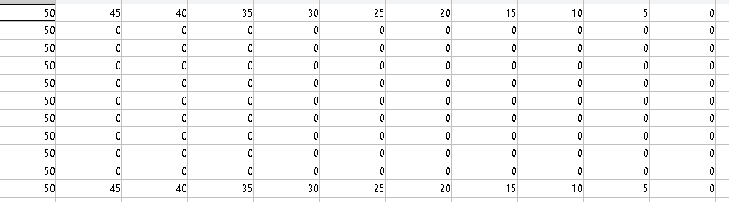
Figure 3.1 Linear distribution Initial and Boundary conditions

Gaussian Distribution script
For the Gaussian distribution script. The initial conditions for the domain nodes were again set to 0ºC. However, the boundary conditions for the south east and west of the plate were also set to 0ºC. Finally, the northern boundary nodes ranged from 100ºC to 10ºC using a Gaussian function. This meant the temperature gradually decreases from the centre in the form of a bell curve. Figure 3.2 below shows an example of a 1x1m plate with 0.1m node spacings.
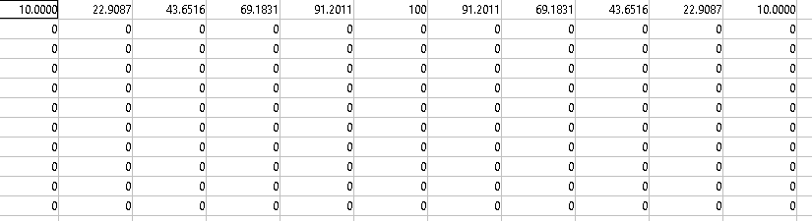
Figure 3.2 Gaussian distribution Initial & Boundary conditions

Methodology
The script starts by calculating the thermal diffusivity of the material. In this case the material being tested is aluminium. For this calculation the following information regarding aluminium is required:
Conductivity: k = 143 W/m.C
Density: ρ = 2.8 × 103 kg/m3
Specific Heat: c = 795 J/kg.C
These properties of the metal are then used to calculate thermal diffusivity using eq 12. This is demonstrated in the script in figure 4.1 below from lines 3 – 6.
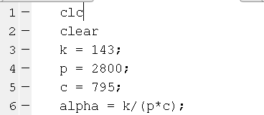
Figure 4.1 Thermal diffusivity calculation
Following this the script then requires 4 user inputs. The inputs required are the X and Y dimensions of the plate. The node spacings and then finally the time interval between calculations. Figure 4.2 below shows how this has been implemented into the script.
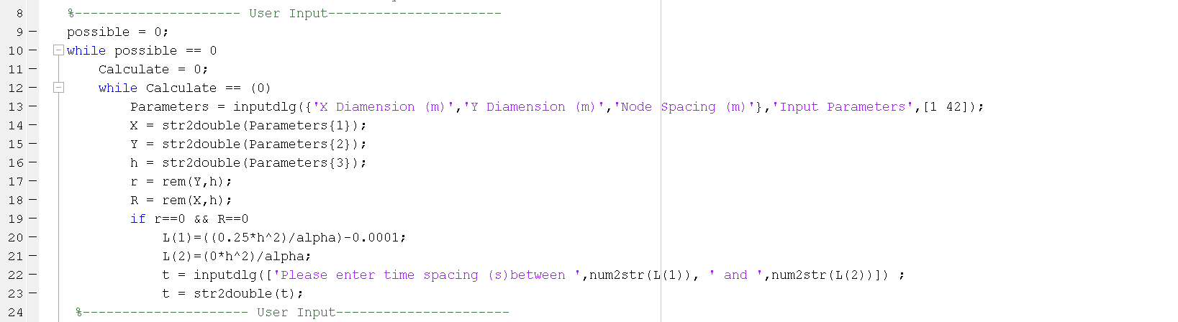
Figure 4.2 User Inputs
The user input section of the script uses the inputdlg function to create a dialog box asking for the X, Y and node spacings as shown in figure 4.2 lines 13 - 16. The time spacing is then asked on a separate dialog as the script can calculate a range of possible parameters for the time spacing input. This is calculated rearranging the Fourier number equation (14) so that t is the subject and the Fourier number is set to 0.25 (max allowed) and 0 (minimum allowed) as 0 multiplied by anything is 0 the minimum will be 0. As demonstrated in figure 4.2 lines 20 -21
$F_{o}=\frac{α*∆t}{h^{2}} t=\frac{F_{o}*h^{2}}{α}$ (14)
On line 20 (max t interval) the equation was completed with a -0.0001. This is because MATLAB will sometimes round up the last digit (that is displayed to the user) making the Fourier number slightly larger than 0.25.
A second dialog box is then created expressing the possible range that t could be is created for user input. This is demonstrated in lines 22 – 23 of figure 4.2.
Figures 4.3 & 4.4 shows the dialog boxes produced with sample parameters in. Figure 4.4 clearly indicates the t range.
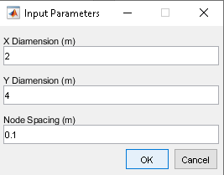
Figure 4.3 User input 1
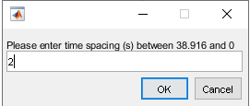
Figure 4.4 User input 2
There are numerous checks in the script to make sure that it cannot be broken. The first is in figure 4.2 lines 17 – 19. This checks that the node spacings are divisible by the X and Y dimensions by looking for remainders when dividing X or Y by h (node spacing) using the rem function. Following this an if statement checks that the remainder is = to 0 for both dimensions. If these criteria are met the script displays the dialog box shown in figure 4 (this is performed before the second dialog box ever appears). However, if the criteria are not met in one of both dimensions an error message is displayed to the user using the errordlg function shown in figure 4.5 lines 44 - 47
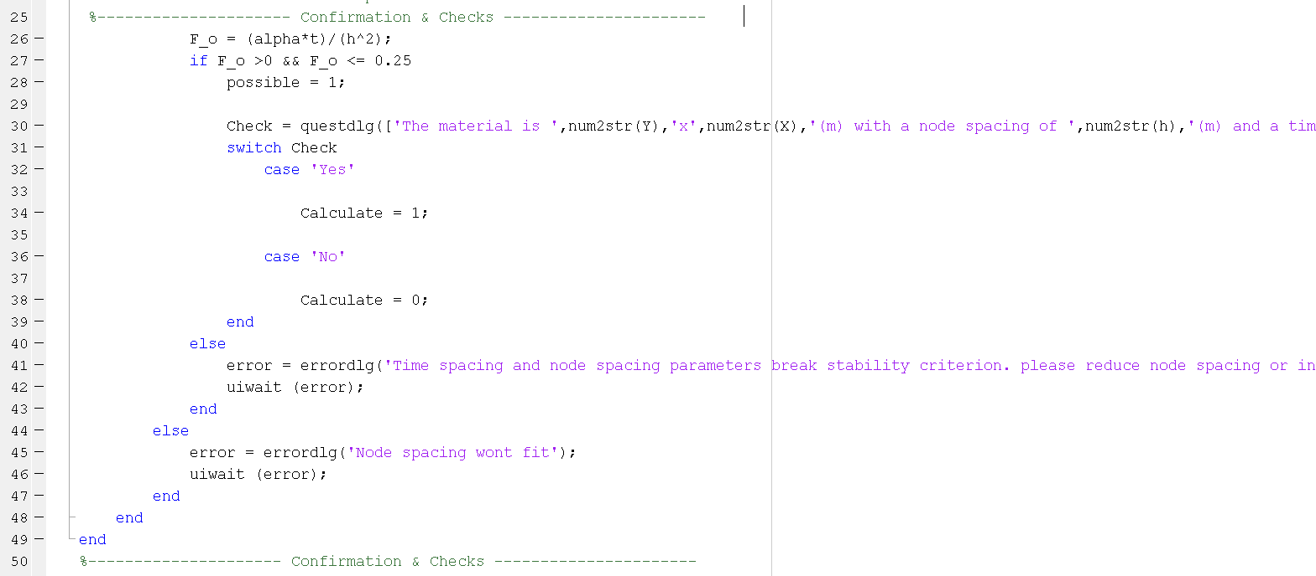
Figure 4.5 Confirmation & input checks
Figure 4.6 shows the error that the user receives. The script won’t continue until the user clicks the ok button. Where they will be taken back to figure 4.3. (line 12)
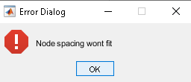
Figure 4.6 Node spacing error
The second check taken is after the time interval is input. Although the range is given to the user. The Fourier number is still calculated and the checked to see if it is equal or below 0.25 and equal or above 0. If the Fourier number is still outside of the range the user is presented with another error dialog shown in figure 4.7. (lines 40 – 43 figure 4.5)
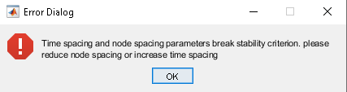
Figure 4.7 Time spacing error
Once ok is pressed the user is returned to figure 4.3. However, if the Fourier number is within the range then the user is presented with the following question dialog as the calculations are possible completing the criteria for the possible while loop (figure 4.2 line 9).
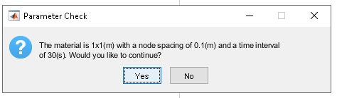
Figure 4.8 User check
This is the user’s chance to verify that the input parameters are correct. If yes is selected the scrip completes the calculate while loop (figure 4.2 line 10) conditions meaning the loop is broken and the calculations can be made. If no is pressed the user is returned to figure 4.3.
The initial and boundary conditions of the Plate are then calculated in figure 4.9.
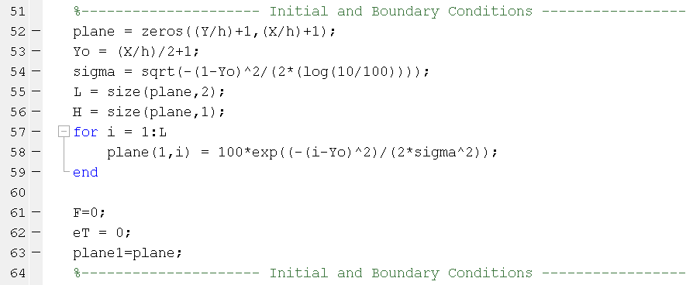
Figure 4.9 Initial and Boundary conditions
This process is started by creating a matrix full of 0’s with the dimensions X, Y broken into h spacings. For example, a 1x1m Plate with 0.1m spacings would have an 11,11 matrix. To set the boundary conditions on the north face the Gaussian distribution equation needed to be implemented.
$T\left(i\right)=A*exp\left[\frac{{-(i-Yo)}^{2}}{{2σ}^{2}}\right]$ (15)
Where:
T = Temperature
A = Amplitude (max temp)
I = Boundary node position
Yo = Midway position
$σ$ = Standard deviation (dictates the shape of the bell curve)
However, $σ$ is an unknown variable as the North East and North West corner of the Plate boundary conditions should = 10. In order to calculate sigma with these boundary conditions intact the Gaussian equations must be rearranged to make sigma the subject.
$σ=\sqrt{\frac{{-(i-Yo)}^{2}}{2ln\left(\frac{T}{A}\right)}}$ (16)
Where i is the first boundary node position (1) T is the temp required (10) A is the amplitude (100) and Yo is calculated using the following formula:
$\frac{\frac{X}{h}}{2}+1$(17)
With sigma assigned to a variable (figure 4.9 line 54) the Gaussian distribution equation can be used across the North face of the plate in order to distribute the correct temperatures across the boundary (figure 4.9 line 57 - 59).
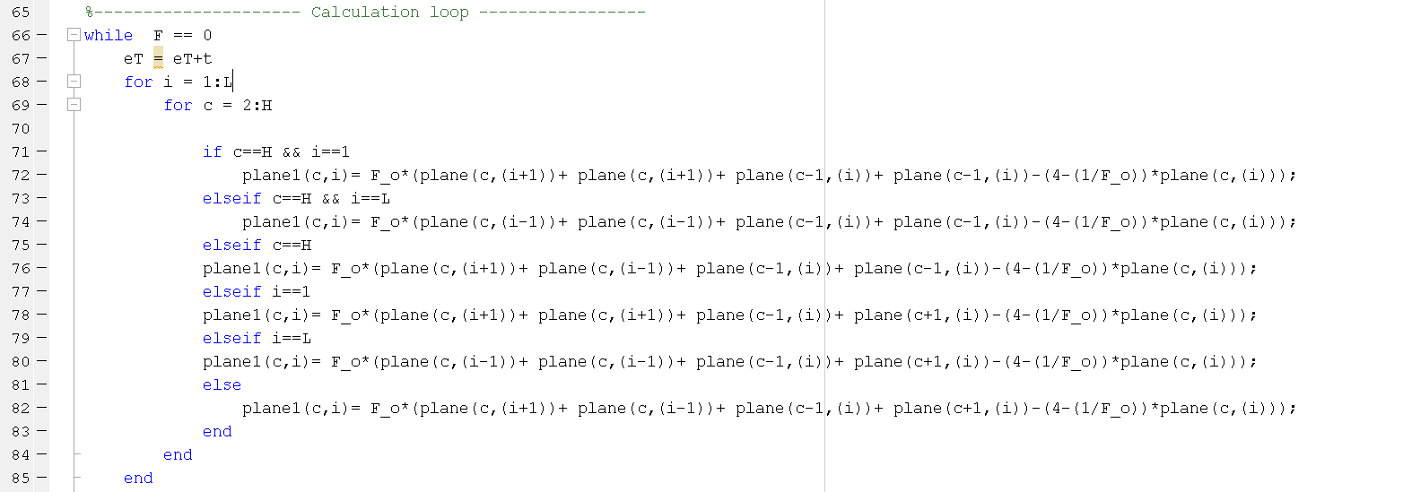
Figure 4.10 Calculation Loops
The next section of script calculates the temperature at each node excluding the north face boundary nodes as those values are fixed. For this task a column is selected and each row in the column’s temperature one-time interval into the future is calculated one by one. Once the column is completed the next column is looked at and so on until the last column is reached. This is achieved using a nested for loop where the primary loop is set to the column of the matrix (i) and the secondary loop is set to the row (c). For the temperature calculation on domain nodes the following equation is used:
${T_{p}}^{t+∆t}=F_{O}\left(T_{E}+T_{W}+T_{N}+T_{S}-\left(4-\frac{h^{2}}{α∆t}\right)T_{p}\right)$ (18)
However, 5 other variants of the equation are needed when looking at boundary nodes. This is due to 5 separate conditions where there will be no node to either the south, west or east. As the south, west and east boundaries are perfectly insulated $\frac{∂T}{∂x}=0$ $\frac{∂T}{∂y}=0$. Figure 4.11 shows the 5 separate conditions as well as the initial domain condition.
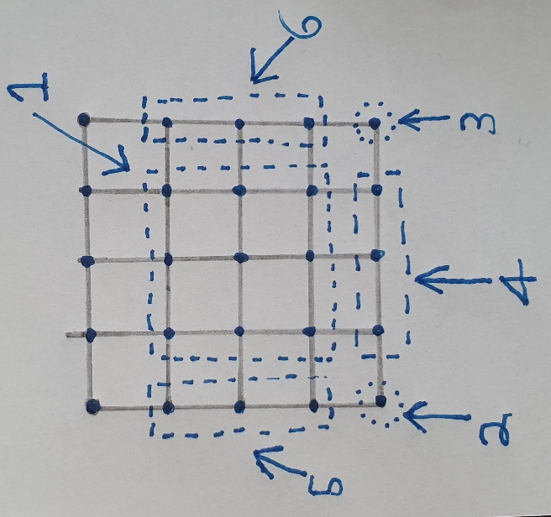
Figure 4.11 Node conditions
When considering the nodes that are not covered by area 1 the equations is changed to
2 (has no South or West node)
${T_{p}}^{t+∆t}=F_{O}\left(T_{E}+T_{E}+T_{N}+T_{N}-\left(4-\frac{h^{2}}{α∆t}\right)T_{p}\right)$ (19)
3 (has no South or East node)
${T_{p}}^{t+∆t}=F_{O}\left(T_{W}+T_{W}+T_{N}+T_{N}-\left(4-\frac{h^{2}}{α∆t}\right)T_{p}\right)$ (20)
4 (has no South node)
${T_{p}}^{t+∆t}=F_{O}\left(T_{E}+T_{W}+T_{N}+T_{N}-\left(4-\frac{h^{2}}{α∆t}\right)T_{p}\right)$ (21)
5 (has no West node)
${T_{p}}^{t+∆t}=F_{O}\left(T_{E}+T_{E}+T_{N}+T_{S}-\left(4-\frac{h^{2}}{α∆t}\right)T_{p}\right)$ (22)
6 (has no East node)
${T_{p}}^{t+∆t}=F_{O}\left(T_{W}+T_{W}+T_{N}+T_{S}-\left(4-\frac{h^{2}}{α∆t}\right)T_{p}\right)$ (23)
With all these equations input into an IF statement with 6 separate conditions as shown in figure 4.10 the temperature can be calculated in every required node. The IF statements work by locating where the node is (Zone 1-6) and then using the correct variation of the equation to calculate the T for that node.
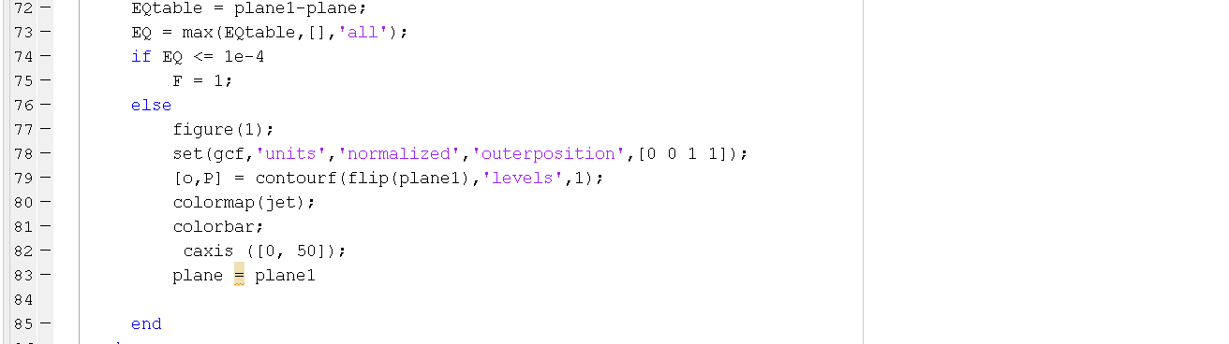
Figure 4.12 Equilibrium or Plot
Each time every node is calculated completing the plate for that time step the script will compare the current plate and the plate one-time step into the future. If the difference between plates is less than or equal to the convergence criterion (1e-4 in this case but can be changed to desired value) then the calculation loop is completed. However, if the condition is not met the matrix of plate1 (future) is plotted.
Finally, the total elapsed time is then converted from seconds into how many Years:Weeks:Days:Hours:Minutes:Seconds to help the user comprehend the time period taken. Figure 4.13 shows the process taken to convert to this format.
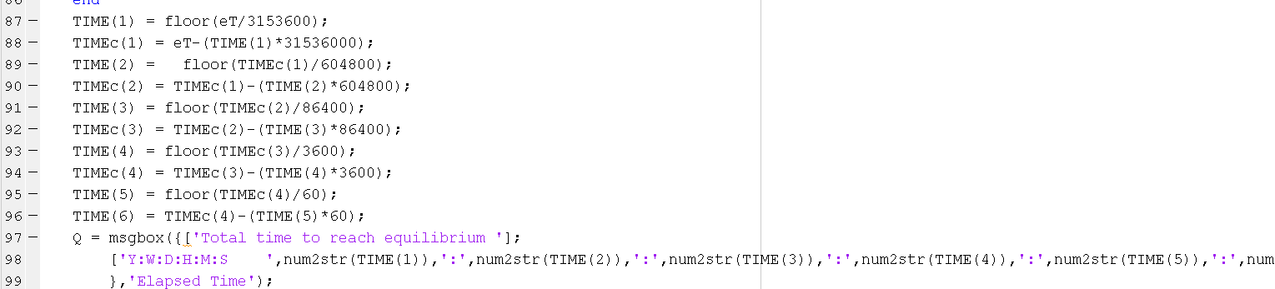
Figure 4.13 Elapsed time calculations
This section required the knowledge of how many seconds in the following time periods
- Year – 3153600 s
- Week – 604800 s
- Day – 86400 s
- Hour – 3600 s
- Minute – 60 s
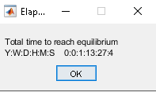
Figure 4.14 Example time output

Results
The results section will show how changing independent variables affect the time taken for the plate to reach equilibrium. In all situations the dependant variable will be the time taken to reach equilibrium. All experiments will be carried out on the linear boundary condition script with the plate size 8x4 (x,y). Figure 5.1 shows an example of the final temperature for 0.5m spacing with an enlarged colour bar indicating what temperature each colour represents. Results for all variations looked this way except when specifically mentioned below
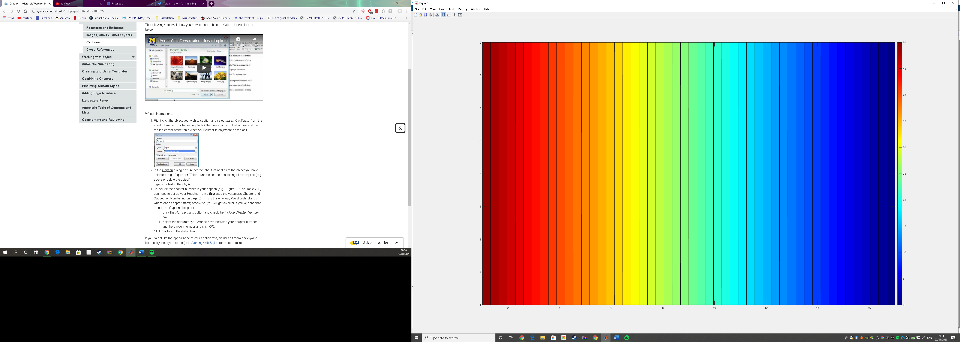
Figure 5.1 Final temperature display

Fixed time step, fixed convergence criterion, multiple grid spacing
The results in this section will be looking at variable grid spacings where the time step and convergence criterion will remain fixed. Several different grids spacings have been selected from 0.1m – 2m in order to effectively make judgement of how the variable effects the dependant variable. The specific grid spacings will be 0.1m, 0.2m, 0.4m, 0.5m, 0.8m, 1m and 2m. Time step is fixed to 38(s) as this is the highest allowed with 0.1m spacings. Finally, the convergence criterion will be set to 1e-4. This convergence criterion was selected as it was the highest number that created straight heat sections (as shown in figure 5.1) over visually curved ones identifying the plate was close enough to equilibrium without drastically modifying the run time.

Table 1 Varied Grid Spacing Results
Grid Spacing (m) | Elapsed Time (s) | Years | Weeks | Days | Hours | Minutes | Seconds
0.1 | 133950 | 0 | 0 | 1 | 13 | 12 | 30
0.2 | 134064 | 0 | 0 | 1 | 13 | 14 | 24
0.4 | 134520 | 0 | 0 | 1 | 13 | 22 | 0
0.5 | 134824 | 0 | 0 | 1 | 13 | 27 | 4
0.8 | 135242 | 0 | 0 | 1 | 13 | 34 | 2
1 | 137598 | 0 | 0 | 1 | 14 | 13 | 18
2 | 148390 | 0 | 0 | 1 | 17 | 13 | 10

Figure 5.2 Grid Spacing Results Graph
The tests showed that by increasing the grid spacing the total time required to reach equilibrium increased. When looking at figure 5.2 with the increase in grid spacing the time taken to reach equilibrium increases exponentially suggesting that the more the grid spacing is increased the greater the increase in elapsed time. The only outlier to the exponential growth is 0.8m spacings however, the time still increased. Table 2 further visualises the exponential growth as the % increase per step is shown to increase instead of a static increase each variation.
Table 2 Variable Grid Spacing Results Differences
From Previous |  |  | From Initial
Time increase | Time increase % | Variable Increase | Time increase | Time increase % | Variable Increase
0 | 0.00% | 0.00% | 0 | 0.00% | 0.00%
114 | 0.09% | 100.00% | 114 | 0.09% | 200.00%
456 | 0.34% | 100.00% | 570 | 0.43% | 400.00%
304 | 0.23% | 25.00% | 874 | 0.65% | 500.00%
418 | 0.31% | 60.00% | 1292 | 0.96% | 800.00%
2356 | 1.74% | 25.00% | 3648 | 2.72% | 1000.00%
10792 | 7.84% | 100.00% | 14440 | 10.78% | 2000.00%

This is likely due to larger node spacings having significantly less interactions dictating the temperature change. For example, 0.1m grid spacings have 11 interactions between 0m and 1m sections allowing for 11 different temperature readouts that have all been affected by the nodes around it. Whereas, with 1 m spacings there will only be a node at 0m and 1m making it a lot less accurate at predicting temperature as there is less detail on the progression of temperature change.

Fixed grid spacing, fixed convergence criterion, multiple time step
The results in this section will be looking at variable time intervals where the grid spacing, and convergence criterion will remain fixed. Several different time intervals have been selected from 50s – 900s. The specific time intervals will be 50s, 100s, 200s, 300s, 400s, 500s, 600s, 700s, 800s, 900s.The grid spacing will be fixed at 0.5m for all iterations as it allows for time intervals between 0 and 900. Finally, the convergence criterion will be set to 1e-4 to maintain correlation with section 5.1.
Table 3 Varied Time Interval Results
Time Interval (s) | Elapsed Time (s) | Years | Weeks | Days | Hours | Minutes | Seconds
50 | 140400 | 0 | 0 | 1 | 15 | 0 | 0
100 | 154400 | 0 | 0 | 1 | 18 | 53 | 20
200 | 168200 | 0 | 0 | 1 | 22 | 43 | 20
300 | 176100 | 0 | 0 | 2 | 0 | 55 | 0
400 | 181600 | 0 | 0 | 2 | 2 | 26 | 40
500 | 186000 | 0 | 0 | 2 | 3 | 40 | 0
600 | 189600 | 0 | 0 | 2 | 4 | 40 | 0
700 | 191800 | 0 | 0 | 2 | 5 | 16 | 40
800 | 194400 | 0 | 0 | 2 | 6 | 0 | 0
900 | 196200 | 0 | 0 | 2 | 6 | 30 | 0

Figure 5.3 Time Interval Results Graph
This test identified a trend in results more specifically an increased time interval caused an increased time taken to reach equilibrium. However, when plotting the results in table 3 into a graph (figure 5.3) it can be established that that although the elapsed time is increasing the magnitude of this increase is exponentially decaying with the increase in time interval suggesting that eventually the increase in time interval would have little effect on the elapsed time.
Table 4 shows that bar 800 seconds time interval (2200 increase) the extent of the exponential decay
Table 4 Variable Time Interval Results Differences
From Previous |  |  | From Initial
Time increase | Time increase % | Variable Increase | Time increase | Time increase % | Variable Increase
0 | 0.00% | 0.00% | 0 | 0.00% | 0.00%
14000 | 9.97% | 100.00% | 14000 | 9.97% | 200.00%
13800 | 8.94% | 100.00% | 27800 | 19.80% | 400.00%
7900 | 4.70% | 50.00% | 35700 | 25.43% | 600.00%
5500 | 3.12% | 33.33% | 41200 | 29.34% | 800.00%
4400 | 2.42% | 25.00% | 45600 | 32.48% | 1000.00%
3600 | 1.94% | 20.00% | 49200 | 35.04% | 1200.00%
2200 | 1.16% | 16.67% | 51400 | 36.61% | 1400.00%
2600 | 1.36% | 14.29% | 54000 | 38.46% | 1600.00%
1800 | 0.93% | 12.50% | 55800 | 39.74% | 1800.00%
The increased elapsed time is subject to the reduced accuracy within the code by increasing the time interval. As with section 5.1 by increasing the time step the interactions within the code are reduced leaving more room for error when calculating the temperature. With a lower time interval selected the plate is updated more meaning a node to the east that was for example 32ºC at 50 seconds ago might have updated to 32.5ºC meaning the effects of that temperature change will now impact the monitored node instead of that eastern node only being updated 900 seconds later and therefore missing so many interactions that could have influenced the temperature on the way as demonstrated in figure 5.4.
Figure 5.4 Example of Time interval increase
P
P
32ºC
P
900
33.5ºC
P
32.5ºC
P
33ºC
P
33.5ºC
Heat
32ºC

On the right P reacts with 32ºC for 900 seconds. Whereas on the left P reacts with the east node at 32ºC for 50 seconds and then reacts with the east node at a higher temp. meaning within 900 seconds only 50 were at 32^{oC} everything else was higher meaning more heat transfer in 900 seconds.
50

Fixed time step, fixed grid spacing, multiple convergence criterion
The results in this section will be investigating the effect of varying the convergence criterion. Both the grid spacing and time intervals will be fixed to 0.5m and 38s. Several different convergence criterions will be used ranging from 1e-1 to 1e-9 with a e-1 increase each iteration and finally 0.
Table 5 Varied Convergence Criterion Results
Convergence Criterion | Elapsed Time (s) | Years | Weeks | Days | Hours | Minutes | Seconds
1.00E-01 | 5928 | 0 | 0 | 0 | 1 | 38 | 48
1.00E-02 | 42332 | 0 | 0 | 0 | 11 | 45 | 32
1.00E-03 | 87932 | 0 | 0 | 1 | 0 | 25 | 32
1.00E-04 | 134824 | 0 | 0 | 1 | 13 | 27 | 4
1.00E-05 | 181792 | 0 | 0 | 2 | 2 | 29 | 52
1.00E-06 | 228760 | 0 | 0 | 2 | 15 | 32 | 40
1.00E-07 | 275690 | 0 | 0 | 3 | 4 | 34 | 50
1.00E-08 | 322658 | 0 | 0 | 3 | 17 | 37 | 38
1.00E-09 | 366282 | 0 | 0 | 4 | 5 | 44 | 42
0.00E+00 | 630496 | 0 | 1 | 0 | 7 | 8 | 16

Figure 5.5 Convergence Criterion Results Graph
When looking at figure 5.5 it can be assumed that lowering the convergence criterion has an exponential increase on the elapsed time. This is due to each increase requiring a 10x smaller number in order to class the plate as being in equilibrium. However, Table 6 shows that the exponential growth actually converts to an exponential decay from 1e-4 onwards (46892 time increase). However, although the % time increase is decaying the time increase is staying relatively similar suggesting that further reduction in the convergence criterion would add a similar amount of time.
Table 6 Variable Convergence Criterion Results Differences
From Previous |  |  | From Initial
Time increase | Time increase % | Variable Increase | Time increase | Time increase % | Variable Increase
5928 | 0.00% | 0.00% | 0 | 0.00% | 0.00%
36404 | 614.10% | -90.00% | 36404 | 614.10% | 10.00%
45600 | 107.72% | -90.00% | 82004 | 1383.33% | 1.00%
46892 | 53.33% | -90.00% | 128896 | 2174.36% | 0.10%
46968 | 34.84% | -90.00% | 175864 | 2966.67% | 0.01%
46968 | 25.84% | -90.00% | 222832 | 3758.97% | 0.001%
46930 | 20.51% | -90.00% | 269762 | 4550.64% | 0.0001%
46968 | 17.04% | -90.00% | 316730 | 5342.95% | 0.00001%
43624 | 13.52% | -90.00% | 360354 | 6078.85% | 0.000001%
264214 | 72.13% | -100.00% | 624568 | 10535.90% | 0.000000%

The increase in elapsed time is to be expected in this test as reducing the convergence criterion requires the plate to be closer and closer to actual equilibrium each reduction. However, as the temperature change is so low towards the end of the test these extra fractions of a degree can take a very long time to complete. This is demonstrated by the plate reaching as close to real equilibrium without unnecessary added time with a convergence criterion of 1e-4 in 1 day 13 hours 27 minutes and 4 seconds compared to the 7 days 7 hours 8 minutes and 16 seconds required to reach complete equilibrium.

Figure 5.6 shows the results of increasing the convergence criterion. Unlike the results for section 5.1 and 5.2 the temperature of the plate isn’t separated into straight sections with a linear decrease in temperature. This suggests that the convergence criterion is too high as the plate isn’t close to equilibrium. figures 5.7 - 5.8 also show this. However, figure 5.9 mirrors figure 5.1 meaning that all convergence criterion below this number will also show a linear decrease in temperature.
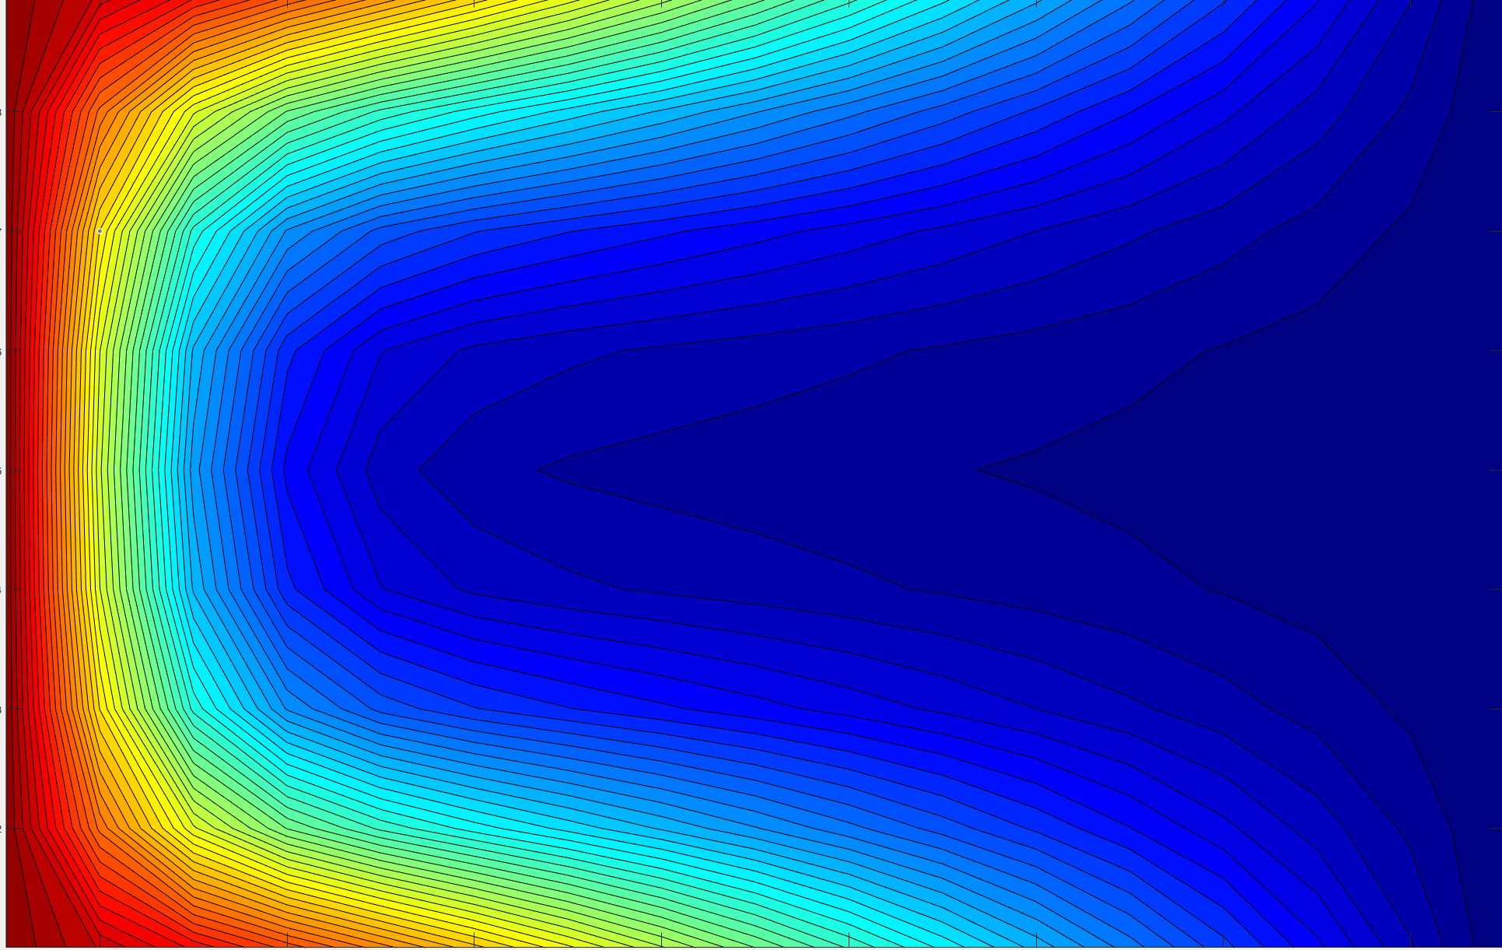
Figure 5.6 Temperature results for 1e-1
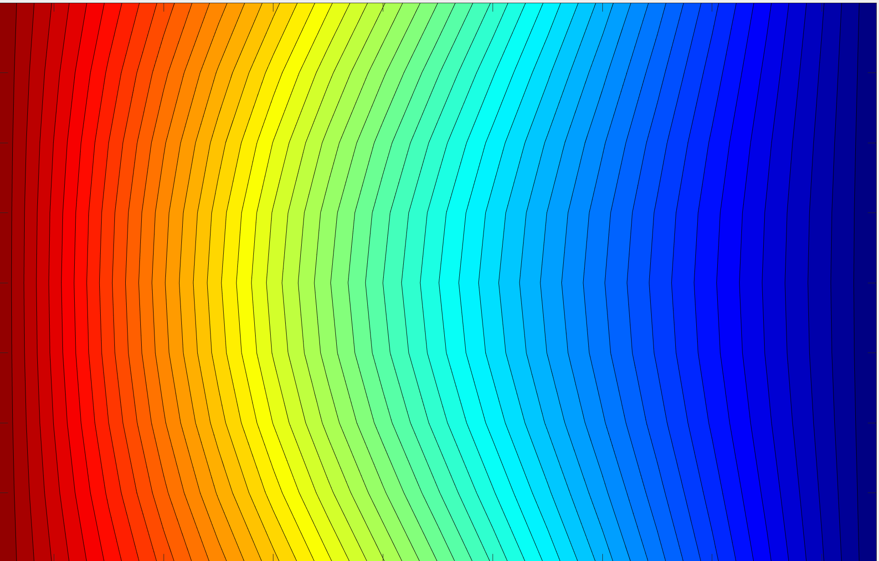
Figure 5.7 Temperature results for 1e-2
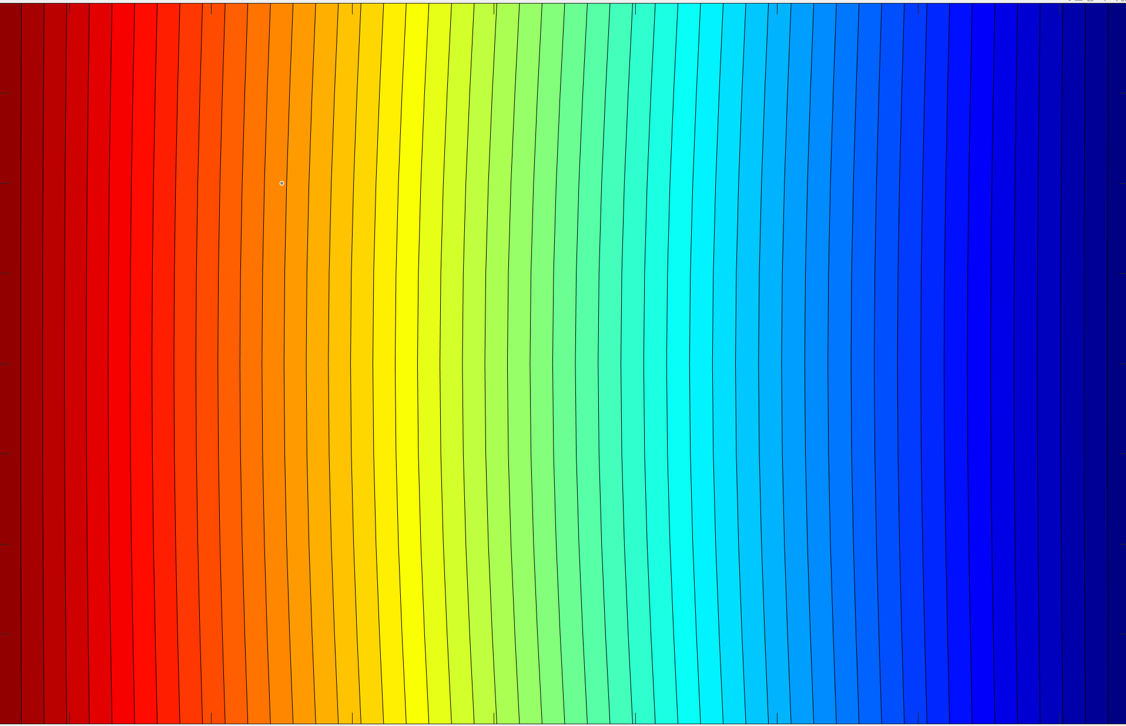
Figure 5.8 Temperature results for 1e-3
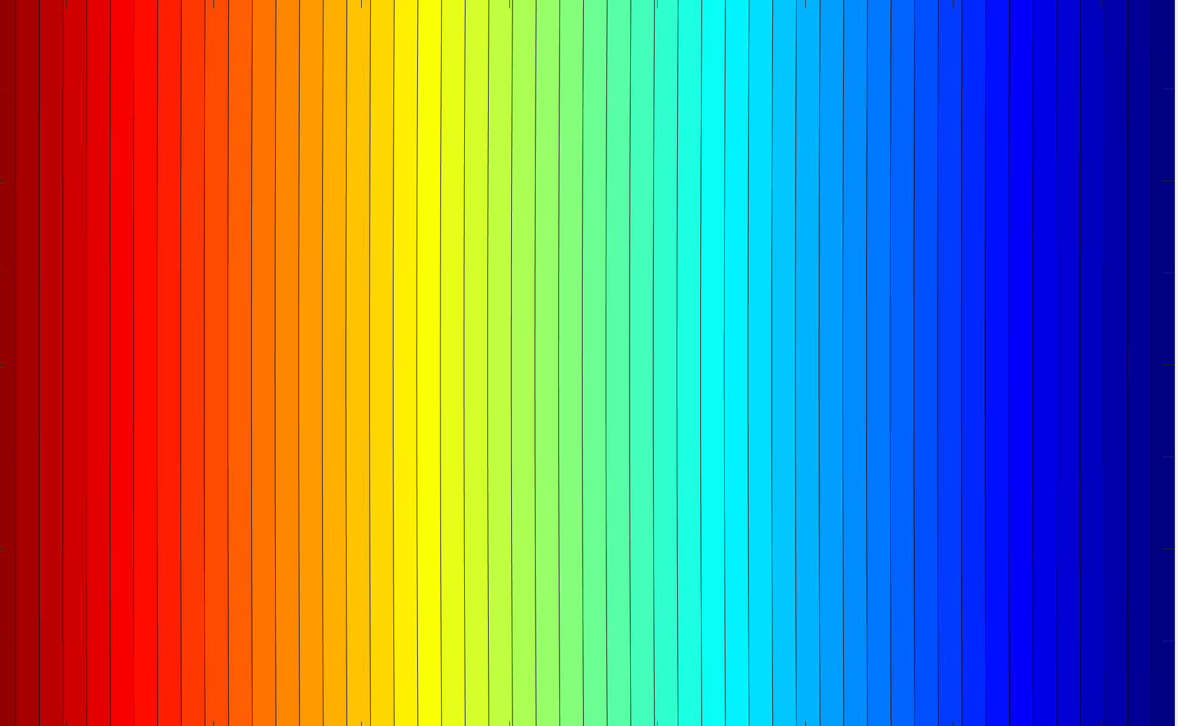
Figure 5.9 Temperature results for 1e-4

Discussion

Limitations of the model
From the obtained results the finite difference model can be seen to have multiple limitations. The first being the convergence criterion which selects where the programme stops calculating the temperature of the plate. As mentioned above having a drastically low convergence criterion can severely impact the run time of the script for very little change in the plate’s actual conditions. Meaning a trade-off is required between accuracy of reaching actual equilibrium and reaching to within a fraction of a degree with a much lower run time. The second limitation being the variation in results, as the results above show the values input into the script have a big effect on the result for an identical plate. Making it important to select low numbers in both time step and node spacing to produce an accurate time scale. However, by reducing these values the run time is considerably increased. Finally, the model is limited to static or insulated boundaries as the model has no way to measure nodes outside of the boundary such as a plate suspended in air.

Potential Improvements
As a limitation to forward differences having a larger h (node spacing) is reduced accuracy a potential improvement to the programme would be to limit the node spacing therefore forcing higher accuracy results.
Currently when considering $\frac{∂T}{∂t}$, $f^{1}(x_{o})≈\frac{f\left(x_{0}+h\right)-f(x_{o})}{h}$ is used however, this leaves room for error as the actual sum is infinite meaning if a larger integral was used then more of the sum is being used and therefore results would be more accurate.
Alternatively, if the central difference approximation could be used to determine $\frac{∂T}{∂t}$ the error would again be reduced.

Conclusion
To conclude using the explicit finite difference method and Taylor series the thermal diffusion equation was modelled in MATLAB to identify the time taken for a plate undergoing thermal diffusion would take to reach equilibrium with the addition of a display showing how the temperature moves throughout the plate. From the results it was gathered that increasing the time interval and grid spacing increased the total elapsed time of the script. Additionally, by reducing the convergence criterion and therefore bringing the elapsed time closer to actual equilibrium by massively increasing the run time. With this information in mind it is clear aims 1 and 2 were achieved even with limitations as outlined in section 6. Finally, potential improvements were suggested by limiting node spacings to low values therefore increasing the accuracy of the results as well as increasing the size of the integrals when substituting.

References
Dehghan, M., 1999. Fully implicit finite differences methods for two-dimensional. Computational and Applied Mathematics, Volume 106, pp. 255-269.
Fabugba, S. E., Edogbanya, O. H. & Zelibe, S. C., 2013. Crank Nicolson Method for Solving Parabolic Partial Differential Equations. Applied Mathematics and Modeling IJA2M, 1(3), pp. 8-23.
Marotin, A., 2019. Taylor Series / Numerical Differentiation & Heat Transfer Calculations using Finite Difference Equations. Swansea: University Of Wales Trinity Saint David.

