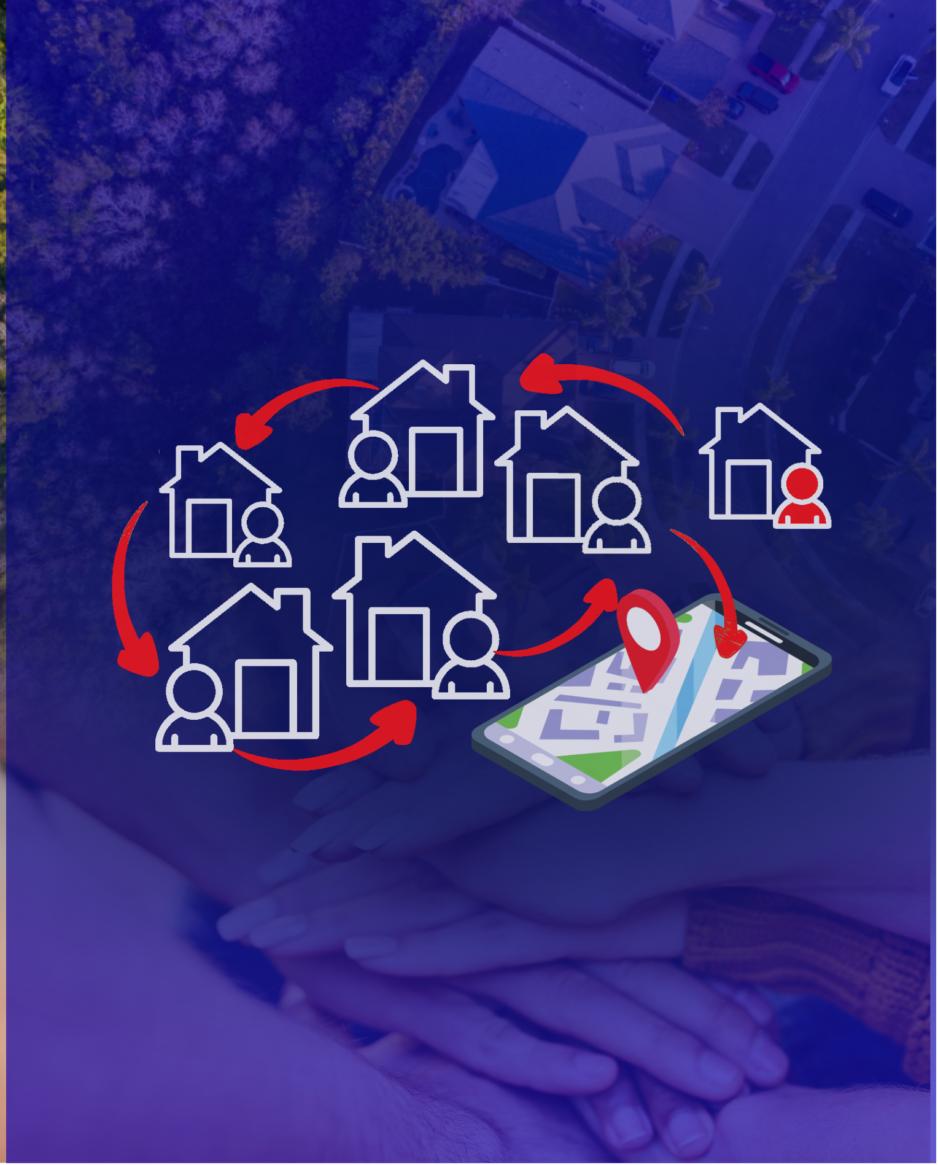  Independent Project  Neighbour Alert  A Community-Based Web and Mobile App  for Real-Time Local Emergency Reporting |   Module: Independent Project  Module code: ACCA6020  Lecturer: Dr Sana Jokhio  Student name: Nadejda Toma  Student ID number: 2232920  Submission deadline: 28th November 2025

Contents

ABSTRACT 3
ACKNOWLEDGEMENT 4
INTRODUCTION 5
1.1 Aims 5
1.2 Objectives 5
1.3 Motivation 5
2. LITERATURE REVIEW 6
2.1 Research on the Problem Domain 6
2.2 Evaluating Existing Examples 7
2.3 Analysis of Tools Required 8
2.4 Software Development Life Cycle (SDLC) 10
3. ANALYSIS 11
3.1 Requirement Analysis 11
3.2 UML – Use Case Analysis 12
3.3 System Requirements 13
3.4 Risk Analysis 14
4. DESIGN 15
4.1 Interface & Visual Design 15
4.1.1 Moodboard & Colour Palette 15
4.1.2 Low-Fidelity Wireframes 15
4.1.4 High-Fidelity Interface (Frontend Prototype) 16
4.2 Storyboard 18
5. IMPLEMENTATION 21
5.1 Frontend Web Module (HTML, CSS, JavaScript) 21
5.1.1 Navigation Structure & Home Page 21
5.2 Code snippets 25
TESTING 27
EVALUATION 29
7.1 Personal Evaluation 29
7.2 System Evaluation 29
FURTHER ENHANCEMENT 31
CONCLUSION 32
REFLECTION 33
REFERENCES 34
APPENDICES 36
Apendix A 36
42
42
Appendix B 48

ABSTRACT

This project presents NeighbourAlert, a simple and community-focused tool designed to help neighbours share local emergency information quickly and clearly. The prototype was created with accessibility and emotional ease in mind, aiming to reduce confusion and hesitation during small but worrying situations. Through a lightweight web interface and a mobile component, the system offers an intuitive reporting flow, calm visual design, and essential features that support neighbourhood awareness.
The development process combined usability principles, technical exploration, and real feedback from informal testing. Each stage highlighted the importance of creating interfaces that feel supportive rather than overwhelming, especially when users may already feel unsure. Although still a prototype, NeighbourAlert demonstrates that even small digital tools can strengthen communication, build trust, and contribute to a safer everyday environment.

ACKNOWLEDGEMENT

I would like to express my sincere gratitude to everyone who supported me throughout this project. My deepest thanks go to my lecturer, Dr. Sana Jokhio, for guidance, patience, and encouragement during each stage of development. Her feedback helped me stay focused and pushed me to think more clearly about both the technical and human sides of this work.
I am also truly grateful to my friends and neighbours who took the time to test the prototype, share their opinions, and help me understand how people feel when interacting with an emergency-related system. Their honesty and reactions shaped many of the decisions that made NeighbourAlert calmer, clearer, and more intuitive.
Finally, I want to thank my family for their constant support, understanding, and belief in me. Their presence gave me the strength to continue even when the project felt challenging. This work would not have been possible without the people who stood beside me, and I am genuinely thankful for each of them.

INTRODUCTION

1.1 Aims
This project aims to create Neighbour Alert, a simple and accessible web and mobile tool that helps neighbours report local emergencies quickly and clearly. The goal is not to replace official services, but to give people a fast way to warn each other when something worrying happens nearby, for example, smoke, a strange smell, or suspicious activity. By building a clean and easy-to-use prototype, the project aims to show how everyday residents can support each other and improve awareness in their own streets and communities.

1.2 Objectives
- To achieve this aim, the project focuses on the following objectives:
- Explore existing community and emergency platforms to understand what works well and where communication gaps still exist.
- Design simple and intuitive interfaces that allow users to report an incident in just a few steps.
- Develop a working prototype using HTML, CSS, JavaScript, Python Flask, SQLite, Leaflet, and Adalo.
- Create a clear incident-reporting process, including type, severity, location, and timestamp.
- Test the system with real users to understand how they experience the reporting flow and how easy the interface feels.
- Evaluate the results and outline practical improvements for future versions.

1.3 Motivation
Small emergencies at the neighbourhood level happen more often than people realise a strange smell of gas, smoke coming from a backyard, a loud noise, or someone acting suspiciously. These moments are usually not big enough for national alert systems, but they matter a lot to the people living nearby. Many residents want to warn their neighbours, but they usually don’t have a fast or structured way to do it. Research shows that when communities share information early, their reactions become quicker and more coordinated, which can prevent harm and reduce confusion [1].
At the same time, today’s neighbourhood communication tools like Facebook groups or messaging apps are not designed for urgent situations. Messages get lost, information is unverified, and important alerts can easily be buried under unrelated posts [2]. Studies highlight that local emergencies need dedicated channels that are simple, focused, and easy for anyone to use, especially under pressure [3].
This project is motivated by that exact gap. Neighbour Alert aims to give ordinary neighbours a reliable and friendly way to help each other, improving awareness and safety without adding complexity. It supports the idea that strong communities are built not only through official systems, but through people looking out for one another.

2. LITERATURE REVIEW

2.1 Research on the Problem Domain
Local emergencies are rarely dramatic or large-scale, yet they matter deeply to the people who live nearby. Many studies highlight that the first few minutes after noticing smoke, a strange smell, or suspicious activity are crucial, because neighbours often know the context better than official responders and can react much faster. What becomes clear from the literature is that small-scale emergencies depend heavily on community awareness. People want to look out for each other, but usually lack a simple, structured way to do so. This gap appears consistently across research exploring emergency communication at the neighbourhood level.
Budi et al. show that people are willing to use location-based emergency applications when they feel they increase personal safety, are easy to use, and help reduce uncertainty [4]. Fear of crime, trust, and social norms all influence whether a community tool becomes part of people’s routine behaviour. This is important because an app like Neighbour Alert does not compete with 999 services, but with hesitation, confusion, and time lost searching for the right communication channel.
Further studies emphasise that emergencies follow an interesting pattern: they often start small, seem ambiguous, and escalate fast if neighbours stay uninformed [5]. Early sharing of information improves clarity and encourages coordinated action, even when official services are not immediately involved. Community-based reporting, therefore, becomes an important “first step” in creating situational awareness, and several researchers identify this as an underdeveloped area in local digital ecosystems [6].
Another aspect highlighted in the literature is that communication frameworks should reflect how people naturally act during stressful moments. Individuals do not want long menus, complex navigation, or large text blocks when they feel something is wrong[5]. Instead, they look for a fast, instinctive action, tap, report, and done. The more an app respects these natural behaviours, the more likely it is to be used in real situations. This supports the choice of a minimal, focused design for Neighbour Alert, keeping cognitive load low and encouraging rapid reporting.
Taken together, the research clearly signals the same issue: everyday emergencies fall between the cracks of existing systems. They are too small for national alerts, too fast for slow communication channels, and too important to ignore. This is the exact space where a lightweight, neighbour-to-neighbour tool can make a real difference.

2.2 Evaluating Existing Examples

To understand the current landscape, it is useful to examine existing platforms that claim to support local safety and community awareness. These include large-scale community networks like Nextdoor, crowd-powered incident apps like Citizen, and informal social media groups used by neighbours. Each of these contributes something valuable, yet each has notable limitations that reinforce the need for a smaller, more focused solution.
Nextdoor is praised in the literature for improving neighbourhood connectedness and giving residents a space to discuss local issues. However, research also shows that engagement within such platforms varies widely, especially in diverse urban settings where not everyone feels equally represented or comfortable participating [7]. While it works well for general community updates, it is not optimised for urgent, time-sensitive alerts.
Citizen, on the other hand, offers more structured incident reporting and uses real-time data, but tends to overwhelm users with notifications that are often not relevant to their immediate surroundings. Carreras-Coch et al. note that emergency communication technologies must avoid “alert fatigue,” because irrelevant or excessive notifications reduce trust and responsiveness [5]. A neighbourhood tool must therefore strike a delicate balance: enough alerts to be useful, but not so many that users ignore them.
Informal tools, like WhatsApp and Facebook groups, are flexible and widely adopted. But they were not designed for emergencies. Posts mix with jokes, event announcements, and off-topic messages, meaning that important alerts can easily get buried. Phengsuwan et al. show that social media generates huge amounts of information during crises, yet lacks the structure and verification mechanisms needed for reliable emergency reporting [8]. This makes informal groups helpful for discussion, but risky as a primary alert channel.

A more direct comparison helps summarise these issues:

Platform | Strengths | Limitations
Nextdoor | Builds local communities; good visibility | Slow for emergencies; mixed engagement; cluttered context
Citizen | Real-time alerts; public safety focus | Too many non-local alerts; creates alert fatigue
Social media groups | Familiar, easy to join | Unstructured; chaotic feeds; unreliable in urgent situations
Neighbour Alert (proposed) | Local-only, fast, simple | Prototype stage; limited scale
Table 1. Comparison of Existing Neighbourhood Communication Tools.

This comparison not only validates the idea of Neighbour Alert but also guides its design philosophy clarity over complexity, locality over scale, and speed over abundance.

2.3 Analysis of Tools Required
The technical stack for Neighbour Alert was not chosen randomly; it directly addresses the needs identified in both the literature and platform evaluation. For a tool intended to be fast, lightweight, and accessible, technologies must be simple, well-documented, and efficient (Figure 1).
HTML, CSS, and JavaScript are natural choices for a clean, responsive interface. They require little overhead and ensure compatibility with any modern browser. Studies on civic prototyping and digital communing emphasise the value of open, adaptable tools that support experimentation and early usability testing [8]. Flask, a lightweight Python framework, aligns perfectly with this approach. It simplifies routing, reduces boilerplate, and allows students to build functional prototypes quickly without compromising clarity [9].
SQLite is an appropriate database for early-stage development because it performs well with small datasets, does not require complex configuration, and keeps all information in a single portable file. For a community-level alert application, which stores short text reports rather than extensive multimedia or analytics, SQLite’s simplicity becomes a genuine advantage.
Leaflet.js supports fast and intuitive map rendering. Compared to larger mapping frameworks, it loads quickly, works well on low-end devices, and offers smooth marker placement, an important detail when representing local emergencies. Incident visualisation is considered essential in modern emergency systems, and research consistently recommends a clear spatial context for decision-making [10].
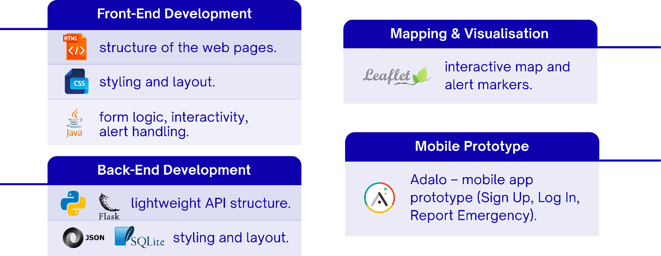

Figure 1. Tools used for the platform and app

The mobile component built using Adalo reflects another direction found in the literature: emerging no-code tools can dramatically accelerate the prototyping of civic applications, enabling teams to test ideas before committing to full development [11]. Adalo ensures that users with a mobile-first preference can engage with the alerting process without the need for building native apps from scratch, which would have exceeded the project’s timeframe.
Together, these tools create a balanced environment: simple enough for rapid progress, strong enough to demonstrate real functionality, and flexible enough to be extended in future work. The literature supports this type of toolchain for early-stage civic innovation, where usability and validation matter more than technical complexity [12].

2.4 Software Development Life Cycle (SDLC)
The SDLC chosen for this project follows an iterative, user-centred structure. This aligns strongly with design and emergency communication research, which highlights the importance of learning from users continuously rather than waiting until the end [13].
The process began with an exploration of user needs and an evaluation of existing systems. This allowed early identification of pain points, slow reporting, cluttered feeds, and lack of relevance and ensured that the design tackled real issues, not hypothetical ones. Iteration is considered essential in digital democratic systems and community platforms, where user behaviour is diverse and context-dependent [7].
During the design phase, mock-ups, sketches, and simple prototypes were created with tools such as Canva, Inkscape, and Photopea (Figure 2). This visual exploration played a major role in clarifying navigation paths and keeping the interface calm and intuitive, a quality frequently recommended in emergency UX research [14].
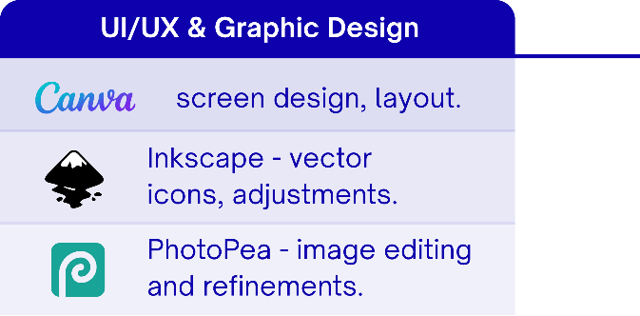

Figure 2. Tools used for UI.

The implementation phase then translated these design ideas into a functioning web and mobile prototype. Because the technologies were lightweight, several design decisions could be tested and refined quickly. For instance, the placement of severity selectors or the structure of the report form evolved naturally after seeing how early testers interacted with the interface.
Finally, the testing stage provided an opportunity to validate the system’s clarity and speed. Even a small user group can reveal practical issues, which is why early, small-scale testing is widely encouraged in usability literature [15]. The iterative cycle design, test, and refine helped ensure that the prototype remained consistent with both user expectations and academic recommendations.
The SDLC used here becomes not just a technical workflow, but a learning process. It supports decisions grounded in evidence, facilitates clean design, and maintains a strong connection between user needs and system behaviour. This is precisely the combination that literature suggests for creating meaningful civic technology.

3. ANALYSIS

3.1 Requirement Analysis
The requirements for Neighbour Alert were met by a very simple idea: during a stressful moment, people need clarity, not complexity. Research on emergency interaction shows that when individuals feel uncertainty or pressure, their ability to process information drops sharply, and they naturally look for the quickest possible action path [16]. This means that a neighbourhood alert system must remove friction and guide the user straight to the main action, reporting what they see.
In early discussions with potential users, it became clear that people are not only searching for a way to send alerts, but for a sense of reassurance. Several studies explain that perceived usefulness in risk situations is strongly linked to how much an application reduces anxiety and offers a feeling of control [17]. This shaped the core requirements: the system should help residents act quickly, understand what is happening around them, and feel that their actions matter.
The functional requirements were therefore based on real community behaviour. Users need to report an incident instantly, select a severity level, add a short description, and place a location on a map. Others should see the update immediately. These expectations match as real-time actionable usability: not just showing information but allowing people to react to it without delays or confusion.
Non-functional requirements were equally important. A system designed for moments of stress must feel light, calm, and responsive. Interface consistency, fast loading times, simple colours, and predictable layout all contribute to emotional comfort, something that emergency UX literature highlights again [18]. Throughout development, it became obvious that whenever a screen felt crowded or slow, the entire experience became less trustworthy. This personal reflection confirmed what the literature suggests: good usability in critical scenarios is a mix of technical performance and emotional clarity.
Together, these requirements build a system that tries to protect the user from feeling overwhelmed, while still giving them enough structure to act confidently.

3.2 UML – Use Case Analysis
The Use Case Diagram created for Neighbour Alert helped organise the relationship between the user and the system. The diagram is simple: report an incident, view alerts, filter them, and mark them as resolved (See Figure 3). It plays an important role. It shows how every action starts and ends with the user, and how each step supports the next in a natural sequence.
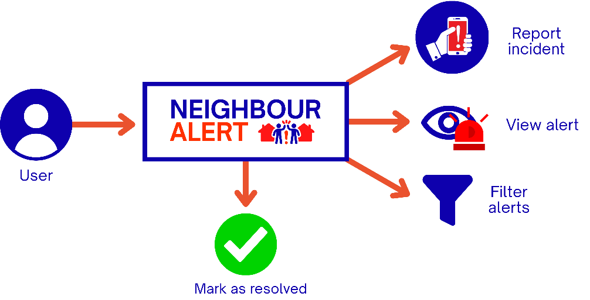

Figure 3. UML Use Case Diagram for Neighbour Alert

During development, a personal observation stood out. The initial flow included an extra confirmation screen before sending a report. When this was tested informally, users hesitated and slowed down. Removing that screen made the interaction smoother and more natural.
The final Use Case represents not just technical logic, but a deeper understanding of how people behave when something feels urgent. A visual Use Case Diagram would be excellent to include in this section, as it helps explain the system’s simplicity and shows the academic design process behind it.

3.3 System Requirements

Hardware Requirements
The hardware required to develop and run Neighbour Alert is modest: any standard laptop with a modern browser, a text editor, and the ability to run Python is sufficient. From a usability perspective, this is ideal. Low hardware requirements make the project accessible to more people, and they reflect a key theme in civic technology research: lightweight systems are more inclusive and more adaptable for community environments.
Testing the prototype on older devices confirmed that performance stayed stable. This is important because not all residents, especially in diverse urban areas, own high-end smartphones. Keeping the system technically simple becomes an ethical choice as well, supporting equitable access.

Software Requirements
Neighbour Alert is built with a practical combination of technologies:
HTML, CSS, and JavaScript for the interface; Flask for the backend; SQLite for lightweight data storage; Leaflet for visualising incidents on a map; and Adalo for the mobile component.
The choice of tools is strongly supported by the literature on rapid prototyping. Researchers emphasise that early-stage systems should prioritise adaptability and quick iteration, rather than heavy frameworks that limit flexibility [19]. Flask’s minimal structure allowed fast adjustments during testing, and SQLite avoided unnecessary database management overhead.
Design tools such as Canva, Photopea, and Inkscape also played a meaningful role. They supported experimentation with wireframes and quick visual ideas, which literature suggests is essential for uncovering usability issues early and preventing conceptual errors later.
Taken together, the system requirements support a development process that is fast, flexible, and deeply user-focused.

3.4 Risk Analysis
Risk analysis is an important part of any project, especially one involving emergency reporting. Risks do not come only from the technical side; they also come from human behaviour, perception, and social dynamics. Civic technology research repeatedly warns that community safety tools succeed or fail based on trust, adoption, and clarity of information [19].
To understand these risks and how they might affect the project, they were reviewed through three lenses: probability, impact, and mitigation. This structured approach makes it easier to see where the system is vulnerable and what actions might reduce those vulnerabilities (see Table 2).
The risk analysis reinforces a central message: Neighbour Alert is not just a technical prototype; it is a social tool. Its success depends on clarity, accuracy, and how comfortably people can integrate it into their daily lives.

Risk | Probability | Impact | Mitigation
False or misleading reports | Medium | High - loss of trust in the tool | Severity filtering, “mark as resolved”, clear incident categories
Low user adoption | Medium | Medium - reduced relevance | Keep UI extremely simple, provide onboarding hints, and test early with users
Technical failure | Rare | High - data loss or downtime | Frequent backups, simple architecture, local + cloud saving
Map rendering issues | Rare | Medium - affects the clarity of alerts | Marker optimisation, map caching, and reduced visual clutter
Privacy concerns | Medium | High-user hesitation | Collect minimal data, avoid exact home coordinates, and transparent disclaimer
Table 2. Overview of Key Risks and Mitigation Strategies

4. DESIGN

4.1 Interface & Visual Design
Neighbour Alert follows a clean, accessible, and intuitive visual design that prioritises clarity during community safety situations [20]. Because the system aims to support rapid decision-making, the interface uses high-contrast visuals, clear typography, and a minimalist layout. All screens were developed as a fully functional frontend prototype using HTML, CSS, and JavaScript, allowing realistic user flows even before backend integration [21].

4.1.1 Moodboard & Colour Palette
This moodboard establishes the visual tone of the system, including colours, typography, and iconography used across the interface (Figure 4Figure 4. Visual Moodboard for Neighbour Alert.).
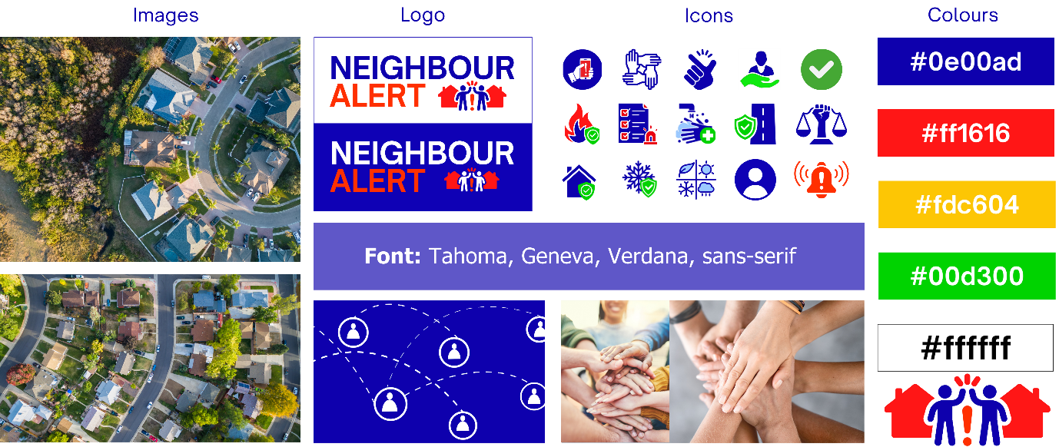
Figure 4. Visual Moodboard for Neighbour Alert.

4.1.2 Low-Fidelity Wireframes
Low-fidelity wireframes were created to outline the basic structure and layout of the app without focusing on visual design (See Figure 5 and Figure 6). These wireframes allowed quick exploration of user flows, navigation, and key interaction points. They served as the foundation for validating functionality before moving to higher-fidelity designs [22].

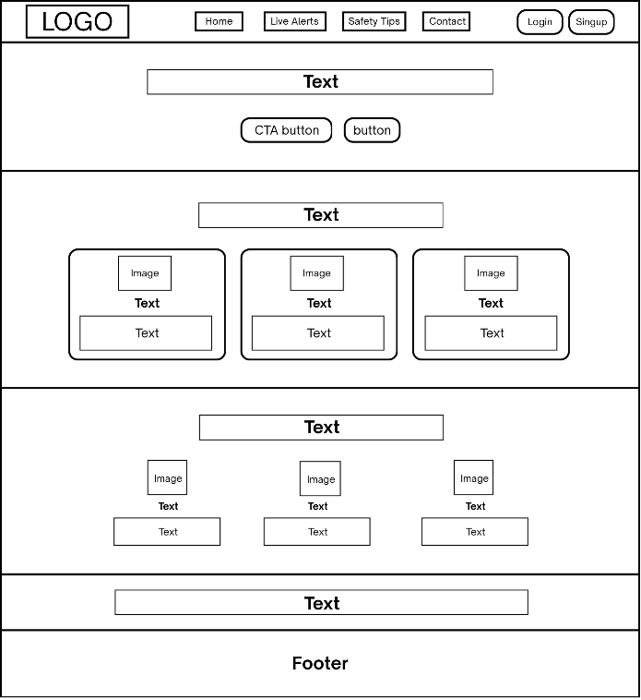
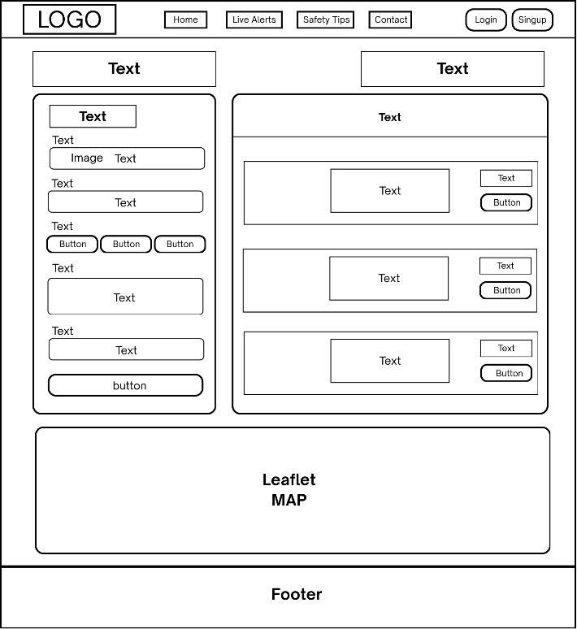

Figure 5. Low-Fidelity Wireframe: Home page.
Figure 6. Low-Fidelity Wireframe: Live Alerts page.

4.1.4 High-Fidelity Interface (Frontend Prototype)
The login interface provides a simple authentication entry point, using clear fields and a centred layout for accessibility (Figure 7).
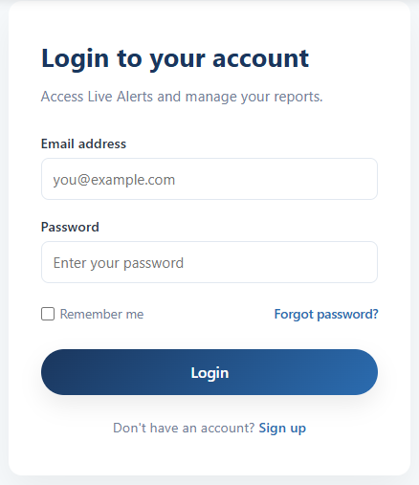

Figure 7. High-Fidelity UI: Login Screen
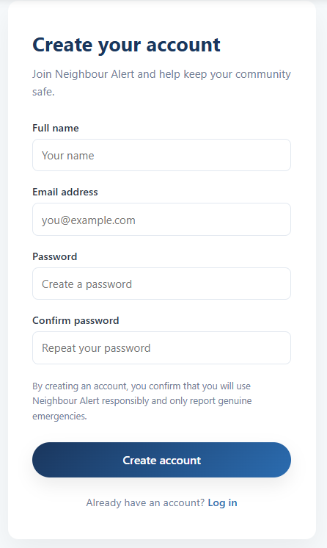
The signup form includes email validation, password confirmation, and clean form grouping for usability (Figure 8).

Figure 8. High-Fidelity UI: Signup Form
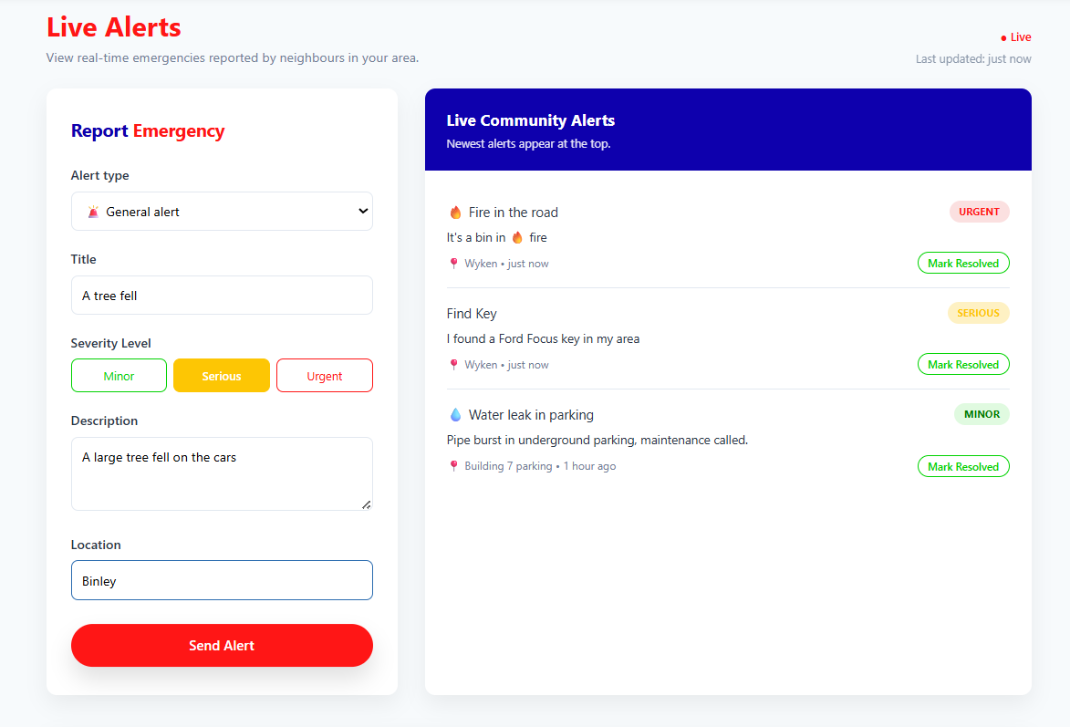
This screen allows users to submit detailed incidents, including type, severity, description, and location (Figure 9). The layout supports fast reporting during emergencies.

Figure 9. High-Fidelity UI: Report Incident Form
The prototype integrates Leaflet to display incident locations using a fully interactive map (Figure 10).
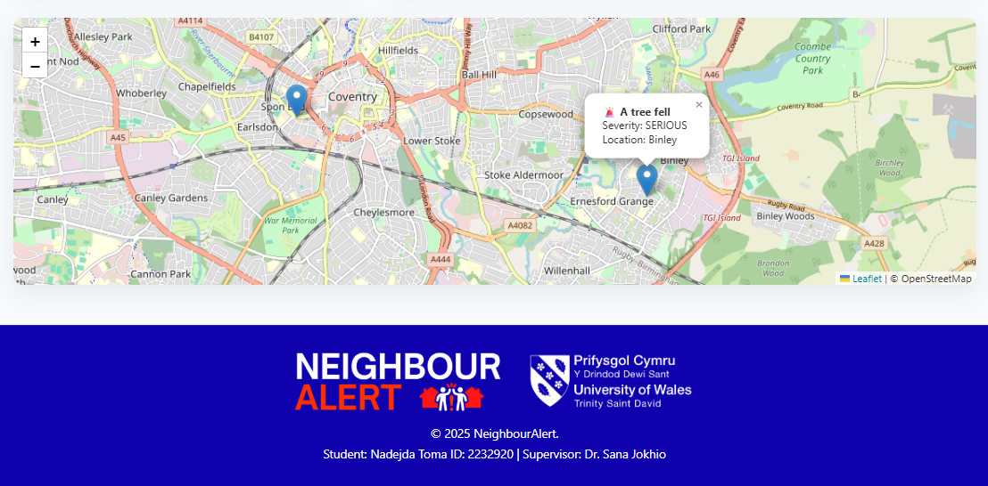
Figure 10. Leaflet | OpenStreetMap.

4.2 Storyboard
Neighbour Alert includes storyboards to show how a real user interacts with the system in typical neighbourhood-safety situations. These scenarios help visualise user goals, system responses, and the order of actions, ensuring that the interface supports fast, intuitive decision-making during emergencies [23]. Each storyboard is based on the high-fidelity interface developed in HTML, CSS, and JavaScript.

4.2.1 Storyboard: Reporting a New Incident
User goal: to quickly report something suspicious in the neighbourhood.
Context: user sees a suspicious person near their house and wants to alert neighbours.
These screenshots illustrate the steps a user takes when reporting a new incident, showing the system interface.
Scenario Goal:
To demonstrate how a user reports an emergency via the mobile application, receives confirmation, and navigates to the list of all emergencies.
The user starts from the mobile Home screen, which displays quick-access buttons such as Settings, Accessibility, Report Emergency, See All Emergencies, and Contact Us.

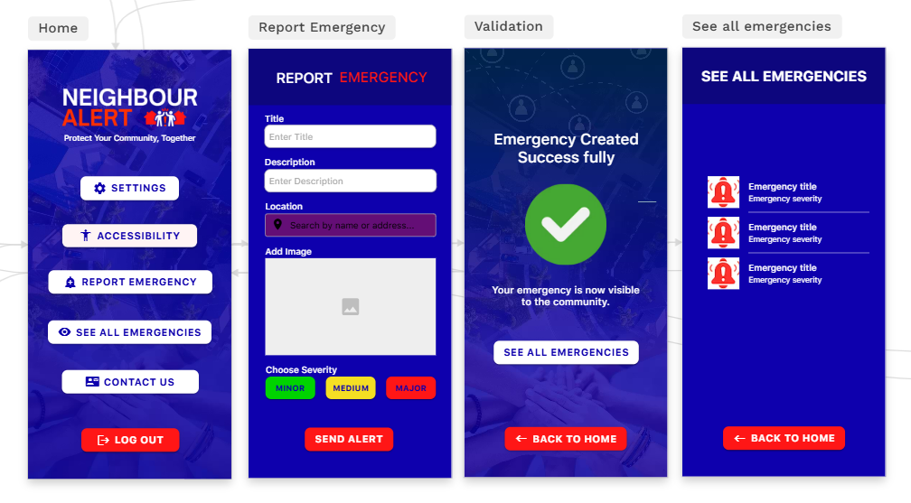







User Journey Steps:
The user taps “Report Emergency” and is redirected to a structured reporting screen.
To complete an emergency report, the user provides a title, description, location, an optional image, and selects the severity level (Minor, Medium, or Major).
The user taps “Send Alert”, which initiates a confirmation step.
A large green checkmark confirms: “Emergency Created Successfully.”
The user can now proceed to see all emergencies.
The final screen displays a list of all current emergencies in the community.

Scenario Goal:
To show how a user navigates through the mobile app settings, updates their profile, and views essential information such as privacy, policy, and app details.

User Journey Steps:
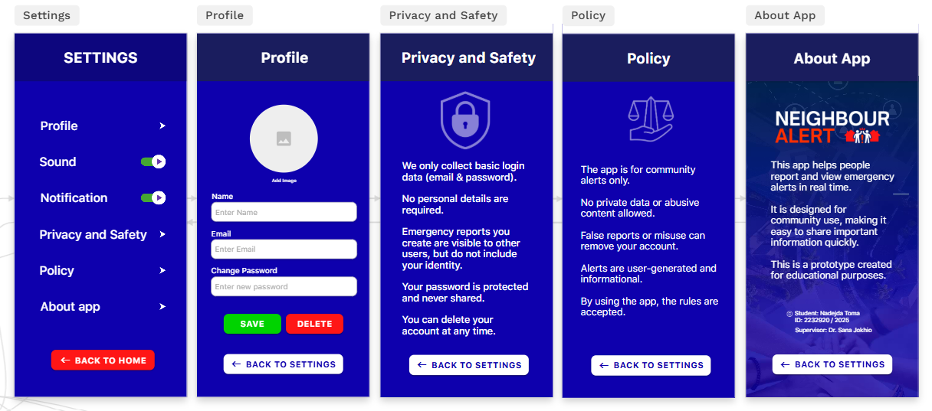
The user taps “Privacy and Safety” and sees details about data handling, anonymity and account security.
Finally, the user checks “About App” to read the purpose of Neighbour Alert and see the student credits.

The user selects “Profile”, where they can change their name, email, and password, and optionally upload an avatar image.

The user opens the mobile home screen and taps “Settings”, entering the configuration area of the app.

The user selects “Profile”, where they can change their name, email, and password, and optionally upload an avatar image.

5. IMPLEMENTATION
This section explains how Neighbour Alert was implemented across its main functional modules. The system currently includes a fully operational frontend prototype, a mobile app interface, interactive mapping, and client-side validation logic. The prototype demonstrates key functionalities through working modules and code snippets.

5.1 Frontend Web Module (HTML, CSS, JavaScript)
The web version of Neighbour Alert was implemented as a fully functional client-side prototype using HTML, CSS, and JavaScript. This module demonstrates how users navigate the system, submit emergency reports, view live alerts, and interact with the map [24]. The interface focuses on clarity, simplicity, and fast access to essential features.

5.1.1 Navigation Structure & Home Page
The navigation bar provides direct access to the core pages: Home, Live Alerts, Safety Tips, and Contact. It also includes Login and Sign-Up buttons aligned to the right, ensuring quick access to authentication functions.
The home page presents the purpose of the platform, key advantages, and a clear “Report Emergency” button that leads users into the alert-submission workflow (See Figure 11).
This page demonstrates the core layout and navigation logic. The hero banner highlights immediate actions (“Live Alert”), while sections such as “Why Choose NeighbourAlert?” and “How It Works” guide users through the system’s benefits and usage flow [25].

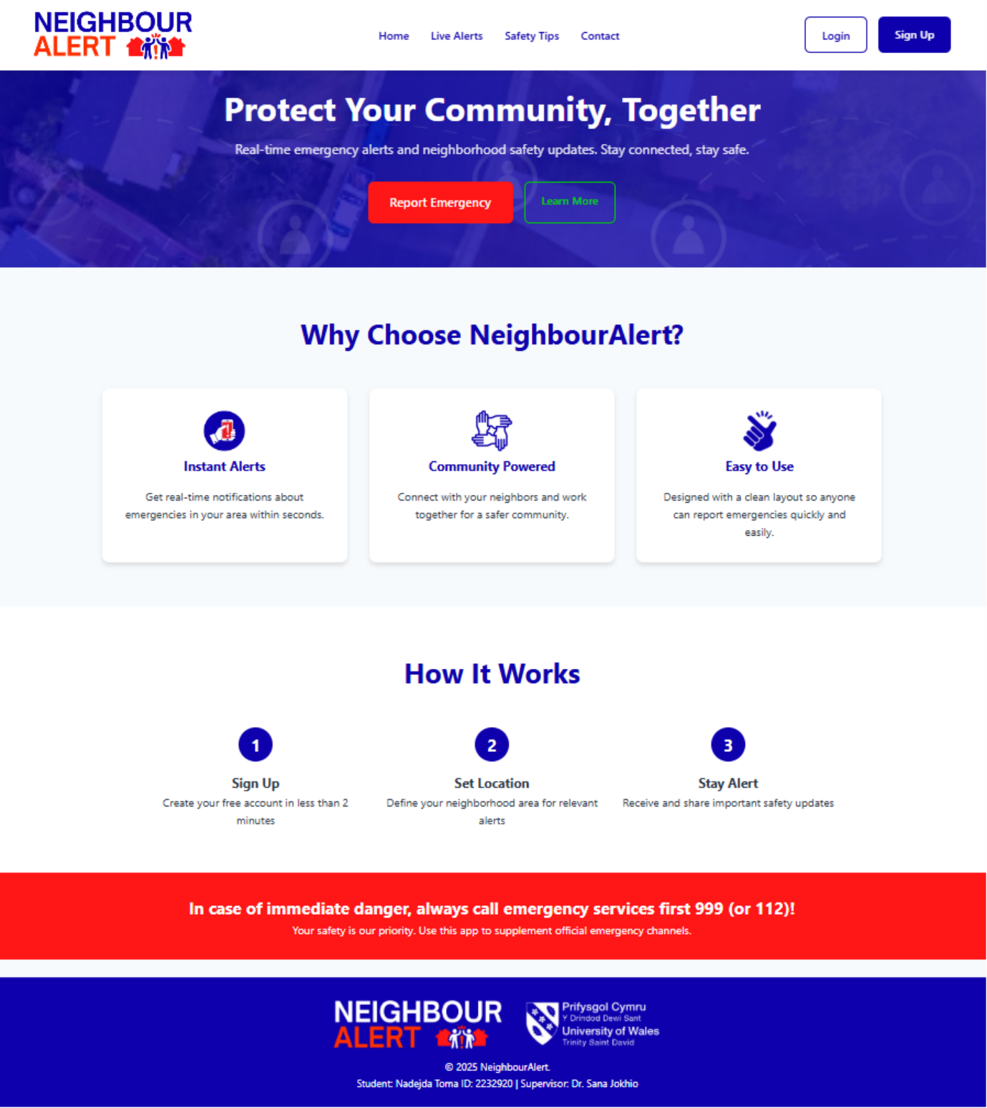
Figure 11. The home page introduces the purpose of the platform and provides quick access to the emergency reporting function.

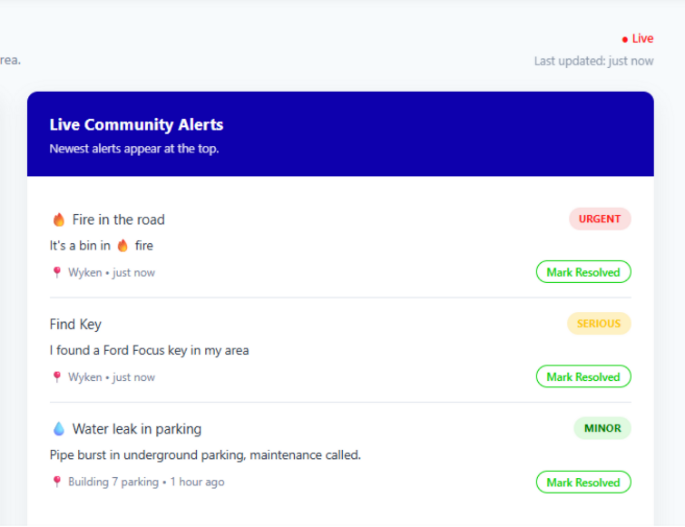
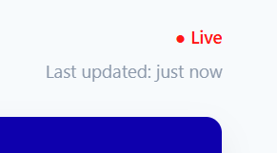
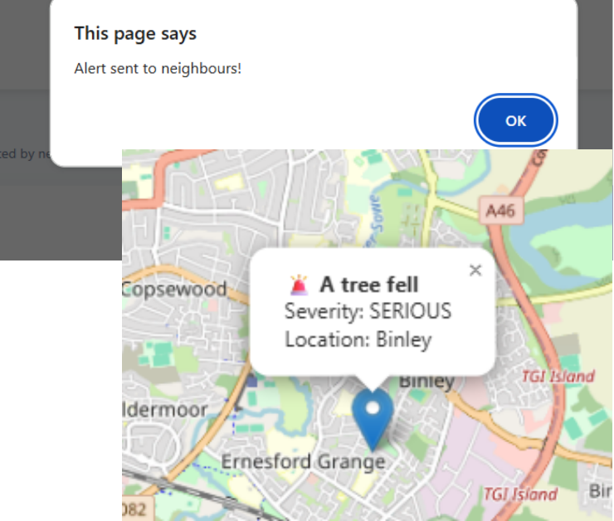
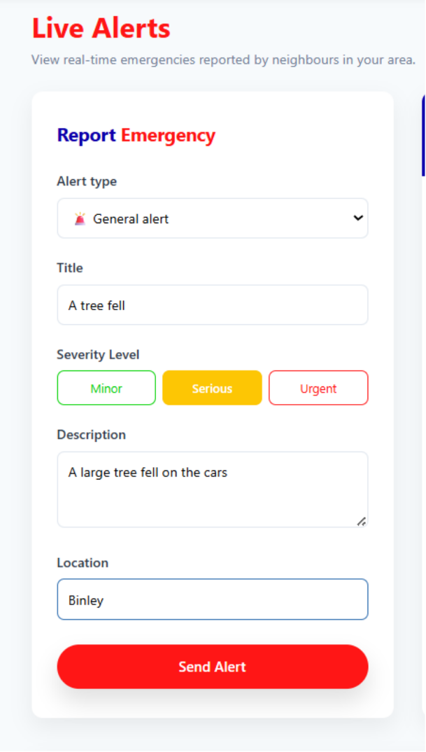
The Live Alerts page () is the central component of the web system. It combines three modules (See Figure 14 - Figure 12):
Figure 12. Report Alert.
Figure 13. Live Alerts Feed
Figure 14. Emergency Reporting Form.
- Emergency Reporting Form
- Live Alerts Feed
- Interactive Map

The reporting form includes: Alert type dropdown, Title, Description, Severity level (colour-coded: Minor, Serious, Urgent), Location
Users can report an emergency by completing a structured form that captures the essential details for community response.
The page is updated visually in real time (“Last updated: just now”), reflecting the intended dynamic behaviour of the future backend (Figure 15).
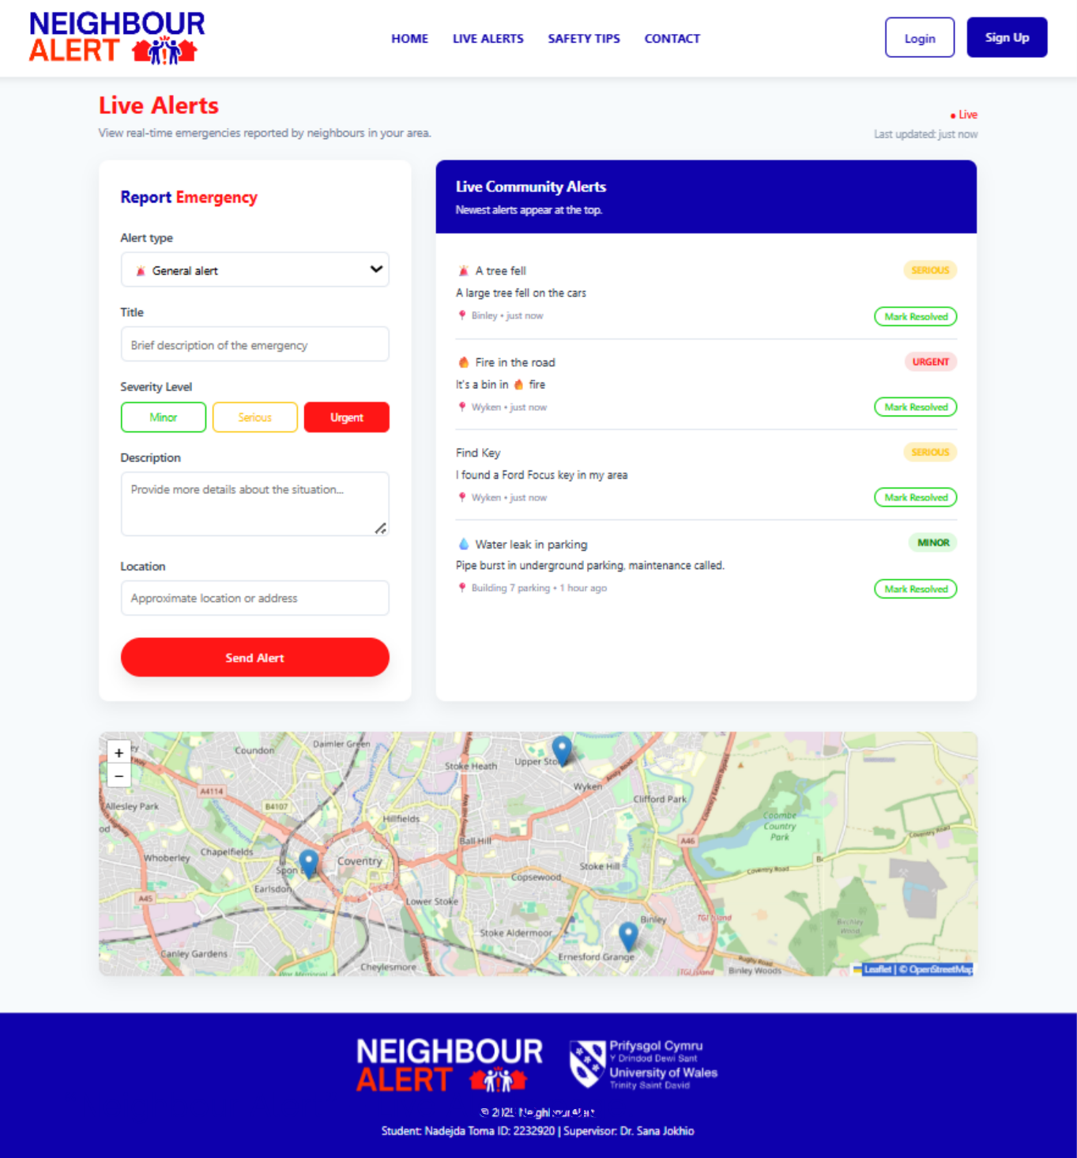
Figure 15. The Live Alerts page integrates the emergency reporting form, real-time alerts feed, and an interactive map, giving users a complete situational overview.

Figure 16 Live Alerts page.

Additional screens and interface examples can be found in Appendix A

5.2 Code snippets
The following code examples illustrate how the core client-side logic was implemented, following established JavaScript patterns for clarity and efficient prototyping [26].
The code below (Figure 17) implements the prototype’s login mechanism using a predefined set of credentials. When the correct email and password are entered, the system assigns the user an admin role and redirects them to the dashboard. This simplified approach allowed the project to check the authentication and restricted access.
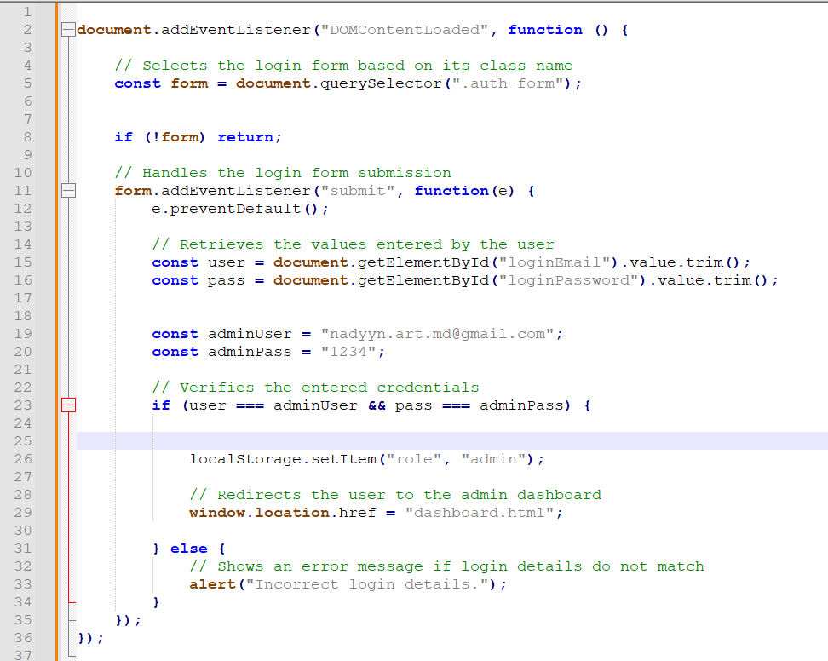
Figure 17. Authentication function for admin

The next snippet (see Figure 18) manages the storage and retrieval of emergency alerts using localStorage. It enables data persistence across page reloads, allowing the system to behave similarly to an application with a lightweight database. This approach supports functional testing without requiring a backend server.

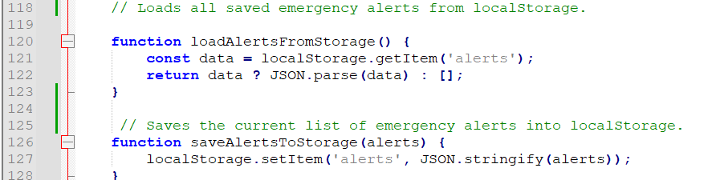

Figure 18. Load function and Save function in the dashboard.js

The code below (see Figure 19) snippet is responsible for displaying all alerts stored in the application. The function first retrieves the saved alert data, clears the existing content on the page, and then dynamically rebuilds each alert card using JavaScript. The layout is constructed entirely through DOM manipulation, ensuring that the interface always reflects the current state of the stored alerts. At the end, the function reactivates the logic for the "Mark Resolved" buttons, enabling users to interact with the displayed alerts immediately.

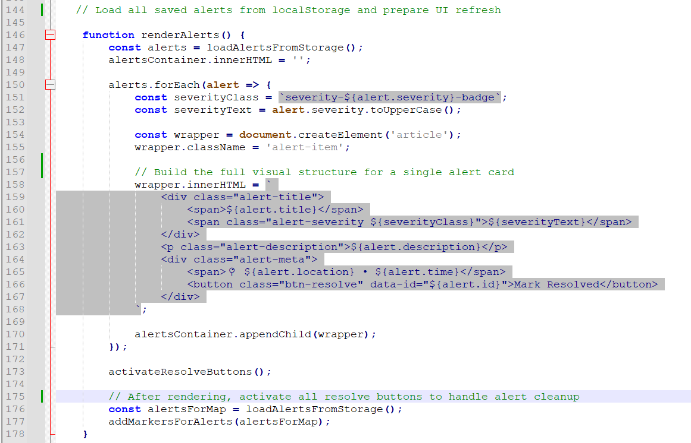
Figure 19. Render alert function description

TESTING

The testing phase aimed to verify that the implemented features of the NeighbourAlert prototype function correctly and provide a smooth user experience. Manual functional testing was conducted using predefined test cases focusing on core user flows such as login, emergency reporting, and dashboard access [27]. The results confirm whether each feature behaves as expected under different conditions.
A set of structured test cases was created to evaluate the system’s main functionalities. Each test includes the purpose, input, expected output, actual output, and pass/fail result [28].

Table 1 – Login Functionality Test Cases
Purpose of the case | Input | Expected Output | Result
Login with incorrect | Email: wrong value  Password: wrong value | System rejects login and shows error message | Pass
Login with correct admin credentials | Email: nadyyn.art.md@gmail.com  Password: 1234 | User is logged in and redirected to dashboard.html | Pass

Table 2 – Emergency Report Tests
Purpose of the case | Input | Expected Output | Result
Submit report with required fields missing | Empty form | System prevents submission | Pass
Submit report with all valid fields | Title, description, location, severity | Report saved and displayed in list | Pass
Select emergency severity | Minor / Medium / Major button | Severity stored correctly | Pass

Table 3 – Mobile App Testing in Adalo
Purpose of the case | Input | Expected Output | Result
Open the mobile app and access the Home screen | User opens the NeighbourAlert app from Adalo preview | Home screen loads with visible navigation options | Pass
Submit an emergency report using the mobile form | User fills in Title, Description, Location, selects Severity, taps Submit | Confirmation screen appears and report is saved | Pass
View emergency details | User taps an alert from the “All Emergencies” list | Details page opens with correct data | Pass
Navigate to Settings section | User taps “Settings” icon on Home screen | Settings screen opens showing profile, privacy and about options | Pass
Test navigation back to Home | User taps the back button in screen header | User returns to previous screen or Home | Pass

The testing process not only confirmed that the prototype’s core features functioned as intended but also highlighted areas for potential improvement in usability. While all test cases passed successfully, several observations emerged during the process. Users responded well to the simple navigation and clear visual hierarchy, but the simulation-based nature of the system limited the realism of some interaction.
Testing also revealed the importance of clear feedback, confirmation messages and consistent button states helped users understand system responses more easily. Finally, the testing phase validated the functional design while also emphasising that future iterations would benefit from enhanced error handling, stronger visual feedback, etc.

EVALUATION

7.1 Personal Evaluation
The development of NeighbourAlert became more than a technical exercise; it offered a genuine opportunity to understand how people think and act when something feels uncertain in their environment. Working with limited time and resources encouraged a sharper focus on what truly matters for the user: a calm layout, a short decision path, and an interface that reduces hesitation rather than adding pressure. Throughout the process, each design choice, spacing, colour use, button clarity, showed how small details can influence someone’s confidence when they need to make quick decisions [29].
Informal user testing played a particularly important role. Observing how friends and neighbours interacted with the prototype, where they moved instinctively, or where they paused, revealed a great deal about the emotional side of usability. These moments helped highlight that an emergency-oriented tool must not only work correctly but also feel supportive and predictable. Even subtle improvements, such as clearer confirmation messages or gentler screen transitions, made the system feel more reassuring [30].
Reflecting on the full journey, this project strengthened both technical skills and human-centred awareness. It deepened understanding of how design, psychology, and community needs come together when building a tool intended to help people look out for one another [31]. NeighbourAlert ultimately shaped a more balanced view of development, one where functionality, clarity, and empathy share equal importance.

7.2 System Evaluation
Evaluating the system as a complete experience shows that NeighbourAlert delivers a clear and approachable reporting flow, which is essential for moments when users may feel unsure or rushed. The interface guides actions gently through simple navigation, visible options, and a layout that avoids unnecessary noise. Testing confirmed that users could understand the reporting steps quickly, and many responded positively to the calm, uncluttered presentation [32].
At the same time, the evaluation highlighted several opportunities for improvement. Because some functions still operate through simulated behaviour, certain interactions felt less dynamic than what users might expect from an emergency tool. Real-time updates, more responsive map behaviour, and smoother transitions would enhance the sense of immediacy and make the system feel more alive and reactive.
Another important insight relates to how users interpret feedback. Confirmation messages worked well, but a few interactions would benefit from stronger visual cues or short animations that reinforce the feeling of progress. These observations underline a central theme: usability in emergency contexts depends not only on what the system does, but also on how confidently and comfortably the user experiences each action [33].
The system demonstrates a solid foundation for neighbourhood reporting, lightweight, clear, and supportive. The evaluation confirms that it meets its core purpose while highlighting meaningful directions for future refinement. With more dynamic behaviour and reinforced feedback, NeighbourAlert can evolve into a tool that feels both technically reliable and emotionally reassuring for the community it aims to serve.

FURTHER ENHANCEMENT
Looking ahead, NeighbourAlert can grow in several meaningful ways that build on what the prototype has already achieved. The evaluation made it clear that people appreciate having a simple and reassuring space to report emergencies, but they would benefit even more from interactions that feel immediate and alive. Adding real-time updates where the map responds without delay, would help the system feel more connected to what is happening in the moment.
Another direction involves strengthening feedback throughout the interface. Small touches such as smoother transitions, clearer confirmations, or gentle animations could make the experience feel even more supportive, especially for users who might already feel uncertain or stressed. These improvements are not about adding complexity but about helping the system communicate more naturally with the people who rely on it.
The mobile side of the platform could also be expanded in a practical way. Features like simple push notifications or quicker access to reporting tools would make the app easier to use during everyday situations. Since the mobile prototype already exists, enhancing it gradually would allow the system to reach users wherever they are, without overwhelming them.
Finally, NeighbourAlert can evolve to offer more community-focused options, such as small groups, shared updates, or a space where neighbours can follow local patterns more easily. These additions should remain lightweight and friendly, but they have the potential to bring people closer and strengthen awareness in a quiet, helpful way.
The possibilities for enhancement are clear and encouraging. Each improvement would make NeighbourAlert feel more responsive, more comforting, and more deeply connected to the needs of the people it aims to support.

CONCLUSION
NeighbourAlert began as a simple idea, a small tool meant to help neighbours look out for each other, but it grew into something far more meaningful during this project. What started as a technical assignment slowly revealed how deeply people rely on clarity, reassurance, and connection when something feels uncertain in their community. Building the prototype showed that even a lightweight system can make a difference when it gives people a calm space to share information and feel less alone in those small but worrying moments that happen close to home.
Throughout development, it became clear that the value of NeighbourAlert does not lie only in its features, but in the intention behind them. A clean button, a clear colour, or a simple form may seem small, but they carry emotional weight for someone who needs to act quickly. This realisation shaped every design choice and reminded me that technology, at its best, supports people quietly, without noise, without pressure, just by being there when it is needed.
The project also highlighted the strength found in community. Even informal conversations with friends and neighbours showed how much people want tools that help them protect their families and their streets, not through complicated systems, but through something warm, accessible, and human. In this sense, NeighbourAlert is more than a prototype; it is a reminder that digital solutions can create moments of trust and solidarity in everyday life.
In the end, this project proved that small ideas, when shaped with care, can grow into something that feels genuinely useful. NeighbourAlert may still be a prototype, but it already reflects a clear purpose: to help people support each other, to make uncertainty feel a little less heavy, and to show that even simple technology can strengthen the quiet bonds that keep a community safe.

REFLECTION

Looking on this project, I realise how much it taught me about both technology and me. NeighbourAlert was not just a technical task; it became a space where I learned to be patient, to stay focused, and to trust my own ability to build something meaningful step by step. There were moments when things felt overwhelming or unclear, but each challenge pushed me to think more calmly, to simplify my approach, and to understand what truly matters in a system meant to help people.
One of the most valuable parts of this journey was discovering how deeply design and emotion are connected. I often found myself imagining the person on the other side of the screen, someone worried, unsure, maybe stressed, and that image guided my decisions more than any line of code. It reminded me that technology has a quiet responsibility: to support, not to complicate; to bring clarity, not confusion; to offer comfort, even in small ways.
Working with limited time and resources also taught me to appreciate progress rather than perfection. Every small improvement, whether in layout, colours, or navigation, felt like a step toward a system that could genuinely make someone feel safer. These moments helped me develop not just technical skills, but also confidence, discipline, and a clearer sense of purpose in my work.
Most importantly, this project helped me understand the value of community. Even simple conversations with friends and neighbours showed how much people want tools that help them stay connected and informed. It made me grateful to build something that, even as a prototype, carries the intention of helping others.
This project became more than a university project. It became a reminder that I can create something useful, thoughtful, and grounded in real human needs. And that real growth happens not only in the code I write, but also in the patience, empathy, and understanding I gain along the way.

REFERENCES
[1] E. R. Oliveira, et al., "An iterative process for the evaluation of a mobile application prototype," SN Computer Science, vol. 3, no. 4, pp.262, 2022.
[2] B. Abboodi, S. F. Pileggi and G. Bharathy, "Social Networks in Crisis Management: A Literature Review to Address the Criticality of the Challenge. Encyclopedia, 3 (3), 1157-1177," 2023.
[3] F. Mowbray, et al., "A systematic review of the use of mobile alerting to inform the public about emergencies and the factors that influence the public response," J.Contingencies Crisis Manage., vol. 32, no. 1, pp.e12499, 2024.
[4] N. F. A. Budi, et al., "Why do people want to use location-based application for emergency situations? The extension of UTAUT perspectives," vol. 65, pp.101480, 2021.
[5] A. Carreras-Coch, et al., "Communication technologies in emergency situations," vol. 11, no. 7, pp.1155, 2022.
[6] R. M. Repanovici, et al., "Improvement of emergency situation management through an integrated system using mobile alerts," vol. 14, no. 24, pp.16424, 2022.
[7] J. Lillie and M. Achhammer, "Nextdoor v. the community network literature: Do Nextdoor’s uses match the potential envisioned for ComNets," vol. 29, no. 4, pp.901–918, 2023.
[8] J. Phengsuwan, et al., "Use of social media data in disaster management: a survey," vol. 13, no. 2, pp.46, 2021.
[9] P. Pranay, et al., "Neighbourhood Safety Alarm System," vol. 16, no. 2, 2025.
[10] D. Cicek and B. Kantarci, "Use of mobile crowdsensing in disaster management: A systematic review, challenges, and open issues," vol. 23, no. 3, pp.1699, 2023.
[11] L. Llerena, J. W. Castro and N. Rodriguez, "Evaluating the usability of open source software tools in e-learning: a systematic mapping study and case study," pp.1–34, 2025.
[12] J. C. N. Bittencourt, et al., "A Survey on Adaptive Smart Urban Systems," vol. 12, pp.102826–102850, 2024. doi: 10.1109/ACCESS.2024.3433381.
[13] J. Berg, J. Lindholm and J. Högväg, "How do we know that it works? Designing a digital democratic innovation with the help of user-centered design," vol. 26, no. 3, pp.221–235, 2021.
[14] B. González and U. Arregui, "6Digital Design Tools & Applications," GIFTLED: Learning by Design Method in My Educational Work, pp.109,
[15] A. Valenti, "Usability Testing Best Practices for Academic Library Websites DIY Usability Testing Toolkit," Weave (Ann Arbor, vol. 7, no. 1, 2024. doi: 10.3998/weaveux.4396.
[16] Z. Hussain and R. Cao, "Human Interface Design in Mobile Apps: Managing Information for Effective Evacuation Strategies," 2024 IEEE Smart World Congress (SWC), 2024.
[17] T. Li, et al., "Alert now or never: Understanding and predicting notification preferences of smartphone users," ACM Transactions on Computer-Human Interaction, vol. 29, no. 5, pp.1–33, 2023.
[18] A. Dirin, M. Nieminen and T. H. Laine, "Feelings of being for mobile user experience design," International Journal of Human–Computer Interaction, vol. 39, no. 20, pp.4059–4079, 2023.
[19] E. Bjarnason, F. Lang and A. Mjöberg, "An empirically based model of software prototyping: a mapping study and a multi-case study," Empirical Software Engineering, vol. 28, no. 5, pp.115, 2023.
[20] J. Beaird, A. Walker and J. George,The Principles of Beautiful Web Design, Sebastopol: SitePoint, 2020. [Online]. Available: http://ebookcentral.proquest.com/lib/trinity/detail.action?docID=6387757
[21] R. E. Roth, et al., "Making maps \& visualizations for mobile devices: A research agenda for mobile-first and responsive cartographic design," pp.1–71, 2024. doi: 10.1080/17489725.2023.2251423.
[22] N. Leonard, A. Way and F. Santune, "Designing for the Web and Platforms," in Bloomsbury Publishing Plc, 2020, pp. 114–141. doi: 10.5040/9781350045859.ch-004
[23] E. Lupton, Thinking with Type: A Critical Guide for Designers, Writers, Editors, and Students (Revised and Expanded), Chronicle Books, 2024.
[24] P. McFedries, HTML CSS \& JavaScript All-in-one for Dummies, John Wiley \& Sons, 2023.
[25] B. Frain, Responsive Web Design with HTML5 and CSS : Develop future-proof responsive websites using the latest HTML5 and CSS techniques, Warsaw ;: Packt Publishing Limited, 2020.
[26] M. Awais, "JavaScript Design Patterns: A Comprehensive Analysis of Their Evolution, Usage, and Impact in Modern Web Development,"
[27] R. Bierig, et al., Essentials of Software Testing, Cambridge University Press, 2021.
[28] S. Loeffler, et al., "Mobile UX design: learning from the Flyover Country mobile app," vol. 17, no. 2, pp.39–50, 2021. doi: 10.1080/17445647.2020.1867247.
[29] M. Hertzum, Usability testing: A practitioner's guide to evaluating the user experience, Springer Nature, 2022.
[30] R. Pushpakumar, et al., "Human-computer interaction: Enhancing user experience in interactive systems," E3S Web of Conferences, 2023.
[31] S. Ntoa, "Usability and user experience evaluation in intelligent environments: A review and reappraisal," vol. 41, no. 5, pp.2829–2858, 2025.
[32] X. Liu, et al., "Enhancing Product Emotional Experience Through Explicit-Implicit Interaction Design: Enhancing Emotional Interaction in Product Design," Journal of organizational and end user computing, vol. 37, no. 1, pp.1–24, 2025. doi: 10.4018/JOEUC.387832.
[33] C. Bolibaugh and P. Foster, "Implicit Statistical Learning in Naturalistic and Instructed Morphosyntactic Attainment: An Aptitude‐Treatment Interaction Design," Language learning, vol. 71, no. 4, pp.959–1003, 2021. doi: 10.1111/lang.12465.

APPENDICES

Apendix A

This appendix presents the supporting screenshots that document the development, interface design, and functionality of the NeighbourAlert prototype.

WEBSITE
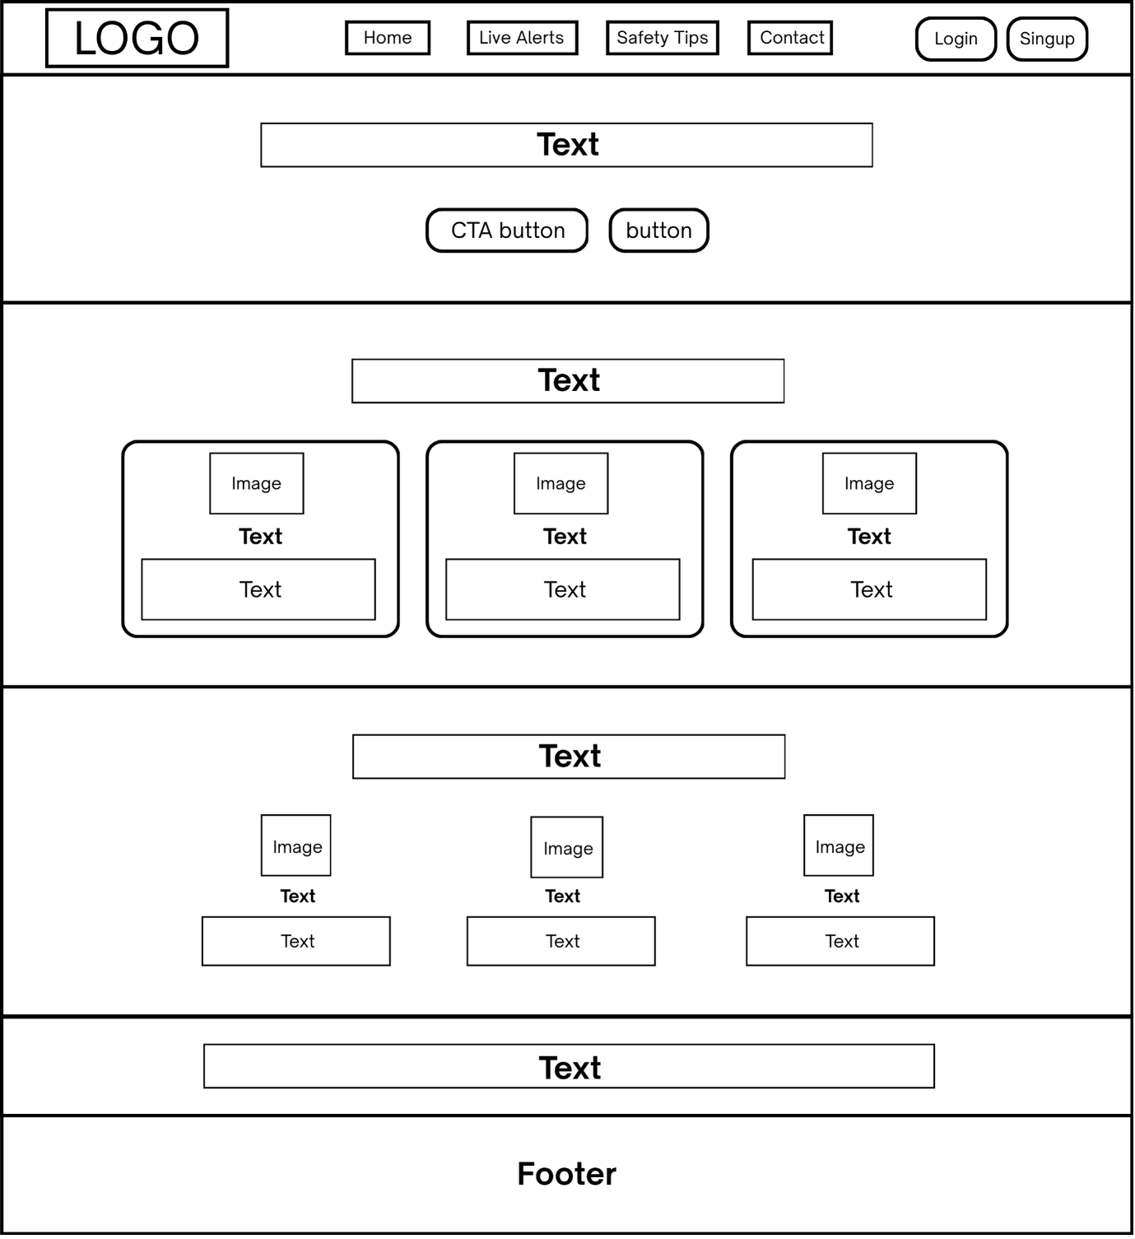

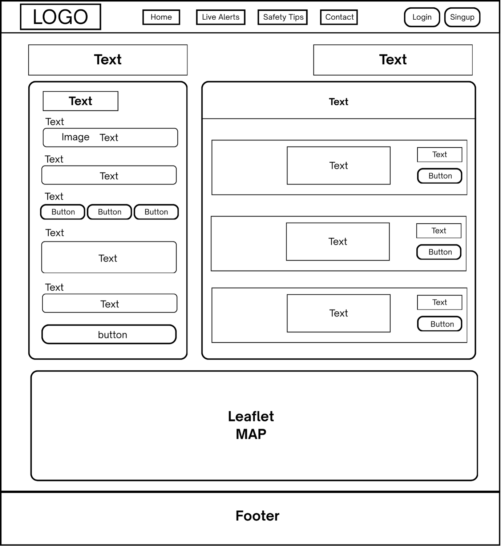

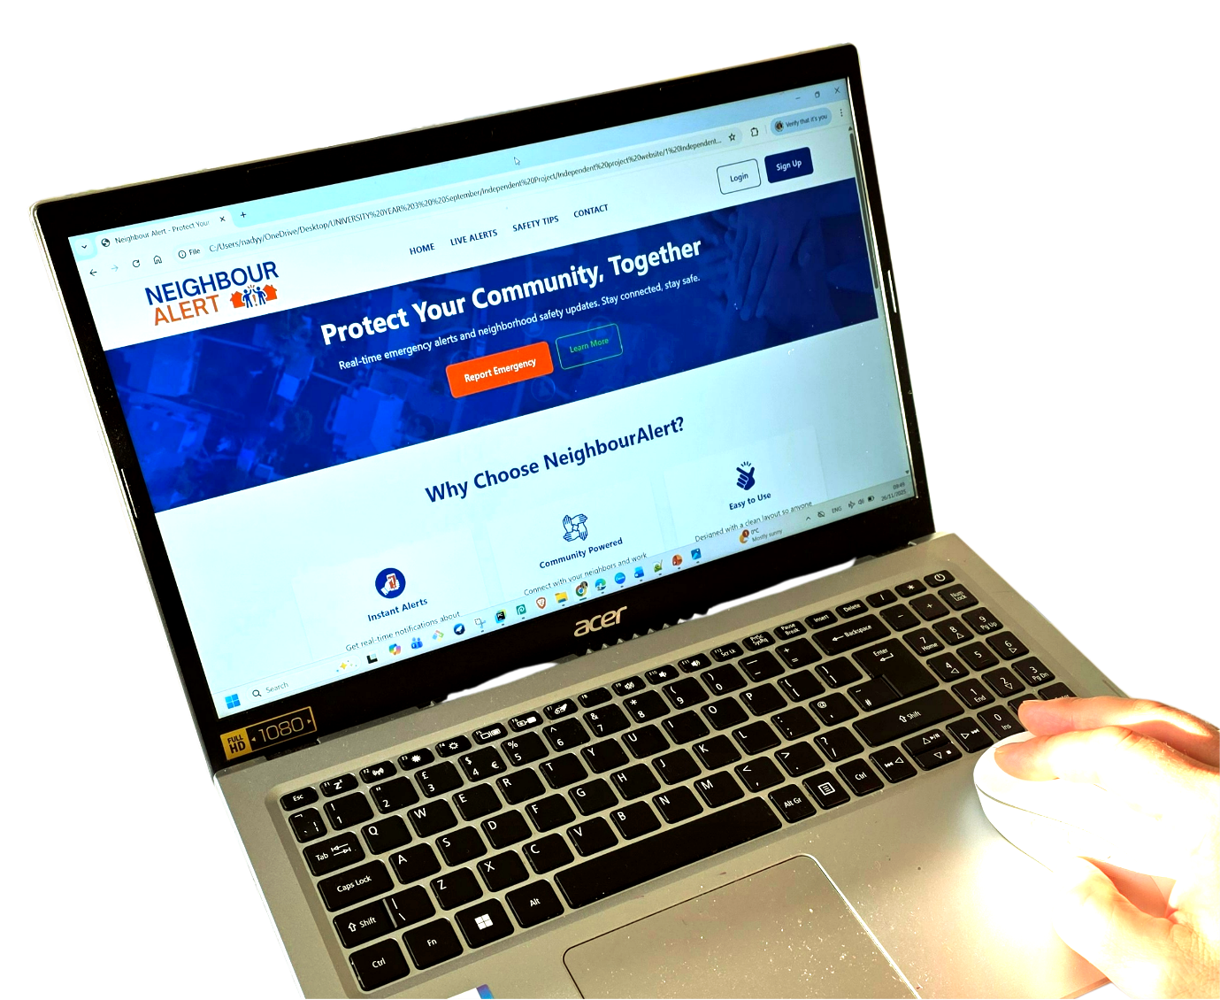

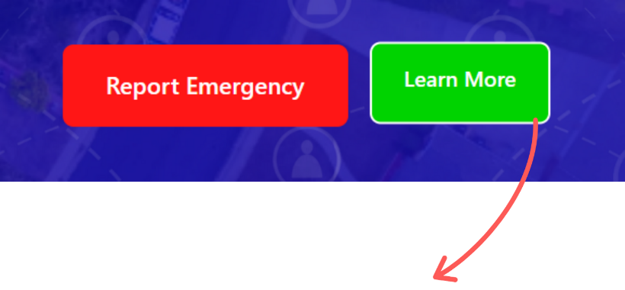

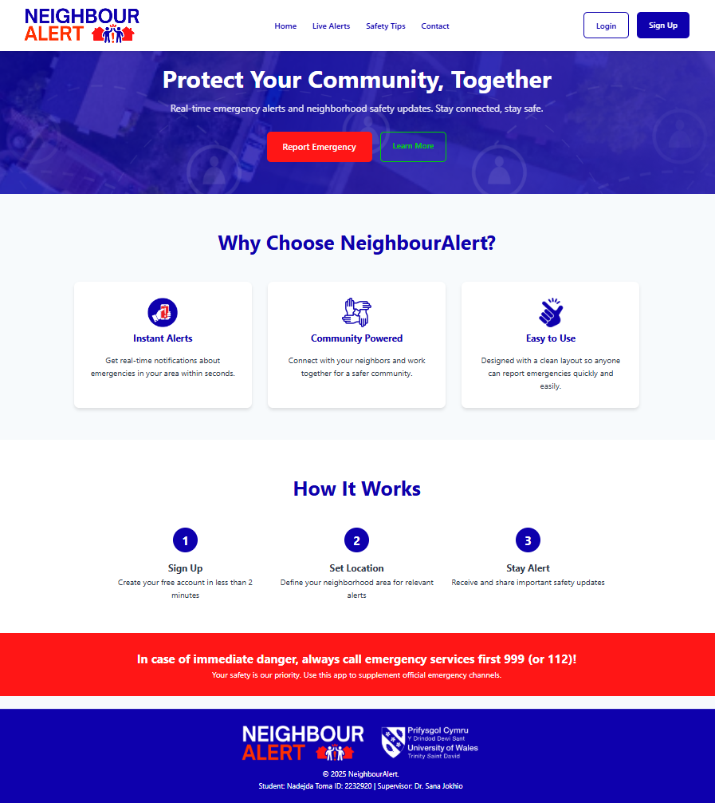

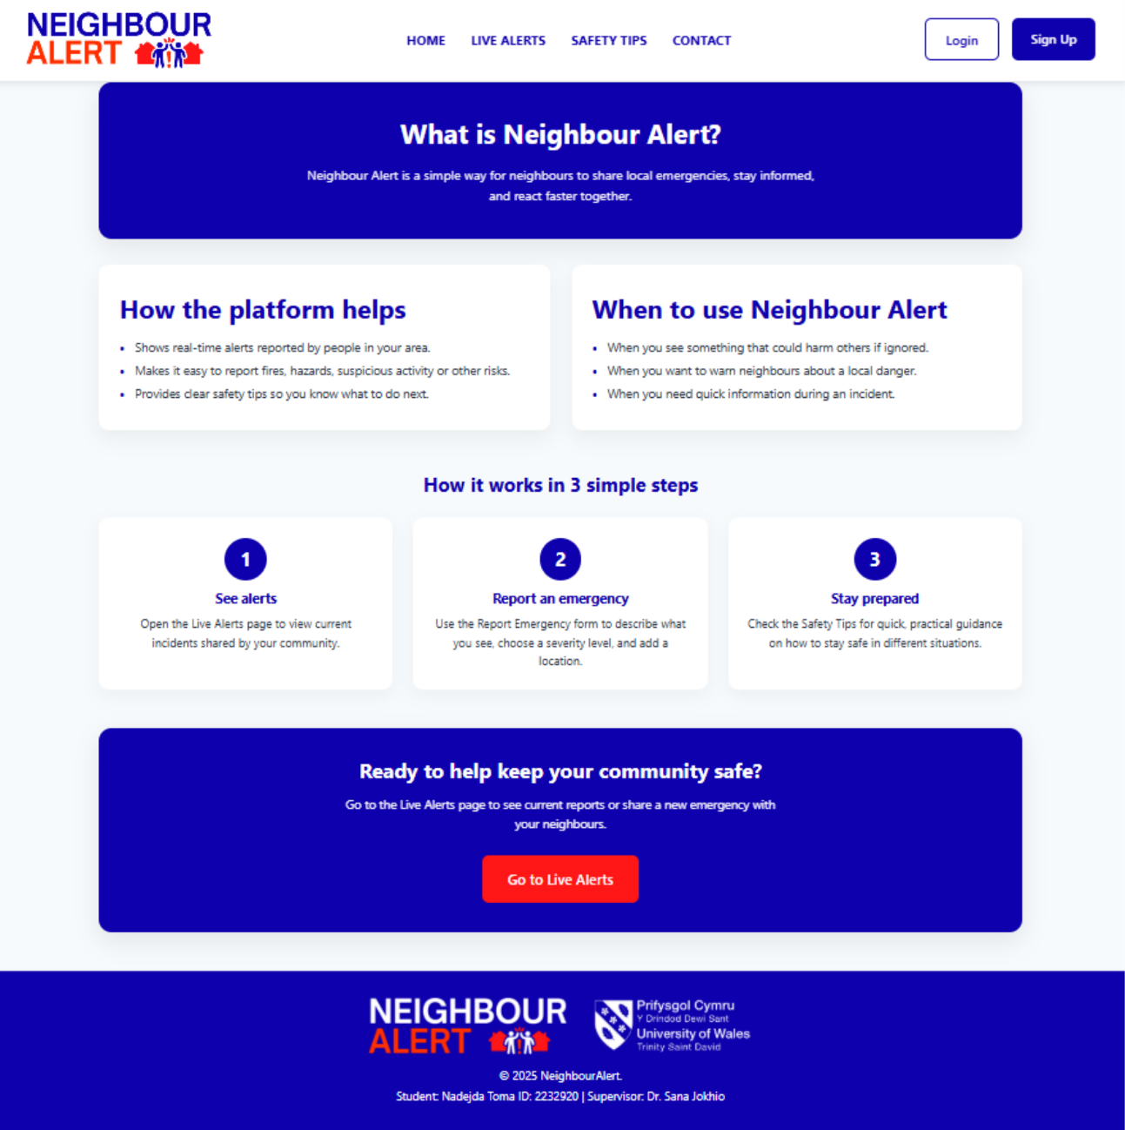

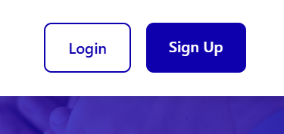

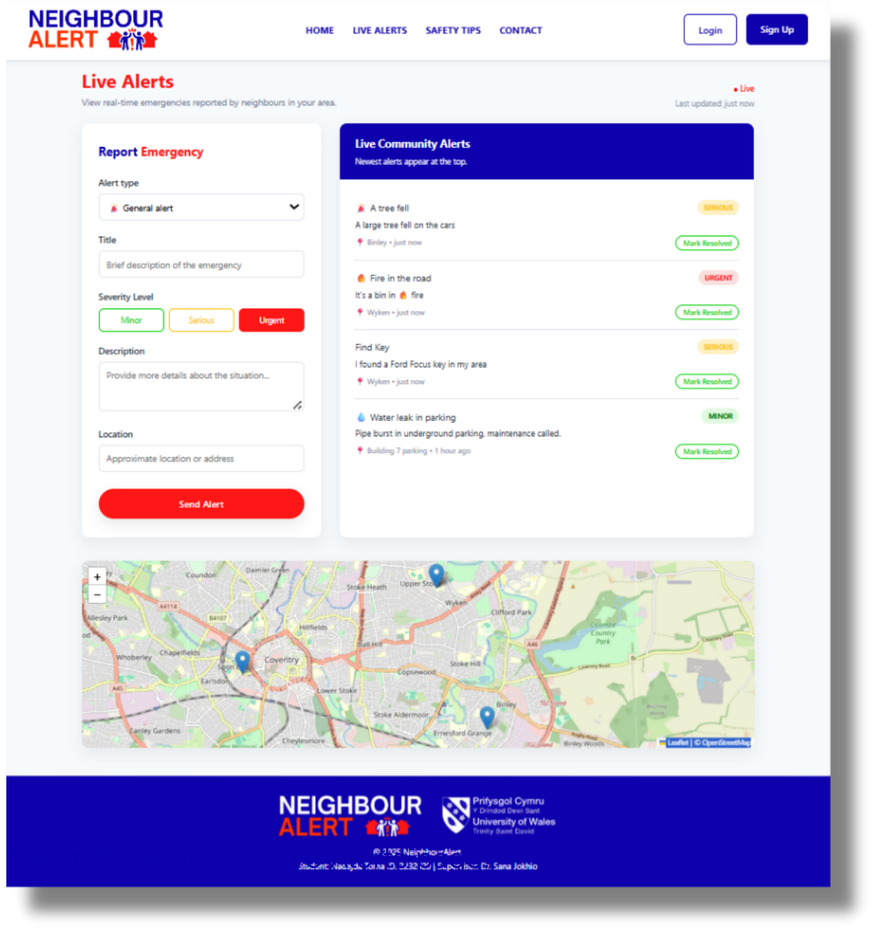



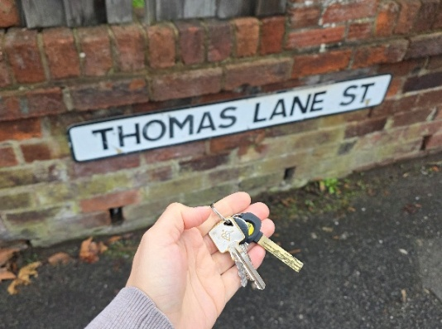

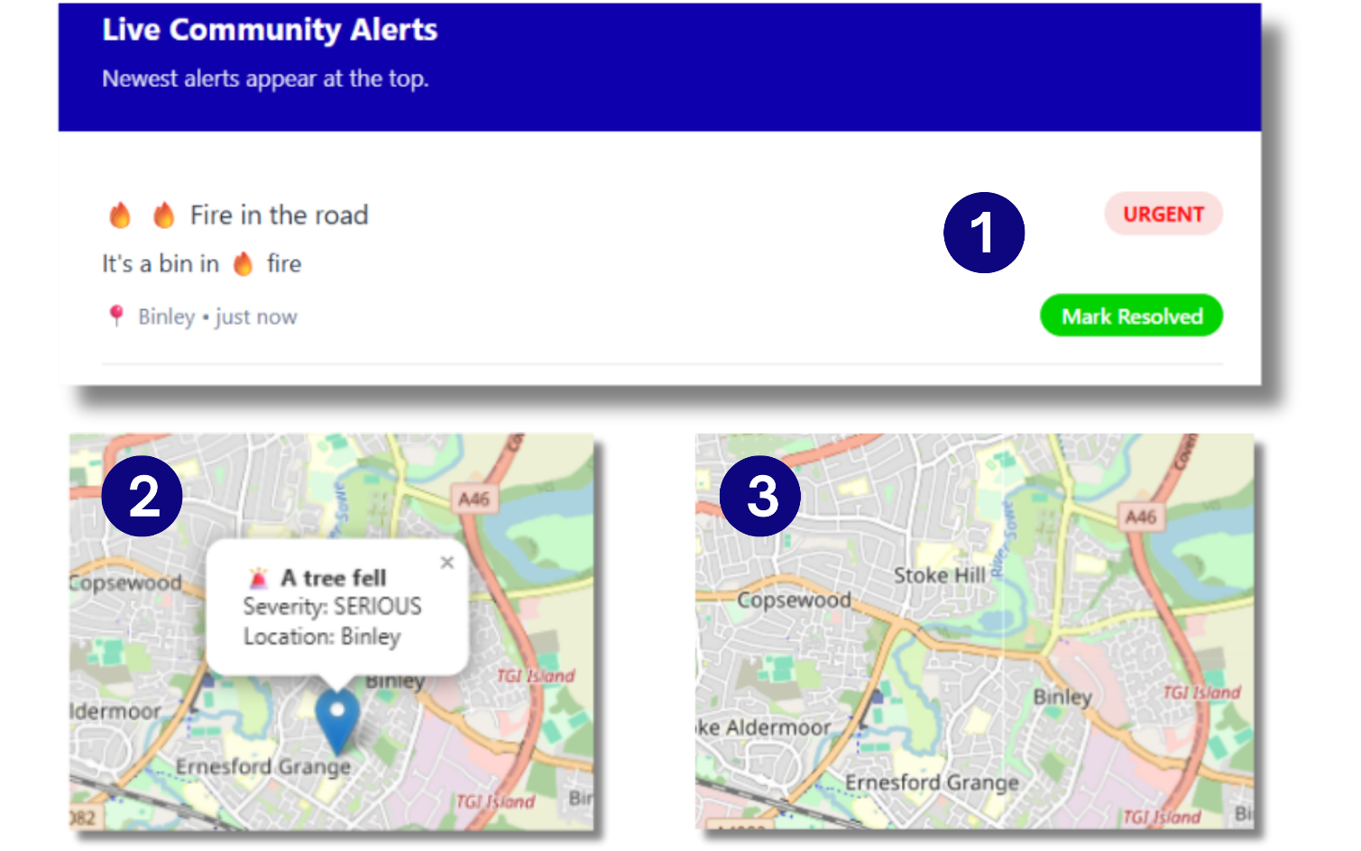

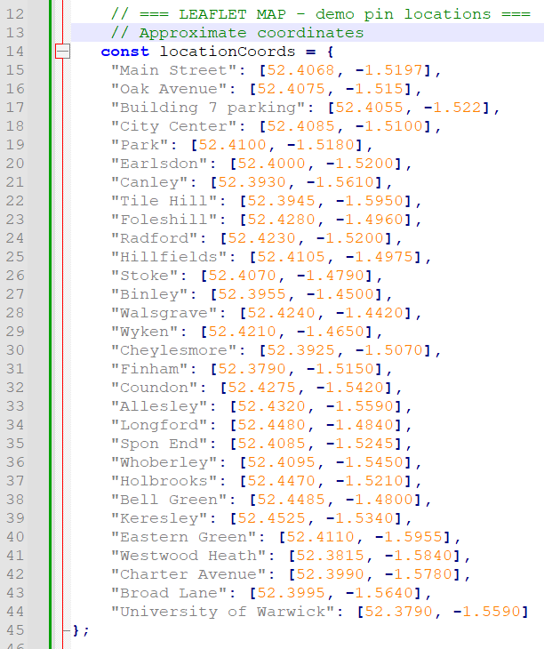

MOBILE APP

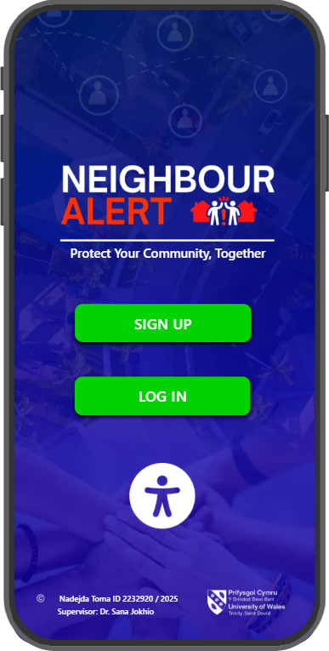
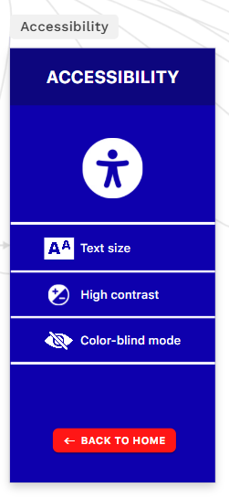

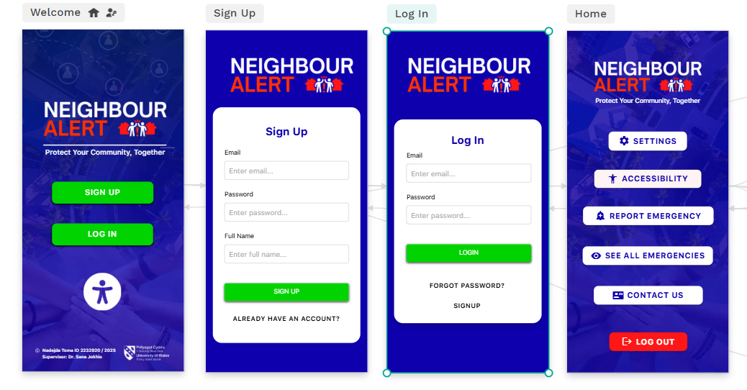

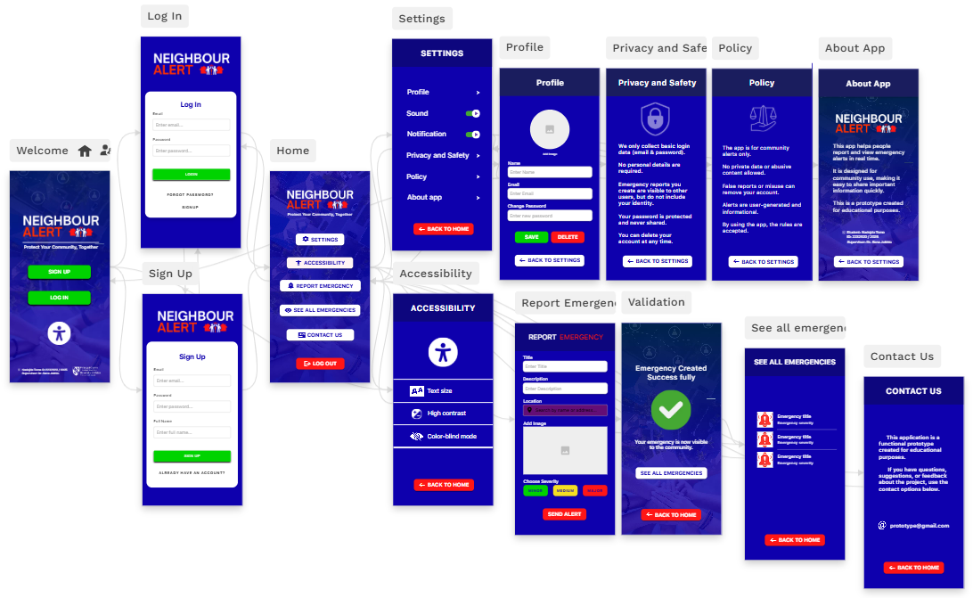

Appendix B
The following appendix section contains the full source code used in the NeighbourAlert prototype, including HTML, CSS, and JavaScript files. The code is provided to demonstrate the implementation details, structure, and functionality of the system.

1. The following HTML files define the structural layout and content of each page within the NeighbourAlert prototype:

Index.html

<!DOCTYPE html>
<html lang="en">
<head>
<meta charset="UTF-8">
<meta name="viewport" content="width=device-width, initial-scale=1.0">
<title>Neighbour Alert - Protect Your Community</title>
<link rel="stylesheet" href="css/style.css">
</head>
<body id="top">
<!-- HEADER -->
<header class="header">
<nav class="nav-container">
<!-- Logo -->
<div class="logo">
<img src="Images/LogoBlack.png" alt="NeighbourAlert Logo" class="logo-image">
</div>

<!-- Navigation Menu -->
<ul class="nav-menu">
<li><a href="index.html">Home</a></li>
<li><a href="dashboard.html">Live Alerts</a></li>
<li><a href="safety.html">Safety Tips</a></li>
<li><a href="#contact">Contact</a></li>
</ul>

<!-- Login/Register + Emergency Button -->
<div class="nav-actions">
<div class="auth-buttons">
<a href="login.html" class="btn btn-login">Login</a>
<a href="register.html" class="btn btn-register">Sign Up</a>
</div>
</div>
</nav>
</header>

<!-- HERO SECTION -->
<section class="hero">
<div class="hero-content">
<h1>Protect Your Community, Together</h1>
<p>Real-time emergency alerts and neighborhood safety updates. Stay connected, stay safe.</p>

<div class="cta-buttons">
<a href="dashboard.html" class="btn btn-emergency">Report Emergency</a>
<a href="learnmore.html" class="btn btn-learn-more">Learn More</a>
</div>
</div>
</section>

<!-- FEATURES SECTION -->
<section class="features" id="features">
<h2 class="section-title">Why Choose NeighbourAlert?</h2>

<div class="features-grid">
<div class="feature-card">
<div class="feature-icon">
<img src="images/alert-icon.png" alt="alert-icon">
</div>

<h3>Instant Alerts</h3>
<p>Get real-time notifications about emergencies in your area within seconds.</p>
</div>

<div class="feature-card">
<div class="feature-icon">
<img src="images/community-powered.png" alt="community-powered">
</div>

<h3>Community Powered</h3>
<p>Connect with your neighbors and work together for a safer community.</p>
</div>

<div class="feature-card">
<div class="feature-icon">
<img src="images/easy-to-use.png" alt="easy-to-use">
</div>

<h3>Easy to Use</h3>
<p>Designed with a clean layout so anyone can report emergencies quickly and easily.</p>
</div>
</div>
</section>

<!-- HOW IT WORKS SECTION -->
<section class="how-it-works" id="how-it-works">
<h2 class="section-title">How It Works</h2>

<div class="steps">
<div class="step">
<div class="step-number">1</div>
<h3>Sign Up</h3>
<p>Create your free account in less than 2 minutes</p>
</div>

<div class="step">
<div class="step-number">2</div>
<h3>Set Location</h3>
<p>Define your neighborhood area for relevant alerts</p>
</div>

<div class="step">
<div class="step-number">3</div>
<h3>Stay Alert</h3>
<p>Receive and share important safety updates</p>
</div>
</div>
</section>

<!-- EMERGENCY BANNER -->
<div class="emergency-banner">
<h2>In case of immediate danger, always call emergency services first 999 (or 112)!</h2>
<p>Your safety is our priority. Use this app to supplement official emergency channels.</p>
</div>

<!-- FOOTER -->
<footer class="footer">
<div class="footer-inner">
<div class="footer-logos">
<img src="Images/LogoWhite.png" alt="LogoWhite" class="footer-logo">
<img src="Images/UWTSD-logo.png" alt="UWTSD Logo" class="footer-logo">
</div>

<p>&copy; 2025 NeighbourAlert.</p>
<p>Student: Nadejda Toma ID: 2232920 | Supervisor: Dr. Sana Jokhio</p>
</div>
</footer>

<script>
// Simple smooth scroll for anchor links
document.querySelectorAll('a[href^="#"]').forEach(anchor => {
anchor.addEventListener('click', function (e) {
e.preventDefault();
const target = document.querySelector(this.getAttribute('href'));
if (target) {
target.scrollIntoView({
behavior: 'smooth',
block: 'start'
});
}
});
});

// Sticky header background on scroll
window.addEventListener('scroll', function() {
const header = document.querySelector('.header');
if (window.scrollY > 100) {
header.style.background = 'rgba(255, 255, 255, 0.95)';
header.style.backdropFilter = 'blur(10px)';
} else {
header.style.background = '#ffffff';
header.style.backdropFilter = 'none';
}
});
</script>
</body>
</html>

Dashboard.html
<!DOCTYPE html>
<html lang="en">
<head>
<meta charset="UTF-8">
<meta name="viewport" content="width=device-width, initial-scale=1.0">
<title>Neighbour Alert - Live Alerts</title>

<!-- Global styles shared across pages -->
<link rel="stylesheet" href="css/style.css">

<!-- Page-specific styles for the Live Alerts dashboard -->
<link rel="stylesheet" href="css/dashboard.css">

<link
rel="stylesheet"
href="https://unpkg.com/leaflet@1.9.4/dist/leaflet.css"
/>
</head>
<body>

<!-- Main header, same structure as Home with Live Alerts highlighted -->
<header class="header">
<nav class="nav-container">
<div class="logo">
<img src="Images/LogoBlack.png" alt="NeighbourAlert Logo" class="logo-image">
</div>

<!-- Primary navigation menu -->
<ul class="nav-menu">
<li><a href="Index.html">Home</a></li>
<li><a href="dashboard.html" class="active-link">Live Alerts</a></li>
<li><a href="safety.html">Safety Tips</a></li>
<li><a href="contact.html">Contact</a></li>
</ul>

<!-- Auth actions: login / sign up -->
<div class="auth-buttons header-auth">
<a href="login.html" class="btn btn-login">Login</a>
<a href="register.html" class="btn btn-register">Sign Up</a>
</div>
</nav>
</header>

<!-- Page title bar with meta information -->
<section class="alerts-title-bar">
<div>
<h1>Live Alerts</h1>
<p>View real-time emergencies reported by neighbours in your area.</p>
</div>
<div class="alerts-meta">
<span class="badge-live">● Live</span>
<span class="last-updated">Last updated: just now</span>
</div>
</section>

<!-- Main content layout: report form on the left, live feed on the right -->
<main class="alerts-wrapper">
<!-- Report Emergency form -->
<section class="alert-form">
<h2>Report <span style="color: #ff1616;">Emergency</span></h2>

<!-- Alert type selection including icons -->
<div class="form-group">
<label class="form-label" for="alertIcon">Alert type</label>
<select id="alertIcon" class="form-control">
<option value="🚨">🚨 General alert</option>
<option value="🔥">🔥 Fire</option>
<option value="🚧">🚧 Road / Traffic</option>
<option value="💧">💧 Water / Leak</option>
<option value="👀">👀 Suspicious activity</option>
<option value="⚡">⚡ Power / Utility</option>
<option value="">No icon</option>
</select>
</div>

<div class="form-group">
<label class="form-label" for="alertTitle">Title</label>
<input type="text" class="form-control" id="alertTitle" placeholder="Brief description of the emergency">
</div>

<!-- Severity selector buttons -->
<div class="form-group">
<label class="form-label">Severity Level</label>
<div class="severity-buttons">
<button type="button" class="severity-btn severity-minor" data-severity="minor">Minor</button>
<button type="button" class="severity-btn severity-serious" data-severity="serious">Serious</button>
<button type="button" class="severity-btn severity-urgent active" data-severity="urgent">Urgent</button>
</div>
</div>

<div class="form-group">
<label class="form-label" for="alertDescription">Description</label>
<textarea class="form-control" id="alertDescription" rows="3" placeholder="Provide more details about the situation..."></textarea>
</div>

<div class="form-group">
<label class="form-label" for="alertLocation">Location</label>
<input type="text" class="form-control" id="alertLocation" placeholder="Approximate location or address">
</div>

<button class="btn-report" id="submitAlert">Send Alert</button>
</section>

<!-- Live alerts feed -->
<section class="alerts-feed">
<div class="feed-header">
<h2>Live Community Alerts</h2>
<p>Newest alerts appear at the top.</p>
</div>

<!-- Alerts rendered dynamically via JavaScript -->
<div id="alertsContainer"></div>
</section>
</main>

<!-- Map container for Leaflet / OpenStreetMap -->
<section class="map-wrapper">
<div id="map"></div>
</section>

<!-- Page-specific JavaScript for Live Alerts -->
<script src="js/dashboard.js"></script>

<!-- Leaflet JS CDN (loaded before closing body tag) -->
<script
src="https://unpkg.com/leaflet@1.9.4/dist/leaflet.js">
</script>

<!-- Global footer with logos and credits -->
<footer class="footer">
<div class="footer-inner">
<div class="footer-logos">
<img src="Images/LogoWhite.png" alt="LogoWhite" class="footer-logo">
<img src="Images/UWTSD-logo.png" alt="UWTSD Logo" class="footer-logo">
</div>

<p>&copy; 2025 NeighbourAlert.</p>
<p>Student: Nadejda Toma ID: 2232920 | Supervisor: Dr. Sana Jokhio</p>
</div>
</footer>

</body>
</html>

Learn.html

<!DOCTYPE html>
<html lang="en">
<head>
<meta charset="UTF-8">
<meta name="viewport" content="width=device-width, initial-scale=1.0">
<title>Neighbour Alert - Learn More</title>

<!-- Global styles shared across the site -->
<link rel="stylesheet" href="css/style.css">
<!-- Page-specific styles for the Learn More page -->
<link rel="stylesheet" href="css/learnmore.css">
</head>
<body>
<!-- Main site header with navigation -->
<header class="header">
<nav class="nav-container">
<!-- Brand logo -->
<div class="logo">
<img src="Images/LogoBlack.png" alt="NeighbourAlert Logo" class="logo-image">
</div>

<!-- Navigation menu (Learn More accessed from Home CTA) -->
<ul class="nav-menu">
<li><a href="Index.html">Home</a></li>
<li><a href="dashboard.html">Live Alerts</a></li>
<li><a href="safety.html">Safety Tips</a></li>
<li><a href="contact.html">Contact</a></li>
</ul>

<!-- Auth actions: login / sign up -->
<div class="auth-buttons">
<a href="login.html" class="btn btn-login">Login</a>
<a href="register.html" class="btn btn-register">Sign Up</a>
</div>
</nav>
</header>

<main class="learn-main">
<!-- Hero section introducing the concept -->
<section class="learn-hero">
<div class="learn-hero-inner">
<h1>What is Neighbour Alert?</h1>
<p>Neighbour Alert is a simple way for neighbours to share local emergencies, stay informed, and react faster together.</p>
</div>
</section>

<!-- Two-column overview: platform benefits and usage scenarios -->
<section class="learn-overview">
<div class="learn-card">
<h2>How the platform helps</h2>
<ul>
<li>Shows real-time alerts reported by people in your area.</li>
<li>Makes it easy to report fires, hazards, suspicious activity or other risks.</li>
<li>Provides clear safety tips so you know what to do next.</li>
</ul>
</div>
<div class="learn-card">
<h2>When to use Neighbour Alert</h2>
<ul>
<li>When you see something that could harm others if ignored.</li>
<li>When you want to warn neighbours about a local danger.</li>
<li>When you need quick information during an incident.</li>
</ul>
</div>
</section>

<!-- Three-step explanation of how the platform works -->
<section class="learn-steps">
<h2>How it works in 3 simple steps</h2>
<div class="learn-steps-grid">
<article class="step-card">
<div class="step-number">1</div>
<h3>See alerts</h3>
<p>Open the Live Alerts page to view current incidents shared by your community.</p>
</article>

<article class="step-card">
<div class="step-number">2</div>
<h3>Report an emergency</h3>
<p>Use the Report Emergency form to describe what you see, choose a severity level, and add a location.</p>
</article>

<article class="step-card">
<div class="step-number">3</div>
<h3>Stay prepared</h3>
<p>Check the Safety Tips for quick, practical guidance on how to stay safe in different situations.</p>
</article>
</div>
</section>

<!-- Final call-to-action linking back to Live Alerts -->
<section class="learn-cta">
<div class="learn-cta-inner">
<h2>Ready to help keep your community safe?</h2>
<p>Go to the Live Alerts page to see current reports or share a new emergency with your neighbours.</p>
<a href="dashboard.html" class="btn btn-emergency">Go to Live Alerts</a>
</div>
</section>
</main>

<!-- Global footer with logos and credits -->
<footer class="footer">
<div class="footer-inner">
<div class="footer-logos">
<img src="Images/LogoWhite.png" alt="LogoWhite" class="footer-logo">
<img src="Images/UWTSD-logo.png" alt="UWTSD Logo" class="footer-logo">
</div>

<p>&copy; 2025 NeighbourAlert.</p>
<p>Student: Nadejda Toma ID: 2232920 | Supervisor: Dr. Sana Jokhio</p>
</div>
</footer>

</body>
</html>

Safety.html

<!DOCTYPE html>
<html lang="en">
<head>
<meta charset="UTF-8">
<meta name="viewport" content="width=device-width, initial-scale=1.0">
<title>Neighbour Alert - Safety Tips</title>

<!-- Global styles shared across the site -->
<link rel="stylesheet" href="css/style.css">
<!-- Page-specific styles for Safety Tips -->
<link rel="stylesheet" href="css/safety.css">
</head>
<body>
<!-- Main site header with navigation -->
<header class="header">
<nav class="nav-container">
<!-- Brand logo -->
<div class="logo">
<img src="Images/LogoBlack.png" alt="NeighbourAlert Logo" class="logo-image">
</div>

<!-- Primary navigation menu -->
<ul class="nav-menu">
<li><a href="Index.html">Home</a></li>
<li><a href="dashboard.html">Live Alerts</a></li>
<li><a href="safety.html">Safety Tips</a></li>
<li><a href="contact.html">Contact</a></li>
</ul>

<!-- Auth actions: login / sign up -->
<div class="auth-buttons">
<a href="login.html" class="btn btn-login">Login</a>
<a href="register.html" class="btn btn-register">Sign Up</a>
</div>
</nav>
</header>

<main class="safety-main">
<!-- Small hero section with title and intro -->
<section class="safety-hero">
<div class="safety-hero-inner">
<h1>Safety Tips</h1>
<p>Practical guidance to help you stay safe at home, on the street, and in your community.</p>
</div>
</section>

<!-- Grid of safety categories and quick tips -->
<section class="safety-grid">
<article class="safety-card">
<div class="safety-icon">
<img src="images/FireSafety.png" alt="FireSafety">
</div>

<h2>Fire Safety</h2>
<ul>
<li>Test smoke alarms at least once a month.</li>
<li>Keep exits and hallways clear of objects.</li>
<li>Never leave cooking or candles unattended.</li>
</ul>
</article>

<article class="safety-card">
<div class="safety-icon">
<img src="images/PersonalSafety.png" alt="PersonalSafety">
</div>

<h2>Personal Safety</h2>
<ul>
<li>Stay aware of your surroundings, especially at night.</li>
<li>Avoid poorly lit or isolated areas where possible.</li>
<li>Share your route with a trusted person when travelling alone.</li>
</ul>
</article>

<article class="safety-card">
<div class="safety-icon">
<img src="images/HomeSecurity.png" alt="HomeSecurity">
</div>

<h2>Home Security</h2>
<ul>
<li>Lock doors and windows, even when you are at home.</li>
<li>Do not share entry codes or keys with unknown people.</li>
<li>Use timers or smart lights when you are away.</li>
</ul>
</article>

<article class="safety-card">
<div class="safety-icon">
<img src="images/Road&TrafficSafety.png" alt="Road&TrafficSafety">
</div>

<h2>Road & Traffic Safety</h2>
<ul>
<li>Use crossings and follow traffic signals.</li>
<li>Avoid distractions like phones when crossing the road.</li>
<li>Report damaged signs or dangerous road conditions.</li>
</ul>
</article>

<article class="safety-card">
<div class="safety-icon">
<img src="images/Weather&Environment.png" alt="Weather&Environment">
</div>

<h2>Weather & Environment</h2>
<ul>
<li>Avoid flooded roads and fast-moving water.</li>
<li>Secure loose objects in strong winds.</li>
<li>Prepare a small emergency kit for bad weather.</li>
</ul>
</article>

<article class="safety-card">
<div class="safety-icon">
<img src="images/EmergencyPreparedness.png" alt="EmergencyPreparedness">
</div>

<h2>Emergency Preparedness</h2>
<ul>
<li>Save important emergency numbers in your phone.</li>
<li>Agree a simple family meeting point in case of evacuation.</li>
<li>Keep basic medicine, water and a torch available.</li>
</ul>
</article>

<article class="safety-card">
<div class="safety-icon">
<img src="images/WinterSafety.png" alt="WinterSafety">
</div>
<h2>Winter Safety</h2>
<ul>
<li>Use salt or sand to prevent slipping.</li>
<li>Wear reflective clothing in dark hours.</li>
<li>Keep extra blankets and warm clothing ready.</li>
</ul>
</article>

<article class="safety-card">
<div class="safety-icon">
<img src="images/Health&Hygiene.png" alt="Health&Hygiene">
</div>
<h2>Health & Hygiene</h2>
<ul>
<li>Wash your hands regularly.</li>
<li>Keep a small first-aid kit at home.</li>
<li>Disinfect surfaces touched frequently.</li>
</ul>
</article>
</section>

<!-- Final call-to-action linking to Live Alerts page -->
<section class="safety-cta">
<div class="safety-cta-inner">
<h2>See something unsafe?</h2>
<p>If you notice danger, suspicious activity, or any urgent risk, report it to your neighbours and local services.</p>
<a href="dashboard.html" class="btn btn-emergency">Report an Emergency</a>
</div>
</section>
</main>

<!-- Global footer with logos and credits -->
<footer class="footer">
<div class="footer-inner">
<div class="footer-logos">
<img src="Images/LogoWhite.png" alt="LogoWhite" class="footer-logo">
<img src="Images/UWTSD-logo.png" alt="UWTSD Logo" class="footer-logo">
</div>

<p>&copy; 2025 NeighbourAlert.</p>
<p>Student: Nadejda Toma ID: 2232920 | Supervisor: Dr. Sana Jokhio</p>
</div>
</footer>

</body>
</html>

Contact.html

<!DOCTYPE html>
<html lang="en">
<head>
<meta charset="UTF-8">
<meta name="viewport" content="width=device-width, initial-scale=1.0">
<title>Neighbour Alert - Contact</title>

<!-- Global styles shared across the site -->
<link rel="stylesheet" href="css/style.css">
<!-- Page-specific styles for the Contact page -->
<link rel="stylesheet" href="css/contact.css">
</head>
<body>
<!-- Main site header with navigation -->
<header class="header">
<nav class="nav-container">
<!-- Brand logo -->
<div class="logo">
<img src="Images/LogoBlack.png" alt="NeighbourAlert Logo" class="logo-image">
</div>

<!-- Primary navigation menu -->
<ul class="nav-menu">
<li><a href="Index.html">Home</a></li>
<li><a href="dashboard.html">Live Alerts</a></li>
<li><a href="safety.html">Safety Tips</a></li>
<li><a href="contact.html">Contact</a></li>
</ul>

<!-- Auth actions: login / sign up -->
<div class="auth-buttons">
<a href="login.html" class="btn btn-login">Login</a>
<a href="register.html" class="btn btn-register">Sign Up</a>
</div>
</nav>
</header>

<main class="contact-main">
<!-- Hero section with intro text and non-emergency warning -->
<section class="contact-hero">
<div class="contact-hero-inner">
<h1>Contact us</h1>
<p>
Have a question about Neighbour Alert, the prototype, or technical issues?
Use the form below to get in touch.
</p>
<p class="contact-warning">
⚠ Do not use this form to report an emergency.
For urgent situations, please call <strong>999</strong> and use the <strong>“Report Emergency”</strong> page.
</p>
</div>
</section>

<!-- Two-column layout: emergency info and contact form -->
<section class="contact-grid">
<!-- Card 1: what to do in an emergency -->
<article class="contact-card">
<h2>In an emergency</h2>
<p class="card-text">
If you or someone nearby is in immediate danger, please contact official emergency services first.
</p>
<ul class="contact-list">
<li>Call <strong>999</strong> for police, fire, or ambulance.</li>
<li>Warn people close to the incident if it is safe to do so.</li>
<li>Use Neighbour Alert to inform your community once you are safe.</li>
</ul>

<a href="dashboard.html" class="btn btn-emergency contact-cta-btn">
Go to Live Alerts
</a>
</article>

<!-- Card 2: general contact form for non-emergency questions -->
<article class="contact-card">
<h2>Questions about Neighbour Alert</h2>
<p class="card-text">
Use this form for feedback, technical problems, or questions about the prototype.
</p>

<form class="contact-form" action="#" method="post">
<div class="contact-group">
<label for="contactName">Full name (optional)</label>
<input type="text" id="contactName" name="fullName" placeholder="Your name">
</div>

<div class="contact-group">
<label for="contactEmail">Email address</label>
<input type="email" id="contactEmail" name="email" placeholder="you@example.com" required>
</div>

<div class="contact-group">
<label for="contactTopic">Topic</label>
<select id="contactTopic" name="topic">
<option value="general">General question</option>
<option value="technical">Technical issue</option>
<option value="feedback">Feedback</option>
<option value="project">University project</option>
</select>
</div>

<div class="contact-group">
<label for="contactMessage">Message</label>
<textarea id="contactMessage" name="message" rows="4" placeholder="Write your message here..." required></textarea>
</div>

<p class="contact-note">
This contact form is part of a student prototype.
We aim to respond to non-emergency questions within 2–3 working days.
</p>

<button type="submit" class="btn btn-auth-primary contact-submit-btn">
Send message
</button>
</form>
</article>
</section>

<!-- Project context and prototype disclaimer -->
<section class="contact-info">
<div class="contact-info-inner">
<h2>Project information</h2>
<p>Neighbour Alert is a prototype developed as part of a student project <strong>(Student Name: Nadejda Toma ID: 2232920 | Supervisor: Dr. Sana Jokhio)</strong> at the <strong>University of Wales Trinity Saint David</strong>. This prototype explores how mobile technology can support neighbourhood awareness and quick community reporting during emergency situations.</p>
<p>The system uses sample data and is not connected to official emergency channels.Technologies used include HTML, CSS, JavaScript.</p>
<p>This version is designed for demonstration and usability testing only and does not replace official emergency services.</p>
</div>
</section>
</main>

<!-- Global footer with logos and credits -->
<footer class="footer">
<div class="footer-inner">
<div class="footer-logos">
<img src="Images/LogoWhite.png" alt="LogoWhite" class="footer-logo">
<img src="Images/UWTSD-logo.png" alt="UWTSD Logo" class="footer-logo">
</div>

<p>&copy; 2025 NeighbourAlert.</p>
<p>Student: Nadejda Toma ID: 2232920 | Supervisor: Dr. Sana Jokhio</p>
</div>
</footer>

</body>
</html>
login.html

<!DOCTYPE html>
<html lang="en">
<head>
<meta charset="UTF-8">
<meta name="viewport" content="width=device-width, initial-scale=1.0">
<title>Neighbour Alert - Login</title>

<!-- Global styles shared across the site -->
<link rel="stylesheet" href="css/style.css">
<!-- Styles shared by authentication pages (login & register) -->
<link rel="stylesheet" href="css/auth.css">
</head>

<script src="js/login.js"></script>

<body>
<!-- Main site header with navigation -->
<header class="header">
<nav class="nav-container">
<!-- Brand logo -->
<div class="logo">
<img src="Images/LogoBlack.png" alt="NeighbourAlert Logo" class="logo-image">
</div>

<!-- Main navigation menu -->
<ul class="nav-menu">
<li><a href="Index.html">Home</a></li>
<li><a href="dashboard.html">Live Alerts</a></li>
<li><a href="safety.html">Safety Tips</a></li>
<li><a href="contact.html">Contact</a></li>
</ul>

<!-- Auth buttons with Login highlighted -->
<div class="auth-buttons">
<a href="login.html" class="btn btn-login active-auth">Login</a>
<a href="register.html" class="btn btn-register">Sign Up</a>
</div>
</nav>
</header>

<main class="auth-main">
<!-- Login form card -->
<section class="auth-wrapper">
<div class="auth-card">
<h1>Login to your account</h1>
<p class="auth-subtitle">Access Live Alerts and manage your reports.</p>

<form class="auth-form" action="#" method="post">
<div class="auth-group">
<label for="loginEmail">Email address</label>
<input type="email" id="loginEmail" name="email" placeholder="you@example.com" required>
</div>

<div class="auth-group">
<label for="loginPassword">Password</label>
<input type="password" id="loginPassword" name="password" placeholder="Enter your password" required>
</div>

<div class="auth-extra">
<label class="auth-remember">
<input type="checkbox" name="remember">
<span>Remember me</span>
</label>
<a href="#" class="auth-link">Forgot password?</a>
</div>

<button type="submit" class="btn btn-auth-primary">Login</button>
</form>

<p class="auth-switch">
Don't have an account?
<a href="register.html">Sign up</a>
</p>
</div>
</section>
</main>

<!-- Global footer with university branding -->
<footer class="footer">
<div class="footer-content">
<img src="Images/UWTSD-logo.png" alt="UWTSD Logo" class="footer-logo">

<div>
<p>&copy; 2025 NeighbourAlert. University of Wales Trinity Saint David.</p>
<p>Student: Nadejda Toma | Supervisor: Dr. Sana Jokhio</p>
</div>
</div>
</footer>

</body>
</html>

Register.html

<!DOCTYPE html>
<html lang="en">
<head>
<meta charset="UTF-8">
<meta name="viewport" content="width=device-width, initial-scale=1.0">
<title>Neighbour Alert - Sign Up</title>

<!-- Global styles shared across the site -->
<link rel="stylesheet" href="css/style.css">
<!-- Styles shared by authentication pages (login & register) -->
<link rel="stylesheet" href="css/auth.css">
</head>
<body>
<!-- Main site header with navigation -->
<header class="header">
<nav class="nav-container">
<!-- Brand logo -->
<div class="logo">
<img src="Images/LogoBlack.png" alt="NeighbourAlert Logo" class="logo-image">
</div>

<!-- Main navigation menu -->
<ul class="nav-menu">
<li><a href="Index.html">Home</a></li>
<li><a href="dashboard.html">Live Alerts</a></li>
<li><a href="safety.html">Safety Tips</a></li>
<li><a href="contact.html">Contact</a></li>
</ul>

<!-- Auth buttons with Sign Up highlighted -->
<div class="auth-buttons">
<a href="login.html" class="btn btn-login">Login</a>
<a href="register.html" class="btn btn-register active-auth">Sign Up</a>
</div>
</nav>
</header>

<main class="auth-main">
<!-- Registration form card -->
<section class="auth-wrapper">
<div class="auth-card">
<h1>Create your account</h1>
<p class="auth-subtitle">Join Neighbour Alert and help keep your community safe.</p>

<form class="auth-form" action="#" method="post">
<div class="auth-group">
<label for="fullName">Full name</label>
<input type="text" id="fullName" name="fullName" placeholder="Your name" required>
</div>

<div class="auth-group">
<label for="registerEmail">Email address</label>
<input type="email" id="registerEmail" name="email" placeholder="you@example.com" required>
</div>

<div class="auth-group">
<label for="registerPassword">Password</label>
<input type="password" id="registerPassword" name="password" placeholder="Create a password" required>
</div>

<div class="auth-group">
<label for="confirmPassword">Confirm password</label>
<input type="password" id="confirmPassword" name="confirmPassword" placeholder="Repeat your password" required>
</div>

<p class="auth-note">
By creating an account, you confirm that you will use Neighbour Alert responsibly and only report genuine emergencies.
</p>

<button type="submit" class="btn btn-auth-primary">Create account</button>
</form>

<p class="auth-switch">
Already have an account?
<a href="login.html">Log in</a>
</p>
</div>
</section>
</main>

<!-- Global footer with university branding -->
<footer class="footer">
<div class="footer-content">
<img src="Images/UWTSD-logo.png" alt="UWTSD Logo" class="footer-logo">

<div>
<p>&copy; 2025 NeighbourAlert. University of Wales Trinity Saint David.</p>
<p>Student: Nadejda Toma | Supervisor: Dr. Sana Jokhio</p>
</div>
</div>
</footer>

</body>
</html>

The following CSS stylesheet defines the visual layout and styling for the NeighbourAlert prototype.

Style.css

/* COLOR PALETTE */
:root {
--primary-blue: #1a365d; /* Dark blue used in the header */
--accent-blue: #2b6cb0; /* Medium blue accent */
--light-blue: #0e00ad; /* Light blue highlight */
--emergency-red: #ff1616; /* Red for emergency actions */
--background: #f7fafc; /* Light background */
--white: #ffffff;
--text-dark: #2d3748;
--text-light: #718096;
}

/* RESET & BASE TYPOGRAPHY */
* {
margin: 0;
padding: 0;
box-sizing: border-box;
font-family: 'Segoe UI', Tahoma, Geneva, Verdana, sans-serif;
}

body {
background-color: var(--background);
color: var(--text-dark);
line-height: 1.6;
}

/* HEADER & MAIN NAVIGATION */
.header {
background: #ffffff;
box-shadow: 0 2px 10px rgba(0,0,0,0.1);
position: fixed;
width: 100%;
top: 0;
z-index: 1000;
}

.nav-container {
max-width: 1200px;
margin: 0 auto;
padding: 1rem 2rem;
display: flex;
justify-content: space-between;
align-items: center;
}

.logo {
display: flex;
align-items: center;
font-size: 1.5rem;
font-weight: bold;
color: #0e00ad;
margin-left: -100px;
}

.logo-image {
height: 70px; /* Adjust logo height */
width: auto;
}

.nav-menu {
display: flex;
gap: 2rem;
list-style: none;
}

.nav-menu a {
text-decoration: none;
color: #0e00ad;
font-weight: 700;
transition: color 0.3s ease;
text-transform: uppercase;
}

.nav-menu a:hover {
color: #ff1616;
}

.auth-buttons {
display: flex;
gap: 1rem;
margin-right: -100px;
}

/* GENERIC BUTTON STYLES */
.btn {
padding: 0.75rem 1.5rem;
border-radius: 8px;
text-decoration: none;
font-weight: 600;
transition: all 0.3s ease;
border: none;
cursor: pointer;
display: inline-block;
}

.btn-login {
background: transparent;
color: #0e00ad;
border: 2px solid #0e00ad;
}

.btn-register {
background: #0e00ad;
color: #ffffff;
}

.btn-emergency {
background: #ff1616;
color: #ffffff;
font-size: 1.1rem;
padding: 1rem 2rem;
}

.btn-login:hover {
background: #0e00ad;
color: #ffffff;
}

.btn-register:hover {
background: #ff1616;
transform: translateY(-2px);
}

.btn-emergency:hover {
background: #ffffff;
color: #ff1616;
transform: translateY(-2px);
box-shadow: 0 4px 12px rgba(229, 62, 62, 0.3);
}

.btn-learn-more {
background: transparent;
color: #00d300;
border: 2px solid #00d300;
}

.btn-learn-more:hover {
background: #00d300;
color: #ffffff;
transform: translateY(-2px);
border: 2px solid #ffffff;
}

/* HERO SECTION (HOME) */
.hero {
background: url('../Images/HeroImage.png') center/cover;
color: #ffffff;
padding: 8rem 2rem 4rem;
text-align: center;
}

.hero-content {
max-width: 800px;
margin: 0 auto;
}

.hero h1 {
font-size: 3rem;
margin-bottom: 1rem;
line-height: 1.2;
}

.hero p {
font-size: 1.2rem;
margin-bottom: 2rem;
opacity: 0.9;
}

.cta-buttons {
display: flex;
gap: 1rem;
justify-content: center;
flex-wrap: wrap;
}

/* FEATURES GRID (HOME) */
.features {
padding: 4rem 2rem;
max-width: 1200px;
margin: 0 auto;
}

.section-title {
text-align: center;
font-size: 2.5rem;
margin-bottom: 3rem;
color: #0e00ad;
}

.features-grid {
display: grid;
grid-template-columns: repeat(auto-fit, minmax(300px, 1fr));
gap: 2rem;
}

.feature-card {
background: #ffffff;
padding: 2rem;
border-radius: 10px;
box-shadow: 0 4px 6px rgba(0, 0, 0, 0.1);
text-align: center;
transition: transform 0.3s ease;
}

.feature-card:hover {
transform: translateY(-5px);
}

.feature-icon img {
width: 60px;
height: 60px;
object-fit: contain;
}

.feature-card h3 {
color: #0e00ad;
margin-bottom: 1rem;
}

/* HOW IT WORKS (HOME) */
.how-it-works {
background: #ffffff;
padding: 4rem 2rem;
}

.steps {
display: flex;
justify-content: space-between;
max-width: 1000px;
margin: 0 auto;
gap: 2rem;
}

.step {
text-align: center;
flex: 1;
}

.step-number {
background: var(--light-blue);
color: #ffffff;
width: 50px;
height: 50px;
border-radius: 50%;
display: flex;
align-items: center;
justify-content: center;
font-size: 1.5rem;
font-weight: bold;
margin: 0 auto 1rem;
}

/* EMERGENCY BANNER (HOME) */
.emergency-banner {
background: var(--emergency-red);
color: #ffffff;
text-align: center;
padding: 2rem;
margin: 0;
}

/* FOOTER – LOGOS + PROJECT TEXT */
.footer {
background: #0e00ad;
color: #ffffff;
padding: 2rem 1rem;
margin-top: 0;
border-top: 1px solid rgba(255, 255, 255, 0.15);
text-align: center;
}

.footer-inner {
max-width: 900px;
margin: 0 auto;
}

/* Horizontal logo row in the footer */
.footer-logos {
display: flex;
justify-content: center;
align-items: center;
gap: 2rem;
margin-bottom: 1rem;
}

/* Footer logos */
.footer-logo {
height: 70px;
width: auto;
}

/* Footer text */
.footer p {
color: #ffffff;
margin: 0.3rem 0;
font-size: 0.9rem;
line-height: 1.4;
}

/* RESPONSIVE ADJUSTMENTS */
@media (max-width: 768px) {
.nav-menu {
display: none; /* On mobile a hamburger menu could be added later */
}

.hero h1 {
font-size: 2rem;
}

.steps {
flex-direction: column;
}

.cta-buttons {
flex-direction: column;
align-items: center;
}
}
Dashboard.css

/* LIVE ALERTS PAGE (dashboard.html) */

body {
background-color: var(--background);
}

/* Title bar with main heading and meta info */
.alerts-title-bar {
max-width: 1200px;
margin: 7rem auto 1.5rem; /* Space for fixed header */
padding: 0 1.5rem;
display: flex;
justify-content: space-between;
align-items: flex-end;
gap: 1.5rem;
}

.alerts-title-bar h1 {
font-size: 2rem;
color: #ff1616;
}

.alerts-title-bar p {
font-size: 0.95rem;
color: var(--text-light);
}

.alerts-meta {
text-align: right;
font-size: 0.85rem;
color: var(--text-light);
display: flex;
flex-direction: column;
gap: 0.25rem;
}

.badge-live {
font-weight: 600;
color: #ff1616;
}

.last-updated {
opacity: 0.8;
}

/* Two-column layout: form + alerts feed */
.alerts-wrapper {
max-width: 1200px;
margin: 0 auto 2.5rem;
padding: 0 1.5rem;
display: grid;
grid-template-columns: 1.1fr 1.9fr;
gap: 2rem;
}

/* Report Emergency form container */
.alert-form {
background: var(--white);
border-radius: 12px;
padding: 2rem 1.8rem;
box-shadow: 0 10px 25px rgba(0,0,0,0.06);
}

.alert-form h2 {
font-size: 1.3rem;
color: #0e00ad;
margin-bottom: 1.5rem;
}

.form-group {
margin-bottom: 1.3rem;
}

.form-label {
display: block;
margin-bottom: 0.4rem;
font-weight: 600;
font-size: 0.95rem;
color: var(--text-dark);
}

.form-control {
width: 100%;
padding: 0.75rem;
border-radius: 8px;
border: 1.5px solid #e2e8f0;
font-size: 0.95rem;
background: var(--white);
}

.form-control:focus {
border-color: var(--accent-blue);
outline: none;
}

/* Severity selector buttons */
.severity-buttons {
display: grid;
grid-template-columns: repeat(3, minmax(0, 1fr));
gap: 0.5rem;
}

.severity-btn {
padding: 0.6rem 0.4rem;
border-radius: 8px;
border: 1.5px solid #e2e8f0;
background: var(--white);
font-size: 0.85rem;
cursor: pointer;
transition: all 0.15s ease;
}

.severity-btn:hover {
transform: translateY(-1px);
}

/* Base severity colours (inactive state) */
.severity-minor {
border-color: #00d300;
color: #00d300;
}

.severity-serious {
border-color: #fdc604;
color: #fdc604;
}

.severity-urgent {
border-color: var(--emergency-red);
color: var(--emergency-red);
}

/* Active state = filled buttons */
.severity-btn.active {
color: #ffffff;
font-weight: 600;
}

.severity-minor.active {
background: #00d300;
}

.severity-serious.active {
background: #fdc604;
}

.severity-urgent.active {
background: var(--emergency-red);
}

/* Submit alert button */
.btn-report {
width: 100%;
margin-top: 0.5rem;
padding: 0.9rem 1.2rem;
border-radius: 999px;
border: none;
cursor: pointer;
font-size: 1rem;
font-weight: 600;
color: #ffffff;
background: #ff1616;
box-shadow: 0 10px 20px rgba(0,0,0,0.08);
transition: transform 0.15s ease, box-shadow 0.15s ease;
}

.btn-report:hover {
transform: translateY(-1px);
box-shadow: 0 14px 26px rgba(0,0,0,0.12);
}

/* Alerts feed container */
.alerts-feed {
background: var(--white);
border-radius: 12px;
box-shadow: 0 10px 25px rgba(0,0,0,0.06);
display: flex;
flex-direction: column;
overflow: hidden;
}

.feed-header {
padding: 1.3rem 1.6rem;
background: #0e00ad;
color: #ffffff;
}

.feed-header h2 {
font-size: 1.15rem;
margin-bottom: 0.2rem;
}

.feed-header p {
font-size: 0.85rem;
opacity: 0.9;
}

#alertsContainer {
padding: 1.2rem 1.6rem 1.4rem;
}

/* Individual alert item */
.alert-item {
padding: 1rem 0;
border-bottom: 1px solid #e2e8f0;
}

.alert-item:last-child {
border-bottom: none;
}

.alert-title {
display: flex;
justify-content: space-between;
align-items: center;
gap: 0.8rem;
margin-bottom: 0.3rem;
}

.alert-title span:first-child,
.alert-title h3 {
font-size: 0.98rem;
color: var(--text-dark);
}

.alert-severity {
padding: 0.2rem 0.7rem;
border-radius: 999px;
font-size: 0.75rem;
font-weight: 700;
}

/* Severity badges in the list */
.severity-minor-badge {
background: rgba(0, 211, 0, 0.12);
color: #007a00;
}

.severity-serious-badge {
background: #fef1c3;
color: #fdc604;
}

.severity-urgent-badge {
background: rgba(229, 62, 62, 0.16);
color: var(--emergency-red);
}

.alert-description {
font-size: 0.9rem;
color: var(--text-dark);
}

.alert-meta {
margin-top: 0.4rem;
display: flex;
justify-content: space-between;
align-items: center;
font-size: 0.8rem;
color: var(--text-light);
gap: 0.6rem;
}

/* "Mark resolved" button in alert meta */
.btn-resolve {
border-radius: 999px;
border: 1px solid #00d300;
padding: 0.2rem 0.7rem;
font-size: 0.78rem;
font-weight: 600;
background: transparent;
color: #00d300;
cursor: pointer;
transition: all 0.15s ease;
}

.btn-resolve:hover:not(:disabled) {
background: #00d300;
color: #ffffff;
}

/* Map container below the feed */
.map-wrapper {
max-width: 1200px;
margin: 0 auto 3rem;
padding: 0 1.5rem;
}

#map {
width: 100%;
height: 320px;
border-radius: 12px;
background: #e2e8f0; /* Grey placeholder until real map is loaded */
box-shadow: 0 10px 25px rgba(0,0,0,0.06);
}

/* Responsive layout adjustments */
@media (max-width: 900px) {
.alerts-wrapper {
grid-template-columns: 1fr;
}

.alerts-title-bar {
flex-direction: column;
align-items: flex-start;
}

.alerts-meta {
text-align: left;
}
}

@media (max-width: 600px) {
.alert-form,
.alerts-feed {
padding: 1.5rem 1.3rem;
}
}

Learnmore.css
/* LEARN MORE PAGE */

body {
background-color: var(--background);
}

/* Space below fixed header */
.learn-main {
padding-top: 6.5rem;
}

/* HERO SECTION */
.learn-hero {
max-width: 1200px;
margin: 0 auto 2rem;
padding: 0 1.5rem;
}

.learn-hero-inner {
background: #0e00ad;
border-radius: 16px;
padding: 2.3rem 2rem 2.6rem;
box-shadow: 0 12px 30px rgba(0, 0, 0, 0.08);
text-align: center;
color: var(--white);
}

.learn-hero-inner h1 {
font-size: 2.1rem;
margin-bottom: 0.7rem;
}

.learn-hero-inner p {
max-width: 640px;
margin: 0 auto;
font-size: 1rem;
opacity: 0.95;
}

/* OVERVIEW – TWO INFO CARDS */
.learn-overview {
max-width: 1200px;
margin: 0 auto 3rem;
padding: 0 1.5rem;
display: grid;
grid-template-columns: repeat(auto-fit, minmax(260px, 1fr));
gap: 1.7rem;
}

.learn-card {
background: var(--white);
border-radius: 12px;
padding: 1.8rem 1.6rem;
box-shadow: 0 10px 25px rgba(0, 0, 0, 0.05);
}

.learn-card h2 {
font-size: 2rem;
color: #0e00ad;
margin-bottom: 0.7rem;
}

.learn-card ul {
list-style: none;
padding-left: 0;
font-size: 0.95rem;
color: var(--text-dark);
}

.learn-card li {
position: relative;
padding-left: 1.2rem;
margin-bottom: 0.3rem;
}

.learn-card li::before {
content: "•";
position: absolute;
left: 0;
top: 0;
color: #0e00ad;
font-weight: 700;
}

/* 3 STEPS SECTION */
.learn-steps {
max-width: 1200px;
margin: 0 auto 3rem;
padding: 0 1.5rem;
text-align: center;
}

.learn-steps h2 {
font-size: 1.5rem;
color: #0e00ad;
margin-bottom: 1.4rem;
}

.learn-steps-grid {
display: grid;
grid-template-columns: repeat(auto-fit, minmax(230px, 1fr));
gap: 1.6rem;
}

.step-card {
background: var(--white);
border-radius: 12px;
padding: 1.6rem 1.4rem 1.5rem;
box-shadow: 0 8px 22px rgba(0, 0, 0, 0.04);
text-align: center;
}

.step-number {
width: 52px;
height: 52px;
border-radius: 999px;
background: #0e00ad;
color: #ffffff;
display: flex;
align-items: center;
justify-content: center;
font-weight: 700;
margin-bottom: 0.6rem;
font-size: 2rem;
}

.step-card h3 {
font-size: 1.05rem;
color: #0e00ad;
margin-bottom: 0.4rem;
}

.step-card p {
font-size: 0.9rem;
color: var(--text-dark);
}

/* FINAL CTA BLOCK */
.learn-cta {
max-width: 1200px;
margin: 0 auto 3rem;
padding: 0 1.5rem;
}

.learn-cta-inner {
background: #0e00ad;
border-radius: 16px;
padding: 2rem 2rem 2.3rem;
box-shadow: 0 12px 30px rgba(0, 0, 0, 0.08);
color: #ffffff;
text-align: center;
display: flex;
flex-direction: column;
align-items: center;
gap: 0.7rem;
}

.learn-cta-inner h2 {
font-size: 1.6rem;
}

.learn-cta-inner p {
font-size: 0.95rem;
max-width: 540px;
opacity: 0.97;
}

.learn-cta .btn-emergency {
margin-top: 0.9rem;
}

/* RESPONSIVE TWEAKS */
@media (max-width: 768px) {
.learn-hero-inner {
padding: 2rem 1.6rem 2.2rem;
}

.learn-hero-inner h1 {
font-size: 1.8rem;
}

.learn-cta-inner {
padding: 1.8rem 1.6rem 2rem;
}
}

Safety.html

/* SAFETY TIPS PAGE */

body {
background-color: var(--background);
}

/* Active link style for the Safety Tips menu item */
.nav-menu .active-link {
font-weight: 700;
text-decoration: underline;
}

/* MAIN SAFETY LAYOUT */

/* Space below fixed header */
.safety-main {
padding-top: 6.5rem;
}

/* Hero container */
.safety-hero {
max-width: 1200px;
margin: 0 auto 2rem;
padding: 0 1.5rem;
}

/* Blue hero block */
.safety-hero-inner {
background: #0e00ad;
padding: 2.3rem 2rem 2.8rem;
box-shadow: 0 12px 30px rgba(0, 0, 0, 0.08);
text-align: center;
color: var(--white);
}

/* Hero title */
.safety-hero-inner h1 {
font-size: 2.1rem;
color: #ffffff;
margin-bottom: 0.7rem;
}

/* Hero description */
.safety-hero-inner p {
color: #ffffff;
opacity: 0.9;
max-width: 640px;
margin: 0 auto;
font-size: 1rem;
}

/* GRID OF SAFETY CARDS */
.safety-grid {
max-width: 1200px;
margin: 0 auto 3rem;
padding: 0 1.5rem;
display: grid;
grid-template-columns: repeat(auto-fit, minmax(260px, 1fr));
gap: 1.8rem;
}

.safety-card {
background: #ffffff;
border-radius: 12px;
padding: 1.6rem 1.5rem 1.5rem;
box-shadow: 0 10px 25px rgba(0, 0, 0, 0.05);
display: flex;
flex-direction: column;
gap: 0.7rem;
}

/* Icon wrapper for each card */
.safety-icon {
width: 100%;
height: auto;
display: flex;
justify-content: center;
align-items: center;
margin-bottom: 1rem;
}

.safety-icon img {
max-width: 80px;
height: auto;
}

.safety-card h2 {
text-align: center;
font-size: 1.1rem;
color: #0e00ad;
margin-bottom: 1rem;
}

.safety-card ul {
list-style: none;
padding-left: 0;
font-size: 0.9rem;
color: var(--text-dark);
}

.safety-card li {
position: relative;
padding-left: 1.2rem;
margin-bottom: 0.25rem;
}

.safety-card li::before {
content: "•";
position: absolute;
left: 0;
top: 0;
color: #0e00ad;
font-weight: 700;
}

/* FINAL CTA BLOCK */
.safety-cta {
max-width: 1200px;
margin: 0 auto 3rem;
padding: 0 1.5rem;
}

/* Blue CTA container */
.safety-cta-inner {
background: #0e00ad;
border-radius: 14px;
padding: 1.8rem 2rem 2rem;
color: #ffffff;
text-align: center;
display: flex;
flex-direction: column;
align-items: center;
gap: 0.7rem;
max-width: 650px;
margin: 0 auto;
}

.safety-cta-inner h2 {
font-size: 1.6rem;
}

.safety-cta-inner p {
font-size: 0.95rem;
max-width: 520px;
opacity: 0.95;
}

/* Keep emergency button inline and centred */
.safety-cta .btn-emergency {
margin-top: 0.9rem;
display: inline-block;
}

/* RESPONSIVE TWEAKS */
@media (max-width: 768px) {
.safety-cta-inner {
padding: 1.6rem 1.4rem 1.8rem;
max-width: 100%;
}
}

Contact.css

/* CONTACT PAGE */

body {
background-color: var(--background);
}

/* Space below fixed header */
.contact-main {
padding-top: 6.5rem;
}

/* HERO SECTION */
.contact-hero {
max-width: 1200px;
margin: 0 auto 2rem;
padding: 0 1.5rem;
}

.contact-hero-inner {
background: #0e00ad; /* Blue header */
border-radius: 0;
padding: 2.2rem 2rem 2.5rem;
box-shadow: 0 12px 30px rgba(0, 0, 0, 0.08);
color: var(--white);
text-align: center;
}

.contact-hero-inner h1 {
font-size: 2.1rem;
margin-bottom: 0.7rem;
}

.contact-hero-inner p {
font-size: 0.97rem;
max-width: 640px;
margin: 0.5rem auto;
}

/* Non-emergency warning banner */
.contact-warning {
margin-top: 0.6rem;
font-size: 0.9rem;
background: #ff1616;
padding: 0.8rem 1rem;
border-radius: 10px;
color: #ffffff;
font-weight: 500;
display: inline-block;
margin-left: auto;
margin-right: auto;
}

/* TWO-COLUMN LAYOUT: INFO CARD + FORM */
.contact-grid {
max-width: 1200px;
margin: 0 auto 3rem;
padding: 0 1.5rem;
display: grid;
grid-template-columns: minmax(0, 1.2fr) minmax(0, 1.4fr);
gap: 1.8rem;
}

.contact-card {
background: var(--white);
border-radius: 14px;
padding: 1.9rem 1.7rem;
box-shadow: 0 12px 30px rgba(0, 0, 0, 0.05);
}

.contact-card h2 {
font-size: 1.25rem;
color: #0e00ad;
margin-bottom: 0.6rem;
}

.card-text {
font-size: 0.95rem;
color: var(--text-dark);
margin-bottom: 0.6rem;
}

/* Bullet list in info card */
.contact-list {
list-style: none;
margin: 0 0 1rem 0;
padding: 0;
font-size: 0.9rem;
color: var(--text-dark);
}

.contact-list li {
position: relative;
padding-left: 1.2rem;
margin-bottom: 0.3rem;
}

.contact-list li::before {
content: "•";
position: absolute;
left: 0;
top: 0;
color: #0e00ad;
font-weight: 700;
}

/* Emergency button inside first card */
.contact-cta-btn {
margin-top: 0.4rem;
display: inline-block;
}

.contact-cta-btn:hover {
background-color: #ffffff;
cursor: pointer;
}

/* CONTACT FORM STYLING */
.contact-form {
display: flex;
flex-direction: column;
gap: 0.9rem;
margin-top: 0.7rem;
}

.contact-group {
display: flex;
flex-direction: column;
gap: 0.25rem;
}

.contact-group label {
font-size: 0.9rem;
font-weight: 600;
color: var(--text-dark);
}

.contact-group input,
.contact-group select,
.contact-group textarea {
border-radius: 8px;
border: 1.5px solid #e2e8f0;
padding: 0.7rem 0.75rem;
font-size: 0.95rem;
background: #ffffff;
resize: vertical;
}

.contact-group input:focus,
.contact-group select:focus,
.contact-group textarea:focus {
outline: none;
border-color: #0e00ad;
}

.contact-note {
font-size: 0.8rem;
color: var(--text-light);
margin-top: 0.2rem;
}

/* Submit button alignment (uses shared .btn-auth-primary styles) */
.contact-submit-btn {
margin-top: 0.8rem;
}

/* PROJECT INFO BLOCK BELOW GRID */
.contact-info {
max-width: 1200px;
margin: 0 auto 3rem;
padding: 0 1.5rem;
}

.contact-info-inner {
background: var(--white);
border-radius: 14px;
padding: 1.8rem 1.7rem;
box-shadow: 0 10px 24px rgba(0, 0, 0, 0.04);
text-align: center;
}

.contact-info-inner h2 {
font-size: 1.3rem;
color: #0e00ad;
margin-bottom: 0.6rem;
}

.contact-info-inner p {
font-size: 0.9rem;
color: var(--text-dark);
margin-bottom: 0.4rem;
}

/* Active link style for Contact menu item */
.nav-menu .active-link {
font-weight: 700;
text-decoration: underline;
}

/* RESPONSIVE LAYOUT */
@media (max-width: 900px) {
.contact-grid {
grid-template-columns: 1fr;
}
}

@media (max-width: 768px) {
.contact-hero-inner {
padding: 2rem 1.6rem 2.2rem;
}

.contact-hero-inner h1 {
font-size: 1.8rem;
}

.contact-card {
padding: 1.7rem 1.5rem;
}
.contact-info-inner {
padding: 1.6rem 1.5rem;
}
}
Auth.css

/* AUTH PAGES (login.html + register.html) */

body {
background-color: var(--background);
}

/* Space below fixed header */
.auth-main {
padding-top: 6.5rem;
}

/* Centered login/register card container */
.auth-wrapper {
max-width: 1200px;
margin: 0 auto 3rem;
padding: 0 1.5rem;
display: flex;
justify-content: center;
align-items: flex-start;
}

.auth-card {
background: var(--white);
border-radius: 14px;
padding: 2.3rem 2.1rem 2.4rem;
max-width: 420px;
width: 100%;
box-shadow: 0 16px 40px rgba(0, 0, 0, 0.06);
}

.auth-card h1 {
font-size: 1.7rem;
color: var(--primary-blue);
margin-bottom: 0.4rem;
}

.auth-subtitle {
font-size: 0.95rem;
color: var(--text-light);
margin-bottom: 1.6rem;
}

/* AUTH FORM FIELDS */
.auth-form {
display: flex;
flex-direction: column;
gap: 1rem;
}

.auth-group {
display: flex;
flex-direction: column;
gap: 0.25rem;
}

.auth-group label {
font-size: 0.9rem;
font-weight: 600;
color: var(--text-dark);
}

.auth-group input {
border-radius: 8px;
border: 1.5px solid #e2e8f0;
padding: 0.7rem 0.75rem;
font-size: 0.95rem;
background: #ffffff;
}

.auth-group input:focus {
outline: none;
border-color: var(--accent-blue);
}

/* Remember me + forgot password row */
.auth-extra {
display: flex;
justify-content: space-between;
align-items: center;
font-size: 0.85rem;
margin-top: 0.3rem;
}

.auth-remember {
display: flex;
align-items: center;
gap: 0.35rem;
color: var(--text-light);
}

.auth-remember input {
width: 14px;
height: 14px;
}

.auth-link {
color: var(--accent-blue);
text-decoration: none;
font-weight: 500;
}

.auth-link:hover {
text-decoration: underline;
}

/* Primary auth button (Login / Create account) */
.btn-auth-primary {
width: 100%;
margin-top: 0.6rem;
padding: 0.85rem 1.2rem;
border-radius: 999px;
border: none;
cursor: pointer;
font-size: 0.98rem;
font-weight: 600;
color: #ffffff;
background: linear-gradient(135deg, var(--primary-blue), var(--accent-blue));
box-shadow: 0 10px 24px rgba(0, 0, 0, 0.08);
transition: transform 0.15s ease, box-shadow 0.15s ease;
}

.btn-auth-primary:hover {
transform: translateY(-1px);
box-shadow: 0 14px 30px rgba(0, 0, 0, 0.12);
}

/* Text link under the form (switch login/register) */
.auth-switch {
margin-top: 1.4rem;
font-size: 0.9rem;
color: var(--text-light);
text-align: center;
}

.auth-switch a {
color: var(--accent-blue);
font-weight: 600;
text-decoration: none;
}

.auth-switch a:hover {
text-decoration: underline;
}

.auth-note {
font-size: 0.8rem;
color: var(--text-light);
margin-top: 0.2rem;
}

/* Active auth button in header */
.active-auth {
border: 2px solid var(--accent-blue);
}

/* RESPONSIVE TWEAKS */
@media (max-width: 768px) {
.auth-wrapper {
justify-content: center;
}

.auth-card {
padding: 2rem 1.6rem 2.1rem;
}
}

The following JavaScript code handles the interactive behaviour and client-side logic for the NeighbourAlert prototype.
Dashboard,js
/* JavaScript for dashboard.html */

document.addEventListener('DOMContentLoaded', () => {

/* --- UI ELEMENT REFERENCES --- */
const severityButtons = document.querySelectorAll('.severity-btn');
const submitBtn = document.getElementById('submitAlert');
const alertsContainer = document.getElementById('alertsContainer');

/* --- DEMO LOCATIONS WITH COORDINATES FOR LEAFLET MAP --- */
const locationCoords = {
"Main Street": [52.4068, -1.5197],
"Oak Avenue": [52.4075, -1.515],
"Building 7 parking": [52.4055, -1.522],
"City Center": [52.4085, -1.5100],
"Park": [52.4100, -1.5180],
"Earlsdon": [52.4000, -1.5200],
"Canley": [52.3930, -1.5610],
"Tile Hill": [52.3945, -1.5950],
"Foleshill": [52.4280, -1.4960],
"Radford": [52.4230, -1.5200],
"Hillfields": [52.4105, -1.4975],
"Stoke": [52.4070, -1.4790],
"Binley": [52.3955, -1.4500],
"Walsgrave": [52.4240, -1.4420],
"Wyken": [52.4210, -1.4650],
"Cheylesmore": [52.3925, -1.5070],
"Finham": [52.3790, -1.5150],
"Coundon": [52.4275, -1.5420],
"Allesley": [52.4320, -1.5590],
"Longford": [52.4480, -1.4840],
"Spon End": [52.4085, -1.5245],
"Whoberley": [52.4095, -1.5450],
"Holbrooks": [52.4470, -1.5210],
"Bell Green": [52.4485, -1.4800],
"Keresley": [52.4525, -1.5340],
"Eastern Green": [52.4110, -1.5955],
"Westwood Heath": [52.3815, -1.5840],
"Charter Avenue": [52.3990, -1.5780],
"Broad Lane": [52.3995, -1.5640],
"University of Warwick": [52.3790, -1.5590]
};

/* --- INITIALISE LEAFLET MAP IF THE ELEMENT EXISTS --- */
let map = null;
let markersLayer = null;

const mapElement = document.getElementById('map');
if (mapElement) {
map = L.map('map').setView([52.4068, -1.5197], 13);

L.tileLayer('https://{s}.tile.openstreetmap.org/{z}/{x}/{y}.png', {
maxZoom: 19,
attribution: '© OpenStreetMap'
}).addTo(map);

markersLayer = L.layerGroup().addTo(map);
}

/* --- Add markers to the map based on saved alerts --- */
function addMarkersForAlerts(alerts) {
if (!map || !markersLayer) return;

markersLayer.clearLayers();

alerts.forEach(alert => {
const coords = locationCoords[alert.location];
if (!coords) return;

const marker = L.marker(coords).addTo(markersLayer);
marker.bindPopup(`
<strong>${alert.title}</strong><br>
Severity: ${alert.severity.toUpperCase()}<br>
Location: ${alert.location}
`);
});
}

/* --- Default starter alerts for first-time users --- */
const defaultAlerts = [
{
id: 1,
title: '🔥 Fire in building 15',
description: 'Smoke coming from third floor, fire department notified.',
location: 'Main Street',
severity: 'urgent',
time: '5 min ago'
},
{
id: 2,
title: '🚧 Road blocked due to accident',
description: 'Car accident on Oak Avenue, avoid the area.',
location: 'Oak Avenue',
severity: 'serious',
time: '15 min ago'
},
{
id: 3,
title: '💧 Water leak in parking',
description: 'Pipe burst in underground parking, maintenance called.',
location: 'Building 7 parking',
severity: 'minor',
time: '1 hour ago'
}
];

/* --- Load alerts from localStorage --- */
function loadAlertsFromStorage() {
const data = localStorage.getItem('alerts');
return data ? JSON.parse(data) : [];
}

/* --- Save alerts to localStorage --- */
function saveAlertsToStorage(alerts) {
localStorage.setItem('alerts', JSON.stringify(alerts));
}

/* --- Initialise alerts (first load) --- */
function initAlerts() {
let alerts = loadAlertsFromStorage();

if (alerts.length 0) {
alerts = [...defaultAlerts];
saveAlertsToStorage(alerts);
}

renderAlerts();
}

/* --- Render all alerts in the UI + update map pins --- */
function renderAlerts() {
const alerts = loadAlertsFromStorage();
alertsContainer.innerHTML = '';

alerts.forEach(alert => {
const severityClass = `severity-${alert.severity}-badge`;

const wrapper = document.createElement('article');
wrapper.className = 'alert-item';

wrapper.innerHTML = `
<div class="alert-title">
<span>${alert.title}</span>
<span class="alert-severity ${severityClass}">${alert.severity.toUpperCase()}</span>
</div>
<p class="alert-description">${alert.description}</p>
<div class="alert-meta">
<span>📍 ${alert.location} • ${alert.time}</span>
<button class="btn-resolve" data-id="${alert.id}">Mark Resolved</button>
</div>
`;

alertsContainer.appendChild(wrapper);
});

activateResolveButtons();
addMarkersForAlerts(alerts);
}

/* --- Toggle severity button selection (UI only) --- */
severityButtons.forEach(btn => {
btn.addEventListener('click', () => {
severityButtons.forEach(b => b.classList.remove('active'));
btn.classList.add('active');
});
});

/* --- Handle submission of a new alert --- */
submitBtn.addEventListener('click', () => {
const icon = document.getElementById('alertIcon').value;
const title = document.getElementById('alertTitle').value.trim();
const description = document.getElementById('alertDescription').value.trim();
const location = document.getElementById('alertLocation').value.trim();
const severityBtn = document.querySelector('.severity-btn.active');
const severity = severityBtn ? severityBtn.dataset.severity : 'minor';

if (!title || !description || !location) {
alert('Please fill all fields.');
return;
}

const finalTitle = icon ? `${icon} ${title}` : title;

addNewAlert(finalTitle, description, location, severity);
clearForm();
alert('Alert sent to neighbours!');
});

/* --- Create new alert and push to storage --- */
function addNewAlert(title, description, location, severity) {
let alerts = loadAlertsFromStorage();

const newAlert = {
id: Date.now(),
title,
description,
location,
severity,
time: 'just now'
};

alerts.unshift(newAlert);
saveAlertsToStorage(alerts);
renderAlerts();
}

/* --- Clear form after submitting --- */
function clearForm() {
document.getElementById('alertIcon').value = '🚨';
document.getElementById('alertTitle').value = '';
document.getElementById('alertDescription').value = '';
document.getElementById('alertLocation').value = '';
}

/* --- Enable the "Mark Resolved" buttons --- */
function activateResolveButtons() {
const buttons = alertsContainer.querySelectorAll('.btn-resolve');
buttons.forEach(btn => {
btn.addEventListener('click', handleResolveClick);
});
}

/* --- Handle resolving/removing an alert (admin only) --- */
function handleResolveClick() {
const id = Number(this.dataset.id);
const role = localStorage.getItem('role') || 'user';

if (role !== 'admin') {
alert('You need an admin account to mark alerts as resolved.');
window.location.href = "login.html";
return;
}

let alerts = loadAlertsFromStorage();
alerts = alerts.filter(alert => alert.id !== id);
saveAlertsToStorage(alerts);
renderAlerts();
}

/* --- Startup --- */
initAlerts();
});

Login.js
/* JavaScript for login.html
Validates login details and grants admin access.
*/

document.addEventListener("DOMContentLoaded", function () {

/* --- Select login form --- */
const form = document.querySelector(".auth-form");

if (!form) return;

/* --- Handle login submission --- */
form.addEventListener("submit", function (e) {
e.preventDefault();

/* Retrieve entered login details */
const user = document.getElementById("loginEmail").value.trim();
const pass = document.getElementById("loginPassword").value.trim();

/* Hardcoded admin credentials for prototype */
const adminUser = "nadyyn.art.md@gmail.com";
const adminPass = "1234";

/* Validate credentials */
if (user === adminUser && pass === adminPass) {

// Store admin role locally for restricted features
localStorage.setItem("role", "admin");

// Redirect user to live alerts dashboard
window.location.href = "dashboard.html";

} else {
// Show error response
alert("Incorrect login details.");
}
});
});

