
Matthew Cooze P1911017
AI and Machine Learning CW1_201920
26/2/2020
Gordon Dickers

Task 1 maze code

#include <iostream>
#include <fstream>
#include <string>
using namespace std;
// reading a text file get maze into array then search for the key practice at home

char maze[16][16];
int x;
int y;

int main() {
string line;
ifstream myfile("maze.txt");
if (myfile.is_open())
{
while (getline(myfile, line))
{
cout << line << '\n';
}
std::cin.ignore();
myfile.close();
}

else cout << "Unable to open file";

{
ifstream fp("maze.txt");
// this is for reading and opening existing file maze.txt
for (int row = 0; row < 16; row++) {
for (int column = 0; column < 16; column++) {
fp >> maze[row][column];
// from fp we read the characters
}
}
for (int row = 0; row < 16; row++) {
for (int column = 0; column < 16; column++) {
cout << maze[row][column] << " ";

char ch = "s";
fstream fin("fp", fstream::in);
while (fin >> noskipws >> ch) {
cout << ch; // Or whatever
}

}
}

std::cin.ignore();
fp.close();
return 0;
}

std::cin.ignore();
{
streampos begin, end;
ifstream myfile("maze.txt", ios::binary);
begin = myfile.tellg();
myfile.seekg(0, ios::end);
end = myfile.tellg();
myfile.close();
cout << "size is: " << (end - begin) << " bytes.\n";
std::cin.ignore();
return 0;
}

}

Task 2
The Steeple Assent Hill Climbing is a local search method that uses the ‘greedy approach’; meaning it will always take the best available option. even if that means one turn down the search it would get stuck - it does this by using the variable h, all available moves from its current position.
1 | 4 | 2
3 | 5 | 8
6 |  | 7
Current:
h=5
Next positions:
h=6,4,5

As you can see from the example above, the only places that can be moved are from the current position are 7, 6 and 5. Luckily in this case moving to 7 means the entire pattern can be solved. However, if 7 and 8 were swapped,
1 | 4 | 2
3 | 5 | 7
6 |  | 8
Current:
h=4
Next positions:
h=5,4,5

this would make it move to 5, as the same number of moves would then be wrong meaning it does not increase the value of h; this can also be done in reverse .
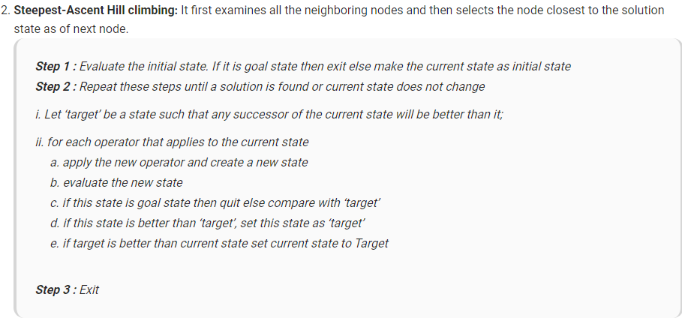
Figure 1 [1]
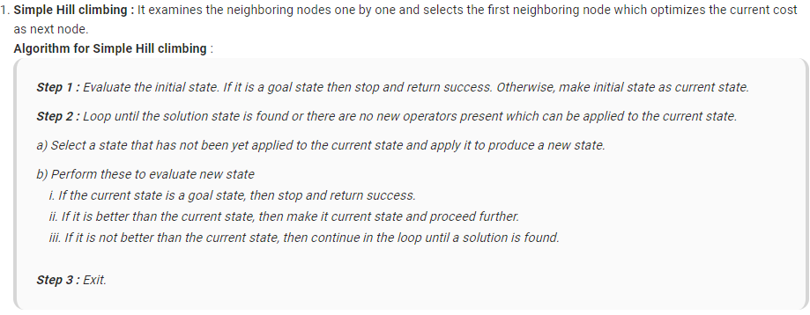
Figure 2 [1]
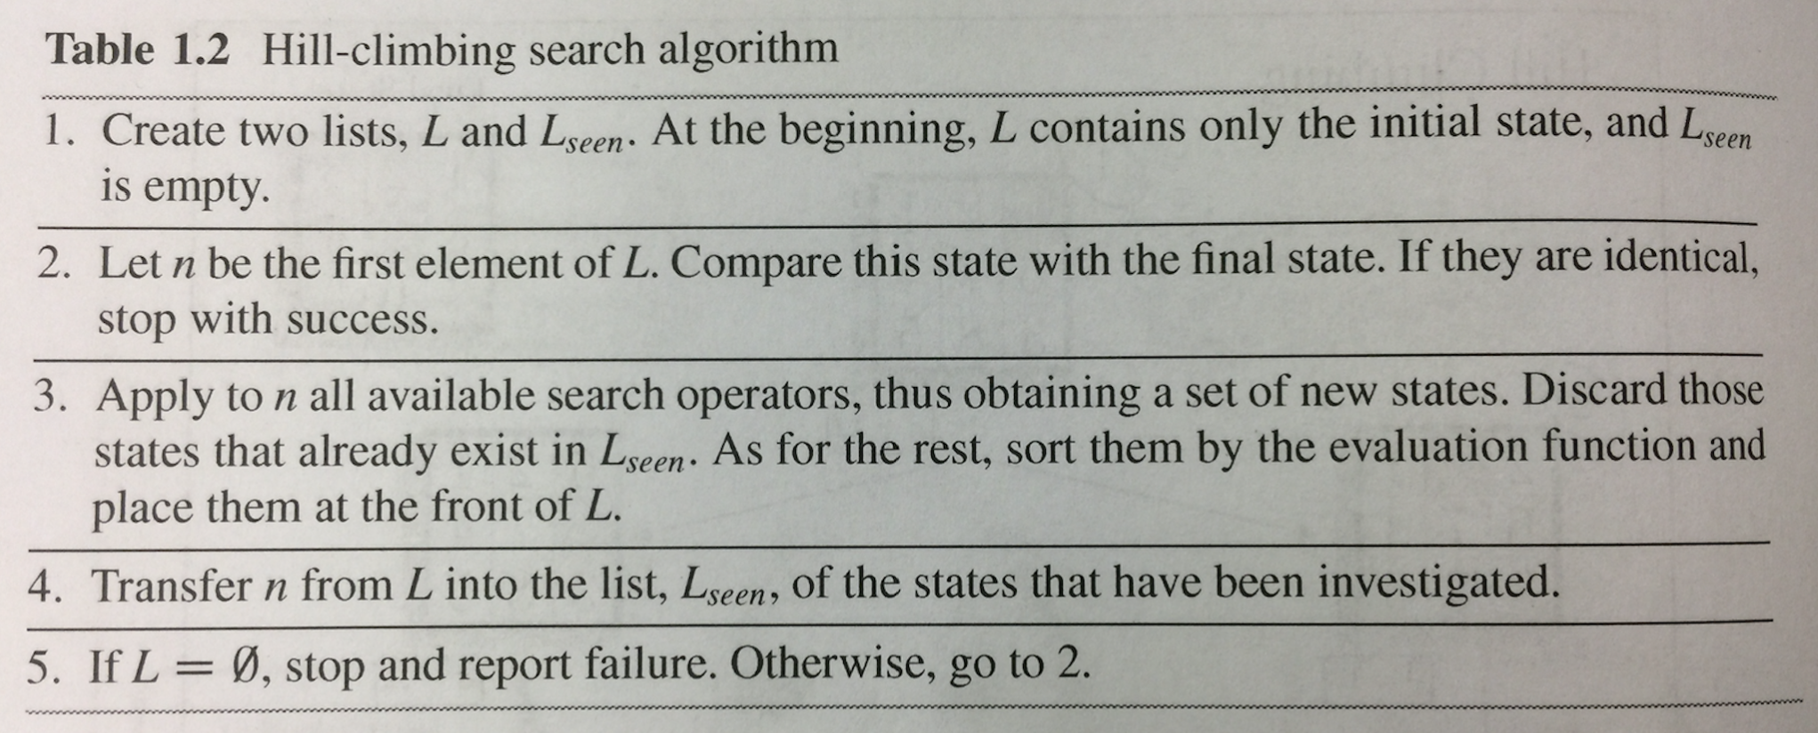
Figure 3 [2]

The Steeple Assent Hill Climbing is the best method for solving the problem of 8 tile search algorithm at this moment in time, but it has the flaw that the search algorithm will always choose the best-looking solution not the most optimum solution.
This is known as “local maximum” [1] this is when the algorithm thinks that it has found the most optimal solution, as it is much better than its neighbouring options, however, there is a state even better known as the “global maximum”. [1] The global maximum is better as it is the most optimal solution.
The way to fix the problem of “local maximum” [1] is to code in backtracking; this is where the code records all options available and then chooses the best available option. If it reaches an undesired state, the algorithm can backtrack to previously available options and explore a new path.
By critically analysing the two types of hill climbing of: simple and steepest we can determine they all have strong points and week points for example

Simple: will test by swapping things it tends to be fast but in return gives a less then perfect answer and might never find the answer to the puzzle.

Steepest: give good quick results on simple puzzles but can get take forever with complex puzzles as it goes around and round looking for the answer of best choice creating an endless loop to fix this we add backtracking as said above this means it will truly find the best path and not just a best-looking path that leads to a dead end or a cliff.
When critically evaluating the hill climbing methods, we are looking for the most reliable method for solving the puzzle of 8 tile, as such the best choice for the solution will be steeple assent hill climbing, as it is not only the most reliable method to solve the puzzle compared to simple hill climbing, that has a good chance of getting into an infinite loop.
When we take into account the known flaws in both methods of hill climbing: steeple assent hill climbing becomes even better as it then has backtracking, meaning it is much more likely to find the most optimal answer and the true answer not getting stuck on a “local maximum” [1]. When we compare this to simple hill climbing there is much more work needed to fix the error of infinite loops and even more to get it to solve the puzzle reliably. This means when critically analysing for this problem steeple assent hill climbing is the best solution.

- The grid below shows the starting positions of tiles of an 8-tiles problem.
1 | 4 | 2
3 | 5 | 8
6 |  | 7
The idea of the puzzle is to move one tile at a time into the adjacent free space until the final “solved” combination of tiles is found. Here the finishing puzzle is:-
 | 1 | 2
3 | 4 | 5
6 | 7 | 8
Illustrate how hill-climbing is used to solve this problem by working through your problem one move at a time.
Student Number: 1911017
1 | 4 | 2
3 | 5 | 8
6 |  | 7

Current:
h=5
Next positions:
h=6,4,5

Start tiles above

1 | 4 | 2
3 | 5 | 8
6 |  | 7

Current:
h=5
Next positions:
h=6,4,5

1 | 4 | 2
3 | 5 | 8
6 | 7

Current:
h=4
Next positions:
h=5,3

1 | 4 | 2
3 | 5
6 | 7 | 8

Current:
h=3
Next positions:
h=4,4,2

1 | 4 | 2
3 |  | 5
6 | 7 | 8

Current:
h=2
Next positions:
h=3,3,3,1

1 |  | 2
3 | 4 | 5
6 | 7 | 8

Current:
h=1
Next positions:
h=0,2,2

 | 1 | 2
3 | 4 | 5
6 | 7 | 8

Current:
h=0
Next positions:
H = -

What to hand in for Task 1 and 2
- A written report, clear sectioned, detailing your answers submitted via TurnItIn and a copy of your working VS code, submitted separately to the assignment link in the module’s Moodle pages.

Variables, functions and user guide

User guide:
The user can either play themselves or give it to the AI to play

If given to the AI the game once started auto completes this is due to the ai talking the controls and solving the puzzle as it was instructed

If the player plays it will go through in the same method just with user controls of w,a,s,d

Global variables

Variable and type | description
enum move myMove; | Keeps track of moves and allows movements
int tiles[3][3]; | Keeps track of puzzle at the moment
int solution[3][3}; | Keeps track of desired outcome
int score = 0; | Keeps track of overall score
int temp_score = 0; | Score won in the game before being added to global score
int h = 0; | Keeps track of number of pieces out of place
int x; //blank x position | Current 0 position x direction
int y; //blank y position | Current 0 position y direction
int movesmade = 0; | Keeps track of number of moves made
int temp; | Used for swapping tile locations around
int hbefore = h; | Used for keeping track of what h was before moving any pieces
int hright = 10; | H right works out if piece moves to right h value
int hleft = 10; | H left works out if piece moves to left h value
int hup = 10; | H up works out if piece moves to up h value
int hdown = 10; | H down works out if piece moves to down h value

function | What it does | Image of working
myPuzzle.display(); | Shows the moved pieces | 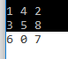
myPuzzle.displayA(); | Shows the expected solution | 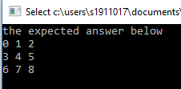
myPuzzle.AI8solver(); | Finds all 5 values in all directions | 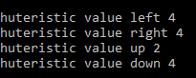
myPuzzle.AI8choice(); | Showing it making its own choice after getting the h values | 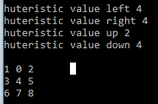
myPuzzle.swap(); | Swaps tiles as can be seen from image on the left | 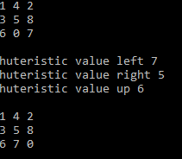
myPuzzle.huturistic(); | Finds all pieces out of place
myPuzzle.finished(); | Says congratulations and starts the next puzzle | 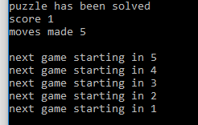
Errors I found in game two | Due to the way h directions work if 2 values can be made correct it duplicates the number and puts it in both spots as you can see from the image | 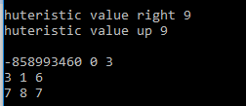

Task 3 8 tile code

#include <iostream>
#include<chrono>
#include<thread>
#include <stdlib.h>

using namespace std;
enum move { NONE, UP, DOWN, LEFT, RIGHT };
class EightTile
{
public:
EightTile(); //constructor
void random(void); //swap the tiles randomly to make a new puzzle
void setMove(enum move); //select direction
void displayA(void); //draw puzzle answer
void display(void); //draw puzzle
void swap(void); //swap blank with selected tile
void finished(void); //is the puzzle solved
void huturistic(void); //number of spots in the wrong placer
void AI8choice(void); //finds the best pick for huristic values
void AI8solver(void); //automatically solve 8 tile useing huteristic value
bool okLeft(void); //can I move left
bool okRight(void);//can I move right
bool okUp(void);//can I move up
bool okDown(void);//can I move down

private:
enum move myMove;
int tiles[3][3]; //puzzle now
int solution[3][3];//puzzle at start (solved).
int score = 0; // running score
int temp_score = 0; // running score
int h = 0; // global h
int x; //blank x position
int y; //blank y position
int movesmade = 0; //keeps track of all moves made
int temp; // used for all swaps made global as there 10 4 different locations makeing the variable otherwise

int hbefore = h; // used to compare the original h value against the later h values
int hright = 10; // starts at 10 as it is higher than the total number and will never have that many h used to find h right
int hleft = 10; // starts at 10 as it is higher than the total number and will never have that many h used to find h left
int hup = 10; // starts at 10 as it is higher than the total number and will never have that many h used to find h hup
int hdown = 10; // starts at 10 as it is higher than the total number and will never have that many h used to find h hdown

};

EightTile::EightTile()
{
myMove = NONE; //initialize member attributes
x = 1; //initial blank position - make sure this agrees with set puzzle!
y = 2;

tiles[0][0] = 1; tiles[1][0] = 4; tiles[2][0] = 2; //set up puzzle tiles
tiles[0][1] = 3; tiles[1][1] = 5; tiles[2][1] = 8;
tiles[0][2] = 6; tiles[1][2] = 0; tiles[2][2] = 7;

solution[0][0] = 0; solution[1][0] = 1; solution[2][0] = 2; //set up solved puzzle tile positions
solution[0][1] = 3; solution[1][1] = 4; solution[2][1] = 5;
solution[0][2] = 6; solution[1][2] = 7; solution[2][2] = 8;
displayA();
}

void EightTile::displayA(void)
//draw puzzle answer
{
cout << "the expected answer below " << endl;
cout << solution[0][0] << " " << solution[1][0] << " " << solution[2][0] << endl;
cout << solution[0][1] << " " << solution[1][1] << " " << solution[2][1] << endl;
cout << solution[0][2] << " " << solution[1][2] << " " << solution[2][2] << endl;
cout << " " << endl;
}

void EightTile::display(void)
//draw puzzle as it is now
{
cout << " " << endl;
cout << tiles[0][0] << " " << tiles[1][0] << " " << tiles[2][0] << endl;
cout << tiles[0][1] << " " << tiles[1][1] << " " << tiles[2][1] << endl;
cout << tiles[0][2] << " " << tiles[1][2] << " " << tiles[2][2] << endl;
cout << " " << endl;

}

void EightTile::setMove(enum move m)
//sets which way you want to move
{
myMove = m;
}
void EightTile::swap(void)
//attempts to move blank in direction set - up, down, left or right by doing a tile/blank swap
//can't move beyond edges of puzzle
{

if (okLeft() & (myMove == LEFT)) {
temp = tiles[x - 1][y];
tiles[x - 1][y] = tiles[x][y];
tiles[x][y] = temp;
x = x - 1;
movesmade++;
}
if (okRight() & (myMove == RIGHT)) {
temp = tiles[x + 1][y];
tiles[x + 1][y] = tiles[x][y];
tiles[x][y] = temp;
x = x + 1;
movesmade++;
}

if (okUp() & (myMove == UP)) {
temp = tiles[x][y - 1];
tiles[x][y - 1] = tiles[x][y];
tiles[x][y] = temp;
y = y - 1;
movesmade++;
}
if (okDown() & (myMove == DOWN)) {
temp = tiles[x][y + 1];
tiles[x][y + 1] = tiles[x][y];
tiles[x][y] = temp;
y = y + 1;
movesmade++;
}
}

void EightTile::random(void)
//swaps the starting puzzle pieces making it random
{

srand(time(NULL));
for (int I = 0; I < 5; I++)
{
for (int j = 0; j < 5; j++)
{
int random = rand() % 8 + 1;

// moves left if chosen
if (okLeft() && random == 1 || random == 8) {
temp = tiles[x - 1][y];
tiles[x - 1][y] = tiles[x][y];
tiles[x][y] = temp;
x = x - 1;
}

// moves right if chosen
else if (okRight() && random == 2 || random == 7) {
temp = tiles[x + 1][y];
tiles[x + 1][y] = tiles[x][y];
tiles[x][y] = temp;
x = x + 1;
}

// moves up if chosen
else if (okUp() && random == 3 || random == 6) {
temp = tiles[x][y - 1];
tiles[x][y - 1] = tiles[x][y];
tiles[x][y] = temp;
y = y - 1;
}

// moves down if chosen
else if (okDown() && random == 4 || random == 5) {
temp = tiles[x][y + 1];
tiles[x][y + 1] = tiles[x][y];
tiles[x][y] = temp;
y = y + 1;
}
}
}
}

void EightTile::finished(void)
//checks if the puzzle is solved or not
{
if (tiles[0][0] == solution[0][0] && tiles[1][0] == solution[1][0] && tiles[2][0] == solution[2][0]) {
if (tiles[0][1] == solution[0][1] && tiles[1][1] == solution[1][1] && tiles[2][1] == solution[2][1]) {
if (tiles[0][2] == solution[0][2] && tiles[1][2] == solution[1][2] && tiles[2][2] == solution[2][2]) {

cout << endl;
cout << "puzzle has been solved";
cout << endl;
temp_score++;
cout << "score " << temp_score;
cout << endl;
cout << "moves made " << movesmade;
cout << endl;
cout << endl;
for (int i = 5; i > 0; i--)
{
cout << "next game starting in " << i;
this_thread::sleep_for(1s);
cout << endl;
}
cout << endl;
EightTile puzzle2;//create class and init.
movesmade = 0;

char d; //keyboard interface valid values a,s,w,d, f
cout << "keyboard controls W,A,S,D, F for AI ";

while (true) //go forever
{
puzzle2.display(); //draw puzzle
cin >> d;
if (d == 'f' || d == 'F')
{
while (true)
{
puzzle2.random(); // randomises the puzzle
puzzle2.display(); //draw puzzle
puzzle2.AI8choice(); // gets all values for h in all directions
puzzle2.AI8solver(); // makes swaps depending on lowest h value
puzzle2.swap(); //move blank
puzzle2.huturistic(); //checks puzzle peices in wrong spot for total wrong places
puzzle2.finished(); //cout if finished
this_thread::sleep_for(1s);
}
}
else
{
while (true)
{
cin >> d;
if (d == 'a' || d == 'A') puzzle2.setMove(LEFT);
if (d == 'd' || d == 'D') puzzle2.setMove(RIGHT);
if (d == 'w' || d == 'W') puzzle2.setMove(UP);
if (d == 's' || d == 'S') puzzle2.setMove(DOWN);
puzzle2.swap(); //move blank
puzzle2.display(); //draw puzzle
puzzle2.huturistic(); //checks puzzle peices in wrong spot for total wrong places
puzzle2.finished(); //cout if finished

}
}
}
}
}
}
}

void EightTile::huturistic(void)
//checks if the puzzle is solved or not
{
h = 0;
for (int I = 0; I < 3; I++) {
for (int J = 0; J < 3; J++) {
if (tiles[J][I] == solution[J][I]) {
// do nothing as they are in correct place
}
else
{
h++;
}
}
}
}

void EightTile::AI8choice(void)
//gets H for choices in all directions
{

// checks left h value if move valid
if (okLeft()) {
temp = tiles[x - 1][y];
tiles[x - 1][y] = tiles[x][y];
tiles[x][y] = temp;
x = x - 1;
huturistic(); //checks puzzle peices in wrong spot
hleft = h; // sets hleft to what was just checked
cout << "huteristic value left " << hleft;
cout << endl;
// sets the peice back in the starting place before allowing the other checks to fire
temp = tiles[x + 1][y];
tiles[x + 1][y] = tiles[x][y];
tiles[x][y] = temp;
x = x + 1;
}

// checks right h value if move valid
if (okRight()) {
temp = tiles[x + 1][y];
tiles[x + 1][y] = tiles[x][y];
tiles[x][y] = temp;
x = x + 1;
huturistic(); //checks puzzle peices in wrong spot
hright = h; // sets hright to what was just checked
cout << "huteristic value right " << hright;
cout << endl;

// sets the peice back in the starting place before allowing the other checks to fire
temp = tiles[x - 1][y];
tiles[x - 1][y] = tiles[x][y];
tiles[x][y] = temp;
x = x - 1;
}

// checks up h value if move valid
if (okUp()) {
temp = tiles[x][y - 1];
tiles[x][y - 1] = tiles[x][y];
tiles[x][y] = temp;
y = y - 1;
huturistic(); //checks puzzle peices in wrong spot
hup = h; // sets hup to what was just checked
cout << "huteristic value up " << hup;
cout << endl;

// sets the peice back in the starting place before allowing the other checks to fire
temp = tiles[x][y + 1];
tiles[x][y + 1] = tiles[x][y];
tiles[x][y] = temp;
y = y + 1;
}

// checks down h value if move valid
if (okDown()) {
temp = tiles[x][y + 1];
tiles[x][y + 1] = tiles[x][y];
tiles[x][y] = temp;
y = y + 1;
huturistic(); //checks puzzle peices in wrong spot
hdown = h; // sets hdown to what was just checked
cout << "huteristic value down " << hdown;
cout << endl;

// sets the peice back in the starting place before allowing the other checks to fire
temp = tiles[x][y - 1];
tiles[x][y - 1] = tiles[x][y];
tiles[x][y] = temp;
y = y - 1;
}

}

void EightTile::AI8solver(void)
//checks if the puzzle is solved or not
{

if (hleft < hright && hleft < hup && hleft < hdown)
{
temp = tiles[x - 1][y];
tiles[x - 1][y] = tiles[x][y];
tiles[x][y] = temp;
x = x - 1;
movesmade++;
}

else if (hright < hleft && hright < hup && hright < hdown)
{
temp = tiles[x + 1][y];
tiles[x + 1][y] = tiles[x][y];
tiles[x][y] = temp;
x = x + 1;
movesmade++;
}

else if (hup < hright && hup < hleft && hup < hdown)
{
temp = tiles[x][y - 1];
tiles[x][y - 1] = tiles[x][y];
tiles[x][y] = temp;
y = y - 1;
movesmade++;
}
else if (hdown < hright && hdown < hup && hdown < hleft)
{
temp = tiles[x][y + 1];
tiles[x][y + 1] = tiles[x][y];
tiles[x][y] = temp;
y = y + 1;
movesmade++;
}
else
{
srand(time(NULL));
for (int I = 0; I < 1; I++)
{
int random = rand() % 8 + 1;

// moves left if chosen
if (okLeft() && random == 1 || random == 8) {
temp = tiles[x - 1][y];
tiles[x - 1][y] = tiles[x][y];
tiles[x][y] = temp;
x = x - 1;
}

// moves right if chosen
if (okRight() && random == 2 || random == 7) {
temp = tiles[x + 1][y];
tiles[x + 1][y] = tiles[x][y];
tiles[x][y] = temp;
x = x + 1;
}

// moves up if chosen
if (okUp() && random == 3 || random == 6) {
temp = tiles[x][y - 1];
tiles[x][y - 1] = tiles[x][y];
tiles[x][y] = temp;
y = y - 1;
}

// moves down if chosen
if (okDown() && random == 4 || random == 5) {
temp = tiles[x][y + 1];
tiles[x][y + 1] = tiles[x][y];
tiles[x][y] = temp;
y = y + 1;
}
}
}
}

bool EightTile::okLeft(void)
//can I move left?
{

if (x > 0)
return true; else return false;
}
bool EightTile::okRight(void)
//can I move right?
{
if (x < 2)
return true; else return false;
}
bool EightTile::okUp(void)
//can I move up?
{
if (y > 0)
return true; else return false;
}
bool EightTile::okDown(void)
//can I move down?
{
if (y < 2)
return true; else return false;
}

int main(void)
{
//simple program to exercise puzzle by moving blank around
//and drawing tiles
EightTile myPuzzle;//create class and init.
this_thread::sleep_for(2.5s);
char d; //keyboard interface valid values a,s,w,d, f
cout << "keyboard controls W,A,S,D, F for AI ";

while (true) //go forever
{
myPuzzle.display(); //draw puzzle
cin >> d;
if (d == 'f' || d == 'F')
{
while (true)
{
myPuzzle.display(); //draw puzzle
myPuzzle.AI8choice(); // gets all values for h in all directions
myPuzzle.AI8solver(); // makes swaps depending on lowest h value
myPuzzle.swap(); //move blank
myPuzzle.huturistic(); //checks puzzle peices in wrong spot for total wrong places
myPuzzle.finished(); //cout if finished
this_thread::sleep_for(1s);
}
}
else
{
while (true)
{
cin >> d;
if (d == 'a' || d == 'A') myPuzzle.setMove(LEFT);
if (d == 'd' || d == 'D') myPuzzle.setMove(RIGHT);
if (d == 'w' || d == 'W') myPuzzle.setMove(UP);
if (d == 's' || d == 'S') myPuzzle.setMove(DOWN);
myPuzzle.swap(); //move blank
myPuzzle.display(); //draw puzzle
myPuzzle.huturistic(); //checks puzzle peices in wrong spot for total wrong places
myPuzzle.finished(); //cout if finished

}
}

}
return 0;
}//the end

