3D Animation
Facial Animation in Film and Media.
R. Kane Morris

1. Abstract
This research paper will study facial animation within 3D animated movies and games and how desired expressions are achieved without being overshot (into the uncanny valley), misinterpreted by the audience or fall short and not convey the wanted emotion to the viewers.
Exaggeration (one of the twelve principals of animation) comes into play a lot with facial animation on 3D characters, mainly being used more on anthropomorphic character designs. Through the research, this was found as a necessary part of portraying the needed emotions on non-human characters. During this paper, this research investigates the construction of character emotions and furthermore, how a non-human character tends to differ from human design. Exaggeration although used in most animated characters today both in the 2D and 3D world is pushed further in the anthropomorphic characters over the human designs. If the same amount of exaggeration was to be used with a human character it would fall into the ‘the uncanny valley’ although with anthropomorphic characters, it is harder to recognise these traits. Stylised human characters can also be animated with more exaggeration than a design closer to being anatomically correct. This paper will primarily focus on anthropomorphic 3D character designs as I believe these problems will be most obvious within these characters.

2. Introduction
Facial expressions have been a key part in the way humans communicate since we walked the earth. We see them in everyday life in media such as in 2D and 3D animated movies, live action films and video games.
The primary purpose of this research paper is to identify the problems and methods of overcoming these tasks when giving a 3D character facial emotion. This paper will discuss how "Exaggeration" is used to achieve the desired outcome without making the expression unbelievable or missing the mark of the needed emotion. Anatomy is also a key factor when creating emotions on non-human character designs, this paper will explore changes in anatomy and uses of exaggeration used within the industry on feature films and also within games.
The "Exaggeration" principle comes from "The Illusion of Life: Disney Animation" (Frank Thomas, Ollie Johnston,1981). In this book, the twelve principles of animation were first publicised. Exaggeration is not the only principle to come into facial animation.
1. Squash and Stretch
2. Anticipation
3. Staging
4. Straight Ahead Action and Pose to Pose
5. Follow Through and Overlapping Action
6. Slow In and Slow Out
7. Arc
8. Secondary Action
9. Timing
10. Exaggeration
11. Solid drawing
12. Appeal
Of these principles, “Squash and Stretch”, “Anticipation”, “Ease in and out”, “Timing” and “Exaggeration” will be discussed when studying the methods used in the animation industry. For example, with ‘Timing’ the point in which the character’s face changes can be important; too soon and character reacts to the wrong prompt; too late and the audience becomes unsure how to react. What the character is doing is also important to when an expression is triggered, such as if the character is going through an action or there is a shot transition, the facial expression could be missed by the viewers altogether as they are focused or distracted on the action or transition taking place.
In animation, facial animation has an extremely important role. It reveals what the character is thinking, planning or feeling in that situation and moment. Done incorrectly it can carry a completely different message to the audience. This is where the illusion of life can truly resonate, giving the impression the character is thinking for themselves and spontaneity. Sight, hearing, smell, taste and touch, these are all things that can affect the character physically or emotionally and provoke a reaction from the animated character. If a character fails to react to a change in temperature, environment or action it can make the character seem fake. The 3D character needs expressions if you want them to seem "alive", not just moving around on screen. In its element, ‘exaggeration’ is the action of focusing or choosing certain features or parts to push beyond their normal positions or abilities. This could be the ends of the mouth, making a smile wider than it should be or is possible to be, this was done in Disney’s Zootopia (2016 Byron Howard, Rich Moore) where the animal characters expressions were pushed passed what is anatomically possible. This involved both “Exaggeration” and “Squash and Stretch” principals.

3. Methodology
There are numerous methods in which this paper can research the problems and methods of portraying 3D character facial animation and expressions. Only the most applicable to effectively research and analyses the effects of these methods, such as "Exaggeration" and other approaches to creating and animating effective facial expressions on these 3D characters. This paper will use both qualitative and based on my own practices researching and exploration of this topic. The following quote suggests a method used to enable the animation of anthropomorphic design-based characters when it comes to adding expression and emotion such as in a human.
‘If an animal in a film is wearing any kind of costume, he can be handled with human attributes and the audience will accept him. In contrast, if an animal in his natural fur should suddenly stand up and start gesticulating, the viewers will feel uneasy. Put a cap on him, or a tie, and he can swagger around, gesturing and pointing like any ham actor.’
-The Illusion of Life, page 331.
Following this, a quote from Walt Disney, emphasising the need to know and understand the real aspect of a character is brought to light.
‘“I definitely feel that we cannot do the fantastic things based on the real, unless we first know the real.” - Walt Disney
The Illusion of Life, page 71.

Animation at its core is part of creative arts like all creative media is subject to personal opinions. However, there will be key underlining expressions, such as with an upset or distressed child expression will appear as distressed to most audiences however, when portraying this on an animated character may appear too upset or not upset enough to show the true weight of the situation at hand. The argument could be raised that the human is simply "overreacting", however, this will be up to the animator to make sure the audience sees the desired emotion and are therefore hit by the emotional impact or feeling intended while watching the movie or playing the game.
Papers and writings from other animators in the field as well as behind the scenes documentaries of movies such as “Finding Nemo” (Andrew Stanton, Lee Unkrich 2003) and “Zootopia (Zootropolis UK title)” (Byron Howard, Rich Moore 2016). These will be used to identify changes made to the anatomy of animals as well as the level of “Exaggeration” needed to enable the audience to translate these non-human 3D animated character’s expressions.

4. Critical and Contextual Review
During the production of Finding Nemo (2003), John Lasseter said,
“I’ve always believed in research, no matter the subject manner”, “you cannot do enough research”.
He was talking about getting the characters and environment correct for the film as the audience will believe in what is real. On the contrary during the production of Zootopia (2016) in the research stage of development, an interesting quote was made,
“We’re going to have to look into our designs, I don’t think we can actually animate the mouth shapes like we need to”
-Renato Dos Anjos (Head of Animation – Zootopia 2016)
This highlights the need for research and planning to make the 3D characters capable of displaying the needed emotions throughout the movie. Even though as John Lasseter said with people believing what is real on screen, a compromise must be made between what is “real” and what is needed for the movie.
“When we say “real,” we mean only what the audience accepts as being real, for obviously a real animal cannot act or emote as broadly as animators require. The more an animator goes toward caricaturing the animal, the more he seems to be capturing the essence for acting. For example, if we had drawn real deer in ‘Bambi’ there would have been so little acting potential that no one would have believed the deer really existed as characters. But because we drew what people imagine a deer looks like, with a personality to match, the audience accepted our drawings as being completely real.”
(Thomas, F. and Johnston, O. (1981). The illusion of life. Disney Editions, pp.332.)
During the design stages of development, the character artists must decide how much they wish to keep anatomically correct or how much they wish to bend the rules to allow for the character to express the needed emotions to tell the story.

5. Project-Specific Research
As well as qualitative research, practice-based methods are also exercised for this research paper. This has been completed to assess how far an emotion can be pushed before it conveys the wrong or removes the emotion as well as how much an emotion needs to be exaggerated to show the desired expression.
With Nick Wilde, one of the main characters from 2016’s Zootopia, “exaggeration” and “squash and stretch” are used a considerable amount throughout the film.
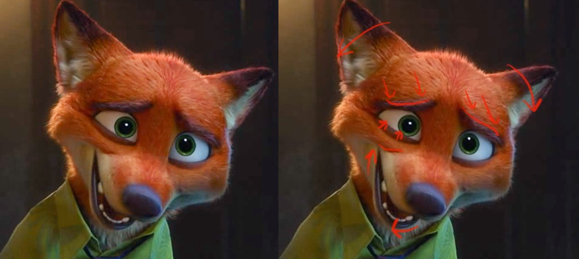
In this example, the anatomy has been amended to allow the character to portray human emotions. This expression works incredibly well with Nick, showing he is uncertain in the excuse he is making. However, when attempting the expression myself or on a human following the correct anatomy the facial expression becomes "overacted", awkward and unnatural.
Animal characters have other features, not available with human rigs though thus enabling other ways to add to an emotion. Multiple quotes from The Illusion of Life backup this idea.
“Ears are an important part of the attitude on any animal.”
“Tails can do much to show the mood of an animal. They can give a perky feeling, or show dejection, or affection. They should not rest on the ground without a reason. They must have life too. Watch out for “dead” tails”
“‘The neck is often passed over when considering parts of the anatomy that can help show an attitude. It can be arched for belligerence, show alertness, be cocky with chest out, or indicate anger.”
(Thomas, F. and Johnston, O. (1981). The illusion of life. Disney Editions, pp.340.)
All these assets can aid in a facial expression’s believability or ease of understanding the characters feelings and thought processes. Humans can see and notice human emotion easily as we see it every day. We are able to see the emotion in animals as well, especially traits of dogs or even cat emotions.
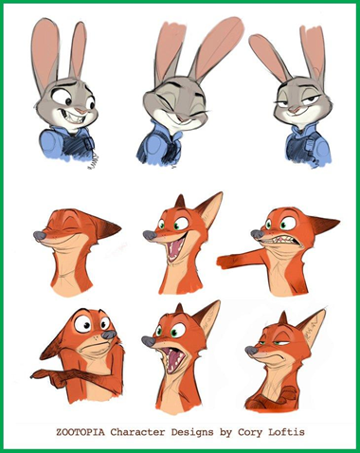
Zootopia (Byron Howard, Rich Moore, 2016) concept art by Cory Loftis.
This piece of concept art from Cory Loftis on Zootopia (2016) shows how much using the animal’s natural aspects can also be used to aid in the display of the wanted emotion. Using the ears to show fear or sadness by lowering them and excitement or happiness by making them stand alert. The expression in the bottom right could have been improved by having his ears down at a close to 90-degree angle to emphasize his boredom/lack of approval but this is down to personal opinion.
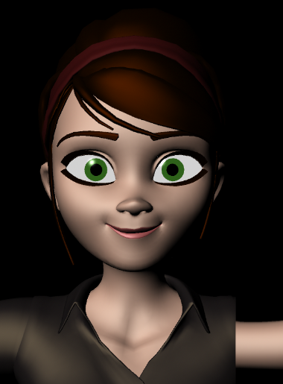
The above image example of the “Mery rig” smiling shows an emotion which can be taken too far. I positioned a simple smile emotion and will push the same moved vertices past the point of believability or to the point where the animated expression on the 3D character no longer portrays the aimed for expression intended. This will allow me to push past the point of believability or enter the uncanny valley. When this happens in a film it will break the audience's emersion and distance the audience from the film and character. Doing the opposite and not giving the expression enough exaggeration can lead to the emotion being overlooked or miss understood.
An emotion is a natural reaction to an input, be that from sight, smell, touch or sound. The expression must be seamless when the character expresses it to the audience. If it is forced, it will seem unnatural to the viewing audience. The expression needs to also be clear if you want the audience to connect with the character in the scene, for example, if the character does an action or full body movement at the same time as a facial expression the audience may miss the emotion in the character. This means when creating the emotion, you must decide at which point it is best for the character to display the expression while also making sure it remains a spontaneous and natural reaction. Making these expressions spontaneous gives the character the illusion of life. The exercises of pushing a character beyond what is believable are referred to as the "uncanny valley". This is when an object appears to look human but not exactly creating an uneasy feeling when looking at it and destroying any and all believability in the object or in our case, the 3D character.
The rest of the research for this paper comes from behind the scenes and documentaries as well as papers and writing from people within the industry. These include animated movies such as “Finding Nemo”, Zootopia” and other films which may aid the research of this paper.

6. Results
The first test was a simple one. Using the Mery project 3D rig I moved her mouth vertices to give her a simple innocent smile before moving the same mouth vertices again but to a greater exaggeration. The image below this shows the expression has been taken too far and is now unbelievable for the audience. It can also be interpreted as a more devious smile with darker intentions over the intended happy, content expression which was originally aimed for.
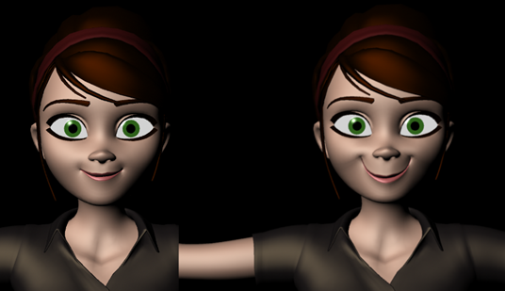
During this test, while also looking at anthropomorphic characters, I found the point of the expression becoming unbelievable was different as you can push the expressions more before it becomes obvious that something is wrong. This is the same with stylised human 3D characters compared to real human characters following the true anatomy of real humans. This was as expected as humans are used to seeing other humans and see emotions and expressions every day of their lives. But with non-human anthropomorphic 3D characters such as Nick Wilde, noticing and interpreting expressions is less natural for us, this means the expressions need to be pushed more than on a human and also are able to be pushed this far without it seeming forced or false to the audience.
To avoid having to work out how much emotion is needed, games such as Hellblade: Senua's Sacrifice (Ninja Theory 2017) used real-time motion tracking on both the characters face and body. Using an actress, they set up motion capture and paired it with facial tracking when using the unreal engine to real-time render the actress's performance on screen, live to the developers. They were able to see the results as they were being performed. This enabled them to give feedback to the actress and reshoot the scene at the same time.

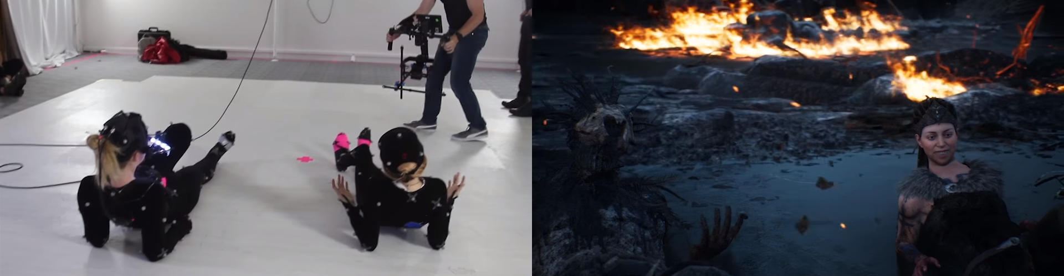
This was a breakthrough in real-time capture as it was the first to display the end result in real time as it was acted out. If the characters facial emotion was too forced or not clear enough, it was simply redone to make sure the desired expressions were achieved. Other movies and game productions have used these technologies before but not integrating it into real time for both the facial expression tracking as well as the body motion capture while rendering an output to the final product level. This was done to such a good quality that the trailer for the game was performed, captured and rendered live to the audience in real time leading up to the games release date.
During looking into the production of Disney’s Zootopia (2016), an important point was made,
“We want them to feel like real animals, not animals we forced human characteristics onto”.
-Cory Loftis (Character Art Director for Disney’s Zootopia, 2016)
The importance of creating the characters to appear alive seem to definitively outweigh them having the characters anatomically correct. However, a balance must be made to keep the characters true to their intended original form or species while designing them to display all the needed human emotions for the story. A similar point was made during the production of 2003's Finding Nemo as fish have far fewer features then humans and definitely far less feature than animals to play with when it comes to creating the expressions of these characters. In the case of the characters for Finding Nemo, the characters were designed with added features/changes to there original real life counterpart’s anatomy, One of these changes was the addition of eyebrows on the fish, this was done to allow for more complex emotions and enable the characters to display all the needed expressions for the main story in a manner in which the audience could easily and naturally convey and interpret. This gives the characters the illusion of feeling human emotions as well as reacting as if they are alive.
During researching I found a video featuring a game called “Beyond: two souls”, the video features the game but with the facial animation of the characters pushed to 500% the original animation.
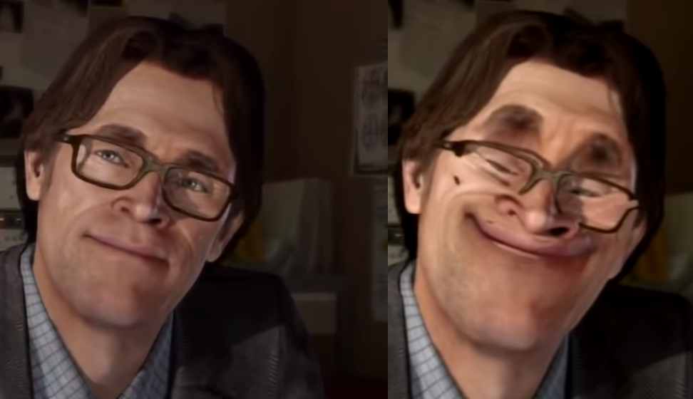
This comparison between the original and altered version of the game forcing the animation on the faces to 500% shows how exaggeration can go too far and give a completely different expression or push the audience or players out of emersion creating a distance and therefore a divide in the viewer's believability in the moment. On the left, we have a natural facial expression and on the right one pushed so far past the uncanny valley to the point of it becoming comedic, which is not the original intent of the scene. Due to this being a human character and not a anthropomorphic character design, it was far easier to see the break in reality and therefore the believability of the expression. The creator of this video has done the same but with other games in similar genres, the results are the same across all the games edited with the facial expression becoming unbelievable to the viewers and of a comedic result instead of their original intended result and atmosphere.

7. Evaluation and Conclusion

Though out this research paper I have studied the processes and design choices made by character artists when approaching their characters with the plan of being able to be animated to display all the complex and desired emotions to successfully be able to tell the story both effectively and in a natural manner.
As expected, when starting this paper, I have found that expressions can be pushed further on anthropomorphic (non-human) characters than on their human counterpart. It was also found for emotions to be able to be pushed more on stylised characters more than atomically correct human figured characters. Within the 3D computer world, we are unlimited to what we wish to create. We can push things as far as we desire. This gives us the power to create whatever we like but also gives us the responsibility of knowing and realising when something has been pushed too far, or not far enough. As artists we need to consider what we wish our character to do before creating the characters 3D mesh, the character must be capable of showing and doing what we want them to do and also do this in an immersive and natural manner, making your character seem alive and to hide the fact they are moved by an animators hand, they must truly seem that they are acting on their own intentions and are a part of the world you have put them in.
I also found it to be necessary, not just possible to push an emotion further into exaggeration in order to successfully and clearly portray the aimed for emotion on an animal character in order for the audience to effectively see and understand the emotion. Humans are not used to reading the emotion of animals, even less so with fish. This meant the character artist had to make changes to the animal’s anatomy to make it possible to display these feelings to the audience, as well as exaggeration in the emotion so it was clear and interpreted correctly on a non-human form. This was a harder task with Finding Nemo as the characters lacked other body parts which would normally aid with emotion, meaning the animators had to include the use of fins and even the bodies position to help aid the emotion and feelings of the animated 3D character.

8. References

Beyond: Two Souls. (2013). [Video Game] Developed by Quantic Dream. Published by Sony Interactive Entertainment

Beyond: First Interview but 500% facial animations (2018) https://www.youtube.com/watch?v=gGgb4OKHfbE (Accessed on 10/12/2018)

Boadway-Masson, D. (2016). Facial Animation 101. [online] animationmentor. Available at: https://blog.animationmentor.com/facial-animation-101/ [Accessed 10 Dec. 2018].

Finding Nemo. (2003). [DVD] Directed by A. Stanton and L. Unkrich. Disney.

Hellblade: Senua's Sacrifice. (2017). [Video Game] Developed and published by Ninja Theory.

Hellblade: Senua’s Sacrifice - Motion capture in the making (2017) https://www.youtube.com/watch?v=smj8i1__bmo Accessed on 10/12/2018

Making of Finding Nemo (2017) https://www.youtube.com/watch?v=UvpUDwlWPxY (Accessed on 10/12/2018) (Also available on Finding Nemo Bonus Features)

Nvidia Face Works Tech Demo Renders Realistic Human Faces. (2013) https://www.youtube.com/watch?v=6cZIaUEmnLI (Accessed 01/11/2018)

Faigin, G. (1990). The artist's complete guide to facial expression. New York: Watson-Guptill.

Julius, J. (2016). The art of Zootopia. San Francisco, CA: Chronicle Books LLC.

Lander, J. (2000). Read My Lips: Facial Animation Techniques. [online] Gamasutra.com. Available at: https://www.gamasutra.com/view/feature/131587/read_my_lips_facial_animation_.php [Accessed 10 Dec. 2018].

Thomas, F. and Johnston, O. (1981). The illusion of life. Disney Editions, pp.71, 331, 332, 340.

Zootopia. (2016). [Movie] Directed by B. Howard and R. Moore. Disney.
- Imagining Zootopia, disc bonus features. https://www.youtube.com/watch?v=1eQgypYsA5U&index=1&list=PL4PxpxvB6U2dZKVptYNYCnBshe-EHWmXX (Accessed on 10/12/2018)

