

March 22, 2026
Analytical Assessment of Engine Internal Components
Contemporary Powertrain Design - ACHA6006
Archie Coveney
Andrew Noble
University of Wales Trinity Saint David
Word Count Excluding Bibliography, Appendices, Equations, Tables and Figures: 2717

Abstract
This report presents the fatigue and stress of Ford 1.6L GTDi EcoBoost engine's bottom-end components using MATLAB, incorporating slider-crank kinematics and in-cylinder pressure data. Components such as the connecting rod bolt, Gudgeon pin, and conrod midpoint were tested under cyclic loading at 6000 and 9000 RPM. Fatigue safety factors, assessed via the Goodman criterion, identified the conrod bolt as the critical component. A geometry-based redesign increased the tensile stress area by 5.7%, restoring baseline safety at higher speeds. Material upgrades to 1200 MPa steel enhanced fatigue performance without adding weight. Comparisons of crankshaft torque between flat and cross-plane configurations showed identical average torque but a 202.8% increase in peak-to-peak torque ripple for the cross-plane setup.

Table of Contents
Abstract II
Table of Figures IV
Table of Tables IV
List of Abbreviations IV
1.0 Introduction 5
2.0 Methodology and Assumptions 6
2.1 Engine Geometry and Input Data 6
2.2 Stress and Fatigue Analysis Approach 6
2.2.1 Bolt Tightening Torque Specification 6
2.3 Assumptions and Limitations 7
2.3.1 Bolt Preload Sensitivity 7
2.4 Model Validation 8
3.0 Baseline Stress & Fatigue Analysis 9
3.1 Force Results 9
3.2 Stress Results 10
3.2.1 Conrod Bolt Stress 10
3.2.2 Gudgeon Pin Stress 10
3.2.3 Conrod Midpoint Stress 11
3.2.4 Conrod Little-End Hoop Stress 11
3.3 Fatigue Safety Factors 12
3.4 Critical Discussion 13
4.0 Extended RPM Analysis to 9000 RPM 14
4.1 Interpolation Method 14
4.2 Revised Loads & Stresses 14
4.3 Fatigue Safety Factor Comparison 15
4.4 Discussion 15
5.0 Conrod Bolt Redesign 16
5.1 Design Objective 16
5.2 Geometry Changes 16
5.3 Revised Stress & Goodman Analysis 17
5.4 Engineering Justification 17
5.5 Alternative Material Evaluation 18
5.6 Thread Root Stress Concentration Sensitivity 19
6.0 Crankshaft Torque Comparison 20
6.1 Standard Flat-Plane Configuration 20
6.2 Cross-Plane Configuration 20
6.3 Comparative Discussion 21
7.0 Conclusion 22
Bibliography 23
Appendix A — Hand Calculations 24
Key Derivations at θ = 19° Crank Angle 24
Stiffness Model 24
Critical RPM 25
Stress 25
Waisted Bolt Shank – Stiffness and FSF Calculation 26
Consistency 26
Torque Validation 27
Appendix B — MATLAB Script 28

Table of Figures
Figure 2.1 — Model Validation: Brake Torque & Power vs Ford 1.6 GTDi EcoBoost 150ps (Ford Component Sales) 8
Figure 3.1 — Net Piston Axial Force vs Crank Angle (6000 RPM) 9
Figure 3.2 — Piston Lateral Force and Friction Force vs Crank Angle (6000 RPM) 9
Figure 3.3 — Conrod Bolt Stress vs Crank Angle (6000 RPM) 10
Figure 3.4 — Gudgeon Pin Von Mises Stress (6000 RPM) 10
Figure 3.5 — Conrod Midpoint Stress vs Crank Angle (6000 RPM) 11
Figure 3.6 — Conrod Little End Hoop Stress vs Crank Angle (6000 RPM) 12
Figure 3.7 — Goodman Diagram: Conrod Bolt (6000 RPM) 13
Figure 3.8 — Goodman Diagram: Gudgeon Pin at Point A (6000 RPM) 13
Figure 3.9 — Goodman Diagram: Conrod Midpoint 13
Figure 4.1 — Conrod Bolt Stress Comparison: 6000 RPM vs 9000 RPM 14
Figure 4.2 — Goodman Diagram: Conrod Bolt at 6000 and 9000 RPM 15
Figure 5.1 — Conrod Bolt Stress at 9000 RPM: Original vs Redesigned Geometry 16
Figure 5.2 — Goodman Diagram: Original vs Redesigned Bolt at 9000 RPM 17
Figure 5.3 — Goodman Diagram: Geometry and Material Comparison at 9000 RPM 18
Figure 6.1 — Instantaneous Crank Torque: Flat-Plane vs Cross-Plane (6000 RPM) 20

Table of Tables
Table 1 — Tightening Torque vs Thread Friction Coefficient 6
Table 2 — Preload Sensitivity Study (FSF vs Yield Fraction) 7
Table 3 — Analytical Validation and Dimensional Verification (θ = 19° Crank Angle) 8
Table 4 — Little-End Hoop Stress Summary 11
Table 5 — Component Stress Summary and Goodman FSF (6000 RPM) 12
Table 6 — Conrod Bolt Stress Summary: 6000 vs 9000 RPM 14
Table 7 — FSF Comparison 15
Table 8 — Bolt Redesign: Stress Comparison at 9000 RPM 17
Table 9 — Material Comparison: Original Geometry (9000 RPM) 18
Table 10 — Material Comparison: Redesigned Geometry (9000 RPM) 18
Table 11 — Thread Root Stress Concentration Sensitivity 19
Table 12 — Crankshaft Configuration Comparison (6000 RPM) 21

List of Abbreviations
ATDC — After Top Dead Centre
BDC — Bottom Dead Centre
BS EN ISO — British Standard European Norm International Organisation for Standardisation
CSA — Cross-Sectional Area
FE — Finite Element
FSF — Fatigue Safety Factor
GTDi — Gasoline Turbocharged Direct Injection
ICE — Internal Combustion Engine
MATLAB — Matrix Laboratory
NVH — Noise, Vibration and Harshness
RMS — Root Mean Square
RPM — Revolutions Per Minute
SI — Système International (d’Unités)
SWT — Smith-Watson-Topper
UTS — Ultimate Tensile Strength
VDI — Verein Deutscher Ingenieure (Association of German Engineers)

1.0 Introduction
The internal combustion engine is vital to motorsport powertrains, where components endure cyclic loads far exceeding those in passenger cars.
Chmielowiec, Woś and Czyżewski (2025) established that, unlike static loads, inertia and combustion forces on bottom-end parts accumulate over millions of cycles, making fatigue the primary failure mode. The connecting rod (Conrod) assembly is prone to fatigue, with its bolt, Gudgeon pin, and midpoint experiencing axial tension, bending, and hoop stress. Their fatigue margins depend on design and engine speed; inertial forces grow with the square of RPM, so small increases greatly affect fatigue limit reliability. The importance of bottom-end design extends beyond motorsport applications; Brankov (2020) demonstrated that range-extender ICE units used in electric vehicles face similar cyclic loading challenges, highlighting the relevance of bottom-end fatigue analysis across established and emerging powertrain architectures.
This study uses geometry and crank-angle pressure data from a Ford 1.6L GTDi EcoBoost engine, applying slider-crank kinematics and a bolt-stiffness model. Cyclic stresses at 6000 RPM were extrapolated to 9000 RPM. Fatigue safety factors based on the Goodman criterion. The crankshaft torque comparison between flat-plane and cross-plane configurations evaluates their suitability for different applications.

2.0 Methodology and Assumptions

2.1 Engine Geometry and Input Data
The study employed a MATLAB single-cylinder model of the Ford 1.6L GDTi EcoBoost engine, with in-cylinder pressure data converted from bar to SI units. Key parameters included a 79mm bore, 40.7mm crank radius, 134mm con-rod length, and a piston-conrod mass of 0.347kg. Piston kinematics were modelled using the standard slider-crank analytical approach described by Mendes, Meirelles and Zampieri (2008) and grounded in classical engine kinematics theory (Challen and Baranescu, 1999).

2.2 Stress and Fatigue Analysis Approach
The axial stresses on the con-rod bolt and midpoint were computed using a bolted-joint stiffness model that included inertial separation forces under preload. The Gudgeon pin was analysed in bending from load transfer. Stress histories determined mean and alternating stresses, and fatigue safety factors were calculated with the Goodman criterion, using the endurance limit approximated as 0.45 x UTS for steels (Lee et al., 2005; Dowling, 2013).

2.2.1 Bolt Tightening Torque Specification
Following the VDI 2230 systematic calculation procedure for high-duty bolted joints (VDI Richtlinien, 1977), validated by Cardoso et al. (2020), the tightening torque for the M8x1.0 bolt to achieve the target preload was calculated, accounting for thread and under-head friction. Table 1 shows representative values for various friction coefficients.

$$T_{tighten}=F_{i}\frac{p}{2π}+F_{i}\frac{μ_{t} x r_{t}}{cosα}+F_{i} x μ_{h} x r_{h}$$
$$Where: p=thread pitch, r_{t}=thread radius, r_{h}=effective head bearing radius, α=30° (metric thread flank half-angle), μ_t=thread friction, μ_h=under-head friction$$

Table 1 — Tightening Torque vs Thread Friction Coefficient
μ_t | T_lead (N·m) | T_thread (N·m) | T_head (N·m) | T_total (N·m) | % Lead | Assembly Margin
0.10 | 5.01 | 13.37 | 23.71 | 42.09 | 11.9 | 1.168
0.12 | 5.01 | 16.04 | 23.71 | 44.76 | 11.2 | 1.128
0.15 | 5.01 | 20.05 | 23.71 | 48.77 | 10.3 | 1.067
0.18 | 5.01 | 24.06 | 23.71 | 52.79 | 9.5 | 1.006

2.3 Assumptions and Limitations
The model’s simplification was based on assumptions due to incomplete geometric and material data. Two lever-arm scenarios limited Gudgeon pin loading without a detailed load path. The analysis focused on a single-cylinder quasi-static fatigue study, excluding residual and thermal effects.

2.3.1 Bolt Preload Sensitivity
Variations in assembly friction can alter the actual preload, in turn impacting fatigue behaviour. A preload sensitivity study was performed over a range of 60-80% of the bolt yield strength, consistent with the assembly range investigated for Conrod bolts by Jia et al. (2025), with the results listed in Table 2.

Table 2 — Preload Sensitivity Study (FSF vs Yield Fraction)
Fraction of Yield | Inertial Force (N) | FSF 6000 | FSF 9000 | σ Mean 6k (MPa) | σ Alt 6k (MPa) | σ Mean 9k (MPa) | σ Alt 9k (MPa)
0.60 | 25,203 | 1.75 | 1.63 | 598.2 | 14.1 | 603.4 | 31.6
0.70 | 29,404 | 1.51 | 1.42 | 697.2 | 14.1 | 702.4 | 31.6
0.75 | 31,504 | 1.41 | 1.34 | 746.2 | 14.1 | 751.9 | 31.6
0.80 | 33,605 | 1.33 | 1.26 | 796.2 | 14.1 | 801.4 | 31.6
Alternating stress remains unchanged under preload, while mean stress increases in proportion. Although the FSF decreases slightly with preload, it remains above 1 at all yield fractions, so the design conclusions remain unaffected.

2.4 Model Validation
Table 3 shows the results from hand calculations used for model validation (Appendix A), with a maximum error of 0.313%.

Table 3 — Analytical Validation and Dimensional Verification (θ = 19° Crank Angle)
Quantity | Analytical | MATLAB | % Difference
Gas Force (N) | 46,844 | 46,844 | 0.000
Inertia Force @ 6000 RPM (N) | 6,606.28 | 6,627 | 0.313
Net Piston Force (N) | 40,237.72 | 40,233 | −0.011
Rod Force (N) | 40,435.55 | 40,431 | −0.011
Rod Angle φ (°) | 5.67 | 5.67 | 0.000
Acceleration Ratio (9000/6000) | 2.25 | 2.25 | 0.000
Alternating Stress Ratio | 2.24 | 2.25 | <0.1
Validation against published Ford data for the 1.6 GTDi Ecoboost 150ps engine (Figure 2.1) used a calibration factor of 1.067 anchored at peak torque (3000 RPM, 248 Nm), resulting in a mean absolute error of 6.4% across 11 RPM points. The overprediction (up to 19%) reflects the quasi-static assumption excluding high-speed breathing losses.

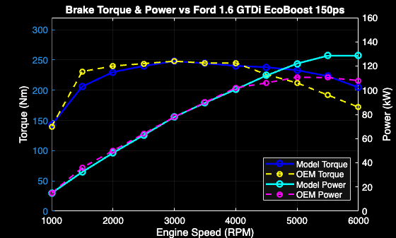
Figure 2.1 — Model Validation: Brake Torque & Power vs Ford 1.6 GTDi EcoBoost 150ps (Ford Component Sales)

3.0 Baseline Stress & Fatigue Analysis

3.1 Force Results
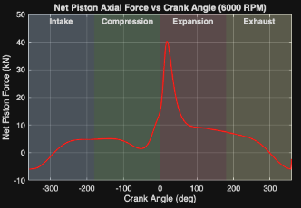
The net axial piston force, resultant from gas pressure and inertia (Figure 3.1), peaks at 19° ATDC during expansion. During intake and exhaust, inertial forces dominate, causing tensile loading that grows with the square of speed, as established by Chmielowiec, Woś and Czyżewski (2025) in their analysis of Conrod inertia force distributions.
Figure 3.1 — Net Piston Axial Force vs Crank Angle (6000 RPM)
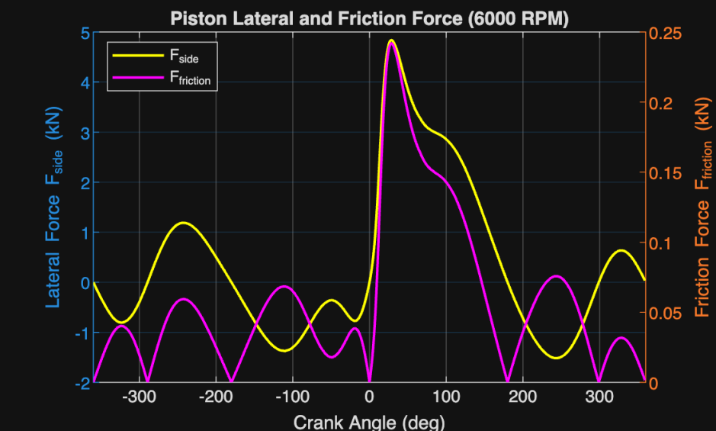
The conrod obliquity angle $φ=arcsin⁡r\left( x \frac{sinθ}{l}\right)$ reaches a maximum of 17.68° at 90° crank angle, generating a lateral force against the wall force: $F_{side}=F_{piston} x tanϕ$ which peaks at 4.84kN during expansion (Figure 3.2); generating a friction force (μ = 0.05) peaking at 0.242 kN. These forces cause efficiency losses, not fatigue in bottom-end parts, and are included in the earlier-described Chen-Flynn model.
Figure 3.2 — Piston Lateral Force and Friction Force vs Crank Angle (6000 RPM)

3.2 Stress Results

3.2.1 Conrod Bolt Stress
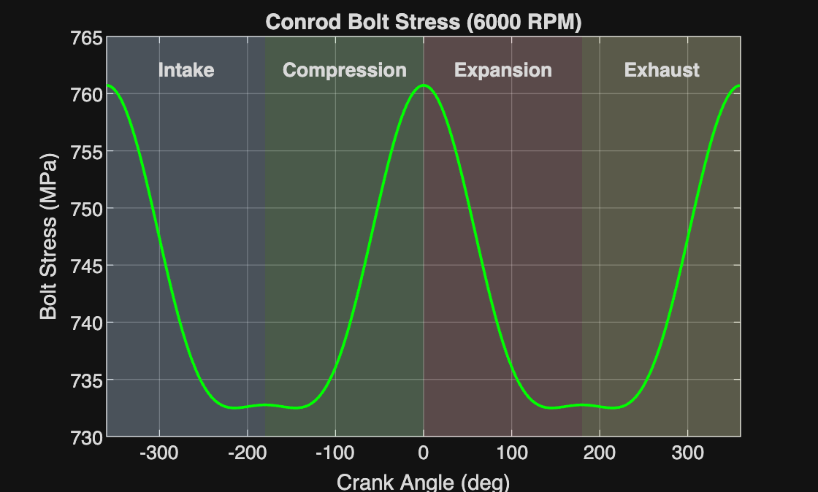
Figure 3.3 shows the conrod bolt stresses at 6000 RPM, with a small alternating component from inertial loads and a high mean tensile component from preload. Peak stresses occur near TDC, indicating resistance to the rod cap's inertial separation. The model omits thread root concentration (Kt), which is addressed later.
Figure 3.3 — Conrod Bolt Stress vs Crank Angle (6000 RPM)

3.2.2 Gudgeon Pin Stress
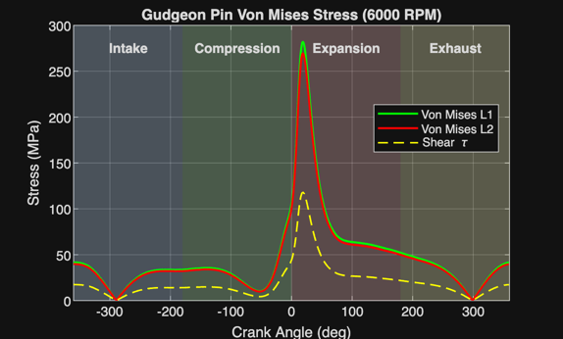
Figure 3.4 shows the Gudgeon pin bending stresses at levers L1 and L2, which peak near firing TDC and form a nearly fully reversed cycle, indicating bending-dominated fatigue, consistent with (Kamble, 2018). Longer lever arms increase stress and bending moments. L1 and L2 stresses converge away from combustion, meaning geometric sensitivity peaks at maximum gas load. Shear stress at the pin support reaches 117.9 MPa, with combined stresses producing a von Mises stress of 282 MPa, 45% above the bending-only value.
Figure 3.4 — Gudgeon Pin Von Mises Stress (6000 RPM)

3.2.3 Conrod Midpoint Stress
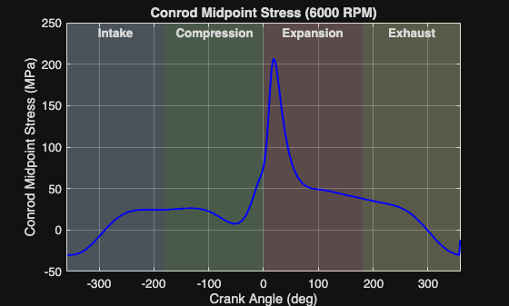
Figure 3.5 shows conrod midpoint stresses at 6000 RPM. The midpoint is purely under axial load, so stress:$\left(θ\right)= \frac{F_{rod}(θ)}{A_{rod}}$ tracks the rod force directly. Peak tensile stress occurs at 15-20° ATDC with maximum piston force. Near the exhaust/intake transition, stresses become compressive as inertia reverses under low cylinder pressure. The axial-only loading differs from the bending-dominated Gudgeon pin response.
Figure 3.5 — Conrod Midpoint Stress vs Crank Angle (6000 RPM)

3.2.4 Conrod Little-End Hoop Stress
Under inertial loading, the little-end bore is pulled apart from tension at TDC. Modelled as a thin-walled ring under diametral force. Hoop stress was given as: $σ_{hoop}=\frac{F_{inertia}}{2 x t_{wall} x b}$
Table 4 shows the little-end Hoop Stress, peaking at 44.87 MPa tension at TDC and -24.62 MPa compression at BDC. The mean stress is 10.13 MPa, with an alternating stress of 34.74 MPa. An FSF of 11.45 suggests it's not fatigue-critical under baseline conditions.

Table 4 — Little-End Hoop Stress Summary
Parameter | Value (MPa)
σ Max | 44.87
σ Min | −24.62
σ Mean | 10.13
σ Alternating | 34.74
FSF Hoop | 11.45
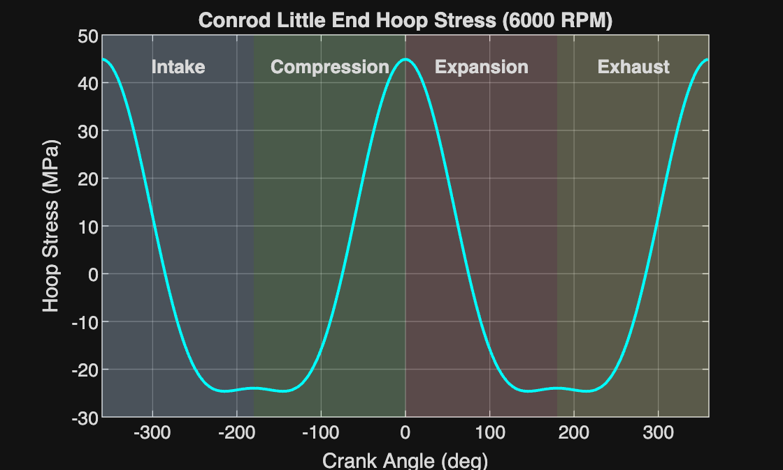
TDC/BDC extremes show inertia-driven loading, with combustion pressure partially offsetting peak tension at TDC, as shown in Figure 3.6.
Figure 3.6 — Conrod Little End Hoop Stress vs Crank Angle (6000 RPM)

3.3 Fatigue Safety Factors
Table 5 presents the max, mean, and alternating stresses at 6000 RPM, along with their respective Fatigue Safety Factors (FSF) evaluated using the Goodman criterion (Dowling, 2013).

Table 5 — Component Stress Summary and Goodman FSF (6000 RPM)
Component | Speed | Case | σ Max | σ Mean | σ Alt (MPa) | FSF
Conrod Bolt | 6000 RPM | 1 | 760.7 MPa | 746.7 MPa | 14.1 MPa | 1.41
Gudgeon Pin | 6000 RPM | L1 | 194.3 MPa | 82.8 MPa | 111.5 MPa | 3.02
Gudgeon Pin | 6000 RPM | L2 | 175.5 MPa | 74.8 MPa | 100.7 MPa | 3.35
Rod Midpoint | 6000 RPM | 1 | 205.9 MPa | 87.8 MPa | 118.1 MPa | 2.86
Little End (Hoop) | 6000 RPM | 1 | 44.87 MPa | 10.13 MPa | 34.74 MPa | 11.45
The conrod bolt exhibits the highest maximum stress but the smallest alternating stress, reflecting that bolt preload governs mean stress levels.

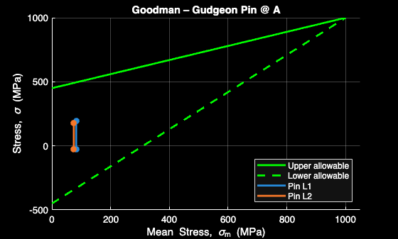
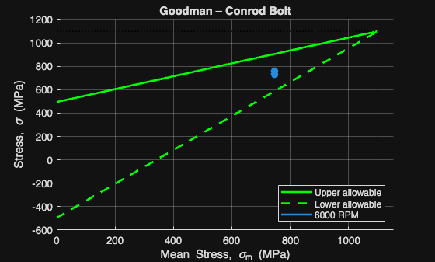
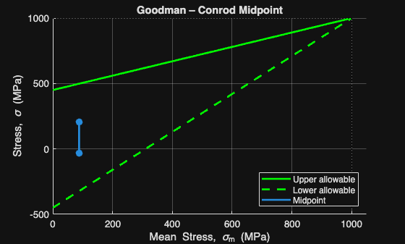
The Goodman diagrams for each component are shown in Figures 3.7–3.9, with the bolt operating closest to the failure boundary.
Figure 3.7 — Goodman Diagram: Conrod Bolt (6000 RPM)
Figure 3.8 — Goodman Diagram: Gudgeon Pin at Point A (6000 RPM)
Figure 3.9 — Goodman Diagram: Conrod Midpoint

3.4 Critical Discussion
The Conrod bolt experiences the highest mean stress due to preload, with low alternating stress, aligning with bolted joint mechanics. Operating at approximately 50% of the Conrod midpoint fatigue margin and less than half of the Gudgeon pin fatigue margin. Reflecting the higher sensitivity of preload-dominated fasteners to mean stress. Gudgeon pin fatigue is bending-dominated, as indicated by fully reversed stress cycles, with larger alternating stresses increasing with lever arm length; the longer L1 arm produces the lower FSF. The Conrod midpoint is dominated by axial loads proportional to piston force. Inertia forces scale with the square of engine speed (Shenoy and Fatemi, 2006). Applying $ω^{2}$ scaling to the Goodman limit suggests a critical RPM of approximately 19,980 for the Conrod bolts, well above the operating envelope, confirming sufficient fatigue margin. Though the decreasing FSF with speed justifies the redesign analysis in section 5, the Goodman criterion is linear and conservative, at the high mean stress ratio present in the bolt (σₘ / Sᵤ) ≈0.68, non-linear models like Morrow or Smith-Watson-Topper (SWT), can more accurately account for mean stress effects and predict a less conservative boundary (Dowling, 2013).

4.0 Extended RPM Analysis to 9000 RPM

4.1 Interpolation Method
To assess component behaviour at 9000 RPM without direct pressure data, a physics-based extrapolation based on crank-slider kinematics extended dynamic loading beyond 6000 RPM, recalculating piston acceleration using analytical crank-slider acceleration: $ω= \frac{2π RPM}{60}$
Since inertial forces are proportional to the square of angular velocity, as established in classical engine theory (Challen and Baranescu, 1999), the following acceleration scaling expression was used: ${\left(\frac{9000}{6000}\right)}^{2}=2.25$ whilst combustion pressure was assumed to be unchanged. Piston acceleration and bolt loads were recalculated at higher rotational speeds, keeping the geometry constant. This isolates engine speed effects for analysis if combustion pressures are similar, offering a reasonable first-order estimate of high-speed fatigue despite simplifications.

4.2 Revised Loads & Stresses
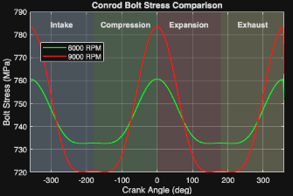
The max stress at 9000 RPM increases from 760.7 to 783.5 MPa (Figure 4.1).
Figure 4.1 — Conrod Bolt Stress Comparison: 6000 RPM vs 9000 RPM

Table 6 — Conrod Bolt Stress Summary: 6000 vs 9000 RPM
Component | RPM | σ Max | σ Min | σ Mean | σ Alt | FSF | R Ratio | Yield Margin
Conrod Bolt | 6000 | 760.7 | 732.5 | 746.7 | 14.1 | 1.41 | 0.96 | 1.30
Conrod Bolt | 9000 | 783.5 | 720.0 | 751.9 | 31.6 | 1.34 | 0.92 | 1.26
% Change | +50% | +2.99% | −1.71% | +0.69% | +124.1% | −4.96% | −4.17% | −3.08%
Table 6 shows the acceleration ratio (2.25) closely matches the alternating stress scaling ratio (2.24), validating the $ω^{2}$ extrapolation method. Alternating stress more than doubles from 14.1 to 31.6 MPa while mean stress changes less than 1%, confirming preload dominance over steady tensile stress. The near-unity stress ratio indicates tensile loading primarily causes bolt fatigue, with limited stress reversal. The static yield margin stays above 1.25 at 9000 RPM, showing fatigue controls the design over static overload.

4.3 Fatigue Safety Factor Comparison
Table 7 shows the Bolt FSF drops from 1.41 to 1.34 at 9000 RPM. Despite more than doubling the alternating stress, preload-dominated mean stress limits FSF reduction to 5%. The bolt stays above the safety margin at 9000 RPM, but higher RPMs could increase alternating stress and risk limiting the Conrod bolt under extreme loads.

Table 7 — FSF Comparison
Case | FSF
Conrod Bolt — 6000 RPM | 1.41
Conrod Bolt — 9000 RPM | 1.34
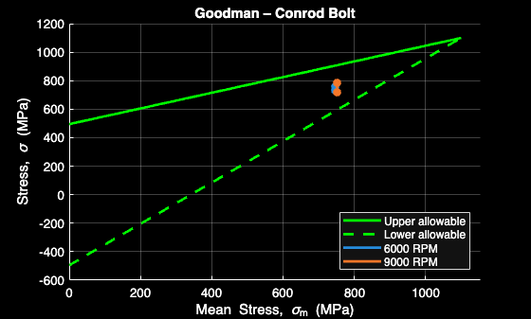
Figure 4.2 — Goodman Diagram: Conrod Bolt at 6000 and 9000 RPM

4.4 Discussion
The agreement between the acceleration ratio and stress ratio confirmed that the scaling method was valid and demonstrated that inertia governs high-speed fatigue behaviour.
The bolt becomes increasingly critical as engine speed increases due to the sensitivity of tensile forces at TDC. Preload remains an essential factor in maintaining joint integrity; however, excessive preload results in a smaller allowable alternating stress under the Goodman theory (Figure 4.2).

5.0 Conrod Bolt Redesign

5.1 Design Objective
The reduction in Conrod bolt safety factor at higher engine speed indicates a higher risk of long-term fatigue failure at repeatedly high loading. The redesign goal is to ensure the safety factor at 9000 RPM matches or exceeds that at 6000 RPM.

5.2 Geometry Changes
Increasing the cross-sectional area reduces tensile stress but increases inertial forces and mass, a constraint recognised in conrod optimisation (Nishanth et al., 2021). The minimum area increase to match the safety factor of the original geometry at 6000 RPM was determined using the Goodman fatigue relation $\frac{1}{n}= \frac{σ_{alternating}}{S_{e}}+ \frac{σ_{mean}}{S_{ut}}$ and recognising the inverse relationship between bolt stress and tensile stress area $σ∝ \frac{1}{A}$ .
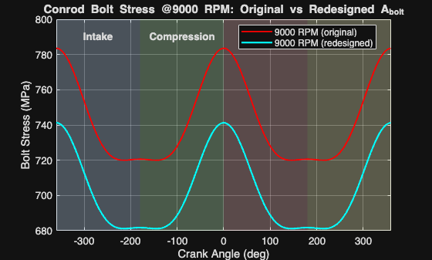
This method determined an increase from 42.43mm² to 44.85mm² (5.7%), equating to a circular diameter change from 7.35mm to 7.56mm.
Figure 5.1 — Conrod Bolt Stress at 9000 RPM: Original vs Redesigned Geometry
Targeting load transmission instead of nominal stress is an alternative strategy. Alternating stress in a bolted joint is governed by $C= \frac{k_{b}}{k_{b}+k_{m}}$ (Shenoy and Fatemi, 2006). Machining the shank to a waisted diameter of 6.5mm (below the M8x1.0 thread minor diameter of 6.77mm) reduces Kb from 311,299N/mm to 243,618N/mm, which lowers C from 0.213 to 0.175. Mean stress remains unchanged as preload acts at the thread root. The revised C gives an alternating stress of 26 MPa and an FSF of 1.36 at 9000 RPM (Figure 5.1), exceeding baseline whilst reducing bolt mass by 21.7%.

5.3 Revised Stress & Goodman Analysis
Table 8 summarises the key stress statistics: peak stress drops from 783.5 MPa to 741.3 MPa. Alternating stress decreases by 1.6 MPa due to a slight CSA increase; mean stress decreases by 40.7 MPa. The Goodman FSF remains at 1.41, matching the original geometry at 6000 RPM.

Table 8 — Bolt Redesign: Stress Comparison at 9000 RPM
Component | Case | σ Max (MPa) | σ Mean (MPa) | σ Alt (MPa) | FSF | Mass vs Original
Conrod Bolt (Original) | 9000 RPM | 783.5 | 751.9 | 31.6 | 1.34 | —
Conrod Bolt (Redesigned) | 9000 RPM | 741.3 | 711.2 | 30.0 | 1.41 | +5.7%
Waisted Shank (∅6.5mm) | — | 783.5 | 751.9 | 26.0 | 1.36 | -21.7%
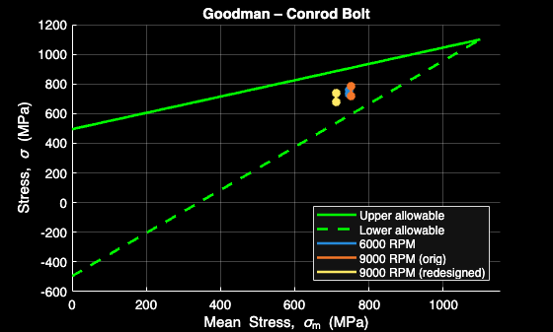
The redesigned geometry in the Goodman diagram (Figure 5.2) shifts left and downward, increasing the gap from stress limits and restoring fatigue margin while keeping stresses below yield.
Figure 5.2 — Goodman Diagram: Original vs Redesigned Bolt at 9000 RPM

5.4 Engineering Justification
Increasing the tensile stress area by the required 5.7% represents a balanced refinement, allowing for minimal area increase while restoring fatigue margin. Bolt stiffness increases slightly $\left(k_{bolt }X \frac{AE}{L}\right)$, which marginally reduces joint separation during inertial loading. However, the change in the stiffness ratio (C) is negligible due to the small increase in area. Since the bolt was already deemed safe for static strength, fatigue safety becomes the main design focus instead of yield. To prevent over-engineering and reduce material use, matching the FSF is preferred over exceeding it. This approach can be applied to reach a target FSF above 1.41.

5.5 Alternative Material Evaluation
Material grades were assessed per BS EN ISO 898-1 (British Standards, 2009), comparing property classes 10.9 (1100MPa), 12.9 (1200 MPa) and 14.9 (1400 MPa).

Table 9 — Material Comparison: Original Geometry (9000 RPM)
Material | UTS (MPa) | Tensile Area (mm²) | FSF | FSF Change
Original Steel | 1100 | 42.43 | 1.34 | —
High Strength Steel | 1200 | 42.43 | 1.46 | +8.95%
Ultra-High Strength Steel | 1400 | 42.43 | 1.70 | +26.86%

Table 10 — Material Comparison: Redesigned Geometry (9000 RPM)
Material | UTS (MPa) | Tensile Area (mm²) | FSF | FSF Change
Original Steel | 1100 | 44.85 | 1.41 | —
High Strength Steel | 1200 | 44.85 | 1.54 | +9.22%
Ultra-High Strength Steel | 1400 | 44.85 | 1.80 | +27.66%
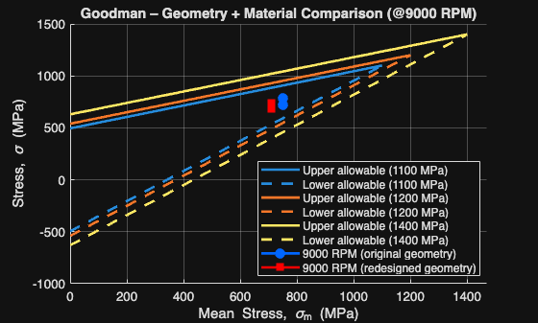
Stress histories remain unchanged since only allowable strengths vary. Tables 9 and 10 show that using high-strength steel (1200 MPa) increases the geometry FSF from 1.34 to 1.46, surpassing the FSF at 6000 RPM without adding mass. Ultra-high-strength steel yields safety factors of 1.70-1.80 but increases notch sensitivity and cost. Therefore, high-strength steel with redesigned geometry offers a balanced solution, highlighted by the Goodman diagram in Figure 5.3.
Figure 5.3 — Goodman Diagram: Geometry and Material Comparison at 9000 RPM

5.6 Thread Root Stress Concentration Sensitivity
The Goodman analysis model uses nominal tensile-area stresses. However, fatigue cracks primarily initiate at the first engaged thread because of geometric stress concentration. A sensitivity study followed the U-notch stress-concentration methodology of Filippini (2000) and the notch sensitivity framework of Dowling (2013). Converting theoretical stress concentration (Kt) to a fatigue notch factor (Kf), with q=0.5 (moderate) and q=1.0 (conservative upper bound): $K_{f}=1+q (K_{t}-1)$

Table 11 — Thread Root Stress Concentration Sensitivity
Thread Case | K_t | Assumed q | K_f | σ Local Alt (MPa) | FSF
M8 × 0.75 | 4.407 | 0.5 | 2.704 | 86.0 | 1.17
M8 × 0.75 | 4.407 | 1.0 | 4.407 | 140.2 | 1.04
M8 × 1.0 | 4.302 | 0.5 | 2.651 | 84.3 | 1.17
M8 × 1.0 | 4.302 | 1.0 | 4.302 | 136.8 | 1.04
Table 11 shows that thread-root stresses reduce FSF by 13-22% depending on the notch sensitivity assumption. This estimate omits three factors: residual compressive stresses from rolled threads, stress distribution across engaged threads, and the larger notch root radius compared to a sharp U-notch assumption (Dowling, 2013). This simplified approach is consistent with the screening methodology described by Xu et al. (2024), who noted that full quantification requires FE analysis to capture residual stress and thread load distribution missed by nominal stress analysis.

6.0 Crankshaft Torque Comparison

6.1 Standard Flat-Plane Configuration

Instantaneous crankshaft torque arises from gas and inertial piston forces transmitted through the crank-slider mechanism, acting via the crank radius and conrod geometry. In inline-4 engines with flat-plane crankshafts at 6000 RPM (throws at 0º/180º/360º/540º), torque traces are phase-shifted, summing to 229.82 N·m with low peak-to-peak variation, indicating smooth torque delivery.

6.2 Cross-Plane Configuration
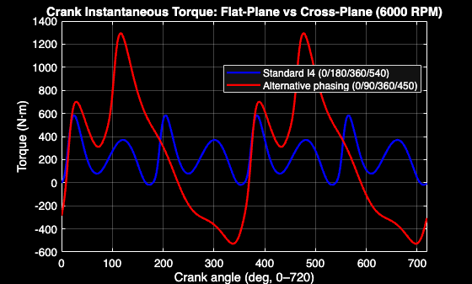
An alternate crank phasing (0º/90º/360º/450º) represents a cross-plane configuration. Total work per cycle remains unchanged; the distribution of firing events influences the interaction between gas and inertial torque. Figure 6.1 shows that the cross-plane setup produces larger torque peaks than the flat-plane, indicating greater torque fluctuations.
Figure 6.1 — Instantaneous Crank Torque: Flat-Plane vs Cross-Plane (6000 RPM)

6.3 Comparative Discussion

Table 12 — Crankshaft Configuration Comparison (6000 RPM)
Configuration | Avg Torque (N·m) | Peak-to-Peak (N·m) | RMS (N·m)
Flat Plane | 229.82 | 602.02 | 281.47
Cross Plane | 229.82 | 1,822.64 | 565.00
% Difference | - | 202.8% | 100.7%
Table 12 shows both configurations produce identical average torque (229.82 N·m) since total combustion work per cycle is constant. The flat-plane crank produces a peak-to-peak ripple of 602.02 N·m, versus 1822.64N·m for the cross-plane (202.8% increase), with RMS torque rising from 281.47N·m to 565N·m. The higher torsional excitation is consistent with the connection between firing irregularity and torsional vibration established by Mendes, Meirelles and Zampieri (2008). The 202.8% ripple increase intensifies oscillatory bending moments on big-end bearing shells and crankshaft fillet radii, imposing fatigue demand on those interfaces in the same $ω^{2}$-driven manner identified for the Conrod bolt in section 3. In cross-plane inline-4s, uneven firing intervals (90º/270º vs 180º in flat-plane) cause asymmetric torsional loads less effectively cancelled. Therefore, the flat-plane crankshaft is preferable for the Ford 1.6L GTDi EcoBoost on both NVH and durability grounds.

7.0 Conclusion
This study analysed the cyclic loading of Ford 1.6L GTDi EcoBoost engine's bottom-end components to identify fatigue-prone parts under baseline and high-speed conditions. At 6000 RPM, the Conrod bolt was most critical with an FSF of 1.41, lower than the 2.86 FSF at the rod midpoint, while the Gudgeon pin had safety factors over 3.0. Although the alternating stresses are low, preload stresses push the operating point closer to failure as per the Goodman criterion. Increasing speed to 9000 RPM raised the inertial load 2.25 times, leading to a 2.24-fold increase in alternating stress on the bolt, with mean stress unchanged, reducing the FSF from 1.41 to 1.34. The static margin remained above 1.25, indicating fatigue as the main failure mode. To restore the FSF to 1.41 at 9000 RPM, a 5.7% increase in tensile stress area was needed, matching baseline safety margins without adding stiffness or mass. Upgrading to 1200 MPa steel improved fatigue margin to 1.46 without increasing CSA. Torque analysis shows crank phasing affects torque ripple, not average torque. The cross-plane setup’s variation is 202.8% larger, increasing cyclic stress on crankshaft fillets. The key constraint is preload-driven mean stress at σₘ/Sᵤ = 0.68, with inertial effects, thread-root concentration, and material sensitivity shaping fatigue limits.

Bibliography

Brankov, I. (2020) “Initial design of an internal combustion engine for a range extender unit for electric vehicles,” Trans & Motauto World, (3), pp. 108–111.
British Standards (2009) Mechanical properties of fasteners made of carbon steel and alloy steel. 4th ed. London: Standards Policy and Strategy Committee.
Cardoso, R.C. et al. (2020) “Study of bolted joint axial stiffness using finite element analyses, experimental tests, and analytical calculations,” Proceedings of the Institution of Mechanical Engineers, Part C: Journal of Mechanical Engineering Science, 234(23), pp. 4671–4681. Available at: https://doi.org/10.1177/0954406220927066.
Challen, B. and Baranescu, R. (1999) Diesel Engine Reference Book (Second Edition).
Chmielowiec, A., Woś, W. and Czyżewski, J. (2025) “Numerical Analysis of Inertia Forces in the Connecting Rod and Their Impact on Stress Formation,” Materials, 18(6). Available at: https://doi.org/10.3390/ma18061385.
Dowling, N.E. (2013) “Mechanical Behavior of Materials Engineering Methods for Deformation, Fracture, and Fatigue Fourth Edition by Norman E. Dowling.”
Filippini, M. (2000) Stress gradient calculations at notches, International Journal of Fatigue. Available at: https://doi.org/https://doi.org/10.1016/S0142-1123(00)00010-4.
Ford Component Sales (no date) “1.6 GTDI EcoBoost 150Ps.” Available at: https://www.ford.co.uk/content/dam/guxeu/uk/documents/home/experience-ford/about-ford/ford-component-sales/specification-details-data-sheets/16-ecoboost-np.pdf (Accessed: March 10, 2026).
Jia, D. et al. (2025) “Analysis of the influence of geometric accuracy on the preload and stress of engine connecting rod bolts,” Scientific Reports, 15(1). Available at: https://doi.org/10.1038/s41598-025-92013-9.
Kamble, V.B. (2018) “Design and Analysis of Gudgeon Pin to Minimize Stress Concentration: A Review,” International Journal for Research in Applied Science and Engineering Technology, 6(3), pp. 2098–2101. Available at: https://doi.org/10.22214/ijraset.2018.3326.
Lee, Y.-L. et al. (2005) Fatigue Testing and Analysis (Theory and Practice).
Mendes, A.S., Meirelles, P.S. and Zampieri, D.E. (2008) “Analysis of torsional vibration in internal combustion engines: Modelling and experimental validation,” Proceedings of the Institution of Mechanical Engineers, Part K: Journal of Multi-body Dynamics, 222(2), pp. 155–178. Available at: https://doi.org/10.1243/14644193JMBD126.
Nishanth, R. et al. (2021) “Generative Design Optimization and Analysis of Connecting Rod for Weight Reduction and Performance Enhancement,” Journal of Physics: Conference Series. IOP Publishing Ltd. Available at: https://doi.org/10.1088/1742-6596/1969/1/012022.
Shenoy, P.S. and Fatemi, A. (2006) “Dynamic analysis of loads and stress in connecting rods,” Proceedings of the Institution of Mechanical Engineers, Part C: Journal of Mechanical Engineering Science, 220(5), pp. 615–624. Available at: https://doi.org/10.1243/09544062JMES105.
VDI Richtlinien (1977) VDI 2230: SYSTEMATIC CALCUlATION OF HIGH DUTY BOLTED JOINTS. Translated by T. LANGUAGE SERVICES. Knoxville.
Xu, W. et al. (2024) “On a numerical methodology to assess the fatigue life of connecting rods,” Proceedings of the Institution of Mechanical Engineers, Part D: Journal of Automobile Engineering, 238(10–11), pp. 3232–3241. Available at: https://doi.org/10.1177/09544070231180996.

Appendix A — Hand Calculations

Key Derivations at θ = 19° Crank Angle
$$θ= 19° → \frac{19π }{180} =0.3316 rad/s$$
$$A_{piston}= \frac{πb^{2}}{4} = \frac{π{(0.079)}^{2}}{4}=4.901 x {10}^{-3}m^{2}$$
$$ω (6000RPM)= \frac{2π (RPM)}{60} = \frac{2π (6000)}{60} =628.32 rad/s$$
$$ω (9000RPM)= \frac{2π \left(RPM\right)}{60} = \frac{2π \left(9000\right)}{60} =942.48 rad/s$$
$$Acceleration \left(6000RPM\right)= Rω^{2}cosθ+ \frac{R^{2}}{L}ω^{2}cos2θ =0.0407 x {628.32}^{2}\cos\left(19\right)+ \frac{{0.0407}^{2}}{0.134}{628.32}^{2}cos38= 19038.12{ms}^{-2}$$
$$Acceleration \left(9000RPM\right)= Rω^{2}cosθ+ \frac{R^{2}}{L}ω^{2}cos2θ = 0.0407 x {942.48}^{2}\cos\left(19\right)+ \frac{{0.0407}^{2}}{0.134}{942.48}^{2}cos38 =42835.76{ms}^{-2}$$
$$F_{gas}= P_{cyl} x Area = \left(95.6 x {10}^{5}\right) x \left(4.9 x {10}^{-3}\right)=46844N$$
$$F_{inertia}= Mass x Acceleration = 0.347 x 19038.12=6606.28N$$
$$F_{net}= F_{gas}- F_{inertia} = 46844 - 6606.28=40237.72N$$
$$F_{rod}= \frac{F_{net}}{cosϕ} = \frac{40237.72}{\cos{(5.67)}} =40435.55N$$
$$F_{ext}= \frac{m_{rec}a}{n_{bolts}} = \frac{0.347 x 19038.12}{2} =3303N$$
$$F_{bolt}= 31504+0.213\left(3303\right) = 3154+703=32207N$$
$$σ_{bolt}= \frac{F_{bolt}}{A_{b}} = \frac{32207}{42.43} =759 MPa$$

Stiffness Model
k_b = E_b·A_b / L_b = 200,000 × 42.43 / 27.26 = 311,299 N/mm
k_m = E_m·A_m / L_m = 170,000 × 210 / 31 = 1,151,613 N/mm
C = k_b / (k_b + k_m) = 311,299 / (311,299 + 1,151,613) = 0.213
The bolted-joint stiffness factor $C= \frac{k_{bolt}}{k_{bolt}+k_{m}}$ is mathematically equivalent to the expression: $F_{extra}= \frac{1}{{1+k}_{cap}/k_{bolt}} x F_{inertia}$

Critical RPM
$$σ_{alt,critical}S_{e}\left(1-\frac{σ_{mean}}{S_{ut}}\right)=495\left(\frac{751.9}{1100}\right)=495 x 0.3164=156.6MPa$$
$$σ_{alt}∝ω^{2}∝{RPM}^{2}$$
$${RPM}_{critical}=6000 x \sqrt{\frac{156.6}{14.1}}=6000 x \sqrt{11.1}=6000 x 3.33=19,982 RPM$$

Stress
$$σ_{max}=\max\left(σ\left(t\right)\right), σ_{min}=\min\left(σ\left(t\right)\right),$$
$$σ_{m}=\frac{σ_{max}+σ_{min}}{2} = σ_{m}=\frac{760.7+732.5}{2}=746.7MPa$$
$$σ_{a}=\frac{σ_{max}-σ_{min}}{2} = σ_{a}=\frac{760.7-732.5}{2}=14.1MPa$$
(9000 RPM): $σ_{m}=\frac{783.5+720}{2}=751.9MPa{ σ}_{a}=\frac{783.5-720}{2}=31.6MPa$
$$Rod Angle \left(ϕ\right)= \sin^{-1}\left(\frac{R sin⁡(θ)}{L}\right) = \sin^{-1}\left(\frac{0.0407 sin⁡(19)}{0.134}\right) =5.67°$$
$$F_{rod} Consistency=\left(\frac{F_{rod} x cos⁡(ϕ)}{F_{piston}}\right) = \left( \frac{40435.55 x cos⁡(5.67)}{40237.72} \right)=1$$
$$Acceleration Ratio = \left( \frac{a_{9000} }{a_{6000}} \right) =\left( \frac{42835.76}{19038.12} \right)= 2.25$$
$$Stress Ratio = \left( \frac{σ_{alt} @ 9000 RPM}{σ_{alt} @ 6000 RPM} \right) = \left( \frac{31.6}{14.1} \right)= 2.24$$
$$Static Yield Margin= \frac{σ_{yield}}{σ_{max}} = \frac{990}{783.5} = 1.26$$
$$σ_{inertia}= {0.75σ}_{y} = 0.75\left(990\right)= 742.5 MPa$$
$$A_{b}=42.43{mm}^{2}$$
$$F_{i}= σ_{i}A_{b} = \left(742.5\right)\left(42.43\right)=31504N$$
$$T_{gas}= F_{gas} x R x (tanϕ x cosθ+sinθ)$$
$$T_{inertia}= F_{inertia} x R x (tanϕ x cosθ-sinθ)$$
$$T_{total}= T_{gas}+T_{inertia}$$
$$a\left(180\right)=rω^{2}\cos\left(180\right)+ \frac{r^{2}}{l}ω^{2}cos⁡(360)$$
$$F_{piston}= F_{gas}-F_{inertia}$$
$$F_{rod}= \frac{F_{piston}}{cosϕ}$$
Since $ϕ\left(180\right)≈0 → F_{rod}≈ F_{piston}$
$τ_{max}=\frac{4}{3} x \frac{V}{A_{pin}}=117.94MPa$
$σ_{VM}=\sqrt{σ_{bend}^{2}+{3τ}^{2}}=\sqrt{{194.45}^{2}+{3(117.94)}^{2}}=282MPa$
Hollow pin cross-section: (D_o = 21$mm$, D_i = 12.3$mm$, A_pin – 227.5${mm}^{2}$),

Waisted Bolt Shank – Stiffness and FSF Calculation
$$d_{waist}=6.5mm$$
$$a_{waist}=\frac{π}{4} x {6.5}^{2}=33.18{mm}^{2}$$
$$k_{b, waisted}=\frac{E_{b} x A_{waist}}{L_{b}}= \frac{200000 x 33.18}{27.26}=243,618N/mm$$
$$C_{ waisted}=\frac{k_{b, waisted}}{k_{b, waisted} {x k}_{m}}= \frac{243618}{243618+1151613}=0.175$$
$$σ_{ alt, waisted}=σ_{ alt,9000} x \frac{C_{ waisted}}{C_{ original}}= 31.6 x \frac{0.175}{0.213}=26.0 MPa$$

$$σ_{ mean} \left(unchanged\right)=751.9 MPa$$
$${FSF}_{ waisted}=\frac{1}{\left(\frac{26.0}{495}\right) x \left(\frac{751.9}{1100}\right)}= \frac{1}{0.0525+0.6836}=1.36$$

Consistency
$$\frac{F_{rod}Cosϕ}{F_{piston}} ≈1$$
$$k_{b}= \frac{E_{b}A_{b}}{L_{b}} = \frac{200000 x 42.43}{27.26}=311299N/mm$$
$$k_{m}= \frac{E_{m}A_{m}}{L_{m}} = \frac{170000 x 210}{31}=1151613N/mm$$
$$C= \frac{k_{b}}{k_{b}+k_{m}} = \frac{311299}{311299+1151613}=0.213$$
$$FSF= \frac{1}{\left(\frac{σ_{a}}{s_{e}}\right)+\left(\frac{σ_{m}}{s_{ut}}\right)} \left(@ 6000 RPM\right): \frac{1}{\left(\frac{14.1}{495}\right)+\left(\frac{746.7}{1100}\right)}=1.41$$
(@ 9000 RPM): $\frac{1}{\left(\frac{31.6}{495}\right)+\left(\frac{751.9}{1100}\right)}=1.34$
$${\overline{T}}_{single}=57.453Nm$$
$${4\overline{T}}_{single}=229.812Nm$$
$${\overline{T}}_{engine}= 229.822Nm$$
$$\overline{T}= \frac{1}{720}\int_{0}^{720}{T\left(θ\right)dθ}$$
$${\overline{T}}_{engine}≈4{\overline{T}}_{single}$$
$$\frac{{\overline{T}}_{engine}}{4{\overline{T}}_{single}}≈1 → \frac{229.822}{229.812}=1.00004$$
At $ω=0$: $a=0$, $F_{inertia}=0$, $σ_{a}=0$, $σ_{m}= σ_{preload}=742.5MPa$
At $θ=180$:
$$a=-11187.45{ms}^{-2}$$
$$F_{inertia}=-3882.04N$$
$$F_{gas}=3579.81N$$
$$F_{piston}=7461.86N$$
$$F_{rod}=7461.86N$$
Rod Consistency = 1.000000
$$Sinθ=0 → ϕ≈0$$
So : $Cosϕ≈1 → F_{rod}≈F_{piston}$

Torque Validation
T̄_single = 57.453 N·m → 4·T̄_single = 229.812 N·m
T̄_engine = 229.822 N·m → Ratio = 229.822/229.812 = 1.00004
Figure A1 – Ford 1.6L GTDi EcoBoost Torque + Power Data (Ford Component Sales, no date)
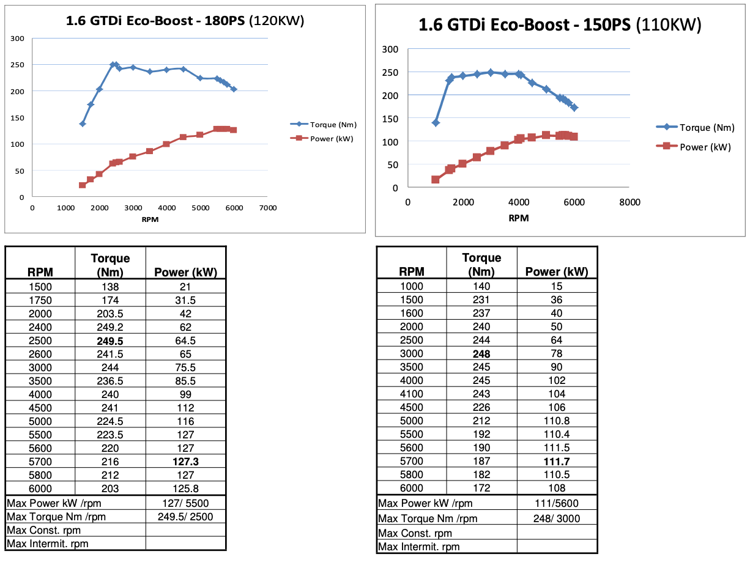
Calibration Factor: $η_{cal}= \frac{Τ_{OEM, anchor}}{Τ_{raw, anchor}} = \frac{248}{232} = 1.067$

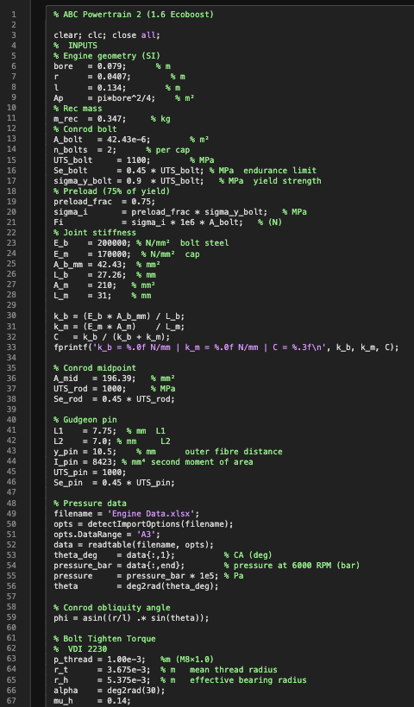
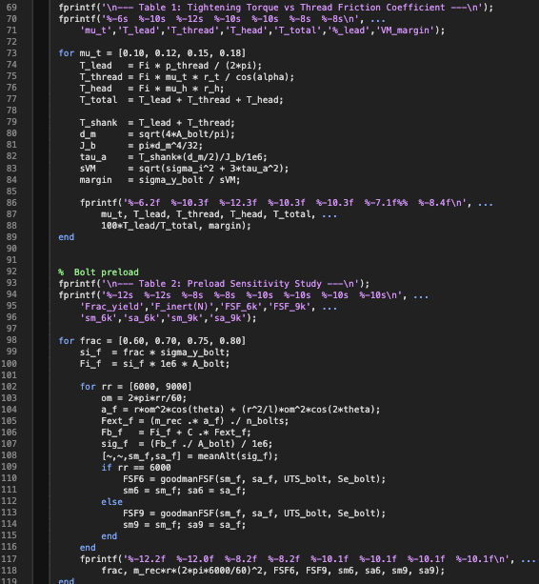
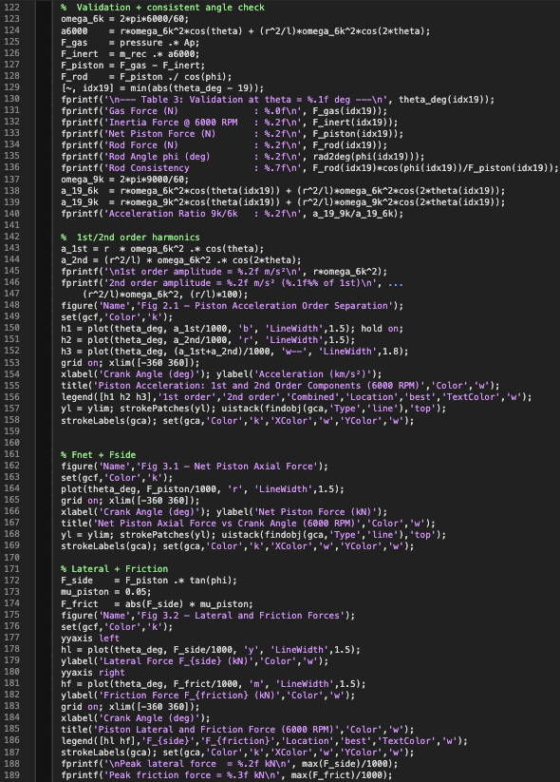
Appendix B — MATLAB Script
Figure A4 – MATLAB Script pt.3
Figure A3 – MATLAB Script pt.2
Figure A2 – MATLAB Script pt.1
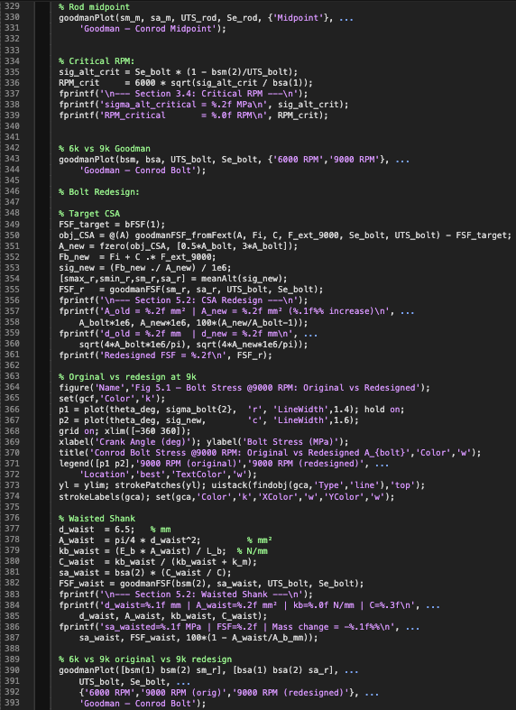
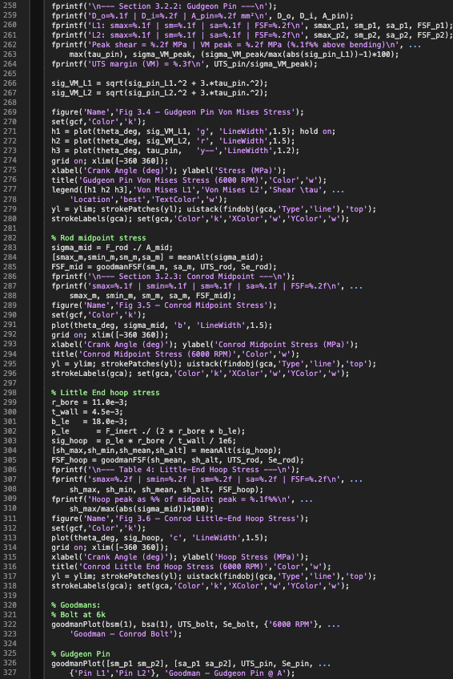
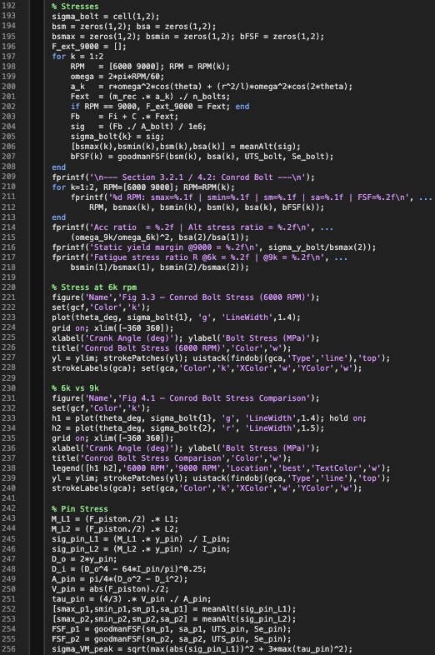
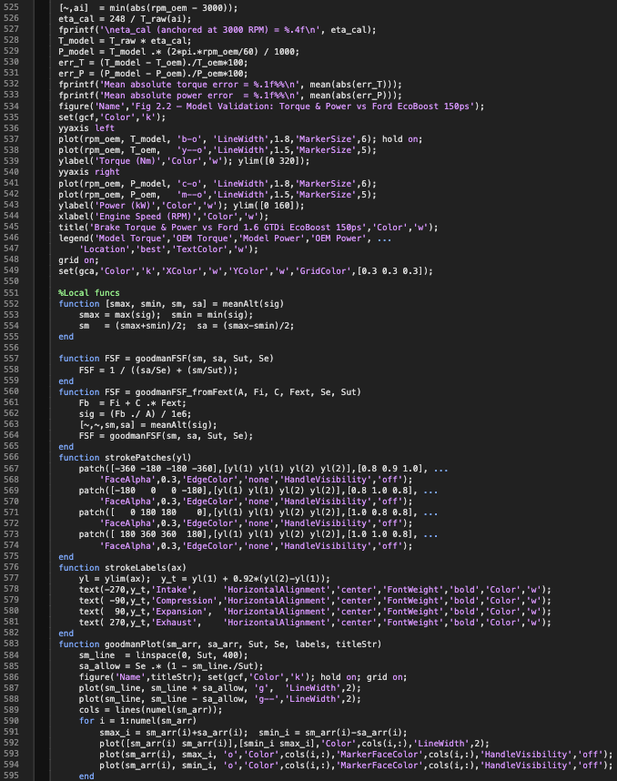
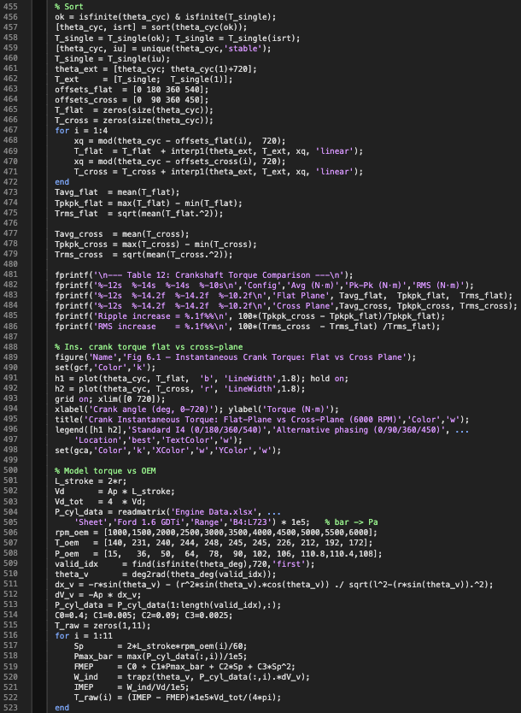
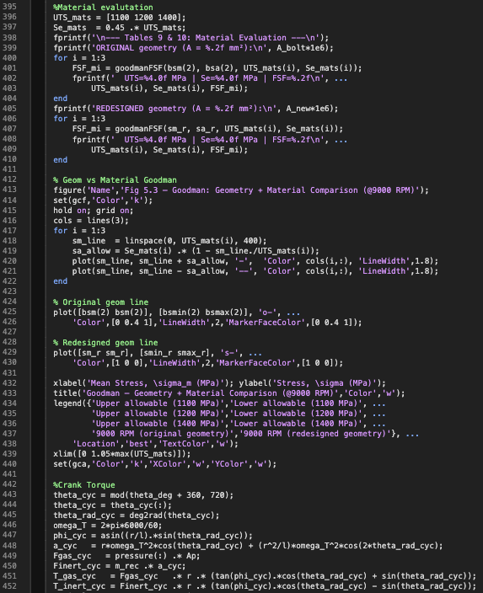
Figure A10 – MATLAB Script pt.9
Figure A9 – MATLAB Script pt.8
Figure A8 – MATLAB Script pt.7
Figure A7 – MATLAB Script pt.6
Figure A6 – MATLAB Script pt.5
Figure A5 – MATLAB Script pt.4

