Janet White - Student number – 1801306 February 2022
Module – Entanglements : Exploring Interactions between the Aegean and the Near East
Module - HPA6010

A Report about the book
Tools, Textiles and Contexts:
Investigating Textile Production in the Aegean and
Eastern Mediterranean Bronze Age.
Edited by Eva Andersson Strand and Marie-Louise Nash with the
editorial and analytical assistance of Joanne Cutler.

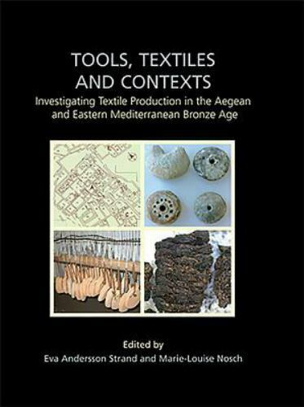
Cover for the book: Tool, Textiles and Contexts.
Contents and Outline

- My Introduction to the Report

- Review of the Eva Andersson Strand Introduction to Tools, Textiles and Contexts.

- Review of Chapter 1 - Research History

- Review of Chapter 2 – Strand,
The Basics of textile tools and the textile technology, from fibre to fabric.

- Review of Chapter 3 - Irene Skals, Susan Moller-Wiering and Marie-Louise Nosch,
Survey of archaeological textile remains from the Aegean and Eastern Mediterranean Area.

- Review of Chapter 4 – The TTTC experiments,

- Review of Chapter 5 – The TTTC database.

- Review of Chapter 6 - Textile tools in Contexts.

- Review of Chapter 7 Eva Andersson Strand and Marie-Nosch,
Summary of results and conclusion.

- Review of Appendices to Tools, Textiles and Contexts

- My conclusion

- Bibliography

- My Introduction to the report
The subject of Tools, Textiles and Contexts is important because it enlightens the reader on a craft that was crucial to Bronze Age Aegean and Eastern Mediterranean society. This is a collaborative work, between textile specialists and archaeologists, providing recent information on methodologies of ancient textile production, data sets and experimental archaeology which show the cruciality of textile production to this society at this time.
The book is presented in a Quarto format, which requires it to be stored away from library books of a more usual size, but those who delve into this book will find it well written for both those with existing research knowledge and yet pleasantly explanatory which benefits newcomers to the subject: There is a two-page Contents guide, but the absence of an index makes dipping quickly into the book a little forbidding.
To explain my report structuring, methodology and approach to this report on Tools, Textiles and Contexts, I advise that the book has a complex structure, so for the sake of clarity in this report, to ensure I cover all aspects and set parameters for my investigation, I will use the editors table of Contents as my framework. I will present a numerical reporting format to provide structured guidelines for my research and work directly with the criteria, specifications and within the limitations of the subject and material presented. Tools, Textiles and Contexts leaps the Bronze Age Aegean and the Eastern Mediterranean craft and culture, and it is difficult to outline a precise theoretical approach, with exact parameters, and methodologies because the book is compiled from work by varied authors, in some chapters the editors and authors collaborate and in others, the chapter is by one writer only. In order to process this information, I will be applying the theoretical and methodological techniques of modern history approaches with specific emphasis on the physical and cultural aspects of the subject of study as I progress systematically through the independently presented and subject related chapters of the book, as follows.
Section 1. This introduction.
Section 2. Review of the Introduction to Tools, Textiles and Contexts by Eva Andersson Strand.
Sections 3 to 8. A brief analysis of Chapter 1 to Chapter 6: The individual chapters are unique in style and content because they are written by a different author or authors, about archaeological evidence found in different Aegean and Eastern Mediterranean locations and each chapter has its own independent and extensive bibliography.
Section 9. The review of Chapter 7, Summary of results and conclusion: This chapter is the most fascinating for me because the editors summarise the work of all the contributing authors and present it alongside their own research findings.
Section 10. A Review of the detailed and concise statistical data table Appendices.
Section 11. My conclusion. Here I will interpret my research on Tools, Textiles and Contexts with the aim to satisfy the requirements set in this assignment with both theoretical and contextual comment.

- Review of the Introduction to Tools, Textiles and Contexts by Eva Andersson Strand
The introductory statements of Strand highlight what initially inspired the editors to study the subject, from which they have produced a tome of information about the tools used in the production of textiles in the Bronze Age Aegean and Eastern Mediterranean. Strand provides a very personal piece of writing which demonstrates her enthusiasm as she introduces the extensiveness and complexities of the content matter to be presented. Strand alures us to read on this ‘important and fascinating’ subject in order to acquire ‘new insights and perspectives’ on the people who crafted the fabrics and participated in the associated ancient Bronze Age techniques and processes. Strand also advises the intent of the editors to discover the exact ‘function of the tools’ by using experimental archaeology to reveal how tools were used and recreate and analyse the fabric which could have been made Bronze Age textile workers, in the varied regions, and relate his back to the data provided by the archaeological finds and excavations on which the book reports. Strand states her intention for this book to also review the impact and importance of ‘textiles and textile production in past societies’ as well as detail the standards to be set in reporting the reliability of tools in the construction of attempted textile reproductions similar to those seen in existing archaeological evidence. Strand explains that the standards, to be adhered to, were established in her work with Anne Batzer in the research formatting data they completed at the end of the Twentieth century. This powerful introduction provides a helpful map to show the locations to which the chapters relate the archaeological finds that are studied in this book.
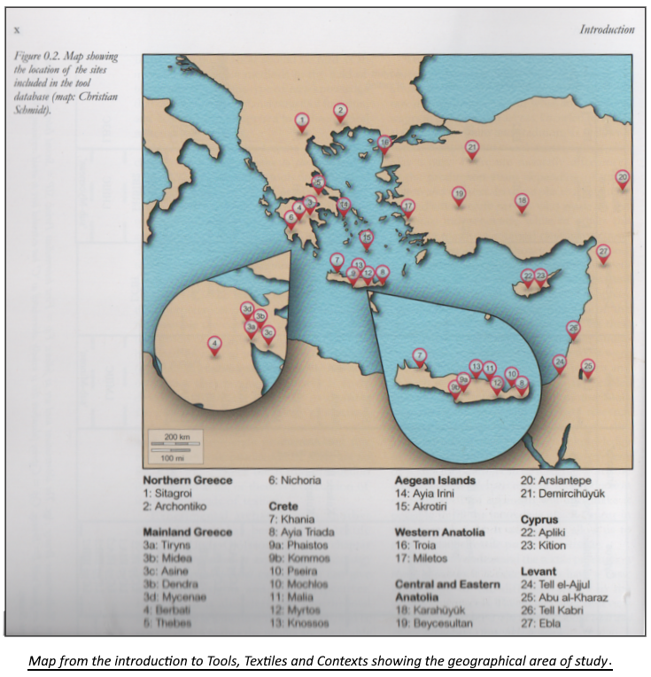
- Review of Chapter 1 - Research History
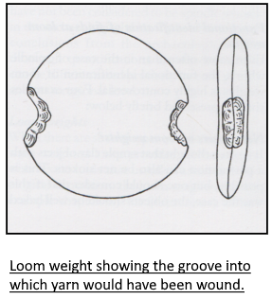
  - In, An Introduction to the Investigation of Archaeological Textile Tools, Lorenz Rahmstorf takes previously research data on textile production and relevant artefact evidence from other geographical areas and contrasts this ‘pool of knowledge’ to the Bronze Age Aegean and Eastern Mediterranean. Rahmstorf states the importance of textiles when investigating status, climate and work practices and Greek Social and Economic Scholar, Brendan Burke, contextualised this elsewhere by explaining that weaving of textiles predates all other craft industries by ‘thousands of years’.
To explain tool-use in textile production, Rahmstorf explains that the abundance of different types of loom weights excavated die to weavers using certain shape, size, and material weights for linen, and others when making cloth from wool or other yarns. Rahmstorf provides clear illustrations to assist the reader.
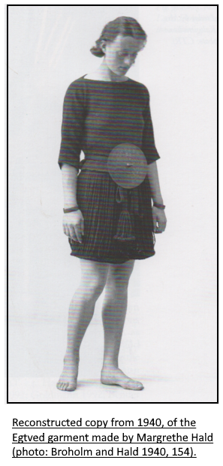
  - Linda Olofsson informs, in An Introduction to Experimental Archaeology and Textile Research, that there is growing interest in the use of experimental archaeology for textile reconstruction: Experiments in replication, pre-1980, were based on items recovered from mid-Twentieth century excavations and she provides a photograph of a garment reconstructed experimentally, in Denmark in 1940, using copies of tools and original textiles finds, from a dig near Vejle. Olofsson believes that technological knowledge, gained worldwide, can assist with reconstructive archaeology in the Aegean and the Eastern Mediterranean.

Olofsson is concerned that disjointed approaches to experimental archaeology maybe failing authenticity when reconstructing textiles. She explains that if we wish to provide credible recreations, it is necessary for the process, from tools to textiles to garments, to be one continual methodological approach, as was practised in the Bronze Age, inferring that unless we follow the processes used in the era, we cannot gain effective reproductions and to recreate textiles without employing correct tools, techniques and processes is not good enough.

- Review of Chapter 2 – Strand,
The Basics of textile tools and the textile technology, from fibre to fabric.
Strand stresses that textile production was important for all groups of Bronze Age society in the Aegean and Eastern Mediterranean because protection from the sun and weather was needed. The demand and uses for textiles soared and this reflected in there increasing value. Textiles were important for clothing but also for sails and caulking on ships, tents, home-goods and much more. When Experimental Archaeologists attempt reconstruction, like Olofsson, Strands wants recognition of the need to authenticate the multi-stage process of textile production with adherence to procedures for raw material processing, yarn preparation, tool-use, dyes and dying, weaving, and sewing. Strand provides extensive clear diagrams, which show regional and time-period differences, for methods and materials of production.
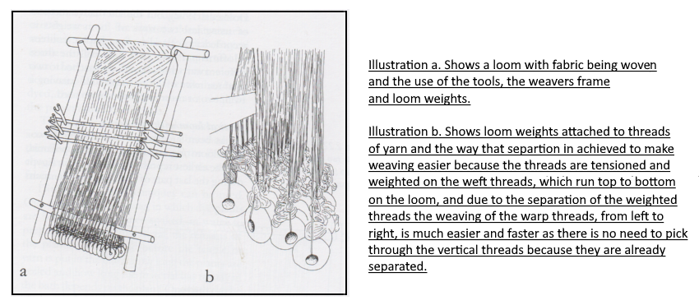

- Review of Chapter 3 - Irene Skals, Susan Moller-Wiering and Marie-Louise Nosch,
Survey of archaeological textile remains from the Aegean and Eastern Mediterranean Area.
This chapter has no illustrations, it reports firstly on the need for ‘improved excavation methods’ to preserve textiles found mainly in burial sites and caves. Secondly, it contrasts Bronze Age to Neolithic and Chalcolithic textile and primitive technology finds. The authors stated they were sometimes unable to make direct comparisons due to different methods of reporting and suggested future standardisation of reports on short forms which lack space for easily misconstrued ‘long descriptive explanations’.

- Review of Chapter 4 – The TTTC experiments,
- 4.1 Olofsson, Strand and Nosch,
Experimental testing of Bronze Age Textile Tools.
- 4.2 Susan Muller-Weiring,
External examination of spinning and weaving samples.
- 4.3 Olofsson and Nosch
Testing of loom weights and 2/2 twill weaving.
- 4.4 Agnete Wisti Lassen
Weaving with crescent shaped loom weights: An investigation of a special kind of loom weight.
- 4.5 Strand
From tools to textile, concluding remarks.
TTTC describes experiments in Tools and Textiles, Texts and Contexts and the authors apply these multi-generational findings specifically to Bronze Age textile production. This is extensive chapter, provides explanations for the reconstruction of samples of fragile or charred fabric remnants, and imprints on clay pots or imprints on soil, found during excavations. The authors explore tool-use in experimental archaeological reconstructions and they compare cloth-making techniques of other periods, to demonstrate the high-level of skills of Bronze Age craftspeople in creating textiles for clothes, textiles used as the base for embroidered goods and functional items such as nets for fishing: These were complemented by illustrations of different styles of reconstructed looms and tools, in use as working objects, and intriguing photographs were supplied to show textiles reconstructed from finds of Bronze Age Aegean and the Eastern Mediterranean, as detailed in the images below.
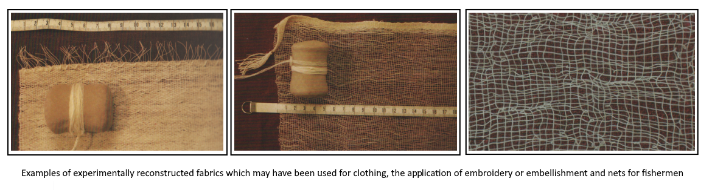

- Review of Chapter 5 – The TTTC database.
- 5.1 Strand and Nosch,
- Introduction to CTR database.
- 5.2 Richard Firth,
Mathematical Analysis of the spindle whorl and loom weight data in the CTR database.
This chapter details technical and mathematical data and lists ancient tools to be replicated for the reconstruction of textiles and assist reconstruction-craftworkers with archaeological context. The detail is extensive and relates thread width to yarn, thread counts per centimetre to style of fabric, and construction-tools to finished textile products. For those intent on reproducing Bronze Age Aegean or Eastern Mediterranean textiles, this chapter is a must read.
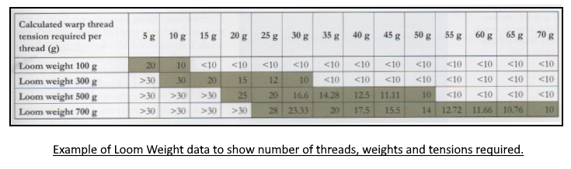

- Review of Chapter 6 - Textile tools in Contexts.
- 6.1 - Strand, Nosch and Joanne Cutler,
Textile tools and textile production- studies of selected Bronze Age sites.
- 6.2 - Marie Lundgren, Strand and Brigetta P. Hallager,
Textile tools from Khania, Crete, Greece.
- 6.3 - Pietro Militello, Strand, Nosch and Cutler,
Textile tools from Ayia Triada, Crete, Greece.
- 6.4 - Militello, Strand, Nosch, Cutler,
Textile tools from Phaistos, Greece.
- 6.5 Jan-Claude Poursat, Francoise Rougemont, Cutler, Strand and Nosch, Textile tools from Quartier Mu, Malia, Crete, Greece.
- 6.6 Iris Tzachilli, Stella Spantidaki, Strand, Nosch and Cutler,
Textile tools from Akrotiri, Thera, Greece.
- 6.7 Katie Demakopoulou, Ioannis Fappas, Strand, Nosch and Cutler
Textile tools from Midea, mainland Greece.
- 6.8 Iphiyenia Tournavitou, Strand, Nosch and Cutler,
Textile tools from Mycenae, mainland Greece.
- 6.9 Lorenz Rahmstorf, Malgorzata Siennicka, Strand, Nosch and Cutler,
Textile tools from Tiryns, mainland Greece
- 6.10 Maria Emanuela Alberti, Vassilis Aravantinos, Fappas, Athina Papadaki, Rougemont,
Textile tools from Thebes, mainland Greece.
- 6.11 Evi Papdopolou, Strand, Nosch and Cutler,
Textile tools from Archontiko, northern Greece.
- 6.12 Ernestine S. Elster, Strand, Nosch and Cutler,
Textile tools from Sitagori, northern Greece.
- 6.13 Marta Guzowska, Ralf Becks, Strand, Nosch and Cutler
Textile tools from Troia, western Anatolia.
- 6.14 Joanna S. Smith, Cutler, Strand and Nosch,
Textile tools from Apliki, Cyprus.
- 6.15 Smith, Cutler, Strand and Nosch,
Textile tools from Kition, Cyprus
- 6.16 Assaf Yasur-Landau, Nurith Goshen, Strand, Nosch and Cutler,
Textile tools from Tel Kabri, Israel.
This chapter relates closely to the previous one, but it specifies the tools and textiles by region. The titles of the sub-chapters are self-explanatory, chronologically based and very varied to reveal the minutiae of textile production by time period, tooling, and yarn type. Shared here are site plans, evidence from buildings where finds were made, information on Bronze Age textiles which were produced by workers as an occasional pursuit or as a continuously worked product to reveal details of the lives of the Bronze Age textile craftspeople. Of the chapters many illustrations and photographs, one is particularly pertinent as it shows loom weight tools used for textile-making just as they are excavated from a Bronze Age home, we see the tools preserved in situ just as the person left them.
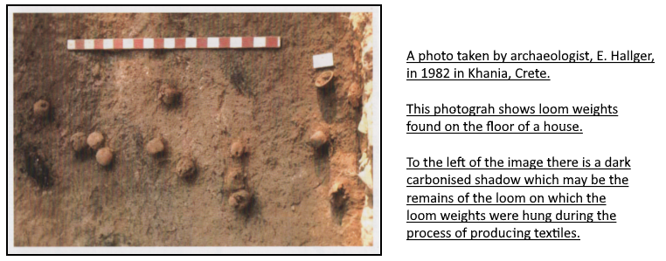

- Review of Chapter 7 Eva Andersson Strand and Marie-Nosch,
Summary of results and conclusion.
It is charming that the editors open this chapter with a statement of pleasure in their achievement: They recap on tools for spinning and they illustrate spindles, they comment on weaving and weavers, loom weights and the textiles they were used to make, we learn about workplaces and how people migrated in order to create new opportunities to improve their status or learn new skills. This is presented in an everyday comfortable style which relays information, and the editors explain their book as not just being collection of facts and figures but as an encouragement for others to ‘take up the thread’, to ‘continue the exploration’ and to ask ‘new questions’ based on the archaeological ‘methodological foundations’ which the editors and authors have laid down for them.

- Review of Appendices to Tools, Textiles and Contexts
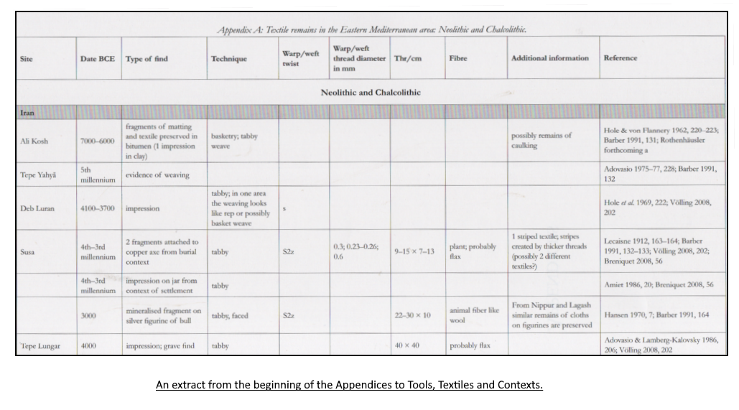
Finally, in Tools, Textiles and Contexts we have the opportunity to review the data which supports the book. Here, we are provided with the hard facts of the country, site, date, type of find, twist style of the thread and its diameter, the thread count per centimetre for the fibre used, some helpful suggestion as to its purpose, colour, pattern, or style and we are provided with a reference which links the data to the person, place, time and recording of the find that was made. This is a practical datasheet.

- My conclusion
If protocol allowed, I would gush enthusiastically about this book: I thought I knew about textile production but going back to the roots, and exploring the Bronze Age basics, has shown me how much more I needed to learn: Every word has been of value to me but the book Textiles, Tools and Contexts could be considered controversial, as it disputes the ‘all importance’ of archaeological fabric related finds as being the only way to shed light on Bronze Age Aegean and the Eastern Mediterranean textiles: The authors show how tools-finds can supplement our knowledge and provide the route to reconstructing the Bronze Age system of textile-making and technology usage.
The facts supplied, in Tools, Textiles and Contexts, have help me to relate my book report to the discoveries, theories and information ascertained from the recommended primary sources outlined in this, appropriately named, Entanglements course and lead me to realise the importance of reviewing explicitly alternative and relevant archaeological and anthropological evidence, to aid me to adhere to the modules instruction notably in sections 3 – 8, the chapter reviews, I have not just delivered a descriptive report but also shown, though briefly, the extensive theories provided in the book which is the subject of this report. I have further engaged with the requirements of the module by exploring the specific dataset, as shown in 10. Review of Appendices to Tool, Textiles and Contexts: This Appendices covers eleven pages and nineteen countries and about the three thousand years, to include the period that is called the Bronze Age, and for the authors, to have constructed such a document, this is a feat in itself.
It has been to contextualise the theories of Tools, Textiles and Contexts with comparisons and evaluations gained while reading required materials from the entangled and interestingly interrelated primary sources set for study in this module: Particularly interesting has been the study of the system of gifting to increase the import of Exotica into pre-palatial Crete and the comments of Bernard Knapp on movement of workers. I regret that word count has limited my opportunity to include contrasts to other related academic works and objects, such as those in the British and Ashmolean Museums: The opportunity to have included these comparisons would have helped to explain the significance of the archaeological finds and reconstructions of the Bronze Age Aegean and Eastern Mediterranean craftspeople.
For me, if this book had been indexed, it would have been near perfect. There is certainly future scope for indexing, just as there is scope for the addition of more chapters as new archaeological finds are made and allow new reconstructive techniques to be developed: Although, with the addition of new material it may be necessary to split the book into two volumes as, for comfortable reading, it is already ready at its maximum size and weight. This book has good potential for use as the basis for an interesting website and each chapter could be used independently for journal articles. The book supplies well written material on an extremely interesting subject and it has left me with the wish to research the subject area further, at a later date. I would be pleased to recommend others to this book as it is a thoroughly beneficial and enjoyable educational read.

- Bibliography
Books
Cline, E. H., 2012. The Oxford handbook of the Bronze Age Aegean. (Oxford: Oxford University Press, 2012).
Strand, E. and Nosch, M., Tools, Textiles and Contexts. (Oxford: Oxbow Books, 2015).

Pfalzner, E. and Al-Maqdissi, E., 2022. Qatna and the Networks of Bronze Age Globalism. (Wiesbaden, Germany: Otto Harrassowitz GmbH & Co, 2022).

Journals
Colburn, C., 2008. Exotica and the Early Minoan Elite: Eastern Imports in Prepalatial Crete. American Journal of Archaeology, 112(2).
Knapp, A., 1993. Thalassocracies in the Bronze Age Eastern Mediterranean Trade: Making and Breaking the Myth. World Archaeology, 24(3).

Strand, E. and Nosch, M., 2015. Tools, Textiles and Contexts: Investigating Textile Production in the Aegean and eastern Mediterranean Bronze Age, (Oxford: Oxbow Books, 2015), p.vii.
Tools, Textiles and Contexts. P.p. x-xi
Tools, Textiles and Contexts. P.p. x
Tools, Textiles and Contexts. P. 1.
Ed. Cline, E., 2012. The Oxford Handbook of The Bronze Age Aegean, (Oxford: Oxford University Press, 2012). P. 430.
Tools, Textiles and Contexts. P. 8.
Tools, Textiles and Contexts. P. 27.
Tools, Textiles and Contexts. P. 53.
Tools, Textiles and Contexts. P. 61.
Tools, Textiles and Contexts. P. 67.
Tools, Textiles and Contexts. P. 94-95.
Tools, Textiles and Contexts. P. 143.
Tools, Textiles and Contexts. P. 199
Tools, Textiles and Contexts. P. 379
Tools, Textiles and Contexts. P. Appendices 1
Ed. Pfalzner, E. and Al-Maqdissi, E., 2022. Qatna and the Networks of Bronze Age Globalism. Wiesbaden, Germany: Otto Harrassowitz GmbH & Co, pp.323-326.
Knapp, A., 1993. Thalassocracies in the Bronze Age Eastern Mediterranean Trade: Making and Breaking the Myth. World Archaeology, 24(3), pp.1-342. Colburn, C., 2008. Exotica and the Early Minoan Elite: Eastern Imports in Prepalatial Crete. American Journal of Archaeology, 112(2), pp.203-220.

