UNIVERSITY OF WALES TRINITY SAINT DAVID
LONDON CAMPUS
Assignment 2
Learning in the Digital Era

Module Name: Learning in the Digital Era
Module Code: ACCA 4025

Student Name:Daud Jama
Student ID:2442748
Group:4

Lecturer’s Name: Dipo Dunsin

Table of Contents
Introduction 2
Main Body 2
Conclusion 9
References 9

PowerPoint Video Link:
:https://youtu.be/9-TMSPb4Iu4?si=4tfTly2jY6Jm4bdX

Introduction
My name is Daud Jama, and this report will cover my personal development plans.
Something that has gradually become a fundamental aspect of my developed understanding of myself is taking time to reflect-particularly on my working practices. Through honest evaluation of my strengths, I’ve learned in what areas I am effective and productive in and those I can consistently rely on. Conversely, recognising the areas I struggle with allows me to plan for ways in which I can develop in them. This self-reflection provides a clear overview of where I’m at currently and where I aim to be[1].
My deeper understanding of myself means I’m able to establish goals that are simultaneously meaningful and achievable. Instead of assuming which areas need improvement, I can make informed decisions based on my prior successes and failures. As a result, I have a structured personal development increasing the chances of a positive outcome.
My PDP is directly linked to this self awareness-this reflection is the very basis on which it was created. It’s not simply a list of tasks but an overhauled lifestyle that allows me to remain focused on my goals by reminding me of my long term aspirations in manageable steps.
In summary, this process is centred around self-awareness-it is imperative I recognise and accept my current capabilities and make informed decisions on how to progress. By developing a deeper understanding of myself, I’m able to construct an effective development plan that will support my growth and provide ways to speed it up.

[1] D. Schön, The Reflective Practitioner: How Professionals Think in Action. New York, NY, USA: Basic Books, 1983.

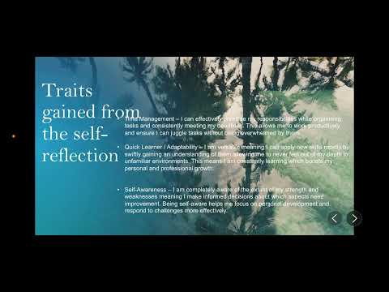

Main Body
I took time in my self evaluation to examine my strengths, weaknesses and the personal qualities I possess from a perspective that remains impartial and unbiased. Engaging in this self reflection provides a clearer understanding of areas I perform well in as well as areas that require further development and upkeep. By reflecting, I was able to identify the skills I’m reliant on, the areas that need to be improved and the personal characteristics that affect and influence my work[2].
This self evaluation improves my understanding of my current stage of development and highlights the progress I need to take as well as the strengths that can help me get to my goals, the weaknesses I am aiming to eliminate and the personal characters that influence my everyday behaviour. My increased awareness of the factors affecting my personal, academic and professional career enables me to make more informed decisions about what my further priorities are[3].
Through this reflective process, I named the strengths I often rely on- I’m a detail-oriented individual who places immense importance on accuracy and the finer aspects of my work. I also excel with time management which makes me punctual, reliable and dependable, allowing others to trust and value my contributions. Additionally, I enjoy working with others and aiding in creating an inclusive, safe environment which encourages confidence and comfort.
I was also made aware of several areas for improvement. I lack confidence particularly when editing or producing advanced creative work and tend to rely on simpler approaches. Furthermore, I am unable to continually focus on longer tasks without getting distracted due to my short attention span which has a negative effect on my overall productivity. The identification of these weaknesses has assisted in me gain a clearer understanding of the skills I need to develop further.
Recognising both what aids me as well as hinders me led to the creation of a Professional Development Plan (PDP). This plan aims to enable me to achieve clear, outlined goals that are explicitly designed to support my personal and professional growth by acting as a structured guide to help me maintain focus on my skill development and progress towards future endeavours.
[2] D. Schön, The Reflective Practitioner: How Professionals Think in Action. New York, NY, USA: Basic Books, 1983.
[3] D. A. Kolb, Experiential Learning: Experience as the Source of Learning and Development. Englewood Cliffs, NJ, USA: Prentice Hall, 1984.
Video Link:
Slide 1 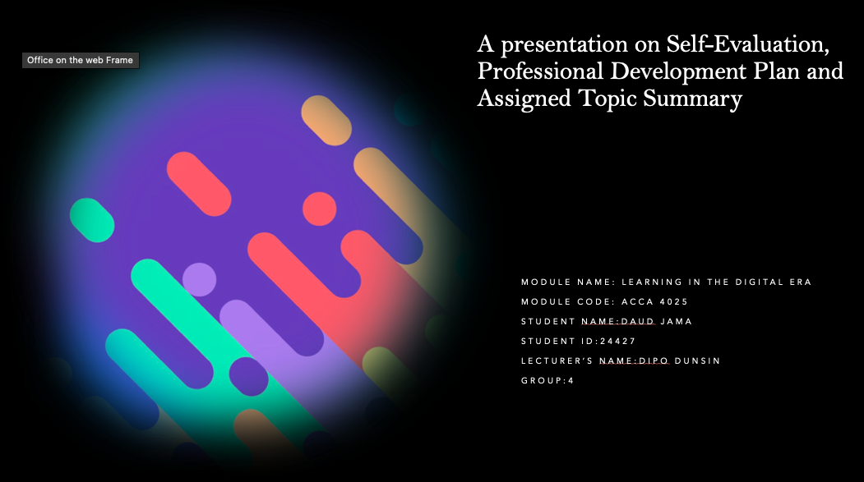

Slide 2 CONTENTS
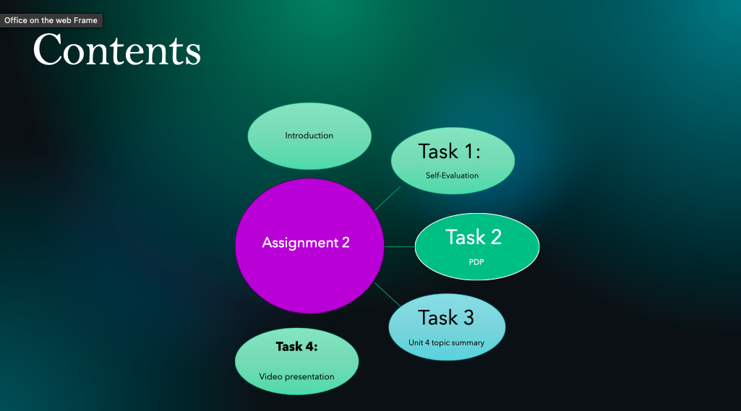

Slide 3 INTRODUCTION
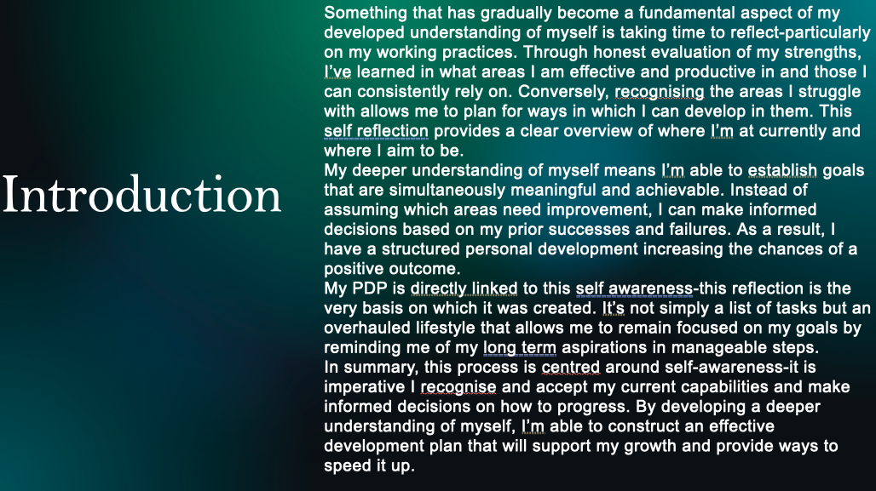

Slide 4 MAIN BODY
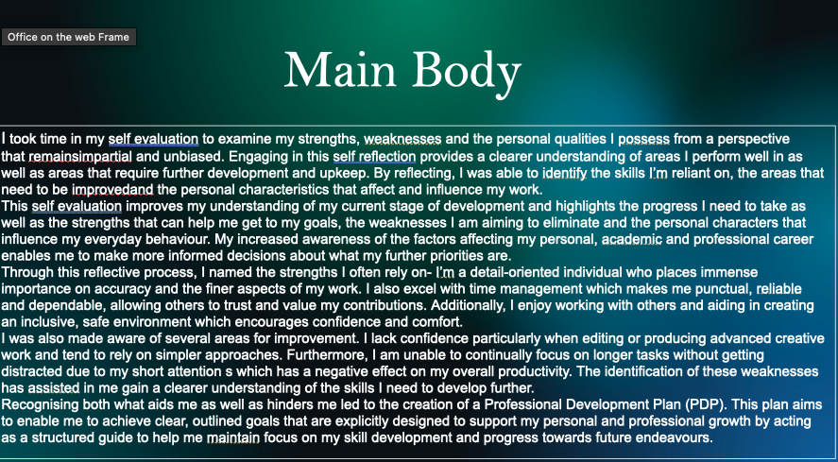

I took time in my self evaluation to examine my strengths, weaknesses and the personal qualities I possess from a perspective that remains impartial and unbiased. Engaging in this self reflection provides a clearer understanding of areas I perform well in as well as areas that require further development and upkeep. By reflecting, I was able to identify the skills I’m reliant on, the areas that need to be improved and the personal characteristics that affect and influence my work[2].
This self evaluation improves my understanding of my current stage of development and highlights the progress I need to take as well as the strengths that can help me get to my goals, the weaknesses I am aiming to eliminate and the personal characters that influence my everyday behaviour. My increased awareness of the factors affecting my personal, academic and professional career enables me to make more informed decisions about what my further priorities are[3].
Through this reflective process, I named the strengths I often rely on- I’m a detail-oriented individual who places immense importance on accuracy and the finer aspects of my work. I also excel with time management which makes me punctual, reliable and dependable, allowing others to trust and value my contributions. Additionally, I enjoy working with others and aiding in creating an inclusive, safe environment which encourages confidence and comfort.
I was also made aware of several areas for improvement. I lack confidence particularly when editing or producing advanced creative work and tend to rely on simpler approaches. Furthermore, I am unable to continually focus on longer tasks without getting distracted due to my short attention span which has a negative effect on my overall productivity. The identification of these weaknesses has assisted in me gain a clearer understanding of the skills I need to develop further.
Recognising both what aids me as well as hinders me led to the creation of a Professional Development Plan (PDP). This plan aims to enable me to achieve clear, outlined goals that are explicitly designed to support my personal and professional growth by acting as a structured guide to help me maintain focus on my skill development and progress towards future endeavours.
[2] D. Schön, The Reflective Practitioner: How Professionals Think in Action. New York, NY, USA: Basic Books, 1983.
[3] D. A. Kolb, Experiential Learning: Experience as the Source of Learning and Development. Englewood Cliffs, NJ, USA: Prentice Hall, 1984.

Slide 5 GIBB’s REFLECTIVE MODEL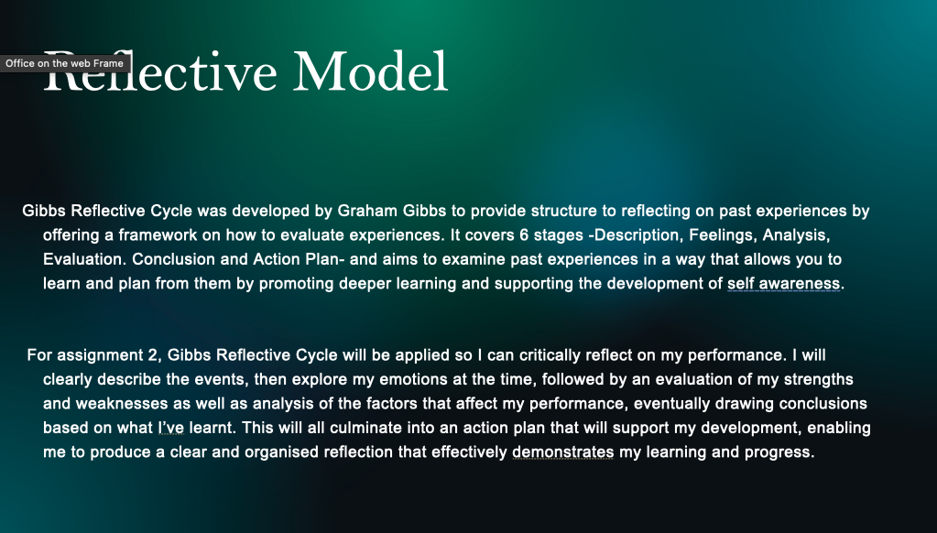

Gibbs Reflective Cycle was developed by Graham Gibbs to provide structure to reflecting on past experiences by offering a framework on how to evaluate experiences. It covers 6 stages -Description, Feelings, Analysis, Evaluation. Conclusion and Action Plan- and aims to examine past experiences in a way that allows you to learn and plan from them by promoting deeper learning and supporting the development of self awareness[4].

For assignment 2, Gibbs Reflective Cycle will be applied so I can critically reflect on my performance. I will clearly describe the events, then explore my emotions at the time, followed by an evaluation of my strengths and weaknesses as well as analysis of the factors that affect my performance, eventually drawing conclusions based on what I’ve learnt. This will all culminate into an action plan that will support my development, enabling me to produce a clear and organised reflection that effectively demonstrates my learning and progress.
[4] G. Gibbs, Learning by Doing: A Guide to Teaching and Learning Methods. Oxford, U.K.: Oxford Polytechnic, 1988.

Slide 6 TASK 1: SELF EVALUATION
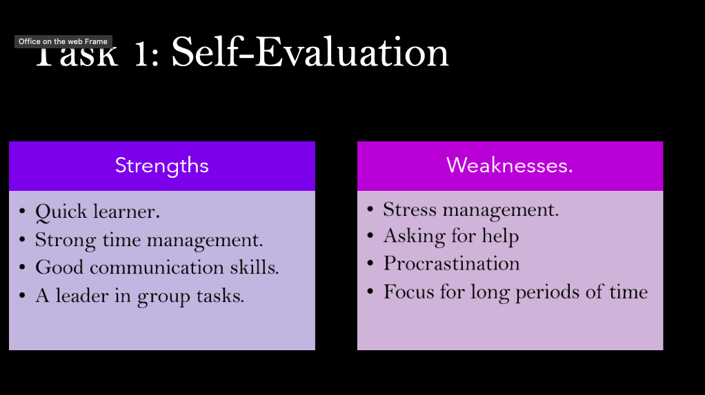
When evaluating myself I can list certain traits that resonate with me. For example, I am a quick learner, this means when content is put in front of me, I able to mentally download, process and understand it [5]. I also have good time management allowing me to keep good track of assignment allowing me to avoid leaving it until the end which removes last minute stress and panic. While having good time management and being a quick learner, I also have good communication skills which allow me to communicate regarding my tasks. This also correlates with my last strength because I can communicate good in group tasks encouraging me to be a leader.

On the other hand. I need to work on stress management this can happen when i feel as if my work does not reach a certain standard of quality leading me to stress, when it could be avoided with good stress management such as taking a deep breath [6]. In addition to this another weakness of mine is not asking for help. This is because I have tendencies of trying to be a perfectionist which is not realistic. My last two weaknesses go hand in hand as I procrastinate which does not promote a hands-on approach which affects my focus for long periods of time because my mindset can be affected.
[5] E. J. McKeachie, McKeachie's Teaching Tips: Strategies, Research, and Theory for College and University Teachers, 14th ed. Boston, MA, USA: Cengage Learning, 2013
[6] S. Covey, The 7 Habits of Highly Effective People. New York, NY, USA: Free Press, 1989

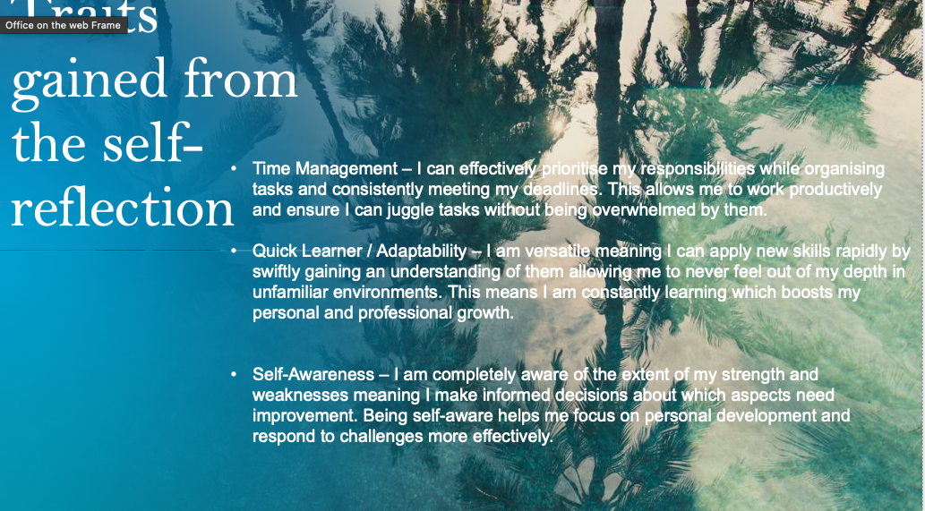

- Time Management – I can effectively prioritise my responsibilities while organising tasks and consistently meeting my deadlines. This allows me to work productively and ensure I can juggle tasks without being overwhelmed by them.

- Quick Learner / Adaptability – I am versatile meaning I can apply new skills rapidly by swiftly gaining an understanding of them allowing me to never feel out of my depth in unfamiliar environments. This means I am constantly learning which boosts my personal and professional growth.

- Self-Awareness – I am completely aware of the extent of my strength and weaknesses meaning I make informed decisions about which aspects need improvement. Being self-aware helps me focus on personal development and respond to challenges more effectively.

]Slide 8 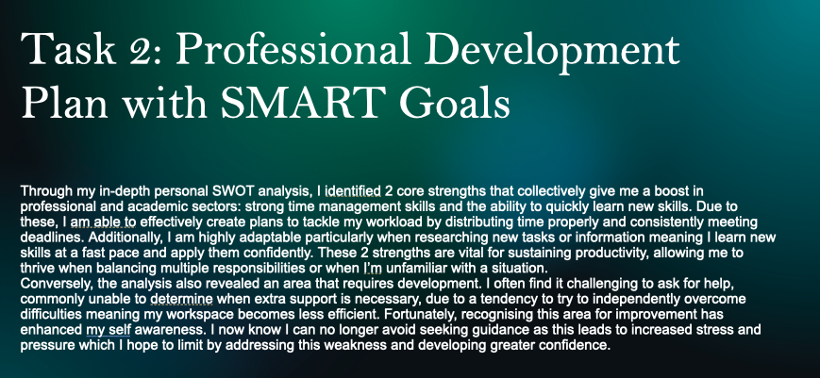Through my in-depth personal SWOT analysis, I identified 2 core strengths that collectively give me a boost in professional and academic sectors: strong time management skills and the ability to quickly learn new skills [7]. Due to these, I am able to effectively create plans to tackle my workload by distributing time properly and consistently meeting deadlines. Additionally, I am highly adaptable particularly when researching new tasks or information meaning I learn new skills at a fast pace and apply them confidently. These 2 strengths are vital for sustaining productivity, allowing me to thrive when balancing multiple responsibilities or when I’m unfamiliar with a situation [8] .
Conversely, the analysis also revealed an area that requires development. I often find it challenging to ask for help, commonly unable to determine when extra support is necessary, due to a tendency to try to independently overcome difficulties meaning my workspace becomes less efficient. Fortunately, recognising this area for improvement has enhanced my self awareness. I now know I can no longer avoid seeking guidance as this leads to increased stress and pressure which I hope to limit by addressing this weakness and developing greater confidence.

[7] A. Hill and T. Westbrook, “SWOT analysis: It’s time for a product recall,” Long Range Planning, vol. 30, no. 1, pp. 46–52, 1997.
[8] S. Covey, The 7 Habits of Highly Effective People. New York, NY, USA: Free Press, 1989

Slide 9 UNIT 4 TOPIC SUMMARY

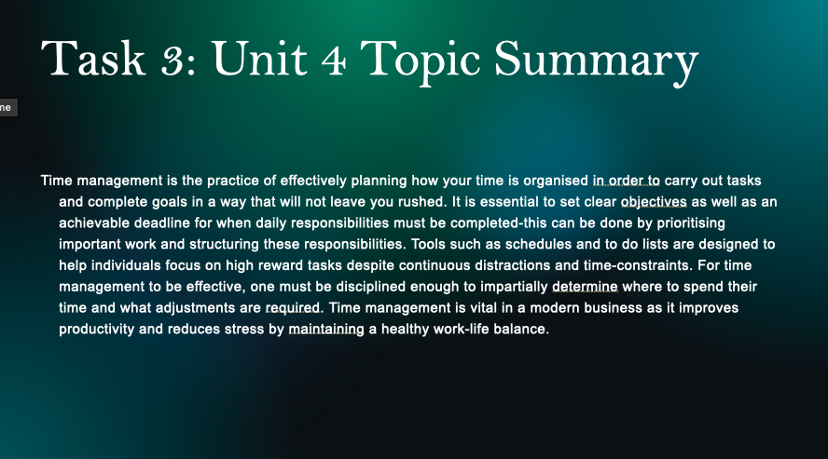

Brief explanation: Time management is the practice of effectively planning how your time is organised in order to carry out tasks and complete goals in a way that will not leave you rushed [9]. It is essential to set clear objectives as well as an achievable deadline for when daily responsibilities must be completed-this can be done by prioritising important work and structuring these responsibilities. Tools such as schedules and to do lists are designed to help individuals focus on high reward tasks despite continuous distractions and time-constraints [10]. For time management to be effective, one must be disciplined enough to impartially determine where to spend their time and what adjustments are required. Time management is vital in a modern business as it improves productivity and reduces stress by maintaining a healthy work-life balance.

[9] A. Lakein, How to Get Control of Your Time and Your Life. New York, NY, USA: Signet, 1973
[10] B. R. Covey, The 7 Habits of Highly Effective People. New York, NY, USA: Free Press, 1989

Slide 10 CONCLUSION

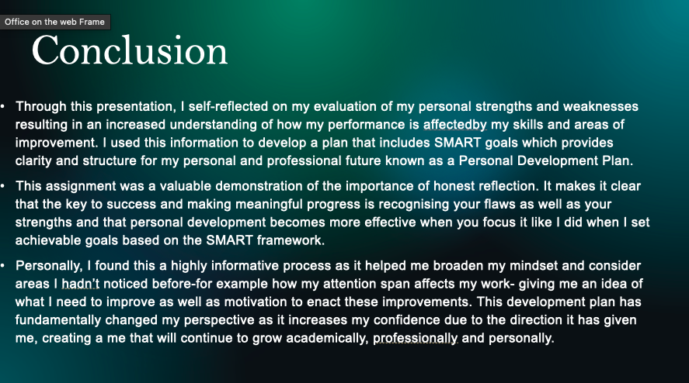

Brief explanation:
Through this presentation, I self-reflected on my evaluation of my personal strengths and weaknesses resulting in an increased understanding of how my performance is affectedby my skills and areas of improvement. I used this information to develop a plan that includes SMART goals which provides clarity and structure for my personal and professional future known as a Personal Development Plan.
This assignment was a valuable demonstration of the importance of honest reflection. It makes it clear that the key to success and making meaningful progress is recognising your flaws as well as your strengths and that personal development becomes more effective when you focus it like I did when I set achievable goals based on the SMART framework.

Slide 11

Conclusion
I found this a highly informative process as it helped me broaden my mindset and consider areas I hadn’t noticed before-for example how my attention span affects my work- giving me an idea of what I need to improve as well as motivation to enact these improvements. This development plan has fundamentally changed my perspective as it increases my confidence due to the direction it has given me, creating a me that will continue to grow academically, professionally and personally.

References
1] D. Schön, The Reflective Practitioner: How Professionals Think in Action. New York, NY, USA: Basic Books, 1983.
[2] D. Schön, The Reflective Practitioner: How Professionals Think in Action. New York, NY, USA: Basic Books, 1983.
[3] D. A. Kolb, Experiential Learning: Experience as the Source of Learning and Development. Englewood Cliffs, NJ, USA: Prentice Hall, 1984.
[4] G. Gibbs, Learning by Doing: A Guide to Teaching and Learning Methods. Oxford, U.K.: Oxford Polytechnic, 1988.
[5] E. J. McKeachie, McKeachie's Teaching Tips: Strategies, Research, and Theory for College and University Teachers, 14th ed. Boston, MA, USA: Cengage Learning, 2013
[6] S. Covey, The 7 Habits of Highly Effective People. New York, NY, USA: Free Press, 1989
[7] A. Hill and T. Westbrook, “SWOT analysis: It’s time for a product recall,” Long Range Planning, vol. 30, no. 1, pp. 46–52, 1997.
[8] S. Covey, The 7 Habits of Highly Effective People. New York, NY, USA: Free Press, 1989
[9] A. Lakein, How to Get Control of Your Time and Your Life. New York, NY, USA: Signet, 1973
[10] B. R. Covey, The 7 Habits of Highly Effective People. New York, NY, USA: Free Press, 1989

