

Module name: Mental Disorders and Psychopathology
Module code: BMHP6006

Student name: Maya Ivanova Hadzhieva
Student ID: 1818829
Lecturer Name: Diya Ganguly

Table of Contents
Introduction 3
Classification 4
Statistics 6
Diagnosis 6
Treatment 8
Rehabilitation 9
The UK Legislation 10
Recommendations 10
Conclusion 12
References and Bibliography 13
Appendix 15

Introduction
A psychological disorder is a condition categorised by abnormal thoughts, feelings, and behaviour (Hertz, 2021). Psychopathology is the study of psychological disorders including their treatment, symptoms, and aetiology. It is known as the origin of mental disorders and their development. Psychopathology refers to the manifestation of a psychological disorder. The concept is to label inner experiences that are dysfunctional, atypical, dangerous, and dysfunctional as signs of the disorder (Hertz, 2021).
Mental illness is known as mental health disorder (Pilgrim, 2021). It refers to a broader range of mental health conditions that affect the individual’s mood, thinking, and behaviour. Some of the most popular mental health disorders are schizophrenia, depression, anxiety disorders, autism, eating disorders, and addictive behaviours. Mental health concerns become a mental disease on-going signs cause recurrent stress and disturb the ability to function (Pilgrim, 2021). The symptoms are reduced ability for concentration, extreme mood changes, delusions, hallucinations, paranoia, inability to cope with everyday problems, violence, suicidal thinking, hostility, and excessive anger.
ICD-10 is a classification of diseases from the World Health Organisation to provide diagnostic criteria to achieve the fundamental goals such as identification of the group of patients with related clinical appearance, to simplify primary diagnosis, and choice of treatment (Jared, 2021). The main purpose of ICD-10 is to outline an identical heritable diagnostic category for aetiological and genetic research.
The aim of this academic work is to provide a critical examination of the classification, diagnosis, and measurements of rehabilitation of schizophrenia, autism, and general anxiety disorder. It provides a vital understanding of psychopathology. This study identifies the gaps in the literature for future researchers and to provide vital recommendations for future improvement in the diagnosis and treatment of these mental health disorders.

Classification
Schizophrenia, autism, and general anxiety disorder are part of the International Classification of Disease (ICD-10), chapter V, disorders of psychological development (Wolfgang, 2020). The difference between ICD-11 and ICD-10 is that ICD-11 has a more sophisticated construction. It uses nearby 55,100 codes for the classification of diseases, disorders, injuries, and reasons for death. The new version proposes an acceptable phase of an element in coding these sicknesses. It provides revision in the theoretic conceptions especially in the part of mental health. ICD-11 addresses the gaps in the ICD-10 such as changes in thinking, medical updates, and discoveries (Wolfgang, 2020). It has a new approach to categorisation and coding structure such as user-friendliness and digital readiness. ICD-11 is based on the new dimensional approach that consists of examination confirmation and recovery from sickness. This dimensional tactic supports the reduction of artificial comorbidity and refers to the individual being diagnosed with various symptoms from the same disease (Wolfgang, 2020).
Vital comparison is between DSM-V and ICD-11. These systems have numerous matches, guidelines, and treatments (Wolfgang, 2020). The main differences are that DSM has a strong focus on mental health worries despite ICD shields all body and mind parts. ICD-11 is much wider in scope and authorship in comparison with DSM-5. ICD-11 has an international focus while DSM has a narrow focus on North America (Wolfgang, 2020). The biggest variance is that DSM does not use codes for its diagnosis and instead uses the codes from ICD. Critically, this causes conflicts and confusion as many disorders are classified differently. Another confusing situation is different treatment from these two main bodies for many disorders (Wolfgang, 2020).
Generalised anxiety disorder (GAD) is when individuals find solid to control their uncertainties (Ollendick, 2021). Their feelings of anxiety disturb their everyday life. GAD is a long-term condition with a broader range of issues and situations. It includes physical and mental symptoms such as dizziness, troubles with concentrating, feeling restless, worries, and heart palpitations. GAD is classified with Code F41.1 Generalised anxiety disorder in the group F40-F48 Neurotic, stress-connected, and somatoform disorders (Ollendick, 2021).
Schizophrenia is a severe long-term mental health disorder. It causes various psychological symptoms such as hallucinations, delusions, losing interest in daily life, and the desire to avoid people (Meas, 2021). Schizophrenia is classified with Code F20 in ICD-10; Chapter V. Various types of Schizophrenia are classified from F20.0 to F20.9. Vital is that the classification of mental disorders is significant to public health, clinical diagnosis, service provision, and precise research applications. The framework of classification of schizophrenia is the deep understanding of this mental disorder. The core issues that challenge the classification are aetiology and whether the phenomena are dimensions or discrete categories (Meas, 2021). Vital critics are that there are no boundaries between disorder and non-disorder because the individuals are diagnosed with multiple conditions. The systems’ approaches are the key to the problematic issues as the result of different purposes. They share the target of reducing the burden of suffering due to mental disorders. However, these systems have different degrees of distinguishing features and overlap (Meas, 2021).
Autism is a developmental disorder of mutable harshness that is categorised by the struggle in communal interface and communication and by limited or monotonous outlines of thought and behaviour (Lester, 2021). This is not an illness. The brain works in a different way. It is classified in group F80-F89 Disorders of mental improvement with F84.0 Childhood autism.
Classification of mental disorders has its origins in ancient times (Beek, 2021). Nowadays, different scientific theories are based on biological research for different biological processes. However, many causes are absent from professional nosology. The psychosocial influences are vital for understanding the multiple factors of the development until the knowledge for the mental disorders such as schizophrenia is still incomplete. The result is that the current ICD-10 classification form is based exclusively on observation signs and behaviour and self-reporting feeling and thoughts. There is no basis for underlying causal mechanisms. The categories and the classification systems are vital for the global healthcare system because of the sense of complex observations (Beek, 2021). However, they cannot reach the limits of understanding mental disorders such as schizophrenia only with observable signs and worldwide experienced symptoms. There are two main classifications of schizophrenia as DSM-IV and ICD-10. DSM-IV shapes this mental disorder as a solitary set for diagnostic criteria for all patients. However, ICD-10 is designed as a family of inter-related varieties addressing different customers (Beek, 2021).
Many critics describe schizophrenia as a psychological response to be oppressive upbringing (Beek, 2021). This is widely accepted nowadays as a physical illness. Society’s neglect of this mental illness leads to the promotion of a humanistic understanding of the affected individual as a human being. There is a doubt about ignoring the social dimensions of schizophrenia. This rebukes the medical practitioners and opens the way for post-modernism tendency to valorise as mental sickness. There is a dilemma for categorical or dimensional structure for classification. The categorical structure is more used by scientists but the dimensions are more accurate measurements (Beek, 2021).

Statistics
GAD is a common condition that affects up to 5 % of the UK population (Herdem, 2020). All Mental illnesses cost the UK economy £78 billion every year or about 4.1% of GDP. Mental illnesses in the UK receive less than 1% research funding and 5.5 for all mental illnesses. However, 10% of total diseases are from the mental health group (Herdem, 2020). Please see Graphs 1, 2, and 3 from the Appendix.
During their life, 1 in 100 individuals will suffer an episode of schizophrenia (ONS, 2021). It is a major illness and about 220, 000 individuals in the UK are treated by the NHS. Between 5 to 10% of patients with schizophrenia will kill themselves. Modern medication reduces the risk of relapse to 10%. The costs for patients with schizophrenia are 6 times more than the patients with heart disease. 30% of all spending in NHS are for schizophrenia. Individuals with schizophrenia die 10-20 years earlier than the general population (ONS, 2021).
There are more than 700, 000 people with autism in the UK (McConkey, 2020). 1% of the children in the country have a diagnosis of autism variety disorder. There are more than 1 million adults with autism in the UK. There is a huge impact from the current COVID-19 pandemic on the number of referrals from diagnosis from autism which increasing the risks of mental health conditions. The closure of the schools leads to a lack of social interaction for children and behaviour changes and more stress in the families (McConkey, 2020). Please see Graph 4.
Diagnosis
This has a critical role in the management of schizophrenia patients (Balakrishnan, 2021). There are many problematic continuous issues such as attempts to resolve them and for identification of the risk factors and causal mechanisms. The prime source of the prime for all difficulties is the complex nature of schizophrenia and the weakness of its diagnosis process because it remains on the assumptions of underlying unknown disease processes. The majority of the attributes define it based on the self-reported and individual experience. The underlying functional and structural pathology is unsatisfactorily understood (Balakrishnan, 2021). There are no tests for objective diagnosis for schizophrenia or confirmed biological markers that can offer evidence for clinical decision-making or epidemiological and biological research. Recurrent controversies in schizophrenia research concern its delimitation from other disorders. The criteria and rating scales for schizophrenia are known as positive (Type I) and negative (Type II). “Type I” is described by formal thought disorder, illusions, and hallucinations. However, it is based on the assumed fundamental dopaminergic dysfunction. “Type II” is described as poverty of speech, social withdrawal, and loss of volition. It is associated with structural brain abnormities (Balakrishnan, 2021).
Understanding the diagnosis of GAD is complex because all criteria allow common diagnostic algorithms to be used (Moller, 2021). DSM-IV has similar symptoms for panic attacks but the most important is the length of time happened. A longer period of feeling anxious or afraid is at the core of the diagnosis. Critically, GAD is frequently related to other psychiatric and medical disorders. It increases the danger of major depression and usually is associated with substantial distress and with disability (Moller, 2021). This disorder increases the risks of suicide and it is related with serious occupational and impaired social functioning. GAD can be diagnosed difficulty because of the stigma of mental sickness and a focus on physical symptoms. The main criteria for this are the individual to have difficulties with controlling the anxiety with several various actions or events. The patients must have at least three out of six psychological symptoms such as feeling the tension in the muscles, hardship for concentration, tiredness, insomnia, feeling nervous, and feeling irritable (Moller, 2021).
Understanding the diagnosis for autism is complex and requires some appreciation such as core symptoms (Volkmar, 2021). It is characterised as extreme autistic aloneness and insistence on sameness. This disorder is described as withdrawal from social relationships. Autism differs from schizophrenia by the absence of delusions and hallucinations and by poor intellectual functioning in the family with autism (Volkmar, 2021). The diagnosis of autism means that the individuals are at a mentally subnormal level. The main difference between autism and other disorders is high rates of comorbidity. Autism cannot be based on the presence of social and language impairments. The special features characteristics of autism are abnormal language development, impaired social relations, and insistence on sameness. This disorder can be diagnosed as abnormal social and language deficits for the children’s mental age and the shown signs of the special features characteristics (Volkmar, 2021).
The main critic for young people and children is to wait too long for starting their autism diagnostic assessment (Cable, 2021). There are different strategies such as from 28 weeks in Wales to 14 weeks in Northern Ireland. These targets are missed. In England, less than 9% of the children have their assessment for autism at 3 months. However, in Scotland, more than 75% need to wait more than 120 days for diagnosis (Cable, 2021). Crucially, these delayed diagnoses have huge potential impacts by denying the children opportunities to understand their response which causes stress to families, a long period of time waiting for a diagnosis, and extra financial costs (Cable, 2021).

Treatment
Treatment of GAD includes psychological therapies such as cognitive behavioural therapy and medication such as antidepressants (Davey, 2021). Advantages are therapies provide long-lasting benefits than medication such as applied relaxation to focus on relaxing and psychological therapies for anxiety, stress, and depression. Disadvantages are the side effects from antidepressants such as feeling agitated, being sick, dizziness, dry mouth, headaches, insomnia, diarrhoea, loss of appetite, and excessive sweating (Davey, 2021).
Treatment of schizophrenia is a combination of medicine and therapy for every individual (Davey, 2021). The majority of patients are treated with cognitive behavioural therapy and antipsychotic medicines. Individuals with schizophrenia accept support from the community mental health team for everyday life and treatment. Many people have recovered from this mental disorder but many of them have periods of returned symptoms. The advantages of antipsychotic drugs for treating schizophrenia are that the individuals can live with schizophrenia and have a normal life, 75% of the patients improve their conditions, and there are positive differences (Davey, 2021). Disadvantages are that antipsychotic drugs have side effects such as tardive dyskinesia. In many situations, schizophrenia can’t be understood as an illness. It increases the risks of violence in comparison with non-drug therapy. The treatment hides the symptoms and is not treat schizophrenia (Davey, 2021). Evaluation of treating schizophrenia is that drugs only look to fix the symptoms. However, the problematic issues are never solved. There is no real improvement but only damage. The drugs reduce the patient’s confidence in understanding the illness and increasing the side effects to be developed (Davey, 2021).
Usually the children from any form of autism receive different forms of treatment in schools such as behaviour support, social and skills training, speech, physical and occupational therapy (Shmueli, 2021). The treatment for adults includes sensory integration therapy and cognitive therapy. Critically, in most cases the family issues are involved such as lack of understanding of the dynamic forces and landscape of autism. Crucially, many family members live with autism as a condition, not as an illness.
There are many harmful autism treatments such as an injection made from blood cells and hyperbaric oxygen therapy. The most important things for autism are awareness and support, continuous research, and support groups willing to help (Shmueli, 2021). Many patients with autism do not socialise with other people and some of them do not speak. They have learning disabilities, usually are being bullied in schools, and the majority of them get rejected, discriminated against, or not accepted as friends.
Applied behaviour analysis (ABA) is a common treatment for autism which is supposed to help with communication and social skills (Dillenburger, 2018). The advantages for children are to adjust to normal life. The main approach is that children with autism learn new behaviours, increased their intellectual abilities, and have better social skills. The therapies can modify the emotional and social behaviour of children. They can help boost their intellectual aptitude. The parents can learn these techniques and use them at home (Dillenburger, 2018). There are positive impacts for the children with better communication and less frustration. Disadvantages are that therapies imply that the child is abnormal or needs to change. Many people believe that the techniques are unethical, abusive and wrong. The main potential problem is that the treatment is individualised. This means that the programme depends on the circumstances (Dillenburger, 2018).
Rehabilitation
Measurements for rehabilitation for schizophrenia are part of numerous clinical studies and practices during the years (Sahoo, 2020). Nowadays, it is understandable that it is more than symptomatic remission because it includes several domains of the person’s life such as individual recovery, quality of life, and psychosocial functioning. It includes satisfaction, side effects, disability, results, and apparent stigma. Many instruments and scales are developed for the measurement of these domains individually (Sahoo, 2020). However, it is essential to use a particular type of instrument for the evaluation of the specific outcome. All these instruments have advantages, disadvantages, limitations, and strengths. Overall, this creates confusion when a particular instrument is used for the evaluation of the specific measure. According to the current healthcare system, the most important is the healthcare workers to receive training to measure the outcomes with currently available instruments. However, many challenges and barriers during the whole assessment will remain the same (Sahoo, 2020).
Psychometric evaluation of the autism stigma development (ASD) knowledge has deficits in contributions to the quality of the autism services and timing (Bradshaw, 2017). The examination has multiple subdomains while support cross-cultural utility and maintaining strong psychometric support. The four subscales are stigma, aetiology, diagnosis, and treatment. The most important is the evaluation of the statistical validity of every participant (Bradshaw, 2017).
The Autism Diagnostic Observation Schedule is a semi-structured observation measure for asserting autism across developmental levels and language skills. The results show difficulties for employment, finances, and socialisation for adults (Olsen, 2021). Critically, despite the progress for full participating in life, the patients with autism are a huge burden for families with critical need periods of childhood. The healthcare system and school system increase resources for children with autism.
Measurements for rehabilitation for generalised anxiety disorder include free diagnostic tools with a combination of treatment modalities tailored to the individual patient (Nazareth, 2021). The effective treatment includes cognitive behaviour therapy to reduce the anxiety symptoms. However, there is limited evidence from alternative and complementary treatments and high risks from adverse effect profiles from medications.

UK Legislation
This includes Mental Health Act 1983 (Updated 2007) for people with mental health experiences, Equality Act 2010 protects from discrimination, Care Act 2014 shapes the duties of local specialists and their links with patients, Human Act 1998 respect the patients, Data Protection Act 2018 protects the information handle by organisations, and Criminal Procedure Act 1964 outlines if the accused person is under disability (Legislation.gov.uk, 2021).

Recommendations
This includes improving the waiting times to start diagnosis for autism includes the local areas to address the target dates for diagnosis and adequate funding that children can’t wait more than three months for an initial assessment (Bailey, 2021). Future research and identification of developmental problems are critical for medical evaluation, diagnosis, treatment, and diagnostic process. Future research is required for chronic-condition management and children with special needs (Bailey, 2021).
Access to the patients with schizophrenia must be increased because they are a risky group from COVID-19 and high mortality (Tihonen, 2021). There are five areas for improvement such as a combination of psychosocial and pharmacological tactics to smoking cessation, treatments in first-episode schizophrenia, antipsychotic treatment, and repetitive magnetic stimulation (Tihonen, 2021).
Researchers on GAD need to be more focused on stigma with more concentration on young people and especially women (Nazareth, 2021). It is essential to inspect the time-based modifications in recording in crucial healthcare and original pharmacologic handlings. Future research is required for trends in anxiety in UK general practice (Nazareth, 2021).

Conclusion
This academic report raised the main points for mental health issues that are more widely spread manifest in a wider variety of different situations both physical and mental. It provides evidence for the complex form of three disorders such as GAD, schizophrenia, and autism. This study provides statistics that show mental health issues are increasing at an alarming rate and they progress during the individual’s lifetime at a faster pace. Reflection is vital to understand how difficult is to diagnose the mental health issue.
This academic report evaluates the key article for schizophrenia, GAD, and autism. The key findings are the patients with mental health disorders have brain tracks dangerous to the affective and social dysfunction is seen in numerous psychiatric disorders. Evidence from clinical-based interventions delivers that early services improve the outcomes for patients. The three disorders have the identical outlines of the suspect gene expression.

References and Bibliography
Bailey, B. (2021). "The promise of comprehensive early reading instruction for children with autism and recommendations for future directions". Language, Speech, and Hearing Services in Schools, 52(1), pp. 225-238.
Balakrishnan, S., and Stanley, S., (2021). "Informal caregivers of people with diagnosis of schizophrenia: determinants and predictors of resilience". Journal of Mental Health, 8(7), pp. 1-8.
Bradshaw, L., Harrison, A., Paff, N., and Campbell, J., (2017). "Development and Psychometric Evaluation of the Autism Stigma and Knowledge Questionnaire (ASK-Q)". Journal of Autism and Developmental Disorders, 47(2), pp. 3281-3295.
Cable, N., Sacker, A., and Hosozawa, M., (2021). "Timing of diagnosis, depression and self-harm in adolescents with autism spectrum disorder". Autism, 25(1), pp. 70-78.
Davey, G. (2021). Psychopathology: Research, assessment and treatment in clinical psychology. New York: John Wiley & Sons.
Diedrich, L. (2016). Indirect Action: Schizophrenia, Epilepsy, AIDS, and the Course of Health Activism. Minneapolis: University of Minnesota Press.
Dillenburger, K., and Fennell, B., (2018). "Applied behaviour analysis: What do teachers of students with autism spectrum disorder know". International Jornal of Educational Research, 87(1), pp. 110-118.
Herdem, G., Ceymi, D., and Tuba, M., (2020). "Behavioral Implications of the COVID-19 Process for Autism Spectrum Disorder, and Individuals's Comprehension of the Reactions to the Pandemic Conditions". Frontiers in Psychiatry, 11(1), p. 1263.
Hertz, P., Berzoff, J., and Flanagan, L., (2021). Psychodynamic clinical theory and psychopathology in contemporary multicultural contexts. New York: Rowman and Littlefield.
Jared, K., Roberts, M., Evans, S., Burke, J., and Espeleta, L., (2021). "Diagnostic classification of irritability and oppositionality in youth: a global field study comparing ICD-11 with ICD-10 and DSM-5." Journal of Child Psychology and Psychiatry, pp. 303-312.
Meas, M., Abbas, A., and Hussein, H, (2021). "Schizophrenia phenomelogy revisted: positive and negative symptoms are strongly related reflective manifestations of an underlying single trait indicating overall severity of schizophrenia". CNC spectrums, 26(4), pp. 368-377.
Moller, J., Seifritz, E., Kasper, S., and Volz, P., (2021). "Subsyndromal generalised anxiety disorder: operationalisation and epidemiology - a systematic literature survey". Journal of Psychiatry in Clinical Practice, 5(4), pp. 1-10.
Legislation.gov.uk. (2021). The UK Legislation. [Online]
Available at: https://www.legislation.gov.uk/all?title=mental%20health [Accesses: 17th August 2021]
Lester, J., Kapp, K., Hand, B., and Bottema-Beutel, K., (2021). "Avoiding ableist language: Suggestions for autism researchers.". Autism in Adulthood, 3(1), pp. 18-29.
McConkey. (2020). "The rise in the number of pupils identified by schools with autism spectrum disorder (ASD): a comparison of the four countries in the United Kingdom". Support for Learning, 35(2), pp. 132-143.
Nazareth, I., Horsfall, L., and Slee, A., (2021). "Trends in generalised anxiety disorders and symptoms in primary care: UK population-based cohort study". The British Journal of Psychiatry, 218(3), pp. 158-164.
Ollendick, T., and Muris, P., (2021). "Selective mutism and its relations to social anxiety disorder and autism spectrum disorder". Clinical Child and Family Psychology Review, 12(13), pp. 1-32.
Olsen, A., Greene, R., and Duvall, W., (2021). "Autism Diagnostic Observation Schedule (ADOS-2) elevations in a clinical sample of children and adolescents who do not have autism: Phenotypic profiles of false positives". The Clinical Neuropsychologist, 14(1), pp. 1-17.
ONS. (2021). Living with Schizophrenia. [Online]
Available at: https://livingwithschizophreniauk.org/facts-and-figures/ [Accessed: 17th August 2021]
Pilgrim, D., and Rogers, A., (2021). A Sociology of Mental Health and Illness. London: McGraw-Hill Education.
Sahoo, S., and Grover, S., (2020). "Outcome Measurement in Schizophrenia: Challenges and Barriers". Schizophrenia Treatment Outcomes, 12(13), pp.91-124.
Shmueli, D., Harel, M., Schnapp, A., and Aran, A., (2021). "Cannabinoid treatment for autism: a proof-of-concept randomized trial". Molecular Autism, 12(6), p. 5629.
Tihonen, J., and Lahteenvuo, M., (2021). "Antipsychotic Polyparmacy for the Management of Schizophrenia: Evidence and Recommendations". Drugs, 12(15), 1-12.
Volkmar., Lord, C., Rosen, N., and Fred, R., (2021). "The Diagnosis of Autism: From Kanner to DSM-III to DSM-5 and Beyond". Journal of Autism and Developmental Disorders, 5(4), pp. 1-18.
Wolfgang, G. (2020). "Changes from ICD-10 to ICD-11 and future directions in phychiatric classification". Dialogues in Clinical Neuroschience, 22(1), pp. 7-15.

Appendix

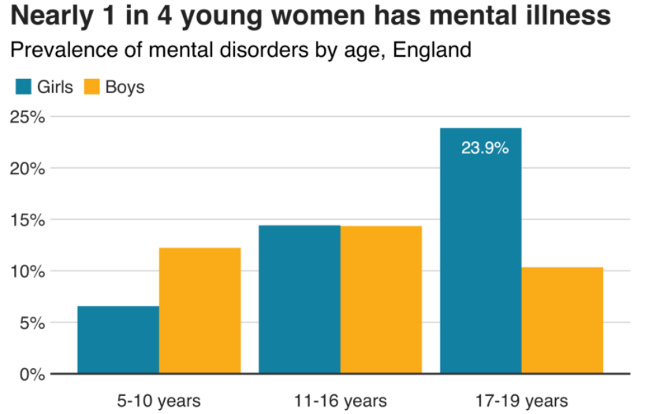

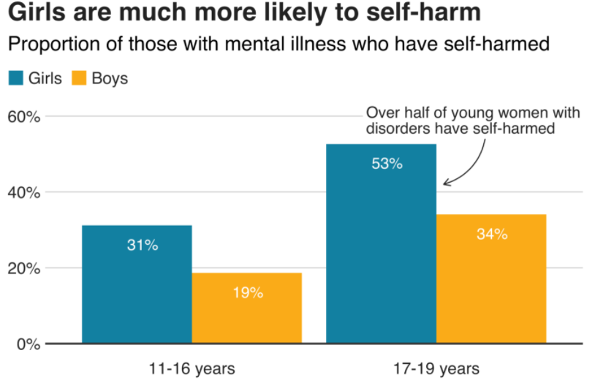

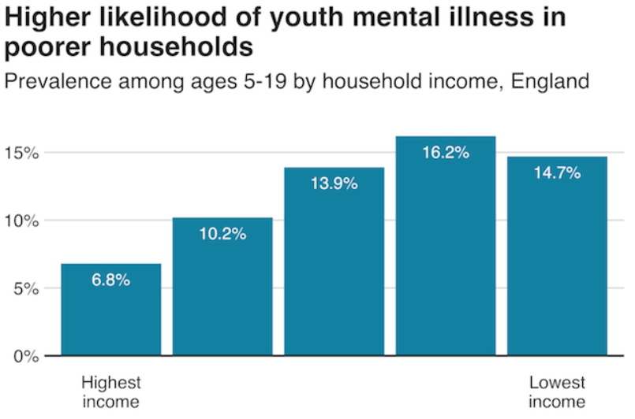

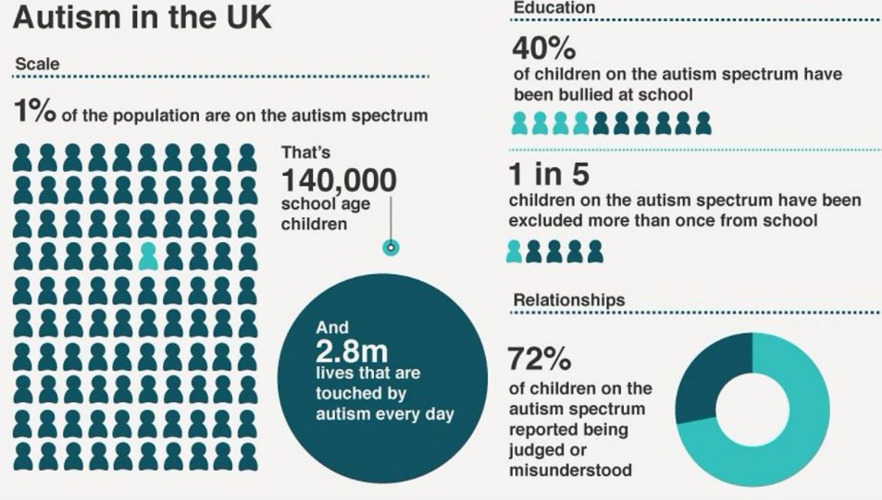
Source: (National Autistic Society, 2021)

