Smart and Connected Devices 1 ACDA5005
Gaynor Thomas
Richard Davies 1701574 Software Engineering

0 - Contents
1 – Searched Used 2
1.1 – Check Login 2
1.2 – Insert Data 2
1.3 – Graph Builder 2
1.3.1 – Query 1 2
1.3.2 – Query 2 2
1.4 – The Graph 3
2 – Graphs Shown 3
3 – Graph Library Used 3
4 – Appendix 4
4.1 – Appendix 1 4

1 – Searched Used
There are many SQL searches used in this website and this section will show and explain them.

– Check Login
The search is used on the login page and checks if the user name and password match data in the login database.
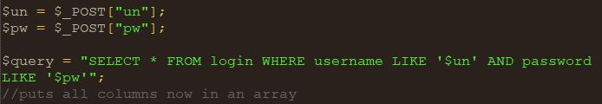
The search uses the information from the username (un) and password (pa) fields from the index page. Using the ‘AND’ instead of ‘OR’ for password ensures that both fields must be correct for it to return any value. This method doesn’t protect against SQL injection so it is possible for someone to get into the site without knowing the correct username or password.

– Insert Data
An insert data was needed to take the data from the text files and put them into the database. Instead of writing this block of code out for every file It was put into a function. After the file contents had been read the data was inserted into the data base.
This statement simply inserts the data form the file int the sensor data table. The data to be inserted has been assigned to variables.

– Graph Builder
The graph builder page has multiple searches present but only in two formats

1.3.1 – Query 1
The first query is simple and only checks if there is any data present in the database.
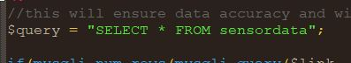
This is used to aid in data accuracy as if this returns no data then the read from files button is shown which allows the user to populate the database using the insert data query.
If the query returns any number of values other than 0 then the read form files button is hidden, this will prevent the data being read more than once without erasing the data in the text files.

1.3.2 – Query 2
The second query is used to populate the date search fields and is repeated three times with a different value.
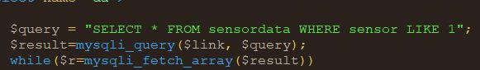
This query returns all values form the sensor data table for the first sensor, this date search is used only by the first sensor.
This query is repeated for each of the sensors (2 and 3) allowing the user to search a specific date for each sensor.

– The Graph
The graph query is based upon the search criteria set by the user on the graph builder page. The query build section of code is present in appendix 1. The query will contain a sensor number if a sensor has been chosen and a date if the date has been chosen.
If only a sensor has been chosen it will show all data for that sensor in a bar graph but if a date has been chosen, then only that specific date will also be chosen.

2 – Graphs Shown
The following are the two examples of what the graphs will look like.

2.1 – Graph 1
This type of graph is generated from only choosing the sensor number.
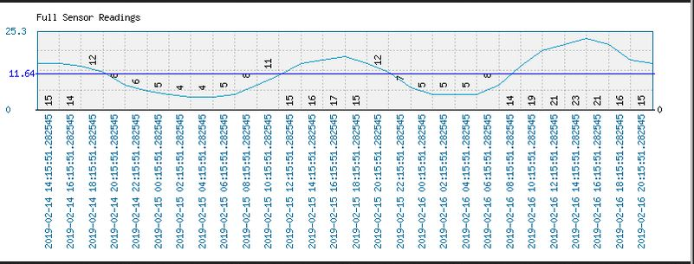
This Line graph shows each reading from all date and time stamps. A line graph was chosen because it is easier to read the data and the changes it has.

2.2 – Graph 2
This type of graph is generated when a specific date is also chosen.
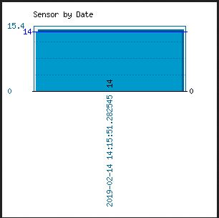
This Bar graph only shows the data from the specific data chosen. A bar graph was chosen over the other line graph because with only one piece of data the line would be hard to see when the solid colour of the bar is easier to see.

3 – Graph Library Used
The graph library used was the phpMyGraph package which can be downloaded from its support site [1] and it was the graph that was introduced in lectures.
It is used by having the graph file (phpMyGraph.php) in the root of the site, and included on the page that is building the graph, the functions are then used with the data passed to them like in any other language.

4 - References

[1] | M. Beulens, “phpMyGraph,” DataCharts, 2013. [Online]. Available: http://datacharts.linuxscada.info/index.php?sel=system&id=11. [Accessed 25 March 2019].

5 – Appendix

5.1 – Appendix 1
The query builder for making the actual graph
$query = "SELECT * FROM sensordata WHERE ";
////////////////////////////////////////////////////////
if(isset($_POST['s1']) || isset($_POST['s2']) || isset($_POST['s3']))
{
$query.="(";
}
if(isset($_POST['s1']))
{
$query.="sensor LIKE 1";
}
if(isset($_POST['s2']))
{
$query.="sensor LIKE 2";
}
if(isset($_POST['s3']))
{
$query.="sensor LIKE 3";
}
if(isset($_POST['s1']) || isset($_POST['s2']) || isset($_POST['s3']))
{
$query.=")";
}
//need a date between date start and date end.
if(isset($_POST['dt']))
{
if(isset($_POST['s1']) || isset($_POST['s2']) || isset($_POST['s3']))
{
$query.=" AND date LIKE '$da'";
}
else
{
$query.=" date LIKE '$da'";
}
}

