Maria Pita (1816554)

VIRTUAL LEARNING ENVIRONMENT

DIGITAL SKILLS AND RESEARCH METHODS
(BMSW4003_LON)

MARIA ADRIANA PITA (STUDENT NUMBER 1816554)
LECTOR : KOUSHIK MODAK

TABLE OF CONTENTS

- INTRODUCTION
- REVIEW OF EXISTING LITTERATURITI
- RATIONALI
- OBJECTIVES
- METHODOLOGY
- FINDINGS ANALYSIS AND DISSCUSION
- CONCLUSION
- REFFERENCES
- APENDIXES

INTRODUCTION
This lets in establishments to instruct now not solely common full-time students alternatively also these who cannot regularly visit the campus due to geographic or time restrictions, e.g. these on distance gaining understanding of courses, doing nighttime classes, or people reading part-time. They can be accessed every on and off-campus, that skill that they can help students' getting to know backyard the lecture hall 24 hours a day, seven days a week. A Virtual Learning Environment (VLE) is a system for handing over studying resources to university college students with the useful resource of the web. There are one of a sort types of VLE, which all work slightly in another way however finally perform the equal attribute and can furnish the equal gaining information of materials. Open supply (often free to use and adapt then again assist is charged for), such as Moodle. A Higher Education group is possibly to have a licence for a VLE that suits into any one of the following three categories: off-the-shelf, such as Blackboard.
These structures encompass assessment, pupil tracking, collaboration and verbal exchange tools.

REVIEW OF EXISTING LITTERATURITI
In the conclusions of the thesis, a descriptive and explanatory mannequin of digital gaining knowledge of environments acceptance amongst educational workforce and college students in blended studying environments is presented making use of the combined views of organisational learning, technology acceptance and diffusion of innovations. According to Christina Keller in 2007, the goal of the thesis used to be to create know-how about factors influencing acceptance or digital learning environments among tutorial team of workers and students in blended gaining knowledge of environments. The organisational tradition of universities, expressed as shared values of what is right fine educating and learning, had been found to partly oppose values inherent in the digital gaining knowledge of environments. The findings indicated that the contextual aspect of subculture was effective in influencing acceptance of digital learning environments, positively as nicely as negatively. The thing of students' getting to know patterns did not have any have an impact on acceptance of digital studying environments. Implications for practice are put forward, emphasizing lifestyle as an essential thing to think about in the implementation of digital getting to know environments.( Christina Keller, Department of Economic and Industrial Development, 2007).

RATIONALI
In the conclusions of the thesis, a descriptive and explanatory model of digital gaining knowledge of environments acceptance amongst instructional team of workers and university students in blended reading environments is presented making use of the blended views of organisational learning, technological know-how acceptance and diffusion of innovations.
According to Christina Keller in 2007, the goal of the thesis used to be to create information about factors influencing acceptance or digital learning environments among tutorial crew of employees and college students in blended gaining knowledge of environments.
The organisational lifestyle of universities, expressed as shared values of what is right first-rate teaching and learning, had been discovered to partly oppose values inherent in the digital gaining know-how of environments.
Being a student, in my opinion, once you have discovered the learning environments, it’s easier to research the for the modules you have.

OBJECTIVES
Provide a analyzing surroundings for college kids so they'll take the courses blackball the time and space constraints of a each day educating setting.
Allow university faculty students with wondrous desires and restrictions to require half within the publications via this mastering setting.
The middle of activity of this mission is to layout and implement a replacement and revolutionary educating paradigm so as to furnish a fee effective, flexible, and steep high notch mastering surroundings for education. This recognition is thanks to the essential get admission to the web likewise because the accessibility of helpful facts like free software package, library access, and native weather forecasts. thence undoubtedly during this project, the web are used because the transport medium for the digital gaining ability of surroundings courseware. In VLE, university faculty students now not undoubtedly will take the route from a ways that flung places at any time, on the opposite hand in addition will offer remarks to the teacher concerning the route style. currently with most part of the globe coupled to net and therefore the last a part of the globe can also not take a seat in dark for extended and faster or later would be a part of the web. offer geographically high notch sized get admission to a large style of guides provided by victimization victimization this analyzing setting. the recognition of the web is developing at a really speedy worth and it's calculable that there ar tons of and many laptop pc structures coupled to the web. supported latest projections, most households within the UK are the utilization of the web for one reason or one among a form with the helpful aid of the quit of the next decade. thence the goal of VLE, coaching for all, is finished utterly via net. the quality dreams of the digital analyzing surroundings ar as follows. Moreover, the VLE can keep track of student's improvement through a VLE aid software package utility module. (Schank, R.C., “Active Learning through Multimedia”, IEEE Multimedia, pp. 69-78, Spring 1994. Anup Kumar, J. P. Wong, H. R. Parsaei, H. R. Leep, “A Remote Education Paradigm with Temporal and Spatial Flexibility”, ASEE Annual Conference, Washington D.C, 1996. Raj. Pakala,”Virtual Learning Environment,” M.S. Thesis, University of Louisville, 1997.)

METHODOLOGY
However, in a very natural context, the place the technological capacity might also also be only one part of a course, totally unique distinction techniques can in addition end result in difficulties in attributing gaining knowledge of consequences to use of the special science (Scanlon, Jones, Barnard, Thompson and statue maker, 2000).
DECODING OUTCOMES Employing experimental techniques to ponder studying applied sciences is often regarded inappropriate due to the fact of the mission of dominant variables which will in addition have a bearing on effects (reviewed in Jones, Barnard, Calder, Scanlon and Thompson, 2000).
KNOWLEDGEABLE VERSUS SHOPPER When gathering subjective judgements, evaluations should in addition undertake a strategy from usability studies, heuristic analysis, or ask for comments from learners, as noted on top of.
In reflective on the implementation and analysis of 2 case analysis on on line interactivity, Boyle and Cook (2001) remark that student attitudes, received with the aid of method of questionnaires, do not imply the splendid of discussion.
This methodology wont to be utilized via victimisation interface style faculty college students to choose the usability of internet web sites developed at any other college the employment of accomplice degree on line cooperative work ecosystem (Collings and Pearce, 2002).
In exploring online teaching and gaining information of equipment in IT for art and organize students, Brown, Hardaker and Higgett (2000) assessed their consequences thru questionnaires posing for student opinions and analysing their performance.
it's not going that this technique would be terrific for a additive assessment of gaining facts of outcomes, though instructors square measure in all likelihood ending a casual model of this take a look at as soon as developing material for inclusion in a very VLE.
8.In partner diploma assessment of VLEs and learners, Richardson (2001) explored whether or now not or no longer person variants of newcomers have an effect on their perceptions of digital learning environments.
FINDINGS ANALYSIS AND DISSCUSION
Questionnaires are regularly used in situations the place the researcher wishes to attain a giant pattern of humans that are unfold out across a giant area. For this reason, it is essential that questionnaire are clear and simple to fill in. It is frequently viewed suited to make the questionnaire seem as quick as feasible so as now not to deter the respondents from answering. However, research suggests that an eye-catching format is likely to extend the response rate. A cramped questionnaire not solely appears unattractive but also runs the danger of questions being ignored if they are too carefully packed together.
According to my survey 13 out of 20 students use virtual environment and other 7 prefer old fashion learning.

According to my survey 12 out of 20 students were SOMEWHAT SATISFIED, other 8 have different opinion about this platform.

According to my study 11 out of 20 students rated VLE being very high quality and just one did not agree, saying that it still need work.

In base of my survey most of the students know and use VLE between one and more that 3 years.

Being a internet based platform, after my survey, I have realized that more students are starting to use VLE saying that “everyone has a smart phone and data plans in their pockets”.

CONCLUSION
For students, a VLE lets in them to benefit from self-paced learning and the possibility to study new skills barring having to tour or prepare childcare while they attend courses. They will also get a real feel of achievement; with Virtual College courses, there is constantly a certificate to download and print at the cease as a report of this achievement.
For teachers, the benefits of a Virtual Learning Environment are also huge. They can set instructions or coaching publications for their college students to complete all at once, no count how far aside they are based, permitting the teacher to work remotely too if needed.
A blended studying strategy can additionally help them to preserve their college students more engaged with a course, spending some time working on practical duties and some studying the concept in the back of what they are doing by a VLE.

REFFERENCES
Oxford University Press, 2016.
Christina Keller, Department of Economic and Industrial Development, 2007.
Schank, R.C., “Active Learning through Multimedia”, IEEE Multimedia, pp. 69-78, Spring 1994. Anup Kumar, J. P. Wong, H. R. Parsaei, H. R. Leep, “A Remote Education Paradigm with Temporal and Spatial Flexibility”, ASEE Annual Conference, Washington D.C, 1996. Raj. Pakala,”Virtual Learning Environment,” M.S. Thesis, University of Louisville, 1997.
Jones, Barnard, Calder, Scanlon and Thompson, 2000.
Scanlon, Jones, Barnard, Thompson and Calder, 2000.
Gunn, 1997.
Heppell, 2000.
Dillon, 1992; Schumacher and Waller, 1985.
Oliver, 2000.
Richardson, 2001.
Boyle and Cook, 2001.
Brown, Hardaker and Higgett, 2000.
Collings and Pearce, 2002.

APENDIX 1
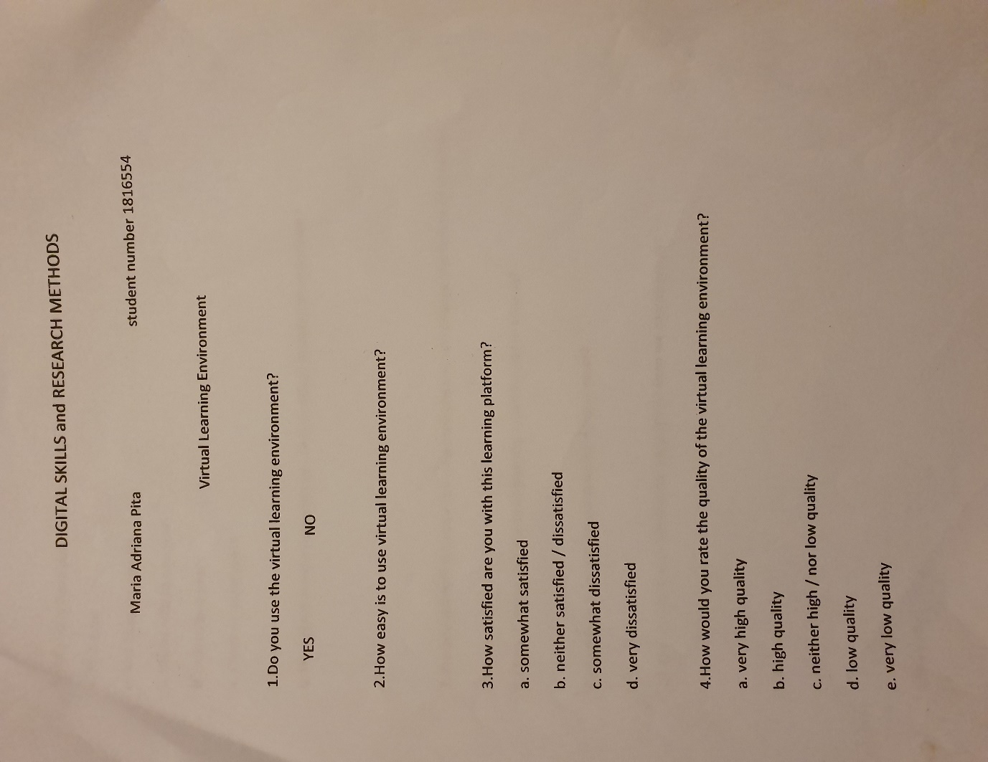

APENDIX 2
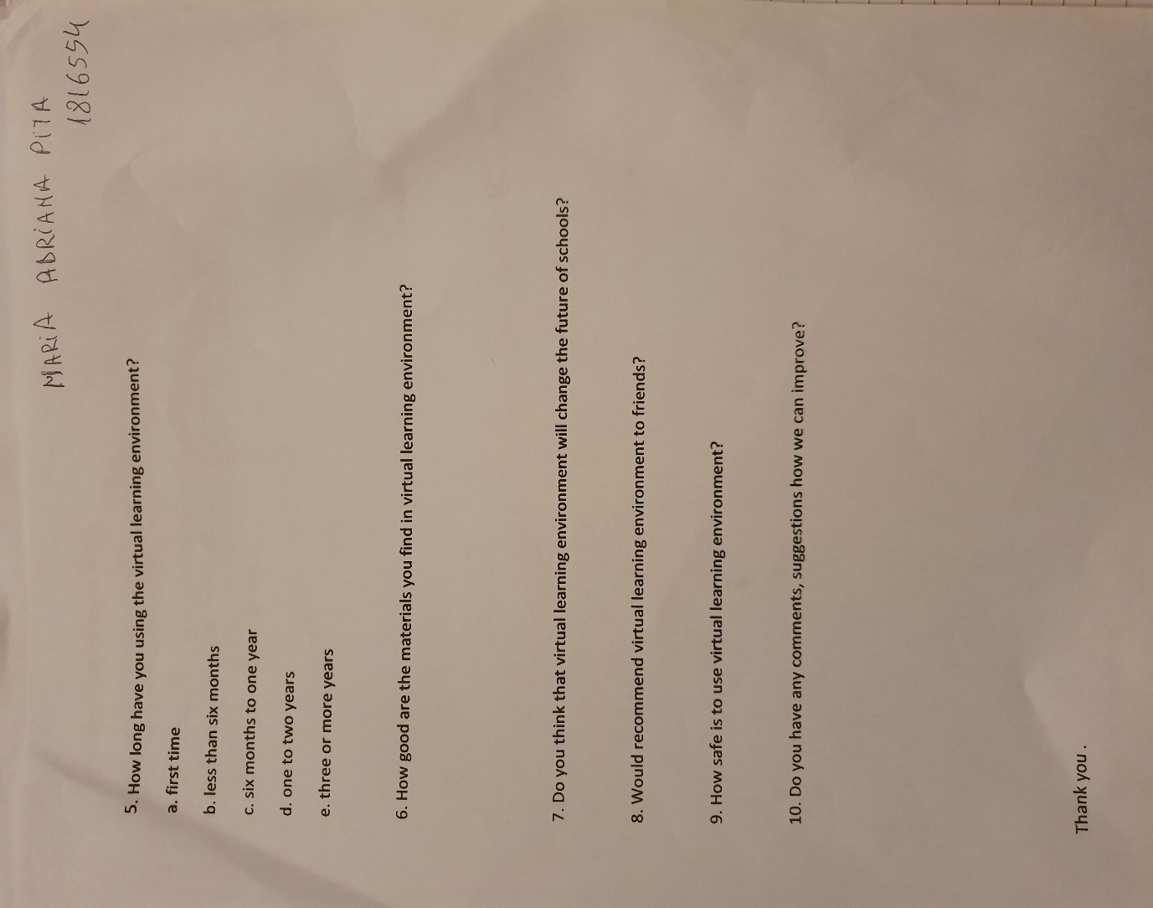

APENDIX 3
QUESTIONS
DO YOU USE THE VIRTUAL LEARNING ENVIRONMENT? | YES | NO
 | 13 | 7
HOW EASY IS TO USE VIRTUAL LEARNING ENVIRONMENT?
HOW SATISFIED ARE YOU WITH THIS LEARNING PLATFORM | SOMEWHAT SATISFIED | DISSATISFIED | SOMEWHAT DISSATISFIED | VERY DISSATIEFIED
 | 12 | 4 | 3 | 1
HOW WOULD YOU RATE THE QUALITY OF THE VLE? | VERY HIGH QUALITY | HIGH QUALITY | NEITHER HIGH/NOR LOW QUALITY | LOW QUALITY | VERY LOW QUALITY
 | 11 | 4 | 3 | 1 | 1
HOW LONG ARE YOU USING THE VLE? | FIRST TIME | LESS THAN 6 MONTHS | 6 MONTHS TO ONE YEAR | ONE TO TWO YEARS | 3 OR MORE YEARS
 | 2 | 3 | 3 | 5 | 7
HOW GOOD ARE THE MATERIALS YOU FIND IN VLE?
DO YOU THINK THAT VLE WILL CHANGE THE FUTURE OF SCHOOLS?
WOULD YOU RECOMMEND VLE TO FRIENDS? | YES | NO
 | 17 | 3
HOW SAFE IS TO USE VLE?
DO YOU HAVE ANY COMMENTS,SUGGESTIONS HOW WE CAN IMPROVE?

