Word count 5000

Part one 1147.
Learning is a complex area of focus within education research that can be partially explained through the use of several different theories. These theories both compliment and contradict each other. (Piaget, 1972; Montessori,1988; Bruner,1960; Vygotsky,1986).

One of the most commonly used tools used to help theorists and researchers understand how we learn is observation. Observation is a term often used by practitioners working with children in the foundation phase. It’s general meaning is often associated with interaction or cooperation. (Steel, 1991) The most common definition offered by professionals is ‘watching’ however simply watching a child without continuing with further analysis or interpretation is of little value. (Steel, 1991; Wragg, 1993) Observation is not and ends to itself but a process which leads to critical investigation. Froebel believed that observation was an important assessment tool, paramount when looking at child development. (Reifel, 2011) It can be used to provide specific examples of what children know and what they can do. (Jablonm 2010). The purpose of the specific observation used in this assignment is to demonstrate links between education theory and current practice.

Observations were carried out in a primary school in South Wales where education is currently undergoing a lot of changes. These changes are being implemented due to the recommendations of Graham Donaldson (Donaldson, 2015). The new curriculum and advice surrounding it brings in wider thinking, surrounding the way in which children learn and the importance of building skills for lifelong learning as opposed to teaching facts and figures.

Ethical considerations were considered to ensure this assignment meets guidelines of BERA. As well as this, the safeguarding procedures of the school were followed. For this reason, the names of the children as well as the school have been replaced with pseudonyms.
The school currently holds around 410 pupils and has already began to introduce elements of the new curriculum into the classrooms and school environment. Poster’s and displays demonstrating the welcoming of the new curriculum are evident throughout the school. However, its implementation within the classroom has been left to the discretion of each individual class teacher, but it is highly encouraged.

The observation this assignment focuses on took place in a year 1 classroom. This particular class teacher had not implemented any of the new elements of the curriculum as she believed her current method of teaching was proving effective. The class teacher selected a child at random by using the register. For the purpose of this assignment this child will be referred to as Child A. It is important to remember that it is possible that the teacher’s knowledge of the children helped influence her decision.

Narrative Observation 10:14

Child A is working on a table with a group of 4 other children playing the with water beads.

The teacher is working 1:1 with another child, the Teaching assistants are doing the same with other children.

A bead drops on the floor, when another child from another table picks it up and brings it back the behaviour is spotted and rewarded with a dojo point by a teaching assistance.
Child A notices this behaviour and takes a step away from the table to look for another other fallen beans.

5 or so beads rolling onto the floor where the children are putting their whole arms in at the same time. The children are chatting about how the beads feel.

Child A stop engaging with the activity and crawls under the table to get the fallen beads. The other children have noticed that the more hands they put in the more beads fall out.

Child A drops them back into the box, but the teacher doesn’t notice.

Child A notices a few that had previously rolled across the classroom and picks them up.

The teacher circles around the room and returns to the table, child A walks over and drops them back in the box.

Again, this behaviour goes un-noticed.

Child A crawls under the table to continue to collect the constantly falling beads.

The teacher passes the table Child A gets up with a handful and says “miss I’m picking up all of these that I dropped on the floor”

The teacher replies “well they shouldn’t be on the floor should they put them back in the box”

Child A turns away from the teacher, she is scowling.

She opens her hands and drops all the beads she has collected on the floor.

She sits on the sofa.
She then helps her friends pick up the Lego next to where the teacher is sat and says “miss I’m helping to pick the Lego up even though I didn’t even play with it”

Figure 1. Transcript of narrative observation made while following child A.
Different techniques and methods are chosen when carrying out observations for a variety of reasons. (Cohen et al, 1997). In this instance narrative observation has been used as it provides a snapshot of a learning experience. It also allows the inclusion of surrounding notes on the interactions of other peers in the class which when incorporated, paint a bigger picture of the learning environment surrounding the chosen child. This form of observation was used to capture this information using short hard in order to capture any speech and ensure it was noted correctly. (Loftland, 1971)Another benefit of this method of observation is that the children are not in any way distracted they be by devices such as Ipad’s or other forms of recording devices. This form of observation was not considered due to the restrictions of the schools safeguarding policy.

This specific observation was chosen for the purpose of this assignment as it highlights flaw’s in the behaviourist theory. Skinner is one of the most influential theoriests building on the work of renowned behaviourists. Skinner defined his own branch of behaviourism, ‘operant conditioning’ a theory that supposed behaviour is determined by positive and negative reinforcers. He argued that the application of these will affect the possibility of this behaviour occurring again. (Johnston and Williams, 2009)

Skinners work advocated the idea that a behaviour could be shaped through operant conditioning and as such, his theories became popular as a mean of modifying behaviour in schools. (Johnstron and Williams, 2009)

The specific school in which this observation took place has adapted a range of measures innkeeping with Skinner’s operant conditioning theory. These measures include a variety of complicated reward systems designed to moderate behaviour of the individual such as stickers, house points, table points and whole class points.

What this observation suggested however is that the children were behaving in a way in order to receive the physical reinforcement. While the field of behaviourism is no longer a dominant school of thought Skinner’s work remains an influential force in schools and institutions with thought Skinner’s work remains an influential force in schools and institutions with operant conditioning being a common strategy for managing behaviour.

Part two. 1212
One clear distinction in the literature surrounding motivation is between intrinsic and extrinsic. (Deci & Ryan, 1985; Harter, 1981). When children are extrinsically motivated they are engaging in an activity for reasons such as receiving a reward. Intrinsic motivation occurs when the child has an internal interest or desire to complete an activity, due to their own interests. (Deci & Ryan, 1985; Harter, 1981). It has been argued that intrinsically motivated children engage more than extrinsically motivated children while creating more memorable learning experiences. (Connel and Wellborn, 1991; Ryan and stiller, 1991)

The reward specific child A desired in this observation took the form of a ‘Dojo point’. An online behaviour tracker used in the class that enable’s practitioners to reward ‘good classroom behaviour’ by giving a point to a virtual representation of the child. Any behaviour that isn’t demmed as classroom behaviour and ‘breaks the rules’ results in the children losing points. This system is also used to provide whole class points. If the online system reflects that the whole class have demonstrated good behaviour they are rewarded with additional time on the yard.
The consequence of undesired behaviour in the classroom were not evident when this observation took place. When points were taken away from children for displaying undesirable behaviour they were not given an explanation as to why their behaviour is deemed undesirable. The children demonstrated no understanding of the natural consequences but rather displayed an understanding of how the teacher would react.
Some may argue that this approach does not teach children the importance of correct behaviour. That they are only behaving in a certain way because of extrinsic motivation. This can be seen by the immediate change in behaviour seen when the online system is displayed on the class smart board.
An example of this can be seen in this observation. Child A was not picking up the balls because she understood that that was the right thing to do. She has seen another child be rewarded for doing so, and then copied this behaviour with the expectation of being rewarded in the same way. The suggestion that this reward system does not promote intrinsically motivated students can be seen by Child A’s reaction after accepting that she was not going to receive a reward for her behaviour. Child A simply dropped the balls on the floor and looked for another way to receive the desired response from the teacher.

The importance of observation

Throughout this observation Child A and other classmates were not engaging with the activity in the way that the class teacher had anticipated. The activity was new to the classroom and the children were simply exploring the textures of the water beads. The way adults present an activity is crucial to how the children engage with it and how motivated they are to engage or avoid it. (Anning and Ring, 2004) Montessori (1988a) suggests that if a new activity as added to a learning environment, it is the role of the practitioner to present this activity to the class, in order to model it’s intended use. (Lillard and Lillard, 2003) This does not limit children to one mode of completion but at gives an idea of what the desired outcome is. Due to this not being done, the children continued simply moving their hands in the water.

In turn they all buried their hands in the water while entering into a complex discussion. What initially was general chat about how the water beads felt soon became an observation of how product displacement works. They noticed that if more hands when in, more beads can out, and if one child put their hands in deeper, even more beads would fall out. They discussed why it was happening that the beads were getting pushed out because there was not enough room for both the beads and their hands.

They’re exploration had many beneficial unintended outcomes that went unnoticed. With the addition of an adult, this understanding could have been taken further and applied to other concepts. The children were not purposely, not engaging with the activity, but they were exploring it. Had the aim of the activity been demonstrated to the children they may have achieved the desired outcome.

When this observation took place there was one teacher in the class and two teaching assistants, however each member of staff was working one to one with children that were behind on their work. Wragg (2012) recognised this as one of the challenges of observation for practitioners. He suggested that sufficient time needs to be given in order for observation to be carried out and analysed successfully and that this time is often hard to come by.

In an ideal learning environment where funding was no concern there would always be a practitioner available to observe the learning taking place in each area of the classroom. This would allow practitioners to use observation to sufficiently scaffold the children’s learning, better predicting next steps specific to each individual child.

This observation was carried out during free play in the morning session. There were 6 activities set up in the classroom that the class teacher had told the children they could engage with. The importance of play in the foundation phase was described by Piaget as an important avenue for learning. (Hendrick, 1992). Piaget was influenced by the work of Maria Montessori, who recognised and valued the importance of play as a vehicle by which children could construct knowledge. (Halpenny and Pettersen, 2014) A rich environment is described as being central to supporting the child’s own search for answers. (Jarvis and Chandler, 2001) (Figure 2. Note taken during lesson)
“you can play with the iPad, the Lego the water beads or the home corner, there’s sand and water outside for you too but you need to put a coat on if you’re going out.”

While this is providing children with the opportunity to play there environment prepared limit’s children’s ability to take control of their own learning. While it is important that children have the opportunity to repeat activities in order to master them it is also important that they have a rich environment that fosters independence and curiosity. Piaget believed that children learn only when their curiosity is not fully satisfied. He thought that genuine curiosity is what drives learning. (Hendrick, 1992).

The importance of a stimulating environment is important when free play is such a large part of the daily routine. In the foundation phase children are encouraged to learn through play. Piaget played a large part in the acceptance of play as a part of students learning. He saw play as a child’s work and said that they needed to be able to explore, create and repeat.

Due to this, in a Montessori environment is rich with difference materials and resources available to children. Montessori described the favourable environment as one where the child is the active agent and the practitioner as the facilitator that scaffolds the child’s learning. Bruner (1960) and Vygotsky (1978) further discussed the importance of scaffolding in the foundation phase and the importance of a more knowledge other (MKO) this is the reason this learning environment is free flow, allowing children to collaborate their learning with other children while support each other.

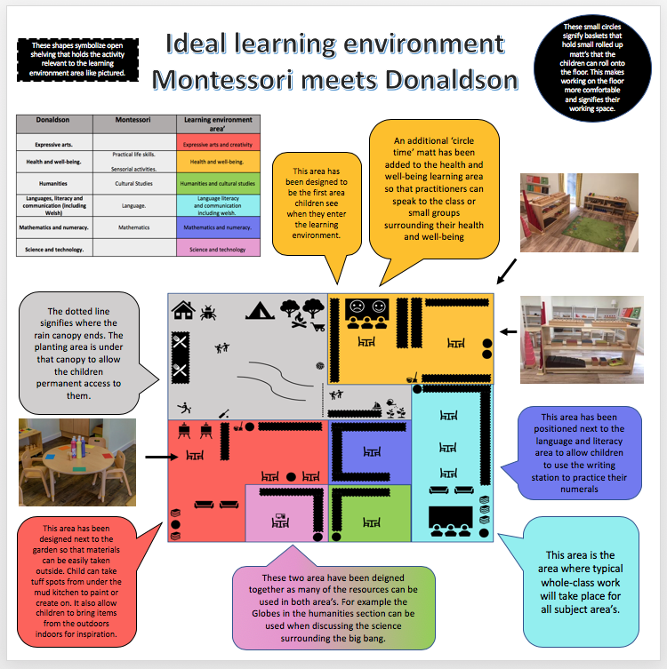
Figure 3, Ideal Learning Environment.

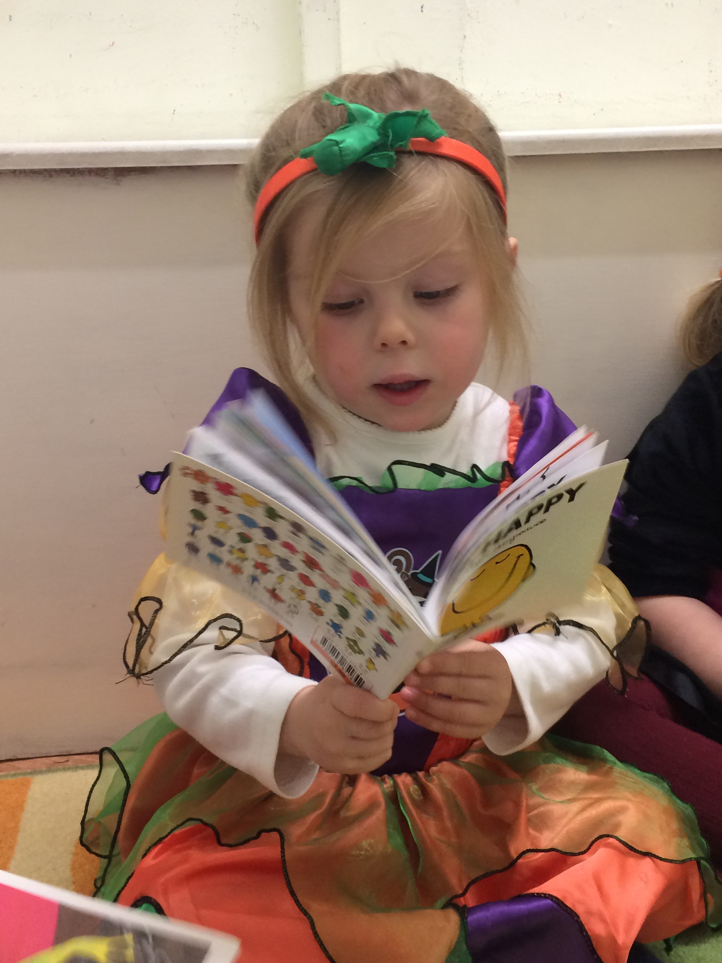
Ideal learning environment 1600 words.

In order to construct this learning environment, elements of the new curriculum and advice from successful futures have been merged with supporting elements from the Montessori approach to education. (Donaldson, 2015; Montessori 1978a; Isaacs, 2010) While previously the Montessori approach to education has been viewed as an alternative style of teaching, the introduction of the new curriculum dismantles a lot of the contrasting ideologies.

This commentary will explain what these similarities are and how the two can be used to provide an ideal learning environment for children in the foundation phase. For the purpose of this assignment the learning environment has been constructed with a reception class in mind. However, with enhanced planning the same environment would be suitable for both younger and older children.

Above all this learning environment is a safe place for the child the follows the governments guidelines and the statutory framework for safeguarding children. (DCSF, 2008) Montessori said that children this age had enormous potential for learning though exploration and active learning. (Isaacs, 2010)Montessori recognised the child as a spontaneous learner she defined children this age as being in the calm stage where they are intrinsically motivated to further their learning and understanding and become part of a wider community. (Isaacs, 2010)

Each individual area in this learning environment has been designed by merging elements of the new curriculum (Donaldson, 2015) with the main area’s of learning in Montessori. (Isaacs, 2010). This can be seen in the table in Figure 3. Some area’s such as Humanities form the new curriculum and cultural studies have obvious central themes. However other’s required more research in order to make deeper connections as two how area’s of learning can merge to create a rounded learning environment.

Initially preparing activities that promote Health and well-being in the foundation phase may seem challenging. However a key ideology that runs through this area of learning in successful futures is the importance of emotional understanding and independence. Activities in the sensorial area of learning in a Montessori setting focus on the child’s attention and learning
on each of their different senses.
(Figure 4. A visual representation of the
senses taken from (Isaacs, 2010).

In this learning environment this has been extended to incorporate a sense of emotional understanding. Activities have been added to the environment that help the children explore emotion such as puzzles that display different facial expression, books that talk about feeling and finally a routed understanding among practitioners in the environment to focus discussing surrounding emotions when working in this area of learning. For this reason, an additional circle time area has been added to this area of learning where practitioners can chat to children in small groups about their day and how different experiences throughout their day have impacted on their emotions.

The practical life activities in this room promote independence skills. Including activities like dressing frames, pouring activities and activities that familiarise children with transferring tools, and cooking tools such as cheese graters. These skills can be used to allow children to help prepare their learning environment each, preparing snack, pouring drinks and helping less able children dress and undress. This not only promotes independence in the early years but allows children to become part of a classroom community which is beneficial to their health and wellbeing.

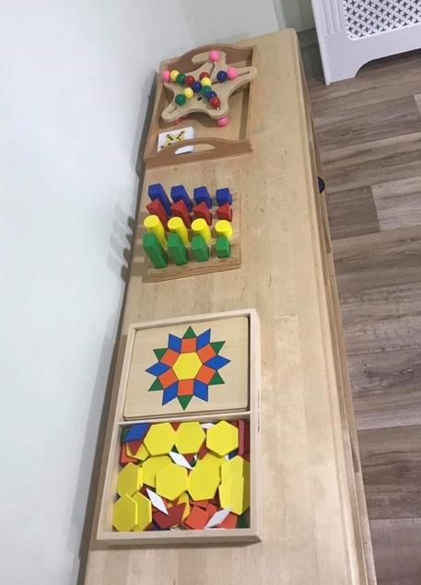
The learning environment has been structured so that this area of learning is the first that children see when they enter the learning environment. This is because Montessori teaches that activities from the practical life area help children within the foundation phase find the transition from home into school easier if they can recognise similarities between the two environments. Children should recognise these activates from their home environment meaning they already have mastery or at least familiarity of some equipment, this can help build their confidence in working with other equipment that they aren’t familiar with such as tying a shoe or polishing silver wear. (Isaacs, 2010)
(Figure 5, Picture taken by author in a Montessori setting)

Four Purposes of education
Four purposes of education will be at the heart of the new curriculum. These purposes are already being integrated into some schools in wales. In this learning environment, these purposes will be paramount as they are also supported by teaching from the Montessori ethos. These purposed will be highlighted by the use of displays in each area of learning, along with summarised in child friendly language in books in the book shelves.

The first outcome of the new curriculum is to help create ambitious capable learners that will be ready to learn throughout their lives. (Donaldson, 2015) The heart of the Montessori ethos is giving children control of their own learning in order to foster the natural desire to learn that children are born with. (Isaacs, 2010)

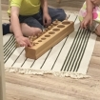
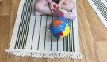
For this reason, this learning environment consists of a lot of open floor space both indoors and outdoors to promote this free flow learning so that children can chose to learn how they think best suits them. This idea was highlighted and incorporated into this environment as Montessori suggests that children do not particularly enjoy sitting at a table and that making them can limit their capability. (Montessori 1988a)
(Figure 6, Pictures taken by Author in a Montessori setting.)
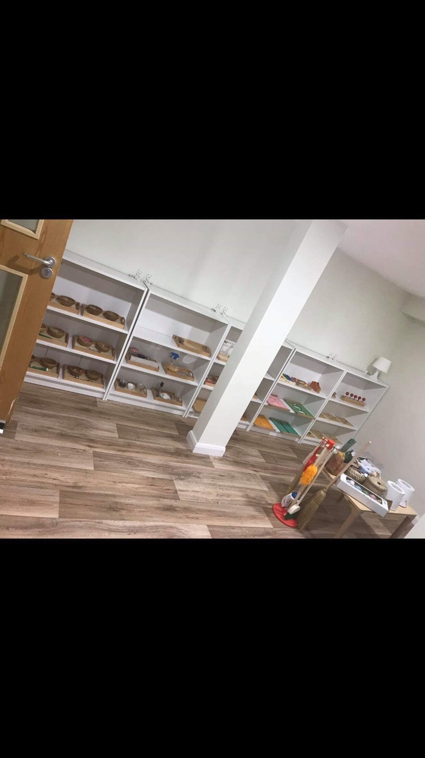
Baskets containing small matts are in the corner of each room so that if a child does decide to work on the floor this can be done comfortably. Some tables remain for reasons as certain activates would be difficult for children to complete on the floor, it also allows the to

(Figure 7, Picture taken by author in a Montessori setting)
take further control of their learning making their own decisions. A key element of this learning environment is its structure and the organisation of activates.

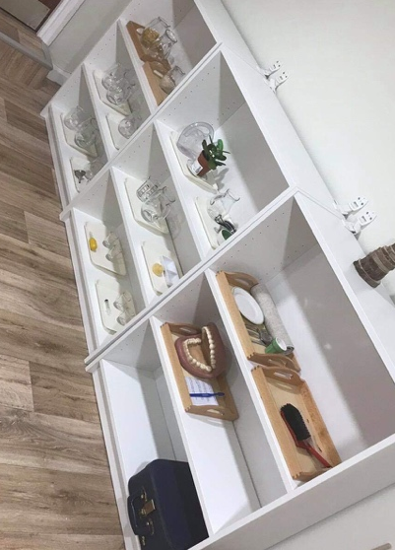
All activates in this learning environment are presented of open shelving that allows children to select their learning and return it when they finish. Each activity has its own home in this learning environment and it is the role of the practitioner to ensure that this environment is maintained. Montessori suggests that a favourable environment provides children with a wide range of accessible and available activates designed to meet their needs in order to support their need for freedom of choice. (Montessori 88a and 1988b; Isaacs, 2010) This is the reasoning behind the size of this learning environment being larger than the typical reception classroom.
(Figure 8, Picture taken by author in a Montessori setting)

The role of the practitioner in this learning environment is to successfully incorporate the philosophy of Montessori into a mainstream foundation phase classroom. The role goes beyond preparing the environment, it extends to developing the materials adding to them and taking away materials that no longer benefit the individuals. The original materials stand as the provisional planning. This consists of traditional Montessori materials that meet the education needs of the children. Amongst these materials are Montessori styled materials developed by the practitioner the meet the individuals needs and incorporate topics and themes. This stands as the classrooms enhanced planning.
The second outcome is to help children become enterprising creative contributors that think creatively, lead and play roles in teams and express idea’s and emotions. (Donaldson, 2015) A well-equipped Montessori environment such as this one has all necessary resources freely available for children to create whatever they have in mind. (Isaacs, 2010)

Teachers in this learning environment can help children to develop the skills to use the tools such as how to apply glue or use scissors but the activities themselves are open ended.

Many of these activities happen in the classroom but in this environment, there is also the opportunity for them to happen outside. This is why the creative area of learning has been designed to run alongside the outdoor learning environment. Montessori also advocated the importance of outdoor learning being available to children during their ‘work cycle’. (Montessori 1988a). Tina Bruce notes that many pioneers of early childhood education agree that intrinsic motivation is the result of child-initiated activities. (Bruce 1987: Bruce 2005). More recently child-initiated activity has become central to the government agenda for the early year’s education (DfSF, 2008). (Outdoor learning references)

The Foundation Phase puts emphasis on learning both indoors and outdoors (Wales: Departments for Children, Education, Lifelong Learning and Skills, 2008). In order to make sure children have access to all outdoor provisions year-round regardless of the weather the outdoor environment has been fitted with an extendable canopy that can be adjusted to cover none off, some of or all of the outdoor environment. This way if children have suitable clothing and footwear they are able to experience different weather types while still allowing other children to access the outdoor provisions.

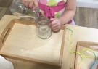
Each activity in this environment is presented on a tray basket or box, once a child selects this activity from the shelf they have everything they need to complete the activity. These materials are aligned in a specific order following the growing complexity of the activity (Figure 9, Picture taken by author building on a specific skill gradually. in a Montessori setting)

This allows the child to move onto a more challenging activity when they feel they are ready. For example, if working in the practical life area a child found transferring small object with a pincer was too difficult for them, they could return to a previous activity that they had mastered in order to build on their confidence and self-esteem before returning to a more challenging activity.
The third outcome is to produce healthy confident individuals, with a good understanding of physical and emotional wellbeing focusing on the importance of the independence of the child. (Donaldson, 2015)

Montessori focuses on the importance of children being independent in all aspects, this includes activities such as snack preparation, growing fruit and caring for each other. All of these are opportunities for practitioners to introduce wider idea’s like where our food comes from, and the importance of a healthy diet and active lifestyle.

The practical skills and sensorial activates from the Montessori curriculum have joined together to help form the health and well-being area of learning. Practical life includes skills that help develop independence coordination concentration, self-control, self-awareness and confidence. Building good practical life skills can help children become part of a wider community contributing to the running of their classroom. It allows them to master skills to help prepare snacks, pour drinks and help set up the learning environment each day. It teaches them independence skills when dressing themselves and helping others.

Similarly, sensorial activities can help children refine their senses, this can include group work with a practitioner. Blindfolds are often used to help refine the other senses, children are asked what they can hear, what they can smell and how they feel. This allows children to explore complex emotions and discuss empathy and their understanding for what impacts on emotions. An additional ‘circle time’ matt has been added to this room so that practitioners can sit with small groups or the whole class in this environment to discuss what they have been exploring and how it makes them feel.

These areas of learning should not dismantle the idea that a child’s learning is holistic, it is simply a way of blocking resources to build a stable environment for learners. It also allows practitioner to recognise what skills children are working on most frequently, for example if a child spends countless hours in the mathematics and numeracy area of learning is expected to have more skills in the area than a child that seldom accessed those resources.
The final outcome of the new curriculum is to help children become ethically informed citizens that understand modern issues and the impact of their actions. (Donaldson, 2015) Montessori philosophy teaches that children learn right from wrong by developing an understanding of natural consequences. (Isaacs, 2010)

In a Montessori setting there are no ‘rewards’ in the sense of stickers and gold stars. Instead children are taught natural consequences of their actions, for example if they break a toy, the toy is broken, and they not only cannot play with it but have upset their friends in stopping them in playing with it. This theory will replace the traditional reward system seen in part one of this assignment as the research in part two suggests a more favourable outcome more likely to produce ethically informed self-motivated pupils with an understanding of their actions. In a Montessori setting children are not introduced to fantasy in the early years as that this can cause confusion between what is reality and what is pretend. Montessori teaches the importance of telling children the truth from a young age in order from them to form a sound understanding of modern issues and current affairs, leading children to become more ethically informed citizens. (Isaacs, 2010)

In conclusion this assignment suggests that the introduction if the new curriculum along with other advice from successful futures may pave the way for alternative approaches to learning. (Donaldson, 2015) Recommendations made by the document identify fault in traditional behaviourist theory and highlight the importance of independent learning that are able to control their own learning. The shift from the importance of simply learning information to developing a deeper understanding of natural consequences, current issues and emotional well-being, along with an array of other skills and outcomes that help children become better life long learners. (Donaldson, 2015)

Reference list.
Anderson, L. W., Krathwohl, D. R., & Bloom, B. S. (2001). A taxonomy for learning, teaching, and assessing: A revision of Bloom’s Taxonomy of educational objectives. New York: Longman.

Anning, A. and Ring, K. (2004) Making Sense of Children’s Drawings. Maidenhead: Open University Press.

Anning, A. and Ring, K. (2004) Making Sense of Children’s Drawings. Maidenhead: Open University Press.
British Educational Journal http://www.bera.ac.uk/publications/BERJ
Bruce, T. (2005) Early Childhood Education. 3rd edition. London: Hodder Arnold

Bruner, j. (1960) The process of Education. Cambridge, MA: Harvard University Press.

Cohen, R., Hughes, M.. with Ashworth, L and Blair, M. (1994) School’s Out! The Family Perspective on School Exclusion. London: Baenardos and Family Service Units.

DCSF, Department for Children, School and Families (2008) The Early Years Foundation Stage. Annesley, UK: DCSF Publications.

Gopnip, A. (2016). The Carpenter and the Gardener. What the New Science of Child Development Tells Us about the Relationship Between Parents and Children. London: Boadley Head
Jablon, J. (2010) ‘Taking It All In: Observation in the Classroom’, Teaching Young Children, 4(2), pp.24-27.

Jarvis, M and Chandler, E, (2001) Angles on Child Psychology. Cheltenham: Nelson Thorne.

Halpenny, A. and Pettersen, J. (2014) Introducing Piaget. Abingdon: Routledge.

Jablon, J. (2010) ‘Taking It All In: Observation in the Classroom’, Teaching Young Children, 4(2), pp.24-27.

Johnson, J. and Nahmad-Williams, L. (2009) Early Childhood Studies. Harlow: Pearson Education.

Lillard, p. p. and Lillard Jessen, l. (2003) Montessori from the start. New York: Schocken Books.

Montessori, M (1988a) The formation of man. Oxford: ABC0Clio, Volume 3.*

Montessori, M (1988b) What you should know about your child. Oxford: ABC-Clio, Volume 2.

Piaget, J. (1962) Play, Dreams and Imitation in Childhood. London: Rouledge & Kegan Paul.
Reifel, S. (2011) ‘Observation and Early Childhood Teaching’, Young Children, 66(2), pp.62-65.

Siraj-Blachford, I., Sylva, K., Muttock, S., Gilden, R. and Bell, D. (2002) Researching Effective Pedagogy in the Early Years. HMSO, Research Report 365. London: DjES.

Steel, F. (1991) ‘Working collaboratively within a multidisciplinary framework in Tilestone, C (ed). Teaching Pupils with Severe Learning Difficulties: Practical; Approached. London: David Fulton Publishers.

Vygotsky, L. (1978) Mind in Society. Cambridge, MA: Harvard University Press.

Wragg, E. C. (1993) Primary Teaching Skills. London; Routledge.

Wragg, T. (2012) An Introduction to Classroom Observation. Routledge: Oxon.

Isaacs B. (2010) Bringing the Montessori Approach to your Early Years Practice. Routledge: London.

