Student Name: Victoria Phillips
Student Number: P150982
Course Code: M5X02111
Course Name: Research Methods
Assignment Title: Research Plan - Proposal
Submission Date: 05.03.2018

Executive summary
Events are growing therefore the more event manager jobs are created, however are some need to plan special events. The role of the wedding planner will be investigated to explore key skills required to plan memorial events. A mixed methods approach will be applied with interviews and questionnaires will be carried out to a sample of both wedding planners and customers who are getting married and planning their own weddings. Data will be collected and analysed on SPSS.
Content page
- Introduction…………………………………………………………………………………………………………………….P4
1.1Working title……………………………………………………………………………………………………P4
  - Background……………………………………………………………………………………………………..P4
  - Aims and objective…………………………………………………………………………………………P4
  - Rational……………………………………………………………………………………………………………P4
  - Literature review……………………………………………………………………………………………..P5
- Methodology……………………………………………………………………………………………………………………...P5
2.1Research positioning…………………………………………………………………………………………P6
- 2.2 Research instrument…………………………………………………………………………………………P6
- 2.3 Sample……………………………………………………………………………………………………………P6
- 2.4 Ethics………………………………………………………………………………………………………………P7
- 2.5 Reliability and validity……………………………………………………………………………………..P7
- Results……………………………………………………………………………………………………………………………….P8
- 3.1 Conclusion………………………………………………………………………………………………………P8
- Refences…………………………………………………………………………………………………………………………….P9
- Appendix………………………………………………………………………………………………………………………….P10
- 5.1 Appendices 1: Research onion………………………………………………………………………P10
- 5.2 Appendices 2: Gantt chart…………………………………………………………………………….P10
- 5.3Appendices 3: Interview questions…………………………………………………………………p11

Introduction
Working Title: The role of the wedding planner: An investigation and analysis into the skills required to plan personal and memorial events.
Background
This research is an introductory investigation into the role of the wedding planner and the key skill set which is required to plan successful personal and memorial events. The role of the wedding planner has and always will evolve throughout the years from new trends which are happening in the world, such as the cost of destination weddings. Investigating various roles that the wedding planner must become to ensure theses memorial, one of life time event runs smoothly. The debate of if wedding planners are needed to plan successful weddings or if customers getting married have the skill set to plan their own weddings will be evaluated.
Aims and objectives
Aim:
To investigate and analysis the requirements of a wedding planner’s skills and the growth of the occupation, which created the development from event mangers into specialist event managers including weddings.
Objectives
- To use a mixed methods research approach to investigate different style of wedding planners what skills are required to become a successful wedding planner
- To investigate the role of the wedding planner as a profession and if the job is needed in the growing world
- To investigate the level of organisation and professionalism needed to plan weddings
Rational
The wedding industry is a slowly growing industry with an annual growth of roughly 2% which is set to keep on growing into the future therefore generating more jobs and more profit for the events industry. The event industry’s annual turnover is £40 billion (HBBA, 2016). With wedding companies and the whole wedding experience worth over £10 billion (Hitched, 2016), that means the wedding industry generates 25% of the event industries annual profit. The managers and planners of weddings are so important for the future of the events industry. The role of the wedding planner must be able to adapt themselves to diverse clients and any diverse situation within a wedding.

Literature review
Loveless (2014) states that wedding planners require many skills and the personal ability of acting as a mediator, a sixth role, thus allowing creative solutions to clearly define any problems that might occur throughout the planning process. (Loveless, 2014, P12). This theory is also supported by a lot of online resources that states that it is highly important that the wedding managers must become peace makers for the whole wedding party, due to the stress levels of this type of event (the spruce, 2018). However, there is some debate that states that some couples find the role of the wedding planner often too involved in parts of the wedding which the couple could resolve themselves. With many couples finding the wedding manager often taking over the whole experience and couples often feeling as if they missed out on the experience of planning their wedding. Majority of couples will only get married once therefore the whole wedding industry is created out of temporary events. “Events are temporary and purposive gatherings of people” (Blanden C,2012,P3). Operational event planning could also be evaluated Allen, J and Harris, R, (2008) shows the planning process which must be followed for event from the very start of planning to shutting down the event, these are just some of the step a wedding planner must follow to have not only a successful business but also one off personal weddings.
Methodology
Research is required to learn and investigate a refined topic area. Hussey defines research as “a process of enquiry and investigation” which also should “increase knowledge” (Hussey,1997, P1). Like this Jankowicz (1997) states that people must undertake research to find out things in a systematic way, which will then increase knowledge. Saunders (2007) states that research can be broken down into “the research onion” where the researcher must be concise and work their way through the onion with every layer being equally important. Starting with the philosophies, deductive and inductive research, for this research inductive research will be collected due to reasonably new research being carried out. This will therefore take longer to gather the data. The researcher will then work their way through the onion to the data collection. See appendices 1. Secondary data will also be investigated to explore research which has already been carried out in this field therefore making this research more detailed and specific.
Saunders et al (2007) also finds that the research strategies should be ‘mixed & matched’ methods. The research being investigated will use a mixed methods approach of using both qualitative and quantitative research to investigate what key skills are required to become a successful wedding planner. Further research will be carried out considering if the role the wedding planner is needed, due to the growth of customers planning their own weddings instead of hiring event professionals. The purpose of collecting data is to obtain information and make decisions, based on this research further information will be gathered on the wedding industry.
For the completion of this research, ensuring everything is completed within an appropriate amount of time will be important. Using a Gantt chart will ensure all data is collected with enough time to analysis everything and ensure everything is investigated thoroughly throughout the whole research. See appendices 2 for Gantt chart.
Research positioning
Qualitative research will be used to collect, non-numerical information, this data will be collected by conducting interviews, with various people who work within the wedding industry and those customers who are planning on getting married within the upcoming year and will be planning their own weddings thus not hiring a wedding planner. This research is crucial to the investigation of wedding planners who want to improve their own businesses. Whereas Quantitative data will collect numerical information. This research will be collected by handing out questionnaires to wedding professionals and participants whom are getting married within the upcoming year and planning the wedding themselves. Theses questionnaires will have to be quite short to ensure all information collected on the questionnaires are correct, often participants get bored while filling in lengthy questionnaires hence resulting in participants filling them incorrectly. See appendix 3 for interview and questionnaire questions.
Research instrument
For this research questionnaires and interviews are being conducted. To gather enough data roughly 200 questionnaires will need to be completed. The proposal to collect these questionnaires and conduct the interviews is to gather the information over a course of 13 weeks from the end of November to the beginning of March, as seen in appendices 2 on the Gantt chart. By allowing 13 weeks it will ensure the research is not rushed to ensure quality data. The questionnaires will be given to 100 wedding professionals and 100 questionnaires will be given to participants who will be getting married within the upcoming year and planning their weddings. Interviews will take roughly 20 minutes to conduct and all interviews will be recorded for the researcher to later scribe. Interviews will take place over a period of 2 weeks, with the additional 13 weeks to ensure flexibly from the participants.
Sample
Figuring out a sample for research will be crucial for this data collection. A sample is the group of people who are taking part in the investigation process, called the “participants” of a study. For this research, a non-probability sample will be used, where individuals are selected based on one or more criteria selected by the researcher. The criteria for this research is either working within the wedding and events industry or the participants are getting married within the upcoming year and planning their own wedding. Saunders et al (2007) states “the sampling frame for any non-probability sample is a complete list of all the cases in the population” (Saunders et al, 2007, P214). Using a non-probability sample for this research will include snowballing as wedding professionals and participants will be able to connect the researcher with more and more professionals to further the study to have a lager sample size therefore having more data to have a more intense research and will include purposive sampling due professional’s knowledge of the wedding industry.
Ethics
Ethics are so important for all research carried out. Information on completion of this study will be offered to all participants, therefore wedding professionals will be able to gain knowledge on how to improve their business. All participants will be given a consent form, which will explain that all information collected, will be anonymously. “Informing the participants that they will be anonymous is important as they are more likely to answer honestly”(Mitchell and Jolley, 2007, P288). Wedding planners might want to be answer anonymously due to their business reputation. The research being carried out does not hold a great ethically risk or harm to anyone involved due to the topic area being about weddings. Baring this in mind the consent form will allow all participants to stop interviews or stop filling out the questionnaire at any time without having to explain. Participants in this research must be over the age of 18 and must confirm this before any answers will be taken from them. Due to the nature of this study everyone who either works in the wedding industry or is getting married in the upcoming year should be over the age of 18.
Reliability and validity
Robson (1993) states that there are many threats to reliability , these include errors and bias being made by both the participant and the researcher. This research could be repeated yearly to ensure the data is up to date, as the wedding industry is always changing with new trends from the growing world. This is therefore making the research reliable. The world is always changing therefore new data in every field must be collected regularly to ensure the current situation is fully represented. This research will examine the current wedding industry. The wedding industry generates a huge part of the events industries profits, therefore research must be kept up to date. Research errors can be made very easily while conducting any type of research. To ensure that no research errors happen questions will be pre-tested to ensure none of the questions are miss leading or bias. It is also important that the research contains the correct participants, this will be ensured by having a wide range of participants from small business owners to wedding planners who work within venues and customers who are getting married and will be planning their own weddings, while the consent form is given various questions will be asked to ensure participants are correct for this study.

Results
Once all the questionnaires and interviews have been conducted research and data findings will be collected and sorted into various charts and tables. The software package of “SPSS” will be used to logically analysis the data. This software is extremely useful for a mixed method approach as Pallant (2013) states the software allows more than one data file can be opened, therefore working on two different data collection methods at the same time is quicker and easier. While analysing Qualitative data, key terms and phases will be picked out of the interviews and a matrix table will be created. With key themes being picked out thus resulting in an answer for does planning special events such as weddings require a trained professional. Quantitative data from the questionnaires will be analysed via charts this will be easier to plan for as most of the questions on the questionnaire are multiply choice.
Conclusion
This research will benefit not only the wedding industry but also the whole events industry as the data will investigate key skills required to plan not only weddings but any type of successful events. The research being collected will answer the question: is it important to have a trained professional plan weddings or if customers are able to plan their own weddings without any training. From this, further research in the future can be investigated into key skills which are required for different types of events such as festivals and business conferences.

References
Allen, J, O’Toole, W, McDonnell, I. and Harris, R (2008). Festivals and special event management. 2nd edn. Milton, Queensland: John Wiley.
Bladen C., Kennell, J., Abson, E., Wilde, N., (2012) Events Management: An Introduction Routledge: Oxford, P3
Callaway N. (2018). What do wedding planners do?. Available: https://www.thespruce.com/what-do-wedding-planners-do-3489822. Last accessed 28 Feb 2018.
HBBUKA. (2016). New report values UK events industry at £39.1bn. Available: http://www.hbaa.org.uk/content/new-report-values-uk-events-industry-%C2%A3391bn. Last accessed 20 Dec 2017.
Hitched W.I.F.E. (2016). Wedding Economics. Available: http://hitched-wife.org/wedding-facts-economics/summary-stats/each-year-uk-weddings-are-worth-10-billion-pounds/. Last accessed 28 Feb 2018.
Hussey R and Collis J (2003). Business Research . 2nd ed. Basingstoke: Palgrave Macmillan. P1.
Jankowicz (1997). Business Research Projects. Cornwall: Chapman and hall. P9.
Loveless, C (2014). Wedding planning and management. 2nd ed. Abingdon: Routledge. P12.
Mitchell and Jolley (2009). Research Design Explained, Internaitonal Edition. 7th ed. California: Wadsworth Publishing. p228.
Pallant, J (2013). SPSS, Survival manual. Maidenhead: Open University press. P15.
Robson, C. (1993) Real World Research, Blackwell: Oxford. In Saunders, M., Lewis, P. and Thornhill, A. (2000) Research Methods for Business Students, 2nd Edition, Financial Times/Prentice Hall: Harlow
Saunders et al (2009). Research methods for business students. 5th ed. Essex: Pearson Education . p1.

Appendices
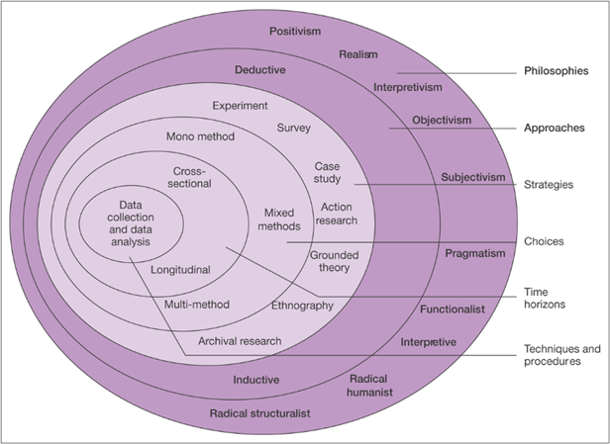
Appendices 1: Research onion

Mark Saunders, Philip Lewis and Adrian Thornhill 2007

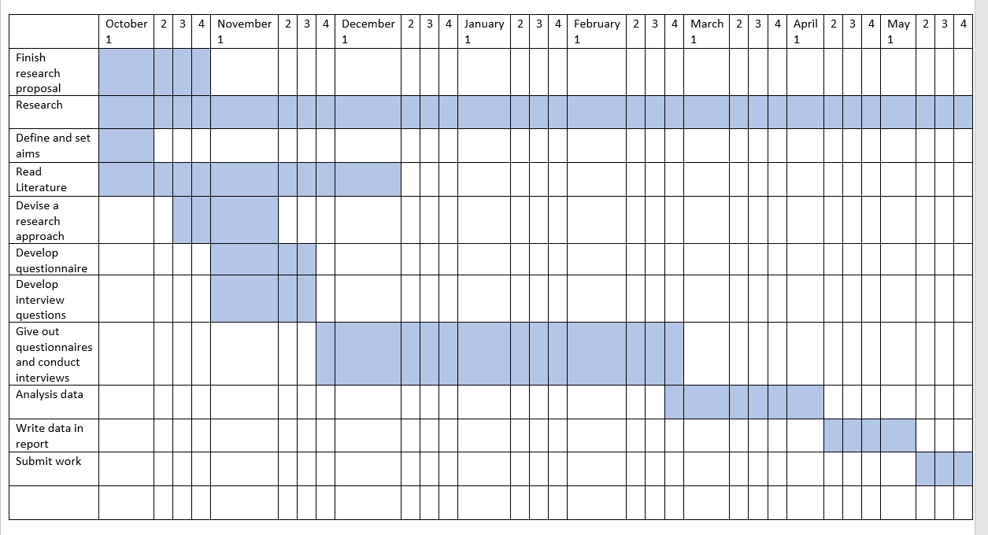
Appendices 2: Gantt chart

Appendix 3: Interview questionnaire
Age? Please circle age group
  - 20-25 26-30 31-35 36-40 41-45 46-50 51-55 56-60 61-65 66-70 70+

Do you work within the wedding industry or are you planning your own wedding within a year? Please circle
Wedding industry Getting married
What would you say are the key skills required to plan a wedding? Please state

What are the key skills you think are important when planning a wedding?

Do you think the total cost of a wedding planner is worth it?

Do you think experience in weddings is more important than cost?

Picking a wedding planner, what are the most important thing customers look out for?

Do you prefer wedding planners who work in a venue and host weddings or independent business who use different locations?
Yes No
Why?

How involved do you feel wedding planners should be in the process of planning a wedding?

Hiring a wedding planner cost effective or just waste of money?

What is the average cost of your weddings?

What is your ways of staying calm during this high-pressure event?

