L5 UCM Assignment 1
TURNITIN Submission

MODULE: Changemakers: Creativity and Value Creation (ACCA5033)
NAME: Ewan Henderson, 1901997
COURSE: BA Computer Games Design

Table of Contents
e-Portfolio
Link: https://redwallgameart.wordpress.com/2020/11/11/changemakers-content-list/

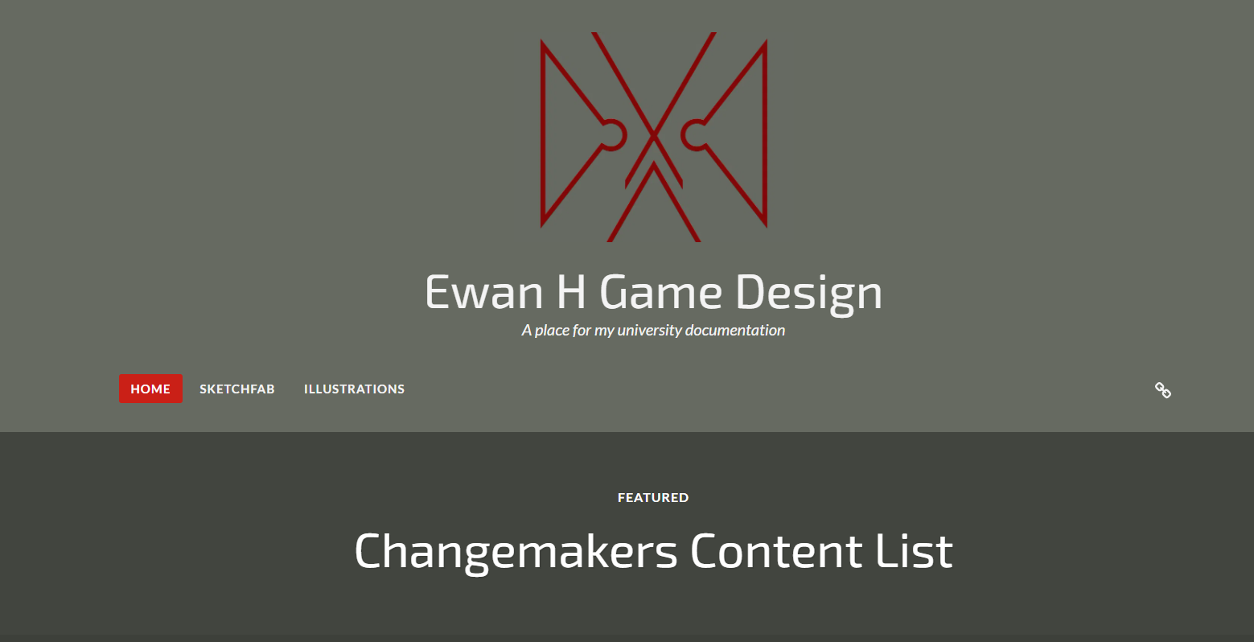
Task 1 – Mind Map.
Link (to portfolio page): https://redwallgameart.wordpress.com/2020/11/11/project-mind-map/
Link (to image): https://uowtsd-my.sharepoint.com/:i:/g/personal/1901997_student_uwtsd_ac_uk/EaFVRgRKsR5NjSKQWl8pFO8BHa-Gvj_UwEwKUOUYJmj3dQ?e=oUfqpP

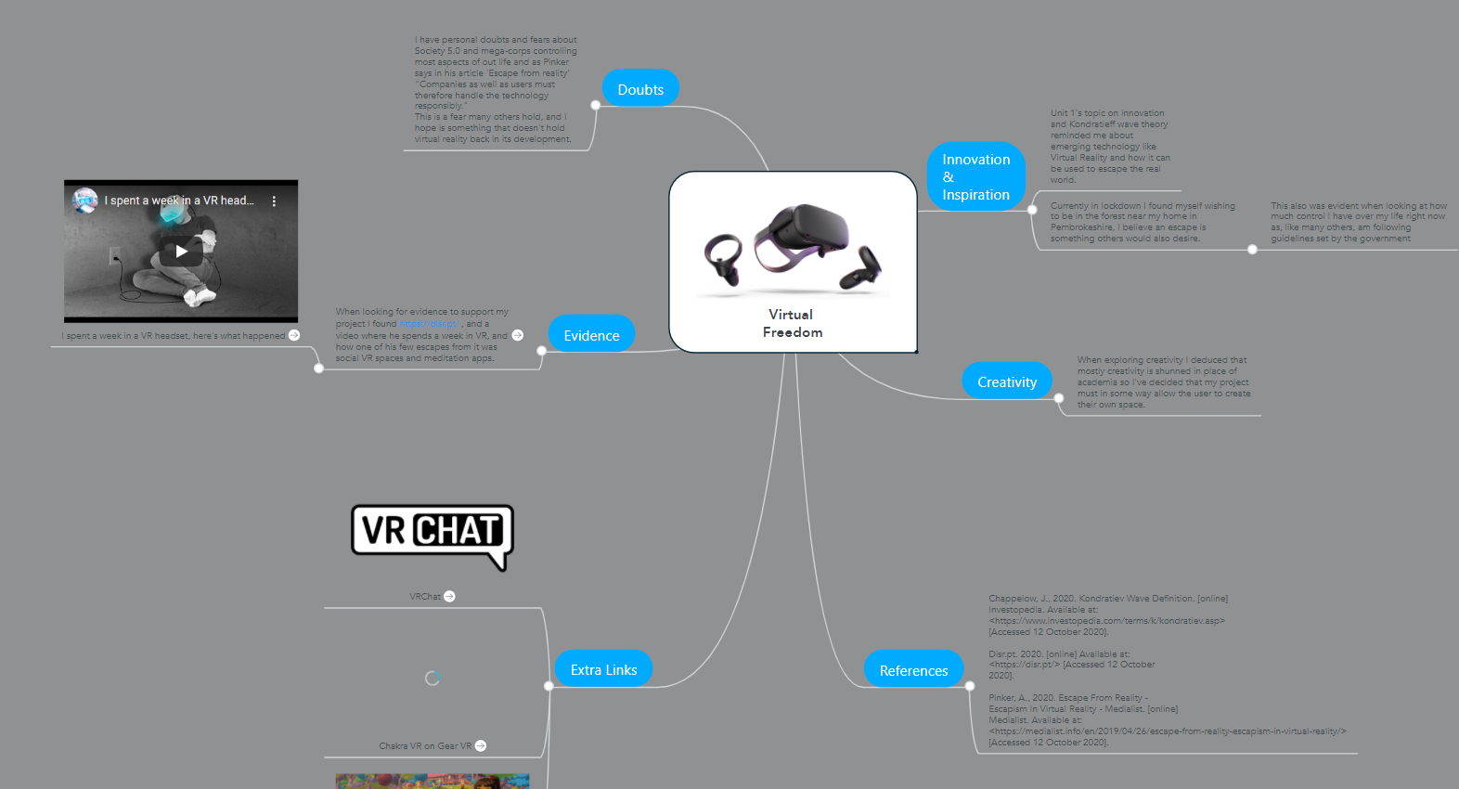

Task 2 – Image-based Video presentation.
Link (to portfolio page): https://redwallgameart.wordpress.com/2020/11/11/unit-2-image-based-video-presentation/
Link (to video): https://www.canva.com/design/DAEObw1nxDY/oiIAA0Dn_LEtCQVWd7DZ4Q/view?utm_content=DAEObw1nxDY&utm_campaign=designshare&utm_medium=link&utm_source=recording_view

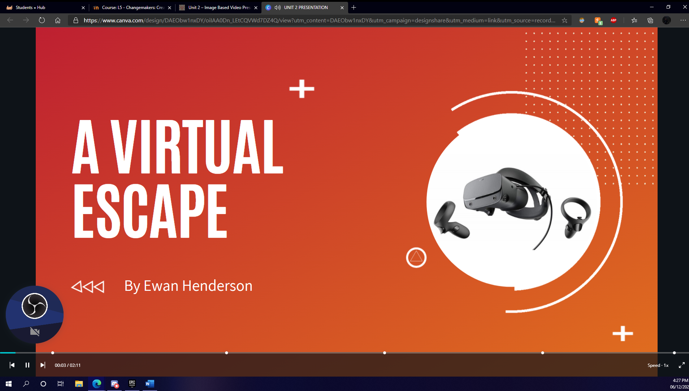
Task 3 – Video presentation.
Link (to portfolio page): https://redwallgameart.wordpress.com/2020/11/11/unit-3-video-presentation/
Link (to video): https://www.canva.com/design/DAEPdYZqjPU/ea1-nX1iwvcnQL45N-UzPA/view?utm_content=DAEPdYZqjPU&utm_campaign=designshare&utm_medium=link&utm_source=recording_view

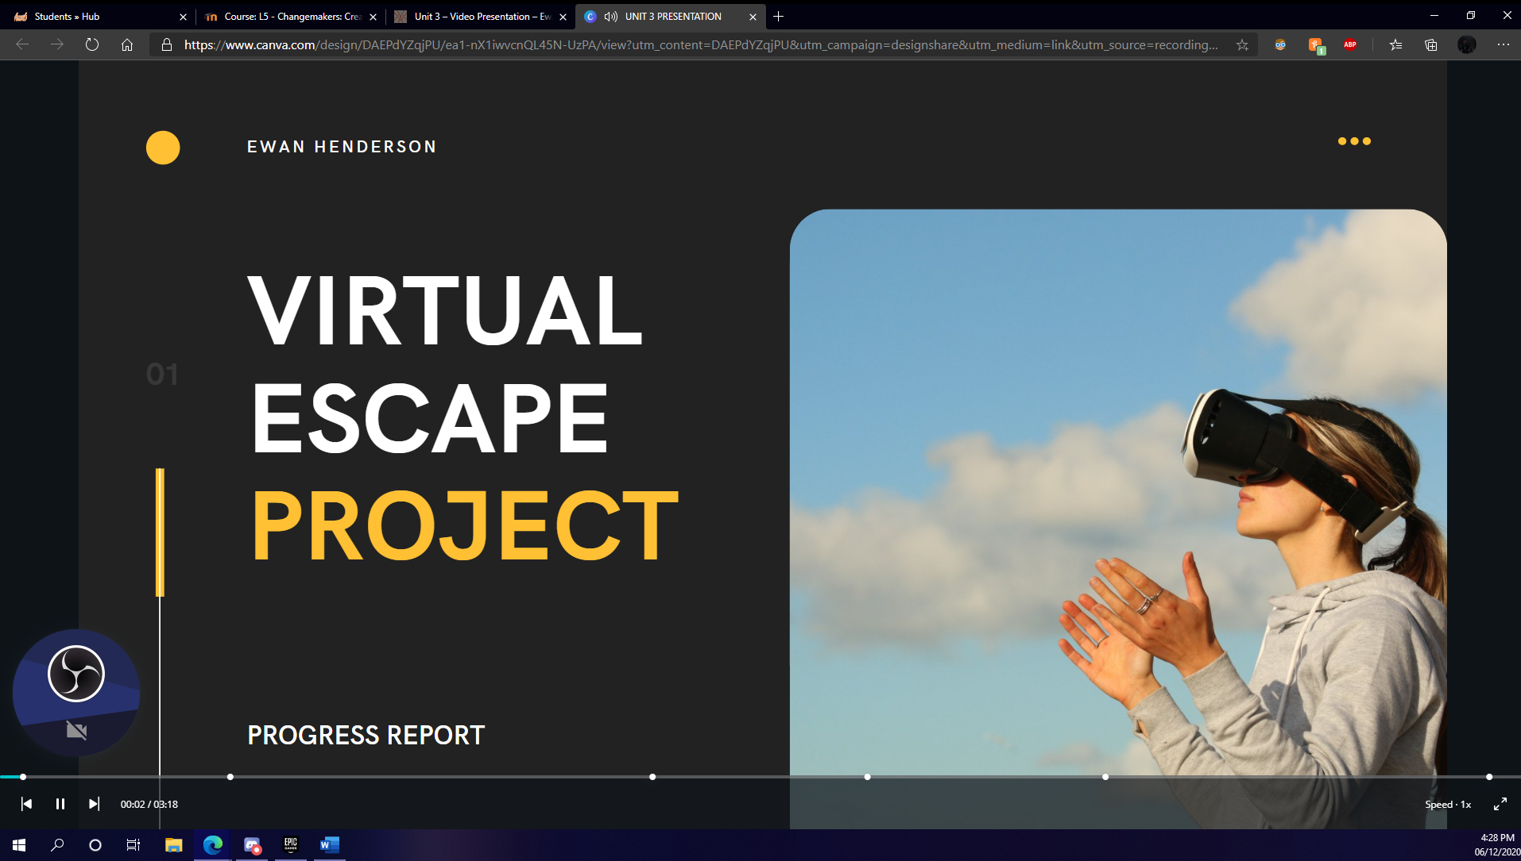

Task 4 – Academic poster.
Link (to portfolio page): https://redwallgameart.wordpress.com/2020/11/11/unit-4-academic-poster/
Link (to image): https://uowtsd-my.sharepoint.com/:b:/g/personal/1901997_student_uwtsd_ac_uk/ESIq5am4YWxKtcsYySSkJkUBvijzh8g-x-2_UAmvuQooiQ?e=JVEgtR



