LEVEL 6 ASSESSMENT SPECIFICATION

Student name: | Georgia Howe | Student ID number: | 1401449
Programme: | Primary PGCE
Module: | Learning and Teaching in the Primary School
Module code: | M6X02149/C | Contribution to Overall Module Assessment (%): | 100%
Lecturer: | Rachel Wallis | Internal Verifier: | Rachel Wallis
Assignment Title: | ‘A critical analysis of the relationship between teacher subject knowledge and effective learning and teaching in the primary school | Word count (or equivalent): | 4,000 words for written assignment with 1,000 equivalent for appendicies
Submission deadline: | 11/01/2019 (23.59) | Return date of provisional marks & written feedback: | 08/02/2019
Submission method: | All written assessments, where practical and possible, must be submitted via Turnitin unless otherwise instructed by the Lecturer. (Please DO NOT put this assessment specification into Turnitin or it will match many similarities with other students’ submissions.)  Alternative submission method (if applicable):  Late submission of the assessment will result in a late penalty mark. Penalties for late submission: Up to one week late, maximum mark of 40%. Over one week late, 0%. Only the Extenuating Circumstances Panel may approve a change to submission dates.
Academic honesty / referencing: | Academic honesty is required. In the main body of your submission you must give credit to authors on whose research and ideas your work is based. Append to your submission a reference list that indicates the books, articles, etc. that you have used, cited or quoted in order to complete this assessment.

A critical analysis of the relationship between teacher subject knowledge and the effective learning and teaching in the primary school

Written by Georgia Howe
PGCE Primary University of Wales Trinity Saint David
Submission date: 11/01/19

Student Number: 1401449

Word count: 4114

Please find at the bottom both my bibliography and appendix

Introduction

It is my intention within this assignment to discuss a compilation of literature encompassing teacher subject knowledge for the primary education sector before analysing and evaluating my own personal knowledge base for primary teaching. The main aspects of my literature consideration will be based on Shulman (1986) and the Knowledge Quartet, conducted by Rowland et al (2003).

Donaldson (2017) discusses the significance of effective teaching and its relation to effective learning, which is what I hope to bring to life within the main body of this assignment. My analysis will be based upon my own experience as a PGCE student undergoing a professional teaching experience in a primary school in South Wales. Although the school is not one of the pioneer schools, they are beginning to incorporate Donaldson’s ideals wherein schools develop ambitious, healthy, confident and capable learners (Dauncey 2015).

Within my analysis of my subject knowledge, I will focus on my professional teaching experience, which took place in a small co-educational, county maintained, English medium primary school. The school had a student population of 247 pupils, iis currently in the yellow support category with a free school meal percentage of 27.9%. Per the latest Estyn report, the school holds a number two grade, meaning ‘good’ and has an average annual attendance of 94.5% acros foundation phase and key stage two. In accordance with Bera guidelines I have made the decision to to not include the name of location of the school in which I underwent my teaching practice. For the purpose of annonyminity I have not included the Estyn report for this school.

A consideration of the literature

While it is universally understood that teachers need knowledge in order to teach, it is open to interpretation just how much is both acceptable and necessary in effective teaching. Skinner (2011) discusses the idea that a teacher who relies solely on standard knowledge isn’t good enough, that research and theory make a huge contribution. Having a base knowledge is vital to teaching any subject, though that may not always be enough to transfer that knowledge into accessible and understandable information within the classroom (Shulman 1987). It is backed by Shepherd (2011) that if a teacher doesn’t know what they are saying, pupil’s learning is likely to be compromised. Skinner adds that effectiveness in teaching depends not only on teaching skills and strategies, but also subject knowledge, thus we return to the importance of knowing what you’re talking about. Skinner (2010) created a figure consisting of five important factors he believed to be pivotal to effective teaching. Among these factors, subject knowledge is one of the influencing conceptions (see appendix). From this, it can be inferred that subject knowledge has a pivotal role to play within the area of teaching (Smithers & Robinson 2005).

According to the National College for Teaching and Leadership, a teacher’s understanding of what they are teaching is regarded as being the base for high-quality teaching. This has never been more true for the curriculum in Wales, with Donaldson’s initiative, teachers need to now more than ever before, adapt their pedagogy to fit Donaldson’s six areas of learning and development (Donaldson 2015). In relation to this, The Welsh Government (2017) invested over £4 million into a network for excellence to specifically target the improvement of teacher skills in technology and raise pupil excellence in both Science and Technology. This links closely to the OECDs Welsh Education Reform Journey (2017), in which Andreas Schleivher discusses that Wales’ “commitment to improving teaching and learning in wales’ schools is visible at all levels of the educational system.” Much like Donaldson, he also discusses Wales’ commitment to providing all children with the necessary skills and information believed to be required to succeed. The newly implemented curriculum has been so created under the generally based acknowledgement that subject knowledge has not only withstood a test of time over the years, but also remains the most viable path that should be taken to gain both a sound and relevant education (Donaldson 2015).

Smithers & Robinson (2005) argue that student’s quality of learning is at risk when there is a lack of subject knowledge on the teacher’s part. Promoting the importance of having the relevant subject knowledge is seen as a way to not only reform teacher training, but to also foster a better quality of learning in schools (McNamara 1991). In recent years, it has been a growing body of opinion within the government that many primary teachers are inadequate to teach the National Curriculum based on their lack of subject knowledge. Teacher Standards (2011) recommends the imperativity of teachers requiring a secure knowledge of relevant subjects in order to both maintain the interest of the pupils and be well versed in addressing misunderstandings. It is implied that alongside this, the ability to plan well structured lessons and to be adaptable where lessons and the needs of pupils are concerned.

Teachers have the ability to inspire a love of learning when they teach something that they are passionate about (Kent 2012). In support of that, McCabe (2012) emphasises the importance of quality of teaching. She is believes that overall, in the importance of inspiring children through sharing your love of a subject knowledge takes precedent as this can shape a lesson in a way that by itself, the curriculum cannot. O’Hear (1988:16) also had the understanding that in order to be a successful teacher, above all you need a sound knowledge and love of the subject you are teaching. It could even be said that combining a passion for teaching and a secure subject knowledge is much more imperative than training in pedagogy (Lawlor, 1990:20). In addition to this, McCabe is very much in favour of teachers having both subject knowledge and passion. She believes that they go hand in hand and that it not only inspires a higher level of attainment in pupils, it also improves the overall quality of teaching.

Pedagogy, being a continuously evolving concept can be linked to having a vast subject knowledge. Approaching subject pedagogically mean to me that you are taking into consideration integrating teaching strategies that use a wide perspective, thus, taking on board new takes on learning and absorbing new information. Pedagogy has a powerful relationship with subject knowledge and the act of transformation wherein a teacher breaks down what they know and converts that information into teaching strategies that are pedagogically understandable by the pupils (Skinner 2011:124). In Shulman’s (1987) case study of Nancy, a teacher of twenty-five years, it is clear that her sufficient understanding of English as a subject combined with her still as a pedagogue had glorious effects on a group of high school pupils. Nancy was described as being somewhat of a mental index when it came to literature, not to mention her impressive ability to draw out the shy pupils whilst keeping the more exuberant pupils happily under control. Nancy, by having an underlying contingency to her lesson plans was able to respond to her pupils in a way that enhanced the lessons she taught and maximise the overall learning of her class (Rowland et al 2003). As a pedagogue, Nancy created four levels of attainment when it came to reading (see appendix), levels which saw them making connections to both their past and future learning to progressively optimise their understanding (Rowland et al 2003). It is through her combination of subject-matter understanding and her pedagogical skill that allowed her to teach so effectively.

It is believed that a teacher cannot simply say that something is so, the teacher must be able to explain pedagogically, exactly ‘why’ and ‘how’ something is so (Shulman 1987). Explanation form of communication which is at the heart of human discourse in a plentitude of fields (Shulman 1987). Teachers can use explanation in a number of ways, ways that rely on a strong subject knowledge. Wragg (1993) suggests that ‘explaining is giving understanding to another’. Although to first explain something, you must first be able to understand it for yourself. Understanding the content of what you are teaching is one of the core beliefs within the Knowledge Quartet. In order to achieve a level of understanding, there are some components to consider. One is knowing subject-specific misunderstandings that can occur and being able to respond with with the support of accurate terminology (Rowland et al 2003). Further, a teacher should be able to help the pupil overcome those misconceptions and errors with various representations and strategies (Ball et al 2008). In doing this, you are implementing the transformation stage of the knowledge quartet and thus should ensure that the pupils understand the concepts and procedures you are putting forward to them (Rowland et al 2003). Explanation cannot simply be done, as I mentioned previously, in order to explain you must first understand for yourself. This level of understanding has been discussed within the taxonomy of educational objectives (see appendix), which has been formulated to identify the hierarchical structure of learning (Bloom 2001). It is not an accident that knowledge is at the base of the taxonomy, and while there are many levels above it, Bloom suggested that one needed the lower levels to accomplish the higher ones.

Expecting teachers to have thorough knowledge of every curriculum they are meant to teach sounds dubious and unrealistic, however, it has been proven that a lack of subject knowledge can have a fundamental effect on both what and how teachers teach (Furlong & Maynard 1995). If you are a newly qualified teacher with a background in mathematics, albeit little experience teaching the subject, you are henceforth unable to provide the pupils with the necessary information and therefore unable to develop their understanding (Murphy 2010).
Many teachers feel that they should always respond to children when they ask the age old question, “Why?” However, it is not always possible to give a viable answer to such a broad question, many teachers have admitted that many problems they faced within the classroom often derived from their own lack of understanding of a subject and that not understanding in front of a classroom of pupils made them feel rather vulnerable (Furlong & Maynard). Having considered these examples, it is my understanding that a strong subject knowledge aids in both confidence and fluidity of teaching. Albeit, a high level of subject knowledge does not always amount to effective teaching (Hotman 2010). The same can be said for experience, it has been suggested that newly qualified teachers improve at greater rates during the first few years of their careers, albeit at a much slower rate throughout the rest of their career (Podolsky 2016).

Both subject knowledge and pedagogical subject knowledge have been proven to affect teachers’ instructional practice as well as how effectively pupils learn in the area of numeracy (Baumert et al 2010). Shulman in prior years, made pedagogical content knowledge (PCK) a central focus for an expanding pool of research. The aspect of PCK is generated by two very vital and distinct types of professional knowledge. The first being what we would call the teachers’ subject knowledge of the subject they are teaching. The second being the understanding the teacher has of the children and how they learn best. Connecting subject knowledge to pedagogical knowledge is imperative to effective teaching, and combined with classroom control and the ability to hold the room makes an excellent if not perfectly well-rounded teacher (Furlong and Maynard 1995). It is apparent from reading the work of Furlong and Maynard that connecting subject knowledge to the overall understanding of how children learn, you are better able to filter and frame appropriate approaches to teaching. Further, it is claimed that teachers must not only have a personal understanding of the subject, but also find ways to transform and represent said understanding in order to make it more easily accessible to pupils (McDiarmid et al 1989).

Analysis and evaluation of your subject knowledge for primary teaching

My teaching practice took place in a year 6 class consisting of 37 pupils. Whilst undergoing teaching practice, my class were covering A Christmas Carol within the subject of literacy. From observing the class retell the story, it quickly became clear that the children had more knowledge of this story than I did as it was also their focus for the Christmas concert, consequently for me, my confidence plummeted. I felt very much out of my depth. Despite having a high pedagogical ability to explain text, this was a story that I was very unfamiliar with. There was no way that I would be able to explain this topic to them without first improving my own subject knowledge and understanding it for myself (Bloom 2001). What with knowledge of a subject being a core belief within the knowledge quarter (Rowland et al 2003).

By furthering my knowledge of this particular piece of literary work, I knew I would feel more confident to command a lesson on it, connecting my pedagogical experience in English to my newly acquired knowledge of A Christmas Carol (Furlong & Maynard 1995). My assumption was correct, I discovered that by improving my subject knowledge, the fluidity of the lesson was much better, I tried to emulate Nancy’s four steps for literacy (see appendix) and found them to be insightful and effective in my teaching. Through the enhancement of my own knowledge of the story, I didn’t need to look at my lesson plan, nor did I need to rely on any written material, save for the resources I used on the interactive whiteboard, which aided in the fluidity of the lessons. Personally, I am drawn to believe that these English lessons were successful by the feedback I received from both the pupils and my mentor, further, from the impressive level of enthusiasm and class discussion that emerged from my lessons. Although I had planned for discussions within my lessons, the students really committed to aiding the flow and aggrandizing the overall learning.

Subsequently, the more subject knowledge I acquired on this topic, the more confident I felt. Building on this, I decided to take the learning further and incorporate Drama into the topic, as a way or using expressive arts (one of Donaldson’s (2015) six areas for learning and development). I took on the topic of hot seating with the children, in which they were asked to write a script and perform to the class. This was an excellent opportunity for them to develop the oracy skills required at level five, more specifically, “speak clearly, using formal language, varying expression, tone and volume, to keep listeners interested” (Welsh Government 2015:3). Having a long-running background in performing arts and teaching the subject to children, I feel that I was able to convey my love of performance in an inspiring manner, which I feel has shaped this drama lesson and the ones I taught thereafter in a way that wouldn’t have been possible with just the curriculum alone (O’Hear 1988).

I am overjoyed that my gusto for teaching this subject had a such a positive effect on the learning and participation within these two topics, though I am drawn to the question of what could have happened had I not shown such a positive attitude to the subject. I fear that had I displayed a pessimistic view toward my lack of knowledge of A Christmas Carol, the effect on the pupil’s learning could have been detrimental. Not only that, I could have inadvertently encouraged an adverse outlook on the entire subject, thus resulting in an unenthusiastic approach to further English lessons (Villamor 2017).

A subject that I found particularly trying was digital competency. The topic I had been given was to get the children into small groups and collaboratively write a monologue from the perspective of the creator of Cadbury’s chocolate, John Cadbury. It seemed easy enough considering my prior knowledge and experience teaching both drama and English, not only that, I felt that this would be a great way to use cross-curricular strategies, combining English with digital competency (Donaldson 2017). However, this arc of lessons required a high level digital competency, more specifically using an app called Morfo. The idea was to have each child record themselves performing the monologue, the app would then take that audio recording and turn it into a moving image of John Cadbury’s face (see appendix). My knowledge of iPads was secure, though in this particular case, my knowledge of the app was nonexistent, putting the potential quality of learning at a disadvantage (Smithers & Robinson 2005). In order to prevent my little experience of this app adversely affecting my pupil’s understanding (Murphy 2010), I spent several hours practicing with the apps functionality and all of the ways it could be used in order to later explain to my class how to complete the task. When it came to recording audio on the iPads, we were almost out of time, so in order to get every pupil’s monologue recorded, I took charge and did it myself, which I realise looking back meant that I had taken part of the independence of the lesson away, which is definitely an area for improvement that I would note for my teaching. Another area of improvement I would suggest for myself is a better grasp on time management, as better time keeping could have meant that the pupils were able to record each other as opposed to me doing it.

I feel the positives of the lesson were that my subject knowledge visibly impacted them in a positive way, as during the lesson several pupils struggled to use the app effectively, which owing to my own practice of using the app and facing this mishap myself, I was able to give the suitable guidance on how to overcome the problem.

My subject knowledge within the area of mathematics is high, however my experience in transferring that knowledge into my teaching was minimal. This put me at a slight disadvantage in my teaching as understandably, knowledge of a subject does not always transfer to effective teaching (Hotaman 2010). It is recommended that we as teachers acquire a secure knowledge of a subject to be able to maintain the interest of a classroom full of pupils and more importantly, to abely address any misunderstandings that could occur, which can only be achieved through having a deep understanding of the subject Teacher Standards (2011).

Thankfully, despite my experience in teaching mathematics being low, the mathematics lessons I had attended within my postgraduate degree put me in a position where I had the pedagogical strategies ready to use fresh from just a week before. This fact is supported by Podolsky (2016) who believed that newly qualified teachers (in my case, soon to be qualified) were advantageous in that they were using freshly learned strategies and methods. He also mentioned that their first few years of teaching would be the years in which they improved at a much greater rate than that of more seasoned professionals. In my case I hope this to be true and that my first few years are spent cultivating and developing a plethora of strategies and emulate Nancy by being somewhat of a mental index for knowledge (Shulman 1987).

Over the course of my teaching practice, I taught a small focus group in maths, the ability level was low. Per the program of study for mathematics as laid out by the curriculum for wales (2016), my focus group were attaining work designed for a year 5 class, though they still struggled at times to understand some of the elements within the curriculum, particularly adding and subtracting three digit numbers. The National College for Teaching and Leadership (2018) hypothesize that when teaching mathematics, it is essential that a teacher demonstrate a clear understanding of the subject and incorporate appropriate teaching strategies. Using my own understanding of subtraction, I combined that with the strategies and methods I had learned at university to break down the topic in a way in which they would not only understand, but remember. I focused on the term ‘borrowing’, in subtraction you borrow from the digit to the left, I scaffolded this information with their prior knowledge of asking a friend for a pencil if they were without one as well as using Dienes as a resource to further their independent experiences and understanding (Carney 1997). I feel that a positive aspect of this lesson was that I was able to get them to connect something from their past knowledge and transform that into a maths strategy (Rowland et al). An area for improvement on my part could be to develop my knowledge further on how to aid low ability groups and help children with ALN.

The Welsh Government’s (2017) vision to have over one million Welsh speakers by 2050 means that there has been a rise in the amount of Welsh being both spoken and taught in schools across Wales. Throughout my teaching practice I’ve heard a great deal of Welsh as per the initiative. Unfortunately, my lack of experience even speaking the Welsh language is limited, meaning not only was I unable to understand some things, I was also unable to respond and build on what was being said. This made me feel very vulnerable to failure. I couldn’t rely on my standard knowledge of Welsh as I didn’t have enough to be able to transfer it to my teaching. I struggled the most when pupils during a lesson would ask me what certain sentences meant in Welsh that I didn’t know the answer to, this problem was caused by my lack of understanding, which is something I found happened more often that not with student teachers (Furlong & Maynard 1995). A useful but not long term solution was to flip any question they had back to them by saying “What do you think?” I felt like a failure doing this as by me not knowing this subject well enough was compromising their learning (Shepherd 2011). The fact that there were some questions that were beyond my subject knowledge told me that I needed to strengthen my base knowledge of the Welsh language as failing to do so could end problematically where the pupils are concerned.

In order to avoid having a negative effect on pupil learning, I sought the advice and instruction of my mentor, who taught me some general phrases to use within the classroom, furthermore, from observing my classroom teacher, I was able to compile a small but useful cluster of questions and phrases that I could incorporate into any lesson and also throughout the day, thus improving the fluidity of Welsh oracy within my class of pupils. Throughout my teaching of other subjects, I am delighted to say that the level of Welsh oracy in my class is high and used continually throughout the day, sometimes even habitually, which is pertinent to the Welsh Government’s (2017). An area of improvement for me would definitely be to improve my Welsh oracy as well as my pedagogical subject knowledge regarding the language as it is my hope to support the Welsh initiative and encourage my future pupils to emulate me as I speak more confidently in Welsh.

Conclusion
It is clear from the reading that as a teacher, maintaining a high standard of transferable subject knowledge is one of the predominant elements to effective learning and teaching at any point in education. There are, of course, arguments to be made that having a secure subject knowledge isn’t essential (Furlong & Maynard 1995), however I truly believe that a sound grasp on what you are teaching young minds is crucial to the overall benefit of a child’s education. Of course, I don’t believe that a teacher having good subject matter knowledge alone can deliver a sound education, but I believe that a lack thereof could be detrimental to the progression of pupil’s learning and understanding.

The development of an understanding on how children learn is pertinent to an educators cognizance of the curriculum requirements, hence a teacher’s necessity to develop their own flexible and thorough subject matter knowledge (Shulman 1987). From my own personal experience I am inclined to agree strongly with this, as it has been through getting to know my pupils and the way they respond to my teaching that I have been able to develop my own strategies to better suit their learning needs. Classroom control and time management also play imperative roles in the attainment of effective learning and teaching. Experience has lead me to believe that this cluster of strategies are the building blocks towards an arc of effective learning and teaching environment, with subject knowledge being the keystone in the archway.

Bibliography

Baumert, J., Kunter, M., Blum, W., Brunner, M., Voss, T., Jordan, A., (2010) Teachers’ mathematical knowledge, cognitive activation in the classroom, and student progress. American Educational Research Journal, 47, 133-180
Carney, J W., (1997) Effectiveness of using structured aids in learning number concepts for middle primary school children. Masters Thesis: Victoria University of Technology (online) Available at: http://vuir.vu.edu.au/18150/1/CARNEY_1997compressed.pdf [Accessed on January 2nd 2019]
Dauncey, M., (2015) Donaldson Review: The ‘purposes’ and content of a Curriculum for Wales: National Assembly for Wales Research Service [online] Available at: https://seneddresearch.blog/2015/03/17/donaldson-review-the-purposes-and-content-of-a-curriculum-for-wales/ [Accessed December 15th 2018]
Furlong & Maynard (1995) The Growth of Professional Knowledge: Mentoring Student Teachers. Routledge Publishing
Hotaman, D., 2010. The teaching profession: knowledge of subject matter, teaching skills and personality traits. Procedia Social and Behavioural Sciences
Kent, P. 2012, BBC news website: 'Secondary school league tables: The schools at the top' [online] Available at: https://www.bbc.co.uk/news/education-42310494 [Accessed January 4th 2019]
Lawlor, S. (1990) Teachers mistaught London: Centre for Policy Studies
McCabe, B. Account of practice: National College for School Leadership Published 2012 [online] Available at: https://www.nationalcollege.org.uk/cm-mc-cd-aop-mccabe.pdf
[Accessed January 4th 2019]

McDiarmin, G.W., Ball, D.L. and Anderson, C. (1989) Why Staying One Chapter Ahead Doesn’t Really Work: Subject-specific Pedagogy. Knowledge base for the beginning teacher. The American Association of Colleges for Teacher Education, New York, Pergamon.
McNamara, D (1991) Subject knowledge and its application: Problems and Possibilities for Teacher Educators. Journal of Education for Teaching
Murphy, C. 2010. The role of subject knowledge in primary student teachers’ approaches to teaching the topic of area [online] Available at: http://ife.ens-lyon.fr/publications/edition-electronique/cerme6/wg10-14-murphy.pdf
[Accessed January 1st 2019]
National College for Teaching and Leadership (2018): Section 4: How leaders improve teaching [online] Available at: http://www.inspiringleaderstoday.com/ILTMaterials/LEVEL3_LIT-v4.0-2014_08_08-11_54_0/leading-and-improving-teaching/lit-s4/lit-s4-t05.html
[Accessed on January 5th 2019]
OECD (2017) The Welsh Education Reform Journey: A Rapid Policy Assessment [online] Available at: http://www.oecd.org/education/The-Welsh-Education-Reform-Journey-FINAL.pdf [Accessed December 17th 2018]
O’Hear, A (1988) Who teaches the teachers? London: Social Affairs Unit
Podolsky, T. (2016) Does Teaching Experience Increase Teacher Effectiveness? A Review of the Research. [online] Available at: https://learningpolicyinstitute.org/product/brief-does-teaching-experience-increase-teacher-effectiveness-review-research [accessed January 2nd 2019]
Rowland, T., Huckstep, P. and Thwaites, A. (2003) The Knowledge Quartet. In WIlliams, J: Proceedings of the British Society for research into Learning Mathematics. University of Cambridge
Shepherd, D., (2011) The impact of teacher subject knowledge on learner performance in South Africa: A within-pupil across-subject approach [online] Available at: http://www.iwaee.org/papers%20sito%202013/Shepherd.pdf
[Accessed January 3rd 2019]
Skinner, D. (2010) Effective teaching and learning in practice. Continuum International Publishing group
Smithers & Robinson (2005) Physics in Schools and Colleges: Teacher Deployment and Student Outcomes. Research Gate [online] Available at: https://www.researchgate.net/publication/281776231_Physics_in_Schools_and_Colleges_Teacher_Deployment_and_Student_Outcomes
Villamor, J., (2017) Negative Attitude of a Teacher: Mindanao State University - Iligan Institute of Technology [online] Available at:
https://www.researchgate.net/publication/321110904_Negative_Attitude_of_A_Teacher
[accessed on December 29th 2018]
Welsh Government (2015), Curriculum for Wales: Program of Study for English Key Stages 2-4. [online] Available at http://learning.gov.wales/docs/learningwales/publications/150717-nc-english-en-v3.pdf
[accessed on November 25th 2018]
Welsh Government (2016), Curriculum for Wales: Program of Study for Mathematics Key Stages 2-4 [online] Available at:
http://learning.gov.wales/docs/learningwales/publications/150717-nc-maths-en-v2.pdf
[accessed on November 25th 2018]

Welsh Government (2017) Cymraeg 2050: Welsh Language Strategy. Published by OGL [online] Available at: https://gov.wales/docs/dcells/publications/170711-welsh-language-strategy-eng.pdf
[Accessed December 15th 2018]
Wragg, E. (1993). Primary teaching skills. London: Routledge/Falmer. (pages 111-112)

Appendix

Don Skinners Factors influencing conceptions and realization of effective teaching

Aims and Values
Judgements about context
Teaching strategies and skills
Subject knowledge
Environment for learning

Effective teaching and learning

Nancy’s Four levels (Shulman 1987)
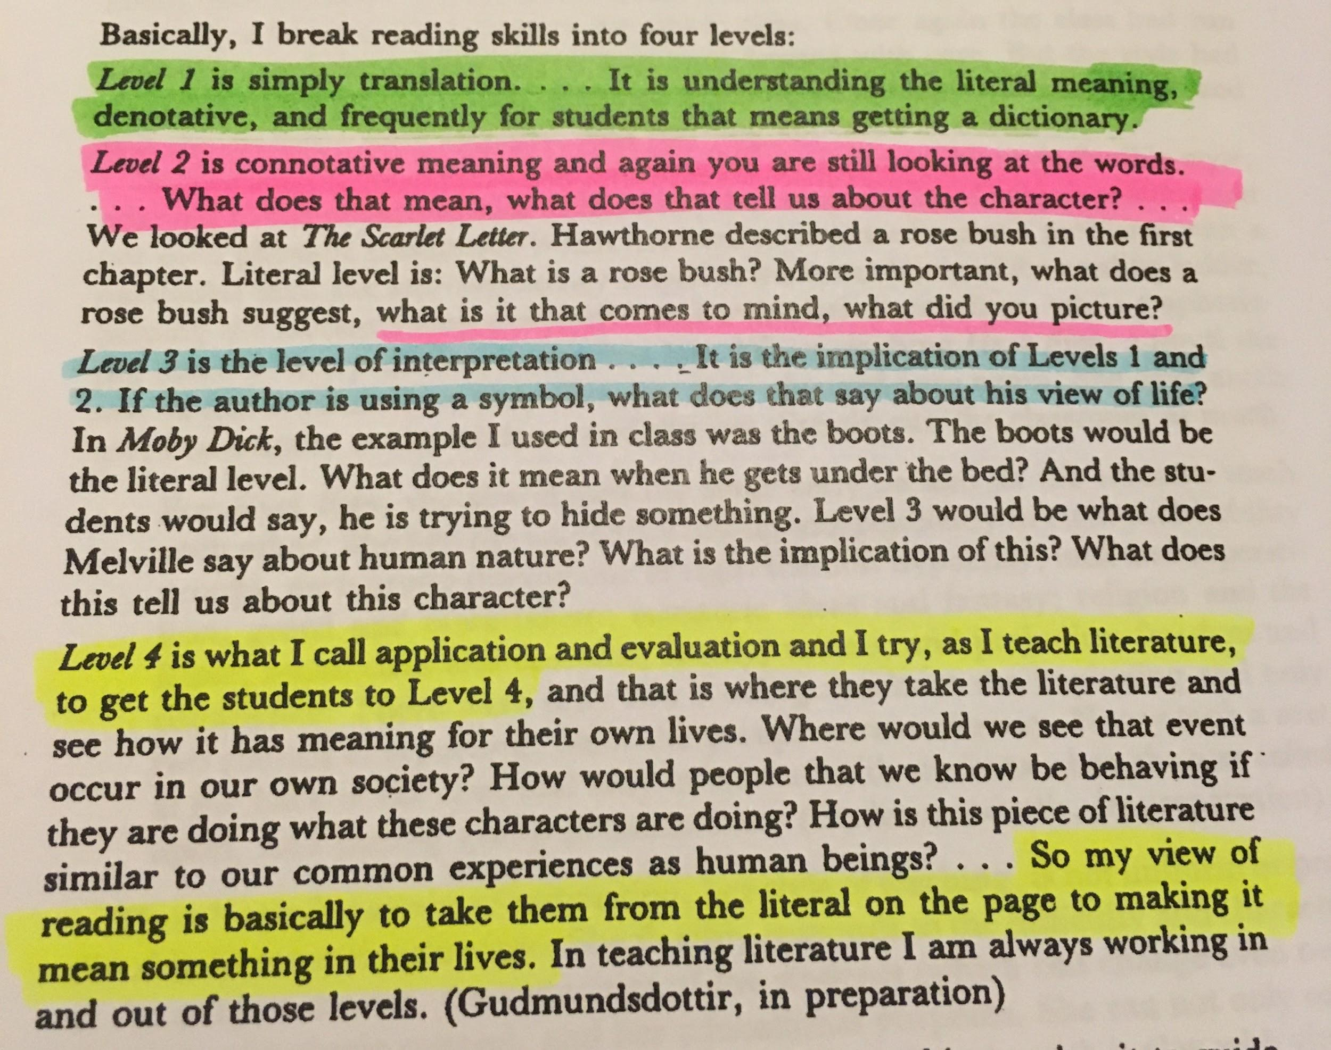

Bloom’s Taxonomy
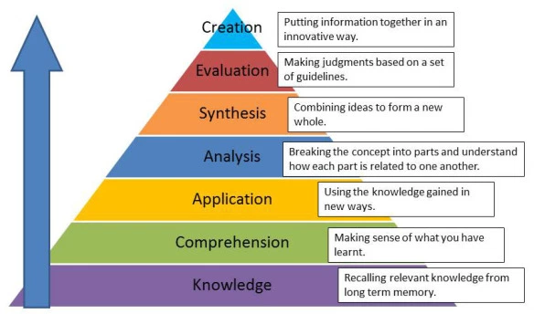

Example of the Morfo my pupils created during the cross-curricular English oracy and drama lesson. (screenshot sent to me from a school iPad)


