Essay title: Story Telling Through Time
Module title: ADDA4023/C Ways of Perceiving
Student name: Gracie Cant-Bull
Student Number: 2404002
BA Course Title: Graphic Design 2025:26
Word Count: 1,601
Lectures Name: Donna Williams

Story Telling Through Time:
I chose to curate this exhibition based off of Folklore as most people’s definitions of folklore is that they are fairytales and aren’t aware of how they are a social glue that binds us together as communities and brings meaning to our environments. What I wanted to illustrate through this exhibition was the gap better modern and traditional folklore, as modern folklore is a combination of creativity, storytelling and resilience as it is formed from integrating migrant traditions into more modern art styles like graffiti. "Folklore is not a thing but a process... It is the informal, unofficial, and creative part of every culture." (Sims, M.C. and Stephens, M. 2011). This illustrates that folklore is not just from the past but has grown into the modern era and is a shared communication through story telling in culture as a whole. Folklore is prevalent in our culture more than ever as "The Internet has not only changed the way we communicate; it has changed the way we relate to our traditions, allowing local myths to find global audiences in a matter of seconds." (T.J. 2009). Folklore has now moved from local myths to global theories as the internet hasn’t forgotten folklore it has accelerated it and spread it to more communities, forming a new kind of culture.
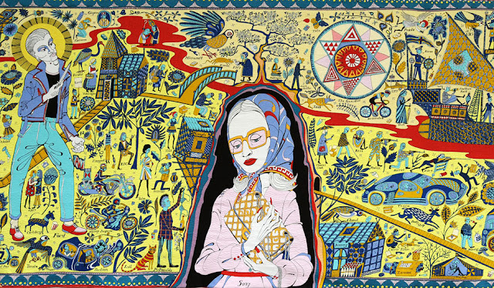
Figure 1: The Walthamstow Tapestry by Grayson perry (Blogspot.com, 2026)
The first piece I chose for my exhibition was The Walthamstow Tapestry as the main theme around this piece is how throughout the years many different kinds of cultures and societal trends have been woven into our society as a whole and formed a new kind of modern narrative that is formed from past stories and lives. Additionally, I like how symbolic this is as it is physically woven into a tapestry. Grayson was inspired by the “the unique flavour of ‘a bit of early Italian fresco painting and folk art.” (Factum Arte, S.L, 2026) and how it incapsulates the stories told from this old folklore, so he decided to explore more, and I think the style in which he did works well, especially with my other pieces in the exhibition. I chose this piece because of the important value that folklore has on communities, and I think it is demonstrated well in this piece as everyone will be able to recognise a sense of self throughout the piece that has come from past story tellers or cultures. It links the past and the present as it shows how throughout time folklore and stories have “new variants evolve" (TEHRANI, 2023) and it shows the evolution of storytelling and how juxtaposing groups come together to form a new kind of community culture.
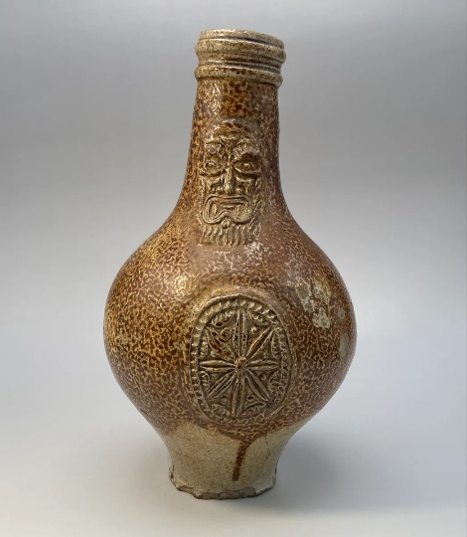
Figure 2: 17th century witch bottle (Ox.ac.uk, 2021)
This second piece is these 17th century witch bottles that help demonstrate another view of folklore, not just the stories. They show the traditional beliefs, practices and customs that are closely associated within folklore as they are used to worn off evil or other harmful spells and this is a perfect example of how folklore expresses itself through physical objects or rituals. They are also personal items from people in the past that formed our modern community we have now and it is interesting to see where they stories come from and how they originated and were told back then to how we view then now as a society. This was also done with “other folk‑protective objects such as concealed shoes or horseshoes.” (History, 2024) that share the same background but different stories. I chose these bottles because of the mythical and interesting backstory they have because witches used to be such a huge part of old folklore, but it isn’t as prevalent now that it makes it interesting to see how that was shaped into culture back then, but it isn’t as relevant now however it is still passed down through stories.

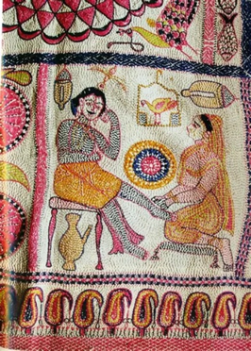
Figure 3: Traditional South Asian Kantha (Indiainch.org, 2026)
This third piece is a South Asian Kantha which is Kanthas are known for “tell tales of mythology and folklore, nature and everyday life,” (Pradhanaya, 2025) as they illustrate a story throughout the embroidery technique and give us insight into how the culture contributed to the communities everyday life and we can see through the art and the art of story telling if these tales have influenced our societal culture today. These sewn stories give us a visual insight into the cultural beliefs and systems that were around at the time and the opinions and narratives around folklore. I chose to include this piece into my exhibition because this cultures way of embroidering has been integrated into our culture and passed down through generations to form how we create textiles and clothing today. This practise is taught the traditional folklore way through verbale teaching and observation, not through written instructions. it shows a more practical use or the art of story telling as you can learn traditional skills that may have been lost if it weren’t for these art pieces and stories.
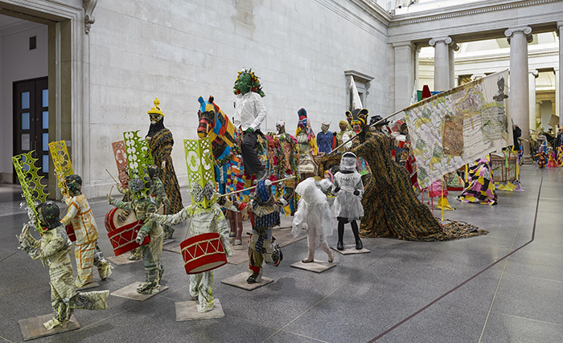
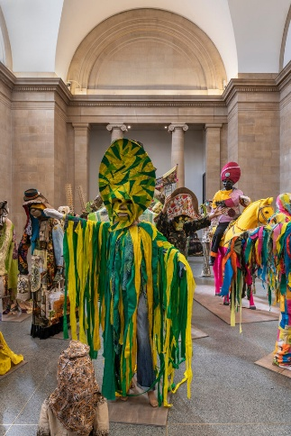
Figure 5: The Procession (Hew Locke, 2026)
Figure 4: The Procession (Culture Type, 2022)
This fourth piece is a mix of 150 statues that each have a vivid style of textiles that is relevant to a range of many traditional cultures that came together and is symbolic of culture moving through out time. I chose these pieces as they are described as “a celebration of narrative in form.” (Hew Locke, 2026) which encapsulates what folklore is all about as it illustrates how these traditions are not only celebrated in these cultures but are also what makes up these cultures narratives and to see it told in front of you in the traditional style would be very captivating. I chose this piece as the costumes tells pass stories to a new generation without it being written, which is a large part of folklore culture and it contrasts with one of my other pieces in the exhibition, the Kantha, as they both give insight into the stories they are trying to tell, whilst evoking a reaction to the unique cultures and interesting stories told how they originally were in the past. The artist Hem Locke is very set on making sure he correctly illustrates these intertwined histories and cultures as he said, “If I wasn’t an artist, I would be a historian.” (Artuk.org, 2026) showing the importance these traditional stories.

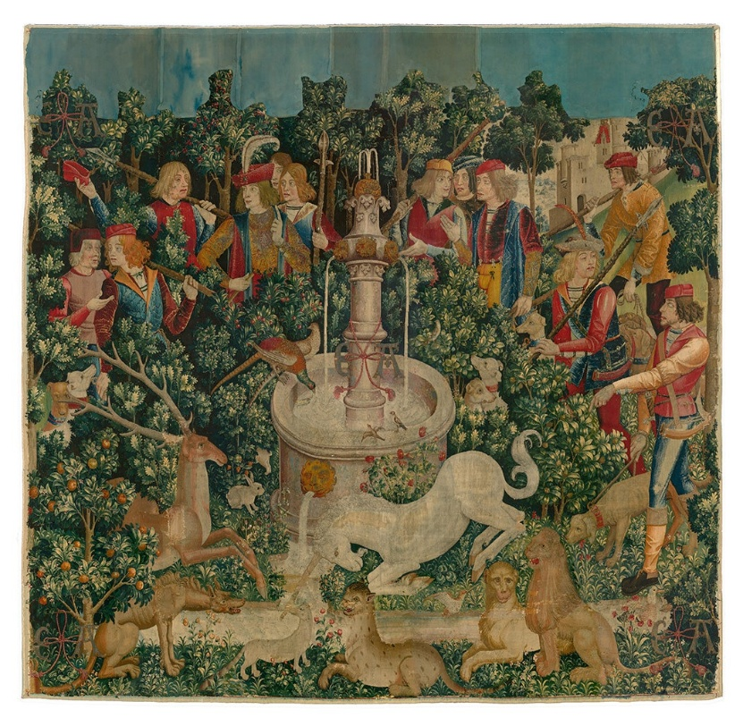
Figure 6: The Hunt of the Unicorn Tapestries (Amanda Parrish Morgan, 2021)
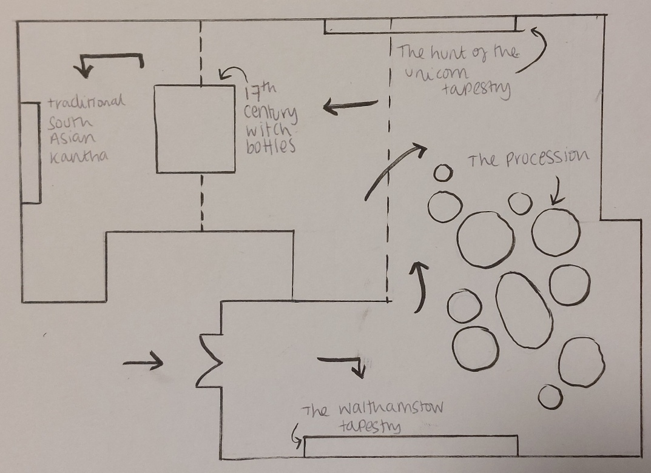
This final piece is a woven tapestry from around 1495 – 1505 created in the Netherlands. It has a narrative visual style that combines myth, storytelling and traditional folklore symbolism which depicts the story of the popular mythical creative, the unicorn. Unicorns have become well known due to stories being passed down through generations. I chose this piece because of the iconic symbol of a unicorn as it is very recognisable, and it just shows how these folklore stories are still prevalent and talked about in our communities and the collective culture. This piece blends myth into this tapestry like it is factual and it shows the difference between past cultures and how some things we still believe and continue to carry on into our own communities, and how some aspects become myths and get remembered as fictional stories. “What makes these tapestries so unusual is… the tension between their realism and their mythology.” (BOGDAN MIGULSKI, 2023) This shows the two different sides of storytelling, the ones we continue to listen to and follow and ones we keep just as stories.
Figure 7: My own illustration of how my exhibition will be laid out in the gallery
I chose to display my exhibition at the sunny bank mills gallery because it has held exhibits based around my theme before and has a history of Folklore style art being displayed there. The gallery is based in Leeds, and the gallery owner likes to include pieces that have stories about them or art that is based on stories, so I think my exhibition would be a good fit. As the gallery is a very airy and open style space, I would utilise this and have the art spread across the brick walls and allow each piece to have its own space to tell its story. The gallery has a lot of floor space where display units and tables could be places to create a flow around the room and I could use them to display the more physical art, like the 17th century witch bottles. This would help lead you around the room and tell a cohesive story together with all the art in the exhibition.

In conclusion I believe these five pieces are very cohesive together and represent my theme of folklore and ‘Story telling through time’ as they each individually display how story telling can be done through sewing it into a kantha, expressing it through a costume, displaying it on a tapestry or seeing how it has manifested into physical personal items from a real person who experienced the culture that influenced ours. These pieces show how community rituals of storytelling form folklore to become more of a global community and bring unlikely groups together. Retelling important stories to influence that culture or share beliefs with new crowds and make new traditions that were inspired by old to keep the heritage alive. I think a combination of these pieces displayed throughout The Sunny Bank Mills gallery will illustrate the important of story telling and folklore and how is it still relevant in today’s society, community traditions and overall culture.

Biography/References:
Artuk.org. (2026). Artist in focus: Hew Locke | Art UK. [online] Available at: https://artuk.org/learn/learning-resources/artist-in-focus-hew-locke?utm_source=copilot.com [Accessed 27 Apr. 2026].
Blank, T.J. (ed.) (2009) Folklore and the internet: vernacular expression in a digital world. Logan: Utah State University Press.
BOGDAN MIGULSKI (2023). The Mystery Behind the Unicorn Tapestries. [online] THE ART BOG - Art, Design, Photography, Music and Culture. Since 2003. Available at: https://theartbog.com/the-mystery-behind-the-unicorn-tapestries/?utm_source=copilot.com [Accessed 27 Apr. 2026].
Factum Arte, S.L (2026). Factum Arte :: The Walthamstow Tapestry. [online] Factum-arte.com. Available at: https://www.factum-arte.com/pag/107/the-walthamstow-tapestry?utm_source=copilot.com [Accessed 27 Apr. 2026].
Hew Locke. (2026). The Procession - Hew Locke. [online] Available at: https://hewlocke.net/artwork/the-procession/?utm_source=copilot.com [Accessed 27 Apr. 2026].
History. (2024). ‘Witch bottles‘ filled with nails and teeth were once thought to heal the cursed. [online] Available at: https://www.nationalgeographic.com/history/article/witch-bottles-rituals-superstition-17th-century?utm_source=copilot.com [Accessed 27 Apr. 2026].
Pradhanaya (2025). Kantha Embroidery-The Storytelling Stitches of Bengal and Odisha: History, Techniques, and Modern Revival. [online] The Culture Gully. Available at: https://www.theculturegully.in/post/kantha-embroidery-the-storytelling-stitches-of-bengal-and-odisha-history-techniques-and-modern-re?utm_source=copilot.com [Accessed 27 Apr. 2026].
Sims, M.C. and Stephens, M. (2011) Living folklore: an introduction to the study of people and their traditions. 2nd edn. Logan: Utah State University Press.
TEHRANI, J.J. (2023). OXFORD HANDBOOK OF CULTURAL EVOLUTION..

Figures:
Figure 1: Blogspot.com. (2026). Grayson Perry - The Walthamstow Tapestry. [online] Available at: https://openfileblog.blogspot.com/2011/10/grayson-perry-walthamstow-tapestry.html.
‌Figure 2: Ox.ac.uk. (2021). PAST EVENT: Unstoppering a 17th-Century ‘Witch Bottle’. [online] Available at: https://www.prm.ox.ac.uk/event/unstoppering-a-17th-century-witch-bottle [Accessed 20 Feb. 2026].
Figure 3: Indiainch.org. (2026). Collections Items – India InCH – Address Directory: Traditional Craftspeople, Weavers, Artists Across India. [online] Available at: https://www.indiainch.org/collection/?crt_category=embroidery [Accessed 20 Feb. 2026].
Figure 4: Culture Type. (2022). On View: See Images From ‘Hew Locke: The Procession,’ New Tate Britain Commission in London is Parade Through Time, Geography, and Cultures. [online] Available at: https://www.culturetype.com/2022/04/02/on-view-see-images-from-hew-locke-the-procession-new-tate-britain-commission-in-london-is-parade-through-time-geography-and-cultures/.
Figure 5: Hew Locke. (2026). The Procession - Hew Locke. [online] Available at: https://hewlocke.net/artwork/the-procession/?utm_source=copilot.com [Accessed 27 Apr. 2026].
‌Figure 6: Amanda Parrish Morgan (2021). The Hunt of the Unicorn Tapestries Depict a ‘Virgin-Capture Legend’. [online] JSTOR Daily. Available at: https://daily.jstor.org/the-hunt-of-the-unicorn-tapestries-depict-a-virgin-capture-legend/.
‌Figure 7: My own illustration of The Sunny Bank Mills Gallery with my exhibition in it.

