Student Name: Sarah Spencer

Student No: 1709418

Assignment title: Leading Service Improvement

Module No: DSAW7508

Institution: University of Wales Trinity St David

Table of Contents

Leading Service Improvement – Project Proposal 4
Objective: 4
Vision: 4
Background: 4
Current state: 4
Future state: 5
Patient impact: 6
Deliverables: 6
Method: 6
Success criteria 7
Ethics approval 7

Leading Service Improvement – Project Report 8
Background 8
Prudent Health Care 9
Understanding current practice 9
Understanding VTE workload 10
Current practice ‘above the waterline’ 10
Culture ‘below the waterline’ 11
Project process: stakeholder engagement 12
An urgent need for a specific change (a diversion from the project plan) 13
Serendipitous work with General Practitioners, GPs) 14
Challenging direction of travel 15
Job planning 15
Depth of engagement 16
Individuals 17
Thoughts on behaviours, attitudes and personality styles 17
Conclusion 18
Project outcome 18
Reflection on learning 18
Bibliography 20

Leading Service Improvement – Project Proposal

Objective:
To deliver an evidence-based, nurse-led pathway for the management of venous thromboembolism in ambulatory emergency medical care in the Princess of Wales Hospital

Vision:
All patients with venous thromboembolic disease who can be safely managed on an ambulatory basis (‘ambulatory VTE patients’) will have the correct diagnosis and most appropriate treatment at the right time.

Background:
Venous thromboembolism is a disease in which a blood clot forms in a deep vein (Deep Vein Thrombosis, or DVT) of which fragments, or the bulk of the clot, can break free and travel to the lung as an embolus (Pulmonary Embolus, PE).

DVT is a common condition with an incidence of 1.6 per 1,000 patients per year. PE is less common with an estimated incidence of 3-4 per 100,000 patients per year (this is likely an underestimate as PE can be rapidly fatal and only approximately 10% of deaths result in post mortem examination (Ministry of Justice, 2017), and PE is one of three “most frequently missed diagnoses” (Perkins et al., 2003).

Although DVT is a heterogeneous condition, there are well recognised treatment pathways and it is one of the conditions most amenable to management on an ambulatory care pathway. Many hospitals treating DVTs have a simple to follow pathway which is often nurse-delivered.

Current state:
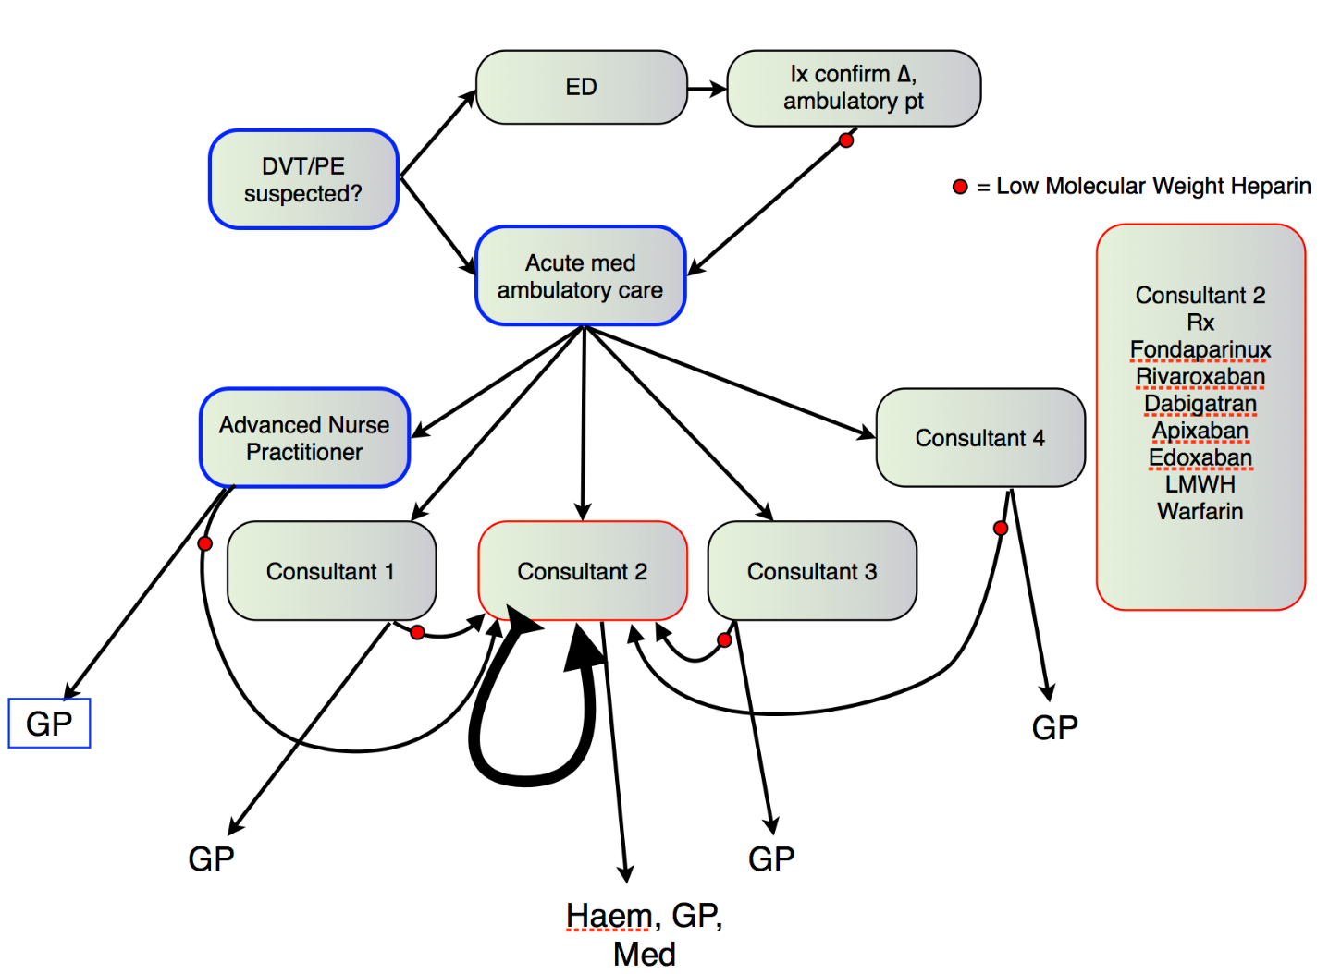
The current process for managing ambulatory VTE patients is not standardised and includes multiple elements of investigation and prescribing that are inconsistent with guidance from NICE (National Institute for Health and Care Excellence, 2013). Currently patients often have two visits to hospital before commencement on oral anticoagulation. Fig 1 is a simplified representation of the current process: a key element is that one of the consultants sees and/or follows-up most of the confirmed VTE patients, and that consultant receives referrals of VTE patients from other practitioners working in the ambulatory emergency care stream. Multiple anticoagulants are used in the care of VTE patients for a variety of reasons, not all of which are clearly understood by other clinicians.
Figure 1

Future state:
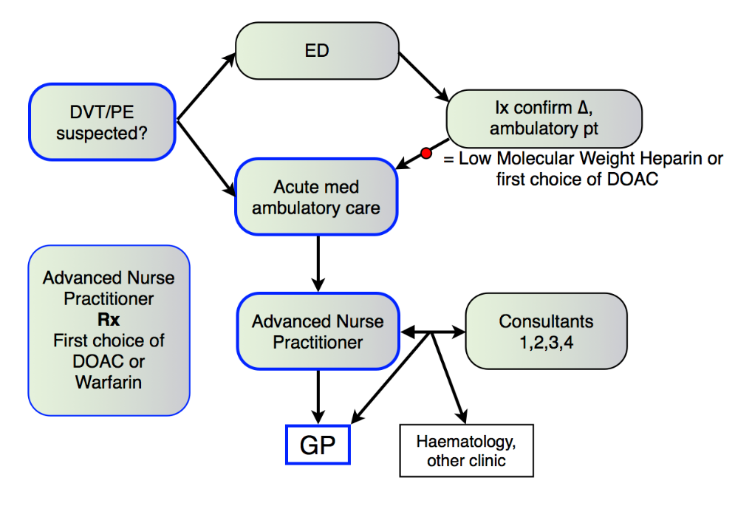
The aim of the project is to deliver a simplified and streamlined process in keeping with NICE guidance (National Institute for Health and Care Excellence, 2013) as shown in Figure 2. A much-simplified pathway in which all ambulatory DVT patients are seen in a largely ANP-delivered service, commenced on anticoagulation at the same visit as that at which the diagnosis is made, or the first subsequent visit if clinical staff availability dictates with a first-line or second-line DOAC, or Warfarin, and discharged to the care of their GP.
Figure 2

Patient impact:
The impact of success of the project will be improved and harmonised patient experience, improved clinical governance as a result of a safe, consistent approach in line with recognised national clinical standards, a reduced number of hospital visits per patient, a resilient service not reliant on the presence of any one individual, and reduced variability of prescribing. These all result in increased alignment with prudent healthcare principles.

Deliverables:
The project deliverables include:
Improved staff engagement
Successful use of a co-production process
An evidence-based pathway
Staff support for, and adoption of, the pathway

Method:
Initial objective is to understand the attachment to current processes which are long standing and familiar: engaging staff in seeking to co-produce a new pathway requires using a breadth of interpersonal and communication skills, personal resilience, and a facilitative leadership style. The anticipated largest challenge is staff engagement. Engaging with staff, acknowledging the culture of the acute medical and ambulatory care unit, using awareness of other staff personalities and preferred communication styles, using appropriate leadership approaches at different times and considering the impact of behaviours will all be employed in pursuing the objective of the project.

Establishing working relationships specific to the project, identifying individuals with an expressed interest in the clinical caseload or with a vested interest in the outcome, will keep the pathway development group small enough to remain focused.

Completing the job planning process, an activity which may require a more directive leadership style, will ensure transparency of availability of time/resource, specifically relating to staff whose current role is dominated by VTE work.

Success criteria
The success of the project will be evidenced by
- the existence of a published DVT pathway;
- the use of the pathway in >90% of appropriate cases;
- the achievement of improved new:follow-up ratios.

Ethics approval
Ethical approval: not required as the project does not require changing any treatment, care or service from accepted standards for the patients involved. Indeed, the project aims to improve compliance with accepted standards.

Leading Service Improvement – Project Report

Background
Venous thromboembolism is a disease in which a blood clot forms in a deep vein (Deep Vein Thrombosis, or DVT) of which fragments, or the bulk of the clot, can break free and travel to the lung as an embolus (Pulmonary Embolus, PE).

VTE is a common condition with an estimated overall incidence of 1 per 1,000 per year (White, 2003). Within this disease group, DVT has an incidence of 1.6 per 1,000 patients per year, whilst PE is less common with an estimated incidence of 3-4 per 100,000 patients per year. This latter figure is likely an underestimate as PE can be rapidly fatal and only approximately 10% of deaths result in post mortem examination (Ministry of Justice, 2017), and post mortem findings suggest PE is one of three “most frequently missed diagnoses” (Perkins et al., 2003).

Current practice includes the diagnosis and treatment of a large proportion of patients presenting with VTE on an ambulatory, or out-patient, basis and the National Institute of Health and Care Excellence includes VTE (National Institute for Health and Care Excellence, 2013), (National Institute for Health and Care Excellence, 2018) in its spheres of guidance.

VTE as a disease group can be divided into ‘provoked’ (by an environmental or acquired risk factor, either transient or permanent) or unprovoked (Kearon et al., 2016). The prognosis and treatment of the VTE are affected by whether an episode is provoked or otherwise, with unprovoked VTE having a greater risk of recurrence than those provoked by a transient risk factor. Part of the management of all cases of VTE includes the consideration of the presence or absence of provoking factors. Simple, provoked, DVT is highly amenable to management on a straightforward pathway with a minimum period of anticoagulation which can be managed in the community. The investigation and treatment of many provoked VTE episodes can also be managed in the community, albeit after more extensive investigation and appropriate out-patient referral to other specialties when needed. The recent government publication, A Healthier Wales (Welsh Government, 2018), reiterates an intention to support care services “delivered closer to home”: increasing ambulatory management is aligned with this intention.

In the Princess of Wales Hospital, Bridgend, the ambulatory management of almost all patients presenting to the hospital who are subsequently diagnosed with VTE is conducted through the Ambulatory Care unit, adjacent to the Acute Medicine Unit and part of the Acute Medicine service.

Prudent Health Care
In January 2015 the Welsh Government Minister for Health and Social Services endorsed the principles of prudent healthcare proposed by the Bevan Commission (Aylward et al., 2013): one of the four principles, stated in their review a year after its introduction, is to “reduce inappropriate variation using evidence based practices consistently and transparently” (Bevan Commission, 2015). The other three principles are: that public and professionals are equal partners through co-production, to care for those with the greatest health needs first and to do only what is needed and do no harm. Delivering prudent healthcare is fundamental to the strategic aims and objectives of Abertawe Bro Morgannwg University Health Board (ABMU), the parent organisation of the Princess of Wales Hospital.

Understanding current practice
At the outset of the project, the process for managing VTE in acute and ambulatory care was stable but complex.
Rivaroxaban, Dabigatran, Apixaban, Edoxaban are DOACs – no injection required, rapid onset of action, easy dosing and no frequent monitoring required, unlike Warfarin, a ‘traditional’ anticoagulant which requires regular, often frequent (not unusually weekly) blood tests.
LMWH = low molecular weight heparin, an injectable medication which produces anticoagulant effects rapidly but is uncomfortable to administer and requires injections to be self-administered or given twice daily
Figure 3

Understanding VTE workload
Confirmation of diagnosis of DVT is achieved using duplex/doppler ultrasound of the leg veins; PE is confirmed, usually, by a CT pulmonary angiogram (CTPA, a specific computerized tomography scan using contrast to visualize the pulmonary vasculature). In Princess of Wales Hospital there were 285 CTPA examinations requested by consultants in either Emergency or Acute Medicine performed in the three months February – April 2018, and 265 ultrasound examinations in the same time period (a small number of patients will have had both though it is hard to identify exactly how many, related to the same care episode). The majority of patients with diagnosed DVT are managed on an ambulatory basis through the Ambulatory Care unit. A smaller, but growing proportion of patients with PE are also managed on an ambulatory basis. In the three months February – April 2018, manual data collection (clinical coding for these diagnoses is not sufficiently specific) suggested 29 patients who attended the Ambulatory Care Unit were confirmed to have DVT, 14 had PE, and 13 were anticoagulated to treat severe thrombophlebitis (inflammation of the superficial veins which, rarely and in a small group of patients, can lead to DVT). In all cases of possible PE or DVT, patients would have received LMWH during the period of diagnostic uncertainty until ultrasound or CTPA were conclusive.

Current practice ‘above the waterline’
Identifying and understanding the practical elements and challenges of the service delivery and structures supporting that delivery was not difficult: these elements are ‘above the waterline’ (Price & Scowcroft, 2011, pp. 53-55).

I was alerted by colleagues in to marked variation in investigation requesting and prescribing patterns in the management of venous thromboembolism in patients referred to the Acute Medical service, which suggested significant potential existed to increase the alignment of the venous thromboembolism service to prudent healthcare principles.

Blood test and further investigation requesting related to the treatment of venous thromboembolism is addressed in NICE guidance (National Institute for Health and Care Excellence, 2018). The variation in test requesting in the current process was highlighted in a request from the laboratory services that the practice be reviewed, and any pattern of excessive testing be addressed.

Choice of pharmacotherapy for VTE is less directive in NICE guidance (National Institute for Health and Care Excellence, 2013) with no strong evidence-based support for one Direct Oral Anticoagulant (DOAC) over any other. The range of medications prescribed was highlighted in communication from pharmacy about inconsistency in observed prescribing practice.

The range of follow-up to new ratios between the different clinicians was very broad, with some patients returning to the hospital many times, and having multiple investigations, potentially not in keeping with the prudent healthcare principle of ‘only do what only you can do’. This came to light as a result of a patient’s complaint about the service prompting me to do a rapid review of current practice which identified a seven-fold variation in follow-up to new ratios across the clinicians in the acute medical service during the preceding two years.

The visible tip of the Acute Medicine ‘iceberg’ presented challenges in several domains – all of which were recognised thought not openly discussed by the wider hospital community to a varying extent. (Undoubtedly the Acute Medicine service is part of a bigger iceberg and related to other units, but deeper consideration of that goes beyond the scope of my project).

Culture ‘below the waterline’
The culture of the Acute and Ambulatory Medicine service has, like all organisations or units, a substantial collection of largely unmentioned factors which have evolved as the service has evolved. A small unit, it was started by one consultant and one nurse practitioner working together in what could now be viewed as a ‘traditional’ doctor-nurse hierarchical manner. Now there are four consultants rather than the one, though not working as a team of peers with similar job roles. The consultant body has encountered more staff turnover than one may have anticipated, with the original consultant remaining constant as colleagues have come and gone. The ‘below the waterline’ factors, particularly interpersonal issues and episodes of conflict, have become progressively better recognised outside the unit, though recognition in and of itself does not facilitate change and arguably the unit has attracted a view of it as being, or having, ‘a problem’.

The Acute and Ambulatory Medical service has strong characteristics of a Dionysus culture (Handy, C. 1991 cited in Price & Scowcroft, 2012, p 63)): although there is a nominally a lead clinician, the consultants work independently, exercising their professional freedom in a flat hierarchy, perceptibly ‘closing ranks’ when perceiving any threat from the outside. The service sits within the Directorate of Unscheduled Care and Hospital Operations alongside with the Emergency Medicine service. Whilst there are similarities, the specialties of Emergency Medicine and Acute Medicine have different training programmes with resultant difference in specialist qualification. The Acute Medicine consultants may perceive the Clinical Director as ‘outside’ their specialty, representing ‘the management’ (regardless of intent).

Although cognisant that the major challenges were below-the-waterline issues, my initial approach to pursuit of the project was to attempt to engage with the visible, tangible, arguably ‘objective’ elements of seeking change.

Project process: stakeholder engagement
I embarked on conversations with multiple stakeholders, individually, to seek to understand their views and appetite for engagement in developing a patient-focused prudent pathway. Whilst endeavouring to pursue an adult-adult communication style (Berne, 1964) (Harris, 1967), I was aware that the depth of emotional engagement in the conversations varied significantly between individuals. I also became aware that some conversations with stakeholders outside the Acute Medicine service drifted (unhelpfully) towards ‘parent-parent’ interactions. Stakeholder analysis confirmed that the major challenge I faced was with developing shared vision with the Acute Medicine team.
- The lead clinician for Acute Medicine was guarded in his response to my request that he work with me, in his lead role, to find a way to improve prudent healthcare delivery in his service. I explained the challenge we faced and sought his advice: he responded that he would not be able to engage with any work on VTE management without involving the consultant colleague whom he felt was expert in this area (the ‘VTE lead consultant’) and he requested that we meet with that consultant too, together.
- The hospital lead nurse for anticoagulation works outside the Acute Medical and Ambulatory Care Units: she had been unable to work with the Acute Medicine consultants successfully and now manages anticoagulation for non-VTE conditions for other specialties, largely cardiology (managing anticoagulation for patients with atrial fibrillation/at risk of stroke). She was enthusiastic to collaborate but cautious about being ‘allowed’ to do so. She provided several VTE pathways from other units, keen to share what she viewed as good practice from elsewhere.
- The Unit Medical Director was strongly supportive of the identified potential for change and planned approach, and suggested that a recognised pathway from elsewhere be adapted for local use and implemented as soon as possible.
- The Advanced Nurse Practitioner in the Ambulatory Care Unit was very enthusiastic about the potential for developing an evidence-based pathway… as long as the Acute Medicine consultants would all support it.
- The pharmacist with responsibility for the area was extremely keen to see rationalisation of prescribing practice with attendant potential for cost and risk reduction.
- The VTE lead consultant expressed the view that a pathway was not applicable to the VTE patients accessing the service: each patient’s uniqueness and need for highly tailored treatment plans could not be accommodated in a pathway which relied on other staff meeting the requirements of managing their condition. Greater resource and support were required for a highly expert service that he stated would be financially beneficial in the long term. It was a challenging conversation in which agreement was not reached on the benefits of the project.

After initial conversations, some weeks passed in which the quiet ‘noise’ surrounding the management of venous thromboembolism was allowed to percolate through the stakeholders with whom I’d spoken directly, the rest of the Acute Medicine service (and beyond). With respect to the VTE lead, I requested that some evidence for his desired service development be made available for consideration. Whilst the majority of the stakeholders I spoke to were openly very keen to work with me on the project, the view (which proved justified) that the key stakeholders (the Acute Medicine lead clinician and the VTE lead consultant) would not support it presented a stumbling block.

An urgent need for a specific change (a diversion from the project plan)
Soon after developing the initial project proposal, scrutiny of the pharmacy spend for the directorate, coupled with a climate of austerity and an urgent need for cost improvement, resulted in an externally identified need for change. The prescription of Fondaparinux injections, whilst not outside NICE guidance (National Institute for Health and Care Excellence, 2013), did not have clear benefit compared to much more cost effective alternatives. (Other benefits of oral vs injectable medication were a secondary benefit to the organization though possibly a primary benefit to the patient in terms of acceptability.) Fondaparinux was prescribed frequently by one of the Acute Medicine consultants who held the view that it was the best first-choice agent but without a supporting evidence-base for that view. Although not my natural style, I adopted a directive approach to achieve appropriately rapid results: I asked the individual to stop prescribing Fondaparinux, preferring more cost-effective alternatives (a DOAC, see Figure 3 above).

I was a little surprised when the request was accepted: the pharmacy spend the subsequent month was significantly reduced as a result (and the change in prescribing persists). This response to a direct request, without engaging in debate, would suggest (far from ideally) that, for this individual, a directive style produced results, albeit without a desired depth of engagement.

Serendipitous work with General Practitioners, GPs)
Whilst DOAC prescription can be commenced easily in secondary care (hospital, out-patients, ambulatory care), continuing care can only be delivered by GPs if appropriately resourced. The infrequent (three or six monthly, or less) blood test monitoring of kidney function that is required for safe DOAC use, coupled with the prescribing cost (DOACs are more expensive than traditionally used Warfarin) had presented an obstacle to successfully managing ongoing DOAC use in the community setting. This had supported frequent out-patient attendances for ambulatory patients established on DOAC treatment. As the work toward pathway co-production progressed, the primary care directorate were establishing agreement from GPs to take over the ongoing DOAC prescribing for patients with diagnosed VTE. Once this agreement was in place, the potential to discharge patients on DOAC treatment to the care of their GPs was confirmed.
Figure 4
The Acute Medicine service was advised of the new service available from GPs and, organically, patients started to be discharged from regular follow-up in ambulatory care at an earlier stage, sometimes after the first attendance at which a DOAC was initiated. These discharges were largely of cases of simple, provoked, VTE who would previously have been referred, internally, to the ‘VTE lead consultant’. This change in flows was not discussed but was aligned to the concept of the project and was welcomed.

The resultant patient flows are described, combined with the cessation of prescription of fondaparinux, in Figure 4. The pathway to discharge from Acute Medicine/Ambulatory Care includes referral to alternative clinics – eg haematology, respiratory medicine – for the small number of complex cases in addition to discharge to GP for straightforward VTE cases.

Challenging direction of travel
Whilst conversations were ongoing, the Acute Medical lead clinician developed a unique pathway for internal referral of all VTE cases deemed ‘complex’ to the VTE lead consultant who is in the role of ‘in house expert’ in managing VTE. Although not clearly supported by evidence, this process achieves a workload for one person that firmly maintains a ‘status quo’ for the team which suits multiple agendas, but not demonstrably that of prudent healthcare, nor that of the organisation. The implemented internal pathway came to light as part of a conversation in which it became clear that there was unspoken but resolute opposition to change that would result in a need for shifts in team dynamics and interpersonal relationships.

Hoped for co-production of a pathway in line with the project plan looked to be in jeopardy. At the same time, job planning afforded the opportunity to explore perceptions of the current state/workload and opportunities for service improvement.

Job planning
Job planning is an annual requirement in which medical staff meet, on an individual basis, with their both their clinical and non-clinical manager to establish a work plan that meets the needs of the organisation and the service and supports the development needs of the individual. It is a formal process subject to NHS Wales standards and Health Board policies (NHS Wales, 2014). Whilst easily described, it is not a straightforward process as lack of agreement leads to an appeal process that promotes an adversarial approach to a situation which requires agreement for it to be implemented. The job planning process seeks to establish agreement of a job plan: when there is divergence between the consultant’s professional opinion of the work that needs to be done and the view of the employer, all collaborative approaches must be explored before deciding that agreement has failed.

As the objective of the project aligns well with organisational priorities, and with ongoing challenges in overcoming individual and team avoidance of progressing the pathway development, the directorate manager and I sought to explore the wider issues of workload and service development as part of the job planning process.

The job planning meetings are individual to each consultant and over the course of the Acute Medicine consultant job planning process, multiple issues surfaced which confirmed that the individuals each had different interests, motivations, and dissatisfactions which reflected a climate in which I could not envisage team collaboration in the development of a pathway being forthcoming.

The job planning meetings have not all been successfully concluded: the process is ongoing with a requirement that more information about workload, activity and outcomes is provided to support decision making and agreement of a job plan for each consultant.

Depth of engagement
Harrison (1970) discusses “depth of organizational intervention” at various levels, which resonates with subsequent iceberg/waterline models related to organizational change. He describes of interventions focused on instrumentality - “the person primarily as a doer of work or a performer of functions related to the goals of the organization” (Harrison, 1970, p 185)– vs focused on interpersonal relationships. He further observes that “increases in personal autonomy dictate change interventions at deeper and more personal levels” (Harrison, 1970, p 192). Consultants in the medical profession exercise considerable personal autonomy: effecting change requires personal emotional commitment to change in people who have perceived or real professional freedom to decline to change. Harrison concludes his paper with suggestion of two criteria for choosing the appropriate depth of intervention: “to intervene at a level no deeper than that required to produce enduring solutions to the problems at hand” and “to intervene at a level no deeper than that at which the energy and resources of the client can be committed to problem solving and to change.” (Harrison, 1970, p 201).

Considering the criteria for choosing the depth of intervention required to deliver the project objectives, the potential for producing ‘an enduring solution’, within intended timescales, whilst the individuals do not appear ‘committed to problem solving and change’ seemed limited.

Individuals
It was evident that individual agendas, on deeper interpersonal levels, conflicted with the intended project plan. The interpersonal relationships within the Acute Medicine unit appeared to be strong influencers of desirability of the proposed solution. The expressed, or covert, wish to work alone, or with some colleagues and not others, was not conducive to the success of a project which required good team working. A successful outcome would not result unless it reflected a desired outcome for the majority (if not all) of the consultants.

There strongest agreement amongst the Acute Medicine team was their will to maintain the status quo in which one consultant continues to work in isolation as a result of both circumstance and, apparently, personal preference. One element of a Dionysian culture strongly in evidence.

Thoughts on behaviours, attitudes and personality styles
With progress on my project stalled, I sought advice from senior management colleagues, clinical and non-clinical, as I sought a win-win (Covey, 1989, pp. 207-234) solution. I also reflected at length on both my interpersonal communication style and preferences, and those that I observed and perceived in other stakeholders.

It became evident that previous, historical, service changes in Acute Medicine had happened without the engagement of the VTE lead consultant whose practice had become increasingly individual, idiosyncratic and focused solely on VTE.

The collection of issues that surfaced, coupled with input and information from senior management, suggested that the VTE lead’s character traits had a major impact on the potential for a positive outcome to a project specifically focused on VTE management. The depth of engagement either needed to remain instrumental and very directive or extend more deeply to the level of interpersonal relationships. At the time of writing, this remains unresolved.

The traits of the other individual stakeholders also influence their involvement in the project too. I spent significant time considering individual roles, motivations and actions in an effort to understand perspectives, and to try to identify potential areas of synergy that may organically develop into an impetus for change. Perhaps my natural facilitative management style contributed to relying on ‘noise’ to generate discussion and alignment of enthusiastic stakeholders? That there has been movement toward earlier discharge of patients to GPs may just be fortuitous, or it may be a result of the ‘noise’ in the system about VTE management.

There are character traits seen in many medical professionals, often regarded with a degree of humour and acceptance, that are considered to be ‘aspie’ (characteristics seen to varying degrees in people who may or may not themselves identify as have Asperger’s traits). Indeed, many of the traits are consistent with success in a highly challenging role: an internet ‘blog’ (Eartharcher, 2016) describes in detail a number of traits and behaviours that are desirable and are characteristic of the autistic spectrum, and suggests that this makes them “exceptionally well-suited for their career field”. She also observes that “there are probably more doctors on the spectrum than anyone realizes”. Whilst this is clearly only one opinion, it highlights that there are many aspects to consider in endeavours to intervene in organisational change at a deeper level. This may or may not be pertinent to my project, but it is something which needs consideration in understanding behaviours of highly skilled and autonomous professionals when one or more of them appear to act in seemingly contrary ways.

Conclusion

Project outcome
The project I planned was superficially simple, with a solid evidence-base, good face validity and the overt, strong support of the organisation. The approach to implementation was in keeping with recognised NHS change management approaches and informed by learning throughout the course of the Medical Leadership Programme. The need for change remains but change is unlikely to be delivered on any more than an instrumental level within a short to medium term timescale. Further conversations are needed, together with additional, possibly external, support and involvement to effect improved adoption of prudent healthcare principles in the VTE workflow in the Princess of Wales Hospital. Not least, acknowledging and managing the impact of diversion of workload away from a doctor for whom it has been the majority of his clinical caseload will be an essential element of any pathway development. A shared view of potential development of his clinical role in an alternative direction would facilitate the development of VTE management more aligned to prudent healthcare principles.

Reflection on learning
Medical leadership training itself risks being something of an ‘iceberg’. There is so much material to assimilate that can be viewed superficially, practically, to illustrate approaches and techniques which are easily described, visible, set out as logical processes which, if followed, will result in intended changes. Initial discomfort with revealing ‘touchy feely’, intangible, interpersonal and intrapersonal facets of oneself within a group of unfamiliar medical professionals is unsurprising, particularly in a group of staff who traditionally engage in somewhat ‘cold’ academic and scientific learning, despite working in an exceptionally human field. Perhaps the distance one learns to employ as self-protection when dealing with illness, injury and death on a regular basis inhibits the ability to let go and be a whole person in dealing with other whole people. The larger part, perhaps, of the iceberg of medical leadership training involves understanding and appreciating the importance of bringing one’s whole person to the role. Self-awareness, comfort with interpersonal relationships, willingness to reflect critically on what one brings to all elements of work as a medical leader, a huge range of personal qualities and interpersonal skills, including resilience and resourcefulness, combine to influence a journey in medical leadership.

I believe my project, although not yet ‘successful’ has provided enormous scope for learning and development. That some small changes in the direction of the intended project outcome have occurred is a positive, if not complete, result.

Bibliography
Aylward, M., Phillips, C., Howson, H. Bevan Commission (2013) ‘Simply Prudent Healthcare–achieving better care and value for money in Wales–discussion paper’.
Berne, E., 1964. Games People Play. New York: Grove Press.
Bevan Commission (2015) ‘Prudent Healthcare one year on’, pp. 1–14.
Covey, S. R., 1989. The 7 habits of highly effective people. Sydney: Simon & Schuster UK Ltd.
Eartharcher, L., 2016. the silent wave. [Online]
Available at: https://thesilentwaveblog.wordpress.com/2016/05/14/why-you-want-an-aspie-for-a-doctor-and-how-to-spot-one/
[Accessed 09/09/2018].
Harris, T. A., 1969. I'm OK - you're OK: a practical guide to transactional analysis. London: Harper & Row
Harrison, R.1970 (1970) ‘Choosing the depth of organizational intervention’, The Journal of Applied Behavioural Science, 6(6), pp. 181–202.
Kearon, C., Ageno, W., Cannegieter, S. C., Cosmi, B., Geersing, G. J., Kyrle, P. A. Subcommittees on Control of Anticoagulation, and Predictive and Diagnostic Variables in Thrombotic Disease (2016) ‘Categorization of patients as having provoked or unprovoked venous thromboembolism: guidance from the SSC of ISTH.’, Journal of thrombosis and haemostasis : JTH, pp. 1480–1483. doi: 10.1111/jth.13336.
Ministry of Justice (2017) ‘Coroners Statistics Annual 2016 England and Wales’, pp. 1–33.
National Institute for Health and Care Excellence (2013) ‘Venous thromboembolism in adults: diagnosis and management’, pp. 1–37. Available at: nice.org.uk/guidance/qs29
National Institute for Health and Care Excellence (2018) ‘Venous thromboembolic diseases: diagnosis, management and thrombophilia testing’, pp. 1–26. Available at: nice.org.uk/guidance/cg144.
NHS Wales (2014) ‘The National Health Service in Wales Effective Job Planning for Consultant Medical and Dental Staff’, pp. 1–37.
Perkins, G. D., McAuley, D. F., Davies, S. and Gao, F. (2003) ‘Discrepancies between clinical and postmortem diagnoses in critically ill patients: an observational study.’, Critical care (London, England), 7(6), pp. R129–32. doi: 10.1186/cc2359.
Price, A. & Scowcroft, A., 2011. Essential Skills for Managing in Healthcare. Oxford, New York: Radcliffe Publishing Ltd.
Price, A. & Scowcroft, A., 2012. Essential Skills for Influencing in Healthcare. London, New York: Radcliffe Publishing Ltd.
Welsh Government (2018) ‘A Healthier Wales:’, pp. 1–38.
White, R. H. (2003) ‘The Epidemiology of Venous Thromboembolism’, Circulation, 107, pp. I4–8. doi: 10.1161/01.CIR.0000078468.11849.66.

