

Module Name: Analysing & Solving Problems
Module Code: ACCA4019
Assignment Title: Component 2: Written assessment: Problem Analysis and Solution Development
Student Name: Prince Derick Yeboah
Student ID: 2523170
Lecturer Name: Abdullah Usman
Submission date: 23/07/2026

Contents
Introduction 3
Section 1: Problem Deconstruction 3
1.1 Requirements and Constraints 4
1.2 MoSCoW Analysis 4
1.3 Key Variables And IPO 5
Section 2: Proposed Solution 7
2.1 Flowchart for Project Time Optimiser (PTO) 8
2.2 Flowchart Explanation 8
Assumptions 9
2.3 Justification 9
3. Reflection and Justification 10
3.1 Reflection 10
3.2 Critical Evaluation 11
Conclusion 11
References 12

Introduction
Problem-solving is an important skill in software development because it helps developers understand a problem before creating a solution. By analysing a problem carefully, it is possible to identify the requirements, break the problem into smaller tasks and design a system that meets the users' needs. Techniques such as problem decomposition, requirements analysis, variables, Input-Process-Output (IPO) tables and flowcharts help developers plan a solution in a logical and organised way [1].
The report focuses on the problem of arranging meetings for student group projects. Students often have different class timetables, work schedules and personal commitments, making it difficult to find a meeting time that is suitable for everyone. To solve this problem, this report proposes Project Time Optimiser (PTO), a simple meeting scheduling system that compares students' availability, checks for timetable conflicts and ensures that meetings are arranged before the weekly project deadline.
The report begins by analysing the problem using decomposition, requirements analysis, constraints, MoSCoW prioritisation and variables. It then presents the proposed solution using an IPO table, a flowchart and an explanation of how the system works. Finally, the report evaluates the solution by discussing its strengths, limitations and possible future improvements.

Section 1: Problem Deconstruction
Problem Description
Student group projects require members to work together and attend regular meetings. However, finding a suitable meeting time can be difficult because students have different class schedules, part-time jobs and personal commitments. These differences often cause timetable conflicts, missed meetings and delays in completing project tasks. As a result, some groups struggle to meet project deadlines and communicate effectively. A solution is needed to make meeting scheduling easier and more organised. This report proposes Project Time Optimiser (PTO), a system that compares students' availability, detects timetable conflicts and helps groups arrange meetings before the weekly project deadline.The solution has been developed using computational thinking techniques taught in this module, including requirements analysis, decomposition, abstraction, algorithm design, variables, flowcharts, and modularisation. These techniques help produce a structured solution that is logical, organised, and easy to understand.

1.1 Requirements and Constraints
The requirements describe the main functions that the Project Time Optimiser must perform, while the constraints identify the limitations that may affect the system [2].
Requirement (What it must do) | Constraint (The limits or rules)
The system must collect each student’s availability. | Students must enter their availability correctly
The system must allow a meeting date to be selected. | The meeting date must be before the project deadline.
The system must allow a meeting time to be selected. | The meeting must be suitable for all group members
The system must check the weekly project deadline | The system cannot change the deadline.
The system must detect timetable conflicts | A meeting cannot be confirmed if a conflict exists.

1.2 MoSCoW Analysis
MoSCoW analysis is used to prioritise the system requirements according to their importance. It helps developers focus on the most important features first while identifying features that can be added later if time and resources are available [3].
Must have | Should Have | Could Have | Won’t Have
Collect student availability. | Allow students to update their availability. | Send meeting reminder notifications. | Video conferencing feature
Select a meeting date. | Allow students to change the meeting date. | Suggest another meeting date. | Automatically choose a meeting without user approval.
Select a meeting time. | Allow students to change the meeting time. | Suggest the next available meeting time. | Change the project deadline automatically.
Check the weekly deadline. | Display a warning if the deadline is close. | Display the number of days before the deadline. | Ignore timetable conflicts.
Detect timetable conflicts. | Display a clear conflict message. | Generate a simple meeting summary. | Collect information other than meeting availability.

The MoSCoW method helps developers decide which features should be developed first. For Project Time Optimiser (PTO), the Must Have requirements are the most important because they solve the main problem of arranging group meetings. The other features can be added later to improve the system if more time is available.

1.3 Key Variables And IPO
Variables are used to keep information that the system needs while it is running. They allow the program to remember data entered by users and use it later when processing or displaying results. Variable names should be meaningful and easy to understand so that anyone reading the solution knows what each variable is used for [4]. PascalCase is used in this project because it is a common way of naming variables.

Variable Name | Purpose
StudentAvailability | Stores the days and times when each student is available for meetings.
MeetingDate | Stores the selected date for the group meeting.
MeetingTime | Stores the selected time for the group meeting.
WeeklyDeadline | Stores the weekly project deadline to ensure the meeting is arranged on time.
ConflictFound | Stores whether a timetable conflict exists (True if there is a conflict, False if there is no conflict).

The variables above help Project Time Optimiser (PTO) organise meetings by storing important information throughout the scheduling process. Choosing meaningful variable names makes the solution easier to understand and supports good programming practice.

Input–Process–Output (IPO) Table
An Input–Process–Output (IPO) table is used to show how a system works. It identifies the information entered into the system (inputs), the actions carried out by the system (processes), and the results produced (outputs). Using an IPO table makes it easier to understand the solution before creating the flowchart [5].
Input | Process | Output
StudentAvailability | Stores the students’ available days and times. | Availability information saved.
StudentAvailability | Compares all students’ availability. | Suitable meeting time identified.
MeetingDate | Checks if the meeting date is before the WeeklyDeadline. | Meeting date accepted or rejected.
MeetingTime | Checks whether the selected meeting time is suitable. | Meeting time confirmed.
ConflictFound | Checks for timetable conflicts between students. | Conflict message displayed if a clash exists.
StudentAvailability, MeetingDate, MeetingTime, WeeklyDeadline | Confirm the meeting when no conflict is found and the deadline is met. | Meeting successfully confirmed.

Section 2: Proposed Solution
Overview of Project Time Optimiser (PTO)
The proposed solution is called Project Time Optimiser (PTO). The system helps student groups arrange meetings by checking their availability and ensuring that meetings are planned before the weekly project deadline.
The solution uses five variables to manage the meeting scheduling process. The StudentAvailability variable stores the days and times when students are available for meetings. The MeetingDate variable stores the selected date for the meeting, while the MeetingTime variable stores the chosen meeting time. The WeeklyDeadline variable stores the project's weekly deadline so that the system can check whether the meeting is scheduled on time. Finally, the ConflictFound variable records whether there is a timetable conflict between group members.
These variables work together to process the meeting information. The system compares students' availability, checks the selected meeting date against the weekly deadline, and identifies any timetable conflicts. If no conflict is found and the meeting date is before the deadline, the meeting is confirmed. Otherwise, the system displays a warning or asks the students to choose another meeting time.
Using these five variables keeps the solution simple, organised, and easy to understand. They also provide the information needed for the IPO table and flowchart, making the design consistent throughout the project.

2.1 Flowchart for Project Time Optimiser (PTO)
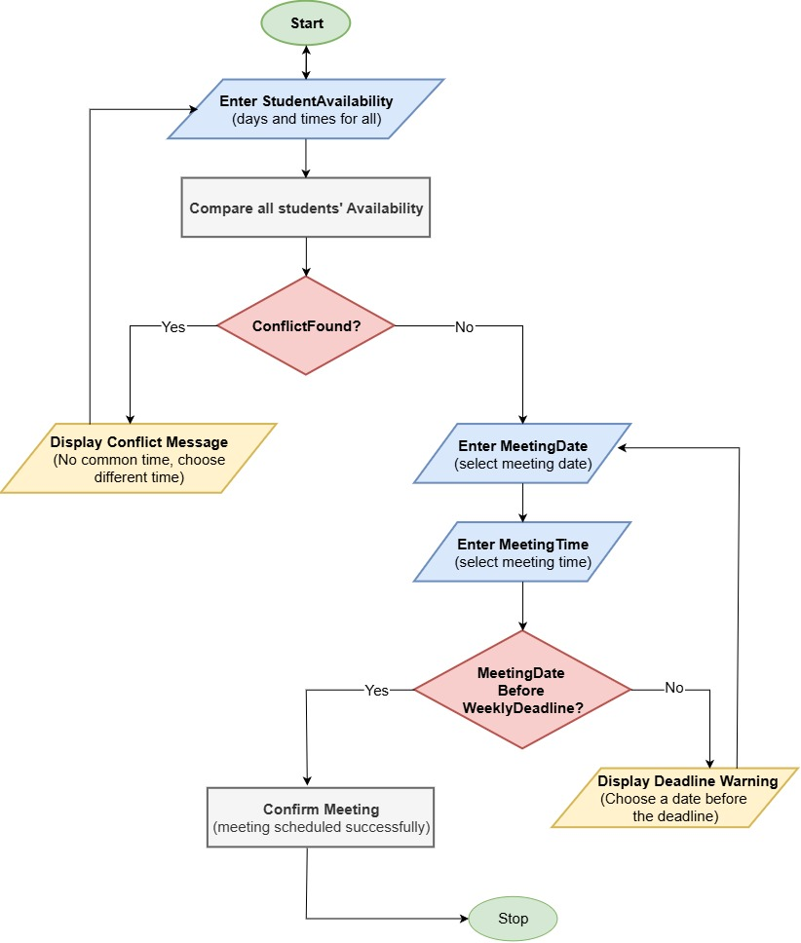

2.2 Flowchart Explanation
The flowchart shows how Project Time Optimiser (PTO) finds a meeting time that works for all group members. The process begins when students enter their availability into the StudentAvailability variable. The system stores this information and compares the available days and times of every student to find a suitable meeting time.
After checking the availability, the system looks at the ConflictFound variable. If a timetable conflict is detected, the system displays a conflict message and asks the students to choose another meeting time. This prevents a meeting from being scheduled when not everyone is available.
If no conflict is found, the students enter the MeetingDate and MeetingTime. The system then compares the MeetingDate with the WeeklyDeadline. If the meeting date is before the deadline, the meeting is confirmed successfully. If the meeting date is after the deadline, the system displays a warning and asks the students to choose another date.
This process helps the system find a meeting time that is suitable for everyone while making sure the meeting is arranged before the weekly project deadline.

Assumptions
The following assumptions were made when designing Project Time Optimiser (PTO):
- Every student has access to the internet.
- Every student enters their availability correctly.
- The weekly project deadline has already been set.
- Students are willing to choose another meeting time if a conflict is found.
- The system is only used for scheduling meetings and does not provide video calls or messaging.

2.3 Justification
Project Time Optimiser (PTO) was chosen because it provides a simple and organised way for student groups to schedule meetings. Many students have different class timetables, work commitments and personal responsibilities, making it difficult to find a meeting time that suits everyone. The proposed solution helps solve this problem by comparing students' availability and identifying a suitable meeting time.
The solution is effective because it uses only five key variables: StudentAvailability, MeetingDate, MeetingTime, WeeklyDeadline, and ConflictFound. These variables store the important information needed to arrange meetings and keep the system simple. Using meaningful variable names also makes the solution easier to understand, develop and maintain.
The IPO table and flowchart show the logical steps the system follows. The IPO table identifies the required inputs, the processes carried out by the system and the outputs produced. The flowchart then shows these steps in a visual format, making it easier to understand how the system works before it is developed.
Another strength of the solution is that it checks for timetable conflicts before confirming a meeting. If a conflict is found, students are asked to choose another meeting time. The system also checks that the meeting date is before the WeeklyDeadline, helping student groups plan their work on time and avoid missing important deadlines.
Overall, Project Time Optimiser (PTO) is a suitable solution because it is simple, logical and easy to use. It addresses the main problem identified in this report. It demonstrates how problem decomposition, requirements analysis, variables, the IPO table and a flowchart can be combined to design an effective software solution.

3. Reflection and Justification

3.1 Reflection
Developing Project Time Optimiser (PTO) helped me understand how a large problem can be divided into smaller and more manageable tasks. Using problem decomposition allowed me to identify the main requirements of the system before designing the solution. This made it easier to organise my ideas and focus on solving one part of the problem at a time.
Creating the requirements analysis, MoSCoW priorities, variables, IPO table and flowchart also helped me understand the software development process. Each stage built on the previous one, making the final solution more organised and easier to follow. The flowchart was especially useful because it showed the logic of the system in a clear visual way before any programming was required.
Overall, this assignment improved my problem-solving skills and showed me the importance of planning before developing a software solution.
Project Time Optimiser (PTO) has several strengths that make it suitable for solving the meeting scheduling problem.
- The solution is simple and easy to understand.
- It helps student groups find a meeting time that works for everyone.
- It checks for timetable conflicts before confirming a meeting.
- It ensures that meetings are arranged before the weekly project deadline.
- The use of meaningful PascalCase variables makes the system easier to read and maintain.
- The IPO table and flowchart clearly explain how the system processes information.
These strengths make the proposed solution practical for student group projects.

3.2 Critical Evaluation
Although Project Time Optimiser (PTO) solves the main problem, it also has some limitations.
The system depends on students entering correct availability information. If incorrect information is entered, the meeting schedule may not be accurate. The solution also assumes that every student has access to the internet and can use the system. In addition, the system does not send reminders or connect with online calendars such as Google Calendar or Microsoft Outlook.
In the future, the system could be improved by adding automatic reminders before meetings. It could also connect with online calendars to reduce manual work when scheduling meetings. Another improvement would be allowing students to receive notifications when a meeting is confirmed or changed. These additional features would make the system more useful while keeping the meeting scheduling process simple.

Conclusion
This report presented Project Time Optimiser (PTO) as a solution to the problem of arranging meetings for student group projects. The problem was analysed using problem decomposition, requirements analysis, constraints, MoSCoW prioritisation, variables, an IPO table and a flowchart. These techniques helped to design a logical and organised solution.
The proposed system uses five main variables to collect students' availability, check for timetable conflicts and ensure meetings are arranged before the weekly project deadline. Although the system has some limitations, it provides a simple and effective way to improve meeting scheduling for student groups. Future improvements, such as calendar integration and automatic reminders, could make the system even more effective.

References
[1] P. J. Denning and M. Tedre, Computational Thinking. Cambridge, MA, USA: MIT Press, 2019.
[2] R. S. Pressman and B. R. Maxim, Software Engineering: A Practitioner's Approach, 9th ed. New York, NY, USA: McGraw-Hill Education, 2019.
[3] S. Malgaonkar, S. A. Licorish, and B. T. R. Savarimuthu, “Understanding requirements prioritisation: Literature survey and critical evaluation,” IET Software, vol. 14, no. 6, pp. 560–575, 2020.
[4] P. J. Denning and M. Tedre, Computational Thinking. Cambridge, MA, USA: MIT Press, 2019.
[5] A. Dennis, B. H. Wixom, and D. Tegarden, Systems Analysis and Design: An Object-Oriented Approach with UML, 5th ed. Hoboken, NJ, USA: John Wiley & Sons, 2015.

