Sean Hazelby

Level 4

Material Science

Alan Nantell

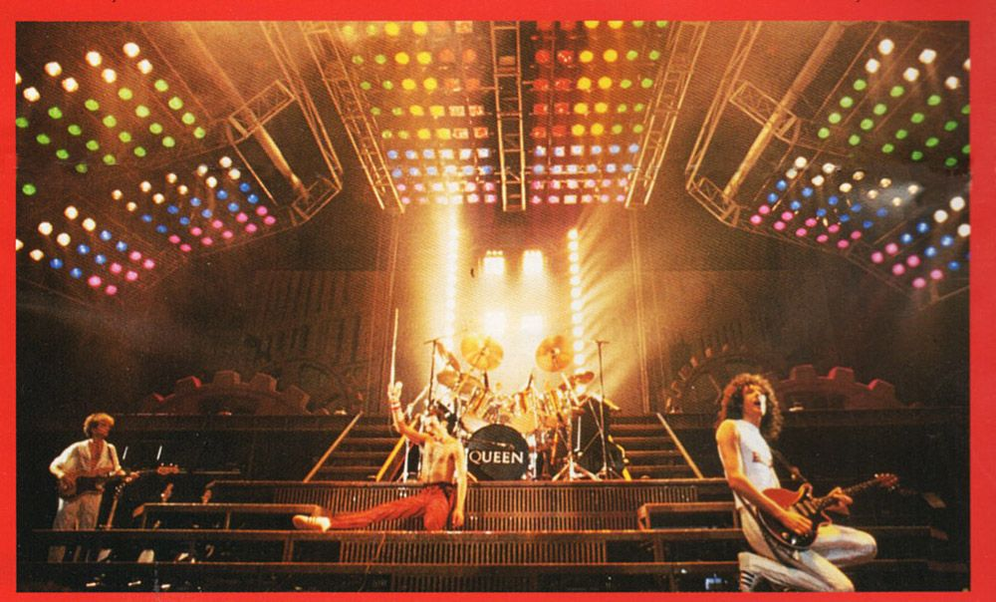

(Rakuten Blog, 2017)

Contents
Task A 3
TASK B 5
Reference list 7

Task A

- The Room Index

L = 60 W = 24 Hm = 8-1 = 7

RI = L x W / Hm x (L + W)

60 x 24 / 7(60 + 24)

= 2.45(2. D. P)

2) The Utilization Factor (from tables), explaining exactly how this value was arrived at.

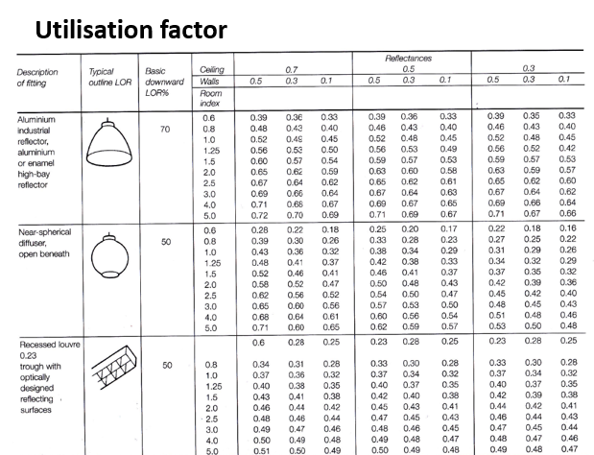
Room index
Ceiling reflectance
Walls reflectce
UF
0.45 (from table)

The coiling reflectance is 0.5 while the walls reflectance is 0.3. This means we are looking at the 3 columns furthers to the right. We then look at the room index of 2.5 while understanding that we are looking at an LQR of 50%. We then match the figures and arrive at a value of 0.45.

3) The Number of lamps required

N = E x A / F x UF x LLF

E = 200 A = 60 x 24 F = 18,000 UF = 0.45 LLF = 0.75

N = 200 x (60 x 24) / 18,000 x 0.45 x 0.75

N = 47.4
N = 48

4) A suitable layout (value of S) for the lamp fittings

We will use value of 1.5 due to the spec being fluorescent lamps.

S max = 1.5 x Hm

Mounting Hight = 7m

S max = 1.5 x 7
S max = 10.5

10.5 meters apart

3 rows of 16
½ of S = 5.25 = distance to walls

Diagram lighting layout

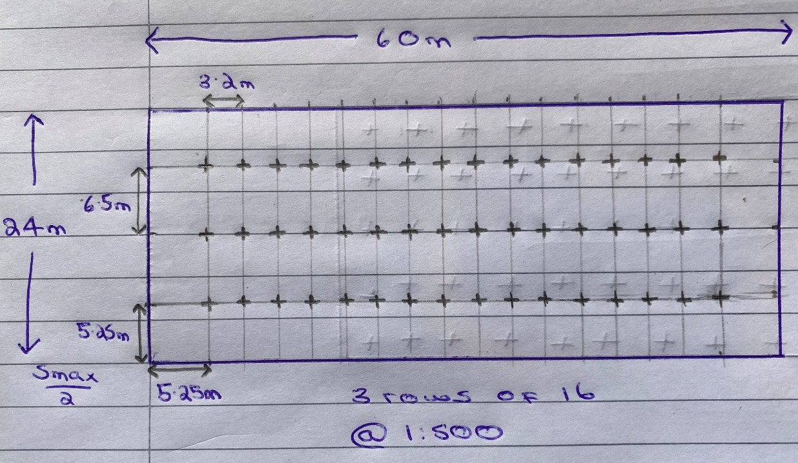

TASK B

- A brick wall of area 20m² contains a window of area 4m².
The values of sound reduction indexes are:
50dB for the brickwork and 10dB for the window.

Calculate the overall sound reduction index for the entire wall.
Include the full arithmetic development of your answer.

For the sound reduction index, we will use:
SRI = 10 x (log10 (1/T))
Composite partition
We will work out the SRI for both brock and the window to later calculate the combo of both.
Brick
50 = 10x (log10 x (1/t1))
5 = log10 x 1/t1
$$1/T^{1}={10}^{5}$$
$$T^{1}={10}^{-5}$$
Transmission coefficient for brick

Window

10 = 10 x log10 x (1/t2)

1 = log10 x (1/t2)
$$\frac{1}{T^{2}}={10}^{1}$$
$$T^{2}={10}^{-1}$$
Transmission coefficient for the window

T = Transmission Coefficient = Transmitted sound energy
Incident sound energy
T0 = average transmission efficient
T0 = (T1 x A1) + (T2 x A2)
A1 + A2
T0 = ${(10}^{-5}$ x 16) + ${(10}^{-1}$ x 4)
16 + 4
T0 = 0.020008 (Average Transmission coefficient)
We now need to put the average transmission confident into:
SRI = 10 x (log10 (1/T))
SRI = 10 x (log10 x (1/0. 0.020008))
SRI = 10 x (log10 x 49.980008)
SRI = 10 x 1.698796321
SRI = 16.99dB (2.d.p) Or, SRI = 17dB
- Discuss the implications of the factors of frequency and wavelength in:

1). Internal sound management

This is method of noise control within a structure to avoid noise from spreading outside of the structure or to tother rooms inside of the main structure. This often involves flats where somebody may be playing music and would hopefully try to manage the sound levels by using things like rubber and sound insulation. This is what is used in a music studio where you don’t want the sound of the drums bleeding into the rest of the studio as it would make other instruments too hard to hear. To manage the sound indoors we want the wavelength and frequency to be shortened and made smaller. Higher frequencies are well absorbed and are poorly transmitted. A lower frequency is not absorbed well but is well transmitted. Therefore, a ship horn can reach miles in wavelength due to the bass nature of the noise.
In a room where an airborne sound is created the sound will hit the walls, vibrate, and then reflect thus causing a reverberation or echo depending on the size of the room. The area of the walls with a smooth surface will dictate the reverb level. A large empty room with solid walls will have a lot of echo e.g a cathedral. To limit this, we will use materials like curtains, carpets, or furniture to stop the reverb. Making sure walls will not reflect noise is important as it can be very annoying when you can hear feedback from your own voice.

2). Partition wall construction technique
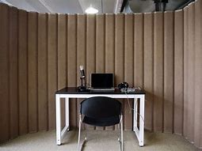
This technique stops the reverberation levels in the building. The larger the surface area of reflection means the more echo or reverb that reflects. By splitting the building into different rooms and sections means that the building will be more habitable due less reverb. This adds more layers to the building thus reducing sound transfer from room to room. By having a partition wall will make the high frequency sounds more manageable due to the loss of its strength as it passes through a wall. However, a low frequency noise is tough to defend against as the wavelength is much longer and tends to be the noises you will hear from your neighbours.
(Acoustical, 2021)

3). The Insulation material choice.

Airborne sounds like voices, music or television are only blocked by mass. Mass = weight, so materials need to be added to the wall makeup to make the wall denser to block airborne sounds. This can be done by using insulation as it offers great heating and protection from noise. Insulation will absorb the noise rather than reflect into the house. When airborne sounds collide with the wall it causes a vibration that produces noise. Insulation will absorb this vibration thus providing a more suitable living environment. Thickness is very important as the thicker this insulation the less vibration and reflection will occur. It is important to note that id the wall is a smooth surface without any method of sound reduction, the reverb will still be high. This is a good defence from impact and airborne sounds. Insulation will absorb higher frequency’s but will struggle with lower frequency’s due to the long wavelength.

(SoundStop, 2021)

Reference list

Citation | URL | Last opened
(Acoustical, 2021) | https://acousticalsolutions.com/product/versipanel-partition-wall/ | 17/04/2021
(Rakuten Blog, 2017) | https://plaza.rakuten.co.jp/ojinami/diary/201705150001/ | 18/04/2021
(SoundStop, 2021) | https://www.soundstop.co.uk/science-of-soundproofing | 18/04/2021

