MSc Digital Transformation for the Health and Care Professionals
BMDS7007 CW1
Coursework one
Executive Summary
Aneurin Bevan University Health Board (ABUHB) launched its 'Transformation through Digital' strategy in 2019 to guide digital innovation and transformation within ABUHB(Aneurin Bevan University Health Board, 2019). The strategy was developed around a series of core themes intended to shape ABUHB's organisational approach to digital innovation.
Since its creation, substantial economic and technological changes have occurred, driving digital transformation much faster than expected(UK Government, 2025). For example, the impact of COVID-19 accelerated digital developments and prompted realignment of national strategies. As a result, the digital strategy that created ABUHB has become outdated and misaligned with the current digital healthcare environment.
An assessment of ABUHB’s digital maturity highlights that the organisation remains at an early stage of transformation . Progress has been made in developing its digital roadmap and introducing new digital solutions, such as EPMA (Electronic Prescribing Service) and advancements in digital records. However, ABUHB’s digital infrastructure and maturity continue to lag many other sectors and organisations(Johnston, 2017).
Fundamental areas of digital transformation, such as infrastructure, interoperability, and workforce, have created gaps in ABUHB’s ability to fully align with national digital platforms. Further investment in digital technologies is needed to minimise this gap(Aneurin Bevan University Health Board, 2019).
Healthcare is a complex and constantly evolving system, so digital transformation cannot follow a straightforward or predictable path. Different services and technologies are at various levels of digital maturity, creating varied and sometimes conflicting starting points for change, which reflects the characteristics of complex adaptive systems described by Plsek and Greenhalgh, (2001).
Despite this early positioning, ABUHB is actively seeking to adopt and accelerate new technological advancements, demonstrating a clear strategic intent to progress further along the digital maturity trajectory. Given the organisation's complexity and scale, ABUHB may need to utilise its own adapted digital maturity model, as standard models do not fully account for the complex nature of a Health Board environment.
The main drivers of transformation in ABUHB are influenced by both internal and external factors, with the digital strategy created to align ABUHB with the government’s main goals in the following areas:
• Improving population health and wellbeing
• Enhancing the quality, accessibility, and experience of health and social care
• Delivering higher value health and social care
• Supporting and motivating a sustainable workforce
Within Wales, the Welsh Government and national authorities have produced multiple strategic reports, frameworks, and policy documents outlining priorities for digital transformation across the healthcare system, where the ambition of digital health is clearly documented (Welsh Government, 2018, 2023).These national documents place increasing demands and expectations on ABUHB to deliver digital highlights within its transformation plan.
ABUHB is currently undertaking a comprehensive review of its digital strategy as part of the development of a long-term ten-year digital plan(Aneurin Bevan University Health Board, 2025). This work is ongoing, and the final strategy has not yet been published. Nevertheless, the review process reflects organisational recognition that the digital landscape and national expectations have advanced since the 2019 strategy was launched. Digital transformation presents opportunities for the health board to improve patient access to digital care and to clarify integration pathways across health and social care at ABUHB. Digital systems and data-driven solutions are more prevalent than ever, and the healthcare landscape is becoming increasingly digital. Proper implementation and foresight could enable digital transformation in ABUHB to further ease pressures on clinical services and improve efficiency.
However, several weaknesses within ABUHB’s current digital transformation efforts can be identified, each presenting significant challenges. A primary barrier is persistent underinvestment in digital technologies. Although new digital systems continue to be introduced, the foundational infrastructure required to support these systems and ensure optimal performance is not being modernised proportionately. Securing sufficient and sustained funding remains an ongoing organisational challenge. Outdated networks and infrastructure hinder efficiency and limit the organisation's ability to align fully with national recommendations and standards.
Strategic analysis of ABUHB highlights strengths, weaknesses, opportunities, and threats to digital transformation within the healthcare environment. These findings show that, although progress is being made and ABUHB is moving toward a more comprehensive digital roadmap, infrastructure and cultural barriers remain. The current digital strategy operates within an outdated environment. Furthermore, as a public sector body, ABUHB operates within complex governance structures that are often slower to enact change than private sector organisations. Lengthy approval processes and lengthy implementation timelines often mean digital solutions become outdated before full deployment. Technological advancements occur rapidly, creating ongoing pressure to adapt and innovate in an environment where stagnation is not an option. The impacts of these weaknesses include delays to programmes, risks to patients, and inefficiencies that could be addressed through effective digital transformation.
This essay will examine digital transformation in relation to key business drivers shaping ABUHB’s strategic direction. It will expand on both internal and external factors, ABUHB partnerships, and the challenges and opportunities influencing digital transformation. ABUHB is progressing in digital healthcare; however, it must strengthen governance and modernise its digital foundations and infrastructure to achieve sustainable digital transformation across the health board.
Business Drivers
One of the most fundamental questions posed by ABUHB in relation to its digital transformation agenda is: Why Digital, Why Now? (Aneurin Bevan University Health Board, 2019). Addressing this question requires alignment with ABUHB's long-term plan and its objectives, Better Health, Better Care, and Better Lives ((Aneurin Bevan University Health Board, 2019). That direction is further reinforced by national policies(Welsh Government, 2018, 2023).
Understanding the distinctions between ABUHB's internal and external organisational environments is essential for analysing how ABUHB sets priorities, makes decisions, and achieves its strategic goals. The internal environment can be defined as the elements of an organisation that can be affected or affect the choices made by the organisation (Business Jargons, no date). encompasses factors within the organisation’s control, such as its workforce, culture, organisational structure, resources, and internal processes, including available financial budgets. All these factors shape ABUHB's decision-making ability regarding digital transformation. In my own area, the focus on improving Stores and Asset Management systems reflects an internal objective to enhance operational efficiency, reduce expenditure, and support better resource utilisation across clinical services.
The illustration Figure 1 below highlights the Internal environment of the organisation (Business Jargons, no date)
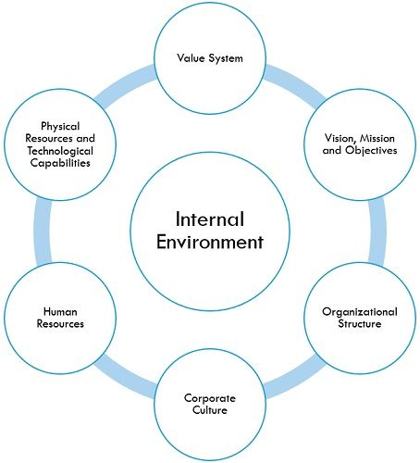
Figure 1 - Internal environment of organisation (Business Jargons, no date)
In contrast, the external environment includes factors outside the organisation that influence its operations, such as national health policies(Welsh NHS Confederation, 2020; Welsh Government, 2023), demographic changes, technological developments, and economic pressures. Additionally, wider economic conditions, technological advancements, and public expectations for digital access to healthcare further shape ABUHB’s objectives and service delivery models.
ABUHB’s strategic and operational objectives are therefore informed by both internal and external environmental considerations. ABUHB’s ability to achieve its long-term goals depends on how effectively it responds to both internal capabilities and external pressures. Understanding both the internal and external environments helps organisations plan effectively, avoid risks, and make the most of new opportunities(Mohamed, 2025). Although ABUHB is committed to Digital Transformation and to advancing the digital roadmap for healthcare, the process is far from straightforward. While the overarching ambition may appear to be simple, implementing and sustaining the digital transformation strategy within ABUHB healthcare environment is complex, with numerous factors contributing to the resistance and risk of the programme/Strategy.
In addition to Infrastructure and legacy system constraints. ABUHB faces significant alignment challenges in coordinating its digital transformation priorities with national and regional strategies. ABUHB must balance its organisational requirements and project timelines with broader Welsh Government and NHS Wales digital policies asidentified in new draft Digital transformation policy being created at ABUHB (Aneurin Bevan University Health Board, 2025). This can introduce complexity and slow implementation at ABUHB, when strategic direction or funding does not fully align. Ensuring coherence between local innovation and national standards is essential but difficult to achieve with differing priorities.
ABUHB’s digital transformation is intentionally aligned with national Welsh bodies, including the Welsh Government and Digital Health and Care Wales (DHCW). These external influences are shaped by key national policies and legislation, such as the Well-being of Future Generations (Wales) Act 2015, which sets a legally binding framework for long-term, sustainable public service delivery(Gov.Uk, 2015; Welsh Government, 2025).
Figure 2 below illustrates how national drivers and ABUHB Digital Transformation strategy align.
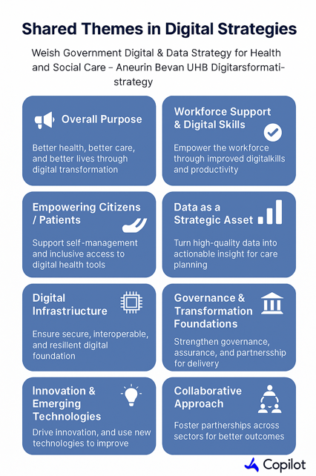
Figure 2 Shared Themes in Digital Transformation.
Work force capacity presents a significant barrier to digital transformation at ABUHB. Effective digital transformation requires specialist technical expertise, advanced data literacy, and the ability to adapt rapidly to evolving technologies. Within ABUHB, there is a limited availability of digital specialists, which places a strain on the staffing of programmes. As digital transformation grows in ABUHB, the demand for specialist skills often exceeds the available capability, resulting in resource limitations, and knock-on effects to delays to projects, implementation, and the delay in successful adoption of digital programmes. Workforce pressures also risk creating dependencies on a small number of specialist staff, which can undermine resilience long-term.
At the same time, digital systems and data-driven solutions are more prevalent across ABUHB, reflecting the shift towards a more digitally enabled healthcare. When implemented correctly and with correct foresight, digital transformation within ABUHB could be used to further ease pressure on clinical services and improve efficiency and enhance outcomes at ABUHB. The barriers to digital Transformation at ABUHB highlight the need for well-resourced and strategic approach. The new draft digital transformation plan currently under review at ABUHB seeks to address these issues by confronting issues directly and delivering improvements for the future of digital health care(Aneurin Bevan University Health Board, 2025)
Technology and Digital Transformation
When examining the principles underpinning ABUHB digital transformation, the most compelling statement, guiding ABUHB approach, is simple but powerful. ABUHB simply states that “Digital should work like electricity, it should always be on (Aneurin Bevan University Health Board, 2025) This emphasises ABUHB's ambition to be a digital-first organisation.
Despite ABUHB progress in developing a new digital strategy and roadmap, and its advances in implementing new digital solutions, such as EPMA and advances in digital records. ABUHB overall maturity remains comparatively low when benchmarked against other sectors and organisations. This is highlighted in Science,(2025)where it discusses that the UK remains under digitised.
When digital transformation is understood as a staged developmental process, such as the model presented by Right Star in Figure 3 (Right Star, no date). ABUHB and other organisations can be positioned along a continuum from early adoption to full optimisation. Within this framework, ABUHB can be placed at Stage 1, with emerging characteristics of Stage 2. This reflects a context in which digital transformation is still at an early stage, with foundational capabilities being established. Despite this early positioning, ABUHB is actively seeking to adopt and accelerate new technological advancements, demonstrating a clear strategic intent to progress further along the digital maturity trajectory. ABUHB may need to utilise its own adapted digital maturity model due to the complexity of the environment.
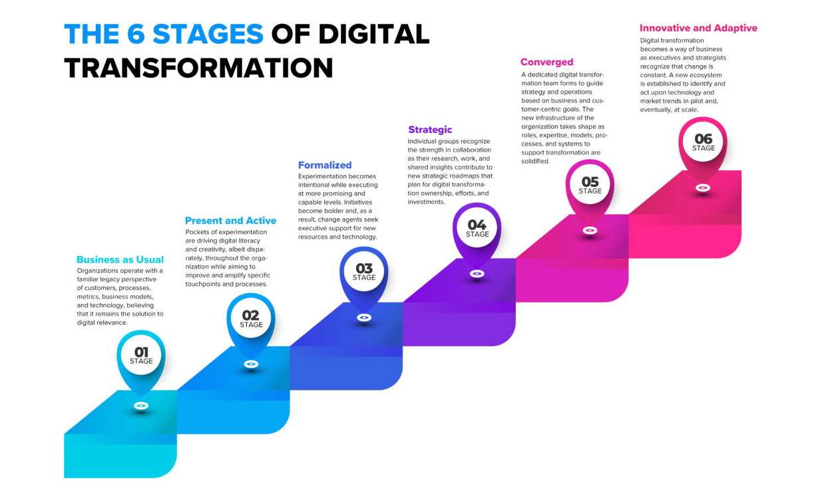
Figure 3 – 6 Stages of Digital Transformation (Right Star, no date)
When reviewing ABUHBs digital transformation policy with respect to sustainability and infrastructure, it is evident that the current plan addresses infrastructure both directly and indirectly(Aneurin Bevan University Health Board, 2019). The strategy sets out the level of digital maturity expected from the organisation and the principles of digital maturity expected to be achieved. including alignment with national standards and a whole-system approach. The illustration in Figure 4, taken from the digital transformation document, highlights ABUHB's commitment to advancing through digital innovation.

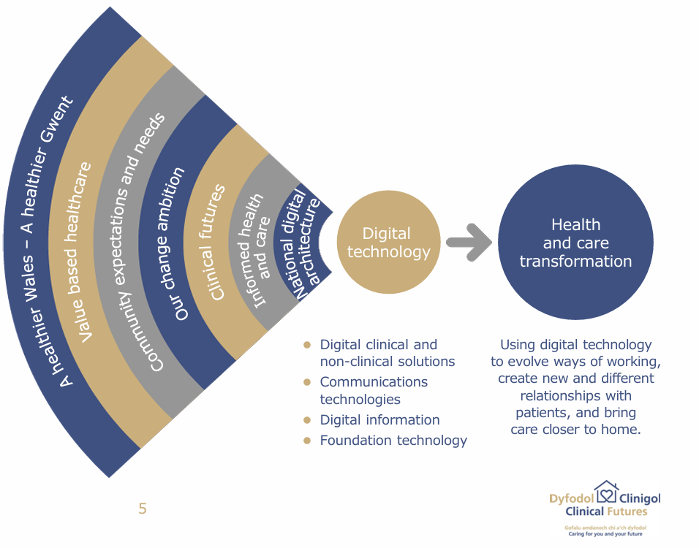
Figure 4 - ABUHB's commitment to advancing through digital innovation(Aneurin Bevan University Health Board, 2019)
ABUHB’s digital transformation initiative is designed to align with and embody the Welsh Government’s principles outlined in national policies (Welsh Government, 2018, 2023). The focus of digital transformation at ABUHB is to be a digital-first organisation and to empower patients to manage their health independently through innovative digital solutions and applications. This transition to digital care promotes greater flexibility and encourages self-management within the community, while simultaneously reducing waste and optimising staff resources.
For ABUHB to address the challenges in managing and integrating aspects of its digital transformation strategy, ABUHB utilise ITIL framework in some departments leveraging ITIL best set of practices. The ITIL framework provides ABUHB with a dependable and structured approach to designing, delivering, and implementing digital services. Figure 5 Illustrates the ITIL framework which underpins ABUHB approach.

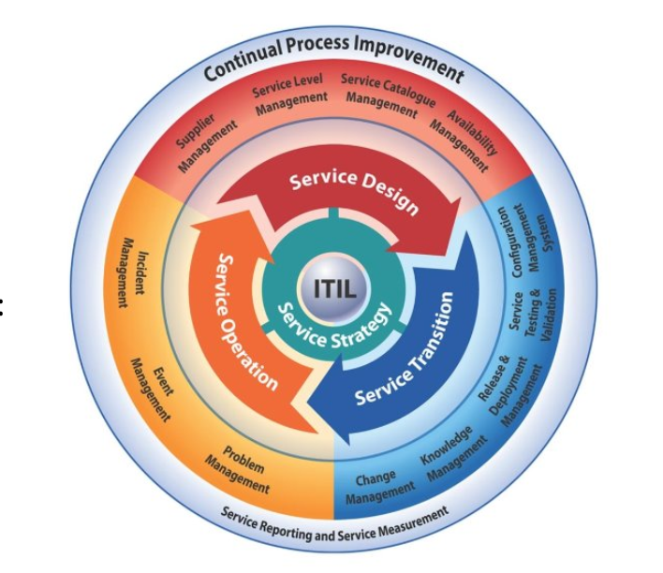
Figure 5 – ITIL Framework Diagram(University of Wales Trinity Saint David., 2026)
Strategic Analysis
To support, structure and review of the digital transformation within ABUHB, this essay applies established strategic frameworks: SWOT and PESTLE. The PESTLE model examines Political, Economic, Social, Technological, Legal, and Environmental factors, while the SWOT framework considers strengths, weaknesses, opportunities, and threats. When applied together, SWOT and PESTLE provide ABUHB with a comprehensive understanding of its digital transformation strategies and policies, and the factors influencing it.
A definition of SWOT analysis is described as a framework, which, when applied correctly, can help an organisation understand factors that may create opportunities and risks by looking four areas: Strengths, Weaknesses, Opportunities, and Threats.(Peterdy, 2022)
PESTLE analysis is defined by (What is PESTLE Analysis? (2024) As external factors affecting the organisation, these may be factors that the organisation has little or no control over: Political, Economic, Social, Technological, Legal, and Environmental factors.
.Although these models deliver detailed insights, both Strategic and theoretical perspectives suggest that organisational value and success extend beyond strategic formulation and require effective implementation (Hall, Pilbeam and Corbridge, 2013). This is particularly significant for ABUHB, as the successful execution of its digital transformation plan depends not only on the identification of strategic factors but also on the organisation's ability to implement these strategies effectively. Figure 4 outlines the key strengths, opportunities, and threats currently influencing ABUHB's digital transformation in the form of SWOT analysis.
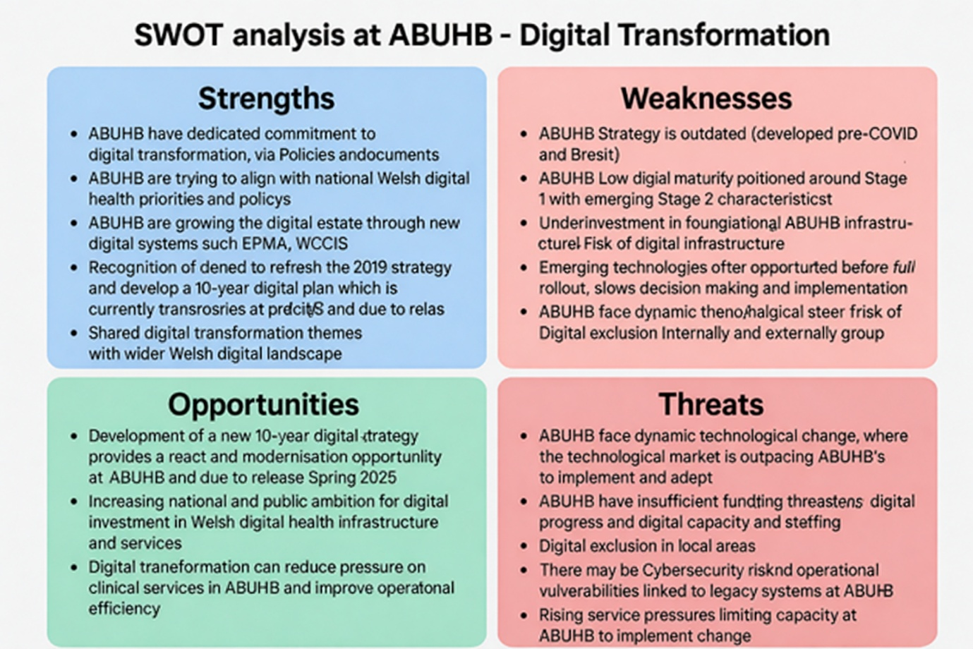

Figure 6 – SWOT Analysis created for ABUHB
Although SWOT analysis can be a good strategic management tool if used correctly, its simplicity can also lead to flawed and unfounded strategic decisions (Pickton and Wright, 1998). To reduce the limitations of SWOT analysis, it could be used alongside a more detailed framework such as PESTLE. Due to its simplicity, SWOT is more comprehensive and robust when used alongside another strategic framework (Pickton and Wright, 1998)
PESTLE
Pestle is a tool used by organisations to understand and validate external influences and factors that can affect the organisation. It draws on six areas: Political, Economic, Social, Technological, Legal, and Environmental (Johnson et al., 2017)
The following table highlights how PESTLE can be applied to an organisation like ABUHB, and how digital strategy can be mapped utilising this model in Table 1
Table 1 – PESTLE analysis of Digital Transformation Strategy ABUHB
Dimension of PESTLE | PESTLE dimension affects ABUHB
Political | ABUHB need to align with national legislation, Welsh Government frameworks such as A Healthier Wales and national digital transformation strategies, ensuring full compliance with national direction.  Digital Transformation highlights the need to make the best decisions for ABUHB while ensuring alignment with the national digital architecture and the Once for Wales approach. ABUHB must ensure that decisions support local priorities while aligning with the national expectations.
Economic | ABUHB need to ensure that the correct level of Investment is applied to modernise infrastructure at ABUHB. Whilst maintaining a good standard of care.  ABUHB need to ensure that the Digital transformation helps reduce operational costs and that the benefit of the transformation is realised. This can then allow ABUHB to reinvest in frontline service.  The Digital Transformation policy looks at the modernisation of ageing infrastructure and the adoption of cloud technologies at ABUHB .  ABUHB Digital Transformation Policy highlights the importance of control on digital transformation as the increasing demand on digital impacts several factors, Including Funding, Digital Exclusion.
Social | Patients and the community utilising ABUHB increasingly expect digital access to Health.  ABUHB's digital strategy focuses on enabling individuals to manage their own health and wellbeing through digital tools.  Staff culture change at ABUHB is needed to support digital-first approaches. Digital Inclusion is essential for ABUHB staff and communities to promote digital first.
Technological | ABUHB are continuing to improve digital services and apply continuity across hospitals and the community.  Network and infrastructure modernisation are being updated at ABUHB, but it is slow and costly.  ABUHB have an increasing reliance on cloud computing, mobile devices, and integrated digital systems. All of which at ABUHB require a strong foundational technology platform.  The digital transformation strategy at ABUHB looks to ensure systems are interoperable, scalable, and aligned with national digital standards.
Legal | ABUHB need to ensure compliance with data protection, clinical safety, and information governance standards across digital systems.  ABUHB need to ensure they align fully with the governance created by the Welsh Government.
Environmental | ABUHB are aiming for Increased digital access across the community and care.  ABUHB are aiming for modern infrastructure, such as cloud services.  Reduced reliance on paper records, which protects the environment (Green footprint).

Figure 7 below illustrates how combining SWOT and PESTLE frameworks can offer ABUHB a more comprehensive platform for strategic decision-making. By combining an assessment of internal and external environmental factors, it supports more informed, evidence-based, and resilient decision-making across the organisation.

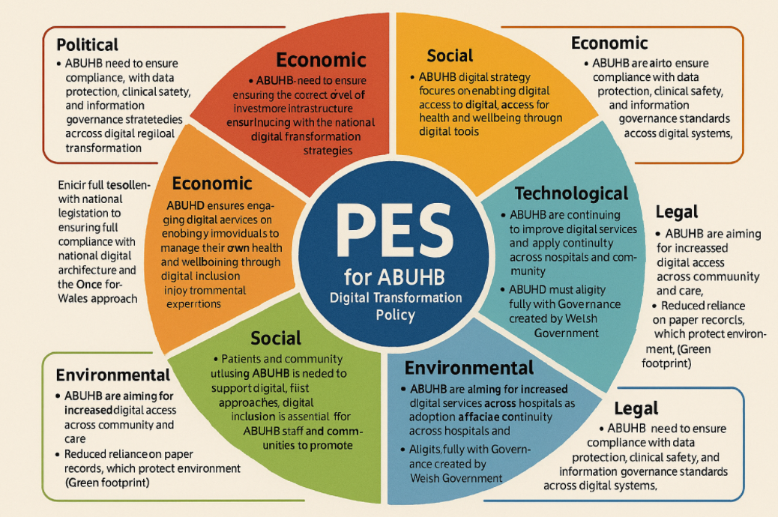
Figure 7 - Combined SWOT and PESTLE ABUHB
Root Cause Analysis
In response to the theoretical perspective outlined by Hall, Pilbeam and Corbridge, (2013), which contends that organisational value and success are not guaranteed by strategy formulation alone. It becomes evident that a more comprehensive approach is necessary for successful delivery. While strategic frameworks such as SWOT and PESTLE are valuable in identifying key factors, their limitations lie in the fact that they do not delve deeply into the underlying reasons behind operational challenges.
The adoption of root cause analysis, a highly effective risk identification technique, offers a crucial advantage in this context and can enable ABUHB to more effectively identify and remove adoption barriers within its digital transformation programme. Unlike SWOT and PESTLE, which primarily focus on surface-level factors and strategic variables, root cause analysis seeks to uncover the fundamental causes of operational issues. By identifying these root causes rather than merely addressing the symptoms, organisations can gain meaningful insights into persistent barriers faced during the implementation of digital transformation strategies. This approach could significantly enhance the digital transformation strategy by facilitating more robust adoption and implementation across the organisation. In turn, this would promote sustainable, long-term organisational improvement.
Digital Transformation Strategy review ABUHB
A review of the existing digital strategy in ABUHB highlighted several concerns regarding its structure, clarity, and practical applicability across the organisation. Although the strategy outlines overarching aims and defines key digital priorities, it does not sufficiently explain how these objectives will be achieved. This limits its usefulness for stakeholders who require more operational detail to understand implementation pathways.
Digital transformation in ABUHB, although complex, has similarities to many other organisations, Digital transformation is continuous and interconnected within areas at AUHB and the wider infrastructure. ABUHB could utilise a similar Tool to the one illustrated in figure 8 to help ABUHB define core capabilities and conditions that will ensure digital transformation success at ABUHB
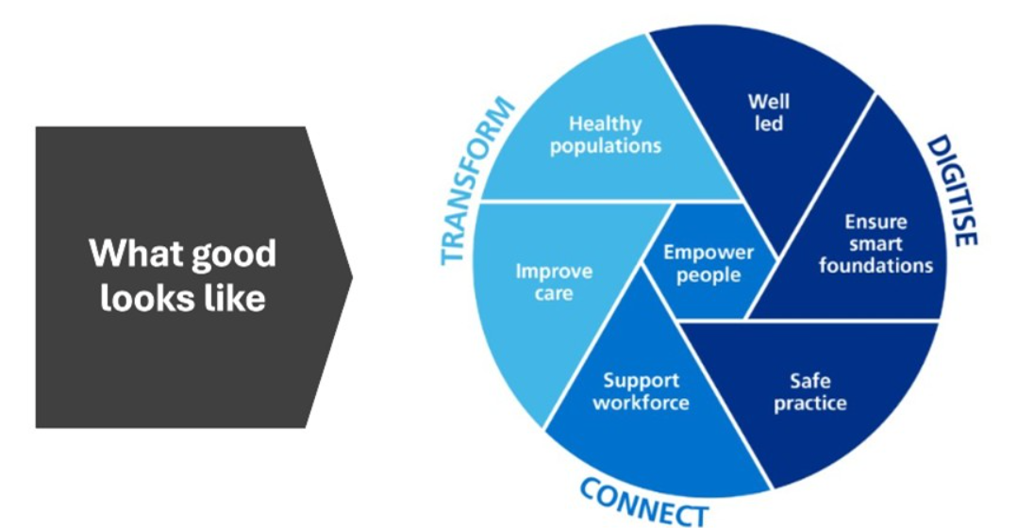
Figure 8 - What Good Looks Like in Digital Transformation(University of Wales Trinity Saint David., 2026)
ABUHB Reviewing the current digital strategy highlights that there are concerns regarding its clarity and operational relevance. Although the existing strategy at ABUHB outlines high-level aims and digital priorities, it does not sufficiently explain how ABUHB will meet the objectives in practice. It details what it wants to achieve, just not how ABUHB will achieve it. This limits it use for staff and stakeholders as there are no clear pathways.

Since the current digital transformation strategy has been primarily written from a digital perspective, the language and narrative style are often highly technical. As a result, the strategy is less accessible to non-digital audiences, including clinicians, nurses, administrative teams, and other operational staff. While the intentions of the strategy may appear clear to digital professionals, this clarity does not always translate for those outside the digital domain.
.
Stakeholders at ABUHB raised broader organisational concerns around the Digital Transformation policy, as it lacks meaningful input from operational and clinical colleagues. This can result in a disconnect between what is written and what is operationally feasible. Furthermore, digital strategies typically span five to ten years yet take considerable time to develop. Consequently, they often become outdated within the first few years because of rapid technological and service changes. This reflects a need for more dynamic future-planning and agile iteration within the strategic process.
The current digital transformation policy provides useful updates on risk identification, demonstrating that ABUHB recognises both the challenges and opportunities associated with digital change. However, the documentation does not consistently articulate the outcomes, impact, or benefits associated with these risks. To strengthen assurance and accountability, in the new transformation policy, ABUHB must clearly demonstrate that digital initiatives are not simply infrastructure upgrades presented as transformation but are supported by measurable indicators showing progression from intention to demonstrable improvement. One of which is Digital inclusion is acknowledged as a priority within the strategy, but it lacks a detailed definition and clear explanation of how inclusion will be operationalised. The strategy often states that objectives will be achieved or included on the roadmap, but does not sufficiently describe the mechanisms, processes, or resources required to deliver these commitments. This represents an area for improvement in the forthcoming ABUHB digital strategy.

ABUHB maintains strong assurance structures, including certification processes and change boards that monitor, record, and report on digital changes and their outcomes. These mechanisms provide a solid foundation on which future; more collaborative and accessible digital strategies can be built. However, a perceived barrier has existed between clinical staff and the digital teams responsible for shaping digital solutions. Although the Digital Directorate at ABUHB functions effectively internally across its specialist areas, stakeholders have reported that accessing digital expertise from outside the directorate can be challenging. To address this, ABUHB has introduced a new front-of-house model through the New Digital Service Request (NDSR) process. This mechanism is designed to improve engagement, ensure early assessment of innovative ideas, and strengthen cross-departmental collaboration. While not fully reflected in the existing digital transformation policy, these enhancements are incorporated within the draft Gwent 35 framework.

Aneurin Bevan University Health Board (2019) Digital Strategy Transformation through digital. Available at: http://howis.wales.nhs.uk/sitesplus/documents/866/ABUHB%20Digital%20Strategy.pdf (Accessed: March 4, 2026).
Aneurin Bevan University Health Board (2025) Gwent35:OurAims.
Business Jargons (no date) “Internal Environment.” Available at: https://businessjargons.com/internal-environment.html (Accessed: March 21, 2026).
Gov.Uk (2015) Well-being of Future Generations (Wales) Act 2015, Gov.Uk. United Kingdom: Gov.UK. Available at: https://www.legislation.gov.uk/anaw/2015/2/contents (Accessed: March 5, 2026).
Hall, David., Pilbeam, Stephen. and Corbridge, Marjorie. (2013) Contemporary themes in strategic people management : a case-based approach. Palgrave Macmillan.
Johnson, Gerry. et al. (2017) Exploring strategy : text and cases . Pearson Education Limited.
Johnston, D.S. (2017) “Digital maturity: are we ready to use technology in the NHS?,” Future Healthcare Journal, 4(3), pp. 189–192. Available at: https://doi.org/10.7861/futurehosp.4-3-189.
Mohamed, N. (2025) Business Environment Analysis: Internal & External Factors That Impact Growth, educatly.
Peterdy, K. (2022) SWOT Analysis, Corporate Finance Institute. Available at: https://corporatefinanceinstitute.com/resources/management/swot-analysis/ (Accessed: March 21, 2026).
Pickton, D.W. and Wright, S. (1998) “What’s swot in strategic analysis?,” Strategic Change, 7(2), pp. 101–109. Available at: https://doi.org/10.1002/(SICI)1099-1697(199803/04)7:2<101::AID-JSC332>3.0.CO;2-6.
Plsek, P.E. and Greenhalgh, T. (2001) “The challenge of complexity in health care,” BMJ, 323(7313), pp. 625–628. Available at: https://doi.org/10.1136/bmj.323.7313.625.
Right Star (no date) Digital Transformation with RightStar, Right Star. Available at: https://www.rightstar.com/services/digital-transformation/ (Accessed: March 4, 2026).
Science, D. for. (2025) State of Digital Government Review. A Review of Technology and Data in the Public Sector : Successes, Challenges and Root Causes.
UK Government (2025) “The wider economic impacts of emerging technologies in the UK,” Gov.UK [Preprint]. Available at: https://www.gov.uk/government/publications/the-wider-economic-impacts-of-emerging-technologies-in-the-uk/the-wider-economic-impacts-of-emerging-technologies-in-the-uk-html (Accessed: March 21, 2026).
University of Wales Trinity Saint David. (2026) “Digital Transformation Overview,” University of Wales Trinity Saint David. [Preprint].
Welsh Government (2018) “A healthier Wales: long term plan for health and social care,” Welsh Government [Preprint].
Welsh Government (2023) Digital and data strategy for health and social care in Wales.
Welsh Government (2025) A healthier Wales: long term plan for health and social care. Available at: https://www.gov.wales/healthier-wales-long-term-plan-health-and-social-care (Accessed: March 5, 2026).
Welsh NHS Confederation (2020) Transforming NHS Wales services through digital developments.
What is PESTLE Analysis? (2024) PESTLE Analysis. Available at: https://pestleanalysis.com/what-is-pestle-analysis/ (Accessed: March 21, 2026).

.

