

Programme name: Master of Business Administration
Module name: Marketing Management
Module code: LCMB7024
Submission title: Marketing Environment Analysis
Lecturer’s name: Tushara Balendran
Student name: Dhruv Tusharbhai Prajapati
Student ID: 2532295
Word count: 2473
Submission date: 24th July, 2026

Table of Contents
Introduction 3
Task 1: Marketing Environment Analysis 3
Task 2: Strategic Growth and Competitive Positioning 7
Task 3: Critical Reflection on AI Usage 11
Conclusion 13
References 14

Introduction
As stated by Camilleri (2017), the marketing environment is continuously changing, since it involves a number of unpredictable forces, which surrounds the firm. The marketing environment involves different external forces that influence the ability of an organisation to create customer value and maintain a significant competitive advantage. The selected company is BHP, which is one of the largest mining companies in the world by market capitalisation and a producer of iron ore and copper (BHP, 2026a). In 1885, BHP was established as the Broken Hill Proprietary Company (BHP, 2026b). The company produces iron ore, copper and nickel that support the global energy transition. The report will conduct a marketing environment analysis and recommend a strategic growth approach for the company.

Task 1: Marketing Environment Analysis
Natural environment
Opportunity
The natural environment is an external marketing environment actor, which generates opportunities for BHP. BHP has invested in renewable energy, water management systems and decarbonisation. The company has signed a renewable Power Purchase Agreement (PPA) with Neoen, which is estimated to meet half of Olympic Dam’s electricity needs from fiscal year 2026 (BHP, 2026c). The transition to renewable energy creates various market opportunities. It is expected that the clean technologies will account for 42% nickel, 36% copper, 52% graphite, 41% cobalt and 87% lithium by the end of 2040, as illustrated in Figure 1 (UNCTAD, 2026). Cooper has become one of the key strategic priorities of BHP with respect to its central role in electrification.
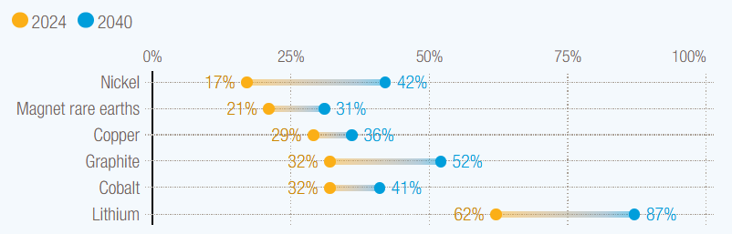
Figure 1: Clean technologies’ share of mineral demand
(Source: UNCTAD, 2026)
The natural environment also influences the purchasing behaviour of customers. Steel manufacturers mainly seek low-carbon iron ore for the reduction of emissions during steel production. BHP made a partnership with POSCO to make advancements in decarbonisation steelmaking technology (BHP, 2025). Environmental sustainability has also become a key component of brand reputation. Investors evaluate mining companies using environmental, social and governance (ESG) criteria. Through the successful implementation of ESG and sustainability criteria, the mining companies become more attractive to investors (Ahmad and Campbell, 2021). The firms demonstrating significant decarbonisation pathways experience stronger investor confidence, easier access to capital and an enhanced level of stakeholder relationships.
Threats
The environmental implications of mining, which are manifested in the degradation of landscapes and pollution, along with the social and economic impacts on local communities, indicate the challenges confronting the industry (Yu et al., 2025). Increasing global temperatures and biodiversity loss have led to the demand for sustainable mining practices. Climate change presents operational risks for BHP. Extreme weather events cause damage to equipment, infrastructure and mining facilities (Qarahasanlou et al., 2024). Canada faces adaptation challenges as climate risks, such as floods and wildfires, affect people, homes and infrastructure (OECD, 2025a). As a result, the operations of BHP are vulnerable to climate-related disruptions.
However, transitioning towards lower-carbon operations requires adequate investment. Renewable energy infrastructure and green hydrogen involve high implementation costs and investment risks (Odenweller and Ueckerdt, 2025). Moreover, balancing environmental commitments with the expectations of shareholders for profitability remains a key strategic challenge. Despite these challenges, the natural environment creates opportunities for BHP to position itself as a leading supplier of responsibly produced minerals supporting the global energy transition.
Legal environment
Opportunity
The legal environment represents a critical marketing actor shaping the transition of BHP towards low-carbon products. When well-designed and appropriately implemented, the regulations of the government can promote environmental goals and encourage technological innovation (OECD, 2025b). The different carbon pricing mechanisms and mandatory climate disclosures encourage the mining companies to reduce greenhouse gas (GHG) emissions. Australia's 2035 target aims for a reduction of 62-70% in net GHG emissions (UNFCCC, 2025). The other countries have also established carbon neutrality targets, leading to an increase in demand for lower-carbon raw materials.
The different government incentives support the transition of BHP. The funding programmes promoting renewable energy, hydrogen production and clean technology development encourage investment in sustainable mining operations. For example, the Indian government has implemented the National Green Hydrogen Mission (NGHM), with the aim of making India a global hub of production and export of green hydrogen (PIB, 2026). This encourages BHP to invest in lower-carbon products, which can foster sustainability.
Threats
Legal factors also affect the expectations of the community. The Australian government promotes environmental, social and governance (ESG) practices in critical minerals mining, which pushes the firms towards sustainability and net-zero emissions (Nadig, 2024). However, regulatory uncertainties present various challenges. The stock of regulations across the countries is expanding, and this has resulted in a rise in regulatory complexities (OECD, 2026). The different environmental standards of different countries increase compliance complexities for multinational companies such as BHP.
Overall, the legal actors encourage innovation, while increasing operational compliance costs. The firms capable of adapting quickly can strengthen competitive positioning and trust of the stakeholders.
Critical analysis
The natural environment and the legal environment are closely interconnected. In the current environment, the government faces increasing concerns over climate change (Kalk and Sorger, 2023). Due to this, they focus on implementing stricter environmental regulations, which shape customer expectations and investment behaviour. The success of BHP has come through a switch to renewables and electrification of mining fleets (Mining Technology, 2024). Instead of viewing sustainability as regulatory compliance, BHP integrates environmental responsibility into its value proposition.
However, the success of BHP in terms of its transition towards lower-carbon products depends on balancing environmental investment with financial performance. It has been analysed previously that sustainable technologies require adequate capital expenditure. The high capital expenditure required for decarbonisation may reduce short-term profit margin, specifically during periods of commodity price volatility. In addition, there is also an increasing level of scrutiny from investors, government and environmental organisations with respect to potential greenwashing. However, long-term competitive advantage will likely favour companies capable of delivering lower-carbon products along with the maintenance of operational efficiency. Apart from this, the natural environment must remain the central consideration in strategic marketing decisions of BHP, since it influences regulatory developments, customer demand, expectations of the investors and future resource markets. By incorporating environmental innovation with regulatory compliance and customer-focused product development, the company can enhance its competitiveness, improve stakeholder trust and capture an increasing demand for responsibly produced minerals in the transition to a low-carbon economy.

Task 2: Strategic Growth and Competitive Positioning
Strategic growth approach using the Ansoff matrix
Based on the environmental analysis, BHP requires a growth strategy which aligns with decarbonisation trends and can strengthen its competitive positioning in the mining industry. Ansoff matrix can be applied in this context, which consists of four attributes, such as market development, market penetration, product development and diversification, as indicated in Figure 2 (Kalogiannidis and Mavratzas, 2020). To accelerate the transition of BHP towards lower-carbon products, the most suitable strategic option from the Ansoff matrix is product development, which involves introducing new or improved products to existing markets. This strategy can allow BHP to leverage its established relationships with steelmakers and battery manufacturers, while responding to an increasing demand for lower-carbon raw materials.
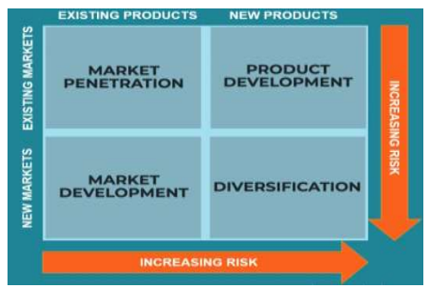
Figure 2: Ansoff Matrix
(Source: Kalogiannidis and Mavratzas, 2020)
Development of low-carbon iron ore products
One of the significant opportunities of BHP lies in developing premium iron ore products, specifically designed for lower-carbon steel production. High-grade iron ore mainly requires less energy to convert to iron, and thus, it is necessary for steelmaking decarbonisation (UNIDO, 2025). Iron ore is the major responsible material for emissions of trace elements during the manufacturing of steel (Lau et al., 2021). As the government introduces stricter carbon regulations and requires the steel producers to commit to net-zero targets, demand is increasing for low-emission iron ore products.
BHP can increase investment in research partnerships with global steel producers to improve iron ore quality and develop products which are compatible with hydrogen-based steelmaking. Developing premium low-carbon iron ore would allow BHP to differentiate itself from the competitors through effective environmental performance instead of solely competing on price. This approach can strengthen customer loyalty and reduce exposure to commodity price fluctuations.
Expansion of low-carbon copper production
Copper has emerged as the most strategically significant mineral, supporting the global energy transition. Electric vehicles (EVs) require more copper than conventional vehicles. EVs contain up to a mile of copper wiring, involving everything from propulsion to infotainment and safety systems (Chenoy, 2025a). Moreover, the battery storage systems and electricity transmission networks depend on reliable copper supplies. The CAGR rate of the global copper market is expected to increase by 4.75% by the end of 2033, as indicated in Figure 3 (Market Data Forecast, 2026). Due to this, it is necessary for BHP to expand production from existing copper operations such as Escondida, while ensuring that the production is powered by renewable electricity.
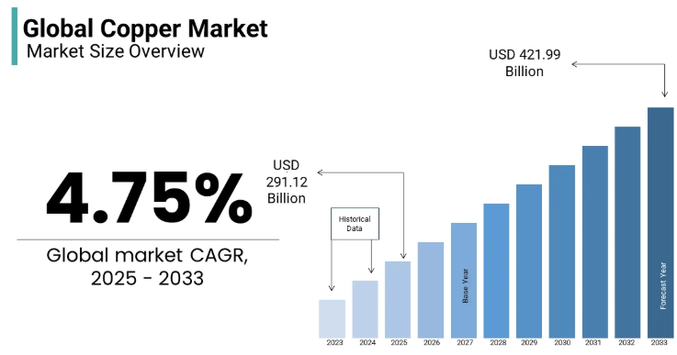
Figure 3: Increase in CAGR rate of global copper market
(Source: Market Data Forecast, 2026)
Rather than promoting production volume, BHP can introduce certified low-carbon copper supported by transparent lifecycle emissions data. Certification strengthens transparency and credibility, giving the customers confidence in the commitment of the organisation (DNV, 2026). This can emerge as valuable for automotive manufacturers, such as Tesla and Volkswagen, whose own sustainability commitments require responsible sourcing throughout the supply chain.
Sustainable nickel products for battery manufacturing
Nickel is another vital mineral supporting the transition of BHP towards clean energy. Increasing nickel content in cathodes from 33% to 90% increases the kilowatt-hour capacity of EV batteries (Chenoy, 2025b). The natural environment drives an increasing customer demand for greener minerals. BHP can focus on investing in nickel operations, while reducing emissions through renewable electricity and improved water management. In addition, the company can also develop a branded portfolio of responsibly produced battery-grade nickel marketed towards EV manufacturers. Strategic partnerships with battery producers can allow collaborative product development, reduce revenue uncertainties and position BHP as a preferred supplier within rapidly growing battery supply chains.
Thus, the product development strategy is the most appropriate growth strategy for responding towards sustainability pressures and strict government regulations.
Achieving competitive advantage through differentiation
Porter’s generic strategies can be applied in this context to suggest ways through which BHP can achieve competitive advantages. The theory suggests that an organisation can achieve competitive advantages through cost leadership, cost focus and differentiation as illustrated in Figure 4 (Subrahmanyam, 2019). For BHP, differentiation represents the most suitable competitive strategy during the transition to lower-carbon products.
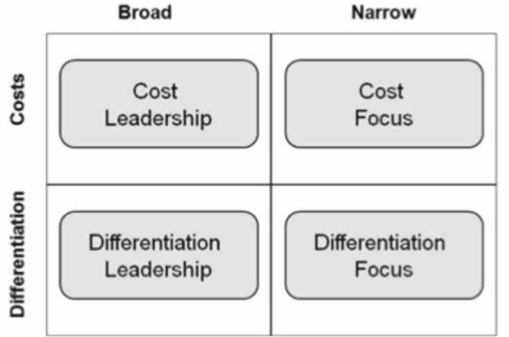
Figure 4: Porter's Generic Strategies framework
(Source: Subrahmanyam, 2019)
BHP can differentiate itself through sustainability leadership, innovation and responsible resource development. Environmental performance has become a significant purchasing criterion among industrial customers. Steel manufacturers and automotive companies face pressure to reduce emissions throughout the supply chain. Supplying certified lower-carbon minerals can allow BHP to satisfy the evolving requirements of the customers along with strengthening long-term commercial relationships.
Continuous investment in technological innovation creates barriers for competitors. Technological innovation creates conscious investment strategies (Stankevičienė et al., 2025). Extensive research into hydrogen-powered mining equipment and renewable energy integration can allow BHP to improve productivity, while simultaneously reducing emissions. The competitors with lower research capabilities may struggle to replicate the advantages quickly. Apart from this, strong ESG performance can enhance access to investment capital. The maintenance of ESG performance can offer financial advantages along with an improvement in reputation. However, developing lower-carbon technologies requires substantial investment and commercial returns may take many years to materialise. In this context, BHP can incorporate a phased investment approach and maintain continuous stakeholder engagement. Transparent ESG reporting can reduce reputational risks and strengthen investor and consumer confidence.

Task 3: Critical Reflection on AI Usage
Artificial Intelligence (AI) was applied as a supportive tool throughout the development of this report to increase the efficiency of research, planning and academic writing. Specifically, ChatGPT was applied to generate an initial report outline, explain marketing theories such as the Ansoff matrix, suggest ways of applying this theory to BHP and enhance both the clarity and coherence of written sections. AI was also applied to summarise background information on sustainability initiatives of BHP and identify links between environmental trends and strategic growth opportunities. However, the AI-generated content served only as a starting point for the report and was not incorporated into the report. In accordance with the AI use policy of the university, the final content remained entirely my own.
One of the critical aspects of using AI involved verifying the accuracy of its outputs. Although AI can quickly generate text, it may produce outdated information and unsupported claims. To reduce the risk, every statement generated by AI was cross-checked using authoritative sources. For example, AI suggested that BHP has invested in renewables. This information was verified through searching for accurate evidence regarding the investment of BHP in renewables and mining fleets. In places where AI offered broad generalisations without any supporting evidence, these statements were either removed or rewritten using information from credible sources.
The report also distinguished between AI-assisted structure and content with my own original contribution. AI offered explanations of theoretical frameworks and suggested proper academic language. However, the selection of the natural environment and legal environment as the two external marketing environment actors was my own decision after reviewing the developments in the mining industry. At the same time, recommending product development as the most appropriate growth strategy using the Ansoff matrix, and evaluating the competitive advantage of BHP through differentiation represents my own analysis. Moreover, critically discussing both the opportunities and risks associated with the transition of BHP to lower-carbon products was my own original contribution. I not only interpreted the evidence, but also compared different sources, evaluated strategic alternatives and also developed the final arguments independently, instead of relying on AI-generated responses.
The use of AI in marketing analysis also raises ethical and professional considerations. AI has the potential to improve productivity by generating ideas and assisting with report structure. However, overreliance on AI may reduce critical thinking and increase the likelihood of plagiarism if outputs are copied without acknowledgement. AI tools generate content; however, if used uncritically, they may result in unintentional plagiarism (Zhai, Wibowo and Li, 2024). Marketing professionals must recognise that AI mainly lacks contextual judgement and cannot evaluate stakeholder interests and ethical implications. The responsible use of AI requires transparency and adherence to academic integrity principles. Thus, in this report, AI functioned as a decision-support tool instead of a substitute for independent learning. By supporting the claims and applying credible sources, I was able to produce a report which is ethically responsible, along with developing my own analytical and strategic thinking skills.

Conclusion
The transition of BHP into a lower-carbon business model is influenced by external marketing environment factors, such as the natural environment and legal environment. Climate change issues, increasing expectations of the stakeholders and changing environmental regulations have accelerated the focus of the company on sustainable mining and the development of lower-carbon products. Adopting a product development strategy can allow BHP to strengthen its competitive positioning through innovation and differentiated offerings.

References
Ahmad, K., and Campbell, C. (2021) Taking ESG seriously: The crucial role of mining investors in the energy transition. Available at: https://www.whitecase.com/insight-our-thinking/taking-esg-seriously-crucial-role-mining-investors-energy-transition (Accessed: 15 July 2026)
BHP (2025) BHP and POSCO partner to advance hydrogen-based ironmaking technology. Available at: https://www.bhp.com/news/media-centre/releases/2025/10/bhp-and-posco-partner-to-advance-hydrogen-based-ironmaking-technology (Accessed: 15 July 2026)
BHP (2026a) About Us. Available at: https://www.bhp.com/about (Accessed: 15 July 2026)
BHP (2026b) Our History. Available at: https://www.bhp.com/about/our-history (Accessed: 15 July 2026)
BHP (2026c) The future is clear. Available at: https://www.bhp.com/about/the-future-is-clear (Accessed: 15 July 2026)
Chenoy, D. (2025a) ‘Copper: The holy grail of EVs’, Economic Times, August 8. Available at:
https://auto.economictimes.indiatimes.com/news/auto-components/unlocking-the-future-of-electric-vehicles-the-critical-role-of-copper/123187313 (Accessed: 15 July 2026)
Camilleri, M.A. (2017) ‘The marketing environment’, In Travel marketing, tourism economics and the airline product: An introduction to theory and practice (pp. 51-68). Cham: Springer International Publishing. Available at: https://www.um.edu.mt/library/oar/bitstream/123456789/21434/5/The%20Marketing%20Environment.pdf
Chenoy, D. (2025b) Why nickel is emerging as the backbone of next-generation batteries. Available at: https://etedge-insights.com/industry/manufacturing/why-nickel-is-emerging-as-the-backbone-of-next-generation-batteries/ (Accessed: 15 July 2026)
DNV (2026) ISO 14001 Certification: Environmental Management System. Available at: https://www.dnv.com/services/iso-14001-environmental-management-3360/ (Accessed: 15 July 2026)
Kalk, A. and Sorger, G. (2023) ‘Climate policy under political pressure’, Journal of Environmental Economics and Management, 122, pp.1-18. Available at: https://doi.org/10.1016/j.jeem.2023.102900
Kalogiannidis, S. and Mavratzas, S. (2020) ‘Impact of marketing mix strategies effective product development issues in MNCs/Retail’, International Journal of Business Marketing and Management (IJBMM) Volume, 5, pp.118-125. Available at: https://www.researchgate.net/publication/347910262_Impact_of_marketing_mix_strategies_effective_product_development_issues_in_MNCsRetail (Accessed: 15 July 2026)
Lau, L.L., Strezov, V., Gonçalves, M.V.B. and Bagatini, M.C. (2021) ‘Trace elements emission in iron ore sintering: A review’, Environmental Advances, 6, pp.1-13. Available at: https://doi.org/10.1016/j.envadv.2021.100123
Market Data Forecast (2026) Global Copper Market Report. Available at: https://www.marketdataforecast.com/market-reports/global-copper-market (Accessed: 15 July 2026)
Mining Technology (2024) On-site renewables best option to cut mine site emissions up to 2030. Available at: https://www.mining-technology.com/analyst-comment/on-site-renewables-mine-site-emissions/ (Accessed: 15 July 2026)
Nadig, S. (2024) Australia’s push for higher ESG standards in critical minerals industry. Available at: https://www.mining-technology.com/features/australias-push-for-higher-esg-standards-in-critical-minerals-industry/ (Accessed: 15 July 2026)
Odenweller, A. and Ueckerdt, F. (2025) ‘The green hydrogen ambition and implementation gap’, Nature Energy, 10(1), pp.110-123. Available at: https://doi.org/10.1038/s41560-024-01684-7
OECD (2025a) OECD Economic Surveys: Canada 2025. Available at: https://www.oecd.org/en/publications/2025/05/oecd-economic-surveys-canada-2025_ee18a269/full-report/adapting-to-climate-change-challenges_e62681b8.html (Accessed: 15 July 2026)
OECD (2025b) OECD Regulatory Policy Outlook 2025. Available at: https://www.oecd.org/en/publications/2025/04/oecd-regulatory-policy-outlook-2025_a754bf4c/full-report/regulating-for-the-planet_a5fdd03c.html (Accessed: 15 July 2026)
OECD (2026) Introduction: Regulating in a fast-changing and complex world. Available at: https://www.oecd.org/en/publications/2026/06/smart-regulations-strong-business_435e39ce/full-report/introduction-regulating-in-a-fast-changing-and-complex-world_4b32f27d.html (Accessed: 15 July 2026)
PIB (2026) Government Drives Green Hydrogen Expansion and Strengthens Clean Energy Transition. Available at: https://www.pib.gov.in/PressReleasePage.aspx?PRID=2244663&reg=48&lang=2 (Accessed: 15 July 2026)
Qarahasanlou, A.N., Garmabaki, A.H.S., Kasraei, A. and Barabady, J. (2024) ‘Deciphering climate change impacts on resource extraction supply chain: a systematic review’, International Journal of System Assurance Engineering and Management, pp.1-13. Available at: https://doi.org/10.1007/s13198-024-02398-5
Stankevičienė, J., Noja, G.G., Pirtea, M.G., Ţăran, A.M., Gînguță, A. and Giovanis, A., (2025) ‘Technological innovations for sustainable business success: enhancing processes and performance’, Business Process Management Journal, 31(5), pp.1884-1907. Available at: https://doi.org/10.1108/BPMJ-07-2024-0667
Subrahmanyam, S., (2019) ‘Carrefour's competitive strategy-cost leadership and differentiation: A case study’, Pacific Business Review International, 11(8). Available at: https://www.researchgate.net/profile/Sarah-Azad-Fouad-Arif/publication/333118406_Carrefour's_Competitive_Strategy-_Cost_Leadership_and_Differentiation_A_Case_Study/links/5cdc7435299bf14d959c419a/Carrefours-Competitive-Strategy-Cost-Leadership-and-Differentiation-A-Case-Study.pdf
UNFCCC (2025) Australia’s 2035 Nationally Determined Contribution. Available at: https://unfccc.int/sites/default/files/2025-09/Australias%20Second%20NDC.pdf (Accessed: 15 July 2026)
UNIDO (2025) Enabling low-carbon steel: Q&A with Rodrigo Lauria of Vale S.A. Available at: https://decarbonization.unido.org/news/enabling-low-carbon-steel-vale/ (Accessed: 15 July 2026)
Yu, H., Zahidi, I., Fai, C.M. and Liang, D. (2025) ‘From devastation to restoration: Charting the course towards sustainable mining practices’, Journal of Environmental Management, 391, pp.1-14. Available at: https://doi.org/10.1016/j.jenvman.2025.126660
Zhai, C., Wibowo, S. and Li, L.D. (2024) ‘The effects of over-reliance on AI dialogue systems on students' cognitive abilities: a systematic review’, Smart learning environments, 11(1), pp.1-37. Available at: https://link.springer.com/article/10.1186/s40561-024-00316-7?fbclid=IwZXh0bgNhZW0CMTEAAR5nkxIdDLo8CdVygkPcbDQO7Tw9yMR1_EgHAElbgowcEB2XoCPscDA4bk47Sw_aem_TwS9UfH378qH6RPQzO9pUg (Accessed: 15 July 2026)

