Name: Tim Kirk
Student Number: 1710839
Module: HPAR4004

The Seascape and Archaeology of
Aberaeron

Aberaeron is a village situated in the historic county of Ceredigion (modern regulatory authority of Dyfed). It is located on the coast at the mouth of the Afon (river) Aeron, in the South of Cardigan Bay in the west of Wales.
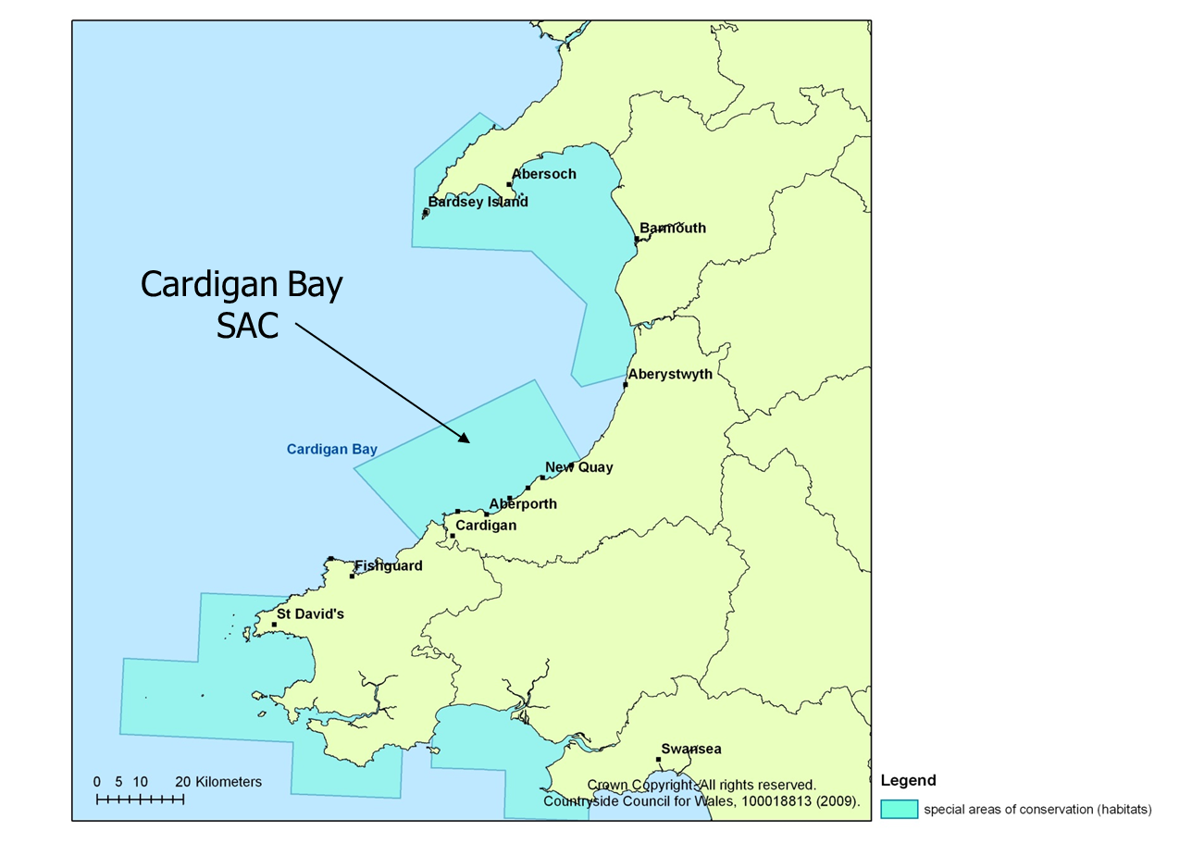
(Source: welshwildlife.org)

Cardigan Bay stretches from the port of Fishguard in the south to Bardsey Island at the tip of the Llyn Peninsula in the North, a distance of some seventy miles and the predominantly rocky coastline is bounded by granite cliffs at the southern end, pierced by small coves and beaches where streams and rivers outflow to the sea. The whole of the Bay is open to the Southwest and strong winds mean that ports and beaches become a lee shore and are at risk from large waves and heavy swell in winds over Force 5 (17 knots, or 31km/hr) from Southwest to Northeast in direction (NRW n.d).

The main archaeological features of the village relate to the planned building layout around the harbour and the, now lost, Castell Cadwgan.

From the coast out to a distance some 20km offshore the Cardigan Bay Special Area of Conservation (SAC) has been designated from Ceibwr Bay in the South to Aberarth in the North order to protect the marine habitat, in particular of the Atlantic Grey Seal and the Bottlenose Dolphin to which the area is home for the largest population in Europe. Under the EU Habitat Directive, the UK government is required to update the Commission every six years on the health and condition of the 1000km² conservation area (defra.org).

Further, Natural Resources Wales have designated the whole of the southern coastline of Cardigan Bay as a ‘Marine Character Area’ (NRW, n.d.) and whilst being beyond the scope of this assessment, this document clearly shows the wide and long-term interaction of human activity with the coastline and the inshore waters along the whole of the Southern half of Cardigan Bay.

Castell Cadwgan is reported to have been built (to the North-East of the river mouth) in 1148AD by Cadwgan ap Bleddyn according to Meyrick (1907) and traces were still visible in 1803 (Jones, 1970). It is identified as a wooden ringwork with an enclosure bank (Gatehouse Gazetteer, n.d.) and has now been lost to erosion and the sea. It does still exist, however as a Historic Environment Record (HER) with Dyfed Archaeological Trust (DAT187).

The harbour itself has historic recognition; the whole coastline was well-known for fishing and shipbuilding from Elizabethan times onward and Jenkins (1982) describes in great detail the seaborne activity along the coast, and indeed internationally – firstly with Ireland and subsequently in exports worldwide. The harbour structures extant today are described as being built 1807-1811 (Jenkins, 1982:65-67) at the behest of Rev. Thomas Jones Gwynne who presented a Private Bill for authorisation of the construction to the House of Lords in 1807. Jones was ‘Lord of the Manor of Llyswen (otherwise Aberayron)’ (Jenkins 1982:66) and the improvements were commissioned at his expense and for the benefit of his manor.

These works and a number of the associated buildings are scheduled as ancient monuments by the Royal Commission on Ancient and Historic Monuments in Wales (RCAHMW):

NPRN Description

405855 Aberaeron Harbour, South Pier
34170 Northeast Pier
34171 Northeast Quay
34172 Southwest Pier and Northwest Quay
34173 Weigh House

(Source: Coflein.gov)

Also, along the beach are a number of fish-traps which have also been scheduled:

NPRN Description

518838 Fish Trap 1
518839 Fish Trap 2
518844 Fish Trap 3

(Source: Coflein.gov)

In the twenty-first century, Aberaeron mainly relies on tourism for it’s economy. The harbour nowadays is filled with trots of drying moorings for small craft. Environmental changes brought about by Global Warming have led to the weather becoming more prevalent to storms and flooding and in November 2018, Storm Callum brought flash floods and debris down through

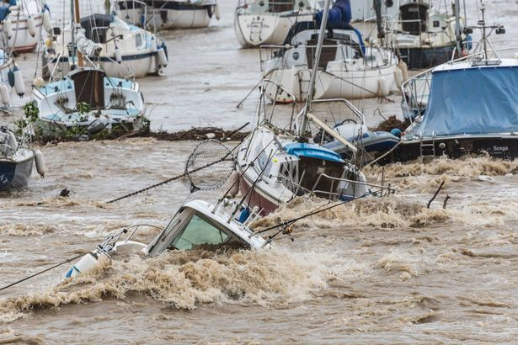
(source: Ceredigion Herald)
The harbour, causing severe damage to a number of pleasure craft (Coles, 2018).

In order for the continued protection of the harbour and residents and tourists alike, it may become necessary to develop relief capacity to facilitate the drainage of the River Aeron to prevent further damages to property and infrastructure. However it would be prudent and necessary to carry out archaeological investigation into the potential negative effects upon this historic environment in advance of any works being carried out.

Bibliography

Cofliein (n.d.). Available at: https://www.coflein.gov.uk (last accessed 01.04.2019).

Coles, J (2018). ‘Aberaeron: Boats Lost as Storm Callum Wreaks Havoc in Harbour’, in Ceredigion Herald available at: https://ceredigionherald.com/41790/ (last accessed:01.04.2019).

DAT187 (n.d.). Available at: https://www.archwilio.org.uk (last accessed 01.04.2019).

DEFRA (n.d.). Available at: https://www.jncc.defra.gov.uk (last accessed 31.03.2019).

Gatehouse Gazetteer (n.d.). Available at: https://www.gatehouse-gazetteer.info/Welshsites/129 (last accessed 01.04.2019).

Jenkins, J. (1982). Maritime Heritage: the Ships and Seamen of Southern Ceredigion. Llandysul: Gomer Press.

Jones, G. (1970). ‘Notes on Aberaeron’ in Ceredigion 6:3 p.285. Available at: https://www.journals.library.wales/browse/1093205 (last accessed 01.04.2019).

Meyrick, S. (1907). The History and Antiquities of the County of Cardigan. Brecon: Davies and Co.

NRW (n.d.). Marine Character Areas MCA16: Cardigan Bay (South). Available at: https://www.naturalresourceswales.gov.uk. (last accessed 01.04.2019.

Welsh Wildlife (n.d.). The Wildlife Trusts of South and West Wales: Cardigan Bay SAC. Available at: https://www.welshwildlife.org (last accessed 31.03.19).

