

ELEVATE SOLUTIONS | CONSULTING FIRM

UNLOCK THE PATH

TO EXCEPTIONAL CUSTOMER SERVICE

AND EMPOWERED STAFF ENGAGEMENT

AT CONRAD LAS VEGAS RESORTS WORLD

Organisational Consultancy BMIH6005

Consultancy Report for Conrad Las Vegas Resorts World

STUDENT: Priyanitha Cooray - 2118031

LECTURER: Jaliya De Silva

DATE: 15 - 02 –2024

CONSULTANCY REPORT

FOR

CONRAD LAS VEGAS RESORTS WORLD

TABLE OF CONTENTS
Table of Contents
1 TABLE OF CONTENTS 1
2 EXECUTIVE SUMMARY 2
2.1 Overview of the issue 3
2.2 Key Findings 3
2.2.1 Customer Service 3
2.2.2 Staff Engagement 3
2.3 Root Causes 4
2.4 Recommendations 4
2.5 Conclusion 6
3 INTRODUCTION 6
3.1 Background of Conrad Las Vegas Resorts World 7
3.2 Overview of the Issues 7
3.3 About our firm Elevate Solutions 7
3.3.1 Theoretical Frameworks and Models 7
4 ANALYSIS 8
4.1 Steepled Analysis 8
4.2 Soar Analysis 12
4.3 Tows Analysis 13
4.4 The McKinsey 7s Framework for Strategy Execution 14
5 RECOMMENDATIONS AND CHANGE MANAGEMENT 16
5.1 DELOITTE MODEL 16
5.2 LEWIN’S CHANGE MODEL 17
5.3 GENERATION Z AND MILLENNIALS 18
5.4 ROOT CAUSES OF INADEQUATE STAFF ENGAGEMENT 18
5.4.1 Inadequate training 18
5.4.2 Our recommendations encompass the following 19
5.4.3 Limited recognition and rewards 19
5.4.4 Our recommendations encompass the following 19
5.4.5 Communication gaps 20
5.4.6 Our recommendations encompass the following 20
5.5 UNLOCK THE PATH TO EXCEPTIONAL CUSTOMER SERVICE 21
5.5.1 Inadequate feedback mechanisms 21
5.5.2 Our recommendations encompass the following 21
6 ACTION PLAN 23
6.1 CUSTOMER RELATIONSHIP MANAGEMENT (CRM) SYSTEM 23
6.2 REPUTATION MANAGEMENT 23
6.3 RESOURCE ALLOCATION 23
6.4 THE FOLLOWING ACTION PLAN IS OUTLINED IN A TABLE FOR CLARITY 24
7 CONCLUSION 25
8 REFERENCE 26
9 APPENDIX 32
FIGURE 1 32
FIGURE 2 33
FIGURE 3 34
FIGURE 4 35
FIGURE 5 36
FIGURE 6 37
FIGURE 7 37
FIGURE 8 38
FIGURE 9 39
FIGURE 10 40

EXECUTIVE SUMMARY

The objective of this report is to analyse and propose strategies for enhancing and optimizing customer service and staff engagement at Conrad Las Vegas Resorts World (Hilton).
As Badawi states (2012), by identifying the key factors that contribute to exceptional customer service and empowering staff engagement, it will be possible to provide actionable recommendations for improving the overall guest experience and fostering a positive work environment.

Overview of the issue

In conducting the research for this consultancy report, we analysed a wide range of customer reviews and feedback to gain insights into the challenges faced by Conrad Las Vegas Resorts World. The findings revealed that the hotel is currently struggling with subpar customer service, which has resulted in dissatisfied guests and negative online reviews (Figure 4-5-6).
Additionally, there is a noticeable lack of staff commitment and engagement, leading to a decrease in overall service quality.

Key Findings

Customer Service

The analysis of customer reviews reveals several recurring issues that have negatively impacted customer satisfaction and loyalty. Long wait times have been a common complaint, indicating a need for improved efficiency and streamlined processes (Figure 1- 2- 3). Additionally, customers have expressed frustration with unresponsive staff, emphasizing the importance of effective communication and prompt problem resolution (Figure 7-8). To address these concerns, it is crucial to implement strategies that prioritize customer needs, enhance service delivery, and ensure a positive customer experience.

Staff Engagement

The findings indicate a decline in staff morale, motivation, and overall engagement within the organization. (Figure 9 -10).
This can be attributed to various factors, including limited opportunities for growth and development. To address this issue, it is essential to invest in employee training and development programs that empower staff members and provide them with the necessary skills to excel in their roles.
Cave (2002a) emphasises the significance of motivation and reward systems in the workplace for organisations.
Creating a positive work environment, fostering open communication, and recognizing and rewarding employee achievements can contribute to boosting staff morale and increasing their commitment to the organization.
By prioritizing these areas, the organization can work towards improving customer satisfaction, loyalty, and employee commitment, ultimately leading to long-term success.

Root causes
The root causes of these issues can be attributed to various factors:

- Inadequate Training:
Insufficient training programs and resources may have contributed to staff members lacking the necessary skills and knowledge to deliver exceptional customer service (Ford and Sturman, 2020)
- Communication Gaps:
A lack of clear communication channels and feedback mechanisms appears to hinder effective communication between management and staff, leading to a disconnect and decreased motivation among employees.
Additionally, ineffective communication channels and a lack of clear expectations appear to hinder staff engagement and alignment with the organization’s goals.
Studies have shown (Agarwal, 2021) that effective communication skills are essential in the modern interconnected world, impacting every aspect of both personal and professional life.

- Limited Recognition and Rewards:
A lack of recognition and rewards for outstanding performance may have contributed to low staff morale and engagement.
The absence of a robust recognition and rewards system may have demotivated employees and hindered their commitment to delivering exceptional service.
Azic (2017) highlights the importance of employee satisfaction in the hospitality industry. Happy employees are more likely to provide better service, leading to increased customer loyalty and ultimately higher profitability. Prioritising employee satisfaction can create a positive work environment and enhance overall business performance.

Recommendations

Research has shown that creating a supportive work environment is crucial. It boosts employee satisfaction and enhances service performance in the hospitality industry (Marshall et al. 2015)

Employees are driven by intrinsic needs like growth, recognition, and contribution to team goals. These factors boost self-worth and identity. Reward systems that support professional development play a crucial role in fulfilling these needs and enhancing employee motivation and satisfaction (Younies and Al-Tawil,2021)
Therefore, to address the above-mentioned challenges, we recommend implementing a comprehensive customer service training program that focuses on enhancing communication skills, problem-solving abilities, and empathy among staff members. This training should be ongoing and include regular assessments to ensure continuous improvement.
As Giousmpasoglou et al. (2021) state staff perceive their leader as a guiding influence therefore establishing clear communication channels, such as regular team meetings and suggestion boxes, will foster a culture of open dialogue and feedback.

Implementing a performance recognition and rewards system is a great way to boost staff engagement. Incentives such as bonuses, employee of the month programs, and career development opportunities foster a culture of appreciation and motivation,
whereas a positive work environment through team-building activities and employee wellness programs will contribute to increased staff satisfaction and engagement.

As Lundberg et al. (2009) state, individuals are driven by a diverse range of needs that fluctuate in significance based on circumstances and evolve, therefore our consultancy report recommends prompt implementation of the following actions:

- Enhance Training Programs:

Develop comprehensive training initiatives that focus on customer service skills, problem-solving, and effective communication to equip staff with the necessary tools to deliver exceptional service.
In fact, according to a study of Hospitality training (Hyasat et al. 2022), on-the-job training emerged as a crucial training approach.

- Improve Communication Channels:

As Chan et al. (2015) state management ought to foster a feeling of inclusion among employees by enhancing transparent, regular, and open communication concerning individual performance. Implement regular communication channels, such as team meetings and feedback sessions, to foster open dialogue, clarify expectations, and ensure alignment with organizational goals.

- Establish a Recognition and Rewards System:

We strongly recommend introducing a structured recognition and rewards program that acknowledges and incentivizes outstanding performance, fostering a culture of appreciation and motivation among staff members.

- Foster Employee Development:

Provide opportunities for professional growth and development through training, mentorship programs, and career advancement pathways to enhance staff engagement and commitment.

- Continuous Feedback Mechanism:

Implement a system for collecting and acting upon customer feedback to identify areas for improvement and ensure prompt resolution of customer concerns.

Conclusion
Addressing the customer service and staff engagement challenges at Conrad Las Vegas is crucial for the hotel to maintain credibility and success in the market. By implementing the recommended strategies, the hotel can enhance customer service, improve staff engagement, and ultimately create a positive and memorable guest experience.
Our consultancy firm is committed to supporting Conrad Las Vegas in achieving its business objectives, providing strategic guidance, and delivering tailored solutions to enhance its operations, customer experience, and overall success in the highly competitive hospitality industry.

INTRODUCTION

Conrad Las Vegas Resorts World is located on the Las Vegas Strip, specifically at the Resort World Las Vegas complex.
The address is 111 Resorts World Avenue, Las Vegas, Nevada 89109 (Yelp).

The above-mentioned Hotel is currently facing significant challenges in terms of customer service and staff engagement.
This report, written by Priyantha Cooray on behalf of the Elevate Solutions consultancy firm seeks to conduct a comprehensive analysis of the primary challenges encountered by the Hotel and offers practical recommendations to effectively tackle them.

Background of Conrad Las Vegas Resorts World

Conrad Las Vegas Resorts World is a renowned luxury hotel that opened in June 2021 (Forbes, 2021).
The prestigious hotel is known for its opulent accommodations, world-class amenities, and prime location on the iconic Las Vegas Strip.
The property boasts 1,496 well-appointed and elegantly designed rooms and suites, offering a range of options to suit different preferences and needs (Figure 13).
The rooms are designed with a contemporary and sophisticated style, providing a comfortable and luxurious environment for guests. Each room is equipped with modern amenities such as flatscreen TVs, high-speed internet access and plush bedding (Resorts World Las Vegas).
Conrad Las Vegas offers a variety of dining options to cater to different tastes. Guests can enjoy a fine dining experience at one of the signature restaurants on-site or indulge in a casual meal at the resort’s more relaxed eateries. The hotel also features bars and lounges where guests can unwind and enjoy a drink (Good Housekeeping Holidays).
In terms of amenities, Conrad Las Vegas offers a rooftop pool where guests can relax and soak up the sun, as well as a fitness centre for those who wish to stay active during their stay (thelasvegastravelguide.com).
Additionally, the hotel houses a spa where guests can indulge in a range of rejuvenating treatments and therapies.
The location of the Hotel is ideal for those who want to explore the vibrant Las Vegas Strip in the vicinity of many popular attractions and entertainment venues.

Overview of the Issues
The primary issues identified at Conrad Las Vegas Resorts World revolve around customer service and staff engagement. The hotel has been receiving complaints regarding inconsistent service quality, lack of personalization, and inadequate response to guest needs.
A noticeable lack of staff engagement and commitment leads to decreased productivity and employee turnover.

About our firm Elevate Solutions

Elevate Solutions is a leading consultancy firm specializing in hospitality management and organizational development. With a team of experienced consultants, we provide tailored solutions to enhance operational efficiency, customer satisfaction, and employee engagement. Our expertise lies in utilizing various frameworks and models to analyse complex issues and devise practical strategies for improvement.

Theoretical Frameworks and Models

Elevate Solutions will conduct a thorough analysis of the challenges encountered by Conrad Las Vegas Resorts World. This report will utilise the following frameworks and models to provide a comprehensive assessment of the situation.

STEEPLED Analysis:

This framework examines the hotel's external environment, considering social, technological, economic, environmental, political, legal, ethical, and demographic factors (The Leadership Hospitality, 2022).

SOAR Analysis:

This model focuses on identifying the hotel's strengths, opportunities, aspirations, and results to develop a strategic action plan (EPM, 2019).

TOWS Analysis:

By combining external opportunities and threats with internal strengths and weaknesses, this model helps formulate effective strategies (Mister Simplify, 2020).

THE MCKINSEY 7S FRAMEWORK:

To identify areas for improvement this framework assesses the hotel's alignment between Hard Elements such as strategy, structure, and systems and Soft Elements such as shared values, skills, style, and staff.
The organisation can directly influence the hard elements however the soft elements are more influenced by the culture and less tangible (AC Training, 2016).

ANALYSIS

Based on the findings of the research, it is evident that inadequate training and low levels of staff engagement are potential factors that contribute to subpar customer service. These factors may hinder the ability of employees to effectively meet customer needs and negatively impact their overall commitment and motivation within the organization. Addressing these issues through targeted training programs and initiatives to enhance staff engagement can significantly improve customer service quality and employee satisfaction.

Steepled Analysis

Conducting a STEEPLED Analysis will help Conrad Las Vegas Resorts World gain a comprehensive understanding of the external factors that may be influencing their current situation.
By examining the following factors, the hotel can identify opportunities for improvement, such as enhancing staff training, addressing customer service issues, and aligning with ethical and environmental standards. This analysis can guide strategic decision-making and help create a positive and memorable experience for guests (BusinessAcademyOnline, 2021).

Social factors

It is vital to assess the evolving needs and preferences of customers. This includes trends in luxury experience, wellness, sustainability, and personalized services. The hotel is currently doing very well in recognising the diverse backgrounds and cultural expectations of guests (Coolist, 2022).
This also involves understanding different customs, languages, dietary requirements, and religious practices to provide inclusive and tailored experiences. However, it is equally important to recognise the impact of social media on customer perceptions and brand reputation. By constantly monitoring online reviews, engaging with customers on social platforms and leveraging social media as a marketing tool, the Hotel will be able to enhance customer service and staff engagement.
Kim et al. (2016) highlight the importance of tracking online customer feedback acknowledging and responding to both positive and negative reviews from past and present. By doing that the Hotel will be able to adapt its customer service strategies to meet the changing demand of guests, foster inclusivity, and leverage social media to enhance the overall guest experience.

Technological factors

It is extremely important to assess the impact of technology on customer service. This involves evaluating how the use of advanced customer service platforms, automation, and digital communication channels can enhance or hinder the overall customer experience.
Technological advancements can streamline processes, improve efficiency, and provide convenience to customers. For example, implementing a robust customer relationship management CRM system which Sebring (2016) defines as a tool for change, can help the organisation track customer preferences, personalize interactions, and ensure timely follow-ups. Automation tools like chatbots can handle routine inquiries, freeing up staff to focus on more complex and relevant customer needs.
Digital communication channels such as social media, mobile apps, and online chat platforms enable quick and seamless interactions with customers. These channels can facilitate real-time feedback, resolve issues promptly, and enhance overall customer satisfaction (Kelly, 2014).
However, as Davis (2005) stated, it is important to consider the potential challenges that technology may bring. For instance, reliance on technology can lead to a loss of personal touch and human interaction, which some customers may value. Technical glitches or system failures can also negatively impact customer service if not addressed promptly.
By conducting a thorough analysis of the technological factors, Conrad Las Vegas Resorts World can identify opportunities to leverage technology for improved customer service while mitigating potential risks and challenges.

Economic factors:

The Hotel should consider the economic conditions in Las Vegas, such as tourism trends, income levels, and employment rates, which can influence customer spending patterns and employee motivation.
Las Vegas is a city heavily reliant on tourism, therefore analysing economic conditions is vital (Lim and Won, 2020).
This includes examining tourism trends, such as the number of visitors, their spending habits, and the overall economic health of the city. Fluctuations in income levels and employment rates can impact customer spending patterns, affecting the demand for luxury accommodations and services offered by the Hotel (Alleyne et al. 2021).
Positive economic conditions can lead to higher customer spending and a greater demand for upscale experiences.
On the other hand, during economic downturns or recessions, customers may be more cautious with their spending, leading to a potential decline in bookings and revenue.
Additionally, economic factors can also influence employee motivation (Kovacevic et al. 2020).
A stable and prosperous economy can create job security and opportunities for career growth, boosting employee morale and engagement. Conversely, economic instability or high unemployment rates may lead to concerns about job security and lower motivation among employees.
By considering these economic factors, the Hotel can adapt its strategies to align with the prevailing economic conditions, ensuring that it remains competitive and responsive to the needs and expectations of both customers and employees.

Environmental factors

By considering the environmental factors in the STEEPLED analysis, Conrad Las Vegas Resorts World can identify opportunities to enhance customer service through sustainable practices and create a pleasant and eco-friendly environment for their guests.
Assessing factors like air quality, noise levels, cleanliness, and aesthetics can help identify areas for improvement. For instance, ensuring proper ventilation and maintaining a serene atmosphere can contribute to a positive customer experience.

Political factors

It is crucial to examine the political and regulatory environment, including government policies, labour laws, and industry regulations that may impact customer service standards and employee rights.
For example, changes in labour laws may affect employee rights and working conditions, which can impact customer service standards. By conducting a thorough analysis of political factors, Conrad Las Vegas Resorts World can anticipate potential challenges and opportunities arising from the political landscape.

Legal factors

Legal considerations encompass various aspects, including consumer protection laws, employment regulations, and intellectual property rights (Genius Group, 2013).
These factors can significantly impact customer service practices and employee engagement within the organization as well as mitigate legal risks and create a positive environment for both customers and employees.
Consumer protection laws ensure that customers and employees are treated fairly, and their rights are protected.
Adhering to these regulations fosters a healthy work environment and promotes employee satisfaction.

Demographic factors

By considering the demographic factors, Conrad Las Vegas Resorts World can tailor its customer service strategies and employee engagement initiatives to meet the specific needs and preferences of its target audience, enhancing the overall guest experience and fostering a positive work environment.
Demographic factors include factors such as age, gender, income, and cultural background.
By understanding the age range of their customers, the resort can tailor its offerings and amenities to cater to different age groups. For example, they might provide family-friendly activities for younger guests and more sophisticated entertainment options for older guests.
Income analysis helps determine the pricing strategy and affordability of the resort's offerings. It allows them to offer a range of options, from luxury experiences for high-income individuals to more affordable packages for those with lower incomes.
Cultural background analysis helps the Hotel understand the diverse backgrounds of its customers and employees (Mariani et al. 2019).
This knowledge can be used to create a welcoming and inclusive environment, provide culturally sensitive services, and ensure effective communication with guests and staff from different cultural backgrounds.

Soar Analysis

This framework is going to focus on the Conrad Las Vegas Resorts World’s Strengths, Opportunities, Aspirations, and Results. The aim is to identify the hotel's strengths, such as location or amenities, and opportunities for improvement, such as staff training or service enhancements (Think Insights, 2023).
It is vital to align aspirations with customer expectations and measure results to track progress.

Strengths
Conrad Las Vegas offers a wide range of luxurious amenities, including world-class restaurants, spa facilities and entertainment options. The Hotel’s location on the Las Vegas Strip provides easy access to popular attractions, making it an attractive choice for tourists. As part of the renewed Conrad Hotels& Resorts brand, the hotel benefits from a strong reputation for quality and sophistication (Jaycation, 2024).

Results
The Hotel has consistently achieved high occupancy rates, indicating its popularity among guests and the effectiveness of its marketing and service strategies (Las Vegas Review-Journal, 2023).
Opportunities
As the Facilities Director of the Hotel says (Schneider Electric, 2022), eco-friendly practices and sustainability practices enhance the hotel’s reputation and attract environmentally conscious guests.
Offering personalized experiences and tailored services can create a unique and memorable stay for guests, fostering loyalty and positive word of mouth
Aspirations
By personalizing guest experiences Conrad Las Vegas Resorts World can enhance convenience and differentiate the Hotel from competitors

Tows Analysis

This framework combines external factors from Steepled with internal factors to identify Threats, Opportunities, Weaknesses, and Strengths. For instance, long waiting times could be a weakness, while reputation management and customer feedback systems could be opportunities to address the issue (The Business Professor, 2023).

Threats
T
      - Intense competition from other luxury hotels in Las Vegas
      - Negative Online Reviews Impacting Reputation
      - Changing customer preferences and demands
      - Economic downturn affecting travel and Tourism Industry

Opportunities

- Implementing a comprehensive customer service training program
O
- Enhancing employee engagement through recognition and rewards
- Utilizing technology for personalized guest experience
- Collaborating with local attractions for unique guest offerings

Weaknesses
W
- Issues with customer service
- Low employee engagement and satisfaction
- Lack of personalized guest experiences
- Inconsistency service quality

Strengths
S
- Established brand reputation
- Luxurious facilities and amenities
- Prime location in Las Vegas
- The diverse range of entertainment options

The McKinsey 7s Framework for Strategy Execution

The McKinsey 7S Framework is a management tool that we are going to use to analyse and align various aspects of the organisation (European Graduate School Of Management, 2021).

This model assesses seven interconnected elements:

Strategy:

Here are some strategies that Conrad Las Vegas Resorts World should consider implementing to address its customer service and employee engagement challenges:

- Training and Development

- Employee Recognition and Rewards

- Feedback and Communication Channels

- Empowerment and Autonomy

- Customer Feedback and Satisfaction Surveys

Structure:

Within the organisational structure of Conrad Las Vegas Resorts World, departments and teams should be organized with reporting lines and decision-making processes.

Systems:

By implementing the following systems Conrad Las Vegas Resorts World can create a structured and supportive environment that enhances customer service and employee engagement, ultimately leading to improved overall performance and customer satisfaction.

- CRM

- Employee Training Development System

- Performance Management System

- Feedback and Communication System

- Service recovery System

Shared Values:

Strong core values and principles will guide the Hotel’s culture and decision-making.
It could be a commitment to exceptional service, Innovation, or a focus on sustainability.
By aligning actions and decisions with these shared values, the Hotel can work towards improving customer service and employee engagement, ultimately enhancing its overall strategy and reputation in the industry.

Skills:

By assessing the needs and challenges of the Organisation it will be possible to tailor skill development accordingly.

Here are some examples of skills that could be beneficial for improving customer service and employee engagement:

- Communication skills

- Problem-solving skills

- Empathy and Emotional Intelligence

- Leadership skills

- Customer Service Skills

- Teamwork and Collaboration

Style:

A collaborative style of Leadership and Management approach within the hotel can encourage employee empowerment and Innovation.

Staff:

This element is fundamental and focuses on the Hotel's workforce, including their recruitment, training, and development. It ensures that the right people are in the right roles to support the Hotel's objectives.

RECOMMENDATIONS AND CHANGE MANAGEMENT

The findings revealed that the Hotel is currently struggling with subpar customer service, which has resulted in dissatisfied guests and negative online reviews. Additionally, there is a noticeable lack of staff commitment and engagement, leading to a decrease in overall service quality.

To tackle these challenges, we suggest implementing strategies such as the Deloitte Model, and Lewin's Model, and understanding Generation Z behaviours. These models offer structured frameworks for organisational development and change management. Embracing these approaches can enhance adaptability and success in today's dynamic business environment.

DELOITTE MODEL

Deloitte’s Model of employee engagement emphasizes five key factors (Deloitte,2015):

- Meaningful work
- Supportive Management
- Positive work environment
- Growth opportunity
- Trust in Leadership (Figure12)

By aligning the hotel strategies with these factors, it will be possible to create an environment where employees feel valued, empowered, and motivated to perform at their best (Deloitte,2015).
It is extremely important to keep in mind that engaged employees are more likely to provide exceptional customer service, leading to a better guest experience. By implementing these recommendations, Conrad Las Vegas at Resorts World can create a positive and engaging workplace that benefits both employees and guests alike.
When staff members are not motivated or engaged, it can hurt their commitment to providing excellent service to guests. Low staff engagement may result in a lack of enthusiasm, decreased productivity, and a decline in the overall quality of service.
Conrad Las Vegas Resorts World must address this issue by implementing strategies to boost staff motivation and engagement. This can be achieved through various methods such as providing training and development opportunities, recognizing, and rewarding outstanding performance, fostering a positive work environment, and promoting open communication and feedback channels.

LEWIN’S CHANGE MODEL

To initiate change and implement new processes as well as solidify these changes to ensure they become the new norm within the organisation we suggest using Lewin’s Change Model (Levasseur, 2021)

Lewin’s Change Model involves three stages (Figure 11):

- Unfreezing

Unfreeze the existing culture by creating AWARENESS of the need for change by emphasizing the “why”.
To break down existing mindsets and practices everyone in the organisation must accept that change is vital (Mind Tool).
This involves creating a sense of urgency and encouraging readiness for the upcoming changes.
Staff training programmes and initiatives to highlight the significance of customer service at Conrad Las Vegas Resorts World can help in unfreezing the current practices and paving the way for successful change implementation.

- Changing

Once the status quo is disrupted, Conrad Las Vegas Resorts World can implement new processes or behaviours. This phase focuses on transitioning from the current state to the desired state, ensuring that employees adapt to the changes effectively and that the new initiatives are successfully integrated into the organisation. It requires effective communication, training, and support to facilitate a smooth transition and ensure that the changes are sustainable in the long run (Whatfix,2022).

- Refreezing

The Refreezing stage of Lewin's change model is about sustaining the change the Hotel has enacted, focusing on solidifying the new practices by reinforcing positive behaviours and fostering a culture of continuous improvement. This involves establishing new norms, values, and systems by embedding the changes into the organization's culture to ensure long-term success and effectiveness (BMC Software, 2019).

GENERATION Z AND MILLENNIALS

We strongly believe that empowering Generation Z and Millennials to deliver change is important for several reasons (LSE Home, 2022).

Firstly, these generations are known for their innovative thinking, digital fluency, and passion for social causes. By empowering them, we tap into their unique perspectives and ideas, fostering creativity and driving positive change.

Secondly, these generations make up a significant portion of the global workforce and consumer base. By empowering them, we harness their potential as future leaders, entrepreneurs, and decision-makers, ensuring a sustainable and prosperous future.
Moreover, empowering Generation Z and Millennials provides a sense of ownership and purpose, enhancing their engagement and productivity. When they feel valued and empowered, they are more likely to contribute their best efforts and make a meaningful impact (Deloitte Insights,2023).

Lastly, as Thom (2011) stated, empowering these generations aligns with the evolving nature of work and society. With rapid technological advancements and shifting societal values, traditional hierarchical structures are giving way to more collaborative and inclusive approaches. Empowering Generation Z and Millennials reflects this shift, fostering a culture of shared responsibility and collective action.
In other words, empowering Generation Z and Millennials to deliver change is crucial for leveraging their unique skills, driving innovation, shaping the future, and creating a more inclusive and sustainable world.

ROOT CAUSES OF INADEQUATE STAFF ENGAGEMENT

Inadequate training

The lack of comprehensive training programs and resources has resulted in staff members not having the necessary skills and knowledge to provide exceptional customer service. This can lead to inconsistent service quality, customer dissatisfaction, and missed business opportunities. Implementing thorough training initiatives, including product knowledge, communication skills, and problem-solving techniques, can address this root cause and empower employees to excel in their roles (Seymour, 2022).
Lack of training can have significant consequences for customer service. When staff members are not adequately trained, they may lack the necessary skills and knowledge to provide exceptional service (EHL Insights, 2023).
Additionally, without proper training, staff members may take longer to complete tasks, resulting in longer waiting times for customers. Investing in comprehensive training programs can help address these issues, ensuring that employees are equipped with the skills and knowledge needed to deliver excellent customer service and minimize waiting times.

Our recommendations encompass the following

Training and Development

Implement comprehensive training programs for employees to enhance their customer service skills, communication, and problem-solving abilities. This can include workshops, role-playing exercises, and ongoing coaching.
A nurturing workplace fosters employees' enthusiasm and interest in their tasks, leading to heightened creativity and performance (Coelho et al. 2011).
Customer service training, leadership development, and ongoing learning opportunities will equip staff with the necessary tools to deliver exceptional service and enhance the overall customer experience.
This will enhance staff engagement and commitment, as employees feel valued and supported in their personal and professional growth.
Meyer (2017) states that to attain exceptional customer service, organisations must prioritise employees’ engagement and satisfaction in their work environment. This focus on employee well-being is crucial for delivering outstanding customer experiences.

Limited recognition and rewards

Without a robust recognition and rewards system, employees may feel undervalued and demotivated, leading to a decline in their commitment to delivering exceptional service. Recognizing and rewarding employees for their achievements and contributions can boost morale, increase job satisfaction, and foster a culture of excellence. This can be done through various means, such as employee appreciation programs, performance-based incentives, and career development opportunities.

Our recommendations encompass the following

Employee Recognition and Rewards

The Hotel should establish a system to recognize and reward outstanding employee performance (Rewardin).
This can include incentives, bonuses, employee of the month programs, or even a recognition wall to showcase exceptional employees.
The Hotel should introduce a structured recognition and rewards program that acknowledges and incentivizes outstanding performance.
According to Kreitner (2023), this will foster a culture of appreciation and motivation among staff members, leading to increased job satisfaction and productivity.
The hotel should provide employees with the authority and autonomy to make decisions and resolve customer issues on their own.
This can boost their confidence, job satisfaction, and overall customer service experience.

Communication gaps

When there are ineffective communication channels and a lack of clear expectations, it can create confusion and hinder staff engagement and alignment with organizational goals.
As Sinek (2020) very well explain open and transparent communication is crucial for fostering a positive work environment and ensuring that everyone is on the same page. Establishing regular team meetings where the organisation provide context, implementing feedback mechanisms, and providing clear guidelines can bridge communication gaps and enhance staff engagement and performance.

Our recommendations encompass the following

Feedback and Communication Channels

Create open lines of communication between management and employees to encourage feedback, suggestions, and concerns.
As Sinek (2023) says leaders play a fundamental role in taking care of those in “their charge”.
Regular team meetings, suggestion boxes, or anonymous surveys can help gather valuable insights and improve employee engagement.
Establishing channels for open and transparent communication, such as suggestion boxes, regular team meetings, and employee surveys, allows employees to voice their concerns, ideas, and feedback. This helps identify areas for improvement and promotes a culture of continuous improvement.

Addressing these root causes requires a proactive approach from Management.
Through strategic investments in extensive training initiatives, enhancing communication networks, and establishing a robust system for acknowledging and incentivising employees, Conrad Las Vegas Resorts World can cultivate a conducive environment for fostering employee development, elevating customer service standards, and ultimately propelling business prosperity.

UNLOCK THE PATH TO EXCEPTIONAL CUSTOMER SERVICE

Inadequate feedback mechanisms

Without an effective system to gather and address customer feedback, it becomes difficult to identify and resolve service issues promptly (Narayan et al. 2022).
This can lead to dissatisfied customers, negative word-of-mouth, and a decline in reputation. Implementing robust feedback mechanisms, such as surveys, suggestion boxes, or online reviews, allows businesses to gather valuable insights, address concerns, and continuously improve their services. As shown in the study of Chung and Cakmak (2018), by actively seeking and acting upon customer feedback, businesses can enhance customer satisfaction, loyalty, and overall success.

Our recommendations encompass the following

Continuous Feedback Mechanism

Implement a system for collecting and acting upon customer feedback. This will help identify areas for improvement and ensure prompt resolution of customer concerns. By actively listening to customer feedback, the Hotel can continuously improve its services and meet customer expectations (Forozia et al.2013).
Implementing a continuous feedback mechanism allows Conrad Las Vegas Resorts World to gather valuable insights from customers, leading to enhanced service quality and customer satisfaction. By promptly addressing concerns and making improvements based on feedback, the Hotel can adapt to changing customer needs and maintain a competitive edge in the hospitality industry (Radojevic et al. 2015).

Service Recovery System

Developing a system to handle customer complaints and service recovery is crucial. This can include a clear process for addressing customer issues, empowering employees to resolve problems, and providing compensation or gestures of goodwill when necessary (Kov, 2019).

Enhance and Reinforce Share Values

Examples of shared values include:

Excellence

According to Guidara (2022), Hospitality is all about making people feel seen and striving for exceptional customer service is the ultimate goal to achieve for every hotel.

Integrity

As shown in the study conducted by Gatling et al. (2017) to ensure excellent customer experience in hospitality, it's crucial to uphold high ethical standards, treating both customers and employees with honesty and respect.

Innovation

Embracing creativity and staying ahead of industry trends to provide unique and memorable experiences for guests (EHL Insight, 2024).

Collaboration

Encouraging teamwork and fostering a positive work environment where employees feel valued and empowered (Sinek, 2023)

Accountability

Taking responsibility for actions and outcomes, ensuring that mistakes are acknowledged and rectified promptly (Sinek, 2023)

Continuous Improvement

According to what Sinek said (2022) by prioritising the well-being and development of employees, Conrad Las Vegas Resorts World can cultivate a customer-centric culture, thereby enhancing the Organisation's overall performance and success.

ACTION PLAN

CUSTOMER RELATIONSHIP MANAGEMENT (CRM) SYSTEM

The study conducted by Bahri-Ammari and Nusair (2015) shows that implementing a CRM system can help track customer interactions, preferences, and feedback. This enables personalized service, targeted marketing, and improved customer satisfaction.

REPUTATION MANAGEMENT

Reputation management is crucial for the success of any business.
Negative reviews and a poor reputation can significantly impact a hotel’s ability to attract potential guests and generate income (com advisor, 2016).
Therefore, it is important for hotels to actively monitor and address negative reviews, as well as proactively manage their online presence (Canary Technology, 2023).
By promptly addressing customer concerns, providing exceptional service, and actively engaging with guests, the hotel can build a positive reputation that attracts new customers and fosters loyalty. Additionally, implementing strategies such as soliciting feedback, conducting surveys, and leveraging social media platforms can help resorts proactively manage their reputation and maintain a positive image in the eyes of potential guests.

RESOURCE ALLOCATION

Insufficient resource allocation can indeed have negative consequences for businesses. When staffing levels are inadequate, it can lead to longer wait times, decreased productivity, and increased customer dissatisfaction. Similarly, outdated, or inadequate technology can hinder efficiency and limit the ability to meet customer demands. An Oracle Hospitality report surveyed 3,000 US and European travellers to gauge the significance of technology in hotel guest experiences. 64% of US guests find it crucial for hotels to invest in technology to improve their stay (Rentokil,2018)
Proper resource allocation is crucial to ensure smooth operations, timely service delivery, and overall customer satisfaction. By investing in the right resources, businesses can optimize their performance and enhance the customer experience.

THE FOLLOWING ACTION PLAN IS OUTLINED IN A TABLE FOR CLARITY

Number | Problem | Solution | Desired outcome | Time scale | Completion date | Planned Budget
1 | Ineffective  Communication  channels | Implement customer feedback channels  THROUGH:  Surveys  Suggestion boxes  Online feedback forms | -Enhance  Guest Satisfaction  -Identify areas for Improvements  -Enhance service quality  -Build customer loyalty  -Stay competitive in the Hotel Industry  -Understand Guest’s preferences  -Tailor services to meet customer expectation | 6 Months | 15/08/2024 | 2,000$
2 | Lack of performance management and Guest Satisfaction  (LPS, 2020) | CRM  Performance Management System  Service Recovery System | Enhance customer satisfaction and loyalty  Systems resolve issues promptly enhancing the hotel’s reputation | 6 Months | 15/08/2024 | 5,000$
3 | Lack of Staff engagement  (Bush, 2019) | Training  Recognition Programs | Motivated employees  Productive Employees  Foster a culture of excellence | 6 Months | 15/08/2024 | 3,000$
4 | Lack of Monitor systems | KPIs  Guest satisfaction score  Employee turnover rates | Regular performance reviews  Monitoring progress effectively | 6 Months | 15/08/2024 | 2,000$
TOT
12,000$

CONCLUSION

As a prestige consultancy firm, we conclude that addressing customer service and staff engagement issues at Conrad Las Vegas Resorts World is crucial for enhancing guest satisfaction and employee morale.

Conrad Las Vegas Resorts can significantly boost guest satisfaction by focusing on personalised experiences, exceptional customer service, innovative technology, unique dining options, engaging entertainment events, top-notch cleanliness, exclusive loyalty programmes, relaxing spa services, beautiful facilities, and diverse recreational activities.
Guest satisfaction is crucial for Conrad Las Vegas Resorts as it directly impacts customer loyalty, positive reviews, and word-of-mouth referrals.
By offering personalised experiences, exceptional service, innovative technology, unique dining, entertainment, cleanliness, and loyalty programmes, guests will have a memorable stay, enhancing the resort's reputation and revenue.
This holistic approach will create a memorable and enjoyable stay for guests, leading to increased customer loyalty and positive word-of-mouth recommendations.

According to Sinek (2024), Conrad Las Vegas Resorts can address underperformance by enhancing employee morale through a comprehensive strategy that includes open communication, team-building activities, fair compensation, regular recognition, career development opportunities, flexible work arrangements, wellness programs, empowerment, diversity initiatives, and fostering a positive work culture.

Enhancing employee morale is crucial for Conrad Las Vegas Resorts as it can lead to increased employee satisfaction, motivation, productivity, and loyalty. Happy and engaged employees are more likely to provide excellent customer service, contribute positively to the hotel's reputation, attract, and retain top talent, foster a positive work culture, improve teamwork and collaboration, reduce turnover rates and associated costs, boost overall organisational performance and profitability, and create a harmonious and thriving work environment for all stakeholders (Sinek, 2022).
This holistic approach can create a more engaged and motivated workforce, leading to improved productivity and employee satisfaction.

By choosing Elevate Solutions as your Consultancy firm, Conrad Las Vegas Resorts World will be able to unlock its full potential through tailored solutions to elevate the guest experience and the overall Hotel’s success.
We appreciate the collaboration and opportunity to work on this project. Thank you for considering our recommendations. We look forward to potential future partnerships.

REFERENCE

AC Training (2016) McKinsey 7’s Model
Available at: https://www.youtube.com/watch?v=Sh4epiY-W4s
(Accessed on the 1st ^{of} February 2024)

Alleyne, L. D., Okey, O.-O., & Moore, W. (2021). The volatility of tourism demand and real effective exchange rates: a disaggregated analysis. Tourism Review (Association Internationale d’experts Scientifiques Du Tourisme), 76(2), 489–502. https://doi.org/10.1108/TR-09-2019-0373

Agarwal, N. (2021). A STUDY OF IMPORTANCE OF COMMUNICATION SKILLS FOR EMPLOYABILITY IN THE HOSPITALITY INDUSTRY. NeuroQuantology, 19(12), 585-. https://doi.org/10.48047/nq.2021.19.12.NQ21258

A. Forozia, M.S. Zadeh, M.H. Gilani
Customer satisfaction in hospitality industry: Middle East tourists at 3star hotels in Malaysia
Research Journal of Applied Sciences, Engineering and Technology, 5 (17) (2013), pp. 4329-4335

Azic, M. L. (2017). The impact of hotel employee satisfaction on hospitability performance. Tourism and Hospitality Management, 23(1), 105–117. https://doi.org/10.20867/thm.23.1.8

Badawi, G. (2012). Delivering quality services — Austin style. Journal of Airport Management, 6(4), 329–338.

BMC Software (2019) Lewin’s 3-Stage Model of Change Explained
Available at: https://www.bmc.com/blogs/lewin-three-stage-model-change/
(Accessed on the 1st ^{of} February 2024)

BusinessAcademyOnline (2021) STEEPLE
Available at: https://www.youtube.com/watch?v=37i4k5lt21Q
(Accessed on the 1st ^{of} February 2024)

Bush Michael C (2019) This is what makes employees happy at work | The way we work, a TED series
Available at: https://www.youtube.com/watch?v=PYJ22-YYNW8
(Accessed on the 3rd ^{of} February 2024)

Cave, M. (2002a). Go ahead, motivate me, Australian Financial Review Boss, May, Fairfax Publishing, Australia.

Chan, S. H., Wan, Y. K. P., & Kuok, O. M. (2015). Relationships Among Burnout, Job Satisfaction, and Turnover of Casino Employees in Macau. Journal of Hospitality Marketing & Management, 24(4), 345–374. https://doi.org/10.1080/19368623.2014.911712

Coelho, F., Augusto, M., & Lages, L. F. (2011). Contextual Factors and the Creativity of Frontline Employees: The Mediating Effects of Role Stress and Intrinsic Motivation. Journal of Retailing, 87(1), 31–45. https://doi.org/10.1016/j.jretai.2010.11.004

Chung, M. J.-Y., & Cakmak, M. (2018). “How was Your Stay?”: Exploring the Use of Robots for Gathering Customer Feedback in the Hospitality Industry. 2018 27th IEEE International Symposium on Robot and Human Interactive Communication (RO-MAN), 947–954. https://doi.org/10.1109/ROMAN.2018.8525604

Conrad Las Vegas at Resorts World – Hotel
Available at: https://www.yelp.com/biz/conrad-las-vegas-at-resorts-world-las-vegas
(Accessed on the 1^{st of} February 2024)

Coolist (2022) I booked the cheapest room at Conrad Las Vegas Resorts World
Available at: https://www.youtube.com/watch?v=M79LREzJ_G4
(Accessed on the 1st ^{of} February 2024)

Davis, S. (2005). The Customer Service Opportunity. Lodging Hospitality, 61(14), 36-.

Deloitte (2015) A new model for employee engagement
Available at: https://www2.deloitte.com/us/en/insights/deloitte-review/issue-16/employee-engagement-strategies.html
(Accessed on the 1^{st of} February 2024)

Deloitte Insights (2023) Gen Z millennials in the workplace
Available at: https://www2.deloitte.com/uk/en/insights/topics/talent/recruiting-gen-z-and-millennials.html/#:~:text=And%20they're%20looking%20for,of%20a%20highly%20engaged%20workforce.
(Accessed on the 1^{st of} February 2024)

EHL Insights (2023) Training is the answer to high Turnover rates in Hospitality
Available at: https://hospitalityinsights.ehl.edu/training-high-turnover-rates-hospitality
(Accessed on the 1^{st of} February 2024)

EHL Insights (2024) Hospitality Industry Trends (2024 update) – EHL Insights
Available at: https://hospitalityinsights.ehl.edu/hospitality-industry-trends
(Accessed on the 3rd ^{of} February 2024)

EPM (2019) Soar Analysis Explained
Available at: https://www.youtube.com/watch?v=d99QTRc_GKw
(Accessed on the 1st ^{of} February 2024)

European Graduate School of Management (2021) McKinsey 7- S Model for Strategy Execution in 4 Minutes
Available at: https://www.youtube.com/watch?v=q8N3xitdVV0
(Accessed on the 1^{st of} February 2024)

Forbes 2021 Resorts World, The newest resort on the Vegas Strip
Available at: https://www.forbes.com/sites/michelerobson/2021/12/29/resorts-world-the-newest-resort-on-the-vegas-stripwhats-it-like-to-stay/?sh=5f71b5bf8c0b
(Accessed on the 1st ^{of} February 2024)

Ford, R. C. (Robert C., & Sturman, M. C. (Michael C. (2020). Managing hospitality organizations : achieving excellence in the guest experience (Second edition.). SAGE Publications, Inc.

Genius Group (2013) Consumer Protection Laws Affecting Hotels
Available at: https://www.youtube.com/watch?v=hbBbMdfF7uM
(Accessed on the 1^{st of} February 2024)

Giousmpasoglou, C., Marinakou, E. and Zopiatis, A. (2021), “Hospitality managers in turbulent times: the COVID-19 crisis”, International Journal of Contemporary Hospitality Management, Vol. 33 No. 4, pp. 1297-1318.

Good Housekeeping Holidays, Conrad Las Vegas at Resorts World
Available at: https://www.goodhousekeepingholidays.com/offers/usa-conrad-las-vegas-resorts-world-hotel
(Accessed on the 1^{st of} February 2024)

Guidara Will (2022) The secret ingredients of great hospitality | TED
Available at: https://www.youtube.com/watch?v=bwcyXcOpWVs
(Accessed on the 1st ^{of} February 2024)

Hilton, Conrad Las Vegas Rooms & Suite | Resorts World
Available at: https://www.hilton.com/en/hotels/rslvhvh-resorts-world-las-vegas/rooms/conrad-las-vegas/
(Accessed on the 1st ^{of} February 2024)

HYASAT, A. S., AL-WESHAH, G. A., & KAKEESH, D. F. (2022). TRAINING NEEDS ASSESSMENT FOR SMALL BUSINESSES: THE CASE OF THE HOSPITALITY INDUSTRY IN JORDAN. Geo Journal of Tourism and Geosites, 40(1), 20–29. https://doi.org/10.30892/gtg.40102-798

Jaycation (2024) Why Conrad Las Vegas at Resorts World is the best Hotel on Property in 2024!
Available at: https://www.youtube.com/watch?v=3LQdGT6SO-s
(Accessed on the 1st ^{of} February 2024)

Kelly, K. (2014). CRM: Seven Steps to Opportunity Automation. In Roofing contractor. BNP Media.

Koc, E. (2019). Service failures and recovery in hospitality and tourism: a review of literature and recommendations for future research. Journal of Hospitality Marketing & Management, 28(5), 513–537. https://doi.org/10.1080/19368623.2019.1537139

Kovačević, M., Blagojević, S., & Kuzmanović, B. (2020). Sustainability of the Motivation Policy Model for Employees in State Administration. Sustainability (Basel, Switzerland), 12(19), 7974-. https://doi.org/10.3390/su12197974

Kreitner Luke (2023) LinkedIn, The importance of Employee recognition in hotels
Available at: https://www.linkedin.com/pulse/importance-employee-recognition-hotels-luke-kreitner
(Accessed on the 1^{st of} February 2024)

Las Vegas Review-Journal (2023) Resorts World reports record financial quarter for end of ‘22
Available at: https://www.reviewjournal.com/business/casinos-gaming/resorts-world-reports-record-financial-quarter-for-end-of-22-2738406/
(Accessed on the 1st ^{of} February 2024)

LPS (2020) How smart technology is changing the hotel industry?
Available at: https://www.youtube.com/watch?v=j_XsgqPu2fI
(Accessed on the 4^{th of} February 2024)

LSE Home (2022) Empowering Generation Z and Millennials to deliver change
Available at: https://www.lse.ac.uk/business/consulting/assets/documents/Freshworks-Empowering-Generation-Z-and-Millennials-to-Deliver-Change.pdf
(Accessed on the 1st ^{of} February 2024)

Levasseur, R. E. (2001). People Skills: Change Management Tools--Lewin’s Change Model. Interfaces (Providence), 31(4), 71–73. https://doi.org/10.1287/inte.31.4.71.9674

Lim, J., & Won, D. (2020). How Las Vegas’ tourism could survive an economic crisis? Cities, 100, 102643-. https://doi.org/10.1016/j.cities.2020.102643

Lundberg, C., Gudmundson, A., & Andersson, T. D. (2009). Herzberg’s Two-Factor Theory of work motivation tested empirically on seasonal workers in hospitality and tourism. Tourism Management (1982), 30(6), 890–899. https://doi.org/10.1016/j.tourman.2008.12.003

Mariani, M., Di Fatta, G., & Di Felice, M. (2019). Understanding Customer Satisfaction With Services by Leveraging Big Data: The Role of Services Attributes and Consumers’ Cultural Background. IEEE Access, 7, 8195–8208. https://doi.org/10.1109/ACCESS.2018.2887300

Mind Tool, Lewin’s Change Management Model
Available at: https://www.mindtools.com/ajm9l1e/lewins-change-management-model
(Accessed on the 1^{st of} February 2024)

Mister Simplify (2020) Tows Analysis Explained with example – simplest explanation ever
Available at: https://www.youtube.com/watch?v=H4cNDnuWUK0
(Accessed on the 1st ^{of} February 2024)

Narayan, R., Gehlot, A., Singh, R., Akram, S. V., Priyadarshi, N., & Twala, B. (2022). Hospitality Feedback System 4.0: Digitalization of Feedback System with Integration of Industry 4.0 Enabling Technologies. Sustainability (Basel, Switzerland), 14(19), 12158-. https://doi.org/10.3390/su141912158

Radojevic, T., Stanisic, N., & Stanic, N. (2015). Ensuring positive feedback: Factors that influence customer satisfaction in the contemporary hospitality industry. Tourism Management (1982), 51, 13–21. https://doi.org/10.1016/j.tourman.2015.04.002

Resorts World Las Vegas, Conrad Las Vegas Premium Room
Available at: https://www.rwlasvegas.com/stay/conrad-las-vegas/premium-room/
(Accessed on the 1^{st of} February 2024)

Rewardian Hospitality Industry Employee Recognition
Available at: https://www.rewardian.com/employee-recognition-in-the-hospitality-industry
(Accessed on the 1st ^{of} February 2024)

Sebring, S. S. (2016). Igniting CRM Strategy. Credit Union Management, 39(1), 26-.

Seymour Andrew (2022) Catering Insight, Lack of staff training causing operational issues for restaurant businesses
Available at: https://www.cateringinsight.com/lack-of-staff-training-causing-operational-issues-for-restaurant-businesses/#:~:text=“By%20ignoring%20the%20need%20for,customer%20relationships%20and%20future%20profitability.
(Accessed on the 1^{st of} February 2024)

Schneider Electric (2022) Resorts World Las Vegas Ensures Sustainability is the cards with EcoStruxure.
Available at: https://www.youtube.com/watch?v=Bdbh8z7HHdI
(Accessed on the 1^{st of} February 2024)

Sinek Simon (2020) What Transparency really means in business | Inc.
Available at: https://www.youtube.com/watch?v=CzQCcpS2NZE
(Accessed on the 1^{st of} February 2024)

Sinek Simon (2022) Love your employees. Customer will follow
Available at: https://www.youtube.com/watch?v=WqpbAJxcBZQ
(Accessed on the 3^{rd of} February 2024)

Sinek Simon (2023) Guide to leadership | MotivationArk
Available at: https://www.youtube.com/watch?v=eXDNkwIeOqA
(Accessed on the 1st ^{of} February 2024)

Sinek Simon (2024) Transform your team: The power of positive leadership
Available at: https://www.youtube.com/watch?v=uNtOiqp1Tzs
(Accessed on the 3^{rd of} February 2024)

Thelasvegastravelguide.com, Conrad Las Vegas at Resorts World | Photo Gallery
Available at: https://www.thelasvegastravelguide.com/photo-gallery/conrad-las-vegas-at-resorts-world
(Accessed on the 1^{st of} February 2024)

The Business Professor (2023) TOWS Analysis
Available at: https://www.youtube.com/watch?v=EGNrGWAnHEk
(Accessed on the 1^{st of} February 2024)

The Leadership Hospital (2022) What is the Steepled Analysis
Available at: https://www.youtube.com/watch?v=HfJsqEghHng&t=24s
(Accessed on the 1st ^{of} February 2024)

Think Insights (2023) SOAR Analysis
Available at: https://www.youtube.com/watch?v=fVdrFg4uzQQ
(Accessed on the 1^{st of} February 2024)

Thom Margaret (2011) Deloitte Canada Boost employee engagement
Available at: https://www.youtube.com/watch?v=YJOStRiBng8
(Accessed on the 1^{st of} February 2024)

Whatfix (2022) Lewin’s 3 Stage Model of Change Theory: Overview
Available at: https://whatfix.com/blog/lewins-change-model/
(Accessed on the 1^{st of} February 2024)

Younies, H., & Al-Tawil, T. N. (2021). Hospitality workers’ reward and recognition. International Journal of Law and Management, 63(2), 157–171. https://doi.org/10.1108/IJLMA-02-2020-0046

APPENDIX

FIGURE 1

Tripadvisor, Conrad Las Vegas Resorts World
Available at: https://www.tripadvisor.co.uk/Hotel_Review-g45963-d23328327-Reviews-Conrad_Las_Vegas_at_Resorts_World-Las_Vegas_Nevada.html
(Accessed on the 10^{th of} February 2024)
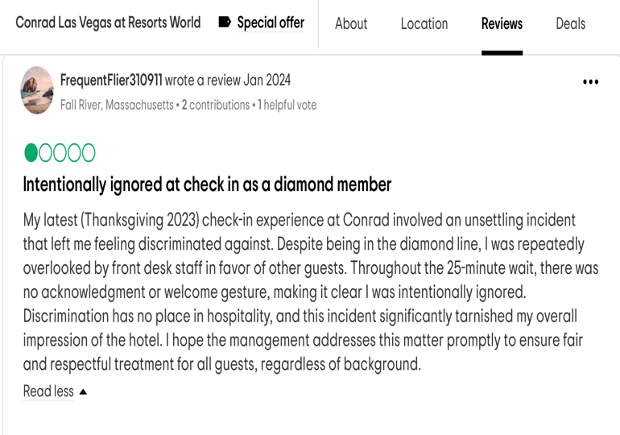

FIGURE 2

Tripadvisor, Conrad Las Vegas Resorts World
Available at: https://www.tripadvisor.co.uk/Hotel_Review-g45963-d23328327-Reviews-Conrad_Las_Vegas_at_Resorts_World-Las_Vegas_Nevada.html
(Accessed on the 10^{th of} February 2024)

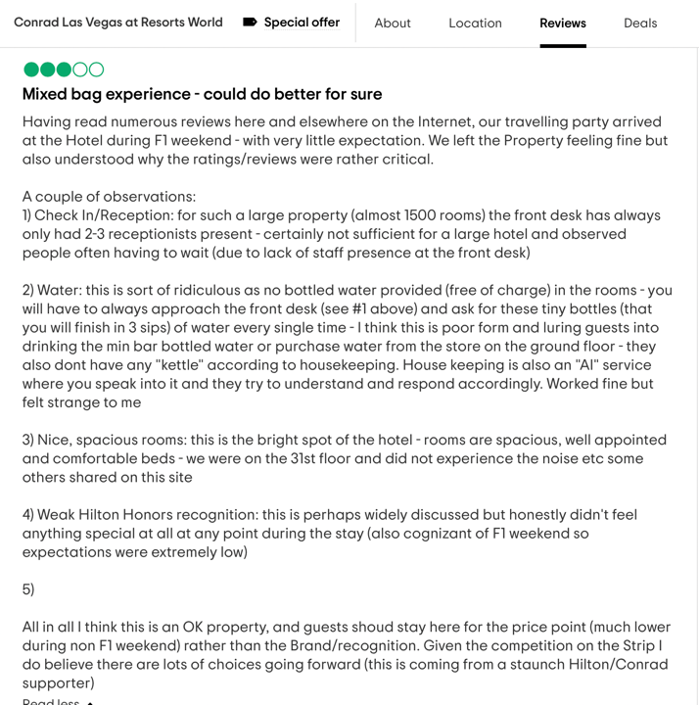

FIGURE 3

Tripadvisor, Conrad Las Vegas Resorts World
Available at: https://www.tripadvisor.co.uk/Hotel_Review-g45963-d23328327-Reviews-Conrad_Las_Vegas_at_Resorts_World-Las_Vegas_Nevada.html
(Accessed on the 10^{th of} February 2024)

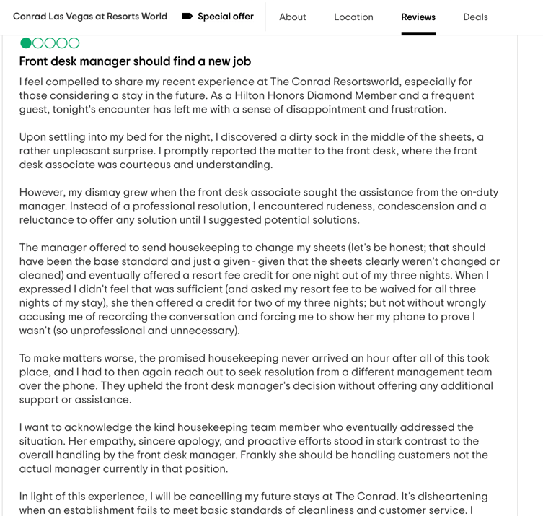

FIGURE 4

Tripadvisor, Conrad Las Vegas Resorts World
Available at: https://www.tripadvisor.co.uk/Hotel_Review-g45963-d23328327-Reviews-Conrad_Las_Vegas_at_Resorts_World-Las_Vegas_Nevada.html
(Accessed on the 10^{th of} February 2024)

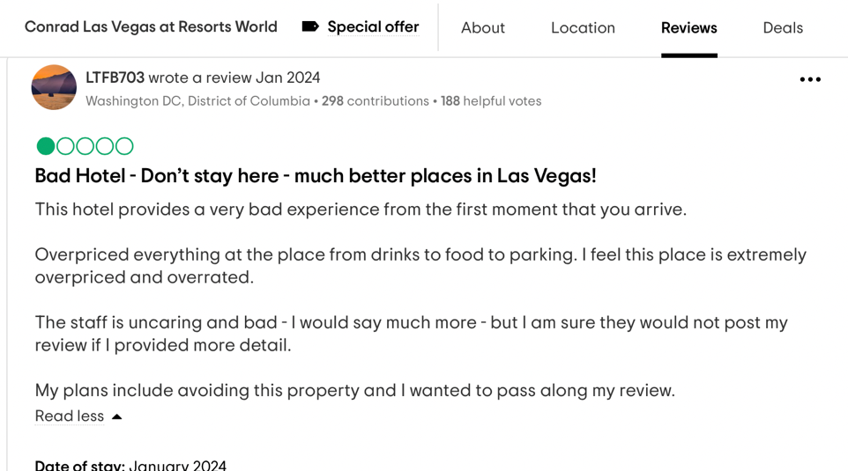

FIGURE 5

Tripadvisor, Conrad Las Vegas Resorts World
Available at: https://www.tripadvisor.co.uk/Hotel_Review-g45963-d23328327-Reviews-Conrad_Las_Vegas_at_Resorts_World-Las_Vegas_Nevada.html
(Accessed on the 10^{th of} February 2024)

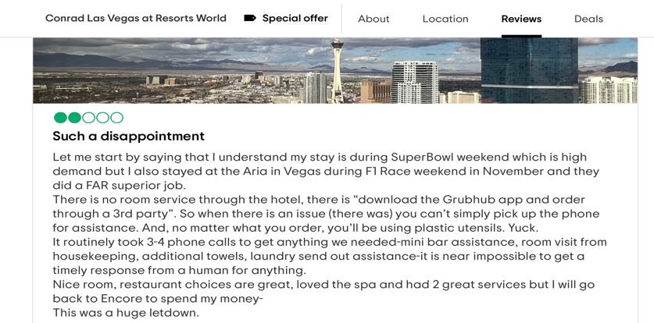

FIGURE 6
Tripadvisor, Conrad Las Vegas Resorts World
Available at: https://www.tripadvisor.co.uk/Hotel_Review-g45963-d23328327-Reviews-Conrad_Las_Vegas_at_Resorts_World-Las_Vegas_Nevada.html
(Accessed on the 10^{th of} February 2024)

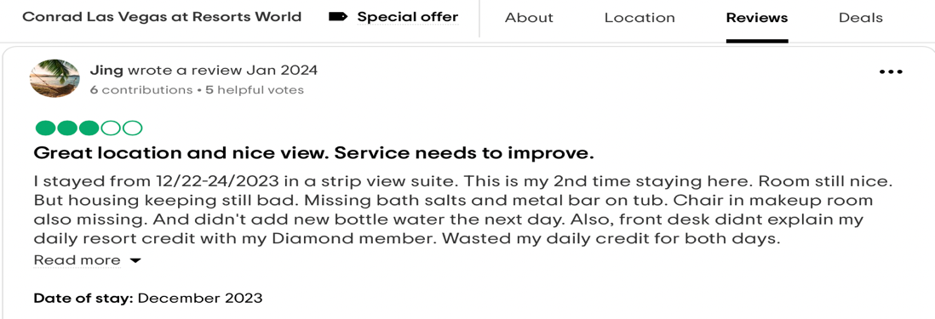

FIGURE 7
Tripadvisor, Conrad Las Vegas Resorts World
Available at: https://www.tripadvisor.co.uk/Hotel_Review-g45963-d23328327-Reviews-Conrad_Las_Vegas_at_Resorts_World-Las_Vegas_Nevada.html
(Accessed on the 10^{th of} February 2024)

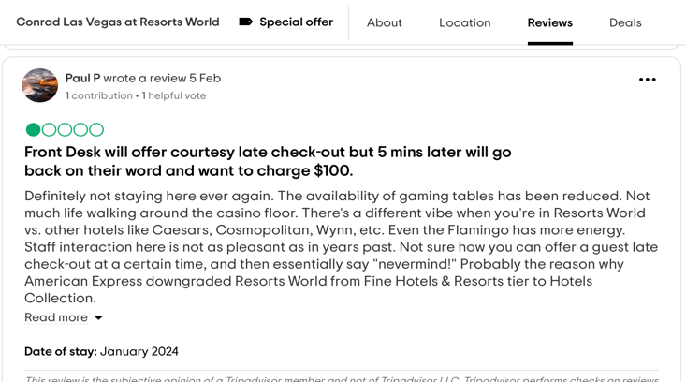

FIGURE 8
Tripadvisor, Conrad Las Vegas Resorts World
Available at: https://www.tripadvisor.co.uk/Hotel_Review-g45963-d23328327-Reviews-Conrad_Las_Vegas_at_Resorts_World-Las_Vegas_Nevada.html
(Accessed on the 10^{th of} February 2024)

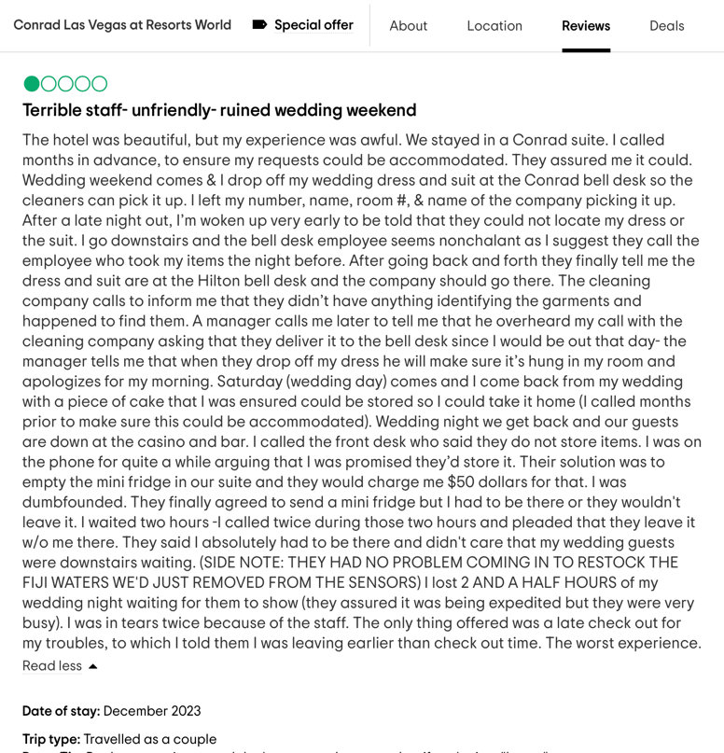

FIGURE 9
Tripadvisor, Conrad Las Vegas Resorts World
Available at: https://www.tripadvisor.co.uk/Hotel_Review-g45963-d23328327-Reviews-Conrad_Las_Vegas_at_Resorts_World-Las_Vegas_Nevada.html
(Accessed on the 10^{th of} February 2024)

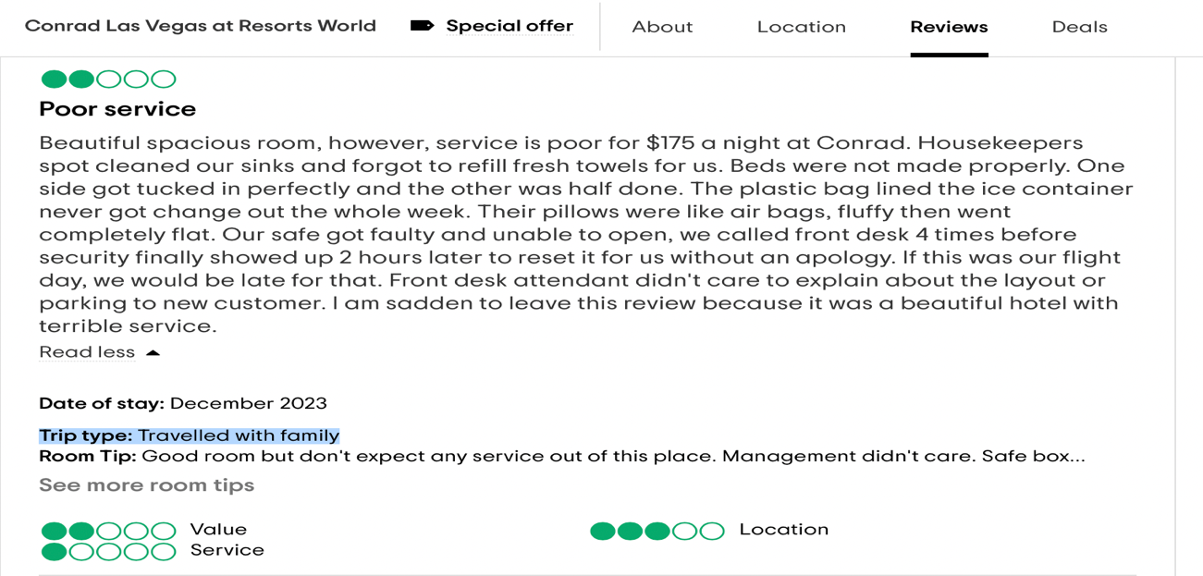

FIGURE 10
Tripadvisor, Conrad Las Vegas Resorts World
Available at: https://www.tripadvisor.co.uk/Hotel_Review-g45963-d23328327-Reviews-Conrad_Las_Vegas_at_Resorts_World-Las_Vegas_Nevada.html
(Accessed on the 10^{th of} February 2024)

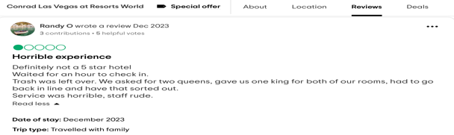

FIGURE 11
LEWIN’S MODEL OF CHANGE
Available at: https://whatfix.com/blog/lewins-change-model/
(Accessed on the 10^{th of} February 2024)

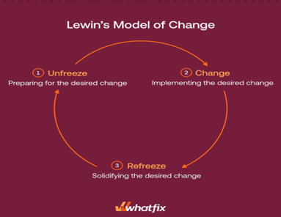

FIGURE 12

Deloitte (2015) A new model for employee engagement
Available at: https://www2.deloitte.com/us/en/insights/deloitte-review/issue-16/employee-engagement-strategies.html
(Accessed on the 1^{st of} February 2024)

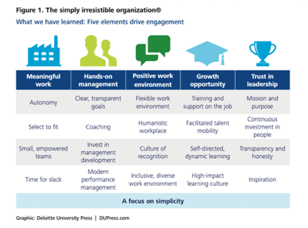

FIGURE 13
Conrad Las Vegas Resorts World
ROOMS & SUITES
Available at: https://www.rwlasvegas.com/stay/conrad-las-vegas/
(Accessed on the 1^{st of} February 2024)



