Personal Development Portfolio

Module | Professional Development within Health and Social Care
Module Code | LCHS4009
Assignment Title | Personal Development Portfolio
Lecturer’s Name | Dr Besty Jose
Student Name | Nadeem Ashraf
Student ID | 2433627
Word Count | 2045

Contents
1 Job Vacancy within Health and Social Care 3
2 Task 1 of 4 – Professional CV 4
3 Task 2 of 4 – Personal Statement 4
4 Task 3 of 4 – SWOT and PDP 6
4.1 SWOT Analysis 6
4.2 Professional Development Plan 6
5 Task 4 of 4Critical reflection – Gibbs Model 8
5.1 Description 8
5.2 Feelings 8
5.3 Evaluation 8
5.4 Analysis 9
5.5 Conclusion 9
5.6 Action Plan 9
References 10
Appendix A - Job Advertisement 12
Appendix B – Professional CV 15

Job Vacancy within Health and Social Care
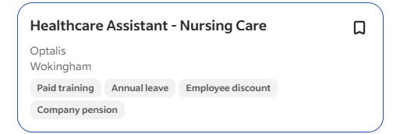
Figure 1: Job Vacancy (Source: (Indeed, 2026) )
This is a position as a Support Worker at Lime House, a residential care home managed by Nugent Care in Lowton, Warrington (Northwest England) (Indeed, 2026). The position is aimed at delivering person-centered, compassionate care to elderly residents in a warm, home-like setting, and has specific areas to offer individuals with dementia (11 specialist places available). Support Workers assist in the daily living activities as well as encourage dignity, independence, emotional wellbeing and comfort. Among the important things are to make people feel involved in meaningful activities, assisting in physical and spiritual needs, and using the beautiful sensory garden at home as a relaxation and contact with nature (Nugent, 2026).
The offer is in both full-time (39 hours per week) and part-time (19.5 hours per week) contracts with an initial salary of £25,621.60 per annum pro rata (about 12.60 per hour). It is a permanent position and is advertised on 25 February 2026 (job reference: REQ000230).
The required essentials and characteristics are passion about excellent care, proper familiarity with principles of person-centered care, readiness to finish a fully funded Level 3 Diploma in Adult Health and Social Care and possessing an enhanced DBS check. Prior healthcare or dementia support experience is also preferable but not mandatory, with entire training being offered.
The benefits are broad and inclusive: 30 days paid annual leave (increasing to 33 after three years, not inclusive of bank holidays), company pension, life insurance, Medicash health scheme, Blue Light Card discounts, continued funded training and development, career advancement opportunities, and employer funded enhanced DBS (kept on the update service).
The organisation has core values that underlie daily practice iACCORD (Integrity, Ambition, Courage, Compassion, Optimism, Respect, Dignity), and focus on heart-centred, positive care.
This role also fits well with the interests regarding supporting the psychological wellbeing of older adults in residential facilities since it includes the establishment of trusting relationships, emotional needs, and holistic care, which are directly relevant to the implementation of theories such as the attachment theory proposed by Bowlby based on continually supporting and showing empathy. It is a great start or advancement point in health and social care especially among those that have interest in dementia and elderly residential settings. Applications are solicited through Nugent Care (wearenugent.org/careers) or such websites as Indeed.

Task 1 of 4 – Professional CV
- Find in Appendix B – Professional CV

Task 2 of 4 – Personal Statement
I am eager to seek the opportunity of being a Support Worker in Lime House, Nugent Care. My future career goal is to establish a satisfying career in the field of adult health and social care, with a focus on residential care of older adults, including those with dementia. The warm and homely atmosphere at Nugent, as well as adherence to outstanding person-centred care based on respecting physical, emotional, and spiritual health, attracts me, in particular. With the help of your iACCORD principles, which are: Integrity, Ambition, Courage, Compassion, Optimism, Respect and Dignity, I would be happy to be part of the team who cares about independence, dignity and connection of nature of residents with your sensory garden.
The academic background has provided me with a firm base to this position. I have a master’s degree in political science which I attained at the University of the Punjab, Lahore where I studied the dynamics of social welfare, ethics, community welfare and human behaviour. This enlightened me to a greater extent about vulnerability, social justice, and respectful relationships. To supplement this, my undergraduate degree in Murray College, Sialkot (English, Political Science and History) instilled into me the skills of excellent communication, critical thinking and interpersonal skills using essays, group discussions and presentations. These experiences have provided me with understanding of the dissimilar needs of the aged and the affection to facilitate dignity and inclusion within the care facilities (Ekman et al., 2021; Lee et al., 2022).
My transferable experience has been acquired in the present position where I am managing our family-owned pharmacy in Pakistan. My frontline service is offered to customers of all ages, with a large proportion of elderly people who need health and medication advice and emotional support. It has sharpened my skill of listening empathetically, being able to keep confidentiality, encouraging independence by using understandable explanations, and establishing a calm and trusting environment to provide person-centered care, which is also directly applicable to working at Lime House (BDA, 2019). I am also fully determined to pursue the Level 3 Diploma in Adult Health and Social Care fully funded and to make the same commitment that Nugent endeavors towards professional development.
My strengths are compassion, patience, optimism and resiliency. Working in a caring team as a college cricket player, I have learned the importance of teamwork, discipline and assistance to others in times of pressure which can be applied to working with other team members. I am flexible, structured and will always tackle any challenge with bravery and dignity. My complete set of these qualities along with effective communication and organizational competencies help me to develop positive relationships, be sensitive to emotional needs, and add value to an environment where values are central to it.
In my opinion, my experience and competencies will be an actual value to Nugent Care. My educational knowledge of human relationships, coupled with direct practice with vulnerable populations, will assist me in providing care that is compassionate and dignified and improve the quality of life of the residents. My motivation to learn and fit iACCORD values imply that I will be a loyal and striving member of the team who will contribute to the establishment of the pleasant and friendly environment that Lime House is characterized by. Even though now located in Pakistan, I am ready, without hesitation to move to the UK and start contributing instantly.
I believe I am the best fit candidate in this position since I am passionate, skilled, and committed, and I am excited to have an opportunity to talk to you about how I can help the residents of Lime House and your exceptional team.

Task 3 of 4 – SWOT and PDP

SWOT Analysis
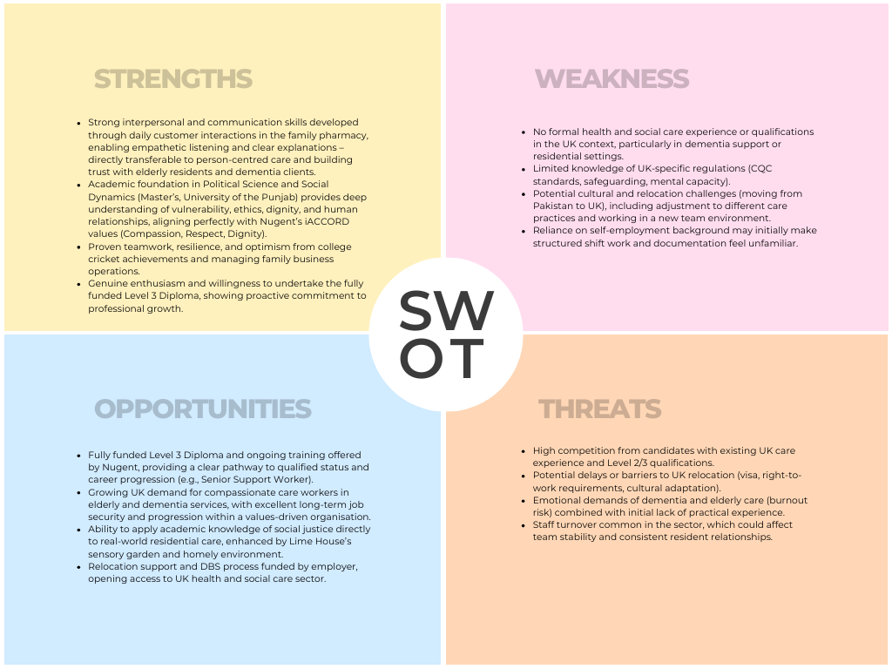
Figure 2: SWOT Analysis - Authors' Created (Source: Canva)

Professional Development Plan
Table 2: Professional Development Plan (PDP) (Karas et al., 2020; Skills For Care, 2026)
Goal | Actions & Development (2026–2028) | Monitoring and Evaluation
Goal 1: Achieve Level 3 Diploma in Adult Health and Social Care (Qualified Status) | Graduate the fully funded diploma in a period of 18 months by participating in all the planned classes and delivering the assignments before the due date.  Implement learning in the form of reflective practice logs following every shift, connecting theory to day-to-day care (e.g. person-centered approaches and dementia residents).  - Year 1: Concentrate on basic courses (safeguarding, communication, dementia awareness).  - Year 2: Sophisticated units and work evaluation. | Monthly review of the assignment deadlines and Tutor feedback; quarterly Sign-off by the supervisor. Success in terms of complete qualification in September 2027 and 90% or above pass rate in modules.
Goal 2: Build Practical Dementia and Person-Centered Care Skills | Shadow with colleagues during first 3 months, then gradually assume more responsibility doing 1-on-1 resident activities (e.g., sensory garden sessions, reminiscence).  Participate in all Nugent internal training (dementia, mental capacity, manual handling) and read one pertinent book/article every month.  - Year 1: Stress on observation and elementary support.  - Year 2: Conduct small group activities and participate in care-plan reviews. | Maintain a reflective journal weekly; request resident/family feedback, through anonymous surveys, every 6 months. Assess in terms of line-manager observations and confidence scores increasing to 9/10 to 4/10 by March 2028.
Goal 3: Develop Cultural Competence and Relocation Resilience | Full training UK cultural awareness and equality and diversity within first 6 months.  Social support: Build social support through Nugent staff networks and local community groups in Warrington.  - Year 1: Concentrate on year 1 UK care cultural and shift patterns.  - Year 2: Mentor new international employees and facilitate one diversity awareness. | Monthly self-evaluation of self against relocation checklist; Team 360-degree feedback.  Measures of success:  - positive integration (no longer sickness)  - Support of others by March 2028.

Task 4 of 4Critical reflection – Gibbs Model

Description
These are the tasks that I performed between March and April 2026 to prepare a professional application to the Support Worker position at Lime House, Nugent Care: tailoring a two-page Curriculum Vitae, writing a 500-words personal statement, creating a SWOT analysis, and developing a two-year Personal Development Plan (PDP). This started with identifying the vacancy, followed by adjusting my Pakistani pharmacy background and academic credentials (MA Political science, BA English/Political science/history) to the UK health and social care specifications. Any document was continuously improved to correspond with the job description, person-centered care ethos, and iACCORD values.

Feelings
At first, I was excited and motivated; the job was exactly what I needed according to my rising curiosity about older-adult wellbeing and the attachment theory of Bowlby that I had studied previously. Nonetheless, anxiety arose, as I pointed out flaws within the SWOT (no experience working in the UK, obstacles to relocation, etc.). Writing the personal statement brought me pride about my transferable pharmacy skills and vulnerability of facing the cultural transition between Pakistan and Warrington. The accomplishment of the PDP provided a feeling of empowerment and hope since tangible objectives substituted ambiguity.

Evaluation
What was good was the obvious customization of all the documents. The CV and personal statement helped to translate self-employment experience into person-centered language in an effective way and the SWOT revealed honest self-knowledge and the PDP provided realistic and funded routes (Level 3 Diploma). Structure and professionalism performance was good; the documents were read in cohesive form as a portfolio. Weak points included the occasional use of generic phrases in the personal statement and lack of depth in connection of academic theory to practice. Comprehensively, the process was a success, but it demonstrated loopholes that may undermine an interview performance.

Analysis
The assignments compelled me to think intensively about myself, which is the reflection of the cycle itself. The job requirements were also met by my strengths (empathy through pharmacy customer care and resilience through cricket), which admitted that transferable skills are also powerful when reconsidered consciously. Nevertheless, a limitation list in the SWOT revealed a real gap in the strengths in the UK-specific expertise (CQC, safeguarding), and this gap was not explained in detail by academic training in political-science. This is in line with literature on career development that focuses on the requirement to be culturally competent upon relocation. The three goals of the PDP were deliberately SMART, but I understand that I will not achieve them until I have an immediate voluntary experience, which will make them practical (Archyangelio, 2025; Borg & Karlsson, 2017). On the emotional front, it changed me because I was no longer in imposter syndrome but rather quietly confident, although now I realize that more research on the practices of dementia care would have empowered each document (Flicker, 1999; Livingston et al., 2017).

Conclusion
Portfolio development was a favorable learning process that turned theoretical career wants into practical application resources. I have done great work in professional presentation and goal setting, but I might have created even more solid evidence by seeking UK care shadowing or volunteering before. The exercise affirmed that I am suitable for the opportunity and confirmed the significance of balancing international experience with local context.

Action Plan
- Do 20 hours of voluntary work in a local Pakistani community elder-support group within the next three months to get examples to apply in the future.
- Do an online UK safeguarding and dementia awareness course (free via Skills for Care) before filling out the application.
- Set up a mock interview with a careers advisor to practice stating the SWOT and PDP. These measures will be checked every month with the help of a reflective journal and will be assessed by new confidence rating and feedback.
- I will have a UK-relevant experience that is demonstrable by September 2026, and the future applications and interviews will be more resilient and genuine.
This reflection has made me more professional and better equipped to work as a Support Worker.

References
Archyangelio, Annesha. (2025). International healthcare professionals’ handbook : a success guide to working in the UK for nurses, midwives and allied health professionals. 268. https://books.google.com/books/about/International_Healthcare_Professionals_H.html?id=uuAsEQAAQBAJ
BDA. (2019). Principles forcontinuing professional development and lifelong learning in health and social care. https://www.bda.uk.com/static/3830abb3-e267-4f5c-a93e7c3aca843ffe/cpdjointstatement.pdf
Borg, M., & Karlsson, B. (2017). Person-centredness, recovery and user involvement in mental health services. Person-Centred Practice in Nursing and Health Care: Theory and Practice, 215–224. https://www.wiley.com/en-us/Person-Centred+Practice+in+Nursing+and+Health+Care%3A+Theory+and+Practice%2C+2nd+Edition-p-9781118990568
Ekman, I., Ebrahimi, Z., & Olaya Contreras, P. (2021). Person-centred care: looking back, looking forward. European Journal of Cardiovascular Nursing, 20(2), 93–95. https://doi.org/10.1093/eurjcn/zvaa025
Flicker, L. (1999). Dementia Reconsidered: the Person Comes First. BMJ : British Medical Journal, 318(7187), 880. https://doi.org/10.1136/bmj.318.7187.880a
Indeed. (2026). Healthcare Support Worker Work, jobs in United Kingdom (with Salaries) | Indeed United Kingdom. https://uk.indeed.com/jobs?q=Healthcare+Support+Worker&l=United+Kingdom&from=searchOnDesktopSerp%2Cwhereautocomplete&cf-turnstile-response=0.22ub1iubbOSCEPrSx94zjtyBDH8KqayxtoEB0VF78smonA_cAtkRqnFVATtu6o6ssEpIvK66gUIA5QoUDa9fMBou5QGCfmFsDdd74xRcI3rFXQdNt7W--hUwwnjgkEN39foaSU6kKeSKODX9Ae60WTgptGwvZpqFCRLv3Q_KUXm5A1fq5MxPYFz3I7geTjC6GUYgCuS6AzzyQNRjFvE5ySDd6cI38nhZFHyu21DrhHNvYIgHc4rUAzwHndiM2vHCNAflHVR3fwNsS5wxEWeDmmb3vOpQuYt8ubutdO1tApXWc1C8y28ExfTHlYDWye0HtdPHRR_rrzmPPExcw9B2DJko40OL8OHlheuAQaBpouZVXiaGDZcRGATKxa7vCzP32-PMAoavXX5Ubx8uW7AgGfVvIVuC5KMDd5tV00aeLB15Q4wE_5wAuvPgcPM-MRAr9_eE7TADYeMndN8FMWLZGmBNPV--0Y7NHOfNhRttb0kMXITA-oViSGkh3nHppuWOUVhcjwOkYJv1uh_ni4hNFtbUGwic2I7FMxxALFq70JK7mqLELZ0iaIm8fdtZrF90zGod7jJnf_LIwMCdOelX0qZtSwKT0XD0sV_g-gCTZMo4yTgGSo7KQ9vxESBZwuNjqMT-TnFiyhhk6jP2Nefdf_YzyGnDxHeq7wX-iNr7v1ZSUqjRPsmuAixC3VLAsIhayOZCyvKrwtmelMw257XQrBeNA0gufFlO2HNrSmI8ohIgQ2fPCIwtlA4SR95-q22OCoPsFXzQctQWGRgcgfTTh7RRklZL7UFmsmo8SHgnpkV9QSVAhFY8hQ8oboOc2Ck85poe5GCFL3HI8Jm4fqISqnHAEoIQPRq2W4ArcufrSFbEP7gi4Fk-6heE-nxXyx7PAe6hDQgIHvzIheO9buoCD1Cii9PdxR38bGU38zcwr7Y.2n1aXfFVtpaR1vXxzeNaXw.d14dd2ea55d422ecce272b9f354d1a79dccd021017cdbbd321c86750d807507c&vjk=527382cfaf77b509
Karas, M., Sheen, N. J. L., North, R. V., Ryan, B., & Bullock, A. (2020). Continuing professional development requirements for UK health professionals: a scoping review. BMJ Open, 10(3). https://doi.org/10.1136/bmjopen-2019-032781
Lee, K. H., Lee, J. Y., & Kim, B. (2022). Person-Centered Care in Persons Living With Dementia: A Systematic Review and Meta-analysis. The Gerontologist, 62(4), E253–E264. https://doi.org/10.1093/geront/gnaa207
Livingston, G., Sommerlad, A., Orgeta, V., Costafreda, S. G., Huntley, J., Ames, D., Ballard, C., Banerjee, S., Burns, A., Cohen-Mansfield, J., Cooper, C., Fox, N., Gitlin, L. N., Howard, R., Kales, H. C., Larson, E. B., Ritchie, K., Rockwood, K., Sampson, E. L., … Mukadam, N. (2017). Dementia prevention, intervention, and care. Lancet (London, England), 390(10113), 2673–2734. https://doi.org/10.1016/S0140-6736(17)31363-6
Nugent. (2026). Home - Nugent. https://wearenugent.org/
Skills For Care. (2026). Statutory and mandatory training guide for adult social care employers. https://www.skillsforcare.org.uk/resources/documents/Developing-your-workforce/Guide-to-developing-your-staff/Statutory-and-mandatory-training-guide-December-2025.pdf

Appendix A - Job Advertisement
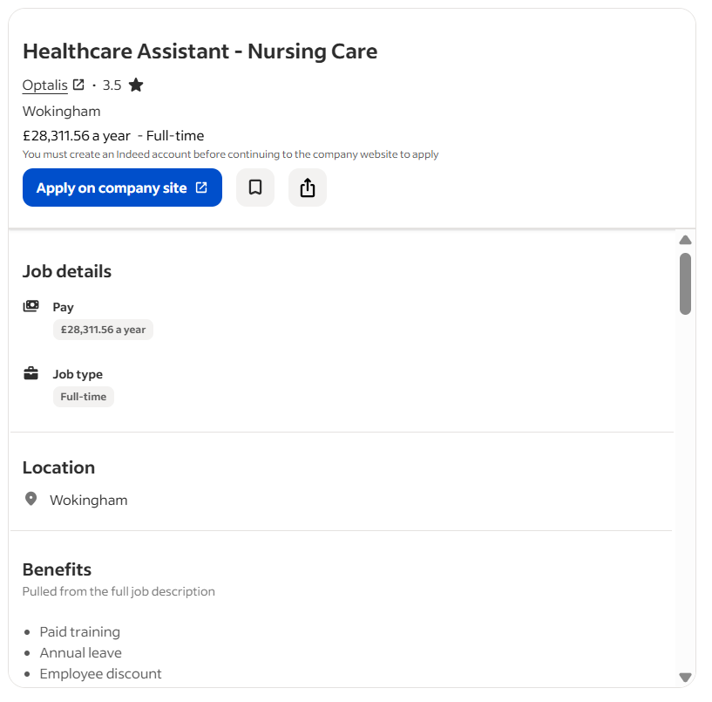
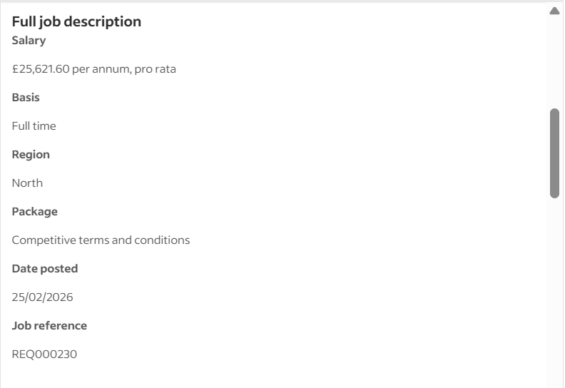
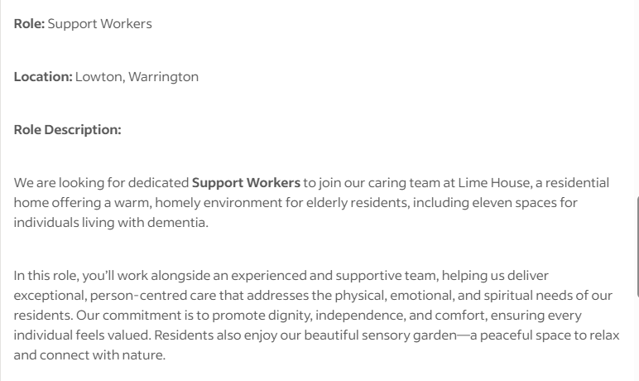
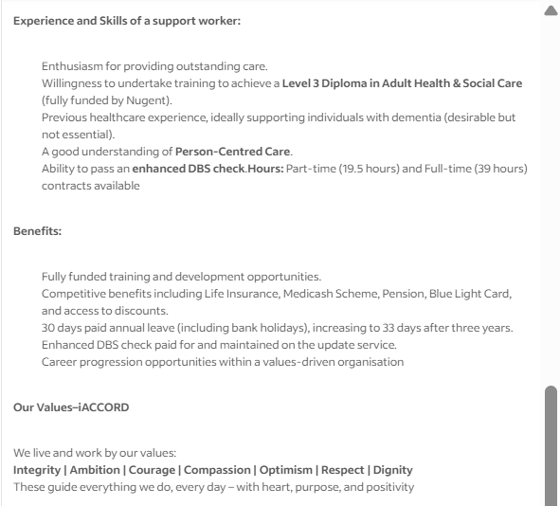

Appendix B – Professional CV
Name: Nadeem Ashraf
Address: 30 Wyatt Close, B57QR
Phone Number: 07578033692
Email: nady10@hotmail.co.uk
Personal Profile
I am a kind and passionate person with excellent academic and transferable skills in family business management and is willing to start a fulfilling career as a Support Worker in Lime House, Nugent Care. Driven by enthusiasm in person-centred care, dignity, independence and emotional wellbeing of elderly residents, including those with dementia. Desire to complete a fully funded course to a Level 3 Diploma in Adult Health and Social Care and be part of a values-based team that follows iACCORD principles (Integrity, Ambition, Courage, Compassion, Optimism, Respect, Dignity). Superior communicator with a patient, understanding attitude acquired during work with customers and a sincere wish to help vulnerable adults in a friendly and home-provided atmosphere.
Key Skills
- Caring & Empathetic
- Communication
- Teamwork and Collaboration
- Adaptability & Resilience
- Organizational Skills
- Dedication to Study
- Understanding of Dignity and Respect
Education
Master of Arts in Political Science
University of the Punjab, Lahore, Pakistan
- Concentrated on social processes, human behaviour, ethics and community well-being, with a good grounding on the needs of different people and social justice- directly applicable to vulnerable older adults.
Bachelor’s Degree (Graduation)
Murray College, Sialkot, Pakistan
(From:To)
- Subjects: English, Political Science and History.
- Grew up great literacy, critical thinking, and people skills in the form of essays, group work and discussions.
Work Experience
Self Employed / Family Business Manager / Pharmacy
Family-Owned Pharmacy, Pakistan
- Helped with daily activities of a community pharmacy, including frontline customer service to a diverse group of customers, including older customers with health-related needs.
- Provided personalized guidance on medications, health questions, and wellbeing and showed patience, effective communication, and empathy.
- Organized stock management provided a clean and safe working environment, and managed sensitive information in secrecy.
- Provide support to family members and community members during difficult situations, develop trust and facilitate comfort- skills that can be applied in residential care.
- Encouraged self-reliance through enabling customers to be informed choices about their health.
Achievements
College Cricket Player
- I participated in inter-college cricket tourism as a member of Murray College, learned about teamwork, discipline, resilience and how to play under pressure, as well as cheering up the team spirit.
- Finished academic studies along with family business obligations successfully and proved to be an effective time manager and a committed person.
Interests and Hobbies
- Cricket and team sports Enjoy playing and watching games, which strengthens teamwork, tactics, and being positive in a team.
- Community engagement - Participate actively in family and local support groups, assisting neighbors and relatives with their day-to-day tasks and emotional support.
- Reading about social issues and wellbeing Keen interest in topics associated with ageing, mental health, and compassionate care to prepare better to work in health and social care.
References
Furnished upon request

