Problem solving and Decision Making
LECTURER: Yajesh Kumar
STUDENT: Maria Stavrou
STUDENT NUMBER: 1817745

Hello
My name is Maria Stavrou, I would like to present my personal opinion on the work problems that an employee may have either at work upstairs or with colleagues .In our work we face daily challenges that concern almost everything , communication problems with our colleagues with our employer fatigue and much more can contribute significantly to your bad psychology and make you want to give up everything and leave. I will make a great reference to communication , which I think is one of the most important pieces.
Many times what spoils the atmosphere at work is the communication we have colleagues everyone has their problems and usually breaks out in the workplace, but there are ways to solve everything and live harmoniously for these 8 or more hours you are in the same place.
Both for your work and for your personal life, there are some life lessons that you should be aware of and apply immediately .In this way you will enhance your professional development and career while at the same time will be able to form a professional profile that will have a positive impact on your workplace and those around you.
Many times going to work and you are not happy , and that has to do, with how much you like your job , if you are happy with yourself, and what your expectations are for the future. If you have not given all your personal issues, they may create a bigger problem at work, this of course concerns your personal part ,but it has a great relationship with your behavior at work ,because if you have a good relationship with yourself you can deal with problems as a professional.
Here we can mention the SWOT analysis , what is and why is important ,SWOT analysis has four stages strengths ,weaknesses, opportunities and threats ,the significance of SWOT analysis is that it provides a good way for companies to examine both positives and negative attributes within a single analysis determining how best to compete in market at large ,it can also be used for personal use .we can analyze these four stages of our character and to find our positive and negative and find the solution to become better ,knowing yourself well ,knowing your options and how to improve them ,you can become a better person and a better partner .and so you can deal with the problems more objectively.
Let’s take things from the beginning a toxic work environment that is negatively charged strongly affects you emotionally and makes you emotionally and you feel high stress and disgust for your work.
It is not hard to tell , if you work environment belongs to this category as long as you see how people work together if the atmosphere is constantly electrified there are big problems in communication constant pressure and complaint then something is wrong.
It is important to stay away from toxic people and environments. Not only because they endanger our health but also because they hold us back and prevent us from evolving. Communication is the most important thing in your job , you cant’t be friends with everyone but you can keep a formal communication. How can you do that : find the positives, in order to deal with negativity, stress and madness in a bad work environment you need to change the perspective of what you see, what you need to do is find the positives in each case, so that you can focus there and get your attention from the negatives.
If, for example you are in a job that is a good opportunity to gain experience or an opportunity for a better position in the future , then consider that it is a step that will help you climb higher.
Don’t’ pay attention to gossip , rumors and constant comments from other colleagues are a reality in all businesses ,but in any toxic work environment they have the first say in everyday life. often it is one of the parameters that can affect the thoughts you make and how you feel ,especially if gossip is aimed at you and hurts you every day .However all of these are often fantasy cases and products.
Unfortunately you can’t control what others do and say but what you can control is yourself and your reaction so don’t let the various stories and comments affect you, stop thinking about what may or may not have happened and turn your gaze to reality and data that exists.
Make sure you are not part of the problem you may want to help a colleague at work or focus on specific problems. However constantly correcting others or complaining all the time does not help much even if you have the best intentions instead of helping things get better and smoother you make them actually worse.
Unfortunately if you are part of the problem it is difficult to understand and deal with it as one does not easily admit ones mistakes and guilt.
However if you want to change something and survive in difficult and toxic work environment you must first make sure that you do nit contribute to the problem in your own way otherwise it is very likely that negativity will follow you everywhere even if you change job.
Workplace communication is essential for teamwork it not only creates and maintains relationships but also facilitates innovation. Employess with strong communication skills tend to have better ideas, without effective communication in the workplace it is certain that there will be several problems.
Unable to follow the team , once an information is shared employees must then take specific action ,however if one or more people do not understand the flow of work properly they will not be able to follow the rest of the group which can lead to problems.
Difficulty listening to each other ,sharing information is just a small part of communication in the office .what matters most is that you really listen to what your colleague has to say ,you should always confirm that the messages have been shared correctly and understood by the whole team.
Relationships with our colleagues are a very important part of our lives ,it is true that we often live with them for more hours than with our family or our closest friends ,so when these relationships cease to be characterized by harmony and good mood a large part of our lives suffer at the same time it is almost impossible to develop professionally if our work is not based on good cooperation with others.
Disagreements competitive behaviors and poor communication can lead to bad relationships between members of a team working for a common goal.
At the same time differences in mentality position level of education in the various hierarchical levels cam contribute to the creation of situations that lead to bad relationships with negative effects in terms of effectiveness.
Strong teams in the workplace can work wonders and when there is proper communication and understanding then you can feel safe in your work environment.
In any job you should try to communicate properly with your co-workers so that you can have better results and be comfortable with each other.
Communication greatly determines our lives as significantly affects the quality of our relationships ,business love relationships all rely heavily on communication between people, just as communication affects our lives so too does lifestyle shape communication over the years ,that’s why technology plays a significant role in our relationships ,it has changed the way people communicate.
Unfortunately ,poor communication often causes tensions and problems affecting our overall quality of life .Many times bad communication is more about the way and not the content. when we use general expressions we repeatedly refute the words of our interlocutor without arguments we make the discussion difficult.in addition many people choose to be bad listeners because they want to establish their own point of view rather than enrich their field of knowledge ,in addition to the problems of everyday life the way we choose to express our personality shapes our relationships with others and therefore our communication with them.
In trying to express our I we make mistakes that create gaps. We come to hasty conclusions we judge and we do not separate the past from the present allowing our negative experiences to anticipate reactions. while it seems that the communication code we choose determines its plays an important role. People from different backgrounds with different views and worldviews are unable to communicate because they put their personal perception of the world first.
After we have mentioned in every detail in communication and communication problems ,when you are in a job you do not always play the role of leader.
Creating a climate of hostility opens the door to climate change with unpredictable consequences. the consequences will hurt the team members who have the differences the whole team the productivity and the effectiveness of the whole. the outward image of workgroup or a company will inevitably suffer from the bad working relationships that may exist.
The role of the person who has a leading position in a particular group, who may be the supervisor or the director plays a decisive role in the genesis but also in the control of situations that arise from dad behavior in the workplace.
The boss himself should first be an example of good behavior in good courtesy with respect and esteem for all employees of his team regardless of the hierarchical position of each.
The other members of the working group inevitably look at and monitor the behavior of their boss they are affected and as a point they can copy this behavior.
The boss in his own way should show that behavior or comments that show disrespect and lack of appreciation for others are not acceptable. With his own behavior he will set the limits and crate a friendly atmosphere in which each member will perform calmly under good conditions to the maximum degree of his skills.
Open discussion within the group under good quiet conditions constructive intervention by other senior executives of a company or work team can help.
Maintaining a state of mutual respect and appreciation in the work environment is the responsibility of all at all hierarchical levels.
Appreciation mutual respect and courtesy towards colleagues create a suitable atmosphere for the possible maximization of the possibilities of the working group.
At the same time the required mental satisfaction is offered which every employee needs in order to continue to perform with pleasure.
The key word is called work life balance and it is nothing but maintain a relatively good balance between professional on the one hand and personal, emotional, mental or spiritual life on the other, necessary to feel good at work.
Work is not everything ,no matter how much we have grown up with the expectation of everyone to succeed and shine in our work this especially in a difficult time is not always possible .Most people need to adjust to jobs below their expectations, the paradox is that many people the more frustrated they feel the more they tired and frustrated at work ,often sacrificing their personal peace their mental and physical well being and health, and yet work no matter how important it is to us should not monopolize our lives for a long time because simply no human being is made just to work .

REFERENCE
https://www.skillsyounedd.com[problem BY SKILLS YOU NEED 2011 solving skills|skillyouneed
www.forbes.com[ BY GLENN LIOPIS 4,2013the most effective ways leades solve problems
https://www.lifehack.org[ BY ZOE B 11,2020 6 ways to enhance your problem solving skills effectively-lifehack
https://time-recruitment.com[ BY TIME RECRUITMENT 2019 the importance of good communication in the workplace-time recruitment
www.consciouscommunication.co.uk/[BY CONSCIOUS COMMUNICATION 2015 level 5 communication skills impove teamwork & results
https://www.reed.co.uk[how STEVE OLENSLI 29,2016 to communicate effectively at work
www.insightsforprofessionals.com/ BY SAMANTHA MARSH 2,2018 communicatio in the workplace
www.wordstream.com[ BY DAN SHEWAN APRIL 20,2020how
to do a SWOT analysis[WITH EXAMPLES
https://articles.bplans.com[SWOT analysis of a person BY NOAH PARSONS APRIL 5,2018
https://managementhelp.org[Carter BY Ncnamara 2013[problem solving and Decion Making
https://www.managers.org.uk
BY chartered Management Institute,2020problem solving techniques and best practices

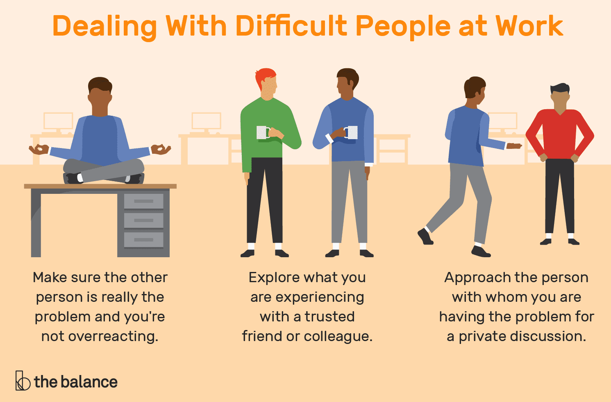

THANK YOU FOR YOUR TIME

